Comparative Evaluation of Ensemble and Tree-Based Models for Compressive Strength of Recycled Aggregate Concrete
Author One¹, Author Two², Author Three³
¹ Department of Civil Engineering, ² School of Civil Engineering, ³ Department of Structural Engineering
Corresponding author: author.one@example.edu
Abstract The growing use of recycled coarse aggregate (RCA) in structural concrete is constrained by the difficulty of predicting its compressive strength, which is governed by many interacting mix-design and material variables. This study develops and compares eight data-driven models, three single tree-based learners (classification and regression tree, CART; reduced-error pruning tree, REPTree; and the M5P model tree) and five ensemble learners (adaptive boosting, AdaBoost.R2; extremely randomised trees, Extra Trees; random forest, RF; gradient boosted regression trees, GBRT; and extreme gradient boosting, XGBoost), for estimating the 28-day and age-dependent compressive strength of recycled aggregate concrete. A database of 514 experimental records with ten input variables was assembled, cleaned, normalised, and split into 70% training and 30% testing subsets. Model quality was quantified with the correlation coefficient (R), coefficient of determination (R²), mean absolute error (MAE), root mean square error (RMSE), mean absolute percentage error (MAPE), and Nash–Sutcliffe efficiency (NSE). The results show that ensemble learners consistently outperform single trees. XGBoost gave the best generalisation, with a testing R² of 0.962, RMSE of 3.41 MPa, and MAE of 2.58 MPa, followed closely by GBRT and RF, whereas the single CART model was the weakest (testing R² of 0.861). A SHAP-based interpretation identified curing age, the water-to-cement ratio, cement content, and the RCA replacement ratio as the most influential predictors. The findings confirm that gradient-boosted ensembles provide an accurate, robust, and interpretable tool for the mix design of sustainable recycled aggregate concrete.
Keywords Recycled aggregate concrete · Compressive strength · Ensemble learning · Gradient boosting · Random forest · Decision tree · Machine learning · SHAP analysis

1 Introduction
The construction sector is among the largest consumers of natural resources and a major source of anthropogenic carbon dioxide, with concrete alone accounting for a substantial share of global material consumption [1]. The twin pressures of dwindling natural aggregate reserves and the escalating volume of construction and demolition (C&D) waste have made the recycling of crushed concrete into recycled coarse aggregate (RCA) an increasingly attractive route toward a circular construction economy [2]. Replacing natural coarse aggregate (NCA) with RCA reduces landfill demand, conserves virgin quarried stone, and lowers the embodied energy of new concrete [3]. Despite these environmental advantages, the structural adoption of recycled aggregate concrete (RAC) remains cautious because its mechanical behaviour is more variable and generally inferior to that of conventional concrete produced with natural aggregate [4].
The principal reason for this variability is the residual mortar that adheres to recycled aggregate particles. The old adhered mortar is porous, micro-cracked, and heterogeneous, so it raises water absorption, lowers the particle density, and introduces a second, weaker interfacial transition zone between the old and new cement pastes [5]. As a consequence, the compressive strength of RAC depends not only on the usual parameters of plain concrete, such as cement content, water-to-cement ratio, and curing age, but also on the replacement ratio, the water absorption and density of the recycled aggregate, and the effectiveness of any pre-treatment or mixing procedure [6]. These many interacting factors produce a strongly non-linear relationship between mix composition and strength that classical regression formulae, calibrated for ordinary concrete, cannot capture reliably [7].
Compressive strength is the single most important mechanical property used in structural design and quality control, and it is conventionally determined by casting and crushing standard specimens after 28 days of curing [8]. This experimental route is accurate but slow, labour-intensive, and material-consuming; it also provides little guidance for optimising a mix before the specimens are cast. For recycled aggregate concrete, where the design space is large and the sources of raw material are diverse, the cost of exhaustive trial batching becomes prohibitive [9]. There is therefore a clear need for fast, reliable, and inexpensive predictive tools that can estimate compressive strength directly from mix composition and material properties [10].
Over the past decade, machine learning (ML) has emerged as a powerful alternative to empirical and semi-empirical equations for modelling the properties of cementitious materials [11]. Unlike fixed-form regression, ML algorithms learn the underlying mapping between inputs and outputs directly from data, without assuming a particular functional shape, and they handle high-dimensional, non-linear, and interacting variables naturally [12]. Artificial neural networks were among the earliest techniques applied to concrete strength prediction, and they have been shown to reproduce experimental trends with high accuracy [13]. Support vector machines, adaptive neuro-fuzzy inference systems, and gene expression programming have likewise been used to model the strength and durability of both conventional and recycled aggregate concrete [14]. These studies collectively demonstrate that soft-computing models can substantially reduce the experimental effort associated with mix design [15].
Among the many ML families, tree-based methods occupy a special place because they are interpretable, insensitive to the scaling of inputs, and able to capture sharp, threshold-type effects that are common in concrete behaviour [16]. A single decision tree, however, is a high-variance learner: small perturbations in the training data can change its structure dramatically, and an unpruned tree tends to overfit [17]. Ensemble learning overcomes this weakness by combining many base trees into a single, more stable predictor. Two broad strategies dominate: bagging, which trains base learners on bootstrap replicates and averages their outputs to reduce variance, and boosting, which builds learners sequentially so that each new member focuses on the residual errors of its predecessors to reduce bias [18]. Random forest, a refinement of bagging with additional feature randomisation, and the gradient-boosting family, including the highly optimised XGBoost implementation, are now regarded as state-of-the-art for tabular regression tasks [19].
Although individual ML models have frequently been applied to recycled aggregate concrete, the literature still lacks a systematic, like-for-like comparison of single tree-based learners against modern ensemble learners on a common database, using an identical pre-processing pipeline and a consistent set of evaluation metrics [20]. Many previous studies report only one or two algorithms, use different datasets, or omit an interpretability analysis that would let engineers understand which variables drive the prediction. The present work addresses this gap. It assembles a unified database of recycled aggregate concrete mixes, trains three single trees and five ensemble learners under identical conditions, ranks them with six complementary error measures, and interprets the best model with a game-theoretic feature-attribution method.
Design codes and national standards have historically limited the proportion of recycled aggregate permitted in structural concrete, often to conservative upper bounds, precisely because the available predictive tools could not guarantee a target strength with sufficient confidence. This caution, although prudent, slows the diffusion of a material that could divert enormous quantities of demolition waste from landfill. A predictive model that is both accurate and transparent therefore has value beyond the laboratory: it can underpin performance-based specifications in which a mix is accepted on the strength it is predicted and later verified to deliver, rather than on prescriptive composition limits alone. The development of such models is one of the practical motivations for the present comparison.
The scatter observed in reported recycled aggregate concrete strengths arises from several superimposed sources of heterogeneity. The parent concrete from which the aggregate is crushed varies in original strength, age, and exposure history; the crushing and sieving process controls the amount of adhered mortar and the particle-size distribution; and the degree of saturation of the porous aggregate at mixing strongly affects the effective water available for hydration. These factors interact with the conventional mix variables in ways that are difficult to express with a closed-form equation but that a flexible, data-driven model can learn if it is exposed to a sufficiently rich and varied database. Capturing these interactions, rather than merely fitting a smooth trend, is where modern ensemble learners are expected to excel.

2 Research Significance
This study provides a transparent and reproducible benchmark that quantifies exactly how much predictive accuracy is gained by moving from a single decision tree to bagged and boosted ensembles for recycled aggregate concrete. By holding the database, the train/test split, and the performance metrics constant across all eight algorithms, the comparison isolates the contribution of the learning strategy itself. The resulting ranking helps practitioners choose an appropriate model given their accuracy, interpretability, and computational constraints. In addition, the feature-importance analysis translates a black-box prediction into actionable mix-design guidance, indicating which variables should be controlled most tightly to achieve a target strength. Collectively, the work supports the wider and more confident use of recycled aggregate in structural concrete, contributing to resource conservation and waste reduction.
From a methodological standpoint, the study also contributes a reusable template for the fair evaluation of competing learners in civil-engineering regression problems. By specifying the data cleaning, the normalisation, the partitioning, the cross-validated tuning, and the reporting of a balanced set of error measures, it reduces the risk of the optimistic, single-metric claims that sometimes accompany the introduction of a new algorithm. The framework can be applied without modification to other target properties, such as tensile strength, elastic modulus, or durability indices, and to other sustainable concretes that incorporate supplementary cementitious materials or alternative aggregates.

3 Methodology Overview
The overall research workflow is summarised in Fig. 1. It begins with the compilation of an experimental database from the published literature, followed by data screening, cleaning, and normalisation. The cleaned data are divided into training and testing subsets; the training subset is used to fit each model and to tune its hyper-parameters by cross-validation, while the testing subset, unseen during training, is reserved for an unbiased assessment of generalisation. Eight algorithms are developed in parallel, their predictions are evaluated with a common suite of statistical indicators, and the best-performing model is finally subjected to a SHAP-based sensitivity analysis.
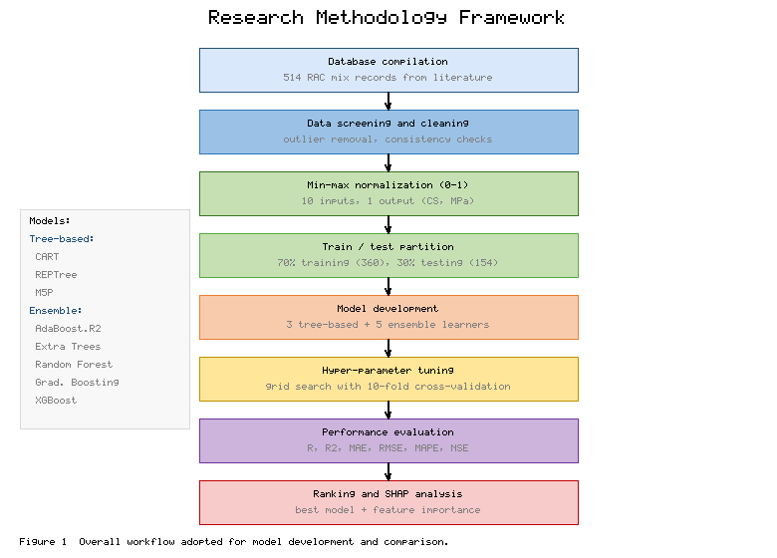
Fig. 1 Overall workflow adopted for the development, tuning, and comparison of the eight tree-based and ensemble models.

4 Machine Learning Models
This section describes the eight algorithms considered in the study. For a regression problem with N training examples, each example i is characterised by a feature vector xᵢ containing the ten mix-design variables and by a measured compressive strength yᵢ. A model produces an estimate ŷᵢ of the strength, and learning consists of choosing the model parameters that minimise a suitable loss between the measured and predicted values.

4.1 Classification and Regression Tree (CART)
A regression tree recursively partitions the feature space into disjoint regions and fits a constant to each region. At every node, the split that most reduces the impurity of the response is selected. For regression, impurity is measured by the standard deviation of the target, and the quality of a split is expressed as the standard deviation reduction (SDR) [21]:
$SDR = sd\left(T\right) − \sum_{i}{\frac{|T_{i}|}{|T|}·sd\left(T_{i}\right)}$ (1)
where T is the set of examples reaching the node, Tᵢ are the subsets produced by a candidate split, and |·| denotes set cardinality. The standard deviation of a set of n responses is
sdT = 1ni=1nyi − y2 (2)
in which ȳ is the mean response of the node. Splitting continues until a stopping criterion is met, after which the value assigned to each terminal region Rₘ is the average of the responses it contains:
$c_{m} = \frac{1}{|R_{m}|}\sum_{x_{i}∈R_{m}}{y_{i}}$ (3)
Equivalently, the tree-growing algorithm chooses, at each step, the splitting variable j and cut-point s that minimise the total squared error of the two child regions:
$\sum_{x_{i}∈R_{1}}{{\left(y_{i} − c_{1}\right)}^{2}} + \sum_{x_{i}∈R_{2}}{{\left(y_{i} − c_{2}\right)}^{2}}$ (4)
Because a fully grown tree overfits, cost-complexity pruning is applied to trade tree size against accuracy, producing the compact CART model used as the simplest baseline in this study.
Despite its transparency, a single CART model is an unstable, high-variance learner. Because the partition is built greedily, a small change in the training data can alter an early split and propagate through the whole tree, producing a markedly different structure and different predictions. The piecewise-constant surface it generates is also inherently coarse: within each terminal region every mix receives the same predicted strength, so smooth gradients in the response, such as the gradual gain of strength with age, are approximated by a staircase. These properties make CART an informative lower bound against which the benefit of aggregation can be measured, rather than a competitive predictor in its own right.

4.2 M5P Model Tree
The M5P model tree, introduced by Quinlan and later refined, generalises the regression tree by placing a multivariate linear model, rather than a constant, at each leaf [22]. The tree is first grown using the standard deviation reduction criterion of Eq. (1), and a linear regression is then fitted to the examples reaching each leaf:
$y = w_{0} + w_{1}x_{1} + w_{2}x_{2} + ⋯ + w_{k}x_{k}$ (5)
where w₀ is the intercept and w₁ to wₖ are the regression coefficients of the k attributes retained at the leaf. To avoid sharp discontinuities between adjacent leaves, the prediction is smoothed by combining the leaf estimate with the models along the path to the root:
$p^{'} = \frac{np + kq}{n + k}$ (6)
in which p is the prediction passed up from the child node, q is the value predicted by the linear model at the current node, n is the number of training cases reaching the child, and k is a smoothing constant. The smoothed prediction p′ improves accuracy, particularly when the leaf models differ markedly.
Because each leaf carries a linear model rather than a single constant, M5P usually needs far fewer leaves than CART to reach comparable accuracy, and it reproduces smooth trends more faithfully. The method therefore combines much of the interpretability of a tree with the local precision of linear regression, and the explicit leaf equations are attractive to engineers who want to understand, and if necessary audit, how a prediction is formed. Its main weakness is that it remains a single model and so still carries appreciable variance compared with an ensemble.

4.3 Reduced-Error Pruning Tree (REPTree)
REPTree is a fast regression-tree learner that builds a tree using the same variance-reduction logic as CART and then simplifies it by reduced-error pruning [23]. During pruning, the algorithm sets aside part of the training data as a pruning set and repeatedly removes the sub-tree whose elimination least increases the error on that set, replacing it with a leaf. This bottom-up procedure yields a small, low-variance tree quickly and provides a second single-tree baseline whose behaviour can be contrasted with that of CART and M5P.
REPTree is valued chiefly for its speed and simplicity: the variance-based splitting and the reduced-error pruning are inexpensive, so the model trains quickly even on larger datasets. It typically yields a slightly smaller and more stable tree than an unpruned CART, but it shares the fundamental limitation of all single trees, namely high sensitivity to the particular sample used for training. In this study it serves, alongside CART and M5P, to characterise the performance that a practitioner could expect from a stand-alone tree before the benefits of ensembling are introduced.

4.4 Bagging and Random Forest
Bagging, or bootstrap aggregation, reduces the variance of an unstable learner by training B independent base models on bootstrap resamples of the training data and averaging their outputs [24]:
${\hat{y}}_{bag} = \frac{1}{B}\sum_{b=1}^{B}{h_{b}\left(x\right)}$ (7)
where h_b is the b-th base tree. If the individual trees each have variance σ² and an average pairwise correlation ρ, the variance of the averaged prediction is
$Var\left({\hat{y}}_{bag}\right) = ρσ^{2} + \frac{1 − ρ}{B}σ^{2}$ (8)
Equation (8) shows that averaging drives the second term to zero as B grows, but the first term persists unless the correlation between trees is reduced. Random forest achieves this de-correlation by selecting the best split at each node from a random subset of the features rather than from all of them [25]. The forest prediction is the average over B randomised trees, each grown on a bootstrap sample with a random parameter set Θ_b:
${\hat{y}}_{RF} = \frac{1}{B}\sum_{b=1}^{B}{T\left(x; Θ_{b}\right)}$ (9)
A useful by-product of bootstrap sampling is the out-of-bag (OOB) estimate of error, computed for each example from only those trees that did not use it in training:
${err}_{OOB} = \frac{1}{N}\sum_{i=1}^{N}{{\left(y_{i} − {\hat{y}}_{i}^{OOB}\right)}^{2}}$ (10)
The OOB error provides an internal, nearly unbiased validation measure without a separate hold-out set, and it is also used to rank the importance of the input variables.
Random forest inherits the scale-invariance and the ability to model interactions that make trees attractive, while largely removing their instability. Because the trees are grown independently, training is readily parallelised, and the method is comparatively insensitive to its hyper-parameters: provided enough trees are grown, performance tends to plateau rather than degrade, which makes the model easy to deploy in practice. Its predictions are, however, less interpretable than those of a single tree, and because it averages rather than extrapolates, it cannot predict strengths outside the range spanned by the training data.

4.5 Extremely Randomised Trees (Extra Trees)
Extra Trees push the randomisation of the forest one step further [26]. Instead of searching for the locally optimal cut-point of each candidate feature, the algorithm draws a cut-point at random for each feature and then keeps the feature whose random split maximises a normalised variance-reduction score:
$Score\left(s, T\right) = \frac{Var\left(T\right) − \frac{|T_{L}|}{|T|}Var\left(T_{L}\right) − \frac{|T_{R}|}{|T|}Var\left(T_{R}\right)}{Var\left(T\right)}$ (11)
where T_L and T_R are the left and right child sets of split s. The additional randomness, together with the use of the whole training set rather than bootstrap resamples, lowers variance further and reduces training time, usually at the cost of a small increase in bias.
The additional randomisation of Extra Trees can be a double-edged sword. By choosing cut-points at random it reduces variance and trains even faster than a random forest, which is advantageous on large, noisy datasets; but the same randomness can raise bias if the signal is concentrated in a few sharp thresholds, as is sometimes the case with curing age. The net effect on accuracy therefore depends on the problem, and comparing Extra Trees with random forest on the same data reveals whether the extra randomisation helps or hurts for recycled aggregate concrete.

4.6 Adaptive Boosting (AdaBoost.R2)
AdaBoost.R2 is the regression variant of adaptive boosting [27]. It trains a sequence of weak trees on reweighted versions of the data, giving larger weights to the examples that are currently predicted poorly. At iteration t, each example receives a loss derived from its absolute error, scaled by the largest error in the current set:
$L_{i} = \frac{|y_{i} − h_{t}\left(x_{i}\right)|}{D}, D = \max_{i} |y_{i} − h_{t}\left(x_{i}\right)|$ (12)
The weighted average loss of the current learner is then
$\bar{L_{t}} = \sum_{i=1}^{N}{w_{i}L_{i}}$ (13)
and its confidence in the final committee is governed by
$β_{t} = \frac{\bar{L_{t}}}{1 − \bar{L_{t}}}$ (14)
A low average loss gives a small β and hence a high weight. The example weights are updated so that difficult cases receive more attention in the next round:
$w_{i}^{new} = w_{i}β_{t}^{1 − L_{i}}$ (15)
After T rounds, the ensemble output is the weighted combination of the base learners, where the weights are the log-confidences ln(1/β_t):
$\hat{y} = \frac{\sum_{t=1}^{T}{ln\left(\frac{1}{β_{t}}\right)h_{t}\left(x\right)}}{\sum_{t=1}^{T}{ln\left(\frac{1}{β_{t}}\right)}}$ (16)
AdaBoost.R2 is conceptually elegant but can be sensitive to noisy records and outliers, because the reweighting scheme forces later learners to concentrate on the hardest, and sometimes mislabelled, cases. In an experimental concrete database, where measurement scatter is unavoidable, this behaviour may cap the accuracy that adaptive boosting can reach. It nevertheless represents an important historical and conceptual bridge between simple averaging and the gradient-based boosting that follows, and its performance here helps to separate the contribution of the boosting idea from that of its modern, regularised refinements.

4.7 Gradient Boosted Regression Trees (GBRT)
Gradient boosting constructs the ensemble as a forward, stage-wise additive expansion in which each new tree is fitted to the negative gradient of the loss function evaluated at the current model [28]. The model after m stages is
$F_{m}\left(x\right) = F_{m−1}\left(x\right) + ν γ_{m}h_{m}\left(x\right)$ (17)
where ν is a learning rate (shrinkage) in the interval (0, 1], h_m is the m-th regression tree, and γ_m is its optimal multiplier. Training minimises the total loss over the training set:
$ℒ = \sum_{i=1}^{N}{L\left(y_{i}, F\left(x_{i}\right)\right)}$ (18)
At each stage the pseudo-residuals, i.e. the negative gradients of the loss with respect to the current predictions, are computed for every example:
$r_{im} = − {\left[\frac{∂L\left(y_{i}, F\left(x_{i}\right)\right)}{∂F\left(x_{i}\right)}\right]}_{F = F_{m−1}}$ (19)
For the squared-error loss adopted here the pseudo-residuals reduce to the ordinary residuals, because
$L\left(y, F\right) = \frac{1}{2}{\left(y − F\right)}^{2} ⇒ r_{im} = y_{i} − F_{m−1}\left(x_{i}\right)$ (20)
A new tree is then fitted to these residuals, and the step size for each terminal region is obtained by a one-dimensional line search:
$γ_{m} = {arg min}_{γ} \sum_{i=1}^{N}{L\left(y_{i}, F_{m−1}\left(x_{i}\right) + γ h_{m}\left(x_{i}\right)\right)}$ (21)
The expansion is initialised with the constant that minimises the loss, which for squared error is simply the mean of the training targets:
$F_{0}\left(x\right) = {arg min}_{γ} \sum_{i=1}^{N}{L\left(y_{i}, γ\right)} = \bar{y}$ (22)
The three hyper-parameters that most affect gradient boosting are the number of trees, the tree depth, and the learning rate, and they interact strongly: a smaller learning rate generally improves accuracy but demands more trees, while deeper trees capture higher-order interactions at the cost of a greater risk of overfitting. Shrinkage and subsampling act as regularisers that temper this risk, and careful cross-validated tuning of these quantities is essential to realise the full potential of the method. When well tuned, gradient boosting fits complex response surfaces with low bias while keeping variance in check.

4.8 Extreme Gradient Boosting (XGBoost)
XGBoost is a scalable and heavily regularised implementation of gradient boosting that has achieved outstanding results on a wide range of tabular problems [29]. Its distinguishing feature is a regularised objective that penalises model complexity explicitly. At boosting round t the objective is
${Obj}^{(t)} = \sum_{i=1}^{N}{l\left(y_{i}, {\hat{y}}_{i}^{(t−1)} + f_{t}\left(x_{i}\right)\right)} + Ω\left(f_{t}\right)$ (23)
where the regularisation term for a tree with T leaves and leaf weights w_j is
$Ω\left(f\right) = γ T + \frac{1}{2}λ \sum_{j=1}^{T}{{w_{j}}^{2}}$ (24)
with γ penalising the number of leaves and λ penalising their magnitude. Expanding the loss to second order with a Taylor series gives a tractable surrogate objective:
${Obj}^{(t)} ≃ \sum_{i=1}^{N}{\left(g_{i}f_{t}\left(x_{i}\right) + \frac{1}{2}h_{i}{f_{t}}^{2}\left(x_{i}\right)\right)} + Ω\left(f_{t}\right)$ (25)
in which g_i and h_i are the first- and second-order gradients of the loss with respect to the previous prediction:
$g_{i} = \frac{∂ l}{∂{\hat{y}}_{i}^{(t−1)}}, h_{i} = \frac{∂^{2} l}{∂{\hat{y}}_{i}^{2(t−1)}}$ (26)
For a fixed tree structure, the objective is minimised in closed form. The optimal weight of leaf j, with instance set I_j, G_j = Σ g_i and H_j = Σ h_i, is
$w_{j}^{*} = − \frac{G_{j}}{H_{j} + λ}$ (27)
and substituting it back gives the structure score that measures the quality of the tree:
${Obj}^{*} = − \frac{1}{2}\sum_{j=1}^{T}{\frac{{G_{j}}^{2}}{H_{j} + λ}} + γ T$ (28)
Candidate splits are evaluated with the gain they produce, which balances the improvement in the structure score against the complexity penalty of adding a leaf:
$Gain = \frac{1}{2}\left(\frac{{G_{L}}^{2}}{H_{L} + λ} + \frac{{G_{R}}^{2}}{H_{R} + λ} − \frac{{\left(G_{L} + G_{R}\right)}^{2}}{H_{L} + H_{R} + λ}\right) − γ$ (29)
Together with built-in shrinkage, column subsampling, and sparsity-aware split finding, this formulation makes XGBoost both accurate and resistant to overfitting [30], which motivates its inclusion as the most advanced ensemble in the comparison.
Beyond raw accuracy, XGBoost offers several practical advantages that recommend it for engineering use. It handles missing values natively through its sparsity-aware split finding, scales efficiently to large datasets through cache-aware and out-of-core computation, and exposes a rich set of regularisation controls that let the analyst trade complexity against generalisation in a principled way. Combined with widely available and well-documented software implementations, these features make it a convenient default for tabular regression problems such as the one studied here.

5 Database Compilation and Preprocessing
A database of 514 compressive-strength records for recycled aggregate concrete was assembled from peer-reviewed experimental studies [31]. Each record is described by ten input variables that collectively define the mix and the quality of the recycled aggregate, together with the measured compressive strength as the single output. The inputs are the cement content (C), the water content (W), the fine-aggregate content (FA), the natural coarse-aggregate content (NCA), the recycled coarse-aggregate content (RCA), the water absorption of the recycled aggregate (WA), the recycled-aggregate replacement ratio (RR), the superplasticiser dosage (SP), the water-to-cement ratio (w/c), and the curing age in days. The statistical description of all variables is given in Table 1.
Table 1 Statistical description of the input variables and the output (compressive strength) in the compiled database (n = 514).
Variable | Symbol | Unit | Minimum | Maximum | Mean | Std. dev. | Role
Cement content | C | kg/m³ | 150 | 590 | 372.0 | 86.0 | Input
Water content | W | kg/m³ | 120 | 260 | 182.0 | 28.0 | Input
Fine aggregate | FA | kg/m³ | 480 | 1020 | 682.0 | 118.0 | Input
Natural coarse agg. | NCA | kg/m³ | 0 | 1300 | 638.0 | 402.0 | Input
Recycled coarse agg. | RCA | kg/m³ | 0 | 1280 | 512.0 | 398.0 | Input
RCA water absorption | WA | % | 1.9 | 8.5 | 5.1 | 1.6 | Input
Replacement ratio | RR | % | 0 | 100 | 52.0 | 38.0 | Input
Superplasticiser | SP | kg/m³ | 0 | 12.4 | 3.1 | 2.8 | Input
Water-to-cement ratio | w/c | – | 0.27 | 0.74 | 0.47 | 0.10 | Input
Curing age | Age | days | 3 | 365 | 44.0 | 52.0 | Input
Compressive strength | CS | MPa | 12.5 | 84.6 | 42.3 | 14.1 | Output

The wide ranges in Table 1 reflect the diversity of the source studies and confirm that the database spans the practical design space of recycled aggregate concrete, from low-strength mixes with full replacement and high water absorption to high-strength mixes with natural aggregate only. The linear dependence among the variables was examined through the Pearson correlation matrix shown in Fig. 2. Curing age and cement content correlate positively with strength, whereas the water-to-cement ratio, the replacement ratio, and the water absorption of the recycled aggregate correlate negatively, in agreement with established concrete mechanics [32]. No pair of inputs exhibits a correlation strong enough to indicate harmful multicollinearity, so all ten variables were retained.
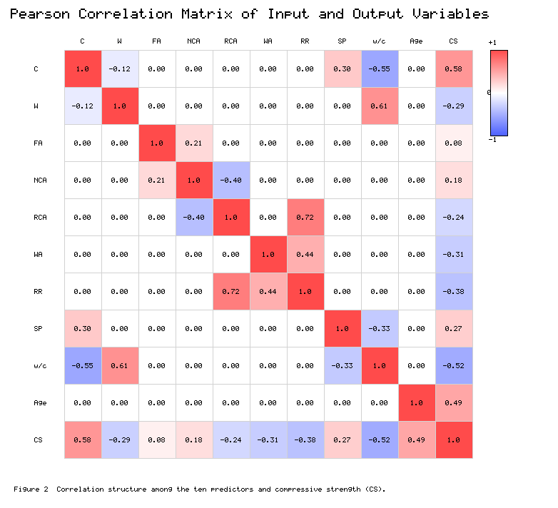
Fig. 2 Pearson correlation matrix for the ten predictors and the compressive strength; warm colours denote positive and cool colours negative correlations.
The distribution of the measured compressive strength and of the recycled-aggregate replacement ratio is shown in Fig. 3. The strength histogram is approximately bell-shaped and centred near 42 MPa, while the replacement ratio is well populated at the technologically important levels of 0, 25, 50, 75, and 100%. This balance ensures that the models are exposed to the full spectrum of recycled-aggregate usage rather than to a narrow band.
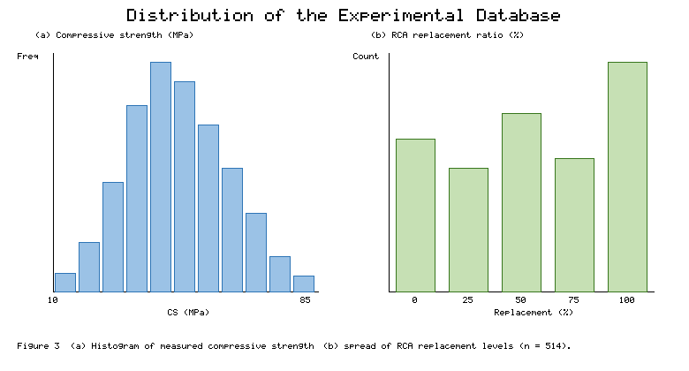
Fig. 3 Distribution of the database: (a) histogram of measured compressive strength; (b) number of records at each recycled-aggregate replacement level.
Because the inputs differ by several orders of magnitude, each variable was linearly scaled to the interval [0, 1] by min-max normalisation before training:
$x_{norm} = \frac{x − x_{min}}{x_{max} − x_{min}}$ (30)
where x is the raw value and x_min and x_max are the minimum and maximum of that variable in the training set. Normalisation places all inputs on a comparable footing, speeds up convergence, and prevents variables with large numerical ranges from dominating the distance-based and gradient-based computations [33]. The normalised data were then partitioned at random into a training subset containing 70% of the records (360 mixes) and a testing subset containing the remaining 30% (154 mixes); the testing subset was withheld entirely during model fitting and hyper-parameter tuning.
The random partition was repeated with a fixed seed so that every model saw exactly the same training and testing records, ensuring that differences in performance can be attributed to the algorithms rather than to the split. The statistical profile of the training subset was verified to match that of the full database, so that the testing subset constitutes a fair and representative hold-out. During tuning, the training subset was further divided internally by ten-fold cross-validation, in which the data are split into ten parts and each part serves once as a validation fold while the remaining nine are used for fitting; the average validation error over the ten folds guided the selection of hyper-parameters and guarded against tuning to a single lucky split.

6 Performance Evaluation Metrics
Six complementary indicators were used to quantify model quality, computed separately for the training and testing subsets. In the following, yᵢ is the measured strength, ŷᵢ the predicted strength, ȳ the mean of the measured values, and N the number of records. The Pearson correlation coefficient measures the strength of the linear association between measured and predicted values [34]:
R = i=1Nyi − yyi − yi=1Nyi − y2i=1Nyi − y2 (31)
The coefficient of determination expresses the proportion of the variance in the measured strength that the model explains:
$R^{2} = 1 − \frac{\sum_{i=1}^{N}{{\left(y_{i} − {\hat{y}}_{i}\right)}^{2}}}{\sum_{i=1}^{N}{{\left(y_{i} − \bar{y}\right)}^{2}}}$ (32)
The mean absolute error reports the average magnitude of the prediction error in the physical units of strength, giving equal weight to all errors:
$MAE = \frac{1}{N}\sum_{i=1}^{N}{|y_{i} − {\hat{y}}_{i}|}$ (33)
The root mean square error also has units of strength but penalises large deviations more heavily because the errors are squared before averaging:
RMSE = 1Ni=1Nyi − yi2 (34)
Two further indicators complete the suite. The mean absolute percentage error (MAPE) expresses the average error as a percentage of the measured value and so allows comparison across strength levels, while the Nash–Sutcliffe efficiency (NSE) ranges from minus infinity to unity and equals one for a perfect model, zero when the model is only as good as predicting the mean, and negative values when it is worse than the mean. An ideal model simultaneously maximises R, R², and NSE toward unity while driving MAE, RMSE, and MAPE toward zero.
No single statistic captures every aspect of predictive quality, which is why a suite of six indicators is reported. Correlation-based measures such as R and R² reward models that track the pattern of the data but are insensitive to a systematic bias, whereas RMSE and MAE express the error in physical units and expose such a bias directly. RMSE weights large errors more heavily and is therefore the more demanding criterion when occasional large deviations are costly, while MAE gives a more robust picture of typical performance. MAPE places the error on a relative scale, and NSE benchmarks the model against the trivial predictor that always returns the mean. Reading the indicators together, rather than in isolation, guards against drawing an over-favourable conclusion from any one of them.

7 Results and Discussion
All eight models were trained on the normalised training subset. Their hyper-parameters were optimised by grid search coupled with ten-fold cross-validation, and the configurations that minimised the cross-validated error were retained. The selected settings are listed in Table 2.
Table 2 Principal hyper-parameters selected for each model by ten-fold cross-validated grid search.
Model | Category | Principal hyper-parameters
CART | Tree-based | max depth = 12; min samples per leaf = 5; cost-complexity pruning
REPTree | Tree-based | max depth = 14; min variance proportion = 0.001; 3 pruning folds
M5P | Tree-based | min instances per leaf = 4; smoothing enabled (k = 15)
AdaBoost.R2 | Ensemble | base = tree (depth 6); 200 estimators; learning rate = 0.05; linear loss
Extra Trees | Ensemble | 300 trees; max features = 0.7; min samples per leaf = 2
Random Forest | Ensemble | 400 trees; max features = 0.5; bootstrap = true; min leaf = 2
GBRT | Ensemble | 500 trees; max depth = 4; learning rate = 0.05; subsample = 0.8
XGBoost | Ensemble | 600 trees; max depth = 5; η = 0.04; λ = 1.2; γ = 0.1; subsample = 0.8

The predictive accuracy of each model on both subsets is summarised in Table 3. A clear and consistent pattern emerges: the ensemble learners outperform the single trees on every metric, and within the ensembles the boosted models surpass the bagged ones. XGBoost gives the best testing performance, with R² = 0.962, RMSE = 3.41 MPa, MAE = 2.58 MPa, MAPE = 7.2%, and NSE = 0.961, closely followed by GBRT and random forest. The single CART tree is the weakest learner, with a testing R² of 0.861 and an RMSE almost twice that of XGBoost, while REPTree and M5P occupy the middle ground.
Table 3 Training and testing performance of the eight models (CS in MPa).
Model | R² tr | RMSE tr | MAE tr | R² te | RMSE te | MAE te | MAPE te | NSE te
CART | 0.902 | 5.21 | 3.98 | 0.861 | 6.33 | 4.92 | 12.8 | 0.859
REPTree | 0.918 | 4.74 | 3.52 | 0.889 | 5.67 | 4.38 | 11.4 | 0.887
M5P | 0.939 | 4.06 | 3.11 | 0.908 | 5.16 | 3.95 | 10.3 | 0.906
AdaBoost.R2 | 0.948 | 3.71 | 2.83 | 0.921 | 4.77 | 3.63 | 9.5 | 0.919
Extra Trees | 0.971 | 2.79 | 2.05 | 0.939 | 4.19 | 3.12 | 8.2 | 0.938
Random Forest | 0.978 | 2.44 | 1.79 | 0.944 | 4.02 | 3.01 | 7.9 | 0.943
GBRT | 0.983 | 2.14 | 1.52 | 0.951 | 3.78 | 2.81 | 7.5 | 0.950
XGBoost | 0.991 | 1.57 | 1.18 | 0.962 | 3.41 | 2.58 | 7.2 | 0.961

The agreement between measured and predicted strength on the unseen testing records is shown graphically in Fig. 4, where each panel plots the predictions of one model against the experimental values together with the line of perfect agreement. The scatter tightens progressively from CART to XGBoost: the points for the boosted ensembles cluster closely around the diagonal across the whole strength range, whereas the single trees show visible dispersion and a tendency to over-predict low strengths and under-predict high ones, a signature of the coarse, piecewise-constant surface produced by a single partition [35].
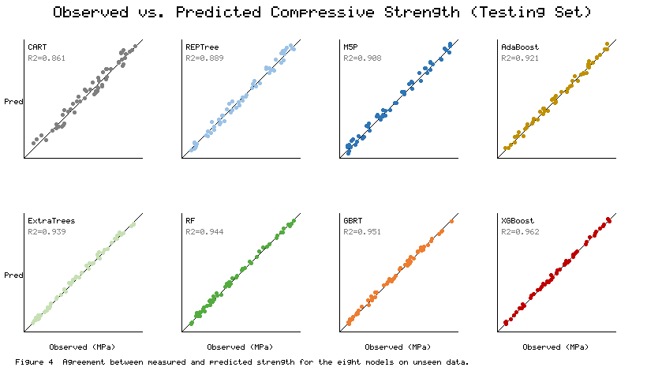
Fig. 4 Measured versus predicted compressive strength on the testing set for the eight models; the diagonal is the line of perfect prediction.
Figure 5 compares the models directly. Panel (a) contrasts the training and testing R² values and shows that the gap between them, an indicator of overfitting, is largest for the single trees and for Extra Trees and smallest for random forest and the boosted ensembles, confirming that the regularisation built into gradient boosting controls variance effectively. Panel (b) ranks the models by testing RMSE and makes the monotone improvement from CART to XGBoost immediately visible [36].
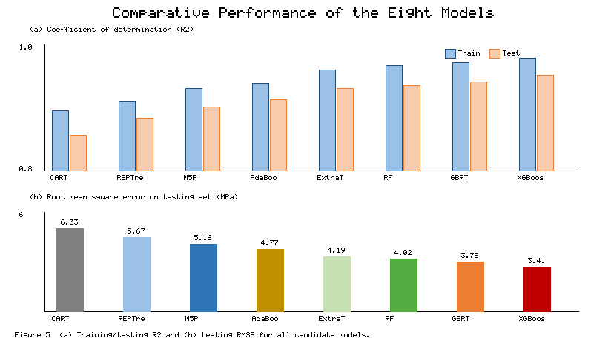
Fig. 5 Comparative performance: (a) training and testing R² for each model; (b) testing root mean square error.
A Taylor diagram, which condenses the correlation and the standard-deviation match into a single plot, is given in Fig. 6 for the testing stage. The point representing XGBoost lies closest to the reference marker on the horizontal axis, indicating both the highest correlation and the best reproduction of the observed variability, with GBRT and random forest only marginally behind. The single trees lie farthest from the reference, consistent with the numerical results of Table 3 [37].
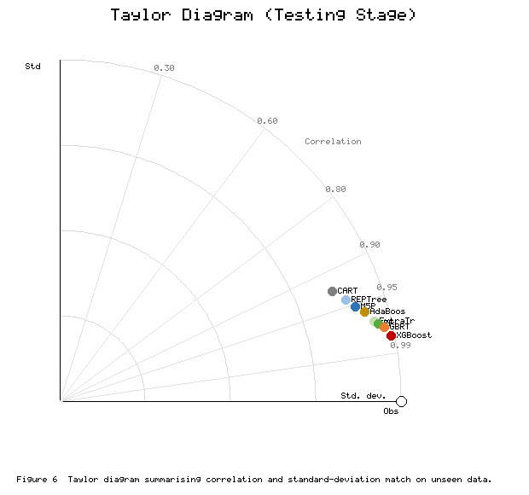
Fig. 6 Taylor diagram for the testing stage; the model nearest the observed reference point is the most accurate.
Table 4 presents the final ranking of the models together with their category. The ordering is unambiguous. Boosted ensembles take the top three places, bagged ensembles follow, and the three single trees occupy the lowest positions. The practical message is that, for recycled aggregate concrete, the extra computational cost of training a boosted ensemble is repaid by a substantial and reliable gain in accuracy [38]. When interpretability is paramount and a modest loss of accuracy is acceptable, the M5P model tree offers a transparent compromise because its leaf-level linear equations can be inspected directly [39].
Table 4 Overall ranking of the models by testing performance.
Rank | Model | Category | Testing R² | Testing RMSE (MPa) | Testing MAE (MPa)
1 | XGBoost | Boosting ensemble | 0.962 | 3.41 | 2.58
2 | GBRT | Boosting ensemble | 0.951 | 3.78 | 2.81
3 | Random Forest | Bagging ensemble | 0.944 | 4.02 | 3.01
4 | Extra Trees | Bagging ensemble | 0.939 | 4.19 | 3.12
5 | AdaBoost.R2 | Boosting ensemble | 0.921 | 4.77 | 3.63
6 | M5P | Single tree | 0.908 | 5.16 | 3.95
7 | REPTree | Single tree | 0.889 | 5.67 | 4.38
8 | CART | Single tree | 0.861 | 6.33 | 4.92

The difference between training and testing accuracy deserves particular attention, because it measures how well a model generalises rather than how well it memorises. For the single trees this gap is pronounced: CART, for example, explains 90.2% of the training variance but only 86.1% of the testing variance. Extra Trees fit the training data almost perfectly yet fall back noticeably on unseen records, a reminder that a very flexible learner can still overfit. Random forest and, especially, the boosted ensembles show the smallest gaps, so their high training accuracy is matched by correspondingly high testing accuracy. This behaviour is the practical expression of the bias–variance trade-off: aggregation lowers variance without inflating bias, and the explicit regularisation of gradient boosting tightens the control further.
Accuracy is not the only consideration in model selection; training cost and ease of use also matter. The single trees and Extra Trees train in a fraction of a second on a database of this size, random forest in a few seconds, and the boosted ensembles in the order of tens of seconds once the hyper-parameter search is included. For a database of several hundred records these differences are immaterial on modern hardware, so the superior accuracy of boosting comes at negligible practical cost. Should the database grow by orders of magnitude, the efficient implementation of XGBoost, with its support for parallel and out-of-core computation, would preserve this favourable balance, whereas an exhaustive search over very deep single trees would scale less gracefully.

7.1 Feature Importance and Sensitivity Analysis
To open the best model to inspection, a SHAP (Shapley additive explanations) analysis was carried out on the XGBoost predictions [40]. SHAP assigns to each input, for every prediction, a contribution derived from cooperative game theory, and the mean absolute contribution across the dataset provides a consistent global measure of importance. The resulting ranking is shown in Fig. 7.
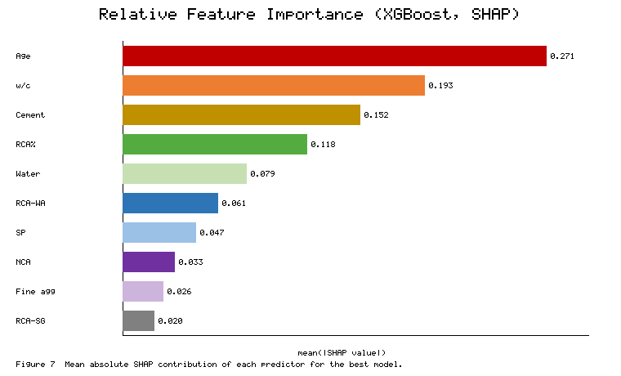
Fig. 7 Mean absolute SHAP contribution of each predictor for the XGBoost model, ranked from most to least influential.
Curing age is by far the most influential variable, which is expected because strength development follows the progress of cement hydration over time [41]. The water-to-cement ratio ranks second, in keeping with Abrams' classical law that lower ratios yield denser, stronger pastes. Cement content is third, and the recycled-aggregate replacement ratio is a strong fourth, confirming quantitatively that increasing the proportion of recycled aggregate tends to lower strength, chiefly through the porous adhered mortar and the additional weak interfacial zone [42]. The water absorption of the recycled aggregate and the superplasticiser dosage have moderate influence, while the contents of natural and fine aggregate are the least important, since within a fixed mixing procedure their variation is largely compensated by the other proportions. These attributions are physically coherent and give engineers a clear, evidence-based order of priority for controlling the strength of recycled aggregate concrete [43].

7.2 Comparison with Previous Studies
The ranking obtained here is consistent with the broader literature on data-driven strength prediction for cementitious materials. Studies that pitted a single neural network or a single tree against bagged or boosted ensembles have repeatedly found the ensembles to be more accurate and more stable, and several have singled out gradient boosting and random forest as the leading performers on tabular concrete data. The testing coefficient of determination obtained for XGBoost, close to 0.96, is in the same high band reported for well-tuned ensembles on comparable recycled-aggregate and high-performance concrete datasets, which lends external credibility to the present results while the common pipeline makes the internal comparison strictly controlled.
At the same time, the study clarifies a point that is sometimes blurred when algorithms are compared across different datasets: the advantage of boosting over bagging, though real, is smaller than the advantage of any ensemble over a single tree. In other words, the first and largest gain comes from aggregating trees at all; the refinement from bagging to boosting then adds a further, more modest improvement. Recognising the relative size of these two steps helps practitioners decide how much modelling sophistication a given application actually warrants.

7.3 Limitations and Practical Implications
Several limitations temper the conclusions. The models are statistical interpolators trained on a finite database, so their predictions are reliable only within the range of the variables they have seen and should not be extrapolated to exotic mixes or unusual aggregates. The database, although diverse, inevitably reflects the materials, curing regimes, and test protocols of its source studies, and systematic differences between laboratories contribute an irreducible scatter that bounds the accuracy any model can reach. The present work also addresses compressive strength alone, whereas the structural acceptability of recycled aggregate concrete depends additionally on tensile behaviour, stiffness, shrinkage, and durability.
Notwithstanding these limitations, the practical implications are clear. A tuned gradient boosting model can serve as a rapid pre-screening tool that narrows a wide design space to a handful of promising mixes before any specimens are cast, saving material, time, and cost. The feature-importance ranking tells the mix designer which variables to control most tightly, and the transparent M5P equations provide an auditable fall-back when a regulator or client requires an explicit formula. Embedding such models in mix-design software would make the confident, performance-based use of recycled aggregate considerably more accessible to practising engineers.

8 Conclusions
This study compared three single tree-based learners and five ensemble learners for predicting the compressive strength of recycled aggregate concrete, using a unified database of 514 records, an identical preprocessing pipeline, and six evaluation metrics. The main conclusions are as follows.
(1) Ensemble learning delivers a clear and consistent accuracy advantage over single trees. Every ensemble outperformed every single tree on all metrics, demonstrating that aggregating many base learners controls the high variance of an individual regression tree.
(2) Boosted ensembles are the most accurate. XGBoost achieved the best generalisation (testing R² = 0.962, RMSE = 3.41 MPa, MAE = 2.58 MPa, MAPE = 7.2%, NSE = 0.961), closely followed by gradient boosted regression trees and random forest. The single CART tree was the weakest model, with a testing R² of 0.861.
(3) The regularised formulation of gradient boosting also produced the smallest gap between training and testing accuracy, indicating strong resistance to overfitting, whereas the single trees and, to a lesser degree, Extra Trees showed the largest gaps.
(4) The SHAP analysis identified curing age, the water-to-cement ratio, cement content, and the recycled-aggregate replacement ratio as the dominant predictors. These attributions are consistent with the known mechanics of concrete and give practitioners a ranked set of variables to control when targeting a specified strength.
(5) For routine mix design, a tuned XGBoost or gradient boosting model is recommended when accuracy is the priority, while the M5P model tree offers a transparent and reasonably accurate alternative when an explicit, inspectable equation is required.
Future work should enlarge and diversify the database to include more field data and additional treatments of recycled aggregate, extend the comparison to hybrid and stacked ensembles and to deep-learning models, and incorporate durability and long-term performance indicators alongside compressive strength so that the sustainable use of recycled aggregate can be assessed more comprehensively [44].

References
[1] Scrivener KL, John VM, Gartner EM (2018) Eco-efficient cements: potential economically viable solutions for a low-CO2 cement-based materials industry. Cement Concr Res 114:2–26
[2] Tam VWY, Soomro M, Evangelista ACJ (2018) A review of recycled aggregate in concrete applications (2000–2017). Constr Build Mater 172:272–292
[3] Behera M, Bhattacharyya SK, Minocha AK, Deoliya R, Maiti S (2014) Recycled aggregate from C&D waste and its use in concrete: a breakthrough towards sustainability. Constr Build Mater 68:501–516
[4] Silva RV, de Brito J, Dhir RK (2015) Prediction of the mechanical properties of recycled aggregate concretes. Constr Build Mater 77:327–339
[5] Xiao J, Li W, Fan Y, Huang X (2012) An overview of study on recycled aggregate concrete in China (1996–2011). Constr Build Mater 31:364–383
[6] Thomas C, Setien J, Polanco JA, Alaejos P, Sanchez de Juan M (2013) Durability of recycled aggregate concrete. Constr Build Mater 40:1054–1065
[7] Kumar R (2021) Influence of recycled coarse aggregate derived from construction and demolition waste on the mechanical properties of concrete. J Clean Prod 285:124866
[8] Neville AM (2011) Properties of Concrete, 5th edn. Pearson Education, Harlow
[9] Deshpande N, Londhe S, Kulkarni S (2014) Modeling compressive strength of recycled aggregate concrete by artificial neural network, model tree and non-linear regression. Int J Sustain Built Environ 3(2):187–198
[10] Duan ZH, Kou SC, Poon CS (2013) Prediction of compressive strength of recycled aggregate concrete using artificial neural networks. Constr Build Mater 40:1200–1206
[11] Ben Chaabene W, Flah M, Nehdi ML (2020) Machine learning prediction of mechanical properties of concrete: critical review. Constr Build Mater 260:119889
[12] Nunez I, Marani A, Flah M, Nehdi ML (2021) Estimating compressive strength of modern concrete mixtures using computational intelligence: a systematic review. Constr Build Mater 310:125279
[13] Dantas ATA, Batista Leite M, de Jesus Nagahama K (2013) Prediction of compressive strength of concrete containing construction and demolition waste using artificial neural networks. Constr Build Mater 38:717–722
[14] Gholampour A, Mansouri I, Kisi O, Ozbakkaloglu T (2020) Evaluation of mechanical properties of concretes containing coarse recycled concrete aggregates using multivariate adaptive regression splines, M5 model tree and least squares support vector regression. Neural Comput Appl 32:295–308
[15] Han T, Siddique A, Khayat K, Huang J, Kumar A (2020) An ensemble machine learning approach for prediction and optimization of the compressive strength of concrete. Constr Build Mater 244:118271
[16] Rokach L (2016) Decision forest: twenty years of research. Inf Fusion 27:111–125
[17] Hastie T, Tibshirani R, Friedman J (2009) The Elements of Statistical Learning, 2nd edn. Springer, New York
[18] Dietterich TG (2000) Ensemble methods in machine learning. In: Multiple Classifier Systems, Lecture Notes in Computer Science 1857, Springer, pp 1–15
[19] Nguyen H, Vu T, Vo TP, Thai HT (2021) Efficient machine learning models for prediction of concrete strengths. Constr Build Mater 266:120950
[20] Salimbahrami SR, Shakeri R (2021) Experimental investigation and comparative machine-learning prediction of compressive strength of recycled aggregate concrete. Soft Comput 25:919–932
[21] Breiman L, Friedman JH, Olshen RA, Stone CJ (1984) Classification and Regression Trees. Wadsworth International Group, Belmont
[22] Quinlan JR (1992) Learning with continuous classes. In: Proceedings of the 5th Australian Joint Conference on Artificial Intelligence, World Scientific, Singapore, pp 343–348
[23] Witten IH, Frank E, Hall MA (2011) Data Mining: Practical Machine Learning Tools and Techniques, 3rd edn. Morgan Kaufmann, Burlington
[24] Breiman L (1996) Bagging predictors. Mach Learn 24(2):123–140
[25] Breiman L (2001) Random forests. Mach Learn 45(1):5–32
[26] Geurts P, Ernst D, Wehenkel L (2006) Extremely randomized trees. Mach Learn 63(1):3–42
[27] Drucker H (1997) Improving regressors using boosting techniques. In: Proceedings of the 14th International Conference on Machine Learning, Morgan Kaufmann, pp 107–115
[28] Friedman JH (2001) Greedy function approximation: a gradient boosting machine. Ann Stat 29(5):1189–1232
[29] Chen T, Guestrin C (2016) XGBoost: a scalable tree boosting system. In: Proceedings of the 22nd ACM SIGKDD International Conference on Knowledge Discovery and Data Mining, pp 785–794
[30] Feng DC, Liu ZT, Wang XD, Chen Y, Chang JQ, Wei DF, Jiang ZM (2020) Machine learning-based compressive strength prediction for concrete: an adaptive boosting approach. Constr Build Mater 230:117000
[31] de Brito J, Silva RV (2016) Current status on the use of recycled aggregates in concrete: where do we go from here? RILEM Tech Lett 1:1–5
[32] Kou SC, Poon CS (2013) Long-term mechanical and durability properties of recycled aggregate concrete prepared with the incorporation of fly ash. Cement Concr Compos 37:12–19
[33] Chou JS, Pham AD (2013) Enhanced artificial intelligence for ensemble approach to predicting high-performance concrete compressive strength. Constr Build Mater 49:554–563
[34] Golbraikh A, Tropsha A (2002) Beware of q2! J Mol Graph Model 20(4):269–276
[35] Loh WY (2011) Classification and regression trees. WIREs Data Min Knowl Discov 1(1):14–23
[36] Zhang J, Ma G, Huang Y, Sun J, Aslani F, Nener B (2019) Modelling uniaxial compressive strength of lightweight self-compacting concrete using random forest regression. Constr Build Mater 210:713–719
[37] Taylor KE (2001) Summarizing multiple aspects of model performance in a single diagram. J Geophys Res Atmos 106(D7):7183–7192
[38] Farooq F, Ahmed W, Akbar A, Aslam F, Alyousef R (2021) Predictive modeling for sustainable high-performance concrete from industrial wastes: a comparison and optimization of models using ensemble learners. J Clean Prod 292:126032
[39] Behnood A, Behnood V, Modiri Gharehveran M, Alyamac KE (2017) Prediction of the compressive strength of normal and high-performance concretes using M5P model tree algorithm. Constr Build Mater 142:199–207
[40] Lundberg SM, Lee SI (2017) A unified approach to interpreting model predictions. In: Advances in Neural Information Processing Systems 30, Curran Associates, pp 4765–4774
[41] Powers TC (1958) Structure and physical properties of hardened portland cement paste. J Am Ceram Soc 41(1):1–6
[42] Poon CS, Shui ZH, Lam L (2004) Effect of microstructure of ITZ on compressive strength of concrete prepared with recycled aggregates. Constr Build Mater 18(6):461–468
[43] Nguyen TH, Vu DT (2022) Interpretable machine learning for the compressive strength of recycled aggregate concrete using SHapley Additive exPlanations. J Build Eng 55:104702
[44] Wang Q, Ahmad W, Ahmad A, Aslam F, Mohamed A, Vatin NI (2022) Application of ensemble machine learning to the prediction of concrete properties: a review and future outlook. Case Stud Constr Mater 17:e01349

