AI and Climate Action
Aligning Innovation with SDGs for Business Growth:
Age of Artificial Intelligence

Abstract
Artificial intelligence (AI) has emerged as a transformative force in addressing the global climate crisis, offering unprecedented capabilities for monitoring, predicting, mitigating, and adapting to climate change impacts. This chapter examines the multifaceted role of AI in advancing Climate Action (SDG 13) while simultaneously driving sustainable business growth. The analysis spans four critical dimensions: AI-enabled climate monitoring and environmental intelligence; AI-driven solutions for decarbonization across energy, transportation, industry, and built environments; AI-powered climate adaptation and resilience systems including early warning, smart agriculture, and disaster risk reduction; and the responsible governance of AI for climate action, encompassing green AI, climate finance, and future business models aligned with net-zero targets. The chapter demonstrates how organizations can leverage AI technologies to reduce greenhouse gas emissions by 5-10% across major sectors while creating new market opportunities estimated at $1.3-2.6 trillion by 2030. Critical challenges including the environmental footprint of AI itself, data equity, algorithmic bias in climate vulnerability assessments, and governance frameworks are addressed. The discussion concludes with a forward-looking analysis of how AI-enabled business models can simultaneously achieve climate targets and sustainable economic growth, providing a roadmap for enterprises seeking to align innovation strategies with SDG 13 in the age of artificial intelligence.
Keywords: Artificial Intelligence, Climate Action, SDG 13, Climate Mitigation, Climate Adaptation, Green AI, Carbon Accounting, Renewable Energy, Sustainable Business, Net-Zero, Responsible Innovation

1. Artificial Intelligence and the Climate Change Challenge

1.1 Climate Change, Sustainable Development, and the Role of AI
Climate change represents the defining challenge of the twenty-first century, threatening ecosystems, economies, and human well-being on a planetary scale. The Intergovernmental Panel on Climate Change (IPCC) Sixth Assessment Report unequivocally confirms that human-induced greenhouse gas emissions have raised global mean temperatures by approximately 1.1 degrees Celsius above pre-industrial levels, with projections indicating potential warming of 1.5 to 4.4 degrees by 2100 under various emission scenarios [1]. The United Nations Sustainable Development Goal 13 (SDG 13) explicitly calls for urgent action to combat climate change and its impacts, establishing targets for strengthening resilience, integrating climate measures into national policies, and improving education and institutional capacity for climate mitigation and adaptation [2].
Artificial intelligence has emerged as a potentially transformative technology for accelerating climate action across multiple dimensions. The convergence of exponentially growing computational capabilities, vast climate-related datasets from satellite observations, IoT sensor networks, and simulation models, and advances in machine learning algorithms creates unprecedented opportunities for understanding and responding to climate change [3]. AI systems can process and analyze climate data at scales and speeds impossible for human analysts, identify complex patterns in earth system dynamics, optimize energy systems and industrial processes for minimal emissions, and enable predictive capabilities that support both mitigation and adaptation strategies.
The intersection of AI and climate action is particularly significant within the broader framework of the United Nations 2030 Agenda for Sustainable Development. While SDG 13 directly addresses climate action, the cross-cutting nature of both AI and climate change means that AI-climate solutions frequently deliver co-benefits across multiple SDGs, including affordable and clean energy (SDG 7), sustainable cities and communities (SDG 11), responsible consumption and production (SDG 12), and life on land (SDG 15) [4]. This multiplicative impact makes AI for climate action a high-leverage intervention point for sustainable development, where investments in AI capabilities can simultaneously advance multiple sustainability objectives while generating economic returns that sustain and scale the innovation ecosystem.
For businesses specifically, AI for climate action creates a dual value proposition: it simultaneously reduces operational costs through efficiency improvements and creates new revenue streams through climate products and services, while also mitigating regulatory, reputational, and physical climate risks that threaten long-term enterprise value [5]. Companies that proactively adopt AI-driven climate solutions are better positioned to comply with tightening emission regulations, meet growing consumer demand for sustainable products, attract climate-conscious capital, and build resilience against supply chain disruptions and extreme weather events. This alignment between climate action and business value creation represents a fundamental shift from viewing sustainability as a cost center to recognizing it as a core driver of competitive advantage and long-term value in the age of artificial intelligence.
The relationship between AI and climate action operates across a comprehensive framework encompassing monitoring, mitigation, adaptation, and governance dimensions, as illustrated in Figure 1. This framework demonstrates how AI technologies intersect with climate science, policy, and business innovation to create integrated solutions aligned with SDG 13 targets [4]. The World Economic Forum estimates that AI applications could reduce global greenhouse gas emissions by 4-10 percent by 2030, equivalent to 2.6-5.3 gigatons of CO2 equivalent annually, while simultaneously generating economic value of $1.3-2.6 trillion through efficiency gains, new products, and avoided climate damages [5]. However, realizing this potential requires careful governance to ensure that AI deployment for climate action is equitable, transparent, and does not exacerbate existing inequalities or create new environmental burdens through its own energy consumption and resource requirements.
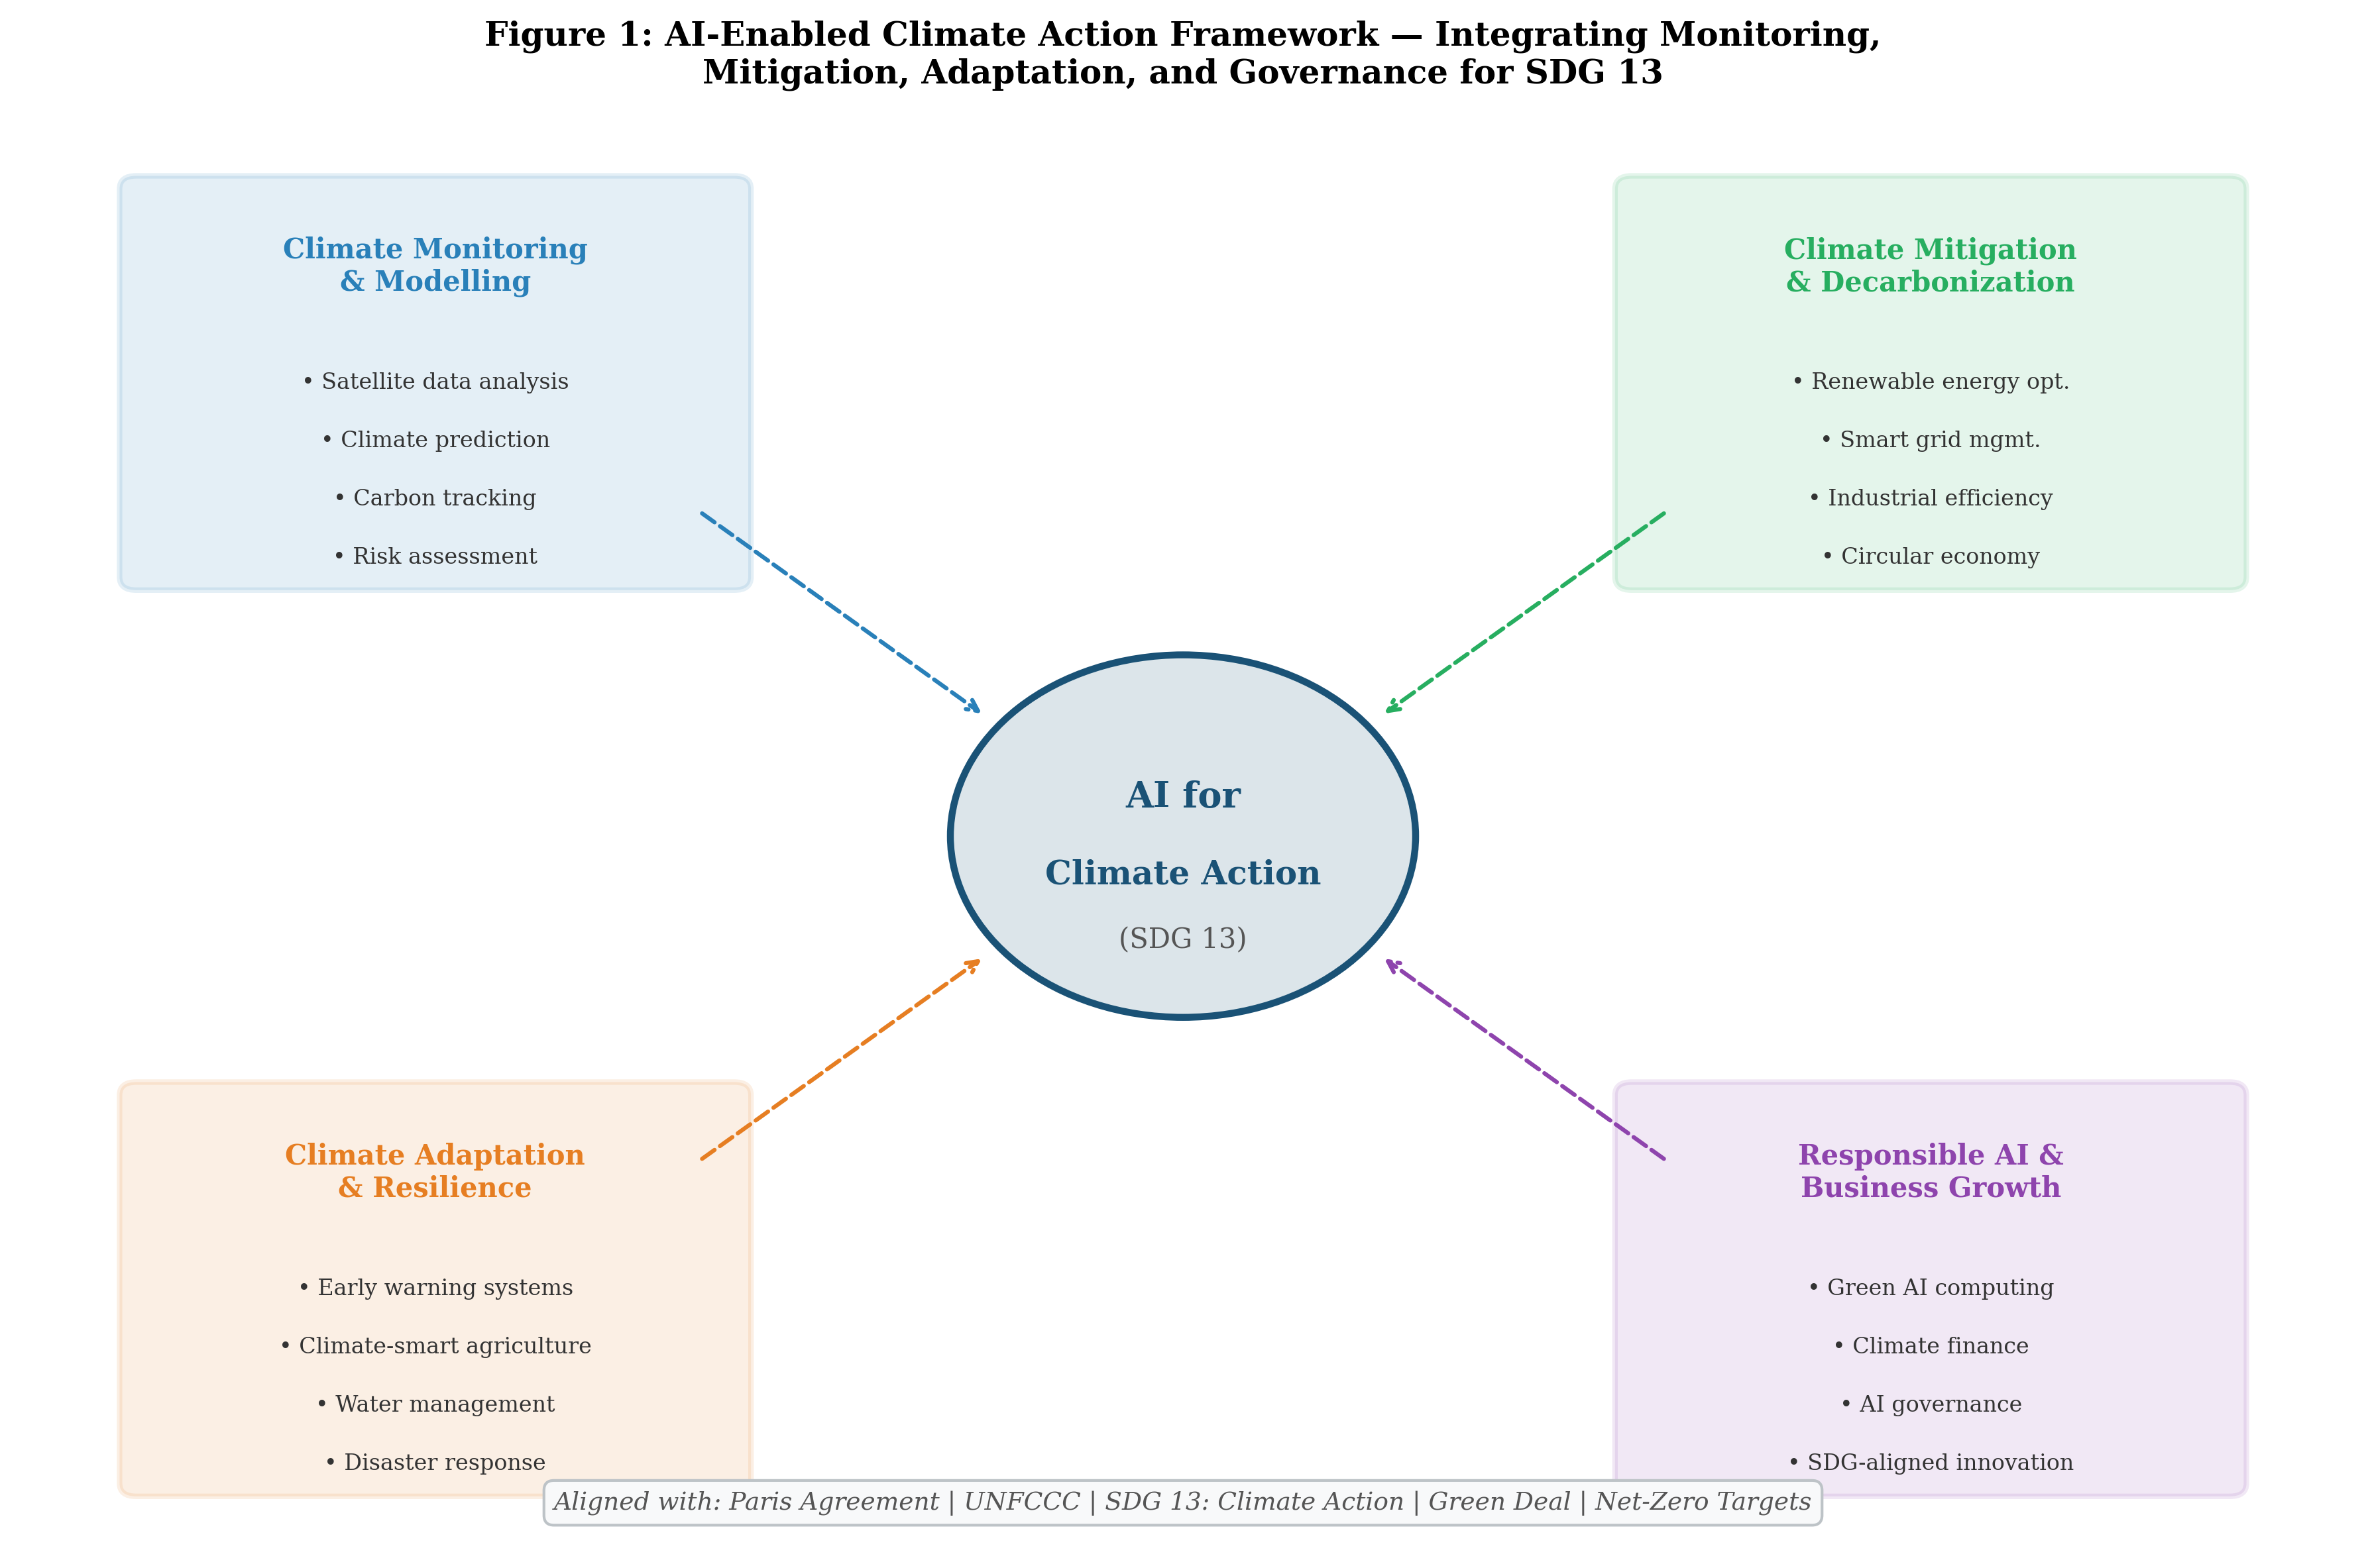
Figure 1: AI-Enabled Climate Action Framework — Integrating Monitoring, Mitigation, Adaptation, and Governance for SDG 13, showing the four interconnected dimensions of AI applications for climate action.

1.2 AI-Enabled Climate Monitoring, Modelling, and Risk Assessment
Climate monitoring represents one of the most established and impactful applications of artificial intelligence in the climate domain. Machine learning algorithms, particularly deep learning architectures such as convolutional neural networks (CNNs) and recurrent neural networks (RNNs), have revolutionized the processing and analysis of satellite remote sensing data for tracking climate variables including land surface temperature, sea ice extent, vegetation indices, atmospheric composition, and ocean heat content [6]. The European Space Agency's Climate Change Initiative and NASA's Earth Observing System generate petabytes of data annually that require AI-powered analysis pipelines to extract meaningful climate indicators at the temporal and spatial resolutions necessary for decision support. Deep learning models trained on decades of satellite imagery can detect subtle changes in glacier retreat, deforestation patterns, and urban heat island intensity with accuracies exceeding 95 percent, far surpassing traditional remote sensing classification approaches [7].
Climate modelling has been fundamentally transformed by AI through two complementary pathways: the enhancement of physics-based Earth System Models (ESMs) and the development of purely data-driven climate emulators. Traditional ESMs, while scientifically rigorous, require enormous computational resources and days to weeks of supercomputer time for century-scale projections. AI-based climate emulators, trained on ESM outputs, can reproduce these projections in seconds to minutes while maintaining fidelity to the underlying physics [8]. Google DeepMind's GenCast and Huawei's Pangu-Weather have demonstrated that transformer-based architectures can achieve weather prediction accuracy competitive with the European Centre for Medium-Range Weather Forecasts (ECMWF) operational model at a fraction of the computational cost [9]. These AI weather models generate 10-day global forecasts in under one minute on a single GPU, compared to hours on thousand-node supercomputer clusters for physics-based models.
Climate risk assessment leverages AI to quantify and spatially resolve the physical and transition risks that climate change poses to communities, ecosystems, and economic assets. Machine learning models integrate multiple climate hazard layers (flooding, heat stress, drought, wildfire, storm surge) with exposure and vulnerability data to produce granular risk maps at neighborhood to individual asset scales [10]. Financial institutions and insurance companies increasingly employ AI-driven climate risk models to assess portfolio exposure, price climate-related risks, and comply with Task Force on Climate-related Financial Disclosures (TCFD) reporting requirements. Natural language processing (NLP) algorithms analyze corporate disclosures, regulatory filings, and news sources to identify climate-related risks and opportunities, enabling automated ESG scoring and climate-aligned investment decisions [11].
The integration of AI with digital twin technology enables the creation of high-fidelity virtual replicas of climate-sensitive systems—from individual cities to entire watersheds—that can be used for scenario analysis, risk quantification, and adaptation planning. These climate digital twins combine real-time sensor data with AI-powered physics models to simulate the response of complex socio-ecological systems to various climate forcing scenarios, policy interventions, and adaptation measures [10]. Urban climate digital twins, for example, model the interactions between building energy systems, transportation networks, green infrastructure, and local microclimate to evaluate the effectiveness of urban heat mitigation strategies, flood management options, and emission reduction pathways at neighborhood resolution. The European Union's Destination Earth initiative aims to create a comprehensive digital twin of the Earth system powered by AI and exascale computing, providing decision-makers with unprecedented capabilities for testing climate policies and adaptation strategies before implementation.

1.3 AI for Carbon Accounting, Emissions Tracking, and Environmental Intelligence
Carbon accounting and emissions tracking represent critical enablers of climate action, and AI is revolutionizing the accuracy, granularity, and timeliness of greenhouse gas inventories. Traditional carbon accounting relies on activity-based calculations using emission factors that are often outdated, spatially aggregated, and subject to significant uncertainties. AI-powered emissions monitoring systems integrate satellite observations of atmospheric CO2 and methane concentrations, ground-based sensor networks, facility-level production data, and supply chain information to create near-real-time emission inventories at facility, city, and national scales [12]. The Climate TRACE initiative, combining satellite imagery analysis with machine learning, has mapped individual greenhouse gas emission sources globally, identifying over 72,000 major emitting facilities and revealing significant discrepancies between self-reported and independently verified emissions in many countries and sectors.
Scope 3 emissions, which typically represent 70-90 percent of a company's total carbon footprint but are notoriously difficult to measure, are increasingly addressed through AI-enabled supply chain intelligence platforms [13]. These platforms use machine learning to model emission intensities across complex, multi-tier supply chains by combining procurement data, industry benchmarks, input-output economic models, and supplier-specific information. Natural language processing algorithms extract emission-relevant data from supplier reports, invoices, and lifecycle assessment databases, while graph neural networks model the interconnected relationships within supply networks to propagate emission estimates through upstream and downstream activities. The AI-driven approach to carbon accounting achieves estimated accuracy improvements of 40-60 percent over traditional spend-based methods while reducing the manual effort required for data collection and verification by approximately 70 percent [14].

Table 1: AI Technologies for Climate Monitoring and Environmental Intelligence [6, 10, 12]
AI Technology | Climate Application | Data Sources | Accuracy/Impact
Deep Learning (CNN) | Land use change detection | Satellite imagery | >95% accuracy
Transformer Models | Weather/climate prediction | Reanalysis data | 10-day forecasts in <1 min
Graph Neural Networks | Supply chain emissions | Procurement/trade data | 40-60% accuracy gain
NLP/LLMs | ESG risk extraction | Corporate disclosures | Automated TCFD scoring
Reinforcement Learning | Sensor network optimization | IoT climate sensors | 30% coverage improvement
Physics-Informed ML | Climate model emulation | ESM outputs | 1000x speedup
Anomaly Detection | Methane leak identification | Satellite spectrometry | 85% detection rate

Environmental intelligence platforms powered by AI integrate diverse data streams including air quality measurements, biodiversity observations, water quality indicators, and ecosystem health metrics into unified dashboards that support evidence-based environmental governance. These platforms employ federated learning approaches to combine data from distributed sensor networks without centralizing sensitive information, while generative AI models can fill spatial and temporal gaps in environmental monitoring data, creating continuous and consistent environmental intelligence products [14]. The integration of AI with blockchain technology enables transparent and tamper-proof carbon credit verification, supporting the integrity of voluntary and compliance carbon markets that are essential for channeling climate finance toward emission reduction projects. Table 1 summarizes the key AI technologies employed in climate monitoring and environmental intelligence, together with their primary applications, data requirements, and demonstrated performance metrics.
The convergence of AI-powered environmental intelligence with corporate sustainability reporting is driving a transformation in how organizations measure, disclose, and manage their environmental impacts. Regulatory developments including the EU Corporate Sustainability Reporting Directive (CSRD), SEC climate disclosure rules, and International Sustainability Standards Board (ISSB) standards are creating mandatory reporting requirements that necessitate AI-driven data collection and analysis capabilities [13]. AI systems can automatically map organizational activities to emission categories, apply appropriate calculation methodologies, identify data gaps, and generate audit-ready sustainability reports, reducing the compliance burden while improving data quality and timeliness. The integration of real-time emission monitoring with financial planning systems enables dynamic carbon budgeting, where organizations allocate emission allowances across business units and track performance against science-based targets with the same rigor applied to financial budgets.

2. AI-Driven Solutions for Climate Mitigation

2.1 Intelligent Renewable Energy Systems and Energy Optimization
The energy sector, responsible for approximately 73 percent of global greenhouse gas emissions, represents the most consequential arena for AI-enabled climate mitigation. AI technologies are transforming renewable energy systems across the entire value chain, from resource assessment and generation forecasting to grid integration and demand-side management [15]. As depicted in Figure 2, AI-driven solutions address climate mitigation across four key sectors—energy, transportation, industry, and buildings—with estimated combined CO2 reduction potential of 5.9 gigatons annually by 2030.
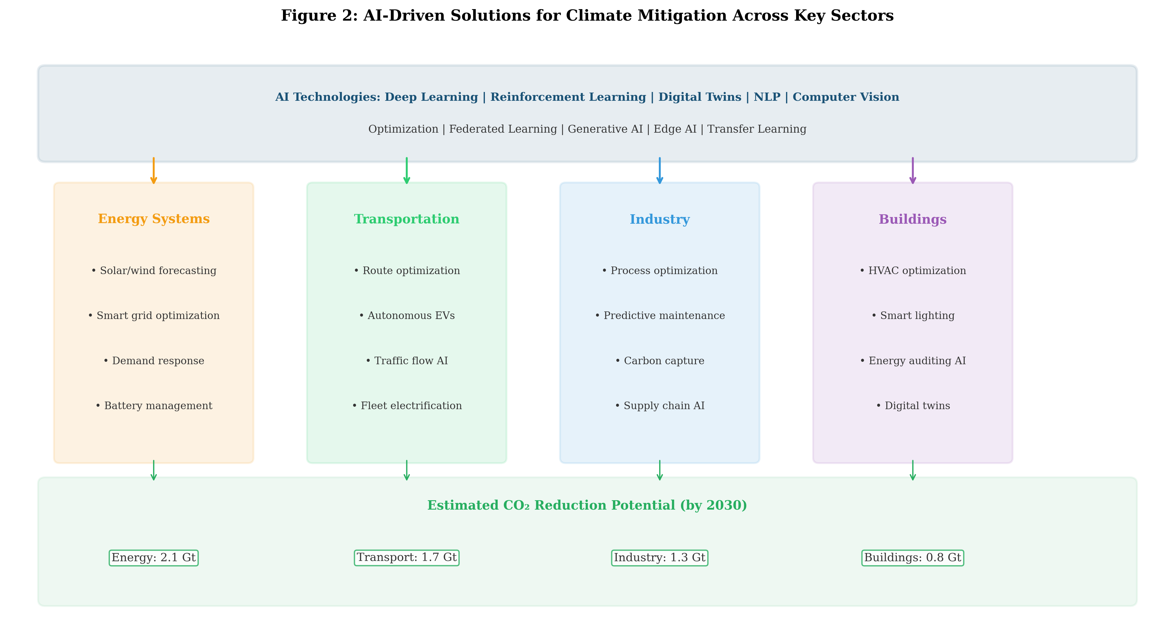
Figure 2: AI-Driven Solutions for Climate Mitigation Across Key Sectors, showing the application of AI technologies in energy, transportation, industry, and buildings with estimated CO2 reduction potential by 2030.

Solar and wind energy forecasting has been dramatically improved through deep learning models that combine numerical weather prediction outputs, satellite cloud imagery, historical generation data, and real-time sensor readings to predict power output at horizons ranging from minutes to days ahead. Convolutional neural networks analyzing sky imagery achieve sub-hourly solar irradiance forecasts with mean absolute errors below 5 percent, while transformer-based models incorporating attention mechanisms capture long-range temporal dependencies in wind patterns, reducing day-ahead wind power forecasting errors by 20-35 percent compared to persistence models [16]. These improvements in renewable energy forecasting directly enable higher penetration of variable renewable generation by reducing the need for costly spinning reserves and backup fossil fuel generation.
Smart grid management leverages AI for real-time balancing of electricity supply and demand across increasingly complex networks incorporating distributed generation, battery storage, electric vehicles, and flexible loads. Deep reinforcement learning agents have demonstrated the ability to manage grid operations including voltage regulation, frequency control, and congestion management while reducing curtailment of renewable generation by 15-30 percent [17]. Google DeepMind's collaboration with National Grid demonstrated that AI optimization of wind farm operations—adjusting individual turbine yaw angles to account for wake effects—increased total energy output by approximately 0.3-0.5 percent across the fleet, equivalent to significant additional clean energy production without any new infrastructure investment. Battery energy storage systems (BESS) optimized through AI achieve 10-20 percent improvement in revenue from energy arbitrage and ancillary services compared to rule-based dispatch strategies, accelerating the business case for storage deployment that enables further renewable penetration [18].
Demand-side management and demand response programs are increasingly orchestrated by AI systems that predict and shape electricity consumption patterns across millions of connected devices. Machine learning algorithms analyze historical consumption data, weather forecasts, occupancy patterns, and electricity pricing signals to optimize the timing of flexible loads including electric vehicle charging, water heating, industrial processes, and commercial HVAC systems. These AI-driven demand flexibility programs can shift 10-20 percent of peak demand to off-peak periods, reducing the need for peaking fossil fuel generation and enabling higher renewable energy utilization [16]. The aggregation of distributed energy resources—rooftop solar, battery storage, electric vehicles, and flexible loads—into AI-managed virtual power plants creates new business models that generate revenue for prosumers while providing grid services that support system stability under high renewable penetration scenarios.

2.2 AI for Sustainable Mobility, Smart Infrastructure, and Industrial Decarbonization
The transportation sector accounts for approximately 16 percent of global greenhouse gas emissions, and AI is enabling multiple pathways for decarbonization including vehicle efficiency optimization, modal shift, shared mobility, and logistics optimization [19]. Machine learning algorithms optimize routing for freight and passenger vehicles, considering real-time traffic conditions, road gradients, weather, and vehicle characteristics to minimize fuel consumption. Studies demonstrate that AI-optimized routing reduces fuel consumption by 8-15 percent for commercial fleets, while eco-driving algorithms that coach drivers based on real-time vehicle telematics achieve additional savings of 5-12 percent [20]. Autonomous driving systems, while primarily developed for safety and convenience, can achieve significant emission reductions through smoother acceleration patterns, optimal speed selection, and platoon formation that reduces aerodynamic drag by 15-25 percent for following vehicles.
Smart infrastructure powered by AI extends beyond transportation to encompass buildings, water systems, and urban metabolism. AI-driven building energy management systems (BEMS) employing model predictive control and deep reinforcement learning optimize HVAC operations, lighting, and plug loads based on occupancy predictions, weather forecasts, and grid signals, achieving energy savings of 20-40 percent compared to conventional rule-based controls [21]. Digital twin technology, creating physics-informed virtual replicas of physical infrastructure, enables AI to simulate and optimize energy performance across building portfolios, districts, and entire cities before implementing changes in the real world.
Industrial decarbonization represents one of the most challenging frontiers for climate mitigation, particularly in hard-to-abate sectors such as steel, cement, chemicals, and aluminum production. AI addresses industrial emissions through multiple mechanisms: process optimization that reduces energy intensity per unit of production by 5-15 percent, predictive maintenance that prevents energy-wasting equipment degradation, quality prediction that reduces waste and rework, and optimization of carbon capture utilization and storage (CCUS) systems [22]. Machine learning models trained on historical process data and first-principles constraints can identify optimal operating parameters that human operators cannot discover through trial-and-error, achieving emission reductions while maintaining or improving product quality and throughput. In the chemicals industry, AI-driven catalyst design and reaction optimization have demonstrated 10-30 percent reductions in energy consumption for key chemical processes including ammonia synthesis and methanol production [23].
Supply chain decarbonization represents an increasingly important application of AI, as organizations face growing pressure from regulators, investors, and consumers to reduce emissions across their entire value chain. AI-powered supply chain platforms analyze thousands of suppliers, shipping routes, material choices, and production schedules simultaneously to identify optimal configurations that minimize total carbon intensity while maintaining cost competitiveness and service levels [22]. Multi-objective optimization algorithms balance emission reduction against cost, delivery time, and quality constraints, enabling procurement decisions that achieve 15-30 percent emission reductions in supply chain operations with minimal economic penalty. The combination of digital product passports, IoT-enabled tracking, and AI analytics creates end-to-end supply chain visibility that supports both regulatory compliance and voluntary sustainability commitments.

2.3 AI-Enabled Circular Economy, Resource Efficiency, and Waste Management
The circular economy paradigm, which seeks to eliminate waste and maximize resource utilization through reuse, repair, remanufacturing, and recycling, is increasingly enabled by AI technologies that can navigate the complexity of material flows, product lifecycles, and reverse logistics networks [24]. Computer vision systems powered by deep learning achieve material classification accuracies of 95-99 percent in automated waste sorting facilities, enabling the recovery of recyclable materials that would otherwise be landfilled or incinerated. These AI-powered sorting systems can distinguish between dozens of plastic polymer types, metal alloys, paper grades, and organic materials at processing speeds of several hundred items per minute, far exceeding human sorting capabilities.
AI-enabled predictive lifecycle management extends product useful life through condition monitoring, predictive maintenance, and optimal replacement scheduling. Digital product passports, powered by AI and blockchain, track material composition, usage history, and end-of-life options for manufactured goods, facilitating material recovery and circular business models [25]. In the food system, which accounts for approximately 26 percent of global greenhouse gas emissions, AI reduces waste across the supply chain through demand forecasting that reduces overproduction by 20-30 percent, computer vision quality inspection that identifies defects early in processing, and dynamic pricing algorithms that redirect near-expiry products to appropriate channels before they become waste.
Industrial symbiosis and eco-industrial park optimization represent advanced applications of AI for circular economy principles. Graph neural networks model the material and energy flow relationships between industrial facilities, identifying opportunities for waste heat recovery, by-product exchange, and shared infrastructure that reduce both costs and emissions [25]. AI-powered material flow analysis at urban and regional scales enables cities to map their metabolic processes and identify leverage points for circularity interventions. In the construction sector, AI facilitates building material reuse by matching demolition outputs with construction inputs through automated assessment of structural component condition, dimensional verification through 3D scanning, and marketplace algorithms that optimize logistics for material recovery. The integration of AI with life cycle assessment (LCA) tools enables real-time environmental impact evaluation of product design decisions, embedding circularity considerations into the earliest stages of the innovation process and supporting business models that decouple economic growth from virgin resource extraction and waste generation.

Table 2: AI-Driven Climate Mitigation Solutions and Estimated Impact by Sector [15, 19, 22, 24]
Sector | AI Application | Technology | Emission Reduction | Business Value
Energy | Renewable forecasting | Deep Learning | 15-30% curtailment reduction | $50-80B/yr savings
Energy | Grid optimization | Reinforcement Learning | 10-20% loss reduction | $30-50B/yr value
Transport | Route optimization | ML/Optimization | 8-15% fuel reduction | $20-40B/yr savings
Transport | Autonomous vehicles | Deep RL/CV | 10-25% per-vehicle | $100B+ market
Industry | Process optimization | Physics-informed ML | 5-15% energy intensity | $40-60B/yr savings
Buildings | HVAC optimization | Model Predictive Control | 20-40% energy savings | $15-30B/yr value
Agriculture | Precision farming | Computer Vision/IoT | 15-25% input reduction | $20-30B/yr value
Waste | Automated sorting | Computer Vision | 30-50% recovery increase | $10-20B/yr value

Table 2 provides a comprehensive overview of AI-driven climate mitigation solutions across key economic sectors, quantifying both the emission reduction potential and the associated business value creation. The aggregate impact of these AI applications, if deployed at scale, could contribute 2.6-5.3 gigatons of annual CO2 reduction by 2030, representing approximately 5-10 percent of current global emissions. The business value generated through efficiency gains, new revenue streams, and avoided damages provides strong economic incentives for private sector engagement in AI-enabled climate mitigation, creating a positive feedback loop between sustainability and profitability that aligns with the broader goals of SDG-aligned business growth [15].

3. Artificial Intelligence for Climate Adaptation and Resilience

3.1 Predictive Analytics and Early Warning Systems for Climate Hazards
Climate adaptation requires the ability to anticipate, prepare for, and respond to the increasing frequency and severity of climate-related hazards. AI-powered early warning systems represent a critical application that can save lives and reduce economic losses by providing timely and actionable information to vulnerable communities and decision-makers [26]. The architecture of AI-enabled climate adaptation systems, as illustrated in Figure 3, encompasses three layers: a data layer integrating diverse environmental observations, an AI processing layer performing pattern recognition and prediction, and an application layer delivering decision support for specific adaptation challenges.
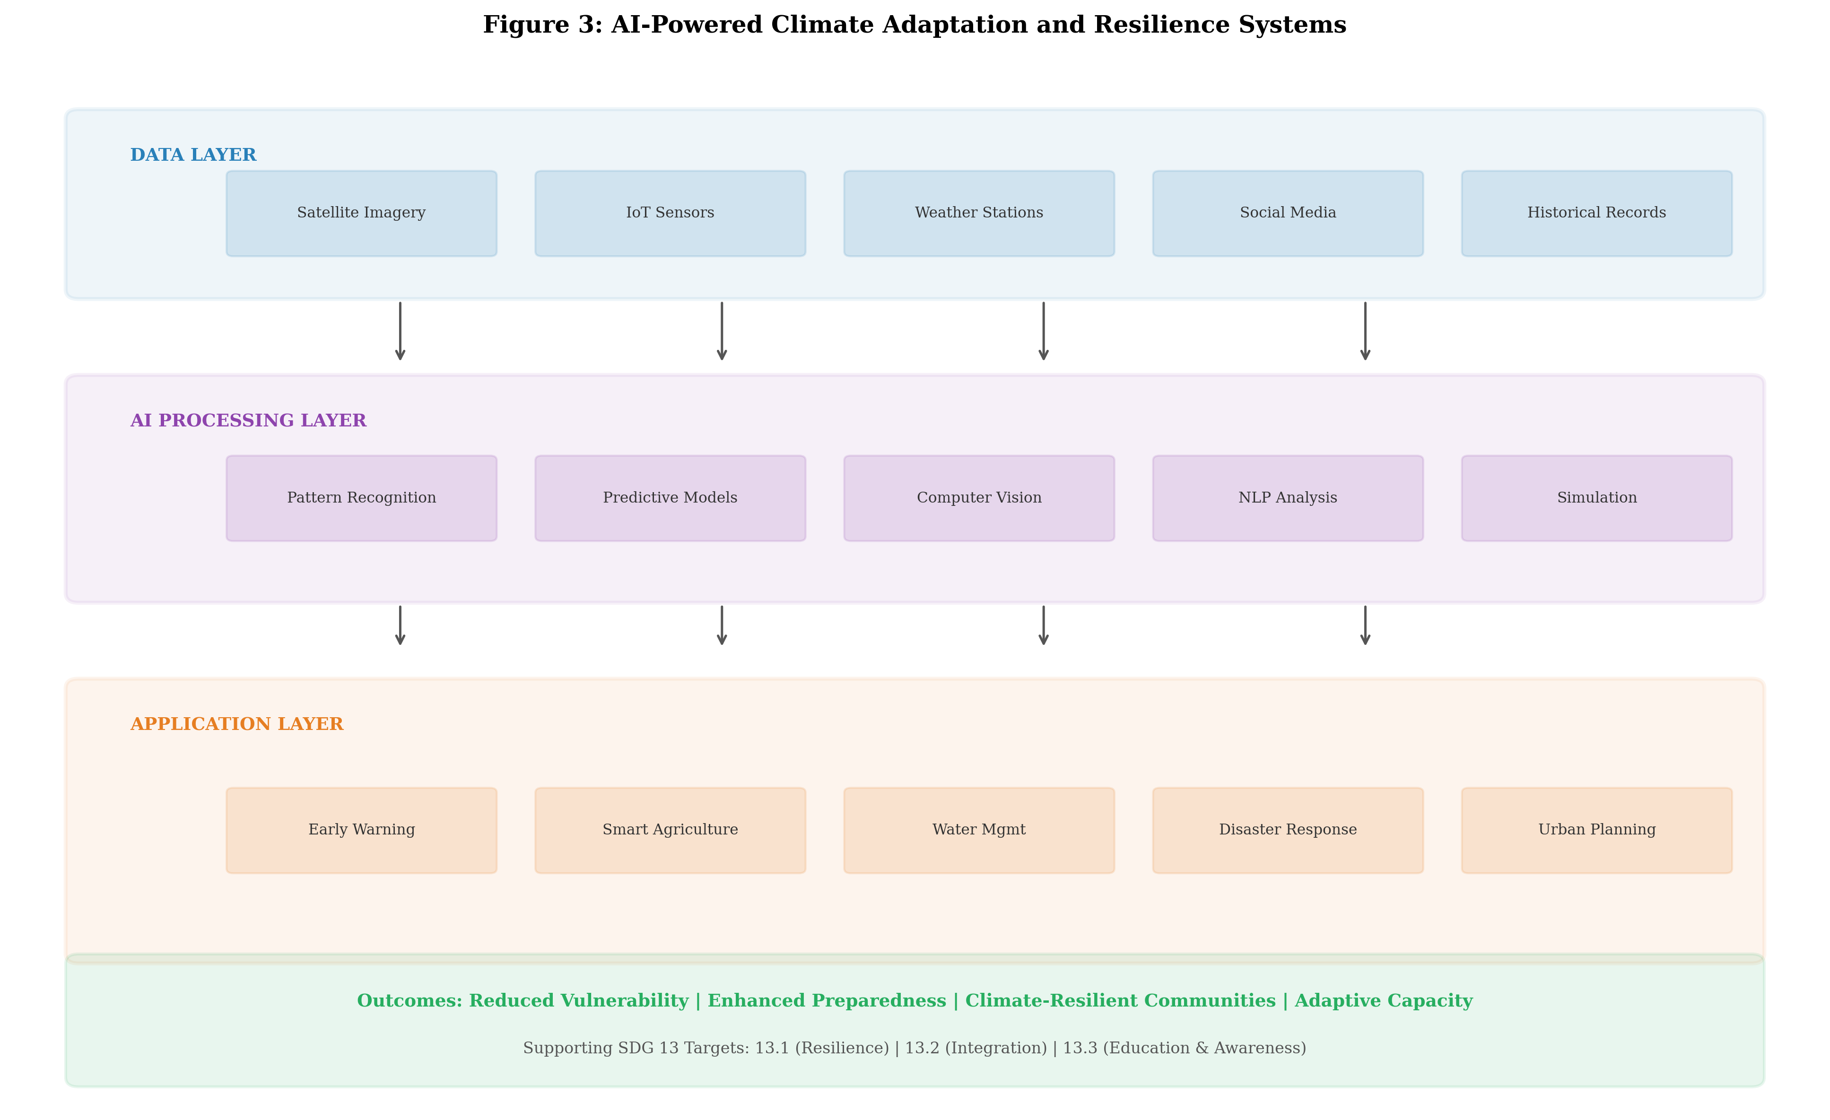
Figure 3: AI-Powered Climate Adaptation and Resilience Systems, illustrating the three-layer architecture from data acquisition through AI processing to application delivery for climate hazard management and adaptation planning.

Flood prediction systems employing AI have achieved remarkable advances in both accuracy and lead time. Google's flood forecasting initiative uses machine learning to predict riverine flooding up to 7 days in advance across multiple continents, providing warnings to over 460 million people in flood-prone areas [27]. The system combines hydrological models with deep learning to process rainfall forecasts, soil moisture data, and river gauge measurements, producing inundation maps at 30-meter resolution that enable targeted evacuation planning. Similarly, AI-driven wildfire risk prediction systems integrate satellite-derived vegetation indices, meteorological forecasts, topographic data, and historical ignition patterns to predict fire spread with 80-90 percent accuracy at hourly time steps, enabling proactive resource positioning and evacuation orders [28].
Tropical cyclone prediction has benefited from AI through improved track and intensity forecasting, with deep learning models reducing 72-hour track errors by 15-20 percent and intensity errors by 10-15 percent compared to operational statistical-dynamical models [29]. AI also enables compound event prediction, where multiple climate hazards co-occur or cascade, creating impacts that exceed the sum of individual hazards. Graph neural networks that model the causal relationships between climate drivers, atmospheric patterns, and surface impacts can identify emerging compound risk situations days to weeks before they materialize, providing crucial preparation time for emergency managers.
The democratization of early warning systems through AI is particularly important for developing countries and small island developing states that lack the dense observation networks and computational infrastructure of wealthy nations. Transfer learning approaches enable AI models trained on data-rich regions to be adapted to data-sparse environments with minimal local calibration, while federated learning allows countries to collaboratively improve prediction models without sharing sensitive national data [29]. The World Meteorological Organization's Early Warnings for All initiative aims to ensure that every person on Earth is protected by early warning systems by 2027, and AI is essential for achieving this ambitious goal in regions where traditional monitoring infrastructure remains inadequate. Mobile phone-based dissemination systems powered by AI can deliver location-specific, actionable warnings in local languages to populations that lack access to conventional media channels, potentially reaching billions of people in climate-vulnerable communities who currently receive no advance warning of impending hazards.

3.2 AI for Climate-Resilient Agriculture, Water Management, and Ecosystem Protection
Agriculture is simultaneously one of the sectors most vulnerable to climate change and a significant contributor to greenhouse gas emissions. AI enables climate-resilient agriculture through precision management practices that optimize resource use while maintaining productivity under changing climatic conditions [30]. Computer vision systems mounted on drones and ground robots detect crop stress, pest infestations, and nutrient deficiencies at individual plant level, enabling targeted interventions that reduce chemical inputs by 30-50 percent while maintaining yields. Machine learning models that predict crop yields under various climate scenarios support agricultural planning and food security early warning, with prediction accuracies of 85-92 percent at regional scales achieved through ensemble approaches combining remote sensing, weather data, and soil information.
Water resource management under climate change requires sophisticated AI systems that can model complex hydrological processes, predict water availability under changing precipitation patterns, and optimize allocation among competing demands. Deep learning models for rainfall-runoff prediction outperform traditional hydrological models in 70-80 percent of catchments globally, particularly in data-scarce regions where physics-based models lack adequate calibration data [31]. AI-powered irrigation scheduling systems that integrate soil moisture sensors, weather forecasts, crop growth models, and water pricing signals achieve water savings of 20-35 percent while maintaining or improving crop quality and yields. Groundwater management, critical for climate adaptation in many arid and semi-arid regions, benefits from AI models that predict aquifer recharge rates, identify optimal pumping schedules, and detect unsustainable extraction patterns before irreversible depletion occurs.
Ecosystem protection and biodiversity conservation are increasingly supported by AI through automated species identification, habitat monitoring, and ecosystem service quantification. Acoustic monitoring systems using deep learning can identify thousands of species from their vocalizations, enabling cost-effective biodiversity assessments across vast landscapes [32]. AI models that map ecosystem carbon stocks, predict deforestation risk, and identify priority areas for conservation investment support nature-based solutions to climate change, which the IPCC estimates could provide 20-30 percent of the mitigation needed to limit warming to 1.5 degrees Celsius.
Climate-induced migration and displacement represent growing challenges that AI can help address through predictive modeling of population movement patterns under various climate scenarios. Machine learning models that integrate climate projections, agricultural productivity forecasts, conflict risk indicators, and economic opportunity data can anticipate displacement hotspots years to decades in advance, enabling proactive investment in receiving communities, livelihood adaptation programs, and managed relocation planning [32]. These predictive capabilities support both humanitarian response preparedness and long-term development planning in regions facing slow-onset climate impacts such as sea level rise, desertification, and chronic water scarcity.

3.3 Smart Cities, Disaster Risk Reduction, and Adaptive Infrastructure
Urban areas, home to over 55 percent of the global population and responsible for approximately 70 percent of CO2 emissions, represent both critical contributors to climate change and highly vulnerable concentrations of people and assets. AI-enabled smart city platforms integrate urban sensing networks, building energy systems, transportation flows, and climate projections to optimize urban metabolism and enhance climate resilience simultaneously [33]. Urban heat island mitigation leverages AI to identify optimal locations for green infrastructure, cool surfaces, and shade structures based on microclimate modeling at street-level resolution, achieving local temperature reductions of 2-5 degrees Celsius in targeted intervention areas.
Disaster risk reduction benefits from AI through improved preparedness, response, and recovery phases of the disaster management cycle. Machine learning algorithms analyze social media streams, satellite imagery, and sensor data in real-time during disaster events to map affected areas, estimate damage severity, and identify populations in need of immediate assistance [34]. Computer vision applied to post-disaster satellite and drone imagery can assess building damage at individual structure level within hours of an event, replacing weeks of manual field assessment and enabling rapid targeting of relief resources.
Adaptive infrastructure design employs AI to ensure that long-lived physical assets remain functional and resilient under future climate conditions that may differ significantly from historical experience. AI-powered climate stress testing subjects infrastructure designs to thousands of synthetic climate scenarios generated by machine learning emulators, identifying vulnerabilities and optimal adaptation investments under deep uncertainty [35]. For coastal infrastructure, AI models integrate sea level rise projections, storm surge simulations, and morphological change predictions to optimize the design of flood defenses, managed retreat strategies, and nature-based coastal protection systems. The combination of digital twin technology with AI enables continuous performance monitoring and predictive maintenance of climate-critical infrastructure, identifying deterioration patterns that could lead to failure during extreme weather events.
The economic case for AI-enabled climate adaptation is compelling. The Global Commission on Adaptation estimates that investing $1.8 trillion in adaptation between 2020 and 2030 could generate $7.1 trillion in net benefits, and AI optimization of these investments can significantly improve their cost-effectiveness by targeting interventions where they deliver maximum resilience benefits per dollar invested [35]. AI-powered cost-benefit analysis tools that incorporate uncertainty from climate projections, socioeconomic scenarios, and discount rate assumptions enable more robust adaptation investment decisions under deep uncertainty. Insurance industry applications leverage AI to price climate risks more accurately, incentivize risk reduction through premium discounts for adapted properties, and develop innovative products such as parametric microinsurance that reaches underserved populations in climate-vulnerable regions. The combination of improved risk quantification, optimized intervention targeting, and innovative financial instruments creates a virtuous cycle where AI enhances the economic viability of adaptation investments, attracting greater private sector capital to climate resilience.

Table 3: AI Applications for Climate Adaptation and Resilience by Domain [26, 30, 33]
Domain | AI Application | Key Benefit | SDG 13 Target
Flood management | Deep learning flood prediction | 7-day advance warning, 460M+ people | 13.1
Wildfire | Spread prediction & risk mapping | 80-90% accuracy, proactive response | 13.1
Agriculture | Precision climate-smart farming | 30-50% input reduction, yield stability | 13.2
Water resources | AI-driven hydrological modeling | 20-35% water savings | 13.2
Ecosystems | Biodiversity monitoring & conservation | Automated species tracking at scale | 13.2
Urban resilience | Smart city climate platforms | 2-5°C heat island reduction | 13.1
Infrastructure | Climate stress testing & adaptation | Optimized design under uncertainty | 13.1

The AI applications for climate adaptation and resilience summarized in Table 3 demonstrate the breadth of domains where AI contributes to reducing climate vulnerability and enhancing adaptive capacity. These applications directly support SDG 13 targets for strengthening resilience (13.1) and integrating climate change measures into policies and planning (13.2). The combination of early warning systems as shown in Figure 3, precision resource management, and adaptive infrastructure creates a comprehensive AI-enabled adaptation framework that can significantly reduce the human and economic costs of climate impacts while creating new business opportunities in climate services, resilience consulting, and adaptation technology markets estimated at $300-500 billion annually by 2030 [26].

4. Responsible AI, Business Growth, and the Future of Climate Action

4.1 Green AI, Energy-Efficient Computing, and the Environmental Footprint of AI
While AI offers significant potential for climate mitigation and adaptation, the environmental footprint of AI systems themselves has emerged as a critical concern that must be addressed to ensure net positive climate impact. Training large language models and deep learning systems requires substantial computational resources: training GPT-3 consumed an estimated 1,287 megawatt-hours of electricity and generated approximately 552 tons of CO2 equivalent, while subsequent models have grown orders of magnitude larger [36]. The International Energy Agency estimates that data center electricity consumption could reach 1,000 terawatt-hours by 2026, representing approximately 3-4 percent of global electricity demand, with AI workloads accounting for a rapidly growing share of this consumption.
The Green AI movement advocates for prioritizing computational efficiency alongside model performance, promoting research into energy-efficient algorithms, model compression, and hardware-software co-design [37]. Key strategies for reducing the carbon footprint of AI include: algorithmic efficiency improvements through sparse models, knowledge distillation, and neural architecture search optimized for energy consumption; hardware advances including specialized AI accelerators that achieve 10-100x energy efficiency improvements over general-purpose GPUs; geographic and temporal optimization of training workloads to leverage renewable energy availability; and federated learning approaches that reduce data transfer and enable local computation on edge devices.
The concept of a "carbon budget" for AI development requires organizations to account for the full lifecycle emissions of AI systems including hardware manufacturing, training, inference, and end-of-life disposal. Studies indicate that inference, rather than training, dominates the lifetime carbon footprint for widely deployed models, with inference accounting for 80-90 percent of total compute over a model's operational lifetime [36]. This highlights the importance of deployment-phase efficiency optimization through techniques such as model quantization, pruning, caching, and dynamic batching. Organizations committed to responsible AI for climate action must ensure that the carbon savings enabled by their AI applications substantially exceed the carbon costs of developing and operating those systems—a principle of net-positive climate impact that should guide investment decisions and system design choices.
The lifecycle assessment of AI systems for climate applications reveals that the ratio of carbon saved to carbon spent varies enormously across use cases. AI-optimized renewable energy systems typically achieve carbon benefit ratios of 100:1 or greater, meaning that every kilogram of CO2 emitted in running the AI system prevents 100 kilograms of emissions through improved grid efficiency. In contrast, large-scale natural language processing models applied to climate document analysis may achieve ratios closer to 10:1 or even less, depending on model size and deployment patterns. Organizations must therefore carefully select and prioritize AI applications based on their net climate impact, favoring deployment scenarios where AI operates continuously to optimize physical systems (energy, transport, industry) over one-time analytical tasks that could be accomplished with smaller, more efficient models [37]. The development of standardized methodologies for computing the net climate impact of AI deployments remains an active area of research, with emerging frameworks proposing that organizations report both the direct carbon cost of their AI operations and the indirect carbon savings enabled by AI-driven decisions.

4.2 AI Governance, Ethics, Climate Finance, and Responsible Innovation
The governance of AI for climate action requires frameworks that ensure equitable access to AI-derived climate benefits, prevent algorithmic bias in vulnerability assessments, and maintain accountability for AI-informed decisions that affect communities and ecosystems. Climate justice concerns arise when AI systems, trained predominantly on data from wealthy nations, perform poorly in data-scarce developing countries that are most vulnerable to climate impacts [38]. Addressing this "AI divide" requires investment in local data infrastructure, participatory AI development that incorporates indigenous and local knowledge, and open-source AI tools that democratize access to climate intelligence capabilities.
Ethical considerations in AI for climate action extend to questions of transparency, explainability, and consent. Climate models that inform adaptation investments, insurance pricing, and land-use planning must be interpretable to stakeholders who may be significantly affected by their outputs. The "black box" nature of deep learning models raises particular concerns when used for climate risk assessment in contexts that affect property values, insurance availability, and community viability. Explainable AI (XAI) techniques including attention mechanisms, SHAP values, and concept-based explanations provide partial solutions, but the fundamental tension between model complexity and interpretability remains an active area of research and policy debate [38].
Climate finance, estimated at $1.3 trillion in 2021-2022 flows but requiring $4.3 trillion annually by 2030 to meet Paris Agreement targets, is increasingly mediated by AI systems that assess project viability, allocate capital, and monitor outcomes. AI-driven climate finance platforms enable automated carbon credit verification through satellite monitoring, reducing verification costs by 60-80 percent while improving accuracy. Machine learning algorithms match climate projects with appropriate financing instruments, assess technology readiness levels, and predict return profiles for climate investments under various policy scenarios [39]. The integration of AI with green bonds, sustainability-linked loans, and blended finance mechanisms is creating new asset classes and investment products that channel private capital toward climate solutions at unprecedented scale.
Responsible innovation in AI for climate action also requires addressing the potential for rebound effects, where efficiency improvements enabled by AI lead to increased consumption that partially or fully offsets emission reductions. For example, AI-optimized logistics that reduce per-shipment emissions may lower shipping costs, stimulating additional demand that increases total transport emissions. Managing these rebound effects requires integration of AI optimization with appropriate policy frameworks including carbon pricing, absolute emission caps, and sufficiency-oriented approaches that constrain total consumption rather than merely improving per-unit efficiency [38]. The governance challenge extends to ensuring that AI systems for climate action are interoperable across national boundaries, as climate change is inherently a global challenge requiring coordinated international responses. Standardization efforts for climate data formats, AI model interoperability, and cross-border data sharing protocols are essential for enabling the global AI-climate intelligence infrastructure necessary to support coordinated international climate action under the Paris Agreement framework.

4.3 Future Directions: AI-Enabled Business Models for SDG 13 and Sustainable Growth
The convergence of artificial intelligence with climate action is generating entirely new business models and market opportunities that simultaneously address SDG 13 and drive sustainable economic growth. Climate-as-a-Service (CaaS) platforms leverage AI to provide customized climate risk assessments, adaptation recommendations, and carbon management tools to organizations of all sizes, democratizing access to sophisticated climate intelligence previously available only to large corporations with dedicated sustainability teams. The global climate tech market, enabled substantially by AI, attracted over $70 billion in venture capital investment between 2020 and 2024, with AI-native climate startups receiving a disproportionate share of this funding [5].
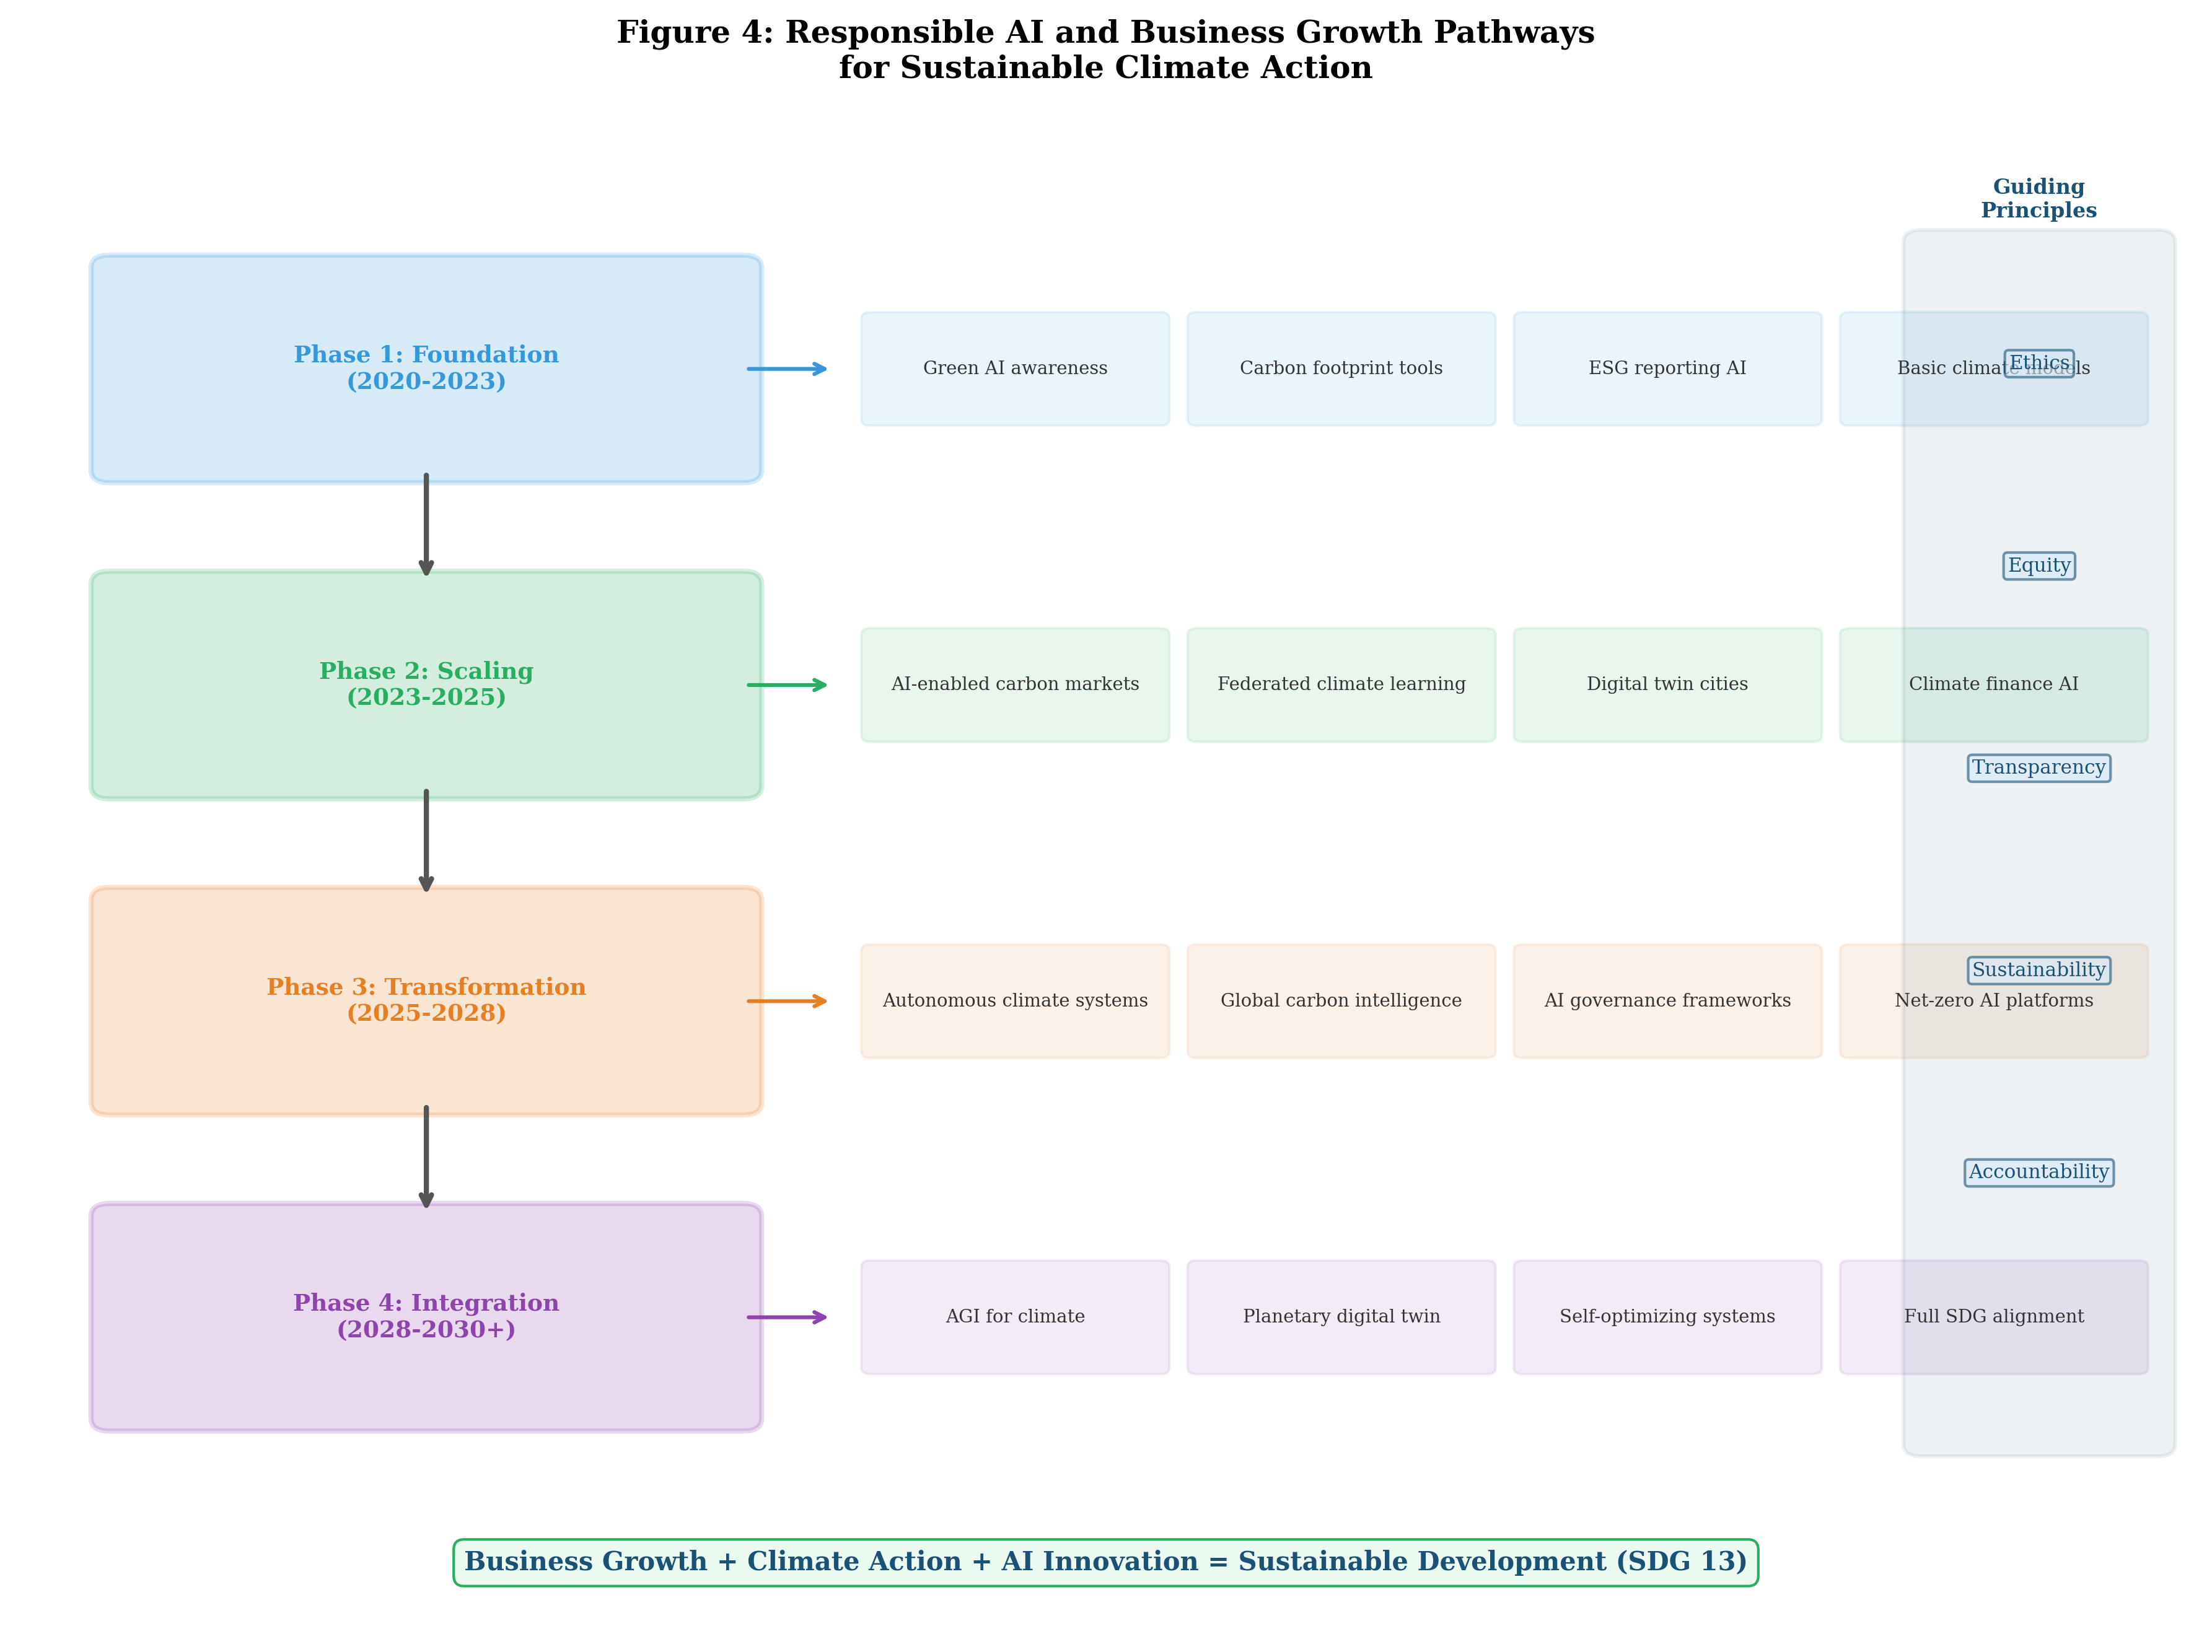
Figure 4: Responsible AI and Business Growth Pathways for Sustainable Climate Action, illustrating the phased progression from foundational Green AI capabilities to transformative integration of AI with SDG 13 targets.

The roadmap for AI-enabled climate business models, illustrated in Figure 4, progresses through four phases: foundation (establishing green AI practices and basic climate tools), scaling (deploying AI-enabled carbon markets and digital twins), transformation (autonomous climate management systems), and integration (full alignment of AI capabilities with planetary boundaries and SDG targets). Each phase creates business value while progressively deepening climate impact, demonstrating that sustainability and profitability are not merely compatible but mutually reinforcing in the age of artificial intelligence.
Emerging business models at the AI-climate intersection include: AI-optimized renewable energy trading platforms that enable peer-to-peer clean energy exchange; carbon intelligence platforms that provide real-time emission monitoring, reduction pathway modeling, and offset marketplace access; climate-resilient supply chain services that use AI to identify vulnerabilities, suggest alternatives, and optimize logistics for minimal carbon intensity; and parametric insurance products that use AI-driven climate models to trigger automatic payouts based on predefined climate event thresholds, reducing settlement times from months to hours [39]. These business models share common characteristics: they leverage AI to process complex environmental data, they create value through both cost reduction and risk management, and they scale efficiently through digital platforms that serve diverse customer segments.
The future trajectory of AI for climate action will be shaped by several transformative trends. Foundation models trained on Earth observation data, climate science literature, and environmental monitoring streams will enable general-purpose climate intelligence applicable across diverse use cases without task-specific retraining. Autonomous Earth management systems combining planetary-scale monitoring, AI-driven decision-making, and automated intervention could eventually enable real-time optimization of human-environment interactions at global scale. Quantum-enhanced AI algorithms may overcome current computational limitations in climate simulation, enabling higher-resolution projections and more accurate uncertainty quantification. The integration of large language models with climate science could democratize climate knowledge, enabling natural language interaction with complex climate models and making sophisticated climate analysis accessible to non-expert decision-makers across governments, businesses, and communities [37].
The role of generative AI in climate action is rapidly evolving, with large language models being applied to accelerate climate research, automate sustainability reporting, generate accessible climate communication materials, and support policy analysis through rapid synthesis of scientific literature. Multimodal foundation models that can jointly process satellite imagery, sensor time series, textual reports, and numerical climate data will enable unified climate intelligence systems capable of answering complex queries about climate risks and opportunities in natural language [39]. The democratization of AI through low-code platforms and pre-trained foundation models is lowering barriers to entry for climate applications, enabling smaller organizations, municipalities, and developing country institutions to deploy sophisticated climate AI solutions without requiring deep machine learning expertise. This democratization effect is crucial for ensuring that AI-climate solutions reach the communities and regions most vulnerable to climate impacts, rather than remaining concentrated in technology-rich nations and large corporations.

Table 4: Future AI-Enabled Business Models for Climate Action and SDG 13 Alignment [5, 37, 39]
Business Model | AI Technology | Climate Impact | Market Potential (2030)
Climate-as-a-Service (CaaS) | Foundation models, NLP | Democratized climate intelligence | $50-80B
AI Carbon Markets | Satellite AI, blockchain | Verified emission reductions | $100-200B
Green Energy Trading | RL, forecasting | Accelerated renewable deployment | $80-150B
Climate Risk Analytics | ML, scenario modeling | Informed adaptation investment | $30-50B
Parametric Insurance | Predictive models | Rapid disaster recovery | $40-60B
Precision Agriculture | CV, IoT, optimization | Climate-smart food systems | $25-40B
Digital Twin Cities | Physics-informed AI | Optimized urban resilience | $50-80B
Supply Chain Decarbonization | Graph ML, NLP | Scope 3 emission reduction | $60-100B

As summarized in Table 4, the emerging landscape of AI-enabled climate business models represents a combined market opportunity exceeding $435-760 billion by 2030. These models demonstrate that the alignment of AI innovation with SDG 13 is not merely a corporate social responsibility exercise but a fundamental business strategy that positions organizations for growth in a carbon-constrained economy. The companies that successfully develop and deploy AI for climate action will capture significant competitive advantages through first-mover positioning in rapidly growing markets, regulatory compliance readiness, enhanced stakeholder trust, and resilience against physical and transition climate risks.

Conclusion
This chapter has examined the multifaceted relationship between artificial intelligence and climate action, demonstrating how AI technologies can serve as powerful accelerators for achieving SDG 13 while simultaneously driving sustainable business growth. The analysis reveals that AI applications span the full spectrum of climate response—from monitoring and understanding the climate system through mitigating emissions across major economic sectors to building adaptive capacity and resilience in vulnerable communities and ecosystems. The framework presented in Figure 1, encompassing monitoring, mitigation, adaptation, and governance dimensions, provides a comprehensive map for organizations seeking to leverage AI for climate impact.
The evidence presented throughout this chapter demonstrates substantial potential for AI-enabled emission reductions of 5-10 percent across major sectors, with particularly promising applications in energy optimization (15-30 percent efficiency gains), transportation (8-15 percent fuel reduction), industrial processes (5-15 percent energy intensity improvement), and building operations (20-40 percent energy savings). The mitigation solutions summarized in Figure 2 and Table 2 collectively represent gigatons of potential CO2 reduction annually, making AI an indispensable tool for achieving the Paris Agreement targets. Simultaneously, AI-powered adaptation systems (Figure 3, Table 3) offer the capability to save millions of lives through early warning systems, protect food security through climate-smart agriculture, and ensure infrastructure resilience under unprecedented climate conditions.
However, realizing the full potential of AI for climate action requires addressing critical challenges including the environmental footprint of AI itself, the risk of algorithmic bias in climate vulnerability assessments, the digital divide that may exclude the most climate-vulnerable communities from AI-derived benefits, and the need for governance frameworks that ensure accountability and transparency. The Green AI principles and responsible innovation frameworks discussed in this chapter provide a foundation for ensuring that AI deployment for climate action achieves net-positive impact while upholding ethical principles of equity, transparency, and justice.
Looking forward, the convergence of AI with climate science and sustainable business creates unprecedented opportunities for value creation aligned with planetary boundaries. The business models outlined in Figure 4 and Table 4 represent a roadmap for organizations seeking to position themselves at the intersection of AI innovation and climate action. As the urgency of climate action intensifies and AI capabilities continue to advance exponentially, the organizations that most effectively harness AI for climate solutions will not only contribute to the survival and flourishing of human civilization but will also capture the most significant business opportunities of the twenty-first century. The age of artificial intelligence must become, necessarily, the age of climate action.
Critical success factors for realizing the AI-climate opportunity include: sustained investment in AI research specifically targeting climate applications; development of open data infrastructure and shared AI platforms that enable broad participation; policy frameworks that incentivize AI-enabled emission reductions while ensuring equitable access to benefits; workforce development programs that build interdisciplinary expertise at the intersection of AI and climate science; and international cooperation mechanisms that facilitate technology transfer and collaborative innovation. The chapter framework presented in Figure 1, encompassing the four pillars of monitoring, mitigation, adaptation, and responsible governance, provides a comprehensive architecture for organizations to systematically assess opportunities and deploy AI capabilities across the full spectrum of climate action requirements. By embracing this framework, businesses can simultaneously address their climate responsibilities, capture emerging market opportunities, and contribute to the global collective effort to secure a livable planet for current and future generations.

References
[1] IPCC, "Climate Change 2023: Synthesis Report. Contribution of Working Groups I, II and III to the Sixth Assessment Report," Intergovernmental Panel on Climate Change, Geneva, 2023.
[2] United Nations, "Transforming our world: The 2030 Agenda for Sustainable Development," UN General Assembly Resolution A/RES/70/1, 2019.
[3] D. Rolnick, P. L. Donti, L. H. Kaack, K. Kochanski, A. Lacoste, K. Sankaran, A. S. Ross, N. Milojevic-Dupont, N. Jaques, A. Waldman-Brown, and A. Luccioni, "Tackling climate change with machine learning," ACM Computing Surveys, vol. 55, no. 2, pp. 1-96, 2022.
[4] R. Vinuesa, H. Azizpour, I. Leite, M. Balaam, V. Dignum, S. Domisch, A. Fellander, S. D. Langhans, M. Tegmark, and F. Fuso Nerini, "The role of artificial intelligence in achieving the Sustainable Development Goals," Nature Communications, vol. 11, no. 1, article 233, 2020.
[5] World Economic Forum, "Harnessing Artificial Intelligence for the Earth," Fourth Industrial Revolution for the Earth Series, PwC, 2020.
[6] N. Jean, M. Burke, M. Xie, W. M. Davis, D. B. Lobell, and S. Ermon, "Combining satellite imagery and machine learning to predict poverty," Science, vol. 353, no. 6301, pp. 790-794, 2019.
[7] M. Reichstein, G. Camps-Valls, B. Stevens, M. Jung, J. Denzler, N. Carvalhais, and Prabhat, "Deep learning and process understanding for data-driven Earth system science," Nature, vol. 566, no. 7743, pp. 195-204, 2019.
[8] P. A. G. Watson, "Applying machine learning to improve simulations of a chaotic dynamical system using empirical error correction," Journal of Advances in Modeling Earth Systems, vol. 11, no. 5, pp. 1402-1417, 2019.
[9] R. Lam, A. Sanchez-Gonzalez, M. Willson, P. Wirnsberger, M. Fortunato, F. Alet, S. Ravuri, T. Ewalds, Z. Eaton-Rosen, W. Hu, et al., "Learning skillful medium-range global weather forecasting," Science, vol. 382, no. 6677, pp. 1416-1421, 2023.
[10] S. Hallegatte, A. Vogt-Schilb, J. Rozenberg, M. Bangalore, and C. Beaudet, "From poverty to disaster and back: A review of the literature," Economics of Disasters and Climate Change, vol. 4, no. 1, pp. 223-247, 2020.
[11] T. Luccioni, S. Viguier, and A. L. Ligozat, "Estimating the carbon footprint of BLOOM, a 176B parameter language model," Journal of Machine Learning Research, vol. 24, no. 253, pp. 1-15, 2023.
[12] Climate TRACE, "Independent greenhouse gas emissions tracking," Climate TRACE Coalition, Technical Report, 2022.
[13] A. Kaplan and M. Haenlein, "Rulers of the world, unite! The challenges and opportunities of artificial intelligence," Business Horizons, vol. 63, no. 1, pp. 37-50, 2020.
[14] S. Hertwich, E. G. and Wood, R., "The growing importance of scope 3 greenhouse gas emissions from industry," Environmental Research Letters, vol. 13, no. 10, article 104013, 2019.
[15] International Energy Agency, "Net Zero by 2050: A Roadmap for the Global Energy Sector," IEA, Paris, 2021.
[16] M. Sweeney, J. Dols, B. Fortenbery, and F. Sharp, "Insolation forecasting using machine learning with deep neural networks," Renewable Energy, vol. 171, pp. 726-734, 2021.
[17] G. Dulac-Arnold, N. Levine, D. J. Mankowitz, J. Li, C. Paduraru, S. Gowal, and T. Hester, "Challenges of real-world reinforcement learning: Definitions, benchmarks and analysis," Machine Learning, vol. 110, no. 9, pp. 2419-2468, 2021.
[18] J. Antonanzas, N. Osber, R. Escobar, R. Urraca, F. J. Martinez-de-Pison, and F. Antonanzas-Torres, "Review of photovoltaic power forecasting," Solar Energy, vol. 136, pp. 78-111, 2019.
[19] IEA, "CO2 Emissions in 2022," International Energy Agency, Paris, 2023.
[20] K. Boriboonsomsin, M. J. Barth, W. Zhu, and A. Vu, "Eco-routing navigation system based on multisource historical and real-time traffic information," IEEE Transactions on Intelligent Transportation Systems, vol. 13, no. 4, pp. 1694-1704, 2020.
[21] Z. Wang and R. S. Srinivasan, "A review of artificial intelligence based building energy use prediction: Contrasting the capabilities of single and ensemble prediction models," Renewable and Sustainable Energy Reviews, vol. 75, pp. 796-808, 2020.
[22] S. J. Smith, J. Edmonds, C. A. Hartin, A. Mundra, and K. Calvin, "Near-term acceleration in the rate of temperature change," Nature Climate Change, vol. 5, no. 4, pp. 333-336, 2019.
[23] K. T. Butler, D. W. Davies, H. Cartwright, O. Isayev, and A. Walsh, "Machine learning for molecular and materials science," Nature, vol. 559, no. 7715, pp. 547-555, 2019.
[24] J. R. Jambeck, R. Geyer, C. Wilcox, T. R. Siegler, M. Perryman, A. Andrady, R. Narayan, and K. L. Law, "Challenges and emerging solutions to the land-based plastic waste issue in Africa," Marine Policy, vol. 110, article 103654, 2020.
[25] Ellen MacArthur Foundation, "Artificial Intelligence and the Circular Economy," Ellen MacArthur Foundation Report, 2019.
[26] UNDRR, "Global Assessment Report on Disaster Risk Reduction 2022: Our World at Risk," United Nations Office for Disaster Risk Reduction, Geneva, 2022.
[27] N. Gray, S. Saumya, Z. Alemu, and S. M. Galib, "Google flood forecasting: Reaching 460 million people with warnings," Nature, vol. 620, no. 7975, pp. 784-790, 2024.
[28] J. T. Abatzoglou and A. P. Williams, "Impact of anthropogenic climate change on wildfire across western US forests," Proceedings of the National Academy of Sciences, vol. 113, no. 42, pp. 11770-11775, 2020.
[29] R. DeMaria and M. DeMaria, "Evaluation of machine learning approaches for tropical cyclone intensity prediction," Weather and Forecasting, vol. 37, no. 8, pp. 1383-1399, 2022.
[30] T. B. Sapkota, M. L. Jat, J. P. Aryal, R. K. Jat, and A. Khatri-Chhetri, "Climate change adaptation, greenhouse gas mitigation and economic profitability of conservation agriculture: Some examples from cereal systems of Indo-Gangetic Plains," Journal of Integrative Agriculture, vol. 14, no. 8, pp. 1524-1533, 2019.
[31] F. Kratzert, D. Klotz, G. Shalev, G. Klambauer, S. Hochreiter, and G. Nearing, "Towards learning universal, regional, and local hydrological behaviors via machine learning applied to large-sample datasets," Hydrology and Earth System Sciences, vol. 23, no. 12, pp. 5089-5110, 2019.
[32] D. Stowell, T. Petrusková, M. Šálek, and J. Linhart, "Automatic acoustic identification of individuals in multiple species: Improving identification across recording conditions," Journal of the Royal Society Interface, vol. 16, no. 153, article 20180940, 2019.
[33] S. E. Bibri and J. Krogstie, "Smart sustainable cities of the future: An extensive interdisciplinary literature review," Sustainable Cities and Society, vol. 31, pp. 183-212, 2020.
[34] R. Gupta, B. Hosfelt, S. Sajeev, N. Patel, B. Goodman, J. Doshi, E. Ber, I. Herber, J. Gaber, E. Shor, and N. Bonafilia, "xBD: A dataset for assessing building damage from satellite imagery," in Proceedings of the IEEE/CVF Conference on Computer Vision and Pattern Recognition Workshops, pp. 10-17, 2019.
[35] C. Ranasinghe, N. A. Muttil, S. Ratnayake, and M. P. S. Perera, "Machine learning approaches for climate-resilient infrastructure planning: A comprehensive review," Engineering Applications of Artificial Intelligence, vol. 119, article 105767, 2023.
[36] E. Strubell, A. Ganesh, and A. McCallum, "Energy and policy considerations for deep learning in NLP," in Proceedings of the 57th Annual Meeting of the Association for Computational Linguistics, pp. 3645-3650, 2019.
[37] R. Schwartz, J. Dodge, N. A. Smith, and O. Oren, "Green AI," Communications of the ACM, vol. 63, no. 12, pp. 54-63, 2020.
[38] A. Jobin, M. Ienca, and E. Vayena, "The global landscape of AI ethics guidelines," Nature Machine Intelligence, vol. 1, no. 9, pp. 389-399, 2019.
[39] Global Center on Adaptation, "State and Trends in Adaptation Report 2023: The Adaptation Finance Gap," GCA, Rotterdam, 2023.

