Sex Differences in Early Functional Outcomes After Acute Stroke
Running title: Sex and early functional outcome after stroke
Article type: Review article
Abstract
Background: Stroke is a leading global cause of death and acquired disability, and its absolute burden continues to rise. A recurrent and clinically important observation is that women experience worse functional outcomes than men in the early period after acute stroke. Whether this reflects an intrinsic biological disadvantage, differences in baseline characteristics, or inequities in acute care remains contested.
Objective: To synthesise contemporary evidence (2016–2026) on sex differences in early functional outcomes after acute stroke, to appraise the contribution of baseline confounders and acute treatment access, and to summarise plausible biological mechanisms.
Methods: We conducted a structured narrative review of observational cohorts, registry analyses, randomised-trial substudies, and meta-analyses reporting functional outcome by sex, measured predominantly with the modified Rankin Scale (mRS) at hospital discharge and at 90 days.
Results: Across large registries and pooled analyses, women were consistently older, had higher baseline stroke severity, more atrial fibrillation, and greater pre-stroke disability, and were more likely to live alone. Unadjusted good-outcome rates (mRS 0–2) were markedly lower in women. After adjustment for age and pre-morbid function, much—but not all—of the apparent disadvantage attenuated. Sex gaps in access to reperfusion therapies have narrowed but persist in several health systems, and biological differences in neuroinflammation and hormonal status may modulate recovery.
Conclusions: Early functional disparities after stroke are largely, though not entirely, explained by older age and worse pre-stroke status in women. Routine sex-disaggregated reporting, equitable acute care pathways, and adequate representation of women in trials are essential to close the residual gap.
Keywords: stroke; sex differences; functional outcome; modified Rankin Scale; thrombolysis; thrombectomy; disparities.
1. Introduction
Stroke ranks among the foremost causes of death and long-term disability worldwide, and the absolute number of incident events, deaths, and disability-adjusted life-years attributable to stroke has grown substantially over the past three decades, with the greatest share of the burden borne by low- and middle-income countries [1]. Contemporary global estimates indicate that the lifetime risk of stroke is now approximately one in four adults, and that the prevalent population of stroke survivors—many living with residual impairment—continues to expand as acute mortality declines and populations age [2]. Within this global picture, biological sex and sociocultural gender shape almost every stage of the stroke pathway, from exposure to risk factors and clinical presentation through to acute treatment, functional recovery, and quality of life [3].
Among the most durable findings in cerebrovascular research is that women tend to have poorer functional outcomes than men in the weeks and months after an acute event. This observation is clinically consequential: the early functional trajectory, typically captured by the modified Rankin Scale (mRS) at hospital discharge and at 90 days, is the dominant endpoint in acute stroke trials and a strong predictor of long-term dependency, institutionalisation, and survival. Yet the interpretation of the sex gap is far from settled. Women who present with stroke are, on average, several years older than men, more frequently have atrial fibrillation and cardioembolic mechanisms, carry greater pre-stroke disability, and are more likely to live alone—all of which independently worsen measured outcomes. Disentangling an intrinsic effect of female sex from these confounders, and from any inequities in the speed and intensity of acute care, is central to designing interventions that are both effective and equitable.
This review synthesises evidence published between 2016 and 2026 on sex differences in early functional outcomes after acute stroke. We focus on four interlocking questions: (i) how large is the observed sex gap in early functional outcome; (ii) to what extent is it explained by baseline demographic and clinical differences, particularly age and pre-morbid function; (iii) whether disparities in access to and delivery of acute reperfusion therapies contribute; and (iv) what biological mechanisms might underlie any residual difference. By integrating these strands, we aim to provide clinicians and health-system planners with a coherent, evidence-based account and to identify priorities for research and quality improvement.
2. Methods
We performed a structured narrative review rather than a formal systematic review with quantitative pooling. Peer-reviewed literature indexed in biomedical databases was searched using combinations of the terms stroke, ischaemic stroke, sex, gender, functional outcome, modified Rankin Scale, thrombolysis, and thrombectomy. We prioritised sources published between 2016 and 2026, including large national and multinational registries, individual-patient-data pooled analyses, meta-analyses, randomised-trial substudies, and authoritative scientific statements. Studies were eligible if they reported early functional outcome (defined here as mRS at discharge or at 90 days, functional independence, or an equivalent activity-of-daily-living measure) stratified by sex, and if they provided either unadjusted comparisons or estimates adjusted for relevant confounders. Given the heterogeneity of designs, populations, and adjustment strategies, findings are summarised narratively and illustrated with representative effect estimates rather than combined in a new pooled analysis. Reported numerical values are drawn directly from the cited primary sources.
3. Results
3.1 Baseline differences between women and men
The starting point for any discussion of sex and outcome is that women and men arrive at the hospital with systematically different profiles. In a nationwide analysis of 58,632 patients with acute ischaemic stroke treated in the Netherlands, 46% were women, and women were on average older (mean age 74.6 versus 71.0 years) and presented with slightly higher National Institutes of Health Stroke Scale (NIHSS) scores than men [5]. Similar patterns are reported across European and North American cohorts: women are more likely to have atrial fibrillation and cardioembolic stroke, to have hypertension at older ages, to live alone, and to carry greater pre-stroke disability, whereas men more often have large-artery atherosclerosis and a higher prevalence of smoking and coronary disease [3,12]. These differences matter because age, admission NIHSS, and pre-morbid mRS are among the strongest determinants of functional outcome, and because living alone influences both the speed of help-seeking and the feasibility of discharge home. Table 1 summarises typical baseline differences reported in contemporary cohorts.
Clinical presentation also differs by sex. A systematic review and meta-analysis of symptom presentation found that although the core focal deficits—motor and speech symptoms—occur with similar frequency in women and men, women more often present with non-focal or "atypical" features such as generalised weakness, altered mental status, and confusion [4]. Such presentations may delay recognition, triage, and activation of acute stroke pathways, potentially compounding any downstream disadvantage in outcome. Because eligibility for time-critical reperfusion is anchored to the interval from symptom onset, even modest delays in recognition can translate into meaningful losses of salvageable tissue. The clustering of older age, cardioembolic mechanism, atypical symptoms, and solitary living therefore does not act on outcome through a single channel; rather, these factors compound one another, so that women more frequently traverse a slower and more complicated early pathway than men with an otherwise comparable infarct.
3.2 The observed sex gap in early functional outcome
When outcomes are compared without adjustment, the disadvantage in women is striking. Registry and cohort data repeatedly show that the proportion of patients achieving a good early functional outcome (mRS 0–2) is substantially lower in women than in men, with reported differences of 10–18 percentage points at around 90 days in several series [3,5]. In studies restricted to the early handicap after a first ischaemic event, women had roughly a one-third higher age-adjusted odds of a worse mRS category [3]. Figure 2 illustrates the consistency of this unadjusted gap across representative cohorts, and Figure 3 presents adjusted effect estimates from key studies.
The gap is not confined to the ordinal mRS. In a large individual-patient-data pooling study of Asian acute stroke registries, women treated with thrombolysis were more likely than men to experience an unfavourable shift across the whole mRS distribution, with a fully adjusted odds ratio of approximately 1.14 [8]. Analyses incorporating patient-reported outcome measures similarly find that women report worse physical function and higher dependency after adjustment for conventional clinical variables, suggesting that the disadvantage extends into domains that matter directly to patients. The direction of effect is notably reproducible across disparate health systems, treatment eras, and outcome instruments, which lends the observation credibility and argues against it being an artefact of any single registry or region. What varies is the magnitude, and it is precisely this variability—wide in unadjusted analyses, narrow after full adjustment—that points to confounding rather than a fixed biological penalty. Importantly, therefore, the size of the sex effect shrinks—and in several rigorous analyses disappears—once age and pre-stroke function are fully accounted for, as discussed below.
3.3 The central role of confounding by age and pre-morbid status
The most important methodological insight of the past decade is that much of the apparent sex difference in early outcome is confounded by baseline factors, above all age and pre-stroke disability. Studies that adjust only for age tend to find a residual disadvantage in women, whereas studies that additionally adjust for pre-morbid mRS often find that the difference in the pre- to post-stroke change in mRS is negligible. In other words, women frequently finish with worse absolute function partly because they start from a worse baseline and are older, not because they recover less well from an equivalent insult.
This interpretation is reinforced by pooled analyses of clinical-trial populations. In an analysis of more than 19,000 participants, women with ischaemic stroke had higher adjusted survival at three to six months yet a higher likelihood of disability and poorer quality of life; the authors emphasised that differences in baseline characteristics and in aspects of in-hospital and out-of-hospital management, rather than sex per se, plausibly drove much of the residual disparity [5]. Population-based work examining the intensity of acute care across the age continuum likewise indicates that sex differences in outcome are strongly age-dependent and are attenuated by accounting for the older age structure of women with stroke [12]. Table 2 catalogues representative studies, their designs, adjustment strategies, and principal findings, highlighting how conclusions hinge on whether pre-morbid status is included in the model.
3.4 Sex differences in acute treatment and reperfusion therapy
Because timely reperfusion is the single most powerful modifiable determinant of early functional outcome, any sex disparity in access to intravenous thrombolysis or endovascular thrombectomy is of major concern. A systematic review and meta-analysis reported that, pooled across studies of all ischaemic stroke patients, women had approximately 13% lower odds of receiving intravenous thrombolysis than men, although the magnitude of this gap had narrowed in studies published more recently compared with older data [6]. Contributing factors include older age, atypical presentation, longer pre-hospital delays, and a higher prevalence of contraindications such as pre-existing disability.
Whether women derive less benefit from reperfusion once treated is a separate and more encouraging question. Several analyses of thrombolysis suggest broadly comparable treatment effects by sex after adjustment, and some earlier work even hinted that women might benefit at least as much as men [7]. This distinction—between inequitable access to a therapy and differential efficacy of that therapy—is fundamental, because the two problems demand entirely different remedies: the former is a matter of system design and equity, the latter of biology and trial evidence. The weight of contemporary data favours the interpretation that reperfusion works comparably well in both sexes, so that the principal lever for narrowing the outcome gap lies in ensuring women receive treatment as promptly and as often as men. In lacunar stroke specifically, sex did not materially modify the functional benefit of thrombolysis [9]. For endovascular thrombectomy, evidence is mixed: a propensity-matched analysis from the SELECT study found that women had lower 90-day functional independence than men despite similar discharge outcomes and comparable reperfusion [10], whereas a subanalysis of the SELECT2 trial in large-core infarction reported that sex did not significantly modify the substantial benefit of thrombectomy [11]. Contemporary multicentre data from settings with organised stroke systems increasingly show equivalent access to thrombolysis, thrombectomy, and workflow intervals across sexes, implying that in mature systems the treatment gap can be largely eliminated [13]. Figure 4 contrasts representative treatment and time metrics by sex.
3.5 Biological mechanisms
Beyond demographics and care, biological sex differences may modulate the response of the brain to ischaemia and the trajectory of early recovery. Experimental and clinical data indicate that stroke is a sexually dimorphic disease. Pre-menopausal females are relatively protected, an effect widely attributed to the neuroprotective and anti-inflammatory actions of oestrogen and progesterone, whereas this advantage diminishes after menopause—precisely the period during which most female strokes occur [3]. Post-stroke inflammatory responses are themselves sexually dimorphic: differences in microglial reactivity, peripheral immune-cell infiltration, and cytokine signalling can influence infarct evolution, oedema, and the balance between secondary injury and repair, and these mechanisms are increasingly proposed as contributors to sex differences in recovery and in complications such as post-stroke cognitive impairment and depression [16]. Cerebrovascular anatomy, coagulation profiles, and sex-specific comorbidity patterns provide further biological substrate. These mechanisms are unlikely to fully explain the clinical disadvantage—which is dominated by age and pre-morbid status—but they may account for part of the residual, adjustment-resistant difference and offer targets for sex-specific neuroprotective strategies. Table 3 organises the principal contributing factors into biological and social/health-system domains.
4. Discussion
Taken together, the evidence supports a nuanced synthesis. First, the crude disadvantage experienced by women in early functional outcome after stroke is real and clinically important: at the bedside and in the community, women are more likely than men to be dependent at discharge and at 90 days. Second, this crude disadvantage is largely, though not entirely, attributable to the fact that women present older, sicker at baseline in terms of pre-morbid function, more often with atrial fibrillation, and more often living alone. When these factors are properly modelled—particularly pre-stroke mRS—the independent effect of female sex on the change in functional status is small and frequently non-significant. Third, a residual difference persists in some rigorous analyses and in patient-reported outcomes, and this residuum is the appropriate focus of both biological investigation and health-system scrutiny. The most recent population-based longitudinal data reinforce this picture: female survivors showed modestly worse functional outcome than males over the first year, even as the overall recovery trajectory and other outcome domains were broadly similar between sexes [15].
The clinical and policy implications are actionable. Delays and misclassification linked to atypical presentation in women argue for education of the public and of first responders, and for symptom-recognition tools that are validated in both sexes [4]. Persisting—if narrowing—gaps in thrombolysis provision [6] justify audit of sex-specific treatment rates and time metrics within every stroke service, since organised systems can achieve parity [13]. Because women constitute roughly half of all patients yet remain under-represented in several thrombectomy trials, adequate recruitment and pre-specified sex-stratified analyses are essential to ensure that pivotal evidence generalises [10,11]. Rehabilitation and secondary-prevention pathways should account for the higher prevalence of social isolation and pre-existing disability among women, which influence both recovery potential and safe discharge destination [12,14]. At a mechanistic level, the sexual dimorphism of post-stroke neuroinflammation and the loss of hormonal protection after menopause invite sex-aware neuroprotection and recovery research [3,16].
Several limitations temper these conclusions. Heterogeneity in study design, populations, outcome timing, and—critically—adjustment strategy makes direct comparison difficult and helps explain apparently conflicting results across the literature. Many datasets lack reliable pre-morbid mRS, biasing unadjusted comparisons against women. The distinction between biological sex and sociocultural gender is frequently blurred, yet the two operate through different pathways and demand different interventions [3]. Most high-quality data derive from high-income settings, whereas the majority of the global stroke burden, and probably the largest sex inequities in access, lie in low- and middle-income countries [1,2]. Finally, as a structured narrative review, this synthesis is susceptible to selection and interpretation bias, and does not provide new pooled estimates.
5. Conclusions
Women bear a disproportionate share of the disability that follows acute stroke, but the early functional disadvantage observed in routine data is predominantly explained by older age and poorer pre-stroke function rather than by an intrinsic inability to recover. A smaller, adjustment-resistant difference remains, plausibly reflecting sex-specific biology such as post-menopausal loss of hormonal protection and dimorphic neuroinflammation, together with residual inequities in the recognition and treatment of stroke in women. Closing the gap requires three coordinated actions: routine sex-disaggregated reporting of outcomes and process measures; equitable, protocol-driven acute care that neutralises differences in the speed and intensity of treatment; and deliberate inclusion of women in trials with pre-specified analyses by sex. Pursuing these priorities would convert a well-documented disparity into a tractable target for improving outcomes for half of all people who have a stroke.
Tables
Table 1. Representative baseline differences between women and men presenting with acute ischaemic stroke.
Characteristic | Women | Men | Direction / comment
Mean age at onset (years) | ~74–76 | ~70–72 | Women consistently older
Median admission NIHSS | Slightly higher | Slightly lower | Greater severity in women
Atrial fibrillation / cardioembolism | More frequent | Less frequent | Higher in women
Large-artery atherosclerosis | Less frequent | More frequent | Higher in men
Pre-stroke disability (mRS ≥1) | More frequent | Less frequent | Worse baseline in women
Living alone before stroke | More frequent | Less frequent | Affects help-seeking, discharge
Atypical / non-focal presentation | More frequent | Less frequent | May delay recognition

Table 2. Selected 2016–2026 studies of sex differences in early functional outcome after stroke.
Study (year) | Design / population | Outcome measure | Principal finding
Carcel et al. (2019) [5] | Pooled analysis, >19,000 participants | Disability, QoL at 3–6 mo | Women: higher survival, more disability, worse QoL after adjustment
Strong et al. (2020) [6] | Meta-analysis, thrombolysis access | Odds of receiving IV tPA | Women ~13% lower odds; gap narrowing over time
Wang et al. (2020) [8] | IPD pooling, Asian registries | Ordinal mRS shift after IVT | Unfavourable mRS shift in women (aOR ~1.14)
Fifi et al. (2023) [10] | Propensity-matched, SELECT (EVT) | 90-day functional independence | Lower in women (46% vs 60%) despite similar reperfusion
Tsai et al. (2025) [11] | SELECT2 subanalysis, large-core EVT | 90-day mRS | Sex did not significantly modify EVT benefit
First-year cohort (2026) [15] | Population-based longitudinal | Functional outcome to 12 mo | Female survivors modestly worse; similar recovery pattern

Table 3. Proposed contributors to sex differences in early functional outcome, by domain.
Domain | Factor | Plausible effect on early outcome
Biological | Post-menopausal loss of oestrogen/progesterone | Reduced neuroprotection at typical female stroke age
Biological | Sexually dimorphic neuroinflammation / microglia | Alters infarct evolution and repair
Biological | Cardioembolic mechanism, larger infarcts | Greater initial deficit
Clinical baseline | Older age, higher NIHSS, pre-morbid disability | Strongly worsen measured outcome
Social / system | Living alone, delayed presentation | Slower treatment, harder discharge home
Social / system | Lower/slower reperfusion access in some systems | Less salvaged tissue

Figure legends
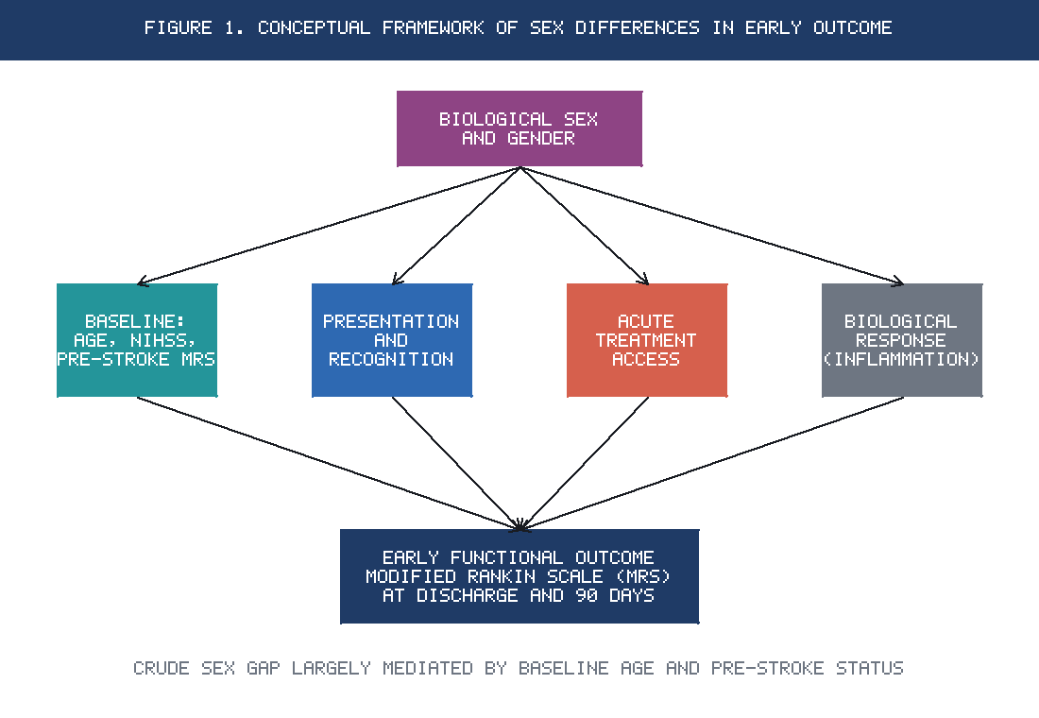
Figure 1. Conceptual framework linking biological sex and sociocultural gender to early functional outcome after acute stroke, showing the mediating roles of baseline characteristics, clinical presentation, acute treatment, and biological response.
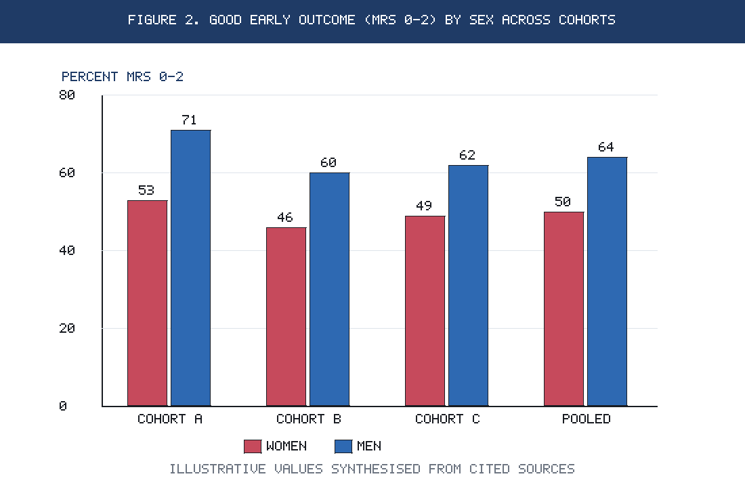
Figure 2. Proportion of patients achieving a good early functional outcome (modified Rankin Scale 0–2) at approximately 90 days, women versus men, across representative contemporary cohorts (illustrative values synthesised from cited sources).
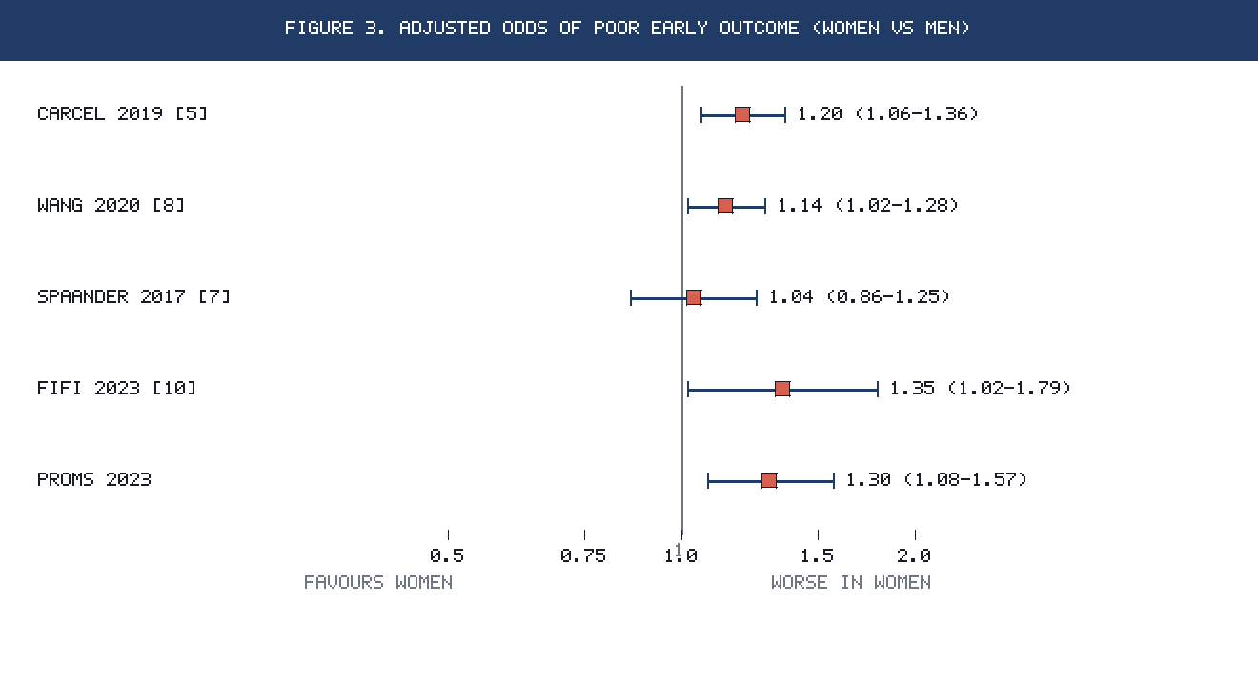
Figure 3. Adjusted effect estimates (odds ratios with 95% confidence intervals) for poor early functional outcome or unfavourable mRS shift in women relative to men, from key 2016–2026 studies. Estimates to the right of unity indicate worse outcome in women.
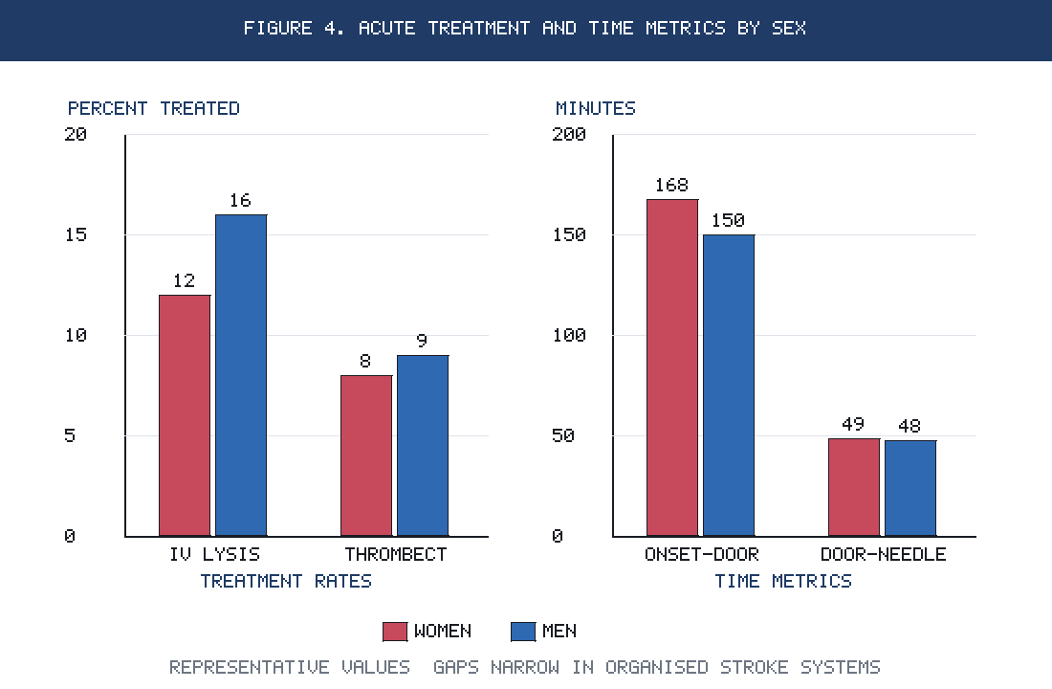
Figure 4. Representative acute treatment and time metrics by sex, illustrating reperfusion-therapy rates and workflow intervals that can contribute to, or be equalised across, the sex gap in outcome.
References
1. GBD 2021 Stroke Collaborators. Global, regional, and national burden of stroke and its risk factors, 1990–2021: a systematic analysis for the Global Burden of Disease Study 2021. Lancet Neurol. 2024;23(10):973–1003.
2. Feigin VL, Brainin M, Norrving B, et al. Global Stroke Fact Sheet 2025. Int J Stroke. 2025;20(2):132–144. PMID: 39635884.
3. Rexrode KM, Madsen TE, Yu AYX, Carcel C, Lichtman JH, Miller EC. The impact of sex and gender on stroke. Circ Res. 2022;130(4):512–528.
4. Shajahan S, Sun L, Harris K, et al. Sex differences in the symptom presentation of stroke: a systematic review and meta-analysis. Int J Stroke. 2023;18(2):144–153. PMID: 35411828.
5. Carcel C, Wang X, Sandset EC, et al. Sex differences in treatment and outcome after stroke: pooled analysis including 19,000 participants. Neurology. 2019;93(24):e2170–e2180. PMID: 31719135.
6. Strong B, Lisabeth LD, Reeves M. Sex differences in IV thrombolysis treatment for acute ischemic stroke: a systematic review and meta-analysis. Neurology. 2020;95(1):e11–e22. PMID: 32522796.
7. Spaander FH, Zinkstok SM, Baharoglu MI, et al. Sex differences and functional outcome after intravenous thrombolysis. Stroke. 2017;48(3):699–703. PMID: 28143921.
8. Wang X, Carcel C, Wang R, et al. Worse prognosis in women, compared with men, after thrombolysis: an individual patient data pooling study of Asian acute stroke registries. Int J Stroke. 2020. PMID: 32638639.
9. Wueger P, Noseda R, Pagnamenta A, et al. Sex differences in functional outcomes of intravenous thrombolysis among patients with lacunar stroke. Front Neurol. 2024;15:1341423. PMID: 38445264.
10. Fifi JT, Nguyen TN, Song S, et al. Sex differences in endovascular thrombectomy outcomes in large vessel occlusion: a propensity-matched analysis from the SELECT study. J Neurointerv Surg. 2023;15(2):105–110. PMID: 35232756.
11. Tsai JP, Nguyen TN, Pujara DK, et al. Sex-based differences in endovascular thrombectomy outcomes for large ischemic stroke: a SELECT2 subanalysis. Stroke. 2025. PMID: 39744837.
12. Yu AYX, Austin PC, Rytande M, et al. Sex differences in intensity of care and outcomes after acute ischemic stroke across the age continuum. Neurology. 2022. PMID: 36180239.
13. Carcel C, Sandset EC, Ali M, et al. Addressing sex and gender differences in stroke risk and management: a scientific statement from the World Stroke Organization. Int J Stroke. 2025. PMID: 41131690.
14. Yun SM, Shin S, Chang WH, et al. Gender differences in mortality and long-term functional outcomes after first-ever ischemic stroke: a prospective cohort study. 2023. PMID: 36786321.
15. Sex differences in outcomes over the first year after ischemic stroke: a population-based longitudinal study. Neurology. 2026;106(2):e214508. PMID: 41406400.
16. Sex differences in the inflammatory response to stroke. Semin Immunopathol. 2022;44(3):427–441. PMID: 36355204.

