Machine Learning for Consumer Preference Prediction
Book: Artificial Intelligence-Based Solutions for Personalized Foods

Abstract
The food industry is undergoing a transformative shift driven by artificial intelligence and machine learning technologies that enable unprecedented levels of consumer personalization. This chapter provides a comprehensive examination of machine learning approaches for predicting consumer food preferences, encompassing the full pipeline from heterogeneous data collection through advanced modeling to actionable personalized recommendations. We explore how supervised, unsupervised, and deep learning methods can extract meaningful patterns from diverse data sources including sensory evaluations, purchase histories, nutritional databases, social media, and wearable device streams. The chapter details predictive modeling techniques for taste and sensory preferences, recommender systems architectures tailored for food applications, and multimodal deep learning frameworks that integrate textual, visual, and behavioral information. Furthermore, we examine the integration of nutritional requirements with taste preferences for personalized dietary planning, machine learning-assisted food formulation, and adaptive context-aware recommendation systems. Critical evaluation metrics, explainability considerations, privacy concerns, and industrial applications are discussed alongside emerging trends including generative AI, federated learning, and digital twin technologies. This chapter establishes a foundation for understanding how machine learning transforms heterogeneous consumer data into actionable predictions that enable intelligent food recommendation, personalized nutrition, and data-driven food product development within AI-enabled food systems.
Keywords: Machine learning, consumer preference prediction, personalized nutrition, food recommendation systems, deep learning, sensory analysis, food personalization, artificial intelligence

1. Foundations of Consumer Preference Prediction

1.1 Consumer Preferences and Personalization in Food Systems
Consumer food preferences represent a complex, multidimensional construct shaped by the interplay of biological, psychological, cultural, economic, and environmental factors [1]. Understanding these preferences has become increasingly critical as the food industry transitions from mass production toward individualized product offerings and personalized nutrition solutions [2]. The concept of food preference encompasses not merely taste acceptance but extends to broader dimensions including sensory attributes (flavor, texture, aroma, appearance), nutritional considerations, convenience factors, ethical concerns (sustainability, animal welfare), cultural appropriateness, and emotional associations [3]. In the contemporary food landscape, consumer expectations have evolved significantly, with individuals increasingly seeking products that align with their personal values, health goals, and lifestyle requirements.
The personalization paradigm in modern food systems recognizes that individual consumers possess unique combinations of preferences, dietary requirements, health goals, and contextual needs that cannot be adequately served by one-size-fits-all product strategies [4]. This recognition has catalyzed substantial investment in technologies capable of capturing, modeling, and predicting individual-level food preferences at scale. Machine learning has emerged as the enabling technology for this transformation, offering computational approaches capable of identifying complex nonlinear patterns within high-dimensional consumer data that would be impossible to discern through traditional statistical methods [5]. The convergence of big data availability, computational power advances, and algorithmic innovation has created an unprecedented opportunity to translate theoretical understanding of food preference into practical predictive systems.
The dimensionality of consumer food preferences can be conceptualized across multiple interacting levels that collectively determine food choice behavior. At the physiological level, genetic variations in taste receptors (such as TAS2R38 for bitter sensitivity and OR genes for olfactory perception) create baseline differences in sensory perception that fundamentally shape food preferences from early life [6]. These genetic predispositions interact with developmental exposures, creating individual sensory worlds that make identical foods taste fundamentally different to different people. Demographic factors including age, gender, income, education level, and household composition systematically influence food choices through mechanisms of access, exposure, knowledge, and learned associations. Cultural and geographic context shapes flavor preferences through early life exposure, social learning, and identity formation, with well-documented differences in spice tolerance, fermented food acceptance, sweetness preferences, and texture expectations across populations and ethnic groups [7].
Nutritional awareness, health conditions (diabetes, cardiovascular disease, food allergies, celiac disease), and personal health goals (weight management, athletic performance, longevity optimization) impose constraints and priorities on food selection that interact with hedonic preferences in complex ways [8]. Furthermore, situational and contextual factors including time pressure, social context, emotional state, physical environment, and sensory cues modulate preferences dynamically, creating substantial within-person variability that static preference models fail to capture. The interplay between these factors creates a preference landscape of extraordinary complexity that motivates the application of sophisticated machine learning approaches.
The framework for understanding how machine learning can address consumer preference prediction in food systems is illustrated in Figure 1, which presents the conceptual pipeline from diverse data sources through computational processing to personalized outputs. This framework emphasizes the iterative nature of preference prediction, where model outputs inform product development and recommendation strategies that generate new consumer interaction data, creating a continuous improvement cycle.

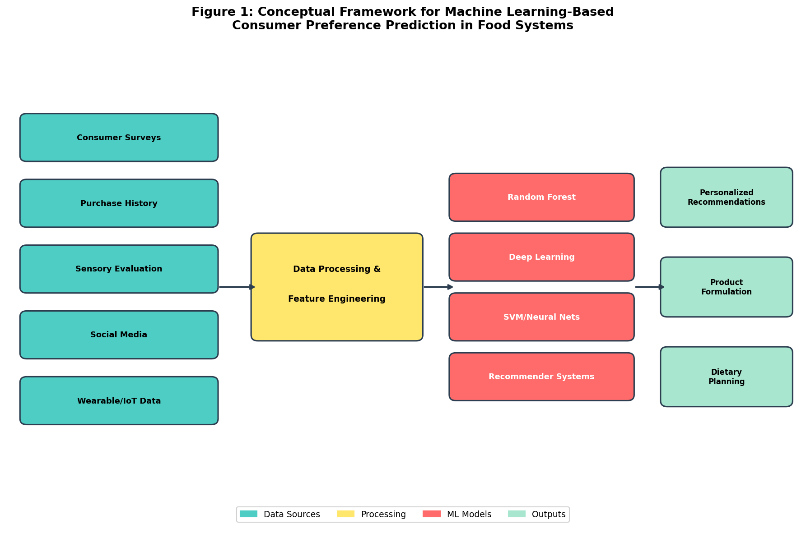
Figure 1: Conceptual Framework for Machine Learning-Based Consumer Preference Prediction in Food Systems

1.2 Data Sources for Consumer Preference Modeling
The effectiveness of machine learning models for consumer preference prediction is fundamentally dependent upon the quality, diversity, and representativeness of available training data [9]. Modern food preference modeling draws upon an increasingly rich ecosystem of data sources, each contributing complementary information about consumer behavior and preferences. The integration of multiple data streams enables more comprehensive preference characterization than any single source can provide, while also introducing challenges of data heterogeneity, temporal misalignment, and quality variation.
Consumer surveys and structured questionnaires remain foundational data sources, providing explicit preference ratings, demographic information, and attitudinal measures through validated instruments [10]. These instruments typically employ hedonic scales (9-point, labeled affective magnitude), just-about-right scales, or choice-based conjoint methodologies to quantify preferences across product attributes. Surveys offer controlled measurement environments, established psychometric properties, and detailed attribute-level preference information. However, they are susceptible to social desirability bias, hypothetical bias, cognitive load effects, and limited ecological validity when conducted in artificial laboratory settings rather than naturalistic consumption contexts.
Purchase history data from loyalty programs, e-commerce platforms, point-of-sale systems, and subscription services provide revealed preference information that reflects actual consumer behavior rather than stated intentions [11]. These transactional datasets offer temporal granularity enabling analysis of preference evolution, seasonal patterns, response to promotional stimuli, and brand switching behavior. The scale of available transaction data—often millions of observations per retailer—supports discovery of subtle preference patterns invisible in smaller survey datasets. However, purchase data conflates preference with availability, price sensitivity, habitual behavior, and household-level decisions that may not reflect individual preferences.
Sensory evaluation data generated through trained panels and consumer acceptance testing provides detailed characterization of product attributes and their relationship to consumer liking [12]. Temporal dominance of sensations, check-all-that-apply (CATA) methodologies, free-choice profiling, and rate-all-that-apply approaches generate rich sensory descriptors that can be linked to preference patterns. The integration of instrumental measurements (electronic nose, electronic tongue, texture analyzers, near-infrared spectroscopy) with sensory panel data enables development of predictive models that relate physical product properties to consumer perception [13]. This bridge between objective product characteristics and subjective consumer experience is essential for machine learning-driven product optimization.
Social media data, food blogs, recipe platforms, restaurant review sites, and food photography platforms constitute an enormous and continuously growing corpus of unstructured preference information [14]. Natural language processing techniques can extract sentiment polarity, flavor preferences, dietary patterns, cuisine exploration behavior, and emerging food trends from these sources. Platforms such as Instagram, Pinterest, Twitter, TikTok, and food-specific applications like Yelp and TripAdvisor generate both textual and visual data amenable to multimodal analysis, providing insights into how consumers discover, evaluate, and share food experiences.
Emerging data sources include wearable devices and IoT-enabled systems that capture physiological responses (heart rate variability, galvanic skin response, facial expressions), eating behavior (bite count, eating speed, mastication patterns), and contextual information (GPS location, ambient temperature, activity level, time of day) [15]. Mobile applications enable ecological momentary assessment, capturing preferences in naturalistic eating contexts rather than artificial laboratory settings. Smart kitchen appliances, connected refrigerators, and automated food tracking systems generate continuous streams of consumption data without requiring active user input.
Table 1 provides a comprehensive summary of data sources for consumer preference modeling, categorizing them by type, information content, advantages, and limitations.

Table 1: Data Sources for Machine Learning-Based Consumer Food Preference Modeling
Data Source | Information Type | Key Advantages | Primary Limitations
Consumer Surveys | Explicit preferences, demographics, attitudes | Controlled measurement, detailed attribute ratings | Social desirability bias, limited scalability
Purchase History | Revealed preferences, temporal patterns | Behavioral validity, large-scale availability | Conflates preference with availability/price
Sensory Evaluation | Detailed sensory profiles, acceptance scores | Scientific rigor, attribute-level detail | Expensive, small sample sizes, lab setting
Social Media/Reviews | Unstructured opinions, trends, visual data | Large volume, naturalistic, real-time | Noisy, biased representation, privacy concerns
Wearable/IoT Devices | Physiological responses, eating behavior | Objective measurement, contextual richness | Adoption barriers, data quality issues
Mobile Applications | Food logging, ratings, contextual data | Ecological validity, longitudinal tracking | Self-reporting burden, selection bias

1.3 Machine Learning Fundamentals for Preference Prediction
Machine learning encompasses a diverse family of computational approaches that learn patterns from data without explicit programming, enabling prediction, classification, and knowledge discovery across complex domains [16]. For consumer preference prediction, these approaches span the spectrum from interpretable linear models to highly flexible deep neural architectures, each offering distinct advantages depending on data characteristics, prediction goals, interpretability requirements, and computational constraints. The selection of appropriate machine learning methodology requires careful consideration of the specific prediction task, available data volume and quality, real-time performance requirements, and the need for model interpretability in consumer-facing applications.
Supervised learning approaches dominate preference prediction applications, leveraging labeled datasets where consumer preferences (ratings, choices, acceptance/rejection decisions) serve as target variables [17]. Classification models predict discrete preference categories (like/dislike, purchase/no-purchase, acceptable/unacceptable), while regression models estimate continuous preference scores on hedonic or intensity scales. Decision trees and ensemble methods (random forests, gradient boosting machines, XGBoost, LightGBM) offer non-linear modeling with inherent feature importance rankings, making them particularly valuable for identifying which product attributes and consumer characteristics drive preference. Support vector machines provide robust classification in high-dimensional feature spaces with strong theoretical guarantees, while k-nearest neighbor approaches leverage the intuitive principle that similar consumers exhibit similar preferences [18]. Logistic regression and elastic net models provide interpretable baselines with regularization for high-dimensional feature spaces.
Unsupervised learning methods serve complementary roles in preference modeling, primarily through consumer segmentation, dimensionality reduction, and pattern discovery [19]. Clustering algorithms (k-means, hierarchical agglomerative clustering, DBSCAN, Gaussian mixture models) identify natural groupings of consumers with similar preference profiles, enabling targeted product development, market segmentation, and personalized marketing strategies. Principal component analysis, factor analysis, and t-SNE reduce the dimensionality of sensory and preference data, revealing latent preference dimensions that may correspond to fundamental taste orientations or lifestyle segments. Association rule mining (Apriori, FP-growth) discovers co-occurrence patterns in food choices, informing cross-selling strategies, menu design, and meal combination recommendations.
Reinforcement learning represents an emerging paradigm for preference prediction, particularly in dynamic recommendation settings where systems must balance exploration (discovering new preferences through novel suggestions) with exploitation (leveraging known preferences for immediate satisfaction) [20]. Multi-armed bandit formulations enable efficient personalization under uncertainty, sequentially allocating recommendations to maximize cumulative user satisfaction. Contextual bandits incorporate situational factors into recommendation decisions, while full reinforcement learning frameworks model sequential food consumption as Markov decision processes where current choices affect future preferences through satiation, variety-seeking, and habit formation mechanisms.
The taxonomy of machine learning approaches applicable to consumer food preference prediction is comprehensively illustrated in Figure 2, which categorizes methods by learning paradigm and specific technique, providing a structured overview of the methodological landscape available to researchers and practitioners.
Feature engineering constitutes a critical preprocessing step that often determines model performance more substantially than algorithm selection [21]. For food preference data, this involves encoding categorical variables (food categories, preparation methods, ingredient lists), normalizing and scaling sensory scores, extracting temporal features from consumption patterns (recency, frequency, periodicity), computing similarity metrics between food items using nutritional profiles or ingredient overlap, generating interaction features between consumer attributes and product characteristics, and creating aggregate behavioral features (variety-seeking tendency, health orientation score, novelty preference). Domain knowledge from food science and sensory evaluation informs effective feature construction.
Model validation strategies must address the temporal, contextual, and individual-specific nature of food preferences [22]. Standard k-fold cross-validation may be inadequate when preferences exhibit temporal drift, seasonal dependence, or contextual specificity. Time-series splitting preserves temporal ordering and prevents information leakage from future to past, leave-one-user-out validation assesses generalization to entirely new consumers, and within-subject cross-validation evaluates individual-level prediction accuracy. Additionally, cold-start scenarios where new users or new products lack historical data require specialized evaluation protocols including content-based fallback strategies, popularity-based initialization, and demographic-based preference imputation.

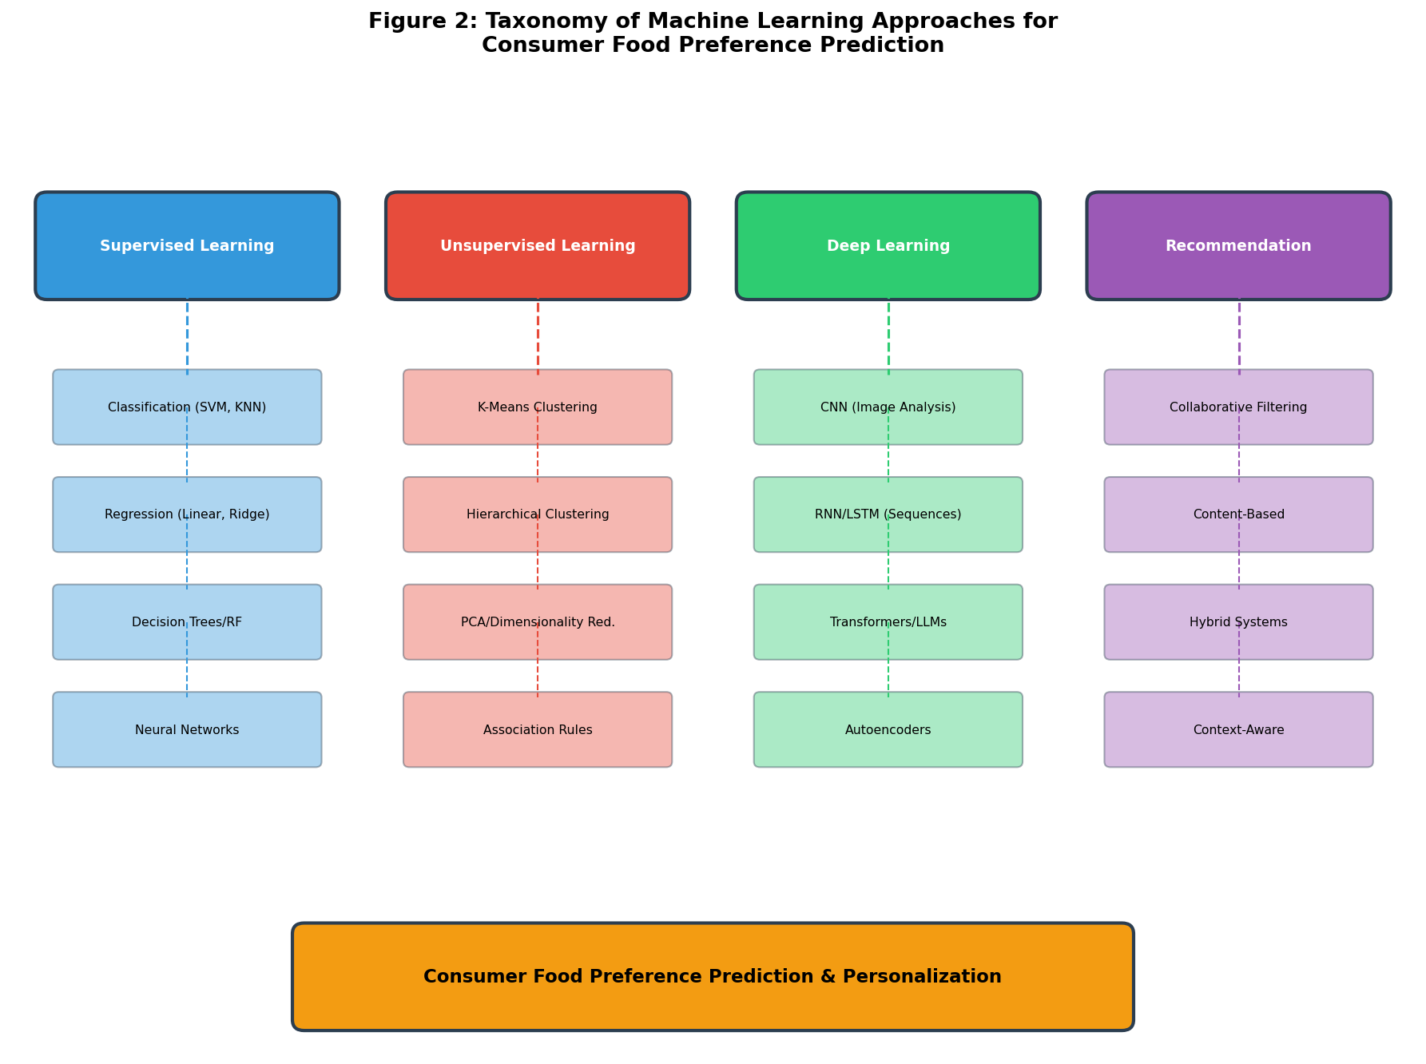
Figure 2: Taxonomy of Machine Learning Approaches for Consumer Food Preference Prediction

2. Machine Learning Models for Personalized Food Preferences

2.1 Predictive Modeling of Taste and Sensory Preferences
Predicting individual taste and sensory preferences represents one of the most challenging applications of machine learning in food science, requiring models to capture the subjective, context-dependent, and temporally varying nature of sensory experience [23]. The prediction targets encompass basic taste modalities (sweet, sour, salty, bitter, umami), complex flavor perceptions arising from taste-aroma interactions, textural preferences spanning multiple dimensions (hardness, crunchiness, smoothness, viscosity), aroma appreciation and identification, and visual appearance acceptance including color, shape, and portion presentation. Each of these modalities is governed by distinct biological, psychological, and cultural mechanisms that introduce unique modeling challenges.
Decision trees and random forest models have demonstrated particular utility for sensory preference prediction due to their ability to capture nonlinear relationships while maintaining interpretability through feature importance rankings and decision path visualization [24]. Random forests generate ensembles of decorrelated decision trees through bagging and random feature subspace selection, providing robust predictions that resist overfitting while naturally ranking feature importance through mean decrease in impurity or permutation importance metrics. In food preference applications, random forests have successfully predicted consumer acceptance of novel food products from sensory panel descriptors, achieving classification accuracies of 75-85% for binary acceptance prediction. The feature importance outputs directly reveal which sensory attributes most strongly drive consumer preference, providing actionable insights for product optimization strategies without requiring post-hoc explanation methods.
Support vector machines (SVMs) excel in high-dimensional sensory spaces where the number of descriptors may approach or exceed the number of training samples, a common situation in food science where detailed sensory profiling generates many attributes from relatively expensive consumer studies [25]. By constructing optimal separating hyperplanes in kernel-transformed feature spaces, SVMs achieve robust classification with strong generalization guarantees even with limited training data. Kernel functions including radial basis function (RBF), polynomial, and sigmoid kernels enable nonlinear decision boundaries appropriate for the complex interactions between sensory attributes and preference outcomes. SVMs have been successfully applied to predict consumer acceptance of wines from chemical composition, cheese quality from spectroscopic data, and beverage preference from sensory panel scores.
Neural networks and deep learning architectures offer superior capacity for modeling complex nonlinear sensory-preference relationships, particularly when large datasets are available for training [26]. Multilayer perceptrons with appropriate regularization (dropout, weight decay, batch normalization) can approximate arbitrary input-output mappings, capturing subtle interactions between taste components, texture parameters, and aroma compounds that influence overall preference in ways that simpler models cannot represent. Convolutional neural networks (CNNs) applied to spectroscopic, chromatographic, or hyperspectral imaging data enable direct prediction of sensory properties and consumer acceptance from instrumental measurements, bypassing traditional feature extraction pipelines and potentially discovering novel predictive patterns.
Table 2 presents a comparative analysis of machine learning models applied to sensory preference prediction, summarizing representative applications, performance metrics, and key findings across different food product categories.

Table 2: Comparative Performance of Machine Learning Models for Sensory Preference Prediction
ML Model | Food Domain | Prediction Target | Performance Metric | Key Advantage
Random Forest | Dairy Products | Consumer acceptance | Accuracy: 82% | Feature importance ranking
SVM (RBF Kernel) | Wine/Beverages | Quality rating prediction | Accuracy: 79% | High-dimensional robustness
Gradient Boosting | Snack Foods | Purchase intent | AUC: 0.87 | Handles mixed data types
Deep Neural Network | Bakery Products | Hedonic score (1-9) | RMSE: 0.65 | Complex nonlinear interactions
CNN (Image-based) | Fruits/Vegetables | Freshness preference | Accuracy: 91% | Visual feature extraction
LSTM Network | Meal Sequences | Next meal preference | MRR: 0.72 | Temporal pattern capture

The integration of population-level and individual-level modeling represents an important methodological consideration in sensory preference prediction [27]. Hierarchical or mixed-effects models capture both common preference patterns shared across the consumer population and individual deviations from these group-level patterns, enabling personalized prediction even with limited individual-level data through partial pooling of information. Transfer learning approaches pre-train models on large population datasets capturing general sensory-preference relationships before fine-tuning on individual consumption histories, addressing the cold-start problem inherent in personalized prediction. Meta-learning frameworks learn to learn preference patterns quickly from few examples, enabling rapid personalization for new consumers.
Temporal dynamics of sensory preferences introduce additional modeling challenges that static cross-sectional approaches cannot address [28]. Preferences for specific tastes and textures evolve with repeated exposure (mere exposure effect), satiation and variety-seeking behavior cycles, aging-related sensory changes, shifting health awareness, and life stage transitions. Sequential models including recurrent neural networks, temporal convolutional networks, and transformer architectures can capture these dynamics, enabling prediction of future preference trajectories rather than static snapshots. State-space models explicitly represent latent preference states that evolve over time according to learned transition dynamics.

2.2 Recommender Systems for Personalized Foods
Recommender systems constitute a specialized class of machine learning applications designed to predict user preferences for items and generate personalized suggestions, with food recommendation representing a particularly complex domain due to the multidimensional nature of food choices and the critical importance of nutritional adequacy [29]. Unlike entertainment recommendation where suboptimal suggestions carry minimal consequences, food recommendations must balance palatability with health implications, dietary constraints, cultural appropriateness, and practical feasibility. A poorly chosen movie wastes time; a poorly chosen food recommendation may compromise health, trigger allergies, or violate deeply held cultural or religious values.
Collaborative filtering approaches leverage the collective preferences of similar users to generate recommendations, operating on the assumption that consumers who agreed in past food choices will continue to share preferences for unobserved items [30]. User-based collaborative filtering identifies neighborhood consumers with similar preference profiles using cosine similarity, Pearson correlation, or learned similarity metrics, then recommends items highly rated by these neighbors but not yet experienced by the target user. Item-based collaborative filtering identifies relationships between food items based on co-consumption patterns and preference correlations across the user population, recommending items similar to those previously enjoyed. Matrix factorization techniques including singular value decomposition (SVD), non-negative matrix factorization (NMF), and alternating least squares decompose the sparse user-item preference matrix into low-rank latent factor representations [31]. These latent factors capture hidden dimensions of food preference such as healthiness orientation, adventurousness, spice tolerance, and cuisine affinity, enabling compact representation of complex preference patterns.
Content-based recommendation systems analyze food item attributes (nutritional composition, macronutrient ratios, ingredient lists, allergen profiles, preparation method, cuisine type, sensory profile descriptors) and match these to consumer preference profiles learned from historical interactions [32]. These systems construct user profiles as weighted aggregations of liked item features, then score candidate items by their similarity to these profiles. Content-based approaches avoid the cold-start problem for new items by leveraging item features directly, provide inherently interpretable recommendations based on explicit attribute matching, and do not require large user communities to function effectively. However, they may suffer from over-specialization, failing to recommend diverse or novel foods outside established preference patterns, and require comprehensive item feature engineering.
Hybrid recommender architectures combine collaborative and content-based signals to overcome the limitations of individual approaches, achieving superior performance through complementary information integration [33]. Weighted hybrid systems combine recommendation scores from multiple methods using learned or fixed weights, switching hybrids select the most appropriate method based on data availability and context, feature combination approaches integrate content features into collaborative factorization models, cascade systems use one method to generate candidates refined by another, and meta-level hybrids use the output representation of one method as input features for another. For food recommendation, hybrid systems can simultaneously leverage social consumption patterns (collaborative) and nutritional appropriateness (content-based), achieving both relevance and healthfulness.
Context-aware food recommendation represents a crucial advancement beyond traditional approaches, recognizing that food preferences are heavily modulated by situational factors including time of day, day of week, weather conditions, social setting, recent consumption history, physical activity level, and emotional state [34]. Contextual pre-filtering restricts the recommendation space based on current context (e.g., breakfast items in the morning), contextual post-filtering re-ranks recommendations for contextual appropriateness, and contextual modeling directly incorporates context features into the prediction function through tensor factorization or deep contextual networks. Nutrition-aware recommendation systems additionally constrain recommendations to satisfy dietary requirements, caloric targets, macronutrient balance, and micronutrient adequacy, formulating recommendation as a constrained optimization problem that balances preference prediction with nutritional constraints [35].
As illustrated in Figure 1, the conceptual framework demonstrates how diverse data sources feed into machine learning models that power these recommendation systems, producing personalized food suggestions that account for individual preferences, nutritional needs, and contextual factors simultaneously. The integration of collaborative, content-based, and contextual signals within unified architectures represents the current state-of-the-art for food recommendation systems.

2.3 Deep Learning and Advanced AI for Preference Prediction
Deep learning has revolutionized consumer preference prediction by enabling automatic feature extraction from raw, high-dimensional data and modeling complex nonlinear relationships that defeat traditional machine learning approaches [36]. The representational power of deep neural networks, combined with the availability of large-scale consumer interaction data and modern GPU computing infrastructure, has enabled breakthrough performance in food preference prediction, particularly for multimodal data integration scenarios where information from multiple sensory channels and data sources must be combined.
Convolutional neural networks applied to food images enable visual preference prediction, learning hierarchical representations of color patterns, texture features, compositional structure, and plating aesthetics that correlate with consumer appeal [37]. Pre-trained models (ResNet, VGG, EfficientNet, Vision Transformer) fine-tuned on food image datasets can predict attractiveness ratings, estimate perceived freshness and quality, identify cuisine style and preparation method, and even predict taste expectations from visual appearance alone. These capabilities enable automated assessment of food presentation quality in restaurant settings, optimization of visual appeal in product photography and packaging design, and personalized visual recommendation where items are ranked by predicted visual appeal for individual consumers.
Natural language processing architectures including recurrent neural networks, LSTM networks, and transformer-based models (BERT, GPT, RoBERTa) extract preference information from textual sources including product reviews, recipe descriptions, ingredient lists, and social media posts [38]. Sentiment analysis reveals overall acceptance and satisfaction levels, while aspect-based opinion mining identifies preferences for specific food attributes (taste intensity, texture quality, portion size, value for money, presentation). Topic modeling and latent semantic analysis discover emergent preference themes across consumer populations, and large language models can generate personalized recipe descriptions, product recommendations in natural language, and explanatory narratives for recommendation decisions.
The multimodal deep learning architecture for food preference prediction is depicted in Figure 3, illustrating how separate encoder networks process different data modalities (visual, textual, nutritional, behavioral) before fusion layers integrate these representations for unified preference prediction. This architecture enables the system to leverage complementary information from food images, textual descriptions, structured nutritional data, and behavioral interaction signals simultaneously, achieving prediction performance that exceeds any single-modality approach.
Attention mechanisms and transformer architectures have proven particularly effective for modeling sequential consumption patterns and capturing long-range dependencies in food choice behavior [39]. Self-attention enables the model to weigh the relevance of each historical food choice when predicting current preferences, naturally adapting to individual consumption rhythms, periodic patterns, and preference evolution trajectories. Multi-head attention captures multiple preference dimensions simultaneously (taste dimension, health dimension, convenience dimension), while cross-attention mechanisms align information across different data modalities, learning which visual features to attend to given textual context and vice versa.
Generative adversarial networks (GANs) and variational autoencoders (VAEs) offer capabilities for synthetic preference data generation, addressing data scarcity for niche consumer segments and novel food products that lack historical consumption data [40]. These generative models learn the distribution of consumer preferences conditioned on product attributes and can simulate realistic preference patterns for hypothetical products, enabling virtual product testing and market simulation before physical prototyping. Additionally, GANs can generate food images optimized for predicted consumer appeal, conditional on target demographic preferences, informing visual product design and marketing materials.

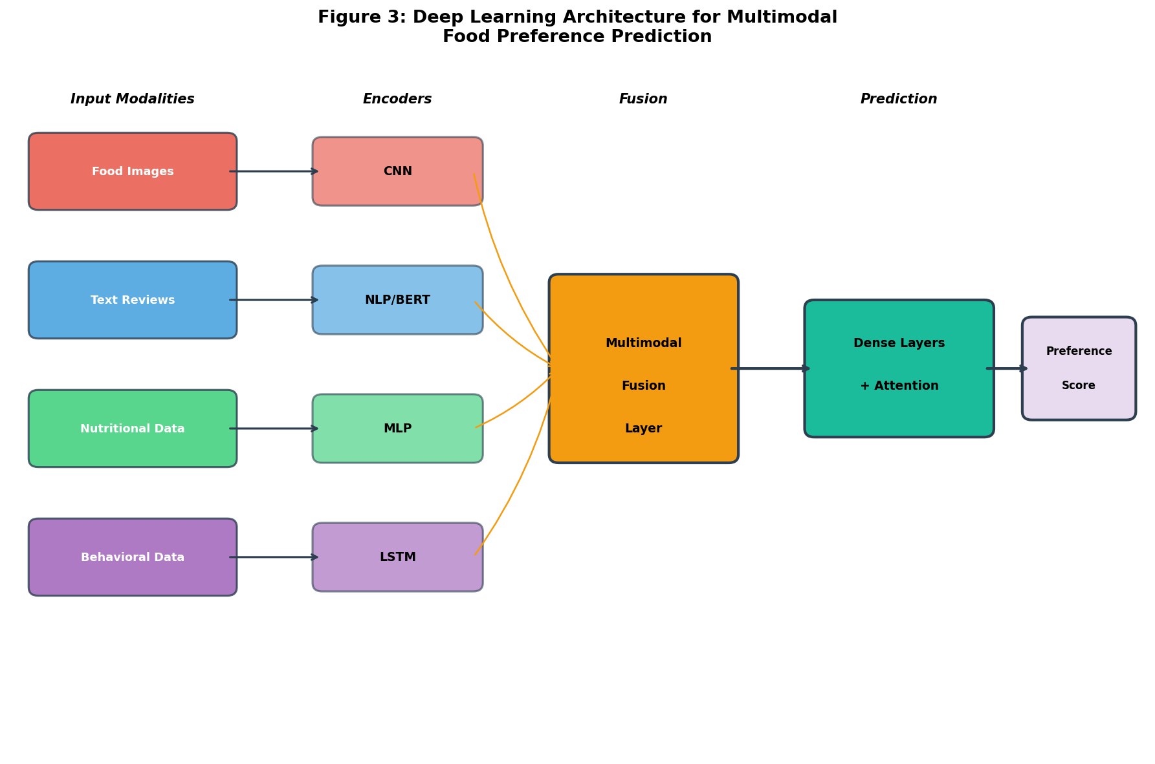
Figure 3: Deep Learning Architecture for Multimodal Food Preference Prediction

3. AI-Driven Personalization of Food Products and Diets

3.1 Integration of Nutritional, Health, and Preference Data
The convergence of nutritional science, health informatics, and machine learning enables a holistic approach to food personalization that simultaneously optimizes for taste preferences and nutritional adequacy [41]. This integration addresses a fundamental tension in dietary behavior: consumers typically prefer foods that are energy-dense, highly palatable, and convenient, which frequently conflicts with nutritional recommendations for health maintenance and disease prevention. Machine learning systems can navigate this trade-off by identifying individually optimal compromises between palatability and nutrition, finding the specific foods and formulations that each consumer will accept while maximizing nutritional benefit.
Combining nutritional requirements with taste preferences requires multi-objective optimization frameworks where machine learning models predict both acceptance probability and nutritional adequacy for candidate food items or meals [42]. Pareto-optimal solutions represent the frontier of maximum achievable nutrition at each level of predicted palatability, enabling personalized recommendations that push consumers toward healthier choices without exceeding their individual tolerance for palatability compromise. Constraint satisfaction approaches ensure minimum nutritional thresholds (established by dietary reference intakes) are met while maximizing predicted preference scores. Weighted-sum scalarization combines nutritional and preference objectives with individually calibrated weights reflecting each consumer's relative prioritization of health versus taste.
Personalized dietary recommendations and meal planning represent a particularly compelling application of integrated preference-nutrition modeling that moves beyond single-item recommendation to complete dietary pattern optimization [43]. Given individual nutritional targets (derived from age, sex, body composition, activity level, health conditions, and personal goals), taste preference profiles learned from interaction history, practical constraints (budget limitations, preparation time available, cooking skill level, ingredient accessibility), and dietary restrictions (diagnosed allergies, intolerances, religious exclusions, ethical choices), machine learning systems can generate optimized daily or weekly meal plans. These systems employ combinatorial optimization algorithms (genetic algorithms, simulated annealing, integer linear programming, constraint programming) guided by preference prediction models to construct meal sequences that satisfy nutritional constraints while maximizing predicted enjoyment and minimizing monotony.
Predicting acceptance of healthier and functional food alternatives represents a critical capability for supporting dietary improvement at both individual and population levels. When consumers must reduce sodium, sugar, or saturated fat intake, increase consumption of fruits, vegetables, whole grains, or functional ingredients, machine learning models can identify the specific alternative products, reformulations, or preparation modifications most likely to gain acceptance from each individual [1]. By leveraging historical preference patterns, sensory sensitivity profiles, personality traits (neophobia, variety-seeking tendency), and demographic characteristics, these models enable personalized nudging strategies that guide consumers toward healthier options through individually optimized paths of least resistance.
Table 3 summarizes key approaches to integrating nutritional and preference data in personalized food systems, highlighting the methodologies employed and their demonstrated outcomes across different application contexts.

Table 3: Approaches for Integrating Nutritional Requirements with Consumer Preferences
Integration Approach | Methodology | Application Context | Demonstrated Outcome
Multi-objective optimization | Pareto frontier of nutrition vs. preference | Meal planning for chronic disease | Improved nutrient intake with maintained satisfaction
Constraint satisfaction | Nutritional bounds with preference maximization | School/hospital meal design | 95% nutritional target achievement
Preference-weighted nutrition scoring | Combined palatability-nutrition ranking | Retail product recommendation | 23% increase in healthy product selection
Substitution modeling | ML-predicted acceptance of healthier alternatives | Sodium/sugar reduction programs | 18% reduction in target nutrients with <5% satisfaction loss
Personalized nudging | Context-aware healthier option presentation | Food delivery applications | 15% shift toward healthier ordering patterns

3.2 Personalized Food Formulation and Product Development
Machine learning-assisted food formulation represents a paradigm shift from traditional trial-and-error product development toward data-driven, predictive approaches that can dramatically accelerate innovation cycles while improving consumer acceptance of new products [2]. The formulation space for food products is combinatorially vast, encompassing ingredient selection from thousands of possible components, proportioning across continuous ranges, processing parameters (temperature, time, pressure, shear), and packaging decisions, making exhaustive experimental exploration of all possible combinations entirely impractical. Machine learning models trained on existing formulation-acceptance databases can predict consumer response to novel combinations, guiding experimental efforts toward regions of the formulation space most likely to achieve target sensory profiles and consumer acceptance.
Ingredient selection and optimization leverages machine learning to identify combinations that simultaneously achieve target sensory profiles, nutritional compositions, cost constraints, shelf-life requirements, and processing compatibility [3]. Random forests and gradient boosting models trained on historical formulation databases predict the sensory attributes, physical properties, and acceptance outcomes of candidate formulations, enabling virtual screening of thousands of possibilities before committing to physical prototyping. Bayesian optimization approaches efficiently navigate the formulation space by strategically selecting the most informative experiments based on surrogate model uncertainty, converging on optimal solutions with minimal experimental iterations. This approach has demonstrated 60-80% reduction in required experimental trials compared to traditional design-of-experiments approaches.
The optimization of flavor, texture, nutritional value, and consumer acceptance requires multi-objective models that explicitly capture trade-offs between competing objectives that cannot simultaneously be maximized [4]. Neural network models with multiple output heads can simultaneously predict sweetness intensity, textural attributes across multiple dimensions, nutritional composition metrics, processing yield, shelf life, and overall consumer liking from formulation inputs, enabling identification of Pareto-optimal formulations that represent the best achievable compromises. Evolutionary algorithms (NSGA-II, MOEA/D, SPEA2) coupled with surrogate preference models generate populations of candidate formulations spanning the trade-off surface, from which product developers select solutions aligned with strategic priorities and market positioning.
Predicting market acceptance of novel and reformulated food products extends beyond individual preference prediction to population-level adoption forecasting that accounts for market dynamics, competitive positioning, and distribution effects [5]. Machine learning models trained on historical product launch data, incorporating formulation characteristics, competitive landscape analysis, pricing strategy, marketing spend, distribution breadth, macroeconomic indicators, and social media buzz metrics, can estimate probability of commercial success before market launch. Natural language processing of social media conversations and early consumer reviews enables real-time monitoring and prediction updating following product introduction, supporting adaptive launch strategies and rapid reformulation decisions.
As previously shown in Figure 2, the taxonomy of machine learning approaches provides the methodological foundation for these formulation optimization applications, with ensemble methods proving particularly effective for structured formulation data and deep learning excelling when sensory and consumer data are abundant.

3.3 Adaptive and Context-Aware Food Recommendation
Adaptive food recommendation systems represent the cutting edge of personalized nutrition technology, continuously learning from consumer behavior and dynamically adjusting recommendations based on evolving preferences, changing contexts, and accumulated interaction history [6]. Unlike static models that provide fixed predictions based on initial preference assessment, adaptive systems recognize that food preferences are inherently dynamic, influenced by satiation cycles, variety-seeking motivation, seasonal variation, life events (pregnancy, illness, aging), health awareness changes, and gradual taste evolution through exposure and experience.
Personalization based on lifestyle, environment, time, and consumption context requires rich contextual modeling that captures the multifactorial nature of food choice situations [7]. Machine learning models incorporating temporal features (meal timing, day of week, season, holiday periods), environmental variables (weather conditions, ambient temperature, geographic location, indoor/outdoor setting), physiological state indicators (physical activity level, sleep quality, stress markers, menstrual cycle phase), and social context information (eating alone, family meal, work lunch, restaurant dining, social gathering) can significantly improve recommendation relevance compared to context-blind approaches. Factorization machines and deep factorization models naturally incorporate contextual dimensions alongside user and item features through interaction modeling [8], while attention-based architectures learn which contextual factors are most relevant for each specific recommendation decision.
Dynamic preference learning from continuous consumer feedback enables recommendation systems to track and adapt to evolving tastes without explicit preference re-elicitation surveys [9]. Online learning algorithms (stochastic gradient descent variants, follow-the-regularized-leader) update preference models incrementally as new interaction data arrives in real-time streams, while forgetting mechanisms (exponential decay, sliding windows, explicit change detection) downweight historical preferences that may no longer reflect current tastes. Exploration strategies (epsilon-greedy, Thompson sampling, upper confidence bounds, information-directed sampling) balance exploitation of known preferences for immediate user satisfaction with exploration of potentially rewarding novel recommendations that expand preference knowledge.
Real-time adaptation of food recommendations and meal plans requires efficient inference architectures capable of generating personalized suggestions with minimal latency for responsive user experiences [10]. Edge computing and model compression techniques (knowledge distillation, quantization, pruning) enable on-device preference inference for mobile applications, preserving privacy by keeping sensitive dietary data local while ensuring sub-second responsiveness. Streaming data architectures (Apache Kafka, Apache Flink) process continuous sensor and interaction data, updating preference representations in near-real-time without expensive batch retraining cycles. Incremental matrix factorization and online deep learning maintain up-to-date preference models as new data arrives continuously.
The complete adaptive personalization pipeline for AI-driven food recommendations is illustrated in Figure 4, demonstrating the cyclical process from consumer profiling through context-aware prediction to recommendation delivery and feedback incorporation. This pipeline emphasizes the continuous learning loop that distinguishes adaptive systems from static recommendation approaches.

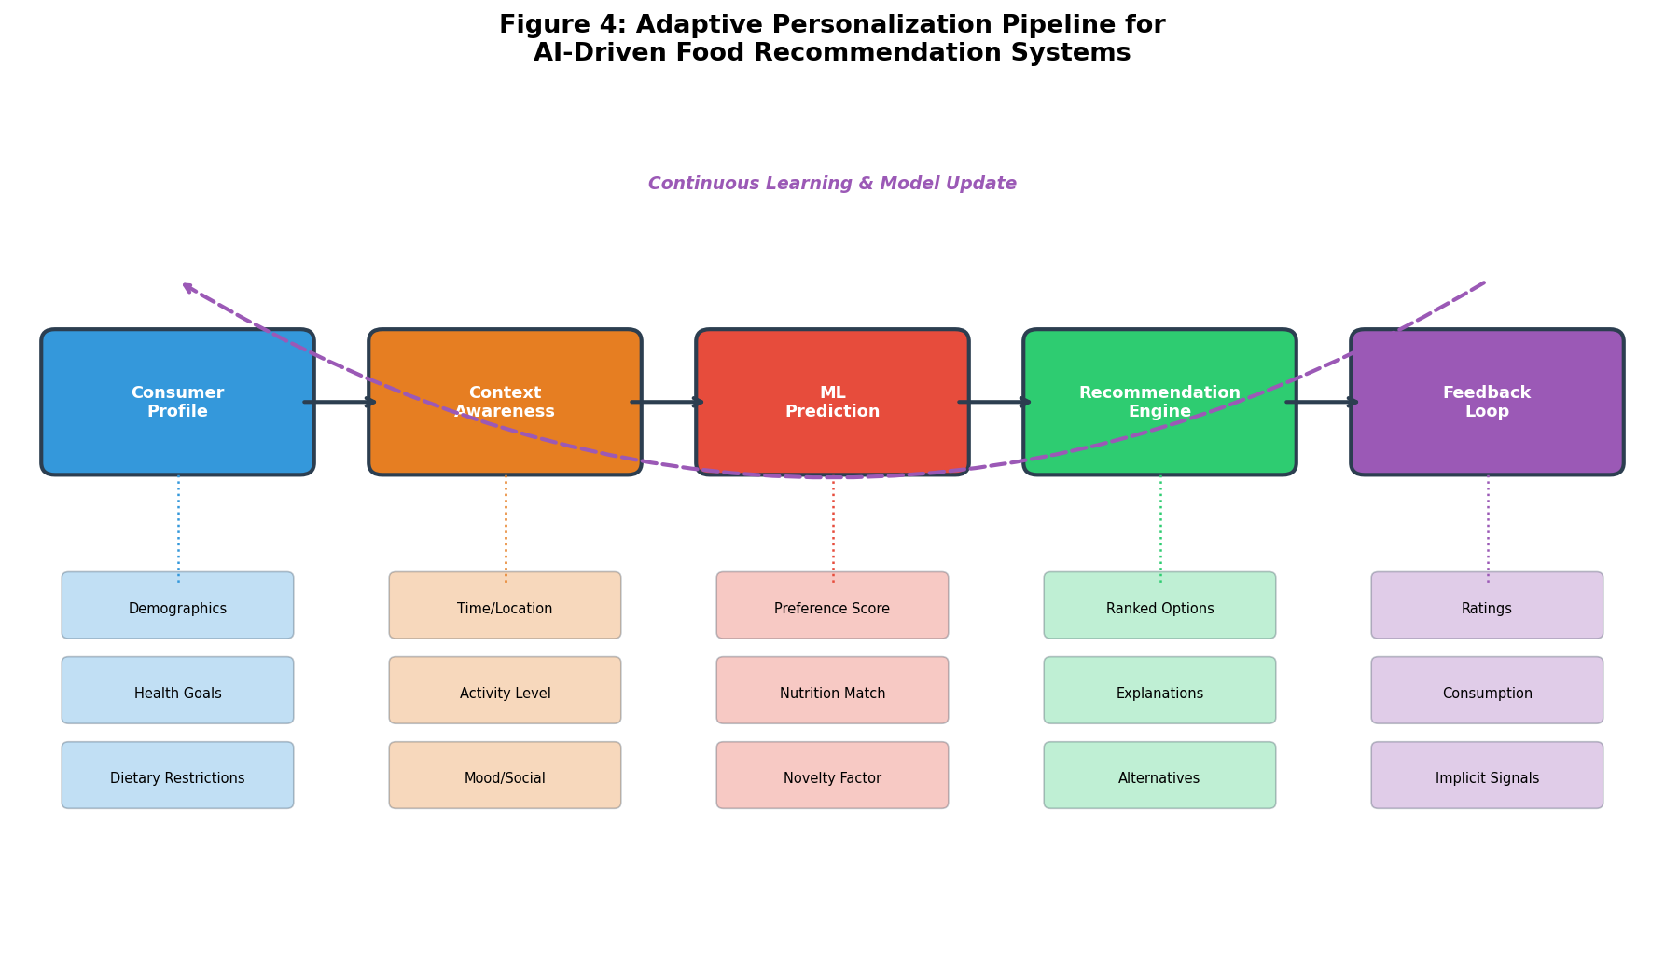
Figure 4: Adaptive Personalization Pipeline for AI-Driven Food Recommendation Systems

4. Evaluation, Challenges, Applications, and Future Perspectives

4.1 Model Evaluation, Explainability, and Consumer Trust
Rigorous evaluation of machine learning models for consumer preference prediction requires metrics aligned with the ultimate application goals, recognizing that statistical accuracy alone does not guarantee practical utility in personalized food systems [11]. The evaluation framework must address both technical model performance and downstream user experience, encompassing prediction accuracy, recommendation quality, diversity, fairness, explainability, and ultimately user satisfaction and behavioral change outcomes.
Classification metrics including accuracy, precision, recall, and F1-score evaluate models predicting discrete preference categories (accept/reject, purchase/no-purchase, like/dislike) [12]. For imbalanced preference distributions common in food applications where most rated products receive positive evaluations, precision-recall curves and area under the ROC curve (AUC-ROC) provide more informative assessments than raw accuracy. Area under the precision-recall curve (AUC-PR) is particularly appropriate for highly imbalanced scenarios. Regression metrics including root mean squared error (RMSE), mean absolute error (MAE), and coefficient of determination (R-squared) evaluate continuous preference score prediction against ground truth ratings.
Recommendation-specific metrics assess the quality of ranked suggestion lists generated by the system [13]. Precision@k and recall@k measure the proportion of relevant items in top-k recommendations, mean reciprocal rank (MRR) evaluates the position of the first relevant recommendation in the ranked list, and normalized discounted cumulative gain (NDCG) accounts for the graded relevance and position weighting of recommended items. Coverage metrics quantify the proportion of available items and users effectively served by the recommendation system, identifying potential blind spots. Diversity metrics (intra-list diversity, unexpectedness) assess the variety within recommendation lists, while novelty and serendipity metrics capture the system's ability to suggest unexpected yet appreciated items that expand consumer horizons, important for avoiding the filter bubble effect and recommendation monotony.
Explainable AI (XAI) for food preference prediction has emerged as a critical requirement for building consumer trust and enabling actionable insights for food professionals [14]. SHAP (SHapley Additive exPlanations) values derived from cooperative game theory quantify individual feature contributions to each prediction, enabling explanations such as "this food is recommended because of your documented preference for spicy flavors combined with its high protein content matching your fitness goals." LIME (Local Interpretable Model-agnostic Explanations) generates locally faithful interpretable approximations of complex model behavior in the neighborhood of specific predictions. Attention visualization in deep learning models highlights which input features, sequence elements, or image regions most influence predictions, providing intuitive visual explanations. Counterfactual explanations identify minimal changes to inputs that would alter the prediction, answering questions like "what would need to be different about this product for you to prefer it?"
Consumer privacy, data security, fairness, and ethical considerations represent foundational challenges for preference prediction systems that collect and process sensitive dietary, health, genetic, and behavioral information [15]. Data minimization principles dictate collecting only information strictly necessary for the prediction task. Purpose limitation ensures data is used only for stated personalization goals. Differential privacy techniques add mathematically calibrated noise to preference data, enabling useful aggregate analysis while providing formal guarantees protecting individual records from re-identification. Algorithmic fairness audits ensure that preference models do not perpetuate or amplify existing disparities in food access, nutrition quality, or recommendation diversity across demographic groups defined by race, gender, socioeconomic status, or geographic location.
Table 4 provides a comprehensive overview of evaluation metrics applicable to different aspects of machine learning-based food preference prediction systems, categorized by evaluation dimension and metric type.

Table 4: Evaluation Framework for Machine Learning Models in Food Preference Prediction
Evaluation Dimension | Key Metrics | Interpretation | Typical Thresholds
Classification Accuracy | Precision, Recall, F1, AUC-ROC | Correctness of discrete preference predictions | F1 > 0.75, AUC > 0.80
Regression Performance | RMSE, MAE, R-squared | Accuracy of continuous preference scores | RMSE < 1.0, R² > 0.60
Recommendation Quality | Precision@k, NDCG, MRR | Relevance and ranking of suggestions | P@10 > 0.30, NDCG > 0.50
Diversity & Coverage | Catalog coverage, ILD, entropy | Breadth and variety of recommendations | Coverage > 50%, ILD > 0.40
Explainability | SHAP consistency, explanation fidelity | Interpretability of model decisions | Fidelity > 0.85
Fairness | Demographic parity, equalized odds | Equity across consumer groups | Disparity ratio < 0.80

4.2 Applications and Industrial Implementation
The translation of machine learning-based preference prediction from academic research to industrial application has accelerated dramatically in recent years, with personalized food technologies now deployed across multiple sectors of the food value chain [16]. These implementations demonstrate the commercial viability and consumer value of ML-driven personalization while revealing practical challenges around data infrastructure requirements, computational scalability, real-time inference performance, integration with existing systems, and regulatory compliance across different jurisdictions.
Personalized nutrition platforms represent the most direct application of preference prediction technology, offering individualized dietary guidance that accounts for both health optimization and taste preferences to maximize long-term adherence [17]. Commercial platforms integrate genetic testing results, gut microbiome analysis, continuous glucose monitoring data, blood biomarker panels, and food preference questionnaires to generate personalized nutritional recommendations. Machine learning models predict individual metabolic responses to specific foods, estimate preference and acceptance probability for recommended items, and optimize meal suggestions for both nutritional benefit and adherence probability. Randomized controlled trials have demonstrated that ML-personalized diets achieve superior outcomes for glycemic control, weight management, cardiovascular risk reduction, and overall nutrient adequacy compared to generic population-level dietary guidelines.
Food retail and e-commerce applications leverage preference prediction for personalized product recommendations, targeted promotions, dynamic assortment optimization, and personalized search ranking [18]. Grocery retailers employ collaborative filtering and purchase pattern analysis to suggest products aligned with individual shopping habits, while adjusting recommendations based on seasonal patterns, local demographic trends, inventory levels, and promotional calendars. Online food delivery platforms (UberEats, DoorDash, Deliveroo) use deep learning models processing order history, restaurant preference patterns, cuisine exploration trajectories, time-of-day behavior, and weather conditions to rank restaurant and menu item suggestions for each user, achieving significant improvements in conversion rates and order frequency.
Restaurant and food service applications include personalized digital menu recommendations, dynamic menu pricing based on predicted demand elasticity, kitchen operations optimization through demand forecasting, and food waste reduction through accurate quantity prediction [19]. Digital menu boards and self-service ordering kiosks employ real-time preference inference to highlight items likely to appeal to individual customers based on order history, stated dietary preferences, and contextual signals. Back-of-house systems predict ingredient requirements, optimize production scheduling, and minimize preparation waste based on anticipated order patterns learned from historical demand data combined with contextual factors.
Applications in functional foods, nutraceuticals, and precision nutrition represent a rapidly growing frontier where preference prediction directly impacts health outcomes by maximizing compliance with beneficial dietary interventions [20]. Machine learning models predict individual acceptance of functional ingredients (probiotics, prebiotic fiber, omega-3 fortification, plant-based protein supplementation, vitamin/mineral fortification), enabling personalized product recommendations that maximize both consumption compliance and biological efficacy. The adaptive personalization pipeline shown in Figure 4 illustrates how these systems continuously refine their recommendations based on consumer feedback and health outcome monitoring, ensuring that functional food suggestions remain both nutritionally appropriate and personally acceptable over time as health status and preferences evolve.
Smart food applications utilizing mobile devices, wearables, and IoT-enabled kitchen systems enable continuous passive monitoring of food behavior and real-time preference inference without requiring active user engagement [21]. Computer vision systems identify consumed foods from smartphone photographs with increasing accuracy, natural language interfaces capture meal descriptions and preferences through conversational interaction, and physiological sensors detect satiation signals, stress levels, and activity states that modulate food preferences throughout the day. These multimodal data streams feed adaptive preference models that evolve with the consumer, providing increasingly accurate and contextually appropriate recommendations over time.
The integration of these industrial applications within the broader framework of machine learning for consumer preference prediction, as depicted in Figure 3, demonstrates the multimodal nature of deployed systems that simultaneously process visual, textual, nutritional, and behavioral data streams for comprehensive preference understanding and real-time personalized recommendation generation.

4.3 Emerging Trends and Future Research Directions
The field of machine learning for consumer food preference prediction continues to evolve rapidly, driven by advances in AI capabilities, expanding data availability from connected devices and digital platforms, and growing consumer demand for personalization that respects individual needs and values [22]. Several emerging trends promise to fundamentally reshape the landscape of personalized food systems within the coming decade, offering both unprecedented capabilities and novel challenges.
Generative AI and large language models (LLMs) represent perhaps the most transformative emerging technology for personalized food applications [23]. Foundation models such as GPT-4, Claude, Gemini, and domain-specific food language models trained on recipe corpora and nutritional databases can generate personalized recipe adaptations that modify dishes to match individual preferences while preserving culinary integrity, create individualized meal plan narratives that explain nutritional rationale in accessible language, provide conversational dietary coaching that adapts communication style and content to individual knowledge levels and motivation states, and synthesize complex nutritional information into personalized actionable recommendations. These models demonstrate remarkable zero-shot and few-shot learning capabilities, enabling meaningful personalization with minimal individual training data. Multimodal foundation models processing text, images, structured nutritional data, and user interaction logs simultaneously offer integrated preference understanding previously requiring multiple specialized systems and complex pipeline engineering.
Federated learning addresses the fundamental tension between data-hungry machine learning models that benefit from large, diverse training datasets and increasingly stringent privacy requirements for sensitive dietary, health, and behavioral information [24]. By training models across distributed datasets held by individual consumers on their devices, restaurants on their ordering systems, retailers on their loyalty platforms, and health providers in their clinical databases, without ever centralizing raw data, federated approaches enable collaborative model improvement while preserving data sovereignty. Federated recommendation systems can leverage the collective intelligence of distributed consumer interactions without exposing individual preference patterns, purchase histories, or health information to centralized servers, addressing both regulatory compliance requirements (GDPR, CCPA, HIPAA) and growing consumer privacy expectations.
Digital twin technologies create comprehensive computational replicas of individual consumers, integrating physiological models (metabolic simulation, gut microbiome dynamics), preference profiles (taste, texture, cuisine, novelty orientation), nutritional requirement calculations, behavioral pattern models (meal timing, eating speed, social eating behavior), and health trajectory projections into unified virtual representations [25]. These digital twins enable simulation of preference responses to hypothetical foods not yet consumed, prediction of long-term dietary adherence under different recommendation strategies, personalized optimization of nutrition interventions accounting for individual metabolic responses, and prospective evaluation of health outcomes from alternative dietary patterns. Coupled with continuous data streams from wearable devices and smart kitchen systems, digital twins evolve alongside the consumer, maintaining accurate representations of changing preferences, health status, and life circumstances.
Multimodal AI systems that seamlessly integrate diverse data modalities including genomic variation, metabolomic profiles, gut microbiome composition, behavioral patterns, environmental exposures, and sensory perception measurements represent the frontier of comprehensive preference understanding [26]. Graph neural networks model complex relationships between foods, nutrients, consumers, health outcomes, and contexts as interconnected knowledge graphs, enabling reasoning about preferences that accounts for mechanistic nutritional relationships alongside empirical consumption patterns. Knowledge-enhanced recommendation systems incorporate domain expertise from food science, nutrition, and medicine into data-driven models, improving prediction accuracy and ensuring nutritional safety.
Autonomous personalized food systems envisioning AI-driven supply chains that respond dynamically to individual consumer preferences represent an ambitious long-term vision for the food industry [27]. From precision agriculture optimizing crop varieties and growing conditions based on predicted consumer demand, through automated formulation systems generating personalized food products on demand, to autonomous delivery networks ensuring freshness and convenience, the complete personalization of the food supply chain from farm to fork becomes theoretically conceivable. While full realization remains decades distant, incremental progress toward this vision through automated food preparation systems, on-demand formulation technology, and AI-optimized supply chain management drives current research and development investment across the food technology landscape.
Reinforcement learning from human feedback (RLHF) applied to food recommendation systems enables alignment of AI recommendations with nuanced human values around food that are difficult to capture in explicit numerical preference labels or binary choice data [28]. By learning from comparative judgments (which of two meals would you prefer?), natural language feedback (the portion was too large and the sauce too sweet), and implicit behavioral signals (hesitation time, portion consumed, reorder frequency), RLHF-trained systems better capture subjective quality aspects of food recommendations including cultural sensitivity and authenticity, emotional appropriateness for different occasions, alignment with personal food philosophies (sustainability, local sourcing, minimal processing), and the balance between familiarity comfort and novelty excitement.
The responsible development of these emerging technologies requires sustained attention to ethical considerations including algorithmic transparency, meaningful informed consent and data rights, prevention of dietary discrimination against underserved populations, preservation of food culture and culinary diversity against homogenizing pressures of optimization algorithms, and environmental sustainability of personalized food systems [29]. As AI systems become increasingly influential in shaping individual food choices at scale, the research community bears responsibility for ensuring these technologies promote human flourishing, nutritional equity, cultural food heritage preservation, and sustainable food systems rather than merely optimizing commercial engagement metrics or narrowing dietary diversity in pursuit of predictive accuracy.

5. Conclusion
Machine learning for consumer preference prediction represents a transformative convergence of computational intelligence, food science, nutritional biology, and personalized medicine that promises to fundamentally reshape how food products are developed, marketed, recommended, and consumed across the global food system. This chapter has systematically examined the complete pipeline from heterogeneous data collection through advanced computational modeling to actionable personalized outputs, establishing both the current capabilities and future trajectory of this rapidly evolving interdisciplinary field.
The foundations of consumer preference prediction rest upon understanding the multidimensional nature of food preferences—spanning sensory, nutritional, cultural, psychological, economic, and contextual dimensions—and the increasingly diverse data sources that capture these dimensions with varying degrees of completeness, accuracy, and ecological validity [30]. Machine learning approaches spanning supervised classification and regression for explicit preference prediction, unsupervised clustering and dimensionality reduction for consumer segmentation and pattern discovery, deep learning architectures for automatic feature extraction and complex relationship modeling, and reinforcement learning for adaptive sequential recommendation provide an increasingly powerful and flexible toolkit for extracting predictive patterns from these complex, heterogeneous datasets.
Predictive modeling of sensory preferences, recommender systems architectures tailored to the unique requirements of food domains, and multimodal deep learning frameworks that integrate visual, textual, nutritional, and behavioral information demonstrate growing sophistication in addressing the unique challenges that distinguish food preference prediction from other recommendation domains [31]. The critical importance of nutritional adequacy, cultural appropriateness, allergen safety, and health consequences elevates food recommendation above entertainment or product recommendation in terms of both impact and responsibility. The integration of nutritional requirements with taste preferences through multi-objective optimization enables personalized dietary planning that optimizes both health outcomes and long-term adherence probability. Machine learning-assisted food formulation dramatically accelerates product development timelines while improving consumer acceptance, and adaptive context-aware systems provide dynamically appropriate recommendations that evolve with consumer needs, health status, and life circumstances.
Critical challenges remain in evaluation methodology that adequately captures real-world system utility beyond offline accuracy metrics, model explainability that builds genuine consumer trust and enables meaningful oversight, robust privacy protection for sensitive dietary and health data, and algorithmic fairness ensuring equitable access to high-quality personalization across all demographic groups [32]. Industrial applications spanning personalized nutrition platforms, food retail recommendation engines, restaurant ordering systems, functional food compliance optimization, and smart food applications validate the commercial viability of these approaches while revealing the substantial engineering and organizational challenges of deploying ML-driven personalization at scale in regulated food industries.
Emerging trends including generative AI with large language models enabling conversational food personalization, federated learning preserving privacy while enabling collaborative model improvement, digital twin technologies enabling prospective health outcome simulation, multimodal foundation models offering unified preference understanding, and autonomous food systems represent the frontier of what becomes possible [33]. The transition toward fully personalized food systems requires a balanced approach in which technological capability, nutritional science rigor, consumer trust, ethical governance frameworks, regulatory adaptation, and practical implementation considerations develop together in coordinated fashion.
A data-driven machine learning framework can provide the food industry with a structured mechanism for identifying unmet consumer needs, predicting individual preferences with sufficient accuracy for actionable recommendation, delivering personalized suggestions that balance multiple objectives, and continuously improving through feedback loops that capture the dynamic nature of food preferences [34]. The consumer should remain at the center of this transformation—as the ultimate beneficiary, the source of training data, and the arbiter of system value—so that AI becomes an enabler of dietary satisfaction, nutritional adequacy, food enjoyment, health optimization, cultural food heritage preservation, and environmentally sustainable consumption rather than simply another layer of technological automation optimizing for commercial metrics.
As the field continues to mature through the coming decade, interdisciplinary collaboration between machine learning researchers, food scientists, nutritionists, sensory scientists, behavioral psychologists, ethicists, policy experts, and most importantly the consumers themselves will be essential for realizing the full potential of AI-driven food personalization while safeguarding against potential harms including dietary homogenization, privacy violations, algorithmic discrimination, and erosion of food culture [34]. The vision of comprehensive, responsible, equitable, and widely accessible personalized food systems that leverage the full power of machine learning to serve individual health and satisfaction goals while promoting broader societal and environmental wellbeing represents both an inspiring research frontier and a profound responsibility for the scientific community.

References
[1] Köster, E.P. (2009). Diversity in the determinants of food choice: A psychological perspective. Food Quality and Preference, 20(2), 70-82.
[2] Bordoni, A., & Capozzi, F. (2014). Foodomics for healthy nutrition. Current Opinion in Clinical Nutrition & Metabolic Care, 17(5), 418-424.
[3] Prescott, J. (2012). Taste Matters: Why We Like the Foods We Do. Reaktion Books, London.
[4] Ordovas, J.M., Ferguson, L.R., Tai, E.S., & Mathers, J.C. (2018). Personalised nutrition and health. BMJ, 361, bmj.k2173.
[5] Mezgec, S., & Koroušić Seljak, B. (2017). NutriNet: A deep learning food and drink image recognition system for dietary assessment. Nutrients, 9(7), 657.
[6] Reed, D.R., & Knaapila, A. (2010). Genetics of taste and smell: Poisons and pleasures. Progress in Molecular Biology and Translational Science, 94, 213-240.
[7] Rozin, P., & Vollmecke, T.A. (1986). Food likes and dislikes. Annual Review of Nutrition, 6(1), 433-456.
[8] Sobal, J., & Bisogni, C.A. (2009). Constructing food choice decisions. Annals of Behavioral Medicine, 38(suppl_1), s37-s46.
[9] Min, W., Jiang, S., Liu, L., Rui, Y., & Jain, R. (2019). A survey on food computing. ACM Computing Surveys, 52(5), 1-36.
[10] Lawless, H.T., & Heymann, H. (2010). Sensory Evaluation of Food: Principles and Practices. Springer, New York.
[11] Trijp, H.C.V., & Steenkamp, J.B.E. (1992). Consumers' variety seeking tendency with respect to foods. European Review of Agricultural Economics, 19(2), 181-195.
[12] Stone, H., & Sidel, J.L. (2004). Sensory Evaluation Practices. Academic Press, San Diego.
[13] Taheri-Garavand, A., Fatahi, S., Omid, M., & Makino, Y. (2019). Advances in sensor-based food quality monitoring systems. Critical Reviews in Food Science and Nutrition, 59(22), 3631-3649.
[14] Abbar, S., Mejova, Y., & Weber, I. (2015). You tweet what you eat: Studying food consumption through Twitter. Proceedings of CHI 2015, 3197-3206.
[15] Vu, T., Lin, F., Alshurafa, N., & Xu, W. (2017). Wearable food intake monitoring technologies: A comprehensive review. Computers, 6(1), 4.
[16] Bishop, C.M. (2006). Pattern Recognition and Machine Learning. Springer, New York.
[17] Hastie, T., Tibshirani, R., & Friedman, J. (2009). The Elements of Statistical Learning. Springer, New York.
[18] Deng, L., & Yu, D. (2014). Deep learning: Methods and applications. Foundations and Trends in Signal Processing, 7(3-4), 197-387.
[19] Jain, A.K. (2010). Data clustering: 50 years beyond K-means. Pattern Recognition Letters, 31(8), 651-666.
[20] Sutton, R.S., & Barto, A.G. (2018). Reinforcement Learning: An Introduction. MIT Press, Cambridge.
[21] Zheng, A., & Casari, A. (2018). Feature Engineering for Machine Learning. O'Reilly Media, Sebastopol.
[22] Arlot, S., & Celisse, A. (2010). A survey of cross-validation procedures for model selection. Statistics Surveys, 4, 40-79.
[23] Tuorila, H., & Monteleone, E. (2009). Sensory food science in the changing society. Trends in Food Science & Technology, 20(2), 54-62.
[24] Breiman, L. (2001). Random forests. Machine Learning, 45(1), 5-32.
[25] Cortes, C., & Vapnik, V. (1995). Support-vector networks. Machine Learning, 20(3), 273-297.
[26] LeCun, Y., Bengio, Y., & Hinton, G. (2015). Deep learning. Nature, 521(7553), 436-444.
[27] Gelman, A., & Hill, J. (2006). Data Analysis Using Regression and Multilevel/Hierarchical Models. Cambridge University Press.
[28] Pliner, P. (1982). The effects of mere exposure on liking for edible substances. Appetite, 3(3), 283-290.
[29] Ricci, F., Rokach, L., & Shapira, B. (2015). Recommender Systems Handbook. Springer, Boston.
[30] Koren, Y., Bell, R., & Volinsky, C. (2009). Matrix factorization techniques for recommender systems. Computer, 42(8), 30-37.
[31] Rendle, S. (2010). Factorization machines. Proceedings of IEEE ICDM 2010, 995-1000.
[32] Lops, P., De Gemmis, M., & Semeraro, G. (2011). Content-based recommender systems. In Recommender Systems Handbook, 73-105.
[33] Burke, R. (2002). Hybrid recommender systems: Survey and experiments. User Modeling and User-Adapted Interaction, 12(4), 331-370.
[34] Adomavicius, G., & Tuzhilin, A. (2011). Context-aware recommender systems. In Recommender Systems Handbook, 217-253.
[35] Ge, M., Ricci, F., & Massimo, D. (2015). Health-aware food recommender system. Proceedings of RecSys 2015, 333-334.
[36] Goodfellow, I., Bengio, Y., & Courville, A. (2016). Deep Learning. MIT Press, Cambridge.
[37] He, K., Zhang, X., Ren, S., & Sun, J. (2016). Deep residual learning for image recognition. Proceedings of CVPR 2016, 770-778.
[38] Devlin, J., Chang, M.W., Lee, K., & Toutanova, K. (2019). BERT: Pre-training of deep bidirectional transformers for language understanding. Proceedings of NAACL-HLT 2019, 4171-4186.
[39] Vaswani, A., Shazeer, N., Parmar, N., et al. (2017). Attention is all you need. Advances in Neural Information Processing Systems, 30, 5998-6008.
[40] Goodfellow, I., Pouget-Abadie, J., Mirza, M., et al. (2014). Generative adversarial nets. Advances in Neural Information Processing Systems, 27, 2672-2680.
[41] Zeevi, D., Korem, T., Zmora, N., et al. (2015). Personalized nutrition by prediction of glycemic responses. Cell, 163(5), 1079-1094.
[42] Mikkelsen, B.E., & Lassen, A.D. (2021). Machine learning in personalized nutrition: A systematic review. Nutrients, 13(12), 4243.
[43] Trattner, C., & Elsweiler, D. (2017). Investigating the healthiness of internet-sourced recipes. Proceedings of WWW 2017, 489-498.

