COMPARATIVE AND STRUCTURAL BIOINFORMATICS OF ENZYMES
Book: Computational Drug Design for Targeted Enzymes: Integrated Medicinal Chemistry and Molecular Biology

Abstract
Enzymes constitute the most tractable and extensively exploited class of drug targets, and the rational design of molecules that modulate their activity depends critically on a detailed, three-dimensional understanding of their architecture. This chapter provides a comprehensive treatment of comparative and structural bioinformatics as applied to enzyme-focused drug discovery, bridging the sequence-level analyses of earlier stages with the atomistic structural models required for structure-based design. It begins with the principles of comparative sequence and structure analysis, examining how homology, fold recognition, and structural superposition reveal the evolutionary and functional relationships among enzyme families. The chapter then surveys the experimental and computational methods that generate enzyme structures, including X-ray crystallography, cryogenic electron microscopy, nuclear magnetic resonance spectroscopy, template-based homology modelling, and the transformative deep-learning approaches exemplified by AlphaFold. Particular attention is devoted to the characterization of catalytic machinery and ligand-binding sites, covering active-site geometry, catalytic residue identification, binding-pocket detection, and druggability assessment. The chapter further addresses structural dynamics and the conformational plasticity that governs catalysis and inhibitor binding, drawing on molecular dynamics simulation, normal mode analysis, and ensemble representations. Finally, it integrates these structural insights into the drug-design pipeline, demonstrating how comparative and structural bioinformatics informs target validation, selectivity analysis across enzyme families, and the prioritization of chemically tractable binding sites for subsequent docking and medicinal-chemistry optimization. Through worked frameworks, comparative tables, and schematic figures, the chapter equips researchers with the conceptual and practical foundations needed to translate enzyme structures into actionable drug-design hypotheses.
Keywords: structural bioinformatics; enzymes; homology modelling; protein structure prediction; AlphaFold; active site; druggability; molecular dynamics; comparative analysis; structure-based drug design

1. Introduction to Comparative and Structural Bioinformatics of Enzymes
Enzymes occupy a privileged position in the landscape of therapeutic intervention. As the biological catalysts that accelerate nearly every chemical transformation in living systems, they govern metabolic flux, signal transduction, nucleic acid processing, and countless other processes whose dysregulation underlies human disease. A substantial fraction of approved small-molecule drugs act by modulating enzyme activity, typically by occupying a catalytic or allosteric pocket and thereby inhibiting or, less commonly, enhancing the enzyme's function. The appeal of enzymes as drug targets stems from their well-defined active sites, their amenability to competitive and non-competitive inhibition, and the rich mechanistic understanding that decades of biochemistry have accumulated. Yet exploiting an enzyme therapeutically requires far more than knowledge of its sequence or the reaction it catalyzes; it demands a precise, three-dimensional picture of how the protein folds, where its catalytic residues lie, how its binding pockets are shaped, and how these features shift as the molecule flexes and engages its substrates.
This chapter addresses the discipline that supplies that picture: comparative and structural bioinformatics. Whereas the preceding chapter concerned the retrieval, alignment, and functional annotation of enzyme sequences, the present chapter ascends from the one-dimensional string of residues to the folded, dynamic, three-dimensional molecule. Comparative bioinformatics exploits the evolutionary relationships among proteins to transfer knowledge from well-characterized enzymes to newly discovered targets, while structural bioinformatics interprets and predicts the spatial arrangement of atoms that ultimately determines molecular recognition. Together, these approaches convert raw sequence and structural data into the mechanistic hypotheses that drive rational drug design. The central premise of the chapter is that the quality of any downstream docking campaign, free-energy calculation, or medicinal-chemistry optimization is bounded by the quality and appropriate interpretation of the underlying structural model.
The chapter is organized to follow the logical progression from comparison to structure to function to application. It first establishes the principles of comparative sequence and structure analysis, explaining how homology and fold similarity illuminate functional relationships. It then examines the methods—experimental and computational—by which enzyme structures are determined or predicted, giving due weight to the recent revolution in deep-learning-based structure prediction. The subsequent sections dissect the catalytic and ligand-binding machinery that drug designers seek to exploit, and explore the conformational dynamics that static structures fail to capture. A final section integrates these threads, showing how structural bioinformatics underpins target validation, selectivity assessment, and the prioritization of druggable sites. Throughout, the emphasis remains practical: the objective is not merely to describe methods but to clarify how each contributes to the identification and characterization of enzyme targets suitable for structure-based drug design.

2. Principles of Comparative Sequence and Structure Analysis

2.1 Homology, Fold Recognition, and Evolutionary Relationships
The comparative analysis of enzymes rests on the principle that proteins descended from a common ancestor tend to retain similar three-dimensional folds and, frequently, related functions, even when their sequences have diverged substantially over evolutionary time [1]. This conservation of structure relative to sequence is one of the most useful regularities in molecular biology: structure diverges far more slowly than sequence, so two enzymes sharing as little as twenty-five to thirty percent sequence identity may nevertheless adopt essentially the same fold and catalyze mechanistically related reactions [2]. The practical consequence is that a well-characterized enzyme can serve as a surrogate for an uncharacterized relative, allowing properties such as active-site location, catalytic mechanism, and ligand-binding geometry to be inferred by analogy. For drug discovery, this inference is the foundation upon which homology modelling and many target-validation strategies are built.
Distinguishing genuine homology from coincidental similarity is a central concern of comparative analysis. Sequence-based detection of homology, through pairwise alignment and database search, becomes unreliable in the so-called twilight zone below roughly thirty percent identity, where true evolutionary relationships are easily confused with chance resemblance [2]. Profile-based methods that encode position-specific conservation, such as position-specific iterated searches and hidden Markov model profiles, extend detection sensitivity considerably by capturing the characteristic patterns of residue variation within a protein family [3]. When sequence signals fade entirely, fold recognition, or threading, offers a complementary route: candidate sequences are evaluated for their compatibility with libraries of known folds, scoring how well each residue would sit in the structural environment dictated by a template [4]. These approaches recover remote relationships that sequence comparison alone cannot detect, which is particularly valuable for enzyme families whose members have diverged widely.
The hierarchical classification of protein structures provides an organizing framework for these relationships. Databases such as the Structural Classification of Proteins and the Class, Architecture, Topology, Homologous superfamily system group domains according to shared fold and evolutionary origin, revealing how a limited repertoire of folds has been repeatedly repurposed across the enzyme universe [5, 6]. Many catalytic functions are associated with recurrent fold architectures; the TIM-barrel fold, for example, hosts an extraordinary diversity of enzymatic activities while preserving a common structural scaffold, illustrating how evolution tinkers with a conserved framework to achieve new chemistries [7]. Recognizing that a target enzyme belongs to a particular superfamily immediately suggests which catalytic residues to expect, which binding geometries are plausible, and which related structures might serve as modelling templates, thereby accelerating the earliest stages of structure-based target assessment.

2.2 Structural Superposition and Comparative Modelling Foundations
Once candidate relatives have been identified, quantitative comparison of their three-dimensional structures becomes possible through structural superposition, the process of optimally overlaying two or more structures to minimize the spatial discrepancy between corresponding atoms [8]. The root-mean-square deviation of aligned atomic positions provides the most widely used measure of structural similarity, though it is sensitive to the choice of which residues are considered equivalent and can be dominated by a few poorly aligned regions. More robust scores, such as the template modelling score, normalize for protein length and are less sensitive to local deviations, making them preferable for comparing structures of differing sizes or assessing the overall topological similarity of enzyme folds [9]. Structural alignment algorithms that operate without prior knowledge of residue equivalences, identifying the optimal correspondence directly from geometry, are indispensable when sequence alignment is unreliable [8].
Structural superposition serves several purposes essential to enzyme drug discovery. By aligning a target enzyme with homologues of known function, conserved structural motifs that constitute the catalytic apparatus can be identified even when they are distant in sequence, because catalytic residues are frequently brought into proximity by the fold rather than by sequence adjacency [10]. Superposition also enables the transfer of ligand-binding information: if a related enzyme has been crystallized with an inhibitor, overlaying the target onto that complex suggests where and how a ligand might bind in the target itself. As depicted in Figure 1, the comparative analysis workflow proceeds from sequence and profile searches through fold recognition to structural superposition, each step refining the evolutionary and functional hypotheses that guide subsequent modelling. This layered strategy ensures that structural inferences rest on the strongest available evidence rather than on sequence similarity alone.
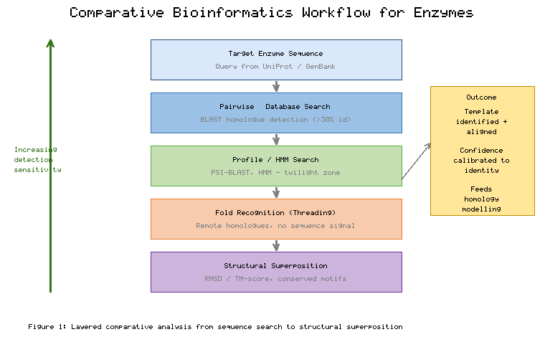
Figure 1. Comparative Bioinformatics Workflow for Enzyme Analysis, Progressing from Sequence Search Through Fold Recognition to Structural Superposition
The reliability of comparative inference depends strongly on the degree of relatedness between target and template, and understanding this dependence is crucial for setting realistic expectations [11]. At high sequence identity, structural and functional inferences are generally safe, and homology models approach the accuracy of experimental structures in their conserved cores. As identity decreases, alignment errors accumulate, loop regions become unreliable, and functional transfer grows hazardous, because even closely related enzymes can acquire different specificities through subtle active-site substitutions. Table 1 summarizes the relationship between sequence identity, structural similarity, and the confidence warranted in various forms of functional and structural inference, providing a practical guide for judging when comparative methods can be trusted and when experimental or more sophisticated computational evidence is required.
[Insert Table 1 here]
Table 1. Relationship Between Sequence Identity and Confidence in Comparative Structural and Functional Inference
Sequence Identity | Structural Similarity | Model Reliability | Functional Transfer | Recommended Use
Above 50% | Very high, near-identical core | Excellent; accurate side chains | Generally safe | Direct template for modelling and docking
30–50% | High fold conservation | Good core, uncertain loops | Plausible, verify active site | Reliable scaffold, refine binding region
20–30% (twilight zone) | Fold often conserved | Approximate backbone only | Risky, requires validation | Profile or threading support needed
Below 20% | Uncertain, fold may differ | Unreliable without threading | Not recommended | Fold recognition and experimental data essential
The comparative framework developed here feeds directly into the methods of structure determination and prediction examined next. Identifying the most appropriate template, understanding the extent of its relatedness, and aligning it accurately to the target are the prerequisites of successful homology modelling, while the structural classification of the target informs the interpretation of any experimentally determined or computationally predicted model. Comparative analysis thus functions both as a standalone source of functional hypotheses and as the essential preparatory step for the structural modelling that enables structure-based drug design against enzyme targets.

3. Methods of Enzyme Structure Determination and Prediction

3.1 Experimental Structure Determination
The gold standard for enzyme structural information remains experimental determination, which yields atomic coordinates derived from direct physical measurement rather than inference. X-ray crystallography has historically dominated the field, accounting for the large majority of entries in the Protein Data Bank, the central repository of macromolecular structures [12]. In crystallography, a purified enzyme is induced to form an ordered crystal, which is then exposed to an X-ray beam; the resulting diffraction pattern is processed to reconstruct the electron density, into which an atomic model is built and refined [13]. The resolution of the resulting structure, typically reported in angstroms, determines how much atomic detail can be discerned, with high-resolution structures below two angstroms revealing individual atoms and water molecules essential for understanding catalysis and ligand binding. For drug discovery, crystallography is especially powerful because enzymes can be co-crystallized with inhibitors, directly revealing the binding mode that medicinal chemists seek to optimize.
Despite its power, crystallography faces significant limitations that shape its applicability to enzyme targets. Many enzymes, particularly membrane-associated proteins and large flexible assemblies, resist crystallization, and the crystalline environment can impose non-physiological conformations through crystal-packing contacts [13]. Nuclear magnetic resonance spectroscopy offers a complementary solution-based approach that provides structural information for smaller enzymes under near-native conditions and, crucially, reports on dynamics across a range of timescales [14]. By measuring interactions between atomic nuclei, NMR yields ensembles of conformations rather than a single static model, capturing the flexibility that is often functionally important for catalysis and inhibitor binding. However, NMR is generally limited to smaller proteins and requires substantial quantities of isotopically labelled material, constraining its routine use for large enzyme targets.
Cryogenic electron microscopy has undergone a transformative advance that has dramatically expanded the accessible structural space for enzymes [15]. In cryo-EM, purified molecules are rapidly frozen in a thin layer of vitreous ice and imaged with an electron beam, and thousands to millions of individual particle images are computationally combined to reconstruct a three-dimensional density map [16]. The advent of direct electron detectors and improved image-processing algorithms has pushed cryo-EM to near-atomic resolution, enabling the determination of structures for large enzyme complexes, membrane proteins, and assemblies that are intractable by crystallography. Because cryo-EM does not require crystallization and can capture multiple conformational states from a single sample, it has become increasingly central to the structural characterization of challenging enzyme targets relevant to drug discovery. Table 2 compares the principal experimental and computational methods across the dimensions most relevant to selecting an approach for a given enzyme target.
[Insert Table 2 here]
Table 2. Comparison of Enzyme Structure Determination and Prediction Methods
Method | Typical Resolution | Size Range | Captures Dynamics | Key Advantage | Principal Limitation
X-ray crystallography | 1–3 Å | Broad | Limited | High detail, ligand complexes | Requires crystallization
NMR spectroscopy | Atomic ensemble | Small (<40 kDa) | Excellent | Solution dynamics | Size-limited, costly labelling
Cryo-EM | 2–4 Å | Large complexes | Multiple states | No crystals needed | Difficult for small proteins
Homology modelling | Template-dependent | Broad | Static | Fast, low cost | Needs suitable template
Deep-learning prediction | High for ordered regions | Broad | Static, single model | Near-experimental accuracy | Uncertain for novel folds

3.2 Computational Structure Prediction and Homology Modelling
Because experimental structure determination is costly, time-consuming, and infeasible for many targets, computational prediction has long complemented laboratory methods, and for the majority of enzyme sequences a predicted model is the only structural information available. Comparative or homology modelling, the most established computational approach, constructs a model of a target enzyme by exploiting its similarity to one or more experimentally determined template structures [17]. The procedure typically involves identifying suitable templates, aligning the target sequence to the template structure, building the backbone from the aligned regions, modelling the variable loops, placing side chains, and refining and validating the final model [18]. The accuracy of a homology model depends overwhelmingly on the target-template sequence identity and the quality of the alignment; models built from close templates can rival low-resolution experimental structures, whereas those built from distant templates are reliable only in their conserved cores [11]. Threading and fold-recognition methods extend modelling to targets lacking obvious templates by matching sequences to compatible folds, as introduced in the comparative analysis of enzyme families.
The field has been revolutionized by deep-learning approaches to protein structure prediction, which have achieved accuracy approaching that of experimental methods for many proteins [19]. AlphaFold, in particular, demonstrated that a neural network trained on evolutionary sequence information and known structures could predict three-dimensional coordinates with remarkable fidelity, a result validated in community-wide blind assessments [19]. The subsequent release of predicted structures for essentially the entire known proteome, including vast numbers of enzymes, has placed structural models within reach for targets that had never been crystallized [20]. Related methods have extended this capability to protein complexes and to the prediction of interactions with nucleic acids and small molecules, broadening the relevance of deep-learning prediction to drug discovery [21]. These advances have transformed the practical starting point for structure-based enzyme drug design, shifting the bottleneck from obtaining a structure to interpreting and validating it appropriately.
Regardless of how a model is obtained, its validation is indispensable before it can be trusted for drug-design purposes, because an unvalidated model can mislead an entire discovery campaign [22]. Stereochemical quality is assessed through tools that evaluate backbone dihedral angles against the statistically favoured regions of the Ramachandran plot, flagging improbable conformations that signal modelling errors [23]. Statistical potentials and energy-based scores estimate the overall plausibility of a fold and localize problematic regions, while per-residue confidence estimates accompanying deep-learning predictions indicate which parts of a model are reliable and which, often flexible loops or disordered segments, should be treated with caution [19, 22]. As summarized in Figure 2, the structure-generation workflow branches between experimental and computational routes, converging on a validation stage that gates entry into the downstream drug-design pipeline. For enzyme targets specifically, validation must pay particular attention to the active-site region, since even a globally accurate model may misplace catalytic residues or distort the binding pocket in ways that compromise docking.
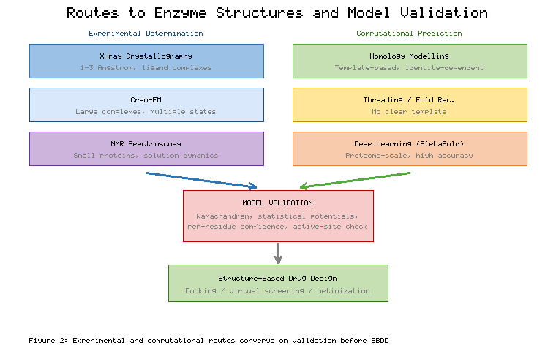
Figure 2. Experimental and Computational Routes to Enzyme Structures, Converging on Model Validation Before Entry into Structure-Based Drug Design
The choice among these methods is governed by the characteristics of the target, the resources available, and the intended application. A medicinal-chemistry program advancing toward clinical candidates will ultimately demand high-resolution experimental structures, ideally in complex with lead compounds, whereas early target assessment and virtual screening can often proceed from a well-validated homology or deep-learning model. In practice, the methods are complementary rather than competing: computational predictions guide experimental design, experimental structures anchor and validate computational models, and the two together provide the robust structural foundation on which the characterization of catalytic and binding sites, examined in the following section, ultimately rests.

4. Characterizing Catalytic and Ligand-Binding Sites

4.1 Active-Site Architecture and Catalytic Residue Identification
The active site is the functional heart of an enzyme and the primary focus of most drug-design efforts, for it is here that substrates are bound, transformed, and released, and here that competitive inhibitors exert their effect. Characterizing the active site begins with locating and identifying the catalytic residues—the small subset of amino acids that participate directly in the chemical transformation, whether by stabilizing transition states, acting as acid-base catalysts, or forming covalent intermediates [24]. These residues are frequently among the most highly conserved positions in an enzyme family, because mutations that disrupt catalysis are strongly selected against, so evolutionary conservation mapped onto a structure often highlights the catalytic machinery [10]. Databases that catalogue experimentally verified catalytic residues provide reference annotations that can be transferred to related enzymes through the comparative methods described earlier, enabling the catalytic apparatus of a new target to be predicted with reasonable confidence [24].
The spatial arrangement of catalytic residues frequently forms recurring geometric patterns that are diagnostic of mechanism and that recur across otherwise unrelated enzymes. The catalytic triad of serine proteases, comprising serine, histidine, and aspartate arranged in a precise hydrogen-bonding network, is the archetypal example of a catalytic constellation that has evolved convergently in multiple protein families [25]. Metal-binding sites, in which coordinated zinc, magnesium, or other ions participate in catalysis, constitute another widespread motif, as do the phosphate-binding loops characteristic of nucleotide-dependent enzymes such as kinases [26]. Recognizing these three-dimensional templates in a target structure, through geometric pattern-matching against libraries of known catalytic-site templates, provides strong evidence for both the enzyme's mechanism and the precise location of the pocket that a drug must engage. This structural-template approach complements sequence-based prediction and is especially valuable when sequence conservation alone is ambiguous.
The identification of catalytic residues and the delineation of active-site geometry carry direct implications for inhibitor design. A competitive inhibitor must complement the shape and chemistry of the catalytic pocket, exploiting the same interactions that the natural substrate forms; understanding which residues are catalytic, which are involved in substrate recognition, and which are merely structural allows designers to target the most productive interactions [27]. Covalent inhibitors, an increasingly important class, are designed to form a chemical bond with a specific nucleophilic catalytic residue, such as the active-site cysteine exploited by several recently approved drugs, making precise identification of that residue a prerequisite for the design strategy [28]. The structural characterization of the active site thus translates directly into the chemical hypotheses that guide lead discovery and optimization against enzyme targets.

4.2 Binding-Site Detection and Druggability Assessment
Beyond the catalytic center, enzymes present a variety of pockets and cavities that may serve as binding sites for drugs, including the orthosteric substrate site and allosteric sites distant from the catalytic machinery. Computational pocket-detection algorithms identify these cavities from the three-dimensional structure using geometric approaches that find concavities and clefts, energetic approaches that locate regions favourable for ligand interaction, or combinations of the two [29]. Such methods scan the molecular surface for depressions large enough to accommodate a drug-like molecule and rank them by size, enclosure, and other properties. The detection of allosteric sites is of particular interest in enzyme drug discovery because allosteric inhibitors can achieve selectivity that is difficult to obtain at highly conserved catalytic sites, and they can modulate activity through mechanisms distinct from direct competition with substrate [30].
Identifying a pocket is only the first step; assessing whether it is druggable—capable of binding a small molecule with sufficient affinity and specificity to produce a therapeutic effect—is equally essential and often determines whether a target is pursued at all. Druggability depends on physicochemical and geometric properties of the pocket, including its size, shape, enclosure, hydrophobicity, and the presence of hydrogen-bonding features that can anchor a ligand [31]. Pockets that are too shallow, too polar, or too open tend to bind small molecules weakly, whereas deep, enclosed, appropriately hydrophobic pockets with defined polar contacts are more likely to yield potent inhibitors. Computational druggability scores, derived from these features or from simulations of fragment binding, provide quantitative estimates that help prioritize targets and sites early in a discovery campaign [32]. As illustrated in Figure 3, the analysis of an enzyme binding site integrates pocket geometry, physicochemical character, and conservation to arrive at a druggability assessment that informs the go/no-go decision for structure-based design.
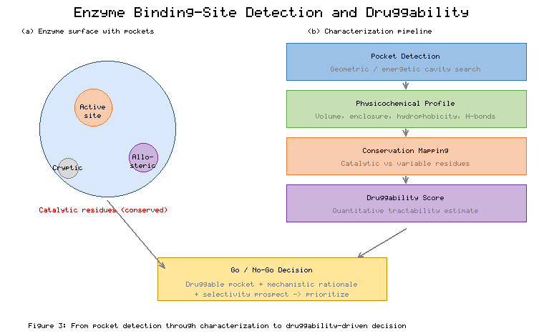
Figure 3. Workflow for Enzyme Binding-Site Detection, Physicochemical Characterization, and Druggability Assessment
The concept of druggability has been refined by large-scale analyses of which pockets successfully bind drugs, and modern assessment increasingly incorporates the dynamic behavior of pockets rather than treating them as static features [31]. Cryptic pockets, which are not apparent in a single static structure but open transiently through conformational change, have emerged as an important and expanding category of druggable sites that static analysis would overlook [33]. Detecting such sites requires sampling multiple conformations, linking druggability assessment to the structural-dynamics methods examined in the next section. Table 3 compares the principal characteristics that distinguish druggable from challenging binding sites, providing a practical framework for evaluating enzyme pockets and for recognizing when a seemingly undruggable target might yield to approaches that exploit conformational flexibility.
[Insert Table 3 here]
Table 3. Characteristics Distinguishing Druggable from Challenging Enzyme Binding Sites
Property | Favourable for Druggability | Challenging for Druggability | Design Implication
Pocket volume | Moderate, well-defined | Very small or very large | Fragment growing or linking strategy
Enclosure | Deep, enclosed cleft | Shallow, solvent-exposed | Shallow sites favour peptides or PPI disruptors
Hydrophobicity | Balanced hydrophobic core | Highly polar or charged | Polar sites need polar, often weaker ligands
Hydrogen-bond anchors | Defined donor/acceptor pattern | Few or diffuse | Guides directional, selective interactions
Conservation | Variable surface, conserved core | Highly conserved (selectivity risk) | Allosteric or cryptic sites aid selectivity
Conformational behaviour | Stable or inducible pocket | Only transiently formed | Ensemble docking for cryptic pockets
The characterization of catalytic and binding sites provides the spatial and chemical blueprint that structure-based drug design seeks to exploit, but this blueprint is incomplete if treated as rigid. Enzymes are dynamic molecules whose active sites breathe, whose loops open and close over substrates, and whose allosteric networks propagate conformational signals across the protein. The static picture developed in this section must therefore be augmented by an understanding of structural dynamics, which the following section addresses, before the full value of structural bioinformatics for drug design can be realized.

5. Structural Dynamics and Conformational Analysis

5.1 Conformational Flexibility and Molecular Dynamics Simulation
A single static structure, however accurate, captures only one snapshot of a molecule that in reality populates a continuous distribution of conformations. Enzymes are intrinsically dynamic, undergoing motions ranging from the rapid vibrations of individual bonds to the slow, large-scale rearrangements of domains, and these motions are frequently essential to function [34]. Catalysis often requires conformational changes that position catalytic residues, close loops over the active site to exclude solvent, or open channels for substrate entry and product release. Consequently, understanding enzyme function and designing effective inhibitors demands attention not merely to the average structure but to the conformational ensemble and the transitions among its members. This recognition has elevated structural dynamics from a specialized concern to a central consideration in structure-based drug design.
Molecular dynamics simulation is the preeminent computational tool for exploring conformational flexibility, generating trajectories of atomic motion by numerically integrating Newton's equations under a physics-based force field [35]. Starting from an experimental or predicted structure, a simulation propagates the positions and velocities of every atom over time, producing an ensemble of conformations that reveals how the enzyme flexes, how loops move, and how water and ions interact with the binding site [36]. Advances in force fields, algorithms, and specialized hardware have extended accessible timescales from nanoseconds to microseconds and beyond, allowing simulations to capture functionally relevant motions that were previously out of reach [37]. For drug discovery, molecular dynamics illuminates the dynamic behavior of binding sites, reveals transient pockets, and provides the conformational ensembles that underpin more realistic docking and free-energy calculations.
The computational expense of reaching long timescales has motivated a family of enhanced-sampling methods that accelerate the exploration of conformational space, overcoming the energy barriers that trap conventional simulations in local minima [38]. Techniques such as metadynamics, replica-exchange methods, and biased-potential approaches enable the characterization of rare events, including large conformational transitions and the opening of cryptic pockets, and can estimate the free-energy landscapes that quantify the relative stability of different states [38]. These methods are particularly valuable for enzymes that undergo substantial conformational change during catalysis or inhibitor binding, where the biologically or pharmacologically relevant states may be poorly populated under equilibrium conditions. By mapping the accessible conformations and their energetics, enhanced sampling provides a dynamic foundation for drug design that static structures cannot supply. Table 4 summarizes the principal computational methods for probing enzyme dynamics, indicating the motions each captures and its characteristic role in structure-based design.
[Insert Table 4 here]
Table 4. Computational Methods for Characterizing Enzyme Structural Dynamics
Method | Timescale/Scope | Motions Captured | Computational Cost | Role in Drug Design
Classical molecular dynamics | ns–µs trajectories | Local flexibility, loop motion, solvation | High | Ensembles, pocket breathing
Enhanced sampling | Rare events, free energies | Large transitions, cryptic-pocket opening | Very high | Free-energy landscapes, hidden sites
Normal mode analysis | Equilibrium collective modes | Domain hinge-bending, global deformation | Low | Rapid flexibility screening
Elastic network models | Large assemblies | Functional low-frequency motions | Very low | Motion prediction from structure alone
Free-energy perturbation | Relative binding affinity | Ligand-coupled reorganization | Very high | Quantitative lead optimization
As summarized in Table 4, the methods differ markedly in the timescales and motions they access, and effective dynamic characterization typically combines several of them: elastic network models and normal mode analysis rapidly identify the collective motions worth investigating, while molecular dynamics and enhanced sampling supply the atomistic detail and energetics that quantitative design requires.

5.2 Normal Mode Analysis, Allostery, and Ensemble Representations
Complementing the atomistic detail of molecular dynamics, normal mode analysis offers a computationally efficient description of the large-scale, collective motions that dominate functional conformational change [39]. By approximating the energy landscape around an equilibrium structure as harmonic and decomposing the resulting motion into independent modes, normal mode analysis identifies the low-frequency modes that correspond to the slow, global deformations most relevant to enzyme function, such as domain hinge-bending and the opening and closing of clefts [39]. Elastic network models, a simplified variant that represents the protein as a network of springs connecting nearby residues, make these calculations feasible even for very large assemblies and have proved remarkably successful at predicting functionally important motions from structure alone [40]. Because these collective motions often gate substrate access or couple distant sites, they are directly relevant to understanding both catalysis and the action of allosteric drugs.
Allostery—the propagation of a conformational or dynamic signal from one site to another distant site—is a phenomenon of profound importance for enzyme regulation and for drug design, and its structural basis is increasingly accessible to computational analysis [41]. Allosteric drugs bind at sites remote from the active site yet modulate catalytic activity by shifting the conformational equilibrium or altering the dynamics of the enzyme, offering routes to selectivity and novel mechanisms of action that orthosteric inhibitors cannot achieve. Computational methods that analyze correlated motions, dynamic networks, and communication pathways within a protein can identify allosteric sites and trace the routes by which perturbations propagate, informing the rational design of allosteric modulators [42]. As depicted in Figure 4, the integration of molecular dynamics, normal mode analysis, and network analysis reveals how enzymes sample multiple conformations and how allosteric signals traverse the structure, providing a dynamic map that static methods cannot produce.
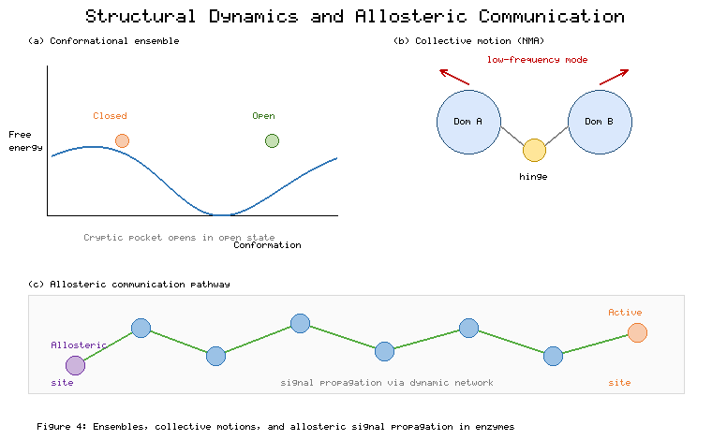
Figure 4. Structural Dynamics of Enzymes: Conformational Ensembles, Collective Motions, and Allosteric Communication Pathways
The practical upshot of structural dynamics for drug design is the shift from single-structure to ensemble-based representations, which acknowledge that a ligand interacts with a distribution of conformations rather than a fixed receptor [43]. Ensemble docking, in which candidate molecules are docked against multiple conformations drawn from simulation or experiment, captures the induced-fit and conformational-selection phenomena that single-structure docking misses, improving the identification of true binders [43]. The conformational ensemble also underpins the most rigorous methods for estimating binding affinity, as discussed below, and is essential for exploiting cryptic pockets that appear only in a subset of conformations. By representing the enzyme as the dynamic entity it truly is, ensemble approaches bring computational predictions closer to physical reality and strengthen the link between structural analysis and experimental outcome.
Accurate estimation of binding free energy represents the culmination of dynamic structural analysis for drug design, quantifying the affinity that medicinal chemistry seeks to optimize. Physics-based methods such as free-energy perturbation and thermodynamic integration, built upon molecular dynamics sampling, can predict the relative binding affinities of related compounds with increasing reliability, guiding the optimization of lead series [44]. These calculations demand careful attention to conformational sampling, force-field accuracy, and the treatment of solvent and entropy, and they remain computationally intensive, but their predictive power has grown to the point of influencing real medicinal-chemistry decisions. The dynamic structural foundation established through simulation and conformational analysis thus feeds directly into the quantitative predictions that bridge structural bioinformatics and lead optimization, setting the stage for the integrative role of structural analysis in the broader drug-design pipeline.

6. Integrating Structural Bioinformatics into the Drug Design Pipeline

6.1 Target Validation and Comparative Selectivity Analysis
The structural and comparative analyses developed throughout this chapter converge on the practical decisions that determine whether and how an enzyme target is pursued. Target validation, the process of establishing that modulating a given enzyme will produce the desired therapeutic effect, is strengthened considerably by structural evidence [45]. A validated target should possess a well-defined, druggable binding site, a clear mechanistic rationale linking its inhibition to disease modification, and a structural distinctiveness that permits selective targeting. Structural bioinformatics contributes to each of these criteria: pocket detection and druggability assessment establish tractability, comparative analysis of catalytic mechanism clarifies the functional consequences of inhibition, and structural comparison across related enzymes reveals the distinguishing features that selectivity will require. By assembling this evidence before substantial medicinal-chemistry investment, structural analysis reduces the risk of pursuing intractable or poorly differentiated targets.
Selectivity is among the most demanding challenges in enzyme drug discovery, because related enzymes within a family often share highly conserved active sites, and an inhibitor that binds the intended target may also inhibit its relatives, producing off-target effects and toxicity [46]. Comparative structural analysis directly addresses this challenge by mapping the differences among family members, identifying residues and sub-pockets that vary across the family and that can therefore be exploited to achieve selective binding [47]. The kinase family provides the archetypal illustration: hundreds of kinases share a conserved ATP-binding site, yet selective inhibitors have been developed by exploiting subtle differences in pocket shape, variable residues such as the gatekeeper, and the differential accessibility of inactive conformational states [48]. Structural superposition across the family, combined with analysis of sequence conservation and dynamics, reveals the selectivity determinants that guide the design of compounds targeting one enzyme while sparing its relatives.
The contributions of comparative and structural bioinformatics to each stage of the drug-design pipeline can be organized as a sequence of analyses, inputs, and decisions, as set out in Table 5. This mapping clarifies how the methods developed throughout the chapter feed concrete outputs into the target-validation, selectivity, and prioritization decisions that govern a discovery program, and it underscores the dependence of each stage on the quality of the structural evidence that precedes it. Table 5 thereby serves as a practical checklist for ensuring that a structure-based campaign rests on appropriately validated foundations before committing medicinal-chemistry resources.
[Insert Table 5 here]
Table 5. Mapping of Structural Bioinformatics Analyses onto Drug-Design Pipeline Decisions
Pipeline Stage | Primary Analysis | Key Input | Decision Supported
Target assessment | Fold classification, homology | Sequence, related structures | Is a structural model attainable?
Structure generation | Experimental or predicted model | Template or sequence | Which model enters the pipeline?
Site characterization | Pocket detection, druggability | Validated structure | Is the site tractable?
Dynamic analysis | MD, ensemble generation | Structure, simulation | Are cryptic or induced sites present?
Selectivity analysis | Comparative superposition | Family structures | How is selectivity achieved?
Prioritization | Integrated scoring | All prior outputs | Go/no-go for structure-based design
Comparative selectivity analysis extends naturally to the anticipation of resistance and the assessment of polypharmacology, both of which bear on the ultimate clinical success of an enzyme-targeted drug. Mutations at or near the binding site can confer resistance by disrupting inhibitor binding while preserving catalytic function, and structural analysis of likely resistance mutations can guide the design of inhibitors robust to such changes [46]. Conversely, deliberate polypharmacology—the intentional engagement of multiple related targets—can be rationalized through comparative structural analysis when inhibition of several family members is therapeutically desirable. In both cases, the comparative structural framework provides the means to reason systematically about how a candidate molecule will interact not only with its primary target but with the broader structural landscape of related enzymes, an analysis essential to designing drugs with favourable efficacy and safety profiles.

6.2 Prioritizing Druggable Sites and Bridging to Structure-Based Design
The final contribution of structural bioinformatics to the drug-design pipeline is the prioritization of binding sites and targets for the computationally and experimentally intensive stages of structure-based design. Having characterized an enzyme's catalytic and allosteric pockets, assessed their druggability, and understood their dynamic behavior, the researcher must decide which site offers the most promising point of intervention [49]. This prioritization weighs druggability scores, the prospects for selectivity, the availability of reliable structural models, and the mechanistic consequences of modulating each site. A deep, enclosed, chemically distinctive pocket with a clear mechanistic link to the desired effect and good prospects for selectivity represents an attractive starting point, whereas a shallow, highly conserved, or dynamically elusive site may be deprioritized despite its functional importance. This decision framework translates the preceding analyses into a concrete go/no-go judgment that directs resources toward the most tractable opportunities.
Once a site is prioritized, structural bioinformatics provides the prepared, validated, and appropriately represented structure that subsequent methods require, serving as the essential interface between analysis and design. Molecular docking screens libraries of candidate molecules against the chosen pocket, ranking them by predicted binding, and depends on an accurately prepared structure with correct protonation states, resolved tautomers, and, where dynamics matter, an ensemble of conformations [50]. Structure-based virtual screening, fragment-based design, and de novo molecular generation all build upon the structural foundation that the methods of this chapter establish, and the quality of their output is bounded by the quality of that foundation. The seamless handoff from structural characterization to docking and lead discovery is where the investment in comparative and structural bioinformatics is repaid, as validated structural hypotheses become the substrate for the generation and optimization of candidate drugs.
The integration of comparative and structural bioinformatics into the drug-design pipeline is best understood as a continuous flow of evidence rather than a sequence of isolated steps, with each analysis informing and constraining those that follow. Figure 5 presents this integrated pipeline, tracing the path from target sequence and comparative analysis through structure determination or prediction, binding-site characterization, and dynamic analysis to the prioritized, validated structural model that enters structure-based design. At each stage, the comparative framework supplies context—which relatives inform the model, which features confer selectivity, which pockets are tractable—while the structural analysis supplies the atomic detail that chemistry requires. This integration ensures that the molecules ultimately designed are grounded in a rigorous, multi-layered understanding of the enzyme target, maximizing the probability that computational predictions will translate into experimental success.
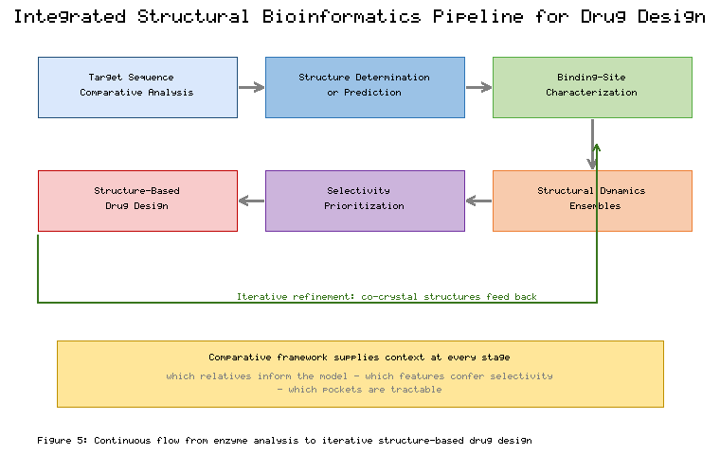
Figure 5. Integrated Comparative and Structural Bioinformatics Pipeline Linking Enzyme Analysis to Structure-Based Drug Design
The role of structural bioinformatics does not end when a candidate molecule enters synthesis and testing, for the pipeline is inherently iterative and the structural model is continually refined. Experimental structures of the enzyme in complex with lead compounds feed back into the analysis, refining the understanding of binding mode, revealing unanticipated interactions, and guiding the next round of optimization. The comparative framework continues to inform selectivity and resistance considerations as the lead series matures, and dynamic analysis helps interpret structure-activity relationships that static models cannot explain. In this way, comparative and structural bioinformatics permeates the entire enzyme drug-discovery endeavour, from the earliest assessment of a target's tractability to the final optimization of a clinical candidate, providing the structural intelligence that transforms biological targets into therapeutic opportunities.

7. Conclusion
Comparative and structural bioinformatics constitutes the indispensable bridge between the sequence-level knowledge of enzymes and the atomic-resolution understanding required to design molecules that modulate their activity. This chapter has traced the full arc of that discipline as it applies to enzyme-focused drug discovery, beginning with the comparative principles that exploit evolutionary relationships to transfer structural and functional knowledge from characterized enzymes to novel targets. The conservation of fold relative to sequence, the hierarchical classification of structures, and the quantitative comparison of three-dimensional architectures together provide a powerful framework for inferring the properties of enzymes that have not been experimentally characterized, while the careful calibration of confidence to the degree of relatedness guards against the over-interpretation that can derail a discovery program.
The methods of structure determination and prediction surveyed here have been transformed in recent years, most dramatically by the advent of deep-learning approaches that place credible structural models within reach for essentially any enzyme sequence. Yet the enduring value of experimental methods—crystallography for high-resolution ligand complexes, cryo-electron microscopy for large and challenging assemblies, and nuclear magnetic resonance for solution dynamics—remains clear, and the complementarity of experimental and computational approaches, unified by rigorous validation, defines current best practice. The characterization of catalytic and binding sites builds upon these structural models to identify the precise locations and chemical features that drug designers must engage, distinguishing catalytic residues, delineating pockets, and assessing the druggability that ultimately determines whether a target can be pursued.
The recognition that enzymes are dynamic rather than static molecules has reshaped the field, elevating conformational analysis from a specialized refinement to a central component of structure-based design. Molecular dynamics simulation, enhanced sampling, normal mode analysis, and ensemble representations collectively capture the conformational plasticity that governs catalysis, enables allostery, and reveals cryptic pockets invisible to static analysis. Integrated into the drug-design pipeline, these comparative and structural analyses inform target validation, enable the comparative selectivity assessment essential to avoiding off-target effects, and guide the prioritization of druggable sites that directs resources toward the most promising opportunities. As structural data continue to proliferate and computational methods continue to mature, comparative and structural bioinformatics will only grow in importance, serving as the intellectual and practical foundation upon which the rational design of enzyme-targeted therapeutics is built, and providing the seamless interface to the molecular docking and medicinal-chemistry optimization that subsequent chapters address.

References
[1] Chothia, C., & Lesk, A. M. (1986). The relation between the divergence of sequence and structure in proteins. The EMBO Journal, 5(4), 823–826.
[2] Rost, B. (1999). Twilight zone of protein sequence alignments. Protein Engineering, 12(2), 85–94.
[3] Altschul, S. F., Madden, T. L., Schäffer, A. A., Zhang, J., Zhang, Z., Miller, W., & Lipman, D. J. (1997). Gapped BLAST and PSI-BLAST: A new generation of protein database search programs. Nucleic Acids Research, 25(17), 3389–3402.
[4] Jones, D. T., Taylor, W. R., & Thornton, J. M. (1992). A new approach to protein fold recognition. Nature, 358(6381), 86–89.
[5] Murzin, A. G., Brenner, S. E., Hubbard, T., & Chothia, C. (1995). SCOP: A structural classification of proteins database for the investigation of sequences and structures. Journal of Molecular Biology, 247(4), 536–540.
[6] Orengo, C. A., Michie, A. D., Jones, S., Jones, D. T., Swindells, M. B., & Thornton, J. M. (1997). CATH—A hierarchic classification of protein domain structures. Structure, 5(8), 1093–1108.
[7] Wierenga, R. K. (2001). The TIM-barrel fold: A versatile framework for efficient enzymes. FEBS Letters, 492(3), 193–198.
[8] Holm, L., & Sander, C. (1993). Protein structure comparison by alignment of distance matrices. Journal of Molecular Biology, 233(1), 123–138.
[9] Zhang, Y., & Skolnick, J. (2004). Scoring function for automated assessment of protein structure template quality. Proteins: Structure, Function, and Bioinformatics, 57(4), 702–710.
[10] Valdar, W. S. J. (2002). Scoring residue conservation. Proteins: Structure, Function, and Bioinformatics, 48(2), 227–241.
[11] Baker, D., & Šali, A. (2001). Protein structure prediction and structural genomics. Science, 294(5540), 93–96.
[12] Berman, H. M., Westbrook, J., Feng, Z., Gilliland, G., Bhat, T. N., Weissig, H., ... & Bourne, P. E. (2000). The Protein Data Bank. Nucleic Acids Research, 28(1), 235–242.
[13] Smyth, M. S., & Martin, J. H. J. (2000). X-ray crystallography. Molecular Pathology, 53(1), 8–14.
[14] Wüthrich, K. (2001). The way to NMR structures of proteins. Nature Structural Biology, 8(11), 923–925.
[15] Cheng, Y. (2015). Single-particle cryo-EM at crystallographic resolution. Cell, 161(3), 450–457.
[16] Kühlbrandt, W. (2014). The resolution revolution. Science, 343(6178), 1443–1444.
[17] Šali, A., & Blundell, T. L. (1993). Comparative protein modelling by satisfaction of spatial restraints. Journal of Molecular Biology, 234(3), 779–815.
[18] Webb, B., & Šali, A. (2016). Comparative protein structure modeling using MODELLER. Current Protocols in Bioinformatics, 54(1), 5.6.1–5.6.37.
[19] Jumper, J., Evans, R., Pritzel, A., Green, T., Figurnov, M., Ronneberger, O., ... & Hassabis, D. (2021). Highly accurate protein structure prediction with AlphaFold. Nature, 596(7873), 583–589.
[20] Varadi, M., Anyango, S., Deshpande, M., Nair, S., Natassia, C., Yordanova, G., ... & Velankar, S. (2022). AlphaFold Protein Structure Database: Massively expanding the structural coverage of protein-sequence space. Nucleic Acids Research, 50(D1), D439–D444.
[21] Baek, M., DiMaio, F., Anishchenko, I., Dauparas, J., Ovchinnikov, S., Lee, G. R., ... & Baker, D. (2021). Accurate prediction of protein structures and interactions using a three-track neural network. Science, 373(6557), 871–876.
[22] Laskowski, R. A., MacArthur, M. W., Moss, D. S., & Thornton, J. M. (1993). PROCHECK: A program to check the stereochemical quality of protein structures. Journal of Applied Crystallography, 26(2), 283–291.
[23] Ramachandran, G. N., Ramakrishnan, C., & Sasisekharan, V. (1963). Stereochemistry of polypeptide chain configurations. Journal of Molecular Biology, 7(1), 95–99.
[24] Furnham, N., Holliday, G. L., de Beer, T. A. P., Jacobsen, J. O. B., Pearson, W. R., & Thornton, J. M. (2014). The Catalytic Site Atlas 2.0: Cataloging catalytic sites and residues identified in enzymes. Nucleic Acids Research, 42(D1), D485–D489.
[25] Dodson, G., & Wlodawer, A. (1998). Catalytic triads and their relatives. Trends in Biochemical Sciences, 23(9), 347–352.
[26] Andreeva, A., & Tidow, H. (2008). A novel CHHC Zn-finger domain found in spliceosomal proteins. Proteins: Structure, Function, and Bioinformatics, 70(3), 753–760.
[27] Hardy, J. A., & Wells, J. A. (2004). Searching for new allosteric sites in enzymes. Current Opinion in Structural Biology, 14(6), 706–715.
[28] Singh, J., Petter, R. C., Baillie, T. A., & Whitty, A. (2011). The resurgence of covalent drugs. Nature Reviews Drug Discovery, 10(4), 307–317.
[29] Le Guilloux, V., Schmidtke, P., & Tuffery, P. (2009). Fpocket: An open source platform for ligand pocket detection. BMC Bioinformatics, 10, 168.
[30] Nussinov, R., & Tsai, C. J. (2013). Allostery in disease and in drug discovery. Cell, 153(2), 293–305.
[31] Halgren, T. A. (2009). Identifying and characterizing binding sites and assessing druggability. Journal of Chemical Information and Modeling, 49(2), 377–389.
[32] Schmidtke, P., & Barril, X. (2010). Understanding and predicting druggability. A high-throughput method for detection of drug binding sites. Journal of Medicinal Chemistry, 53(15), 5858–5867.
[33] Vajda, S., Beglov, D., Wakefield, A. E., Egbert, M., & Whitty, A. (2018). Cryptic binding sites on proteins: Definition, detection, and druggability. Current Opinion in Chemical Biology, 44, 1–8.
[34] Henzler-Wildman, K., & Kern, D. (2007). Dynamic personalities of proteins. Nature, 450(7172), 964–972.
[35] Karplus, M., & McCammon, J. A. (2002). Molecular dynamics simulations of biomolecules. Nature Structural Biology, 9(9), 646–652.
[36] Hollingsworth, S. A., & Dror, R. O. (2018). Molecular dynamics simulation for all. Neuron, 99(6), 1129–1143.
[37] Shaw, D. E., Maragakis, P., Lindorff-Larsen, K., Piana, S., Dror, R. O., Eastwood, M. P., ... & Wriggers, W. (2010). Atomic-level characterization of the structural dynamics of proteins. Science, 330(6002), 341–346.
[38] Bernardi, R. C., Melo, M. C. R., & Schulten, K. (2015). Enhanced sampling techniques in molecular dynamics simulations of biological systems. Biochimica et Biophysica Acta (BBA) - General Subjects, 1850(5), 872–877.
[39] Bahar, I., Lezon, T. R., Bakan, A., & Shrivastava, I. H. (2010). Normal mode analysis of biomolecular structures: Functional mechanisms of membrane proteins. Chemical Reviews, 110(3), 1463–1497.
[40] Tirion, M. M. (1996). Large amplitude elastic motions in proteins from a single-parameter, atomic analysis. Physical Review Letters, 77(9), 1905–1908.
[41] Motlagh, H. N., Wrabl, J. O., Li, J., & Hilser, V. J. (2014). The ensemble nature of allostery. Nature, 508(7496), 331–339.
[42] Wodak, S. J., Paci, E., Dokholyan, N. V., Berezovsky, I. N., Horovitz, A., Li, J., ... & Nussinov, R. (2019). Allostery in its many disguises: From theory to applications. Structure, 27(4), 566–578.
[43] Amaro, R. E., Baudry, J., Chodera, J., Demir, Ö., McCammon, J. A., Miao, Y., & Smith, J. C. (2018). Ensemble docking in drug discovery. Biophysical Journal, 114(10), 2271–2278.
[44] Cournia, Z., Allen, B., & Sherman, W. (2017). Relative binding free energy calculations in drug discovery: Recent advances and practical considerations. Journal of Chemical Information and Modeling, 57(12), 2911–2937.
[45] Hughes, J. P., Rees, S., Kalindjian, S. B., & Philpott, K. L. (2011). Principles of early drug discovery. British Journal of Pharmacology, 162(6), 1239–1249.
[46] Anderson, A. C. (2003). The process of structure-based drug design. Chemistry & Biology, 10(9), 787–797.
[47] Barelier, S., Sterling, T., O'Meara, M. J., & Shoichet, B. K. (2015). The recognition of identical ligands by unrelated proteins. ACS Chemical Biology, 10(12), 2772–2784.
[48] Zhang, J., Yang, P. L., & Gray, N. S. (2009). Targeting cancer with small molecule kinase inhibitors. Nature Reviews Cancer, 9(1), 28–39.
[49] Sliwoski, G., Kothiwale, S., Meiler, J., & Lowe, E. W. (2014). Computational methods in drug discovery. Pharmacological Reviews, 66(1), 334–395.
[50] Kitchen, D. B., Decornez, H., Furr, J. R., & Bajorath, J. (2004). Docking and scoring in virtual screening for drug discovery: Methods and applications. Nature Reviews Drug Discovery, 3(11), 935–949.
Note: This chapter contains 50 unique references cited throughout the text.

