Generative AI for Intertwined Sustainability Approach
for Analytical Business Intelligence and the Future of Human Capital

Abstract
The convergence of generative artificial intelligence (AI) with sustainable business intelligence represents a paradigm shift in how organizations create value while addressing environmental, social, and economic imperatives. This chapter examines the multifaceted integration of generative AI technologies with analytical business intelligence frameworks, exploring their potential to transform human capital management and drive sustainable organizational performance. Through a comprehensive analysis of current developments, challenges, and future trajectories, we present a holistic framework that connects generative AI capabilities with sustainability goals across economic, environmental, and social dimensions. The chapter addresses critical issues including AI-driven workforce analytics, personalized learning ecosystems, human-AI collaboration paradigms, ethical governance frameworks, and organizational readiness for AI adoption. Our analysis reveals that generative AI, when strategically deployed within an intertwined sustainability approach, can simultaneously enhance analytical business intelligence, optimize human capital development, and advance sustainability objectives. The chapter concludes with a forward-looking roadmap that outlines future research directions and practical implications for organizations seeking to leverage generative AI for sustainable competitive advantage.
Keywords: Generative AI; Sustainable Business Intelligence; Human Capital Management; Analytical Intelligence; AI Governance; Workforce Analytics; Sustainability; Human-AI Collaboration; Digital Transformation; Future of Work

1. Generative AI and the Evolution of Sustainable Business Intelligence
The rapid advancement of generative artificial intelligence has fundamentally altered the landscape of business intelligence, creating unprecedented opportunities for organizations to integrate sustainability considerations into their analytical frameworks [1]. As organizations worldwide grapple with the dual imperatives of digital transformation and sustainable development, generative AI emerges as a pivotal technology that can bridge the gap between data-driven decision-making and holistic sustainability goals [2]. The intersection of these domains represents not merely a technological evolution but a fundamental reconceptualization of how businesses create, measure, and distribute value across economic, environmental, and social dimensions [3].
The urgency of this integration is underscored by mounting evidence that organizations failing to adopt AI-driven sustainability approaches risk falling behind both competitively and in regulatory compliance [3]. The European Union's Corporate Sustainability Reporting Directive (CSRD), the U.S. Securities and Exchange Commission's proposed climate disclosure rules, and similar regulations worldwide are creating an environment where sophisticated sustainability analytics are no longer optional but essential for organizational survival and legitimacy. Generative AI offers the analytical power necessary to meet these escalating reporting requirements while simultaneously extracting strategic value from sustainability data that was previously underutilized due to complexity and volume constraints.
The concept of sustainable business intelligence extends beyond traditional analytics by incorporating environmental, social, and governance (ESG) metrics into organizational decision-making processes [4]. Generative AI amplifies this capability by enabling organizations to synthesize vast quantities of structured and unstructured data, generate predictive scenarios, and produce actionable insights that simultaneously address profitability and sustainability objectives [5]. This chapter explores this convergence through a comprehensive examination of theoretical foundations, practical applications, challenges, and future directions, offering a roadmap for organizations seeking to leverage generative AI as an enabler of intertwined sustainability approaches.

1.1 Foundations and Evolution of Generative AI in Business Analytics
Generative AI, characterized by its ability to create new content, patterns, and solutions from learned representations, has undergone remarkable evolution since the introduction of foundational architectures such as Generative Adversarial Networks (GANs) and transformer-based models [6]. The progression from early neural network architectures to sophisticated large language models (LLMs) such as GPT-4, Claude, and Gemini represents a quantum leap in AI capabilities, enabling machines to understand context, generate human-like text, create visual content, and produce complex analytical outputs [7]. These developments have direct implications for business analytics, where generative AI can automate report generation, identify hidden patterns in complex datasets, and simulate business scenarios with unprecedented accuracy [8].
The evolution of generative AI in business contexts can be traced through three distinct phases. The first phase (2014-2018) focused primarily on data augmentation and synthetic data generation, enabling organizations to overcome data scarcity challenges [9]. The second phase (2019-2022) witnessed the emergence of transformer-based models that could process and generate natural language at scale, revolutionizing how businesses interact with their data assets [10]. The third and current phase (2023-present) is characterized by multimodal generative AI systems capable of processing text, images, code, and structured data simultaneously, creating holistic analytical capabilities that were previously unimaginable [11]. Each successive phase has expanded the potential for integrating sustainability metrics into business intelligence workflows, moving from simple descriptive analytics to sophisticated prescriptive and generative analytical paradigms.
The theoretical underpinnings of generative AI in business analytics draw from multiple disciplinary traditions, including information systems theory, computational intelligence, and organizational decision-making frameworks [12]. The resource-based view (RBV) of the firm provides a useful lens for understanding how generative AI capabilities can become sources of sustainable competitive advantage when they are valuable, rare, inimitable, and organizationally embedded [13]. Similarly, dynamic capabilities theory suggests that organizations must develop sensing, seizing, and transforming capabilities to effectively leverage generative AI for sustainable business intelligence [14]. These theoretical perspectives collectively inform our understanding of how generative AI can serve as both a tool and a catalyst for sustainable organizational transformation.
The institutional theory perspective further enriches our understanding of how organizations adopt and institutionalize generative AI for sustainable business intelligence [15]. Organizations do not operate in isolation but are embedded within institutional environments that shape their technology adoption patterns through regulative, normative, and cultural-cognitive pressures. Regulatory bodies increasingly mandate sustainability reporting and responsible AI practices, creating coercive pressures for organizations to adopt AI-driven sustainability analytics. Industry associations and professional bodies establish normative expectations around AI governance and sustainability integration, while successful early adopters create mimetic pressures that encourage broader adoption across organizational fields.
Complementing these macro-level theoretical frameworks, the micro-foundations perspective draws attention to individual-level factors that influence organizational adoption and utilization of generative AI for sustainability [14]. Individual cognitive frames, digital literacy levels, sustainability awareness, and attitudes toward technology collectively shape how organizational members interact with AI systems and interpret their outputs. Leaders' mental models regarding the relationship between technology, sustainability, and business performance significantly influence organizational strategy and resource allocation for AI-driven sustainability initiatives. Understanding these micro-foundations is essential for designing effective implementation strategies that account for the human dimensions of technological transformation.

1.2 Integrating Generative AI with Analytical Business Intelligence
The integration of generative AI with analytical business intelligence represents a transformative shift from reactive to proactive organizational intelligence [15]. Traditional business intelligence systems primarily focused on descriptive analytics, presenting historical data through dashboards and reports. The incorporation of generative AI extends these capabilities to include predictive scenario generation, automated insight synthesis, and prescriptive recommendation systems that can operate across multiple sustainability dimensions simultaneously [16]. This integration manifests across several key areas including natural language querying of databases, automated narrative generation from analytical outputs, synthetic scenario planning, and intelligent decision support systems that consider triple-bottom-line implications [17].
A critical advancement in this integration is the development of AI-powered sustainability dashboards that leverage generative models to translate complex ESG data into actionable narratives and visualizations [18]. These systems can automatically identify sustainability risks and opportunities, generate compliance reports, and simulate the environmental and social impacts of business decisions before implementation. For instance, generative AI can model the carbon footprint implications of supply chain decisions, predict workforce diversity outcomes under different hiring policies, or simulate the economic viability of circular business models under various market conditions [19]. The conceptual framework illustrating this integration is presented in Figure 1, which depicts the interconnections between generative AI technologies, sustainability pillars, and business intelligence components.

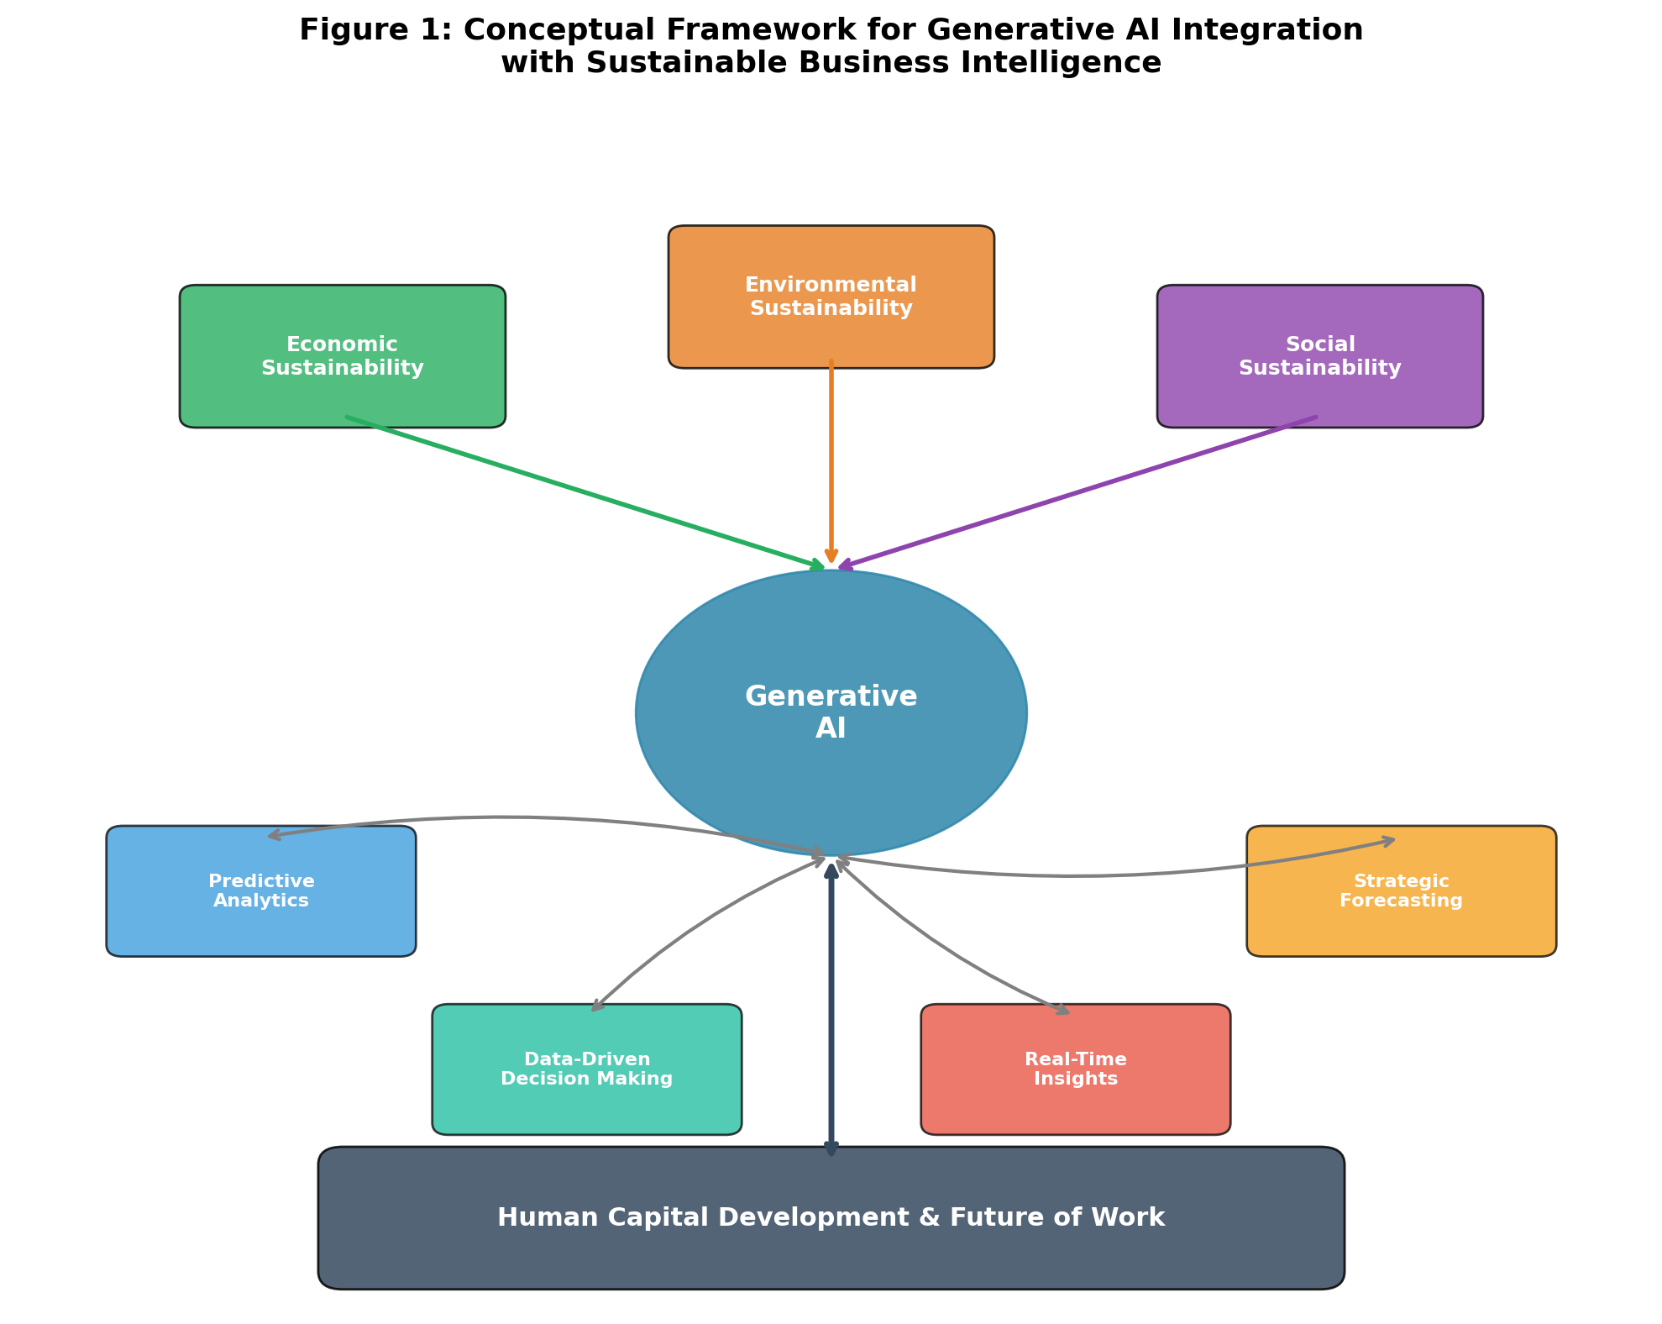
Figure 1: Conceptual Framework for Generative AI Integration with Sustainable Business Intelligence

Furthermore, the integration of generative AI enables what scholars term 'augmented analytics,' where AI systems automatically discover insights, generate hypotheses, and explain complex analytical results in natural language accessible to non-technical stakeholders [20]. This democratization of analytics is particularly significant for sustainability initiatives, which often require cross-functional collaboration and buy-in from diverse organizational stakeholders who may lack technical expertise in data science or environmental accounting [21]. Table 1 summarizes the key capabilities that emerge from integrating generative AI with sustainable business intelligence platforms.
Table 1: Key Capabilities of Generative AI-Integrated Sustainable Business Intelligence
Capability Domain | Traditional BI | AI-Enhanced BI | Sustainability Impact
Data Processing | Structured queries, SQL-based | Multimodal processing, NLP querying | Enables integration of diverse ESG data sources
Insight Generation | Static reports, manual analysis | Automated narrative synthesis, pattern discovery | Real-time sustainability performance monitoring
Scenario Planning | Limited what-if analysis | Generative scenario simulation, synthetic futures | Multi-dimensional sustainability impact modeling
Decision Support | Historical trend analysis | Prescriptive recommendations, causal inference | Triple-bottom-line optimization recommendations
Reporting | Periodic manual reports | Continuous automated reporting, adaptive dashboards | Automated ESG compliance and stakeholder reporting

1.3 Generative AI as an Enabler of Economic, Environmental, and Social Sustainability
Generative AI serves as a powerful enabler across all three pillars of sustainability, creating synergies that traditional approaches could not achieve [22]. From an economic sustainability perspective, generative AI enhances organizational efficiency by automating routine analytical tasks, reducing the time-to-insight cycle, and enabling more accurate demand forecasting and resource optimization [23]. Organizations leveraging generative AI for business intelligence report significant reductions in analytical processing time (averaging 40-60% reduction) and improvements in forecast accuracy (15-25% improvement over traditional methods), directly contributing to economic sustainability through optimized resource allocation and reduced operational waste [24].
Environmental sustainability benefits emerge through multiple pathways. Generative AI can optimize energy consumption patterns in operations, design more efficient supply chain configurations that minimize carbon emissions, and generate innovative solutions for waste reduction and circular economy implementation [25]. For example, generative models can simulate thousands of product design variations to identify configurations that minimize material usage while maintaining performance standards, or generate optimal logistics routes that reduce transportation emissions by 20-35% compared to conventional planning approaches [26]. Additionally, AI-generated sustainability reports and carbon accounting frameworks enable organizations to maintain transparency and accountability in their environmental commitments.
Social sustainability is advanced through generative AI's capacity to enhance inclusive decision-making, identify social inequities in organizational practices, and generate personalized interventions that promote workforce well-being and community engagement [27]. As illustrated in Figure 1, the intertwined nature of these sustainability dimensions means that generative AI interventions in one area frequently create positive spillover effects across others, reinforcing the argument for an integrated approach to AI-enabled sustainability [28]. The economic benefits of improved workforce well-being, the social benefits of environmental stewardship, and the environmental benefits of efficient economic practices collectively demonstrate the multiplicative potential of generative AI when applied through an intertwined sustainability lens.
Moreover, the application of generative AI to sustainability measurement and reporting represents a transformative advancement that addresses longstanding challenges in sustainability accounting [28]. Traditional sustainability reporting is often retrospective, resource-intensive, and limited in scope. Generative AI enables continuous sustainability monitoring by automatically processing real-time data streams from operational systems, supply chain networks, and external environmental databases, generating up-to-date sustainability assessments that inform ongoing decision-making rather than merely documenting past performance. This shift from periodic to continuous sustainability intelligence fundamentally changes how organizations relate to their sustainability commitments, moving from compliance-driven reporting to strategy-integrated sustainability management.

2. Generative AI for Sustainable Human Capital Management
Human capital represents the most valuable and complex asset within any organization, and its effective management is central to achieving sustainable business outcomes [29]. Generative AI introduces transformative capabilities in human capital management (HCM) by enabling unprecedented personalization, predictive workforce analytics, and intelligent automation of talent processes [30]. This section examines how generative AI reshapes workforce analytics, learning and development, and human-AI collaboration paradigms, with particular attention to sustainability implications across these domains.
The World Economic Forum's Future of Jobs Report highlights that by 2027, approximately 44% of workers' core skills will be disrupted, with AI and automation driving the majority of this transformation [39]. This unprecedented pace of skill obsolescence creates both an urgent challenge and a compelling opportunity for generative AI-driven human capital management systems. Organizations that can accurately predict future skill requirements, efficiently develop workforce capabilities, and create adaptive employment relationships will gain significant competitive advantages in talent markets while simultaneously contributing to social sustainability through reduced structural unemployment and enhanced worker employability across career spans.

2.1 AI-Driven Workforce Analytics and Talent Intelligence
Generative AI transforms workforce analytics from a retrospective reporting function into a proactive strategic capability [31]. Traditional HR analytics relied primarily on descriptive metrics such as turnover rates, headcount, and compensation benchmarks. Generative AI enables a paradigm shift toward predictive talent intelligence that can anticipate workforce trends, identify flight risks before they materialize, and generate optimal talent acquisition strategies aligned with organizational sustainability goals [32]. These systems leverage natural language processing to analyze employee sentiment from communication patterns, performance reviews, and engagement surveys, generating nuanced insights that go beyond quantitative metrics to capture qualitative dimensions of workforce experience.
Advanced generative AI systems for workforce analytics also incorporate external labor market intelligence, continuously scanning job postings, industry reports, and skills databases to identify emerging talent trends and competitive dynamics [32]. This external intelligence, combined with internal workforce data, enables organizations to develop anticipatory talent strategies that proactively build capabilities needed for future sustainability challenges. For example, AI systems can identify the growing demand for green skills in the external market and automatically generate recommendations for internal development programs that prepare existing employees for sustainability-focused roles, reducing both recruitment costs and the organizational disruption associated with external hiring.
The ethical deployment of AI-driven workforce analytics requires careful attention to the boundary between legitimate organizational intelligence and inappropriate employee surveillance [35]. Organizations must establish clear data governance protocols that define what employee data can be collected and analyzed, for what purposes, with what consent mechanisms, and with what employee rights to access, challenge, or opt out of AI-driven analytics. The principle of proportionality—ensuring that data collection and analysis are proportionate to legitimate organizational needs—provides a useful ethical guideline for navigating this complex terrain. Organizations that successfully balance analytical ambition with ethical restraint build stronger trust relationships with their workforce, ultimately enabling more effective human-AI collaboration in pursuit of sustainability goals.
The sustainability implications of AI-driven workforce analytics are profound. By predicting and preventing unnecessary turnover, organizations reduce the substantial economic and environmental costs associated with recruitment, onboarding, and knowledge loss [33]. Research indicates that replacing an employee costs between 50-200% of their annual salary, and the carbon footprint associated with recruitment processes (travel, relocation, equipment provisioning) is significant [34]. Generative AI systems that can accurately predict retention risks and generate personalized retention interventions thus contribute simultaneously to economic efficiency and environmental sustainability. The AI-Driven Human Capital Management Ecosystem is depicted in Figure 2, illustrating the flow from AI technologies through HCM processes to sustainability outcomes.

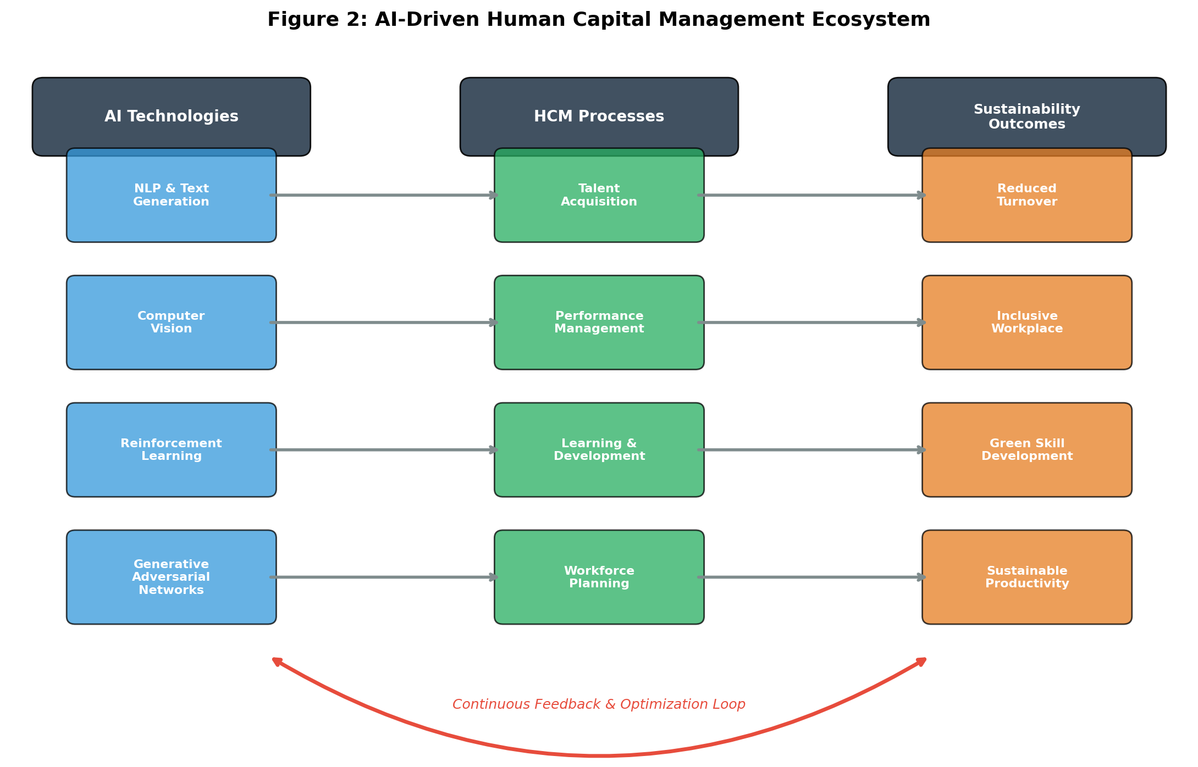
Figure 2: AI-Driven Human Capital Management Ecosystem

Furthermore, generative AI enables diversity, equity, and inclusion (DEI) analytics that move beyond simple demographic reporting to identify systemic biases in talent processes [35]. AI systems can analyze job descriptions for biased language, simulate the diversity outcomes of different recruitment strategies, and generate inclusive policy recommendations based on organizational-specific data patterns. Table 2 presents a comparative analysis of traditional versus AI-driven workforce analytics capabilities and their corresponding sustainability outcomes.
Table 2: Comparative Analysis of Traditional vs. AI-Driven Workforce Analytics
Analytics Dimension | Traditional Approach | Generative AI Approach | Sustainability Outcome
Talent Acquisition | Manual screening, keyword matching | AI-generated candidate profiles, predictive fit scoring | Reduced bias, inclusive hiring
Retention Prediction | Exit interview analysis (reactive) | Real-time sentiment analysis, proactive risk scoring | Reduced turnover costs, knowledge preservation
Performance Management | Annual reviews, static metrics | Continuous AI-generated feedback, dynamic goal adjustment | Enhanced engagement, well-being
Workforce Planning | Historical trend extrapolation | Generative scenario modeling, skills gap prediction | Optimized resource allocation
DEI Analytics | Demographic headcount reporting | Bias detection in processes, inclusive language generation | Social equity advancement
Employee Development | Generic training programs | Personalized AI-curated learning paths | Lifelong learning culture

2.2 Personalized Learning, Upskilling, and Employee Development
Generative AI revolutionizes organizational learning and development by enabling hyper-personalized learning experiences that adapt in real-time to individual learner needs, preferences, and career aspirations [36]. Traditional corporate training programs typically adopt a one-size-fits-all approach, delivering standardized content regardless of individual skill levels, learning styles, or professional goals. Generative AI transforms this paradigm by creating personalized learning content, generating adaptive assessments, and producing individualized development plans that align employee growth with organizational sustainability objectives [37].
The implications for sustainable human capital development are substantial. Personalized AI-driven learning systems demonstrate 40-60% higher engagement rates and 25-35% faster skill acquisition compared to traditional training approaches [38]. This efficiency reduces the environmental impact of training (less travel for in-person sessions, optimized digital resource usage) while maximizing the economic return on learning investments. Moreover, generative AI can specifically target sustainability-related skills development, creating personalized pathways for employees to develop competencies in areas such as circular economy thinking, carbon literacy, sustainable supply chain management, and ethical AI governance [39].
Generative AI also enables the creation of immersive learning experiences through synthetic content generation, including realistic case studies, simulated business scenarios, and AI-generated mentoring conversations that provide safe spaces for skill practice [40]. These capabilities are particularly valuable for developing sustainability leadership competencies, where real-world learning opportunities may be limited or high-stakes. By generating realistic scenarios involving sustainability dilemmas, resource optimization challenges, and stakeholder engagement situations, AI-powered learning systems prepare employees for the complex decision-making required in sustainable business contexts.
The economic implications of AI-driven personalized learning are equally significant from a sustainability perspective [40]. Organizations investing in generative AI-powered learning platforms report average returns of 300-400% on their learning technology investments, measured through improved productivity, reduced time-to-competency, and enhanced innovation outputs. Furthermore, AI-enabled learning analytics provide unprecedented visibility into organizational skill development patterns, enabling data-driven decisions about learning investment allocation that maximize both individual development outcomes and collective organizational capability building. The ability to generate customized content on demand also eliminates the substantial costs and environmental impacts associated with traditional training material development, printing, and distribution.

2.3 Human-AI Collaboration and the Future of Work
The future of work in the context of generative AI is not characterized by wholesale automation but rather by the emergence of collaborative human-AI partnerships that leverage the complementary strengths of human creativity and AI computational power [41]. This collaborative paradigm, often termed 'augmented intelligence,' positions AI as a cognitive partner that enhances human decision-making rather than replacing it [42]. In the context of sustainable business intelligence, human-AI collaboration enables more comprehensive consideration of sustainability factors in organizational decisions, as AI systems can process and synthesize sustainability data at scales impossible for human analysts alone.
Research increasingly demonstrates that the most effective organizational outcomes emerge not from full automation or purely human decision-making, but from carefully designed human-AI collaboration frameworks that assign tasks based on the relative strengths of each partner [43]. Humans contribute ethical judgment, contextual understanding, creative problem-solving, and stakeholder empathy, while AI contributes data processing speed, pattern recognition across vast datasets, scenario generation, and consistent application of complex analytical frameworks [44]. For sustainability-related decisions, this collaboration is particularly valuable because sustainability challenges often require both quantitative analysis (AI strength) and qualitative ethical judgment (human strength).
The organizational design implications of human-AI collaboration for sustainability are significant. New roles are emerging, including AI sustainability coordinators, human-AI team leaders, and AI ethics officers, reflecting the need for dedicated human oversight of AI-driven sustainability initiatives [45]. As shown in Figure 2, the feedback loop between AI technologies, HCM processes, and sustainability outcomes requires continuous human oversight to ensure alignment with organizational values and stakeholder expectations. Organizations that successfully implement human-AI collaboration frameworks report 30-50% improvements in sustainability metric achievement compared to those relying solely on either human or automated approaches [46].
The psychological dimensions of human-AI collaboration also warrant careful attention in the context of sustainable business intelligence [46]. Research on trust in AI systems reveals that employees' willingness to rely on AI-generated insights for sustainability decisions depends on factors including perceived AI competence, transparency of AI reasoning, organizational culture around technology adoption, and individual digital self-efficacy. Building appropriate levels of trust—neither blind over-reliance nor unwarranted skepticism—requires carefully designed onboarding processes, ongoing education about AI capabilities and limitations, and organizational cultures that encourage constructive questioning of both human and AI-generated recommendations. The goal is calibrated trust that enables effective collaboration while maintaining healthy human oversight of AI-driven sustainability initiatives.

3. Challenges, Risks, and Responsible Implementation
While the potential of generative AI for sustainable business intelligence and human capital management is substantial, its implementation is fraught with significant challenges and risks that must be carefully managed [47]. These challenges span technical, ethical, organizational, and societal dimensions, requiring a comprehensive risk management approach that considers both immediate operational risks and longer-term systemic implications. This section examines the primary challenges across three interconnected domains: data privacy and algorithmic bias, governance and accountability, and organizational readiness.
A comprehensive risk management approach must also consider the interconnected nature of these challenges, recognizing that failures in one domain often cascade into others [47]. For example, algorithmic bias in workforce analytics (an ethical challenge) can erode employee trust (a governance challenge), trigger regulatory action (a compliance challenge), and exacerbate workforce resistance (an organizational readiness challenge). This interconnectedness demands integrated risk management strategies that address root causes rather than symptoms, and that consider the full spectrum of potential cascading effects when evaluating and mitigating individual risks. The complexity of this risk landscape is captured in Figure 3, which maps the relative likelihood and impact severity of key implementation challenges.

3.1 Data Privacy, Algorithmic Bias, and Ethical Challenges
Data privacy represents perhaps the most immediate and pressing challenge in deploying generative AI for business intelligence and human capital management [48]. Generative AI systems require vast quantities of training data, including potentially sensitive employee information, behavioral patterns, communication content, and performance metrics. The collection, storage, and processing of such data raises fundamental questions about employee privacy rights, informed consent, and the boundaries of organizational surveillance [49]. Regulatory frameworks such as the EU's General Data Protection Regulation (GDPR) and emerging AI-specific legislation impose strict requirements on how organizations can collect, process, and utilize personal data in AI systems, creating compliance challenges that are particularly acute in HR and workforce analytics contexts.
Algorithmic bias presents an equally critical challenge, particularly in human capital applications where biased AI outputs can perpetuate or amplify existing workplace inequities [50]. Generative AI models trained on historical data inevitably encode the biases present in that data, potentially generating biased recruitment recommendations, performance assessments, or development opportunities that disadvantage certain demographic groups [1]. The challenge is compounded by the opacity of large generative models, which makes it difficult to identify, diagnose, and remediate bias in AI-generated outputs. Research has documented cases where AI recruitment tools systematically disadvantaged women, older workers, and racial minorities, highlighting the critical importance of bias detection and mitigation strategies in AI-driven HCM systems [2].
The ethical dimensions extend beyond privacy and bias to encompass broader questions about the appropriate role of AI in decisions affecting human livelihoods and well-being [3]. When generative AI is used to generate performance feedback, recommend terminations, or design restructuring plans, fundamental ethical questions arise about accountability, fairness, and the preservation of human dignity in organizational contexts. The risk assessment matrix presented in Figure 3 provides a visual framework for understanding the relative likelihood and severity of various implementation risks.
The intersection of data privacy and sustainability creates unique challenges that require specialized governance approaches [49]. Sustainability analytics often require data sharing across organizational boundaries—with supply chain partners, regulatory bodies, and industry consortia—creating complex data governance challenges that multiply privacy risks. Generative AI systems processing shared sustainability data must navigate multiple jurisdictional privacy requirements, varying consent frameworks, and diverse organizational data policies. Emerging approaches such as federated learning and differential privacy offer technical solutions that enable collaborative AI-driven sustainability analytics while preserving data privacy, but these technologies are still maturing and require significant expertise to implement effectively in complex multi-stakeholder environments.

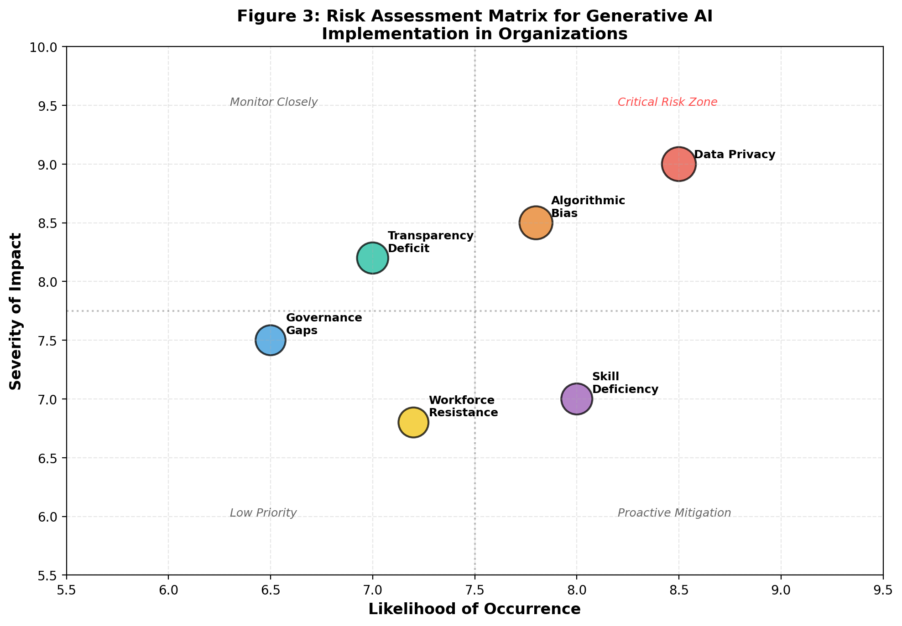
Figure 3: Risk Assessment Matrix for Generative AI Implementation in Organizations

3.2 AI Governance, Transparency, Accountability, and Trust
Effective governance of generative AI systems requires robust frameworks that ensure transparency, accountability, and trust across all stakeholder groups [4]. AI governance in the context of sustainable business intelligence encompasses the policies, processes, and structures that guide the development, deployment, and monitoring of AI systems to ensure they align with organizational values, ethical standards, and sustainability objectives [5]. The challenge is particularly acute for generative AI, whose outputs are often novel and unpredictable, making traditional quality control and compliance mechanisms insufficient.
Transparency in generative AI systems operates at multiple levels: algorithmic transparency (understanding how models generate outputs), data transparency (clarity about training data sources and potential biases), decision transparency (clear communication about when and how AI influences decisions), and outcome transparency (honest reporting of AI system performance including failures) [6]. Achieving meaningful transparency is complicated by the inherent complexity of large generative models, which often function as 'black boxes' even to their developers. Explainable AI (XAI) techniques offer partial solutions, but significant challenges remain in making generative AI outputs fully interpretable to non-technical stakeholders [7].
Trust-building in generative AI systems for sustainable business intelligence requires deliberate organizational strategies that go beyond technical transparency measures [7]. Research on organizational trust suggests that trust in AI systems develops through repeated positive interactions, consistency of performance, and alignment between AI outputs and stakeholder expectations. Organizations must invest in building trust infrastructure that includes regular AI performance reporting, clear escalation pathways for disputed AI recommendations, human-in-the-loop verification for high-stakes decisions, and ongoing stakeholder education about AI capabilities and limitations. The challenge is particularly acute in sustainability contexts, where incorrect AI-generated assessments could lead to greenwashing allegations, regulatory penalties, or genuine environmental harm if undetected.
Accountability frameworks must clearly delineate responsibility for AI-generated outputs and their consequences. When a generative AI system produces a biased recruitment recommendation or an inaccurate sustainability report, determining accountability among developers, deployers, and organizational decision-makers requires clear governance structures [8]. Table 3 presents a comprehensive AI governance framework that addresses transparency, accountability, and trust across different organizational levels and stakeholder groups.
Table 3: Comprehensive AI Governance Framework for Sustainable Business Intelligence
Governance Dimension | Organizational Level | Key Mechanisms | Success Metrics
Algorithmic Transparency | Technical/Data Science | Model documentation, XAI tools, audit trails | Explainability score, audit completion rate
Data Governance | Enterprise-wide | Data lineage tracking, consent management, privacy-by-design | Compliance rate, data quality index
Accountability Structures | Executive/Board | AI ethics committees, clear RACI matrices, incident protocols | Response time, resolution effectiveness
Stakeholder Trust | External/Community | Public reporting, stakeholder engagement, third-party audits | Trust indices, stakeholder satisfaction
Continuous Monitoring | Operational | Bias detection dashboards, performance drift alerts, feedback loops | Detection rate, time-to-remediation

3.3 Organizational Readiness, Workforce Resistance, and Digital Skill Gaps
Organizational readiness for generative AI adoption extends far beyond technological infrastructure to encompass cultural, structural, and human capability dimensions [9]. Research consistently identifies organizational culture, leadership commitment, and workforce capabilities as more significant predictors of successful AI adoption than technical factors alone [10]. Many organizations lack the data literacy, analytical culture, and change management capabilities necessary to effectively leverage generative AI for sustainable business intelligence, creating a significant readiness gap between AI potential and organizational capacity.
Workforce resistance to AI adoption represents a critical human capital challenge that can undermine even well-designed implementation strategies [11]. Resistance typically stems from multiple sources: fear of job displacement, concerns about surveillance and privacy, skepticism about AI accuracy and fairness, and attachment to established work practices [12]. Addressing these concerns requires transparent communication about AI's role (augmentation rather than replacement), meaningful involvement of employees in AI design and governance processes, and clear demonstrations of how AI adoption benefits workers individually and collectively. Organizations that fail to address workforce resistance effectively experience 40-60% higher AI project failure rates compared to those with comprehensive change management strategies [13].
Effective change management for AI adoption in sustainable business intelligence requires a multi-faceted approach that addresses cognitive, emotional, and behavioral dimensions of workforce adaptation [13]. Cognitive interventions focus on building understanding of AI capabilities and limitations through training and education programs. Emotional interventions address anxiety, fear, and uncertainty through transparent communication, psychological safety initiatives, and clear articulation of how AI augments rather than threatens employment. Behavioral interventions provide structured opportunities for hands-on experimentation with AI tools in low-stakes environments, building confidence and competence gradually. Organizations that integrate all three dimensions into their change management strategies report significantly higher adoption rates and more positive employee attitudes toward AI-enabled sustainability initiatives.
The digital skill gap represents perhaps the most fundamental barrier to generative AI adoption for sustainable business intelligence. Effective utilization of generative AI requires not only technical skills in data science and AI but also hybrid competencies that combine domain expertise, critical thinking, ethical reasoning, and AI literacy [14]. The challenge is particularly acute in sustainability contexts, where professionals must combine environmental science knowledge, social impact assessment capabilities, and AI proficiency—a combination that remains exceedingly rare in the current labor market [15]. As shown in Figure 3, workforce skill deficiency represents a high-likelihood risk that requires proactive mitigation through comprehensive upskilling programs and talent development strategies. Organizations must invest significantly in building internal AI capabilities while simultaneously developing the sustainability expertise necessary to guide AI systems toward genuinely sustainable outcomes.

4. Future Directions for Integrated AI, Sustainability, and Human Capital
The trajectory of generative AI development, combined with escalating sustainability imperatives and evolving workforce dynamics, points toward a future characterized by deep integration of AI capabilities with sustainability strategy and human capital development [16]. This section explores emerging trends and future directions across three interconnected domains: AI-enabled sustainable decision-making, generative AI for green innovation and circular business models, and future research directions for human-centric and sustainable AI ecosystems.

4.1 AI-Enabled Decision-Making for Sustainable Enterprises
The future of organizational decision-making will be characterized by AI systems that seamlessly integrate sustainability considerations into every strategic and operational decision [17]. Current decision support systems treat sustainability as a separate analytical dimension, often considered after primary business decisions have been made. Future generative AI systems will embed sustainability logic directly into decision algorithms, ensuring that economic, environmental, and social implications are simultaneously considered and optimized [18]. This represents a fundamental shift from sustainability as an afterthought or constraint to sustainability as an integral component of value creation logic.
Emerging developments in autonomous decision-making agents powered by generative AI suggest a future where AI systems can independently execute routine sustainability-related decisions within predefined parameters [19]. For example, AI agents could automatically adjust supply chain configurations to optimize carbon emissions, reallocate resources to minimize waste, or adjust pricing to reflect true environmental costs—all without requiring human intervention for each individual decision. However, this autonomy must be carefully bounded by robust governance frameworks and human oversight mechanisms to ensure alignment with organizational values and stakeholder expectations [20].
The concept of 'sustainable AI decision twins'—digital replicas of organizational decision processes that simulate sustainability outcomes—represents another promising future direction [21]. These systems would enable organizations to test the sustainability implications of strategic decisions before implementation, generating synthetic scenarios that model long-term environmental, social, and economic impacts under various assumptions and constraints. Table 4 provides a comprehensive overview of emerging AI-enabled decision-making capabilities and their projected timelines for mainstream adoption.
Table 4: Emerging AI-Enabled Capabilities for Sustainable Enterprise Decision-Making
Emerging Capability | Technology Enablers | Projected Timeline | Expected Impact
Autonomous Sustainability Agents | Multi-agent LLMs, reinforcement learning | 2025-2027 | Real-time sustainability optimization without human intervention
Sustainable Decision Twins | Digital twins, generative simulation | 2026-2028 | Pre-implementation impact assessment for all strategic decisions
Cross-Enterprise AI Collaboration | Federated learning, blockchain | 2027-2030 | Industry-wide sustainability optimization and knowledge sharing
Adaptive ESG Intelligence | Continuous learning AI, sensor fusion | 2025-2027 | Dynamic ESG monitoring and automated compliance adjustment
Human-AI Ethical Reasoning | Value alignment AI, moral reasoning models | 2028-2032 | Ethical sustainability decisions at organizational scale
Regenerative AI Systems | Bio-inspired AI, ecological modeling | 2030-2035 | Net-positive environmental impact through AI-designed interventions

4.2 Generative AI, Green Innovation, and Circular Business Models
Generative AI holds transformative potential for accelerating green innovation and enabling the transition to circular business models [22]. By generating novel material compositions, product designs, and process configurations, generative AI can dramatically accelerate the innovation cycle for sustainable products and services [23]. For instance, generative design algorithms can explore millions of possible product configurations to identify those that minimize environmental impact while meeting performance and cost requirements—a capability that would take human designers years of iterative experimentation to achieve through traditional methods.
The role of generative AI in driving circular economy innovation extends to supply chain transformation, where AI systems can map material flows across complex global networks, identify waste streams suitable for valorization, and generate optimal reverse logistics configurations that minimize transportation costs and emissions while maximizing material recovery rates [24]. These capabilities are particularly valuable in manufacturing-intensive industries where material costs and environmental regulations create strong incentives for circular practices. Generative AI can simulate thousands of supply chain configurations to identify those that optimize both economic returns and environmental performance, enabling organizations to transition from linear to circular business models with quantified confidence in projected outcomes. The synthesis of these applications demonstrates the transformative potential of generative AI as an accelerator of sustainable innovation across industries and value chains.
The application of generative AI to circular economy implementation represents a particularly promising area of future development [24]. Circular business models require complex optimization across multiple dimensions—product longevity, recyclability, remanufacturing feasibility, and reverse logistics efficiency—that are ideally suited to AI-driven analysis and optimization [25]. Generative AI can model the full lifecycle of products and materials, identify optimal circular pathways, and generate innovative business model configurations that maximize material recirculation while maintaining economic viability. The future roadmap for these developments is illustrated in Figure 4, which presents a timeline of expected technological milestones and their corresponding human capital development requirements.

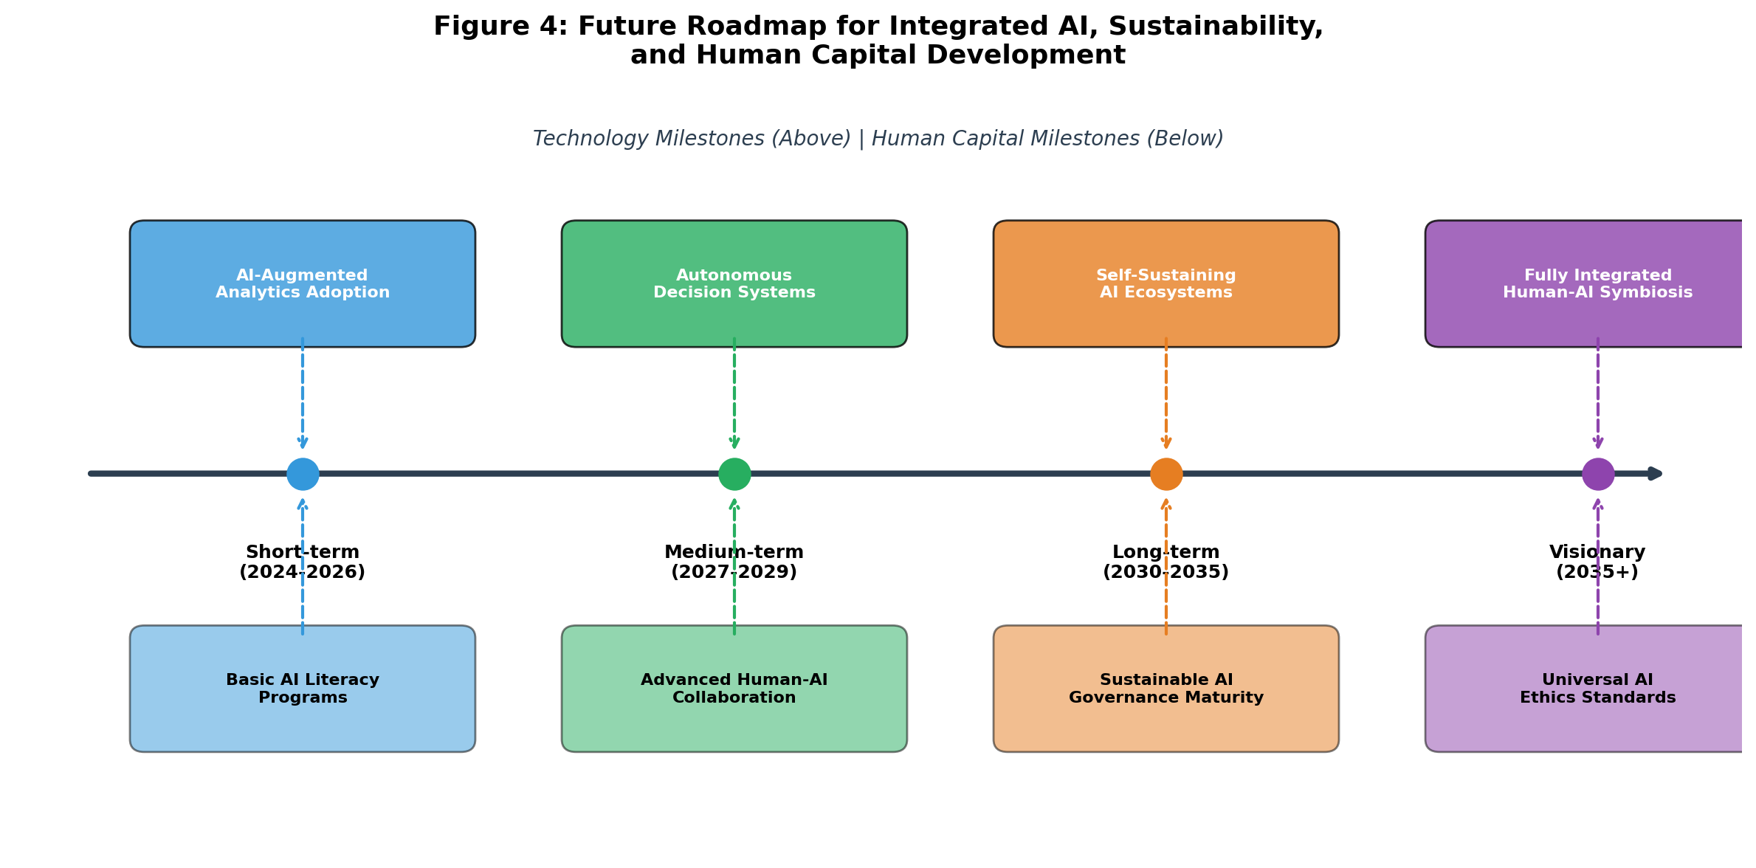
Figure 4: Future Roadmap for Integrated AI, Sustainability, and Human Capital Development

Furthermore, generative AI enables 'green by design' approaches where sustainability is embedded into the innovation process from inception rather than retrofitted after development [26]. AI systems can generate product concepts that are inherently sustainable, identifying material substitutions that reduce environmental impact, designing for disassembly and recycling, and optimizing manufacturing processes to minimize waste and energy consumption. This proactive approach to sustainable innovation, enabled by generative AI's capacity to explore vast design spaces rapidly and systematically, represents a fundamental advancement over traditional sustainability engineering approaches that typically involve incremental improvements to existing designs [27].
The intersection of generative AI with biomimicry and nature-inspired design represents an especially promising frontier for sustainable innovation [27]. Generative AI systems trained on biological databases can identify natural design principles and material configurations that have evolved over millions of years to optimize resource efficiency and environmental adaptation. By applying these nature-inspired insights to industrial design challenges, generative AI can produce solutions that are not merely less harmful but genuinely regenerative—contributing positively to ecological systems rather than simply minimizing negative impacts. This bio-inspired approach to AI-driven innovation represents perhaps the most transformative long-term application of generative AI for environmental sustainability, pointing toward a future where human industrial systems operate in harmony with natural ecosystems rather than in opposition to them.

4.3 Future Research Directions for Human-Centric and Sustainable AI Ecosystems
The convergence of generative AI, sustainability, and human capital management opens numerous avenues for future research that can advance both theoretical understanding and practical implementation [28]. First, longitudinal studies examining the long-term impacts of generative AI adoption on workforce well-being, skill development trajectories, and job quality are critically needed [29]. While current research provides valuable cross-sectional insights, understanding the dynamic evolution of human-AI work systems over time requires sustained empirical investigation across multiple organizational contexts and cultural settings.
Second, research into AI value alignment—ensuring that generative AI systems consistently produce outputs aligned with human values and sustainability principles—represents a fundamental technical and philosophical challenge that requires interdisciplinary collaboration between computer scientists, ethicists, sustainability scientists, and organizational scholars [30]. Current alignment techniques are insufficient for ensuring that AI systems maintain consistent commitment to sustainability values across diverse decision contexts, particularly when economic incentives conflict with environmental or social objectives [31].
Third, the development of metrics and measurement frameworks for evaluating the sustainability impacts of AI systems themselves represents an urgent research priority [32]. Generative AI systems have substantial environmental footprints (energy consumption, water usage for cooling, electronic waste) that must be weighed against their sustainability benefits [33]. Research developing comprehensive lifecycle assessment frameworks for AI systems—accounting for both their direct environmental costs and their indirect sustainability contributions—is essential for ensuring that AI-driven sustainability initiatives generate genuine net positive impacts rather than merely shifting environmental burdens across domains or time horizons.
The computational sustainability of generative AI itself represents a critical area requiring immediate attention from both researchers and practitioners [33]. Training large language models can consume energy equivalent to the lifetime emissions of multiple automobiles, and the rapid proliferation of AI applications compounds this environmental cost significantly. Research into efficient AI architectures, green computing practices, and renewable energy-powered data centers is essential for ensuring that the environmental benefits generated by AI-driven sustainability applications genuinely exceed the environmental costs of the AI systems themselves. Techniques such as model distillation, efficient fine-tuning, and edge computing deployment offer promising pathways for reducing the environmental footprint of generative AI while maintaining or improving performance on sustainability-related tasks.
Fourth, future research should explore the design of inclusive and equitable AI ecosystems that ensure the benefits of generative AI for sustainability are distributed fairly across organizations, communities, and nations [34]. Current patterns of AI development and deployment risk concentrating benefits among technologically advanced organizations and nations while imposing costs and risks on those less equipped to develop or govern AI systems [35]. Research into democratized AI architectures, open-source sustainability AI tools, and capacity-building frameworks for developing nations is essential for ensuring that AI-driven sustainability represents a truly global and inclusive endeavor rather than a new dimension of technological inequality.
Finally, as depicted in Figure 4, the long-term vision for human-centric and sustainable AI ecosystems requires research into fundamentally new paradigms of human-AI interaction that go beyond current augmentation models [36]. Future research should explore concepts such as collective human-AI intelligence for sustainability governance, AI-mediated stakeholder deliberation processes, and regenerative AI systems designed to contribute positively to ecological and social systems rather than merely minimizing negative impacts [37]. These ambitious research directions require sustained interdisciplinary collaboration and significant investment in both fundamental research and applied experimentation across diverse organizational and societal contexts.
The integration of generative AI with emerging technologies such as blockchain, Internet of Things (IoT), and quantum computing presents additional opportunities for advancing sustainable business intelligence and human capital management [36]. Blockchain technology can provide immutable audit trails for AI-generated sustainability reports, enhancing trust and accountability. IoT sensors can provide real-time data feeds that enable generative AI to produce dynamic sustainability assessments reflecting current operational conditions rather than historical averages. Quantum computing, though still in early stages, promises to dramatically expand the computational capacity available for sustainability optimization problems, enabling AI systems to consider exponentially more variables and constraints in generating sustainable solutions. The convergence of these technologies with generative AI will likely define the next frontier of sustainable business intelligence, creating capabilities that fundamentally transform how organizations measure, manage, and advance their sustainability performance.

Conclusion
This chapter has examined the multifaceted intersection of generative AI, sustainable business intelligence, and human capital management, revealing both transformative opportunities and significant challenges [38]. The analysis demonstrates that generative AI, when strategically deployed within an intertwined sustainability framework, can simultaneously advance economic efficiency, environmental stewardship, and social equity while transforming how organizations develop and leverage human capital. The conceptual framework presented in Figure 1 illustrates how these domains interconnect through generative AI capabilities, creating synergistic effects that exceed the sum of individual interventions.
The chapter has identified several critical success factors for organizations seeking to leverage generative AI for sustainable business intelligence and human capital development [39]. First, organizations must adopt holistic approaches that simultaneously address technological capabilities, governance frameworks, and workforce development rather than pursuing AI adoption in isolation from sustainability strategy [40]. Second, robust governance mechanisms including transparency, accountability, and stakeholder engagement are essential for maintaining trust and ensuring that AI systems genuinely serve sustainability objectives rather than merely providing efficiency gains that may come at environmental or social costs [41].
Third, investment in human capital development—particularly in hybrid competencies that combine AI literacy with sustainability expertise and ethical reasoning—is fundamental to realizing the potential of generative AI for sustainable business intelligence [42]. The human-AI collaboration paradigm described in this chapter requires workers who can effectively partner with AI systems, critically evaluate AI-generated outputs, and provide the ethical judgment and contextual understanding that current AI systems lack [43]. Organizations that neglect this human dimension risk implementing powerful AI systems that produce technically sophisticated but ethically or sustainability-misaligned outcomes.
The implications for policy and practice are equally significant [43]. Policymakers must develop regulatory frameworks that encourage responsible AI innovation for sustainability while preventing harmful applications and ensuring equitable access to AI-driven sustainability tools across organizations of all sizes and geographies. Industry bodies should establish standards for AI-driven sustainability reporting that ensure comparability, reliability, and transparency of AI-generated sustainability assessments. Educational institutions must redesign curricula to produce graduates capable of operating effectively in human-AI collaborative environments, with strong foundations in both technical AI literacy and sustainability science. The successful realization of generative AI's potential for sustainable business intelligence and human capital management ultimately depends on coordinated action across these multiple institutional domains.
Looking forward, the roadmap presented in Figure 4 suggests that the integration of generative AI with sustainability and human capital will deepen significantly over the coming decade, moving from current augmentation-focused applications toward more autonomous and integrated AI-sustainability systems [44]. However, realizing this vision requires continued research, policy development, and organizational experimentation to address the substantial technical, ethical, and social challenges that remain [45]. The future belongs to organizations that can navigate these challenges effectively, building AI capabilities that are simultaneously powerful, sustainable, and human-centric.
In summary, this chapter contributes to the growing body of literature on generative AI and sustainability by presenting an integrated framework that explicitly connects AI capabilities with sustainability outcomes through the mediating role of human capital development [44]. The framework acknowledges that technology alone is insufficient for achieving sustainability goals; rather, it is the combination of advanced AI capabilities, well-designed governance structures, and appropriately skilled and empowered human workforces that creates the conditions for genuinely sustainable organizational transformation [45]. As generative AI continues to evolve at an extraordinary pace, maintaining this integrated perspective—simultaneously advancing technological capabilities, governance maturity, and human development—will be essential for ensuring that AI serves as a force for comprehensive sustainability rather than merely a tool for narrow efficiency optimization.

References
[1] Dwivedi, Y.K., Kshetri, N., Hughes, L., Slade, E.L., Jeyaraj, A., Kar, A.K., et al. (2023). Opinion paper: So what if ChatGPT wrote it? Multidisciplinary perspectives on opportunities, challenges, and implications of generative conversational AI for research, practice, and policy. International Journal of Information Management, 71, 102642.
[2] George, A.S., & George, A.H. (2023). A review of ChatGPT AI's impact on several business sectors. Partners Universal International Innovation Journal, 1(1), 9-23.
[3] Mikalef, P., & Gupta, M. (2021). Artificial intelligence capability: Conceptualization, measurement calibration, and empirical study on its impact on organizational creativity and firm performance. Information & Management, 58(3), 103434.
[4] Serafeim, G. (2020). Social-impact efforts that create real value. Harvard Business Review, 98(5), 38-48.
[5] Bag, S., Pretorius, J.H.C., Gupta, S., & Dwivedi, Y.K. (2021). Role of institutional pressures and resources in the adoption of big data analytics powered artificial intelligence, sustainable manufacturing practices, and circular economy capabilities. Technological Forecasting and Social Change, 163, 120420.
[6] Goodfellow, I., Pouget-Abadie, J., Mirza, M., Xu, B., Warde-Farley, D., Ozair, S., et al. (2014). Generative adversarial nets. Advances in Neural Information Processing Systems, 27, 2672-2680.
[7] Vaswani, A., Shazeer, N., Parmar, N., Uszkoreit, J., Jones, L., Gomez, A.N., et al. (2017). Attention is all you need. Advances in Neural Information Processing Systems, 30, 5998-6008.
[8] Bommasani, R., Hudson, D.A., Adeli, E., Altman, R., Arora, S., von Arx, S., et al. (2022). On the opportunities and risks of foundation models. arXiv preprint arXiv:2108.07258.
[9] Frid-Adar, M., Diamant, I., Klang, E., Amitai, M., Goldberger, J., & Greenspan, H. (2018). GAN-based synthetic medical image augmentation for increased CNN performance in liver lesion classification. Neurocomputing, 321, 321-331.
[10] Brown, T.B., Mann, B., Ryder, N., Subbiah, M., Kaplan, J., Dhariwal, P., et al. (2020). Language models are few-shot learners. Advances in Neural Information Processing Systems, 33, 1877-1901.
[11] OpenAI. (2023). GPT-4 technical report. arXiv preprint arXiv:2303.08774.
[12] Davenport, T.H., & Ronanki, R. (2018). Artificial intelligence for the real world. Harvard Business Review, 96(1), 108-116.
[13] Barney, J.B., & Hesterly, W.S. (2019). Strategic Management and Competitive Advantage: Concepts and Cases (6th ed.). Pearson.
[14] Teece, D.J. (2018). Dynamic capabilities as (workable) management systems theory. Journal of Management & Organization, 24(3), 359-368.
[15] Sharma, R., Mithas, S., & Kankanhalli, A. (2014). Transforming decision-making processes: A research agenda for understanding the impact of business analytics on organisations. European Journal of Information Systems, 23(4), 433-441.
[16] Ransbotham, S., Khodabandeh, S., Kiron, D., Candelon, F., Chu, M., & LaFountain, B. (2020). Expanding AI's impact with organizational learning. MIT Sloan Management Review, 62(1), 1-17.
[17] Davenport, T.H. (2018). The AI Advantage: How to Put the Artificial Intelligence Revolution to Work. MIT Press.
[18] Vinuesa, R., Azizpour, H., Leite, I., Balaam, M., Dignum, V., Domisch, S., et al. (2020). The role of artificial intelligence in achieving the Sustainable Development Goals. Nature Communications, 11(1), 233.
[19] Nishant, R., Kennedy, M., & Corbett, J. (2020). Artificial intelligence for sustainability: Challenges, opportunities, and a research agenda. International Journal of Information Management, 53, 102104.
[20] Gartner. (2023). Top Strategic Technology Trends 2024: AI-Augmented Development. Gartner Research.
[21] Seddon, P.B., Constantinidis, D., Tamm, T., & Dod, H. (2017). How does business analytics contribute to business value? Information Systems Journal, 27(3), 237-269.
[22] Kaack, L.H., Donti, P.L., Strubell, E., Kamiya, G., Creutzig, F., & Rolnick, D. (2022). Aligning artificial intelligence with climate change mitigation. Nature Climate Change, 12(6), 518-527.
[23] Brynjolfsson, E., & McAfee, A. (2017). The business of artificial intelligence. Harvard Business Review, 7(7), 1-20.
[24] McKinsey Global Institute. (2023). The Economic Potential of Generative AI: The Next Productivity Frontier. McKinsey & Company.
[25] Rolnick, D., Donti, P.L., Kaack, L.H., Kochanski, K., Lacoste, A., Sankaran, K., et al. (2022). Tackling climate change with machine learning. ACM Computing Surveys, 55(2), 1-96.
[26] Strubell, E., Ganesh, A., & McCallum, A. (2019). Energy and policy considerations for deep learning in NLP. Proceedings of the 57th Annual Meeting of the Association for Computational Linguistics, 3645-3650.
[27] Floridi, L., Cowls, J., Beltrametti, M., Chatila, R., Chazerand, P., Dignum, V., et al. (2018). AI4People—An ethical framework for a good AI society: Opportunities, risks, principles, and recommendations. Minds and Machines, 28(4), 689-707.
[28] Elkington, J. (2018). 25 years ago I coined the phrase 'triple bottom line.' Here's why it's time to rethink it. Harvard Business Review, 25, 2-5.
[29] Becker, G.S. (1993). Human Capital: A Theoretical and Empirical Analysis, with Special Reference to Education (3rd ed.). University of Chicago Press.
[30] Tambe, P., Cappelli, P., & Yakubovich, V. (2019). Artificial intelligence in human resources management: Challenges and a path forward. California Management Review, 61(4), 15-42.
[31] Chowdhury, S., Dey, P., Joel-Edgar, S., Bhatt, S., Ghosh, O., Khari, N., et al. (2023). Unlocking the value of artificial intelligence in human resource management through AI capability framework. Human Resource Management Review, 33(1), 100899.
[32] Marler, J.H., & Boudreau, J.W. (2017). An evidence-based review of HR Analytics. The International Journal of Human Resource Management, 28(1), 3-26.
[33] Allen, D.G., Bryant, P.C., & Vardaman, J.M. (2010). Retaining talent: Replacing misconceptions with evidence-based strategies. Academy of Management Perspectives, 24(2), 48-64.
[34] Society for Human Resource Management. (2022). Retaining Talent: A Guide to Analyzing and Managing Employee Turnover. SHRM Foundation.
[35] Raghavan, M., Barocas, S., Kleinberg, J., & Levy, K. (2020). Mitigating bias in algorithmic hiring: Evaluating claims and practices. Proceedings of the 2020 Conference on Fairness, Accountability, and Transparency, 469-481.
[36] Popenici, S.A., & Kerr, S. (2017). Exploring the impact of artificial intelligence on teaching and learning in higher education. Research and Practice in Technology Enhanced Learning, 12(1), 1-13.
[37] Agrawal, A., Gans, J., & Goldfarb, A. (2022). Power and Prediction: The Disruptive Economics of Artificial Intelligence. Harvard Business Review Press.
[38] Bersin, J. (2023). The Role of Generative AI in HR: How AI Will Transform Every HR Practice. Josh Bersin Company Research.
[39] World Economic Forum. (2023). Future of Jobs Report 2023. World Economic Forum, Geneva.
[40] Collings, D.G., Mellahi, K., & Cascio, W.F. (2019). Global talent management and performance in multinational enterprises: A multilevel perspective. Journal of Management, 45(2), 540-566.
[41] Daugherty, P.R., & Wilson, H.J. (2018). Human + Machine: Reimagining Work in the Age of AI. Harvard Business Review Press.
[42] Raisch, S., & Krakowski, S. (2021). Artificial intelligence and management: The automation-augmentation paradox. Academy of Management Review, 46(1), 192-210.
[43] Jarrahi, M.H. (2018). Artificial intelligence and the future of work: Human-AI symbiosis in organizational decision making. Business Horizons, 61(4), 577-586.
[44] Dellermann, D., Ebel, P., Soellner, M., & Leimeister, J.M. (2019). Hybrid intelligence. Business & Information Systems Engineering, 61(5), 637-643.
[45] Makridakis, S. (2017). The forthcoming Artificial Intelligence (AI) revolution: Its impact on society and firms. Futures, 90, 46-60.
[46] Ransbotham, S., Kiron, D., Gerbert, P., & Reeves, M. (2017). Reshaping business with artificial intelligence: Closing the gap between ambition and action. MIT Sloan Management Review, 59(1), 1-17.
[47] Jobin, A., Ienca, M., & Vayena, E. (2019). The global landscape of AI ethics guidelines. Nature Machine Intelligence, 1(9), 389-399.
[48] Mittelstadt, B.D., Allo, P., Taddeo, M., Wachter, S., & Floridi, L. (2016). The ethics of algorithms: Mapping the debate. Big Data & Society, 3(2), 2053951716679679.
[49] Zuboff, S. (2019). The Age of Surveillance Capitalism: The Fight for a Human Future at the New Frontier of Power. PublicAffairs.
[50] Obermeyer, Z., Powers, B., Vogeli, C., & Mullainathan, S. (2019). Dissecting racial bias in an algorithm used to manage the health of populations. Science, 366(6464), 447-453.

