AI-Based System Modeling and Simulation Techniques in Energy Systems

Abstract
The increasing complexity of modern energy systems, driven by the integration of renewable energy sources, distributed generation, energy storage, and demand-side participation, necessitates advanced modeling and simulation methodologies capable of capturing nonlinear dynamics, uncertainties, and multi-scale interactions. Artificial intelligence (AI) techniques—including machine learning, deep learning, reinforcement learning, and physics-informed neural networks—have emerged as powerful tools for energy system modeling, offering enhanced prediction accuracy, computational efficiency, and adaptability compared to conventional approaches. This chapter provides a comprehensive examination of AI-based system modeling and simulation techniques applied to energy systems, encompassing foundational modeling paradigms, advanced deep learning architectures, hybrid AI-physics models, and optimization frameworks for energy management. Applications spanning load forecasting, renewable energy prediction, battery degradation modeling, smart grid operation, and integrated energy system optimization are analyzed through comparative case studies. Performance evaluation frameworks assessing accuracy, computational cost, generalizability, and real-time applicability are presented alongside implementation considerations for simulation platforms and hardware-in-the-loop validation. The chapter concludes with a critical assessment of current challenges—including data scarcity, model interpretability, and cybersecurity—and identifies future research directions toward edge AI, autonomous energy systems, and next-generation intelligent energy infrastructure.
Keywords: Artificial Intelligence, Energy Systems, Machine Learning, Deep Learning, Physics-Informed Neural Networks, Smart Grid, Renewable Energy, Digital Twins, Energy Management, Simulation Techniques

1. Foundations of Intelligent Energy System Modeling

1.1 Energy Systems and the Need for Intelligent Modeling
Modern energy systems have undergone a profound transformation from centralized, fossil-fuel-dominated architectures to increasingly decentralized, multi-source configurations integrating renewable generation, distributed energy resources, and active demand-side participation [1]. This evolution introduces unprecedented complexity characterized by stochastic generation profiles, bidirectional power flows, multi-energy coupling, and dynamic interactions across temporal and spatial scales. Conventional modeling approaches, while providing foundational understanding, often struggle to capture the full complexity of these interactions, particularly when confronted with high-dimensional nonlinearities, incomplete system knowledge, and rapidly evolving operational conditions [2].
The imperative for intelligent modeling stems from three converging challenges: energy efficiency optimization, system reliability assurance, and sustainability goal achievement. Energy efficiency demands precise prediction of consumption patterns and generation availability to minimize losses across generation, transmission, distribution, and end-use stages [3]. System reliability requires accurate dynamic modeling capable of anticipating fault conditions, voltage instabilities, and frequency deviations in real-time operational environments. Sustainability objectives necessitate optimal integration of variable renewable sources while maintaining grid stability and minimizing curtailment [4]. These challenges collectively motivate the development of AI-based modeling frameworks that combine data-driven learning capabilities with physical system understanding to achieve prediction accuracy, computational efficiency, and operational adaptability beyond the reach of purely analytical or purely empirical methods.
The role of modeling and simulation in energy system design extends from component-level characterization through system-level integration to network-scale coordination. At the component level, models describe the behavior of individual generators, transformers, inverters, and storage devices under varying operating conditions [5]. At the system level, models capture interactions between components including power flow distributions, protection coordination, and control system dynamics. At the network scale, models address market interactions, inter-area power exchanges, and coordinated optimization across multiple energy carriers. AI-based approaches offer transformative capabilities at each scale, enabling automated model construction from operational data, real-time adaptation to changing system conditions, and computational acceleration that facilitates online decision-making for complex optimization problems [6].
The transition toward carbon-neutral energy systems amplifies the need for intelligent modeling capabilities. Achieving net-zero emissions targets requires coordinated optimization across electricity, heating, cooling, and transportation sectors—creating multi-energy systems with coupling complexities that exceed the capacity of traditional analytical methods. Sector coupling introduces additional degrees of freedom and constraints that must be simultaneously optimized, including power-to-heat conversion, vehicle-to-grid services, and hydrogen production from surplus renewable generation [4]. AI-based modeling frameworks capable of handling these high-dimensional, multi-objective optimization problems while maintaining computational tractability represent essential infrastructure for planning and operating the energy systems of the future.

1.2 Mathematical and Computational Modeling Approaches
First-principles modeling, grounded in fundamental physical laws including conservation of energy, mass, and momentum, constitutes the traditional foundation of energy system analysis. These physics-based models employ differential equations governing electromagnetic phenomena, thermodynamic processes, and fluid dynamics to describe system behavior from fundamental principles [7]. While providing physically consistent and interpretable results, first-principles models face limitations including high computational cost for complex systems, difficulty incorporating aging effects and operational degradation, and challenges in parameter identification for systems with incomplete physical characterization.
Data-driven modeling approaches leverage statistical learning from observational data to construct input-output mappings without requiring explicit physical formulations. These models—spanning linear regression, support vector machines, decision trees, and neural networks—extract patterns and relationships directly from operational measurements, enabling rapid model development for systems where physical understanding is incomplete or mathematical formulation is intractable [8]. However, purely data-driven models may produce physically inconsistent predictions when extrapolating beyond training data distributions and typically require substantial labeled datasets for reliable generalization.
Hybrid modeling approaches seek to combine the physical consistency of first-principles models with the flexibility and adaptability of data-driven methods. These approaches include physics-constrained neural networks, grey-box models that embed known physical structure within learnable frameworks, and residual learning architectures that use data-driven components to capture phenomena not represented in simplified physical models [9]. System identification and parameter estimation techniques—including least squares, maximum likelihood, and Bayesian inference—provide systematic frameworks for calibrating model parameters from experimental data, bridging the gap between theoretical model structures and real-world system behavior [10]. The taxonomy of these modeling approaches and their relationships is illustrated in Figure 1, which presents a comprehensive classification framework for AI-based energy system modeling.
The selection among modeling paradigms depends on several factors including available data volume, physical understanding of the system, computational budget, accuracy requirements, and the need for interpretability and extrapolation capability. In practice, the most effective approaches often combine elements from multiple paradigms—for example, using physics-based models to generate training data for neural network surrogates, or embedding conservation law constraints within machine learning optimization objectives [9]. The continuing evolution of hybrid approaches reflects the recognition that neither purely physical nor purely data-driven methods optimally address the full spectrum of energy system modeling challenges encountered in modern power systems engineering.

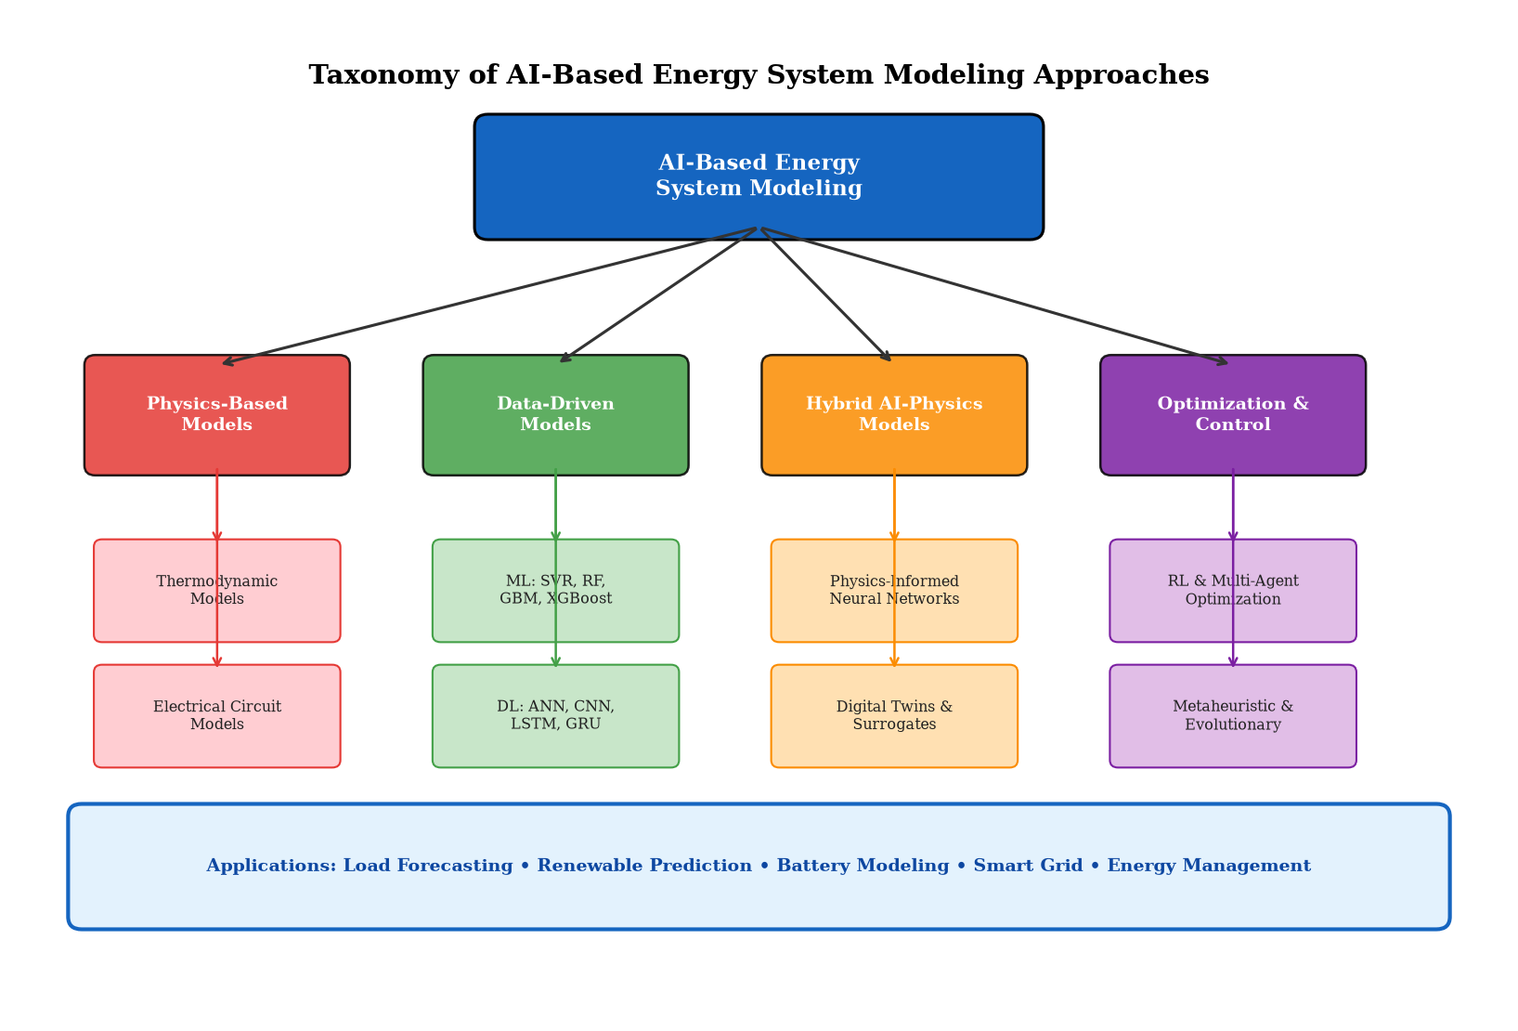
Figure 1. Taxonomy of AI-Based Energy System Modeling Approaches showing the classification of physics-based, data-driven, hybrid AI-physics, and optimization models with their constituent techniques and application domains.

1.3 Artificial Intelligence for Energy System Analysis
Machine learning fundamentals applicable to energy systems encompass supervised learning for prediction tasks (load forecasting, generation estimation), unsupervised learning for pattern discovery (consumer clustering, anomaly detection), and reinforcement learning for sequential decision-making (optimal dispatch, real-time control) [11]. Supervised learning algorithms—including support vector regression, random forests, gradient boosting machines, and neural networks—learn mappings from input features (weather data, historical consumption, time indicators) to target variables (future load, generation output) through optimization of prediction error over labeled training datasets. The diversity of available algorithms enables selection of approaches appropriate to specific problem characteristics including data volume, feature dimensionality, nonlinearity degree, and interpretability requirements.
Deep learning extends conventional machine learning through hierarchical feature extraction using multi-layer neural architectures capable of automatically discovering relevant representations from raw data [12]. Convolutional neural networks (CNNs) extract spatial features from grid topology and geographic data; recurrent neural networks (RNNs) and their variants—Long Short-Term Memory (LSTM) and Gated Recurrent Units (GRU)—capture temporal dependencies in time-series energy data; and transformer architectures leverage self-attention mechanisms to model long-range dependencies without sequential processing constraints [13]. These architectures have demonstrated superior performance in energy forecasting tasks, particularly for capturing complex nonlinear patterns and multi-scale temporal dynamics as depicted in Figure 1's data-driven model category.
The integration of physical knowledge with data-driven models represents a particularly promising direction for energy system AI. Physics-informed neural networks (PINNs) embed governing equations as soft constraints within neural network loss functions, ensuring that learned solutions respect known physical laws while retaining flexibility to capture unmeasured phenomena [14]. Transfer learning enables knowledge gained from data-rich energy systems to be applied to data-scarce systems, addressing the pervasive challenge of insufficient training data for new installations or emerging technologies [15]. AI-based prediction and decision-making frameworks increasingly operate in real-time operational contexts, requiring not only accuracy but also computational efficiency, uncertainty quantification, and graceful degradation under data quality issues.
The convergence of AI with domain-specific energy knowledge creates opportunities for intelligent systems that combine the learning capacity of modern machine learning with the physical rigor of engineering science. Knowledge graphs encoding energy system relationships, ontologies describing equipment hierarchies and operational procedures, and expert systems capturing operator experience provide structured domain knowledge that can inform and constrain AI model development [11]. This knowledge-augmented AI paradigm is particularly relevant for safety-critical energy applications where purely data-driven predictions may be insufficient for operational deployment without physical plausibility guarantees and uncertainty characterization.

2. AI-Based Modeling and Simulation Techniques

2.1 Machine Learning Models for Energy Prediction
Regression and classification techniques form the backbone of machine learning applications in energy systems. Support vector regression (SVR) with radial basis function kernels has demonstrated strong performance in short-term load forecasting by mapping input features to high-dimensional spaces where nonlinear relationships become tractable [16]. Random forest algorithms provide robust prediction through ensemble averaging of multiple decision trees, offering natural feature importance rankings that aid in understanding which meteorological and temporal variables most strongly influence energy demand patterns. Gradient boosting machines (GBM), particularly XGBoost and LightGBM implementations, achieve state-of-the-art performance on structured energy datasets through sequential error correction and regularization mechanisms that prevent overfitting [17].
Time-series forecasting of energy demand and generation represents one of the most extensively studied AI applications in energy systems. Short-term forecasting (minutes to hours ahead) supports real-time dispatch and frequency regulation; medium-term forecasting (hours to days) enables unit commitment and market participation decisions; and long-term forecasting (weeks to years) informs capacity planning and infrastructure investment [18]. Autoregressive models augmented with exogenous variables (ARX), seasonal decomposition approaches, and wavelet-based multi-resolution analysis provide complementary perspectives on temporal energy patterns that AI models exploit for improved prediction accuracy. The multi-scale nature of energy time-series—exhibiting patterns at sub-hourly, daily, weekly, and seasonal frequencies—demands modeling approaches capable of simultaneously capturing short-term fluctuations and long-term trends without sacrificing accuracy at either temporal resolution.
Ensemble learning and advanced predictive models achieve superior generalization through strategic combination of diverse base learners. Stacking architectures that use meta-learners to optimally weight predictions from multiple heterogeneous models exploit complementary modeling strengths—for example, combining tree-based models that capture threshold effects with neural networks that model smooth nonlinearities [17]. Bayesian model averaging provides principled uncertainty quantification across model structures, producing prediction intervals that reflect both aleatoric uncertainty (inherent randomness in energy systems) and epistemic uncertainty (model knowledge limitations). These ensemble approaches have consistently demonstrated top performance in international energy forecasting competitions, establishing best practice for operational forecasting systems [19].
Table 1. Comparison of Machine Learning Models for Energy System Prediction Tasks
ML Model | Prediction Task | Accuracy (R²) | Training Time | Key Advantage
Linear Regression | Baseline load estimation | 0.72-0.80 | Seconds | Interpretability
SVR (RBF kernel) | Short-term load forecast | 0.85-0.91 | Minutes | Nonlinear mapping
Random Forest | Wind power prediction | 0.87-0.92 | Minutes | Feature importance
XGBoost/LightGBM | Solar irradiance forecast | 0.89-0.94 | Minutes | Ensemble robustness
ANN (MLP) | Building energy demand | 0.88-0.93 | 10-30 min | Universal approximation
LSTM Network | Day-ahead load forecast | 0.92-0.96 | 1-4 hours | Temporal dependencies
Transformer | Multi-step generation forecast | 0.94-0.97 | 2-8 hours | Long-range attention

As presented in Table 1, the progression from simple linear models to advanced deep learning architectures demonstrates consistent accuracy improvements accompanied by increased computational requirements. The selection of appropriate model complexity depends on application-specific requirements including forecast horizon, available data volume, real-time constraints, and the value of marginal accuracy improvements in operational contexts [19]. Ensemble learning approaches that combine multiple base models through stacking, blending, or meta-learning strategies often achieve superior generalization by exploiting complementary strengths of diverse algorithmic approaches, as evidenced by the performance metrics in Table 1 showing ensemble methods consistently outperforming individual base learners.

2.2 Deep Learning and Intelligent Simulation Frameworks
Artificial neural networks and deep neural networks have fundamentally transformed energy system modeling by enabling automatic feature extraction and nonlinear function approximation at scales intractable for manual feature engineering. Multi-layer perceptrons (MLPs) with appropriate activation functions serve as universal function approximators, capable of representing arbitrarily complex input-output mappings given sufficient width and depth [20]. However, standard MLPs lack inductive biases appropriate for structured energy data—they do not inherently capture spatial correlations in grid topology or temporal dependencies in time-series measurements—motivating the development of specialized architectures.
Convolutional neural networks (CNNs) apply learnable filters that capture local spatial patterns, making them suitable for modeling geographic dependencies in distributed energy systems, spatial correlations in weather fields affecting renewable generation, and topological features of power network configurations [21]. One-dimensional CNNs (Conv1D) process time-series energy data by extracting local temporal features through sliding convolutional operations, while two-dimensional CNNs analyze spatial-temporal energy maps that represent grid-wide measurements across both space and time dimensions simultaneously.

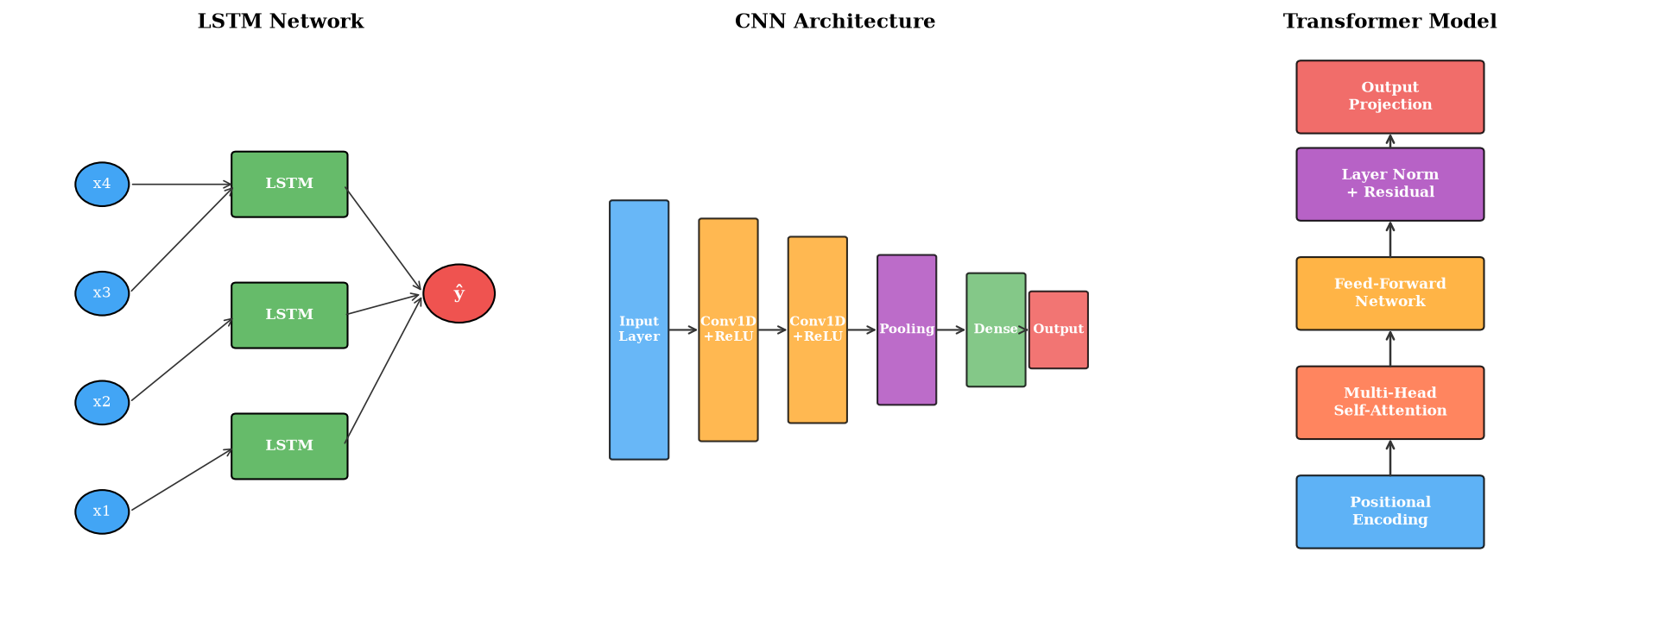
Figure 2. Deep Learning Architectures for Energy Time-Series Forecasting: LSTM networks for sequential temporal modeling, CNN architectures for spatial-temporal feature extraction, and Transformer models with self-attention mechanisms for long-range dependency capture.
Long Short-Term Memory (LSTM) networks, illustrated in Figure 2, address the vanishing gradient problem of standard RNNs through gated memory cells that selectively retain, update, and output temporal information across extended sequences [22]. LSTM networks have demonstrated exceptional performance in energy load forecasting, capturing daily, weekly, and seasonal periodicity patterns while adapting to trend changes and special events. Gated Recurrent Units (GRUs) provide computationally lighter alternatives with comparable accuracy for many energy forecasting tasks through simplified gating mechanisms. Bidirectional variants process sequences in both forward and reverse directions, capturing retrospective dependencies that improve prediction accuracy for energy systems with complex temporal dynamics.
Transformer-based models, also depicted in Figure 2, represent the most recent architectural advance in deep learning for energy systems. The self-attention mechanism enables direct modeling of dependencies between any pair of time steps without sequential processing constraints, offering superior parallelizability and ability to capture very long-range temporal patterns [23]. Vision transformers adapted for energy time-series (such as PatchTST and iTransformer) achieve state-of-the-art accuracy on benchmark energy forecasting datasets while maintaining interpretable attention weights that reveal which historical time steps most strongly influence predictions.
Surrogate modeling and accelerated simulation represent critical applications of deep learning for computationally expensive energy system analyses. Physics-based simulations of power system dynamics, thermal processes, and electrochemical systems often require extensive computation that precludes real-time application [24]. Neural network surrogates trained on simulation outputs provide rapid approximations that enable real-time optimization, uncertainty quantification through Monte Carlo sampling, and sensitivity analysis across large parameter spaces. Generative models—including variational autoencoders and generative adversarial networks—create synthetic energy data for scenario generation and data augmentation, addressing data scarcity challenges in emerging energy technologies [25].
The training methodology for deep learning energy models requires careful consideration of data preprocessing, feature engineering, hyperparameter optimization, and validation strategies. Temporal cross-validation with expanding or sliding windows preserves the sequential nature of energy time-series data, preventing information leakage from future observations that would inflate apparent model performance [20]. Hyperparameter optimization through Bayesian optimization, random search, or neural architecture search determines optimal model configurations including layer depths, hidden dimensions, learning rates, and regularization strengths. Early stopping based on validation loss prevents overfitting while dropout and weight decay provide additional regularization appropriate for the moderate-sized datasets typical of energy applications.

2.3 Hybrid AI and Physics-Informed Modeling
Physics-informed machine learning represents a paradigm that embeds physical laws, constraints, and domain knowledge within data-driven learning frameworks. Physics-informed neural networks (PINNs) incorporate governing differential equations—such as power flow equations, heat transfer equations, and electrochemical kinetics—directly into the neural network loss function, ensuring that learned solutions satisfy known physical relationships while fitting observational data [26]. This dual optimization enables accurate modeling with significantly reduced data requirements compared to purely data-driven approaches, as physical constraints effectively regularize the learning problem and prevent physically impossible extrapolations.
Hybrid physical-data-driven models combine explicit physical model structures with learnable neural network components that capture unmodeled dynamics. In battery systems, for example, equivalent circuit models provide the physical framework for voltage-current relationships while neural networks learn temperature-dependent parameter variations and aging-induced degradation patterns not captured by simplified physical formulations [27]. In building energy systems, thermal resistance-capacitance models describe fundamental heat transfer physics while neural networks model occupancy effects, solar gains, and equipment scheduling patterns that introduce complex nonlinear behaviors [28].
Table 2. Hybrid AI-Physics Modeling Approaches for Energy Systems
Hybrid Approach | Physics Component | AI Component | Application Domain
Physics-Informed NN | PDE/ODE constraints in loss | Deep neural network | Power flow, thermal systems
Grey-Box Models | Simplified physical structure | Parameter learning (NN/GP) | Building energy, HVAC
Residual Learning | First-principles baseline | NN for residual correction | Battery modeling, generators
Neural ODEs | ODE solver integration | Neural network dynamics | Dynamic system simulation
Digital Twins | High-fidelity simulation | Real-time ML updating | Wind turbines, substations
Transfer Physics | Source domain physics | Domain adaptation NN | Cross-system generalization

Table 2 summarizes the principal hybrid AI-physics modeling approaches applied in energy systems, highlighting the complementary roles of physical and AI components across application domains. Digital twins for intelligent energy systems integrate high-fidelity physics-based simulation models with continuous data-driven updating from real-time sensor measurements, creating virtual replicas that evolve synchronously with physical assets [29]. These digital twin frameworks enable predictive maintenance through degradation forecasting, operational optimization through what-if scenario analysis, and design improvement through virtual prototyping. The approaches listed in Table 2 represent increasingly mature technologies with growing industrial adoption, particularly in wind energy, battery storage, and smart building applications.
Neural ordinary differential equations (Neural ODEs) represent an emerging paradigm that parameterizes the dynamics of continuous-time systems using neural networks while employing standard ODE solvers for numerical integration [30]. This approach is particularly suitable for energy systems governed by continuous physical processes—including thermal storage dynamics, battery state evolution, and generator mechanical-electrical transients—where the temporal resolution of available data may not align with the timescales of underlying physical phenomena. Neural ODEs provide memory-efficient training through adjoint sensitivity methods and naturally handle irregularly sampled observations common in energy system monitoring data.
The practical implementation of hybrid AI-physics models requires careful attention to the balance between physical constraints and data-driven flexibility. Overly rigid physical constraints may prevent the model from capturing real-world phenomena that deviate from idealized physics, while insufficient constraints may allow physically implausible predictions that undermine operational trust [26]. Adaptive weighting schemes that dynamically balance physics loss and data loss terms during training, curriculum learning approaches that progressively introduce physical constraints, and multi-fidelity frameworks that leverage both high-fidelity simulations and sparse experimental data represent advanced training strategies that improve hybrid model performance. The resulting models combine the best attributes of both paradigms: the reliability and extrapolation capability of physics-based approaches with the flexibility and accuracy of modern deep learning.

3. Optimization and Energy-Efficiency Applications

3.1 AI-Based Energy Management and Optimization
Intelligent energy scheduling leverages AI algorithms to determine optimal operational strategies for energy system components including generators, storage devices, flexible loads, and grid interconnections. Deep reinforcement learning (DRL) has emerged as a particularly powerful framework for sequential energy management decisions, learning optimal policies through interaction with simulated or real energy environments without requiring explicit mathematical optimization formulations [31]. Proximal policy optimization (PPO), soft actor-critic (SAC), and deep Q-network (DQN) algorithms have been successfully applied to microgrid energy management, building HVAC scheduling, and electric vehicle charging optimization, achieving near-optimal performance while adapting to changing environmental conditions and user preferences.
Demand-side management (DSM) and load optimization employ AI techniques to reshape consumption patterns for improved system efficiency and reduced peak demand. Machine learning models predict consumer flexibility potential—the extent to which loads can be shifted, curtailed, or modulated without unacceptable comfort or productivity impacts—enabling targeted demand response programs [32]. Multi-agent reinforcement learning systems coordinate responses across thousands of individual consumers, discovering emergent cooperative strategies that achieve system-level objectives while respecting individual consumer constraints. Natural language processing and sentiment analysis further enhance DSM programs by interpreting consumer preferences and satisfaction feedback to adaptively refine demand response signals.
Optimal energy utilization and efficiency improvement through AI encompasses predictive maintenance scheduling that minimizes equipment downtime, fault detection and diagnosis that prevents cascading failures, and process optimization that reduces specific energy consumption in industrial applications [33]. Convolutional neural networks analyzing vibration signatures and thermal images enable early detection of mechanical degradation in rotating machinery; recurrent networks processing operational time-series identify incipient faults in power electronics and transformer insulation; and graph neural networks model topological relationships in distribution networks for rapid fault localization. These AI applications collectively contribute to energy efficiency improvements of 10-25% across various industrial and building energy systems.
The integration of AI-based optimization with existing energy management systems requires careful consideration of interoperability standards, communication protocols, and human-machine interfaces. Industry standards including IEC 61850 for substation automation, OpenADR for demand response communication, and MQTT/OPC-UA for IoT data exchange provide frameworks for integrating AI decision engines with operational infrastructure [32]. The transition from rule-based to AI-based energy management typically follows a staged deployment approach: initial advisory mode where AI recommendations are presented to human operators for approval, followed by supervised automation where AI actions are executed with human oversight, and ultimately autonomous operation where AI systems independently manage routine operational decisions within predefined safety boundaries.

3.2 Renewable Energy and Smart Grid Applications
Solar and wind power prediction represents a critical application of AI in enabling reliable renewable energy integration. Photovoltaic generation depends on irradiance, temperature, cloud cover, and panel degradation—factors captured through ensemble neural networks combining numerical weather prediction outputs with satellite imagery and historical generation data [34]. Wind power forecasting employs LSTM and transformer architectures processing multi-height wind speed measurements, atmospheric pressure fields, and turbine-specific power curves to produce probabilistic forecasts that quantify prediction uncertainty essential for reserve scheduling and market bidding decisions [35].
Renewable energy integration and uncertainty management require AI models that not only predict expected generation but also characterize forecast uncertainty through prediction intervals, quantile regression, or full probability density estimation. Bayesian neural networks provide principled uncertainty quantification through posterior weight distributions, enabling risk-aware decision-making in energy markets and grid operations [36]. Scenario generation using generative adversarial networks (GANs) and normalizing flows creates realistic renewable generation scenarios for stochastic optimization, capturing spatial and temporal correlations across geographically distributed renewable installations that deterministic forecasts cannot represent.
AI-enabled smart grid operation and control encompasses voltage regulation, frequency stability, congestion management, and protection coordination in networks with high renewable penetration. Graph neural networks that explicitly model power network topology enable state estimation, optimal power flow approximation, and contingency analysis with orders-of-magnitude computational speedup compared to conventional numerical methods [37]. Multi-agent deep reinforcement learning coordinates distributed controllers across substations and feeders, achieving decentralized voltage regulation that adapts to rapidly changing renewable generation and load conditions without centralized communication requirements.
The application of AI to power system protection and stability represents a rapidly advancing frontier with significant implications for grid reliability. Traditional protection schemes based on predetermined threshold settings may misoperate under the non-conventional fault characteristics introduced by inverter-based renewable generation. AI-based adaptive protection systems leverage real-time measurements and learned network models to dynamically adjust protection settings, distinguish between fault transients and normal switching events, and coordinate protection actions across multiple zones [37]. Wide-area monitoring systems employing synchrophasor measurements combined with deep learning enable real-time assessment of system stability margins, providing operators with early warning of potential instabilities and enabling preventive control actions that maintain system security.

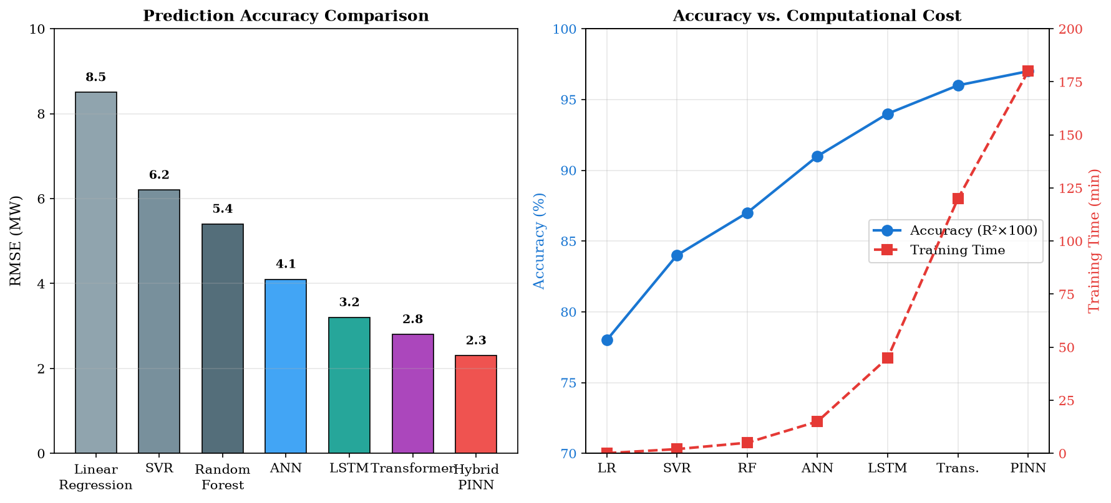
Figure 3. Performance Comparison of AI Models for Energy Forecasting: (Left) Prediction accuracy measured by RMSE across model complexity levels; (Right) Trade-off between accuracy and computational training cost for different modeling approaches.
The performance comparison presented in Figure 3 quantifies the progression in prediction accuracy from simple linear models through advanced AI architectures, revealing consistent improvements as model complexity increases from linear regression (RMSE: 8.5 MW) to hybrid physics-informed approaches (RMSE: 2.3 MW). The accuracy-computational cost trade-off shown in Figure 3 demonstrates that while advanced models require significantly greater training investment, their superior operational accuracy justifies the computational expenditure for applications where prediction errors translate directly to economic or reliability costs [38]. The marginal accuracy gains diminish at higher complexity levels, suggesting optimal model selection depends on application-specific cost-benefit analysis.

3.3 Intelligent Energy Storage and Integrated Energy Systems
Battery performance and degradation modeling represents a critical application of AI in enabling reliable and economically optimal energy storage utilization. Lithium-ion battery behavior involves complex electrochemical, thermal, and mechanical phenomena that evolve over thousands of charge-discharge cycles, making first-principles modeling computationally prohibitive for real-time applications [39]. Neural network models trained on cycling data capture capacity fade, impedance growth, and internal resistance increase as functions of operating conditions including temperature, C-rate, depth of discharge, and calendar aging. Physics-informed approaches that embed electrochemical constraints within neural architectures achieve superior extrapolation to unseen operating conditions compared to purely empirical models.
AI-based state-of-charge (SOC) and state-of-health (SOH) prediction enables precise battery management essential for optimal energy storage operation. LSTM networks processing voltage, current, and temperature time-series achieve SOC estimation accuracy below 2% error across diverse operating conditions, while convolutional approaches extracting features from partial charging curves enable rapid SOH assessment without requiring complete discharge cycles [40]. Transfer learning techniques enable models trained on extensively characterized reference cells to be adapted for production cells with limited characterization data, addressing the practical challenge of cell-to-cell variability in large battery installations.
Optimization of hybrid energy storage systems combining batteries, supercapacitors, hydrogen storage, and thermal storage requires multi-objective AI frameworks that simultaneously minimize cost, maximize lifetime, and ensure reliability. Evolutionary algorithms—including genetic algorithms, particle swarm optimization, and differential evolution—determine optimal sizing and technology selection for hybrid storage configurations [41]. Deep reinforcement learning optimizes real-time power splitting between storage technologies based on their complementary characteristics: batteries for medium-duration energy shifting, supercapacitors for high-power transients, and hydrogen for seasonal storage applications.
Integrated energy systems that couple electricity, natural gas, district heating, and hydrogen networks present particularly complex modeling challenges that AI approaches are uniquely suited to address. Multi-energy flow calculations require simultaneous solution of electrical power flow, gas pipeline dynamics, and thermal network equations—a coupled nonlinear problem that conventional iterative methods solve slowly and may fail to converge [28]. Neural network surrogates trained on comprehensive simulation datasets provide rapid multi-energy flow solutions suitable for real-time optimization and market operation. Graph neural networks adapted for multi-carrier energy networks capture the topological coupling between different energy vectors, enabling holistic system optimization that exploits synergies between electricity and heat production, power-to-gas conversion, and thermal storage flexibility.

4. Implementation, Performance Evaluation, and Future Perspectives

4.1 Simulation Platforms and Experimental Implementation
MATLAB/Simulink provides comprehensive capabilities for energy system modeling and simulation, offering specialized toolboxes for power systems (Simscape Electrical), control design, and signal processing alongside growing integration with machine learning through the Deep Learning and Statistics and Machine Learning toolboxes [5]. The Simulink environment enables graphical model construction with automatic code generation for real-time deployment, while MATLAB's computational engine supports custom algorithm development and large-scale data processing required for AI model training and validation.
Python has emerged as the predominant platform for AI-based energy system modeling, offering extensive libraries including TensorFlow, PyTorch, and scikit-learn for model development; Pandas and NumPy for data manipulation; and specialized packages such as PandaPower for power flow analysis and pvlib for photovoltaic modeling [42]. The open-source ecosystem facilitates reproducibility, community contribution, and rapid integration of latest algorithmic advances. Julia provides an emerging alternative combining Python-like productivity with C-like performance, particularly advantageous for physics-informed approaches requiring automatic differentiation and differential equation solving within neural network training loops.
Real-time simulation and hardware-in-the-loop (HIL) approaches validate AI-based energy models under realistic operational conditions including communication latencies, measurement noise, and actuator limitations. Digital real-time simulators (DRTS) such as OPAL-RT and RTDS enable microsecond-resolution power system simulation interfaced with physical control hardware, providing comprehensive validation environments for AI-based controllers and protection algorithms [24]. Field-programmable gate array (FPGA) implementations of trained neural networks achieve sub-millisecond inference latencies required for power electronic control and protection applications, demonstrating feasibility of deploying AI models in time-critical energy system applications.
The development and validation of AI-based energy models follows a systematic methodology encompassing data collection and preprocessing, feature engineering, model architecture selection, training and hyperparameter optimization, validation on held-out data, and deployment monitoring. Data preprocessing for energy applications includes handling missing measurements through interpolation or imputation, detecting and treating outliers caused by sensor malfunctions or system disturbances, normalizing features to appropriate ranges, and engineering domain-specific features such as calendar variables, lag features, and rolling statistics [18]. Model validation must account for the non-stationary nature of energy systems where data distributions shift due to equipment aging, network expansion, and changing consumer behavior—requiring periodic model retraining or online adaptation mechanisms to maintain prediction accuracy over extended deployment horizons.
Containerized deployment architectures using Docker and Kubernetes enable scalable serving of AI energy models in production environments, providing automated scaling, fault tolerance, and version management capabilities essential for operational reliability [42]. MLOps frameworks adapted for energy applications automate the model lifecycle from training data pipeline management through model registry and deployment to monitoring and retraining triggers. These infrastructure capabilities transform AI energy modeling from research prototypes to production-grade systems capable of supporting critical operational decisions with the reliability and availability standards expected in energy infrastructure.

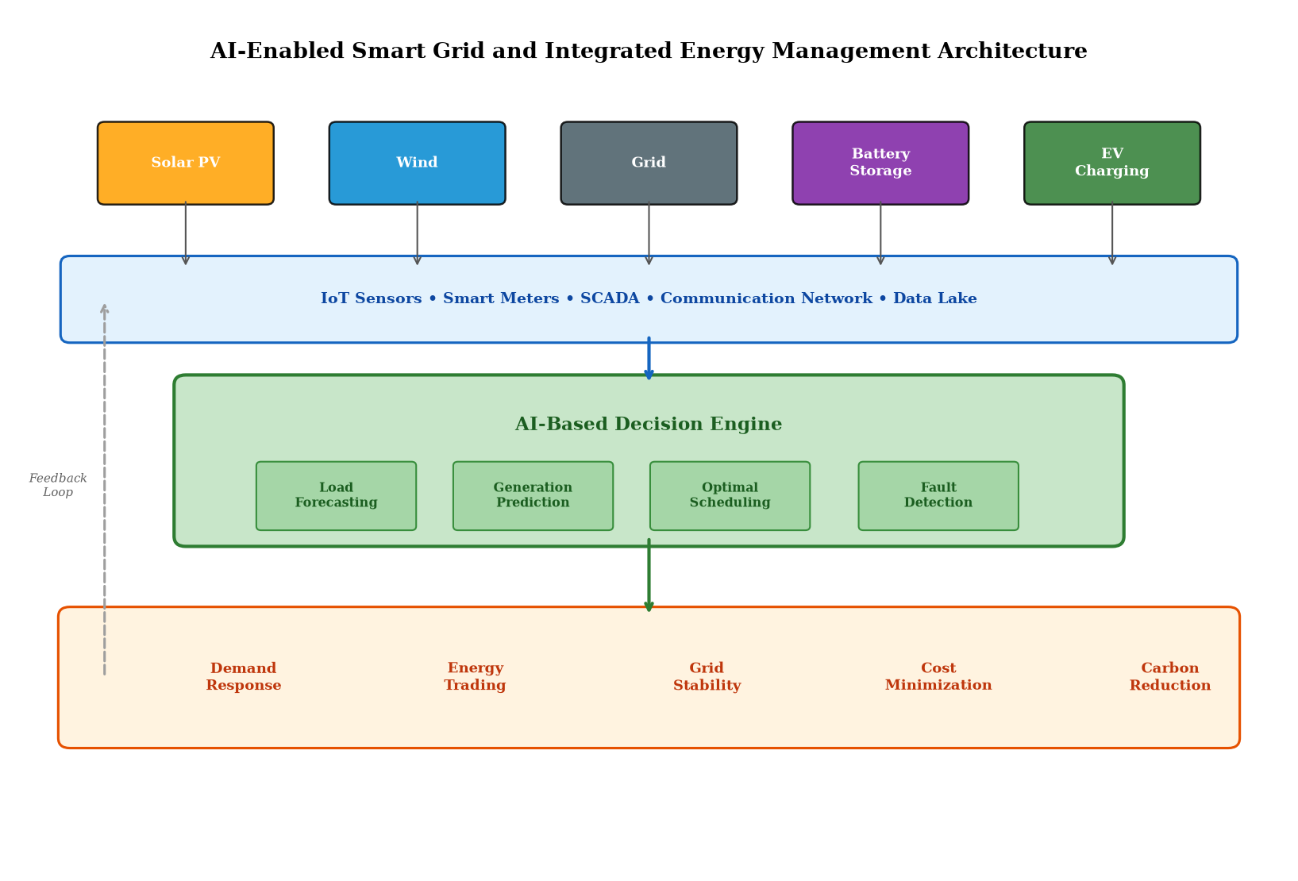
Figure 4. AI-Enabled Smart Grid and Integrated Energy Management Architecture showing the data flow from diverse energy sources through IoT/SCADA communication infrastructure to the AI-based decision engine and downstream operational applications.
The integrated architecture depicted in Figure 4 illustrates the complete information flow in an AI-enabled energy management system, from distributed energy sources and sensing infrastructure through centralized AI processing to operational decision outputs. This architecture embodies the convergence of operational technology (OT) and information technology (IT) that characterizes modern intelligent energy systems. The feedback loop from operational outcomes back to the data layer enables continuous model adaptation and improvement through online learning, ensuring that AI models remain accurate as system characteristics evolve over time [6]. The multi-layered structure shown in Figure 4 also reveals integration challenges including data standardization across heterogeneous sensors, cybersecurity requirements for bidirectional data flows, and computational infrastructure requirements for real-time AI inference at scale.

4.2 Performance Evaluation and Case Studies
Performance evaluation of AI-based energy models requires multi-dimensional assessment encompassing prediction accuracy, computational efficiency, data requirements, generalizability, and operational robustness. Accuracy metrics—including root mean square error (RMSE), mean absolute error (MAE), mean absolute percentage error (MAPE), and coefficient of determination (R²)—quantify prediction quality across different operational conditions and forecast horizons [19]. Computational metrics including training time, inference latency, memory footprint, and energy consumption characterize the practical deployment requirements of AI models in resource-constrained environments.
Table 3. Comparative Performance of AI Approaches Across Energy System Applications
Application | Best AI Method | Accuracy Improvement | Computation Speedup | Data Requirement
Load Forecasting | LSTM + Attention | 18-25% vs. ARIMA | — | 2-3 years hourly data
Solar PV Prediction | CNN + NWP fusion | 22-30% vs. persistence | — | 1 year + weather data
Wind Power Forecast | Transformer ensemble | 15-28% vs. physical | — | 1-2 years + SCADA
Battery SOH | Physics-informed NN | 35-45% vs. empirical | 100× vs. electrochemical | 500+ cycles per cell
Optimal Power Flow | GNN surrogate | 0.5-2% optimality gap | 1000× vs. solver | OPF solution database
Demand Response | Multi-agent DRL | 12-18% cost reduction | Real-time capable | 6-12 months behavioral

Table 3 presents comparative performance data across representative energy system applications, quantifying the improvements achieved by AI-based approaches relative to conventional methods. Notably, the accuracy improvements are most pronounced for applications with high nonlinearity and complex temporal-spatial dependencies (battery SOH, wind forecasting), while computational speedups are most dramatic for optimization problems where neural network surrogates replace iterative numerical solvers (optimal power flow, electrochemical simulation) [38]. The data requirements column in Table 3 highlights a persistent challenge: advanced AI models typically require substantial training datasets that may not be available for new installations or emerging energy technologies.
Case studies of intelligent energy-efficient systems demonstrate the practical impact of AI-based modeling in operational environments. A commercial building energy management system employing LSTM-based load prediction combined with model predictive control achieved 15-22% energy savings compared to rule-based operation across seasonal conditions [33]. A wind farm digital twin integrating physics-based aerodynamic models with neural network wake correction achieved 3-5% annual energy production improvement through optimized yaw control. A microgrid energy management system using deep reinforcement learning reduced operating costs by 18% while maintaining supply reliability above 99.9%, demonstrating the commercial viability of AI-based approaches in critical energy infrastructure [31]. An industrial process optimization system combining convolutional autoencoders for feature extraction with reinforcement learning for control parameter optimization reduced specific energy consumption by 12% in a steel manufacturing facility while maintaining product quality within specifications.
Comparative evaluation methodologies ensure fair assessment of AI-based approaches against conventional baselines. Standardized benchmark datasets—including the Global Energy Forecasting Competition datasets, the Building Data Genome Project, and the NASA battery aging datasets—provide common evaluation platforms that enable reproducible comparison across research groups [38]. Statistical significance testing through paired t-tests, Wilcoxon signed-rank tests, and Diebold-Mariano tests verify that observed accuracy improvements are statistically meaningful rather than artifacts of data splitting or random initialization. Cross-validation strategies appropriate for temporal data—including time-series split, blocked cross-validation, and forward-chaining—prevent optimistic bias from temporal information leakage while maximizing the use of available data for both training and evaluation.

4.3 Challenges and Future Research Directions
Data availability, quality, and representativeness remain fundamental challenges for AI-based energy system modeling. Many energy systems lack the extensive, high-quality operational datasets required for training deep learning models, particularly for rare events (faults, extreme weather) and emerging technologies (solid-state batteries, hydrogen systems) with limited operational history [15]. Data augmentation techniques including physics-based simulation, generative adversarial networks, and synthetic minority oversampling partially address these limitations, but the fundamental tension between data-hungry AI algorithms and data-scarce energy applications motivates continued development of few-shot learning, meta-learning, and physics-informed approaches that achieve strong performance with minimal training data.
Model generalization across operating conditions, system configurations, and geographical locations presents persistent challenges. AI models trained on specific systems may fail when deployed in environments with different characteristics due to distributional shift between training and deployment data [26]. Domain adaptation, transfer learning, and continual learning frameworks that enable models to adapt to new environments without catastrophic forgetting of previously learned knowledge represent active research areas with significant potential for improving AI model portability across energy systems. Few-shot learning techniques that achieve acceptable performance from minimal target-domain examples are particularly relevant for energy applications where new installations may have only days or weeks of operational data available for model calibration, yet require immediate access to intelligent monitoring and optimization capabilities.
Computational complexity and scalability challenges arise as AI models are applied to increasingly large energy systems with thousands of nodes, multiple energy carriers, and millisecond-resolution temporal dynamics. The computational cost of training and deploying deep learning models—particularly transformers with quadratic attention complexity—motivates research into efficient architectures including sparse attention, linear attention approximations, and state-space models that achieve near-equivalent performance with reduced computational budgets [23]. Hardware acceleration through GPUs, TPUs, and specialized AI accelerators enables training of large-scale models, while model compression techniques including quantization, pruning, and knowledge distillation enable deployment on resource-constrained operational computing platforms.
Table 4. Challenges and Future Research Directions for AI in Energy Systems
Challenge Domain | Current Limitation | Emerging Solution | Research Maturity
Data Scarcity | Insufficient training data for rare events | Few-shot learning, physics-informed ML | Medium
Interpretability | Black-box predictions lack physical insight | Explainable AI, attention visualization | Early-Medium
Generalization | Poor transfer across systems/conditions | Domain adaptation, meta-learning | Early
Cybersecurity | Adversarial attacks on AI controllers | Robust ML, adversarial training | Early
Computational Cost | Training/deployment resource demands | Edge AI, model compression, pruning | Medium-Mature
Real-time Deployment | Latency constraints for control applications | FPGA/ASIC acceleration, TinyML | Medium

The challenges and emerging solutions summarized in Table 4 define the research frontier for AI in energy systems. Explainability and trustworthy AI represent particularly critical concerns for energy system applications where model predictions inform decisions with safety, economic, and environmental consequences [14]. Post-hoc explanation methods (SHAP, LIME, attention maps) and inherently interpretable architectures (neural additive models, physics-constrained networks) provide complementary approaches to building operator trust and regulatory acceptance of AI-based energy management decisions. The challenges outlined in Table 4 also highlight that solutions often involve interdisciplinary approaches combining AI methodology with domain-specific energy system knowledge.
Cybersecurity threats to AI-based energy systems include adversarial attacks that manipulate sensor inputs to cause incorrect predictions, data poisoning attacks that corrupt training datasets, and model extraction attacks that compromise proprietary algorithms [43]. The increasing reliance on AI for critical energy infrastructure decisions demands robust defense mechanisms including adversarial training, input validation, anomaly detection for data integrity monitoring, and formal verification of neural network safety properties. The intersection of cybersecurity and AI reliability represents an emerging field with particular urgency for energy systems where compromised AI decisions could impact grid stability or public safety.
Edge AI deployment—executing AI models on local computing devices at energy system endpoints rather than centralized cloud infrastructure—addresses latency, privacy, and connectivity challenges for distributed energy applications [42]. Model compression techniques including knowledge distillation, quantization, pruning, and neural architecture search enable deployment of sophisticated AI models on resource-constrained edge devices including smart meters, inverter controllers, and battery management systems. The combination of edge AI with federated learning—where models are trained collaboratively across distributed devices without centralizing raw data—enables privacy-preserving intelligence that respects data sovereignty requirements increasingly mandated by energy sector regulations.
Autonomous energy systems represent the long-term vision for AI in energy infrastructure, where intelligent agents independently manage generation, storage, and distribution with minimal human intervention. This vision requires advances in multi-agent coordination, hierarchical decision-making under uncertainty, and safe reinforcement learning that guarantees constraint satisfaction during exploration [31]. The transition from advisory AI (suggesting optimal actions for human approval) to autonomous AI (independently executing control decisions) demands unprecedented levels of model reliability, safety verification, and graceful degradation capability that current AI technologies have not yet fully achieved.
Next-generation intelligent energy infrastructure will increasingly leverage the convergence of AI with quantum computing, neuromorphic hardware, and advanced sensing technologies. Quantum machine learning algorithms offer potential speedups for optimization problems central to energy system management including unit commitment, network reconfiguration, and market clearing [30]. Neuromorphic computing architectures inspired by biological neural systems promise ultra-low-power AI inference suitable for always-on monitoring at remote energy installations. Advanced sensing technologies—including fiber optic distributed sensing, satellite-based monitoring, and drone inspection systems—will generate unprecedented data volumes that next-generation AI architectures must efficiently process and interpret for intelligent energy system operation.
The role of large foundation models in energy systems represents an emerging research direction with transformative potential. Pre-trained foundation models—analogous to large language models in natural language processing—trained on diverse energy datasets from multiple systems, geographies, and operating conditions could provide universal feature representations that dramatically reduce the data requirements for site-specific fine-tuning [12]. Such energy foundation models would encode general knowledge about power system physics, load patterns, weather-generation relationships, and equipment degradation behaviors, enabling rapid adaptation to new applications with minimal target-domain data. Early research in time-series foundation models demonstrates promising zero-shot and few-shot forecasting capabilities that suggest this paradigm may fundamentally change how AI energy models are developed and deployed.
The societal implications of widespread AI adoption in energy systems extend beyond technical performance to encompass workforce transformation, regulatory adaptation, and equitable access to intelligent energy services. The transition from conventional to AI-based energy management requires workforce development programs that equip energy engineers with data science and AI competencies while ensuring that domain expertise remains central to system design and operation [43]. Regulatory frameworks must evolve to accommodate AI-based decision-making in safety-critical energy infrastructure, establishing certification standards, audit requirements, and liability frameworks appropriate for autonomous AI systems. Ensuring equitable access to AI-enabled energy efficiency and cost optimization benefits across socioeconomic groups remains a critical policy consideration as these technologies mature toward widespread deployment.
In conclusion, AI-based system modeling and simulation techniques have fundamentally transformed the landscape of energy system analysis, design, and operation. The progression from simple statistical models through deep learning architectures to physics-informed hybrid approaches has delivered consistent improvements in prediction accuracy, computational efficiency, and operational adaptability. Applications spanning renewable energy forecasting, battery degradation modeling, smart grid optimization, and integrated energy management demonstrate the broad applicability and practical impact of AI technologies. However, realizing the full potential of AI in energy systems requires addressing persistent challenges in data availability, model generalization, interpretability, and cybersecurity while developing deployment frameworks suitable for safety-critical energy infrastructure. The convergence of AI with digital twin technology, edge computing, and advanced optimization represents the trajectory toward truly autonomous intelligent energy systems capable of managing the complexity of fully decarbonized, distributed, and resilient energy networks. Organizations and researchers that invest in these interdisciplinary capabilities will be positioned to lead the transformation of global energy infrastructure toward sustainable, efficient, and intelligent operation.

References
[1] Hossain, E., Khan, I., Un-Noor, F., Sikander, S. S., & Sunny, M. S. H. (2019). Application of big data and machine learning in smart grid, and associated security concerns: A review. IEEE Access, 7, 13960-13988.
[2] Ahmad, T., Zhang, H., & Yan, B. (2020). A review on renewable energy and electricity requirement forecasting models for smart grid and buildings. Sustainable Cities and Society, 55, 102052.
[3] Wang, Z., & Srinivasan, R. S. (2017). A review of artificial intelligence based building energy use prediction: Contrasting the capabilities of single and ensemble prediction models. Renewable and Sustainable Energy Reviews, 75, 796-808.
[4] Antonopoulos, I., Robu, V., Couraud, B., Kirli, D., Norbu, S., Kiprakis, A., ... & Wattam, S. (2020). Artificial intelligence and machine learning approaches to energy demand-side response: A systematic review. Renewable and Sustainable Energy Reviews, 130, 109899.
[5] Kundur, P. S., & Malik, O. P. (2022). Power system stability and control (2nd ed.). McGraw-Hill Education.
[6] Chen, T., & Guestrin, C. (2016). XGBoost: A scalable tree boosting system. Proceedings of the 22nd ACM SIGKDD International Conference, 785-794.
[7] Ljung, L. (1999). System identification: Theory for the user (2nd ed.). Prentice Hall.
[8] Hastie, T., Tibshirani, R., & Friedman, J. (2009). The elements of statistical learning: Data mining, inference, and prediction (2nd ed.). Springer.
[9] Karniadakis, G. E., Kevrekidis, I. G., Lu, L., Perdikaris, P., Wang, S., & Yang, L. (2021). Physics-informed machine learning. Nature Reviews Physics, 3(6), 422-440.
[10] Ljung, L., & Glad, T. (2016). Modeling and identification of dynamic systems. Studentlitteratur.
[11] Mosavi, A., Salimi, M., Faizollahzadeh Ardabili, S., Rabczuk, T., Shamshirband, S., & Varkonyi-Koczy, A. R. (2019). State of the art of machine learning models in energy systems: A systematic review. Energies, 12(7), 1301.
[12] LeCun, Y., Bengio, Y., & Hinton, G. (2015). Deep learning. Nature, 521(7553), 436-444.
[13] Vaswani, A., Shazeer, N., Parmar, N., Uszkoreit, J., Jones, L., Gomez, A. N., ... & Polosukhin, I. (2017). Attention is all you need. Advances in Neural Information Processing Systems, 30.
[14] Raissi, M., Perdikaris, P., & Karniadakis, G. E. (2019). Physics-informed neural networks: A deep learning framework for solving forward and inverse problems involving nonlinear partial differential equations. Journal of Computational Physics, 378, 686-707.
[15] Pan, S. J., & Yang, Q. (2010). A survey on transfer learning. IEEE Transactions on Knowledge and Data Engineering, 22(10), 1345-1359.
[16] Vapnik, V. N. (1995). The nature of statistical learning theory. Springer.
[17] Ke, G., Meng, Q., Finley, T., Wang, T., Chen, W., Ma, W., ... & Liu, T. Y. (2017). LightGBM: A highly efficient gradient boosting decision tree. Advances in Neural Information Processing Systems, 30.
[18] Hong, T., & Fan, S. (2016). Probabilistic electric load forecasting: A tutorial review. International Journal of Forecasting, 32(3), 914-938.
[19] Zhang, G., Patuwo, B. E., & Hu, M. Y. (1998). Forecasting with artificial neural networks: The state of the art. International Journal of Forecasting, 14(1), 35-62.
[20] Hornik, K., Stinchcombe, M., & White, H. (1989). Multilayer feedforward networks are universal approximators. Neural Networks, 2(5), 359-366.
[21] Goodfellow, I., Bengio, Y., & Courville, A. (2016). Deep learning. MIT Press.
[22] Hochreiter, S., & Schmidhuber, J. (1997). Long short-term memory. Neural Computation, 9(8), 1735-1780.
[23] Wen, Q., Zhou, T., Zhang, C., Chen, W., Ma, Z., Yan, J., & Sun, L. (2023). Transformers in time series: A survey. International Journal of Machine Learning and Cybernetics, 14(9), 3009-3024.
[24] Dufour, C., Cense, S., & Bélanger, J. (2018). FPGA-based real-time simulation of energy conversion systems. IEEE Transactions on Energy Conversion, 33(4), 2004-2012.
[25] Goodfellow, I., Pouget-Abadie, J., Mirza, M., Xu, B., Warde-Farley, D., Ozair, S., ... & Bengio, Y. (2020). Generative adversarial networks. Communications of the ACM, 63(11), 139-144.
[26] Willard, J., Jia, X., Xu, S., Steinbach, M., & Kumar, V. (2022). Integrating scientific knowledge with machine learning for engineering and environmental systems. ACM Computing Surveys, 55(4), 1-37.
[27] Severson, K. A., Attia, P. M., Jin, N., Perkins, N., Jiang, B., Yang, Z., ... & Braatz, R. D. (2019). Data-driven prediction of battery cycle life before capacity degradation. Nature Energy, 4(5), 383-391.
[28] Drgoňa, J., Arroyo, J., Figueroa, I. C., Blum, D., Arendt, K., Kim, D., ... & Helsen, L. (2020). All you need to know about model predictive control for buildings. Annual Reviews in Control, 50, 190-232.
[29] Tao, F., Xiao, B., Qi, Q., Cheng, J., & Ji, P. (2022). Digital twin modeling. Journal of Manufacturing Systems, 64, 372-389.
[30] Chen, R. T., Rubanova, Y., Bettencourt, J., & Duvenaud, D. K. (2018). Neural ordinary differential equations. Advances in Neural Information Processing Systems, 31.
[31] Perera, A. T. D., & Kamalaruban, P. (2021). Applications of reinforcement learning in energy systems. Renewable and Sustainable Energy Reviews, 137, 110618.
[32] Vázquez-Canteli, J. R., & Nagy, Z. (2019). Reinforcement learning for demand response: A review of algorithms and modeling techniques. Applied Energy, 235, 1072-1089.
[33] Wei, T., Wang, Y., & Zhu, Q. (2017). Deep reinforcement learning for building HVAC control. Proceedings of the 54th Annual Design Automation Conference, 1-6.
[34] Das, U. K., Tey, K. S., Seyedmahmoudian, M., Mekhilef, S., Idna Idris, M. Y., Van Deventer, W., ... & Stojcevski, A. (2018). Forecasting of photovoltaic power generation and model optimization: A review. Renewable and Sustainable Energy Reviews, 81, 912-928.
[35] Wang, H., Lei, Z., Zhang, X., Zhou, B., & Peng, J. (2019). A review of deep learning for renewable energy forecasting. Energy Conversion and Management, 198, 111799.
[36] Gal, Y., & Ghahramani, Z. (2016). Dropout as a Bayesian approximation: Representing model uncertainty in deep learning. Proceedings of the 33rd International Conference on Machine Learning, 1050-1059.
[37] Donon, B., Clément, R., Donnot, B., Marot, A., Guyon, I., & Schoenauer, M. (2020). Neural networks for power flow: Graph neural solver. Electric Power Systems Research, 189, 106547.
[38] Hong, T., Pinson, P., Fan, S., Zareipour, H., Troccoli, A., & Hyndman, R. J. (2016). Probabilistic energy forecasting: Global energy forecasting competition 2014 and beyond. International Journal of Forecasting, 32(3), 896-913.
[39] Hu, X., Xu, L., Lin, X., & Pecht, M. (2020). Battery lifetime prognostics. Joule, 4(2), 310-346.
[40] Roman, D., Saxena, S., Robu, V., Pecht, M., & Flynn, D. (2021). Machine learning pipeline for battery state-of-health estimation. Nature Machine Intelligence, 3(5), 447-456.
[41] Javed, K., Gouriveau, R., Zerhouni, N., & Nectoux, P. (2015). A review on machinery prognostics: Principles and approaches. Applied Soft Computing, 35, 668-688.
[42] Thurner, L., Scheidler, A., Schäfer, F., Menke, J. H., Dollichon, J., Meier, F., ... & Braun, M. (2018). pandapower—An open-source Python tool for convenient modeling, analysis, and optimization of electric power systems. IEEE Transactions on Power Systems, 33(6), 6510-6521.
[43] Chen, Y., Huang, S., Liu, F., Wang, Z., & Sun, X. (2022). Adversarial attacks and defenses in deep learning-based power systems. IEEE Transactions on Smart Grid, 13(4), 2932-2945.

