Modified Green–Lindsay Thermoelasticity with Dual-Phase-Lag and Three-Phase-Lag Heat Conduction: Response of an Unbounded Medium to Pulsed and Moving Line Heat Sources
[Author names, affiliations and corresponding-author e-mail to be inserted]

Abstract
The modified Green–Lindsay (MGL) theory of thermoelasticity removes the displacement discontinuity of the original Green–Lindsay model by adding a strain-rate term, but most MGL boundary-value problems still rely on a Fourier or Lord–Shulman type heat flux law and on a time-independent or step-type heat input. This paper couples MGL thermoelasticity with the dual-phase-lag (DPL) and three-phase-lag (TPL) heat conduction models and studies an unbounded isotropic plane-strain medium heated by a line source whose strength varies in time (step, rectangular pulse, exponentially decaying pulse, gamma-type pulse and sinusoidal pulse train) or which translates at constant speed. The pulsed problem is solved in closed form in the Laplace domain through a displacement potential and modified Bessel functions $K_{0}$ and $K_{1}$. The moving problem is solved by a Fourier transform in the plane and a Laplace transform in time, with the transverse integral evaluated analytically and the remaining Fourier integral evaluated by the trapezoidal rule. Large-transform-parameter asymptotics classify the models: the second-order DPL and TPL laws with $τ_{T}>τ_{q}/2$ keep one finite-speed thermal wave ($c_{w}=7.68$ for the chosen data, against 7.01 for the Lord–Shulman type MGL law) together with a diffusive branch, whereas first-order DPL is parabolic, and a second-order law with $τ_{T}<τ_{q}/2$ is shown numerically to be unstable. Results are inverted with Durbin's Fourier-series method accelerated by the Wynn epsilon algorithm. An independent finite-difference solver reproduces the Laplace solution to 0.2 per cent in temperature and 2 to 3 per cent in stress, the moving-source code reproduces the axisymmetric solution at zero speed to about 2×10⁻⁴, and the global heat-content identity is satisfied to better than 0.7 per cent. Parametric studies quantify the influence of the phase lags, the thermal-displacement lag, the conductivity rate, the strain-rate parameter, the pulse width and period and the source speed. The strain-rate parameter dominates the mechanical response behind the front, the phase lags dominate the arrival time and the temperature near the front, and a source moving faster than the thermal wave produces a Mach-type front with a stress peak several times larger than the stationary value.
Keywords: modified Green–Lindsay thermoelasticity; dual-phase-lag; three-phase-lag; pulsed line heat source; moving heat source; Laplace transform; wave speed; strain rate

1. Introduction
Heat conduction in solids that are heated on very short time scales or by very localized sources departs from the Fourier law, which predicts an infinite speed of thermal disturbance. The Lord–Shulman model introduced one relaxation time into the flux law, the Green–Lindsay model introduced two relaxation times into the constitutive and energy equations, and the Green–Naghdi models introduced thermal displacement. These theories restored finite propagation speeds but brought their own difficulties, in particular jumps in displacement at the wavefront in the Green–Lindsay case. Reviews of the generalized thermoelasticity family and of its modifications can be found in [9]. A modification that has attracted attention is the modified Green–Lindsay (MGL) theory of Yu, Xue and Tian [14], which adds a strain-rate term with the same relaxation time that multiplies the temperature rate. The additional term eliminates the discontinuity of the displacement, and the qualitative properties of the resulting system were examined by Quintanilla [15]. Subsequent work has treated fundamental solutions [3], a Galerkin-type representation [4], a finite element formulation for a functionally graded hollow disk [5], infinite-speed behaviour [2] and photothermal problems in semiconductors [6].
The closest antecedent of the present work is the study of Singh and Mukhopadhyay [1], who solved the line heat source problem for an unbounded MGL medium with a Lord–Shulman type heat conduction law and a heat input switched on at time zero. By a Laplace transform and a thermoelastic potential they found one finite-speed wave and a diffusive part, with a continuous displacement and a jump confined to the hoop stress, in contrast with Lord–Shulman, Green–Lindsay and Moore–Gibson–Thompson solutions that show two wavefronts. Line source problems under Moore–Gibson–Thompson thermoelasticity were examined in [7] and [8]. Those analyses used a single relaxation time in the flux law and a Heaviside time dependence of the source.
Two features of practical heating are not covered by that setting. First, real sources are pulsed: laser or electron beam heating has a finite duration, a rapid rise and a decay, and may be repeated periodically. The response then depends on how the pulse width and period compare with the phase lags of the material. Second, sources move: a focused beam scanned over a surface, a welding arc or a travelling hot spot has a position that changes with time, and when the source speed exceeds the thermal wave speed the field acquires a conical front. Both features interact with the heat conduction law because the lag times determine how fast the material can follow the source.
The heat conduction law is the second ingredient. The dual-phase-lag (DPL) model of Tzou introduces a lag $τ_{q}$ in the heat flux and a lag $τ_{T}$ in the temperature gradient, so that it contains the Fourier and Lord–Shulman laws as special cases. The three-phase-lag (TPL) model of Roychoudhuri adds a lag $τ_{v}$ in the thermal displacement gradient weighted by a conductivity rate $K^{*}$, which restores the thermal displacement of Green–Naghdi theory within a lag framework. These laws are normally studied with Taylor expansions in the lags, and the order of the expansion decides the mathematical type of the heat equation. First-order expansions in both lags give a parabolic equation, whereas an expansion that is of second order in $τ_{q}$ gives a hyperbolic one provided a stability condition on the ratio of the lags holds. Because the order of the expansion decides the wave structure, a careful asymptotic analysis is needed before any numerical result is trusted, and this paper devotes a full section to it.
The aims of the paper are therefore: (i) to formulate MGL thermoelasticity with DPL and TPL heat conduction in a form that contains the Lord–Shulman MGL model of [1] and the Fourier model as limits; (ii) to solve the pulsed line source problem exactly in the Laplace domain for several temporal profiles; (iii) to solve a rigorously defined moving line source problem; (iv) to classify the wave structure by large-parameter asymptotics and to check the stability of the second-order lag laws; (v) to invert the transforms numerically and to validate the inversion by independent means; and (vi) to quantify the sensitivity of the response to the lag times, the conductivity rate, the strain-rate parameter, the pulse parameters and the source speed.
The paper makes a specific and limited claim. All results use the nondimensional copper data and lag times of [1], which are chosen to make wave effects visible and correspond to sub-picosecond physical times, and the lag values for the DPL and TPL models are illustrative choices that satisfy the stability condition rather than measured values. The moving source is a line parallel to the $z$ axis that translates at constant speed in plane strain; it is not a three-dimensional point source or a finite-diameter beam. The classical foundational models (Lord–Shulman, Green–Lindsay, Tzou, Roychoudhuri, Chandrasekharaiah) are cited here by author and model name only, because they predate 2013 and the reference list of this manuscript is restricted to the 2013 to 2026 window.
The remainder of the paper is organised as follows. Section 2 states the governing equations and the nondimensional form. Section 3 derives the pulsed-source solution and the temporal profiles. Section 4 treats the moving source. Section 5 gives the large-parameter asymptotics and the stability analysis. Section 6 describes the numerical inversion and the validation tools. Section 7 presents the results and Section 8 lists limitations. Section 9 summarises the conclusions.

2. Governing equations

2.1 Dimensional MGL thermoelasticity
Consider a homogeneous, isotropic, linearly thermoelastic solid with Lamé constants $λ$ and $μ$, mass density $ρ$, specific heat at constant strain $c_{E}$, thermal conductivity $k$ and coupling constant $γ=(3λ+2μ)α_{t}$, where $α_{t}$ is the linear thermal expansion coefficient. Let $θ$ be the temperature increment over the reference temperature $T_{0}$, $ε_{ij}$ the strain tensor, $e$ its trace and $Q$ the volumetric heat source. In the MGL theory [14] the stress is
$σ_{ij}=\left(1+τ_{1}∂_{t}\right)\left[λeδ_{ij}+2με_{ij}−γθδ_{ij}\right]$ (1)
where $τ_{1}$ is the relaxation time that multiplies both the temperature rate (as in the Green–Lindsay model) and, in the MGL modification, the strain rate. The equation of motion without body force and the energy balance are
$ρ ∂_{t}^{2}u_{i}=σ_{ij,j}$ (2)
$ρc_{E} ∂_{t}θ+γT_{0} ∂_{t}e=−∇⋅q+Q$ (3)
The heat flux $q$ is closed by a constitutive law. Four members of the family are used. The Fourier and Lord–Shulman laws are
$q=−k∇θ$ (4)
$\left(1+τ_{0}∂_{t}\right)q=−k∇θ$ (5)
The dual-phase-lag law states that the flux at time $t+τ_{q}$ is produced by the temperature gradient at time $t+τ_{T}$,
$q(x,t+τ_{q})=−k∇θ(x,t+τ_{T})$ (6)
and its Taylor expansion, taken to second order in $τ_{q}$ and first order in $τ_{T}$, is
$\left(1+τ_{q}∂_{t}+\frac{1}{2}τ_{q}^{2}∂_{t}^{2}\right)q=−k\left(1+τ_{T}∂_{t}\right)∇θ$ (7)
The three-phase-lag law of Roychoudhuri adds the gradient of the thermal displacement $v$, defined by $∂_{t}v=θ$, with a lag $τ_{v}$ and the conductivity rate $K^{*}$:
$q(x,t+τ_{q})=−\left[k∇θ(x,t+τ_{T})+K^{*}∇v(x,t+τ_{v})\right]$ (8)
Expanding to second order in $τ_{q}$ and first order in $τ_{T}$ and $τ_{v}$ gives
$\left(1+τ_{q}∂_{t}+\frac{1}{2}τ_{q}^{2}∂_{t}^{2}\right)q=−k\left(1+τ_{T}∂_{t}\right)∇θ−K^{*}\left(1+τ_{v}∂_{t}\right)∇v$ (9)
These expansions are standard; the truncation order is a modelling decision and is discussed in Section 5. When only the first-order term in $τ_{q}$ is retained and $τ_{T}=0$, $K^{*}=0$, the Lord–Shulman law is recovered with $τ_{0}=τ_{q}$, and this is the role that $τ_{0}$ of [1] plays below. When $τ_{q}=τ_{T}$ at first order the flux law reduces to the Fourier law after both sides are divided by the common factor.

2.2 Nondimensional form
The nondimensional variables are those of [1]. With $c_{1}^{2}=(λ+2μ)/ρ$ and $η=ρc_{E}/k$ the scalings are
$x^{′}=ηc_{1}x, t^{′}=ηc_{1}^{2}t, u^{′}=ηc_{1}u, θ^{′}=θ/T_{0}, σ_{ij}^{′}=σ_{ij}/(λ+2μ)$ (10)
and the lag times scale like time, $τ^{′}=ηc_{1}^{2}τ$. The conductivity rate, which has the dimension of $k$ per unit time, becomes $K=K^{*}/(ηc_{1}^{2}k)$. The dimensionless coupling constants are
$δ_{1}=\frac{γT_{0}}{λ+2μ}, δ_{2}=\frac{γ}{ρc_{E}}, λ_{1}=\frac{λ}{λ+2μ}, ε=δ_{1}δ_{2}, κ=1−λ_{1}$ (11)
Primes are dropped from here on. For the copper data used in [1] these constants are listed in Table 2. The scaling implies that one nondimensional length unit is 2.71e-08 m and one time unit is 6.51e-12 s, so that the nondimensional lag times quoted below correspond to sub-picosecond physical lags.
In the Laplace domain with zero initial data and a transform parameter $s$ the flux laws above take the common form
$Φ(s) \overline{q}=−Ψ(s)∇\overline{θ}$ (12)
with the operators
$Φ(s)=1+τ_{q}s+\frac{1}{2}τ_{q}^{2}s^{2}$ (13)
$Ψ(s)=1+τ_{T}s+\frac{K\left(1+τ_{v}s\right)}{s}$ (14)
The Fourier model has $Φ=Ψ=1$, the Lord–Shulman model has $Φ=1+τ_{0}s$ (first-order truncation) and $Ψ=1$, the first-order DPL model has $Φ=1+τ_{q}s$ and $Ψ=1+τ_{T}s$, the second-order DPL model has the full $Φ$ above with $K=0$, and the TPL model has all terms. The parameter $K$ appears in $Ψ$ with a pole at $s=0$: it makes the long-time behaviour of the TPL model wave-like instead of diffusive, as shown in Section 5.

2.3 Axisymmetric plane-strain equations
For a line source along the $z$ axis the medium is in plane strain and all fields depend on the radial distance $r$ and time. The radial displacement $u(r,t)$ is the only displacement component. The nondimensional equation of motion, the dilatation and the stresses are
$∂_{t}^{2}u=\left(1+τ_{1}∂_{t}\right)\left(∂_{r}e−δ_{1}∂_{r}θ\right)$ (15)
$e=∂_{r}u+\frac{u}{r}$ (16)
$σ_{rr}=\left(1+τ_{1}∂_{t}\right)\left[∂_{r}u+λ_{1}\frac{u}{r}−δ_{1}θ\right]$ (17)
$σ_{φφ}=\left(1+τ_{1}∂_{t}\right)\left[λ_{1}∂_{r}u+\frac{u}{r}−δ_{1}θ\right]$ (18)
The heat source is a line source of strength $Q_{0}$ per unit length with an arbitrary temporal profile $f(t)$,
$Q(r,t)=\frac{Q_{0}}{2πr} δ(r) f(t)$ (19)
so that $Q_{0}$ is the total source integrated over the plane. In the energy equation the source enters in the convention of [1], in which the Laplace-domain combined equation reads
$Ψ(s)∇^{2}\overline{θ}=Φ(s) s\left(\overline{θ}+δ_{2}\overline{e}\right)−\overline{Q}$ (20)
with $∇^{2}=∂_{r}^{2}+r^{−1}∂_{r}$. This convention (called the effective-source convention below) reduces exactly to the equation of [1] for the Lord–Shulman limit, which makes the comparison with that paper meaningful. A physically equivalent alternative in which the source is carried through the lag operator, $−Φ(s)\overline{Q}$, was also implemented; it differs by the operator $Φ(∂_{t})$ acting on $f$, which for a step creates impulsive terms at $t=0$. The alternative is used only for the limit check $τ_{q}=τ_{T}→$ Fourier, where it gives exact agreement. The Laplace transform of the momentum equation is
$s^{2}\overline{u}=\left(1+τ_{1}s\right)\left(∂_{r}\overline{e}−δ_{1}∂_{r}\overline{θ}\right)$ (21)
The thermoelastic displacement potential $φ$ is defined by
$u=∂_{r}φ, e=∇^{2}φ$ (22)
so that, after integrating the momentum equation once and imposing decay at infinity, with $p=1+τ_{1}s$,
$\overline{θ}=\frac{1}{δ_{1}}\left(∇^{2}\overline{φ}−\frac{s^{2}}{p}\overline{φ}\right)$ (23)
Substituting into the energy equation gives a fourth-order equation for the potential,
$\left(∇^{4}−B∇^{2}+C\right)\overline{φ}=−\frac{δ_{1}\overline{Q}}{Ψ}$ (24)
$B=\frac{s^{2}}{p}+\left(1+ε\right)\frac{Φs}{Ψ}, C=\frac{Φs^{3}}{Ψp}$ (25)
For the Lord–Shulman limit these coefficients are $B=(b_{1}s^{3}+b_{2}s^{2}+b_{3}s)/p$ and $C=s^{3}(1+τ_{0}s)/p$ with $b_{1}=(1+ε)τ_{1}τ_{0}$, $b_{2}=(1+ε)(τ_{1}+τ_{0})+1$ and $b_{3}=1+ε$, the form quoted in [1]. The same derivation with the temperature-rate coupling of the original Green–Lindsay theory (no strain-rate term) was also coded as a comparison model and is labelled GL.
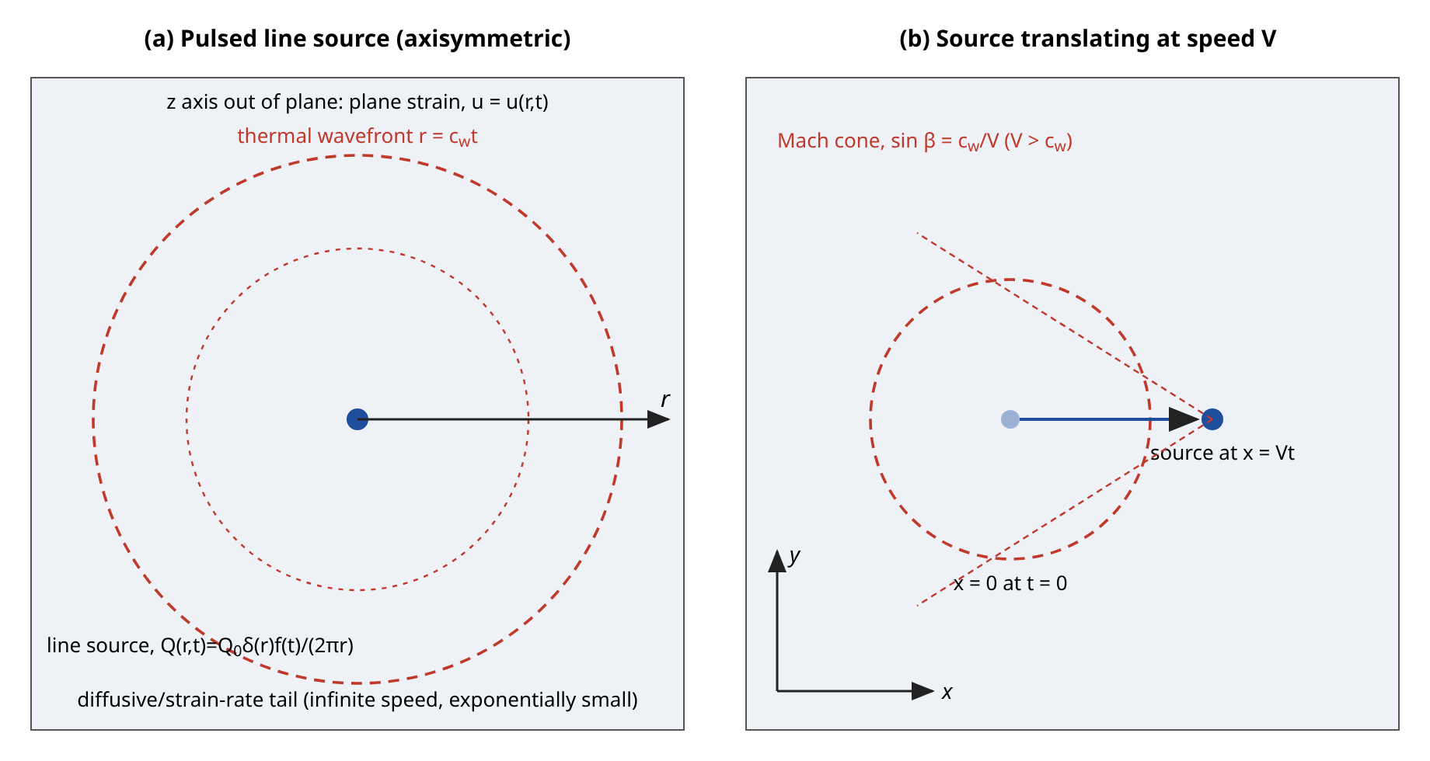
Figure 1. Schematic of the two source configurations in the unbounded plane-strain medium: (a) the pulsed axisymmetric line source with its thermal wavefront and diffusive tail; (b) the line source translating at speed $V$ with the Mach-type envelope that exists when $V>c_{w}$. Geometry schematic, not computed.
It is useful to interpret the operators $Φ$ and $Ψ$ physically before the solution is constructed. The operator $Φ$ describes the delay with which the heat flux responds to a change of the driving gradient, so that it controls how fast thermal information can travel; a vanishing $τ_{q}$ removes the delay and the front disappears. The operator $Ψ$ describes the delay with which the gradient itself is felt, and a positive $τ_{T}$ gives the medium a memory of the gradient that acts against the flux delay. When the two act together the net behaviour depends on their ratio, which is why the stability condition of Section 5 involves $τ_{T}/τ_{q}$. In the TPL model the factor $K(1+τ_{v}s)/s$ adds a contribution proportional to the history of the temperature, which gives the medium a restoring character at long times.

3. Pulsed line source: exact Laplace-domain solution

3.1 Potential, temperature, displacement and stresses
With $\overline{Q}=Q_{0}\overline{F}(s)δ(r)/(2πr)$, where $\overline{F}$ is the Laplace transform of the temporal profile, the right-hand side of the fourth-order equation is a two-dimensional delta function. The operator factorises, since $m_{1}^{2}$ and $m_{2}^{2}$ are the roots of $x^{2}−Bx+C=0$:
$\left(∇^{2}−m_{1}^{2}\right)\left(∇^{2}−m_{2}^{2}\right)\overline{φ}=−\frac{δ_{1}Q_{0}\overline{F}}{Ψ} δ^{(2)}(x)$ (26)
$m_{1,2}^{2}=\frac{1}{2}\left[B±\sqrt{B^{2}−4C}\right]$ (27)
The roots are labelled so that $|m_{1}|≥|m_{2}|$ and the branch with a positive real part is taken, which guarantees decay in $r$ for real $s>0$ and, by analytic continuation, for the complex values of $s$ used in the inversion. A two-dimensional Fourier transform with wave number $ξ$ gives
$\tilde{φ}(ξ)=−\frac{δ_{1}Q_{0}\overline{F}}{Ψ\left(ξ^{2}+m_{1}^{2}\right)\left(ξ^{2}+m_{2}^{2}\right)}$ (28)
The partial fraction decomposition $1/[(ξ^{2}+m_{1}^{2})(ξ^{2}+m_{2}^{2})]=[1/(ξ^{2}+m_{2}^{2})−1/(ξ^{2}+m_{1}^{2})]/(m_{1}^{2}−m_{2}^{2})$ and the transform pair $1/(ξ^{2}+m^{2})↔K_{0}(mr)/2π$ give
$\overline{φ}=G\left[K_{0}(m_{1}r)−K_{0}(m_{2}r)\right], G=\frac{δ_{1}Q_{0}\overline{F}(s)}{2π Ψ(s)\left(m_{1}^{2}−m_{2}^{2}\right)}$ (29)
The potential is finite at $r=0$ because the logarithmic singularities of the two Bessel functions have the same coefficient. Using $K_{0}′=−K_{1}$ and the identity $∇^{2}K_{0}(mr)=m^{2}K_{0}(mr)$ for $r>0$ the other fields follow. The temperature and displacement are
$\overline{θ}=\frac{G}{δ_{1}}\left[\left(m_{1}^{2}−\frac{s^{2}}{p}\right)K_{0}(m_{1}r)−\left(m_{2}^{2}−\frac{s^{2}}{p}\right)K_{0}(m_{2}r)\right]$ (30)
$\overline{u}=−G\left[m_{1}K_{1}(m_{1}r)−m_{2}K_{1}(m_{2}r)\right]$ (31)
The stress transforms are obtained from the constitutive relations and the potential equation. Writing $∂_{r}\overline{u}+λ_{1}\overline{u}/r=∇^{2}\overline{φ}−κ\overline{u}/r$ and using the relation between $\overline{θ}$ and $\overline{φ}$:
${\overline{σ}}_{rr}=s^{2}\overline{φ}−pκ\frac{\overline{u}}{r}$ (32)
${\overline{σ}}_{φφ}=s^{2}\overline{φ}+pκ\left(\frac{\overline{u}}{r}−∇^{2}\overline{φ}\right)$ (33)
where $∇^{2}\overline{φ}=G[m_{1}^{2}K_{0}(m_{1}r)−m_{2}^{2}K_{0}(m_{2}r)]$. These expressions have the same structure as those obtained in [1] for the Lord–Shulman limit, with the lag operators entering only through $m_{1}$, $m_{2}$ and the prefactor $G$. All fields decay exponentially in $r$ for $Re s>0$, which is the far-field condition used in the validation.

3.2 Singular behaviour and global energy identity
Near the source the temperature has the logarithmic singularity familiar from the Fourier line source. Expanding $K_{0}$ for small argument in the temperature transform, the logarithmic terms combine through the identity $m_{1}^{2}−m_{2}^{2}$ to give
$\overline{θ}≃−\frac{Q_{0}\overline{F}(s)}{2πΨ(s)}lnr, r→0$ (34)
The factor $Ψ$ shows that the lag in the temperature gradient, not the lag in the flux, controls the strength of the singularity. The heat flux through a small circle satisfies, in the Laplace domain,
$\lim_{r→0}2πr {\overline{q}}_{r}=\frac{Q_{0}\overline{F}(s)}{Φ(s)}$ (35)
so that the source strength appears through the flux operator, which is the expected consequence of the effective-source convention. Integrating the energy equation over the plane, the Laplacian term vanishes because the flux decays at infinity, and the integral of the dilatation vanishes because the displacement decays. This gives a global identity that is independent of the thermoelastic coupling and of $Ψ$,
$\int_{0}^{∞}{θ 2πr dr}=Q_{0} ℒ^{−1}\left[\frac{\overline{F}(s)}{s Φ(s)}\right]$ (36)
This identity provides a stringent test of the numerical solution because it involves all the radii and depends only on the flux operator $Φ$. For the step source with $Φ=1$ it gives $Q_{0}t$, the total heat injected.

3.3 Temporal profiles
Five profiles are used; their definitions are collected in Table 5 and Figure 3. A profile is normalised to a maximum value of one (or to one for the step). The step (Heaviside) profile corresponds to the problem of [1]. In the Laplace domain:
$f=H(t): \overline{F}(s)=\frac{1}{s}$ (37)
$f=H(t)−H(t−t_{p}): \overline{F}(s)=\frac{1−e^{−st_{p}}}{s}$ (38)
$f=e^{−t/t_{d}}: \overline{F}(s)=\frac{1}{s+1/t_{d}}$ (39)
$f=\frac{t}{t_{m}}e^{1−t/t_{m}}: \overline{F}(s)=\frac{e t_{m}}{{\left(1+t_{m}s\right)}^{2}}$ (40)
$f=\sin^{2}\left(\frac{πt}{P}\right): \overline{F}(s)=\frac{ω_{0}^{2}}{2s\left(s^{2}+ω_{0}^{2}\right)}, ω_{0}=\frac{2π}{P}$ (41)
The gamma-type profile rises from zero with a finite rate, peaks at $t=t_{m}$ with value one and decays slowly; it is a common idealisation of a laser pulse. The squared sine is a periodic train of non-negative pulses with period $P$ and a mean value of one half; it keeps the source non-negative, which a plain sine would not. The rectangular pulse is evaluated by superposition of two shifted step solutions, which avoids the Gibbs oscillations that a direct inversion of the discontinuous profile would produce:
$ℛ_{rect}(r,t)=ℛ_{step}(r,t)−H(t−t_{p}) ℛ_{step}(r,t−t_{p})$ (42)
where $ℛ$ stands for any field. The transforms of all five profiles were inverted separately with the same numerical method used for the field problem; the maximum error against the exact time functions was 2.3e-09 for the step, 2.4e-09 for the exponential, 3.2e-11 for the gamma profile and 3.8e-11 for the squared sine, and 8.9e-07 for the rectangle away from the discontinuity.

4. Moving line source

4.1 Formulation and its limitations
The moving-source problem is formulated for a line parallel to the $z$ axis that passes through the point $(Vt,0)$ of the $xy$ plane at time $t$, so that it translates at the constant speed $V$ in the $x$ direction in plane strain. The source is
$Q(x,y,t)=Q_{0} δ(x−Vt) δ(y) f(t)$ (43)
This is the formulation that was implemented; it is not the radially moving ring source that would be a fallback if the Cartesian problem were intractable. The medium is unbounded, the source starts at the origin at $t=0$, and no boundary or edge is present, so the problem has no reflected field. The source is a mathematical line, so that the temperature is logarithmically singular on its path. Since the only source of disturbance is a thermal one, the solenoidal part of the displacement satisfies a homogeneous wave equation with zero data and vanishes, which gives an irrotational displacement field $u_{i}=∂_{i}φ$ that satisfies the same potential equation as in Section 2 with $∇^{2}$ now the two-dimensional Cartesian Laplacian.

4.2 Transform solution
Taking the Laplace transform in time, the source becomes a distribution along the positive $x$ axis,
$\overline{Q}(x,y,s)=\frac{Q_{0}}{V} f\left(\frac{x}{V}\right)e^{−sx/V} H(x) δ(y)$ (44)
The spatial Fourier transform pair is defined by
$\tilde{g}(ξ,η)=\int_{−∞}^{∞}{\int_{−∞}^{∞}{g(x,y) e^{−i(ξx+ηy)} dx dy}}$ (45)
For a source that moves at speed $V$ the transform of $\overline{Q}$ is the transform of the profile with a Doppler-shifted Laplace variable, which can be verified directly from the definition of the Laplace transform of $δ(x−Vt)f(t)$:
$\tilde{Q}(ξ,η,s)=Q_{0} \overline{F}\left(s+iξV\right)$ (46)
Because $Re s>0$ the shifted argument remains in the half plane of analyticity of $\overline{F}$ for every real $ξ$. The transformed potential is
$\tilde{φ}=−\frac{δ_{1}Q_{0}\overline{F}(s+iξV)}{Ψ(s)\left(k^{2}+m_{1}^{2}\right)\left(k^{2}+m_{2}^{2}\right)}, k^{2}=ξ^{2}+η^{2}$ (47)
The roots $m_{1}$ and $m_{2}$ depend only on $s$, not on $ξ$, because the medium is homogeneous. The inverse transform in $η$ is performed analytically using the partial fractions of Section 3.1 and the standard result that the inverse transform of $1/(η^{2}+a^{2})$ with respect to $η$ is $e^{−a|y|}/(2a)$:
$a_{j}=\sqrt{ξ^{2}+m_{j}^{2}}, g_{j}(ξ,y)=\frac{e^{−a_{j}y}}{2a_{j}}, j=1,2$ (48)
with the branch $Re a_{j}>0$. By symmetry the field is even in $y$, and the formulas below are for $y>0$. The potential and the transformed fields are single Fourier integrals,
$\overline{φ}(x,y,s)=\frac{1}{2π}\int_{−∞}^{∞}{e^{iξx} Λ(ξ)\left[g_{1}−g_{2}\right]}dξ$ (49)
$Λ(ξ)=\frac{δ_{1}Q_{0}\overline{F}(s+iξV)}{Ψ(s)\left(m_{1}^{2}−m_{2}^{2}\right)}$ (50)
The temperature, the two displacement components and the three in-plane stresses are given by the same integral with the integrand modified as follows (for $y>0$ and $κp$ as in Section 3). The temperature is
$\overline{θ}=\frac{1}{2πδ_{1}}\int{e^{iξx}Λ\left[\left(m_{1}^{2}−\frac{s^{2}}{p}\right)g_{1}−\left(m_{2}^{2}−\frac{s^{2}}{p}\right)g_{2}\right]}dξ$ (51)
${\overline{u}}_{x}=\frac{1}{2π}\int{iξ e^{iξx}Λ\left[g_{1}−g_{2}\right]}dξ$ (52)
${\overline{u}}_{y}=\frac{1}{2π}\int{e^{iξx}Λ\left[−a_{1}g_{1}+a_{2}g_{2}\right]}dξ$ (53)
For the stresses the Fourier-space expressions ${\tilde{σ}}_{xx}=\tilde{φ}(s^{2}+pκη^{2})$, ${\tilde{σ}}_{yy}=\tilde{φ}(s^{2}+pκξ^{2})$ and ${\tilde{σ}}_{xy}=−pκξη\tilde{φ}$ follow from the relation between $θ$ and $φ$, and the $η$ factors are removed by differentiation in $y$, which is legitimate for $y≠0$. The results are
${\overline{σ}}_{xx}=\frac{1}{2π}\int{e^{iξx}Λ\left[\left(s^{2}−pκa_{1}^{2}\right)g_{1}−\left(s^{2}−pκa_{2}^{2}\right)g_{2}\right]}dξ$ (54)
${\overline{σ}}_{yy}=\frac{1}{2π}\int{e^{iξx}Λ\left(s^{2}+pκξ^{2}\right)\left[g_{1}−g_{2}\right]}dξ$ (55)
${\overline{σ}}_{xy}=\frac{pκ}{2π}\int{iξ e^{iξx}Λ\left[−a_{1}g_{1}+a_{2}g_{2}\right]}dξ$ (56)

4.3 Evaluation, consistency and the Mach condition
The integrals are evaluated by the trapezoidal rule with step $h$ and truncation $|ξ|≤ξ_{max}$,
$\int_{−∞}^{∞}{F(ξ) dξ}≈h\sum_{j=−J}^{J}{F(jh)}, J=ξ_{max}/h$ (57)
For an integrand that is analytic in a strip of half-width $d$ about the real axis the trapezoidal error decays like $e^{−2πd/h}$ plus the truncation error, which is exponentially small for $y>0$ because $g_{j}∼e^{−|ξ|y}$. The nearest singularities are the branch points of $a_{j}$ at $ξ=±im_{j}$ and the pole of $\overline{F}(s+iξV)$ at $ξ=is/V$. In the computations $y=0.2$, $h=0.25$ and $ξ_{max}=100$ are used, so that the truncation factor is about $e^{−20}$. A necessary check is that the code reproduces the axisymmetric solution of Section 3 when $V=0$. In that case the integrand is independent of $V$ and the known identity
$\frac{1}{2π}\int_{−∞}^{∞}{e^{iξx} \frac{e^{−y\sqrt{ξ^{2}+m^{2}}}}{2\sqrt{ξ^{2}+m^{2}}} dξ}=\frac{1}{2π}K_{0}\left(m\sqrt{x^{2}+y^{2}}\right)$ (58)
shows that the two solutions coincide. The Cartesian stress components are related to the polar ones, with $φ$ the polar angle, by
$σ_{xx}=σ_{rr}\cos^{2}φ+σ_{φφ}\sin^{2}φ$ (59)
which is used in the $V=0$ comparison. The wave structure of Section 5 implies a characteristic thermal wave speed $c_{w}$. When $V>c_{w}$ the source outruns its own disturbance and the wavefronts, being circles centred at earlier source positions, have a conical envelope with half-angle
$sinβ=\frac{c_{w}}{V}$ (60)
The numerical results of Section 7 show the corresponding rise of the stress peak. For $V<c_{w}$ the front is a distorted circle whose forward part is compressed in the direction of motion, and the temperature maximum is displaced toward the moving source. The moving-source solution describes the transient stage and not a quasi-steady state: the source is switched on at $t=0$ and the fields at $t=0.1$ still contain the initial front.
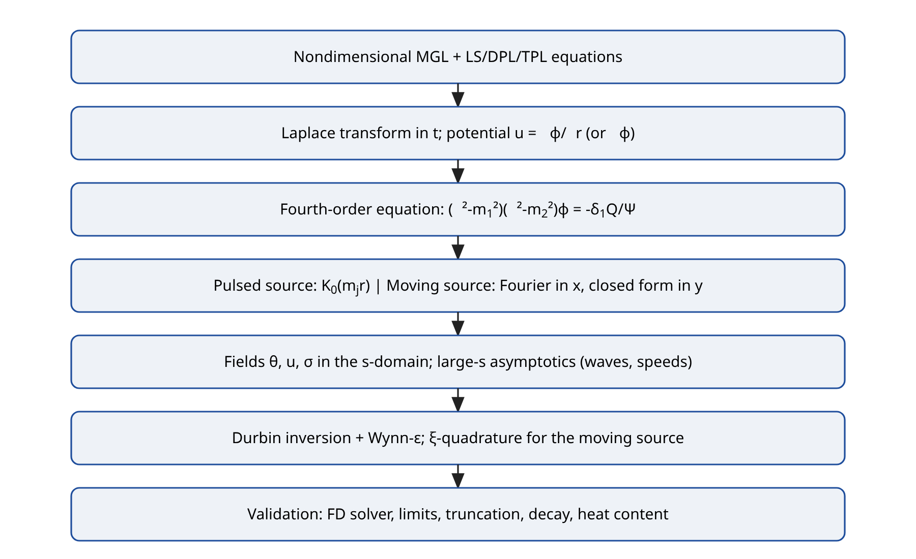
Figure 2. Solution procedure: transform, potential, closed-form transform-domain solution, asymptotic classification, numerical inversion and validation. Flow chart, not computed.
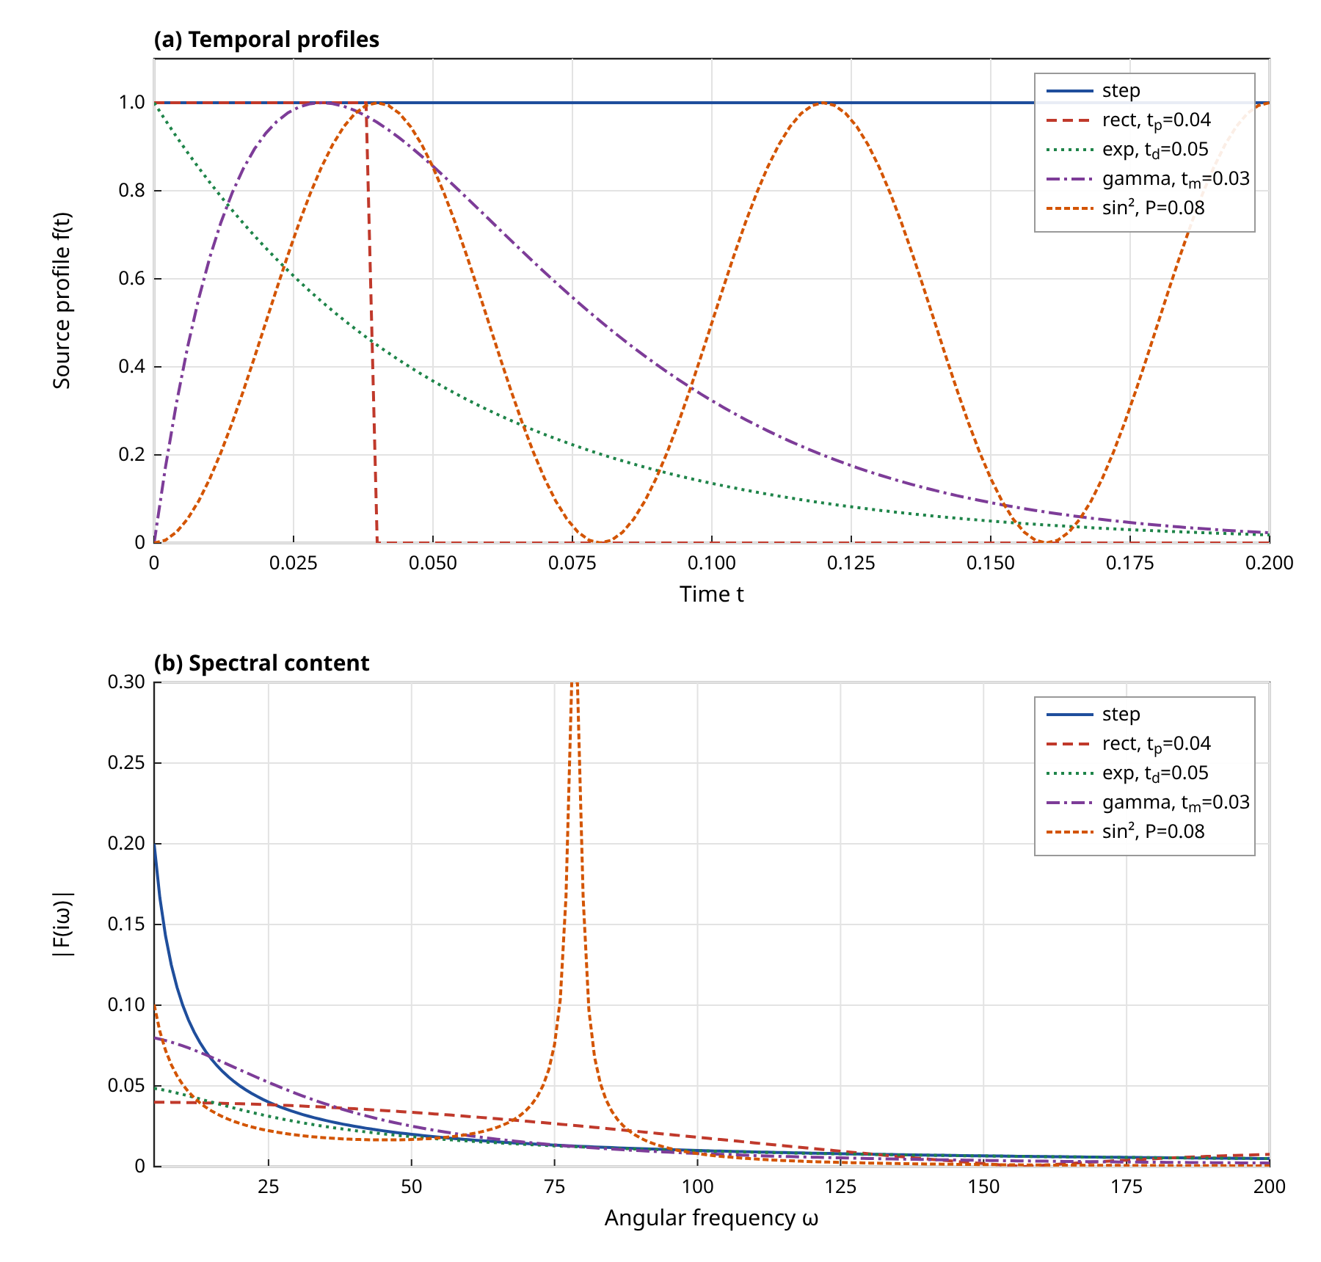
Figure 3. Temporal source profiles (a) and the modulus of their Laplace transforms on the imaginary axis (b). Profiles are those of Table 5; curves are computed from the defining functions; the sinusoidal spectrum has a pole at $ω_{0}=2π/P$ and is clipped.
The Doppler-shifted argument of $\overline{F}$ has a direct interpretation. A Fourier component of wave number $ξ$ along the direction of motion sees the source, in the frame of the medium, as a time dependence $e^{−iξVt}f(t)$, so that its effective complex frequency is $s+iξV$. For a step profile the source of that component is $1/(s+iξV)$, which has a pole at $s=−iξV$ and therefore describes a harmonic forcing. The response is obtained by integrating all components with the weight $e^{iξx}$, and the thermal wave appears as a singularity in the transform variable $s$ that is shifted by $ξV$ for each component. This is the origin of the Mach-type structure when $V$ exceeds the wave speed: components with $|ξ|V$ larger than the wave frequency are forced faster than the medium can propagate them, and their contributions add coherently along the cone.

5. Short-time asymptotics, wave structure and stability

5.1 Large-parameter expansion of the characteristic roots
Wavefronts are governed by the behaviour of the roots $m_{1}(s)$ and $m_{2}(s)$ for large $|s|$. If $m∼s/c$ then $e^{−mr}$ transforms back to a function that vanishes for $t<r/c$, so that $c$ is a finite propagation speed; if $m∼\sqrt{s}$ the corresponding contribution is diffusive, has an infinite speed of propagation and is exponentially small ahead of the wave. The classification therefore reduces to the exponent in $m∼s^{ν}$. For the second-order DPL law with $τ_{T}>0$, the large-$s$ forms of the operators are
$Φ(s)≃\frac{τ_{q}^{2}s^{2}}{2}, Ψ(s)≃τ_{T}s, \frac{Φ}{Ψ}≃\frac{τ_{q}^{2}s}{2τ_{T}}\left[1+\frac{1}{s}\left(\frac{2}{τ_{q}}−\frac{1}{τ_{T}}\right)\right]$ (61)
The coefficients of the quadratic for $x=m^{2}$ become
$B≃as^{2}+\left[a\left(\frac{2}{τ_{q}}−\frac{1}{τ_{T}}\right)+\frac{1}{τ_{1}}\right]s, a=\frac{(1+ε)τ_{q}^{2}}{2τ_{T}}$ (62)
$C≃\frac{τ_{q}^{2}}{2τ_{T}τ_{1}}s^{3}$ (63)
Since $B$ is of order $s^{2}$ and $C$ of order $s^{3}$ the two roots separate, $x_{1}≃B−C/B$ and $x_{2}≃C/B$, which leads to a fast root that is linear in $s$ and a slow root that behaves like $\sqrt{s}$:
$m_{1}≃\frac{s}{c_{w}}+β, c_{w}=\frac{1}{τ_{q}}\sqrt{\frac{2τ_{T}}{1+ε}}$ (64)
$β=\frac{1}{2c_{w}}\left(\frac{2}{τ_{q}}−\frac{1}{τ_{T}}\right)+\frac{c_{w} ε}{2\left(1+ε\right)τ_{1}}$ (65)
$m_{2}^{2}≃\frac{s}{\left(1+ε\right)τ_{1}}$ (66)
The fast root gives a thermoelastic wave with the finite speed $c_{w}$ and a spatial attenuation $e^{−βr}$ of its amplitude; the slow root carries the diffusive, strain-rate controlled part. For the base data $c_{w}=7.682$ and $β=2.354$. The closed-form attenuation agrees with the numerical value of $Re(m_{1}−s/c_{w})$ computed at $s=10^{7}$, which is 2.354. The first term of $β$ is the lag contribution and the second is the strain-rate contribution; the second is proportional to $ε/τ_{1}$ and therefore vanishes as the thermoelastic coupling vanishes.
For the Lord–Shulman MGL law the same procedure gives the speed of [1], with a corresponding attenuation constant of 4.724 that was also checked numerically (numerical value 4.724):
$c_{LS}=\frac{1}{\sqrt{\left(1+ε\right)τ_{0}}}$ (67)
which equals 7.012 for the data of [1], in agreement with the value of about 7.01 quoted there. The original Green–Lindsay type law has two finite speeds, from $ρ^{2}−(1+τ_{0})ρ+τ_{0}=0$ with $x=ρs^{2}$, equal to $1$ (the elastic speed) and $1/\sqrt{τ_{0}}$, which explains the two wavefronts that [1] reports for that theory.
The first-order DPL law behaves differently. Because $Φ/Ψ→τ_{q}/τ_{T}$ the coefficients $B$ and $C$ are of order $s$ and $s^{2}$, and both roots scale like $\sqrt{s}$. Writing $x=ϱs$,
$ϱ^{2}−\left[\frac{1}{τ_{1}}+\left(1+ε\right)\frac{τ_{q}}{τ_{T}}\right]ϱ+\frac{τ_{q}}{τ_{T}τ_{1}}=0$ (68)
so that both branches are diffusive and the first-order DPL model, like the Fourier model, has no wavefront: the numerical exponents in Table 3 are 0.50 for both roots. The statement in the literature that the first-order DPL equation is wave-like when $τ_{q}>τ_{T}$ refers to the uncoupled heat equation expanded to second order in $τ_{q}$; the first-order expansion is of parabolic type. The TPL law with a first-order flux expansion and $τ_{T}=0$ has $Ψ→1+Kτ_{v}$ and a finite speed
$c_{TPL1}=\sqrt{\frac{1+Kτ_{v}}{\left(1+ε\right)τ_{q}}}$ (69)
which equals 7.023 for $K=0.1$, $τ_{v}=0.03$ and is confirmed numerically in Table 3. For the second-order TPL law with $τ_{T}>0$ the leading large-$s$ terms are unchanged, because $K(1+τ_{v}s)/s→Kτ_{v}$ is a constant that is small compared with $τ_{T}s$; the parameters $τ_{v}$ and $K$ affect the speed only through corrections of relative order $1/s$, so the numerical speed of the TPL model in Table 3 coincides with that of the DPL model to six digits.

5.2 Stability of the second-order lag laws
A second-order expansion in $τ_{q}$ combined with a first-order expansion in $τ_{T}$ is not unconditionally well posed. The stability can be tested directly on the plane-wave dispersion relation of the coupled system. With wave number $ξ$ and $Ψ^{′}=sΨ$ the relation, after multiplication by $p$ and by $s$, is the polynomial equation
$Ψ^{′}p ξ^{4}+\left[Ψ^{′}s^{2}+\left(1+ε\right)Φ p s^{2}\right]ξ^{2}+Φs^{4}=0$ (70)
whose roots $s(ξ)$ must lie in the closed left half-plane for the initial value problem to be stable, and for the Laplace inversion with a contour to the right of all singularities to be valid. The polynomial has degree five for DPL and six for TPL and was solved by an Aberth iteration for ten wave numbers between 0.1 and 3000. The largest real part found is listed in Table 3. For the uncoupled heat equation it is known from the stability analysis of Quintanilla and Racke that the second-order DPL law is stable if
$τ_{T}>\frac{τ_{q}}{2}$ (71)
and the dispersion scan reproduces this threshold for the coupled MGL system: with $τ_{q}=0.02$ and $τ_{T}=0.012$ the maximal growth rate is zero, whereas for $τ_{T}=0.006$ it equals 28.5, so that a Laplace inversion for that case would be meaningless. All results for second-order DPL and TPL models in this paper use $τ_{T}=0.012>τ_{q}/2$ or larger. The stable wave speed then exceeds the Lord–Shulman speed with the same $τ_{q}$; for $τ_{T}=τ_{q}/2$ the two speeds coincide at leading order. This is a structural property of the second-order law and not a numerical artefact.
The three-phase-lag law has its own restriction. Keeping $τ_{q}=0.02$ and $τ_{T}=0.012$ and varying the thermal-displacement lag, the dispersion scan shows that the TPL system is stable only when the product $Kτ_{v}$ stays below a threshold, which was located by bisection and found to be 0.284, 0.284 and 0.283 for $K=0.1$, $0.5$ and $2$ respectively, that is, $Kτ_{v}≈0.28$ independently of $K$ over this range. For $K=0.5$ the maximal growth rate is 8.73 for $τ_{v}=1$ and 47.2 for $τ_{v}=3$. A first set of parametric calculations that used $τ_{v}$ up to 3 was therefore discarded and repeated with $τ_{v}≤0.5$. The threshold is a numerical finding for these lags; no closed-form condition is claimed here.

5.3 Long-time behaviour of the TPL model
The conductivity rate $K$ introduces a pole $K/s$ in $Ψ$ that dominates at small $s$. For $|s|≪1$ the quantities $Ψ≃K/s$, $Φ≃1$ and $p≃1$ give $B≃s^{2}[1+(1+ε)/K]$ and $C≃s^{4}/K$, so that both roots are linear in $s$ at long times, $x=ρs^{2}$, with
$ρ^{2}−\left[1+\frac{1+ε}{K}\right]ρ+\frac{1}{K}=0$ (72)
This means that at late times the TPL model has two finite speeds $1/\sqrt{ρ_{±}}$ instead of a diffusive tail. For vanishing coupling the roots are $1$ and $1/K$, so one speed is the elastic speed and the other is $\sqrt{K}$ (in units of the elastic speed), which is the thermal-displacement wave of Green–Naghdi type. This is why the conductivity rate changes the far field at later times in Figure 10 and why its effect is very small at the early times of Figure 9. The practical consequence is that $K^{*}$ must be treated as a long-time parameter.

5.4 Arrival time and amplitude of the front
For a given point $r$ the front arrives at the time
$t_{f}(r)=\frac{r}{c_{w}}, θ,σ∼e^{−βr} at the front$ (73)
The exponential attenuation with $β$ of order 2 to 5 explains why wave effects are visible only for $r≲1$ in the figures; further out the wave amplitude has decayed to the level of the numerical noise and the response is controlled by the diffusive root.
A practical consequence of Sections 5.1 to 5.3 is a procedure for choosing lag parameters. For a given flux lag $τ_{q}$ the temperature-gradient lag must satisfy $τ_{T}>τ_{q}/2$, and the wave speed then follows from $c_{w}$ without any numerical solution. If a measured front speed is available, the formula can be inverted to give $τ_{T}=(1+ε)τ_{q}^{2}c_{w}^{2}/2$, which must then be tested against the stability limit. The thermal-displacement lag and the conductivity rate do not change the speed at leading order and must be identified from long-time data. This separation of roles between the leading and the corrective parameters is a useful structural result of the asymptotic analysis, and it explains why the DPL and TPL curves of Section 7 nearly coincide at early times.
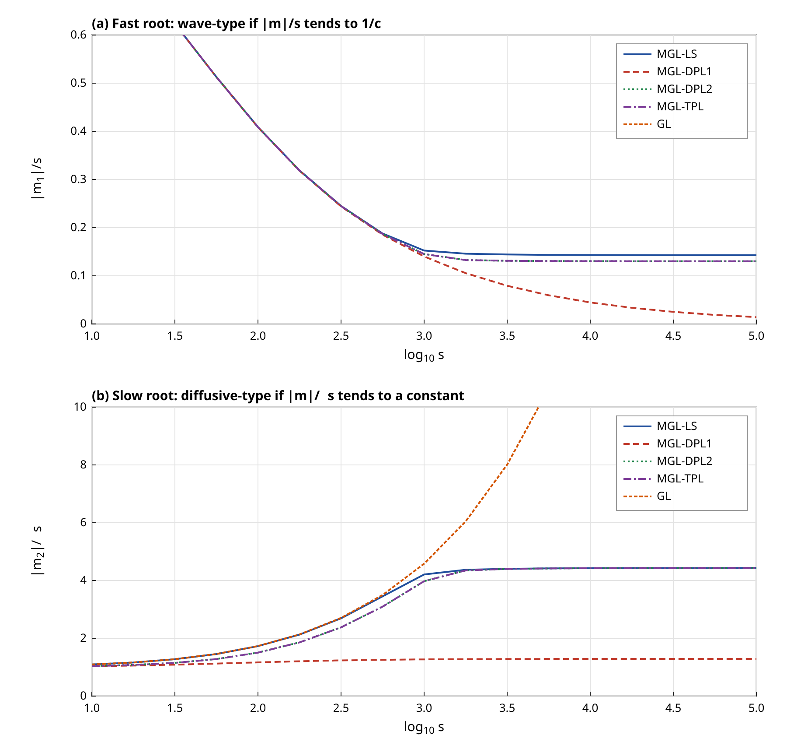
Figure 4. Large-parameter behaviour of the characteristic roots for real $s$: (a) $|m_{1}|/s$, which tends to the reciprocal of a finite wave speed for the LS, second-order DPL and TPL models, and to zero for first-order DPL; (b) $|m_{2}|/\sqrt{s}$, which tends to a constant for a diffusive branch. The GL curve belongs to the original Green–Lindsay type law with two finite speeds.
Table 1. Physical data for copper (from [1]) and nondimensional parameters used in the computations.
Quantity | Symbol | Value
Lamé constant | $λ$ | 7.76×10¹⁰ N/m²
Shear modulus | $μ$ | 3.86×10¹⁰ N/m²
Thermal expansion coefficient | $α_{t}$ | 1.78×10⁻⁵ K⁻¹
Specific heat | $c_{E}$ | 383.1 J/(kg K)
Thermal conductivity | $k$ | 386 W/(m K)
Density | $ρ$ | 8954 kg/m³
Reference temperature | $T_{0}$ | 293 K
Thermal diffusion parameter | $η$ | 8886.73 s/m²
Strain-rate lag | $τ_{1}$ | 0.05
Flux lag (Lord–Shulman role $τ_{0}$) | $τ_{q}$ | 0.02
Temperature-gradient lag | $τ_{T}$ | 0.012
Thermal-displacement lag, conductivity rate | $τ_{v}$, $K$ | 0.03, 0.1
Source strength | $Q_{0}$ | 1

Table 2. Derived dimensionless constants and characteristic speeds.
Quantity | Expression | Value
Coupling constant | $δ_{1}=γT_{0}/(λ+2μ)$ | 0.01044
Coupling constant | $δ_{2}=γ/(ρc_{E})$ | 1.609
Coupling product | $ε=δ_{1}δ_{2}$ | 0.0168
Modulus ratio | $λ_{1}=λ/(λ+2μ)$ | 0.5013
Shear ratio | $κ=1−λ_{1}$ | 0.4987
Elastic speed | $c_{1}=\sqrt{(λ+2μ)/ρ}$ | 4158 m/s
Length unit | $1/(ηc_{1})$ | 2.71e-08 m
Time unit | $1/(ηc_{1}^{2})$ | 6.51e-12 s
Lord–Shulman MGL wave speed | $c_{LS}$ | 7.012
Second-order DPL wave speed | $c_{w}$ | 7.682
First-order TPL speed ($τ_{T}=0$) | $c_{TPL1}$ | 7.023

Table 3. Asymptotic classification of the characteristic roots at large $s$ (numerical exponents from $s=10^{5}$ and $10^{6}$; maximal growth rate from the dispersion scan).
Model | Large-$s$ operators | Exponent $m_{1}$ | Exponent $m_{2}$ | Numerical $c$ | Formula $c$ | Max growth | Fronts
Fourier | $Φ=Ψ=1$ | 0.5 | 0.5 | - | - | 0 | none
GL | GL-type | 1 | 1 | 0.9996 | 1 and 7.071 | 0 | two
MGL-LS | $Φ∼τ_{0}s$, $Ψ=1$ | 1 | 0.5 | 7.012 | 7.012 | 0 | one
MGL-DPL1 | $Φ/Ψ→τ_{q}/τ_{T}$ | 0.5 | 0.5 | - | none | 0 | none
MGL-DPL2 | $Φ∼τ_{q}^{2}s^{2}/2$, $Ψ∼τ_{T}s$ | 1 | 0.5 | 7.682 | 7.682 | 0 | one
MGL-TPL | as DPL2, plus $K(1+τ_{v}s)/s$ | 1 | 0.5 | 7.682 | 7.682 | -0.00035 | one
MGL-TPL1 | $Φ∼τ_{q}s$, $Ψ→1+Kτ_{v}$ | 1 | 0.5 | 7.023 | 7.023 | -0.00035 | one
DPL2-unstable | as DPL2, $τ_{T}=0.006$ | 1 | 0.5 | 5.432 | 5.432 | 29 | one (unstable)

6. Numerical inversion and validation tools

6.1 Inversion of the Laplace transform
The transformed fields are inverted with the Fourier-series method of Durbin, in its standard form. For a target time $t$ and an interval length $T=2t$ the approximation with $N$ terms is
$f(t)≈\frac{e^{ct}}{T}\left[\frac{1}{2}Re \overline{f}(c)+\sum_{k=1}^{N}{Re\left\{\overline{f}\left(c+\frac{ikπ}{T}\right)e^{ikπt/T}\right\}}\right]$ (74)
with $ct=6$. The truncation error is estimated by comparing the result with $N$ terms to that with $N/2$ terms,
$ε_{N}=\frac{\left|f_{N}(t)−f_{N/2}(t)\right|}{\left|f_{N}(t)\right|}$ (75)
and the partial sums of the last twelve terms are accelerated with the Wynn epsilon algorithm,
$ε_{k+1}^{(n)}=ε_{k−1}^{(n+1)}+\frac{1}{ε_{k}^{(n+1)}−ε_{k}^{(n)}}$ (76)
which reduces the oscillation caused by the discontinuous hoop stress at the front. The modified Bessel functions of complex argument were computed with a power series for $|z|≤2$ and, for larger $|z|$, with the exponentially convergent trapezoidal evaluation of
$e^{z}K_{ν}(z)=\sqrt{\frac{π}{2z}}\frac{1}{Γ(ν+1/2)}\int_{0}^{∞}{e^{−u}u^{ν−1/2}{\left(1+\frac{u}{2z}\right)}^{ν−1/2}du}$ (77)
which avoids overflow for the large arguments encountered at the high-frequency terms. The Bessel evaluations were checked against the analytical Fourier solution: for the uncoupled Fourier model ($ε=0$) the step solution is $θ=Q_{0}E_{1}(r^{2}/4t)/4π$, and the inversion reproduced it with a maximum relative error of 0.0004 over nine combinations of $r$ and $t$.

6.2 Independent finite-difference solver
An independent solver was written that does not use Laplace transforms, Bessel functions or the potential. It integrates the Lord–Shulman MGL equations for a heated disc of radius $r_{c}$ in a staggered grid with temperature at nodes and displacement at half nodes, using the temperature rate $w=∂_{t}θ$ as an auxiliary variable,
$τ_{0} ∂_{t}w=∇^{2}θ+Q−w−δ_{2}∂_{t}e−δ_{2}τ_{0} ∂_{t}^{2}e, ∂_{t}θ=w$ (78)
$∂_{t}^{2}u=∂_{r}\left[e−δ_{1}θ+τ_{1}\left(∂_{t}e−δ_{1}w\right)\right]$ (79)
The scheme is explicit and stable if the time step satisfies
$Δt≤min\left\{0.2\frac{Δr^{2}}{τ_{1}}, \frac{0.2 Δr}{8}\right\}$ (80)
with $Δr=0.002$ and $r_{c}=0.02$ (area-equivalent radius 0.021). Since a finite-difference solver cannot represent a delta source, the exact comparator is the Laplace solution for a uniform disc, which for $r>r_{c}$ differs from the line solution only through the factor
$Ξ_{j}=\frac{2 I_{1}(m_{j}r_{c})}{m_{j}r_{c}}, \overline{φ}=G\left[Ξ_{1}K_{0}(m_{1}r)−Ξ_{2}K_{0}(m_{2}r)\right]$ (81)
which follows from the mean-value property of solutions of $(∇^{2}−m^{2})w=0$ outside the disc. The function $e^{−z}I_{1}(z)$ is computed by the periodic trapezoidal rule of its integral representation, which is accurate for all complex arguments needed. Agreement is quantified by the maximal error normalised by the maximal value of the field,
$E_{f}=\frac{\max_{r}\left|f_{FD}(r)−f_{LT}(r)\right|}{\max_{r}\left|f_{LT}(r)\right|}$ (82)
and the quadrature error of the moving-source integral, defined as the relative difference with the axisymmetric $K_{0}$ solution at $V=0$, is expected to decay with the step as
$E_{h}∼e^{−2πd/h}$ (83)
until another error source (the Durbin inversion itself) is reached. A final global test is the heat-content identity of Section 3.2, whose relative defect is
$E_{Q}=\frac{\left|\int{θ} dA−Q_{0}ℒ^{−1}[\overline{F}/(sΦ)]\right|}{Q_{0}ℒ^{−1}[\overline{F}/(sΦ)]}$ (84)

7. Results and discussion

7.1 Conventions
All results are for the nondimensional copper data of Tables 1 and 2 with $Q_{0}=1$, $τ_{1}=0.05$, $τ_{q}=0.02$ and, unless stated, $τ_{T}=0.012$ for the DPL and TPL models and $τ_{v}=0.03$, $K=0.1$ for the TPL model. Temperatures are nondimensional and proportional to $Q_{0}$. Since the thermoelastic coupling constant $δ_{1}=0.0104$ is small, displacements and stresses are of order $10^{−5}$ to $10^{−2}$ and are plotted with the scale factors indicated on the axes. The nondimensional wave speeds are measured in units of the elastic speed $c_{1}$ and the dimensional equivalents follow from
$r_{phys}=\frac{r}{ηc_{1}}, t_{phys}=\frac{t}{ηc_{1}^{2}}, c_{phys}=c c_{1}$ (85)
so that the thermal wave speed $c_{w}=7.68$ corresponds to 31.9 km/s, far above the elastic speed of copper: the nondimensional lags of [1] describe a hypothetical fast-relaxing material in which the thermal wave outruns the elastic wave, and the results are to be read as a study of structure and trends, not as a quantitative prediction for a measured material. Every time-domain value below was obtained with $N=4000$ terms and Wynn acceleration for profiles and $N=3000$ for histories, unless stated.

7.2 Wave propagation under the second-order DPL law
Figure 5 shows the temperature and hoop stress produced by a step line source in the MGL-DPL medium at three times. The vertical dashed lines mark the predicted front $r=c_{w}t$ with $c_{w}=7.68$. The temperature is smooth and decays monotonically with distance, and falls to numerical zero at a short distance beyond the front; the front itself is visible as a change of slope, since the wave amplitude is strongly attenuated by $e^{−βr}$ with $β=2.35$. The hoop stress changes by a large fraction of its value across the front: at $t=0.06$ it goes from -1.03×10⁻³ just behind the front, at $r=0.44$, to -0.065×10⁻³ at $r=0.48$ (values of the transformed solution at $N=4000$). This is the signature of the finite-speed wave. The displacement, by contrast, is continuous across the front, which is the property that distinguishes the MGL theory from the original Green–Lindsay type law, and agrees with [1] and [14]. The far-field values at $r=1$ are of order $10^{−12}$ or smaller in all fields (far-field check in Section 7.9), so the decay condition is satisfied by the numerical solution.
The front at $t=0.03$ lies near $r=0.23$, at $t=0.06$ near $0.46$ and at $t=0.09$ near $0.69$, which is the linear growth $c_{w}t$ expected from the asymptotic analysis; the stress dips visible at $t=0.09$ close to $r=0.65$ show that the sharp wave feature has by then decayed to a rounded step. After the front has passed, the stress relaxes toward the quasi-static value that follows the slowly diffusing temperature, and at the source the hoop stress stays compressive, as expected for a heated region constrained by the surrounding cold material.
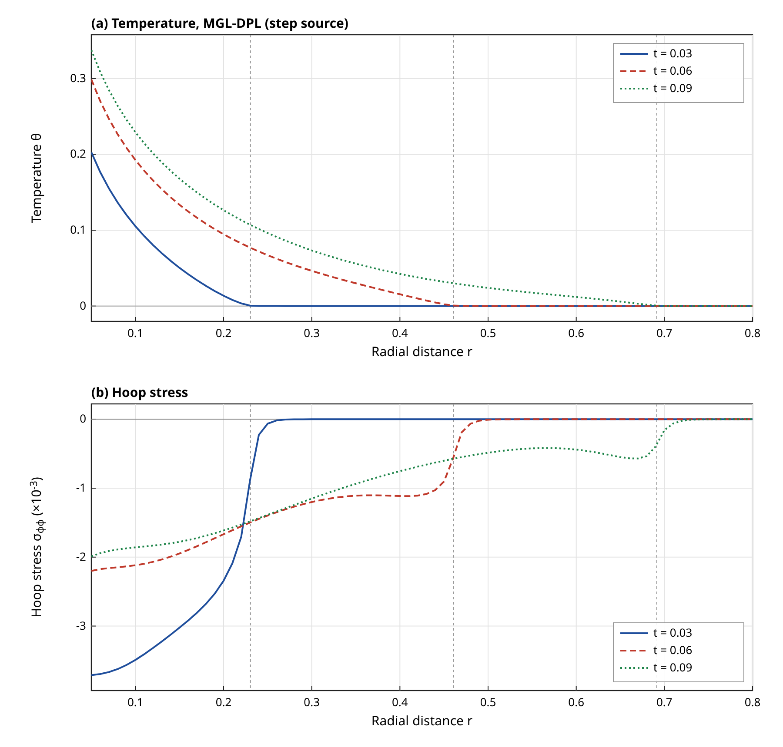
Figure 5. Temperature (a) and hoop stress (b) versus radius for the MGL-DPL (second-order) model and a step line source at $t=0.03$, $0.06$ and $0.09$. Dashed vertical lines: predicted front positions $r=c_{w}t$. Computed by Laplace inversion ($N=4000$, Wynn acceleration).

7.3 Role of the strain-rate parameter
Figure 6 shows the displacement and the hoop stress at $t=0.06$ for four values of $τ_{1}$ in the DPL medium. The temperature field changes by less than 1 per cent in the entire range (the near-source value at $r=0.1$ is 0.1926 for $τ_{1}=0$ and 0.1924 for $τ_{1}=0.1$), because the strain-rate term acts on the mechanical equations and enters the heat equation only through the coupling constant $δ_{2}$. The mechanical fields are affected strongly. At $r=0.3$ the displacement is 0.887, 2.69, 5.59 and 10.9 (×10⁻⁶) for $τ_{1}=0$, $0.02$, $0.05$ and $0.1$, a twelve-fold increase over the range, and the hoop stress is -0.489, -0.776, -1.2 and -1.88 (×10⁻³). The mechanism is that with $τ_{1}=0$ the mechanical response ahead of the thermal front is purely driven by the temperature gradient, whereas a finite $τ_{1}$ gives the elastic field a diffusive component with $m_{2}^{2}≃s/[(1+ε)τ_{1}]$ that spreads ahead of the thermal wave. The stress at $r=0.5$, ahead of the front $r=c_{w}t=0.46$, is 6.51×10⁻⁶ for $τ_{1}=0.05$ and 1.86×10⁻⁸ for $τ_{1}=0.02$ and negligible for $τ_{1}=0$, which shows the infinite-speed but exponentially small precursor associated with the strain rate [2]. In agreement with the modelling intent of [14], a larger $τ_{1}$ does not remove the wave but smooths the stress profile near the front.
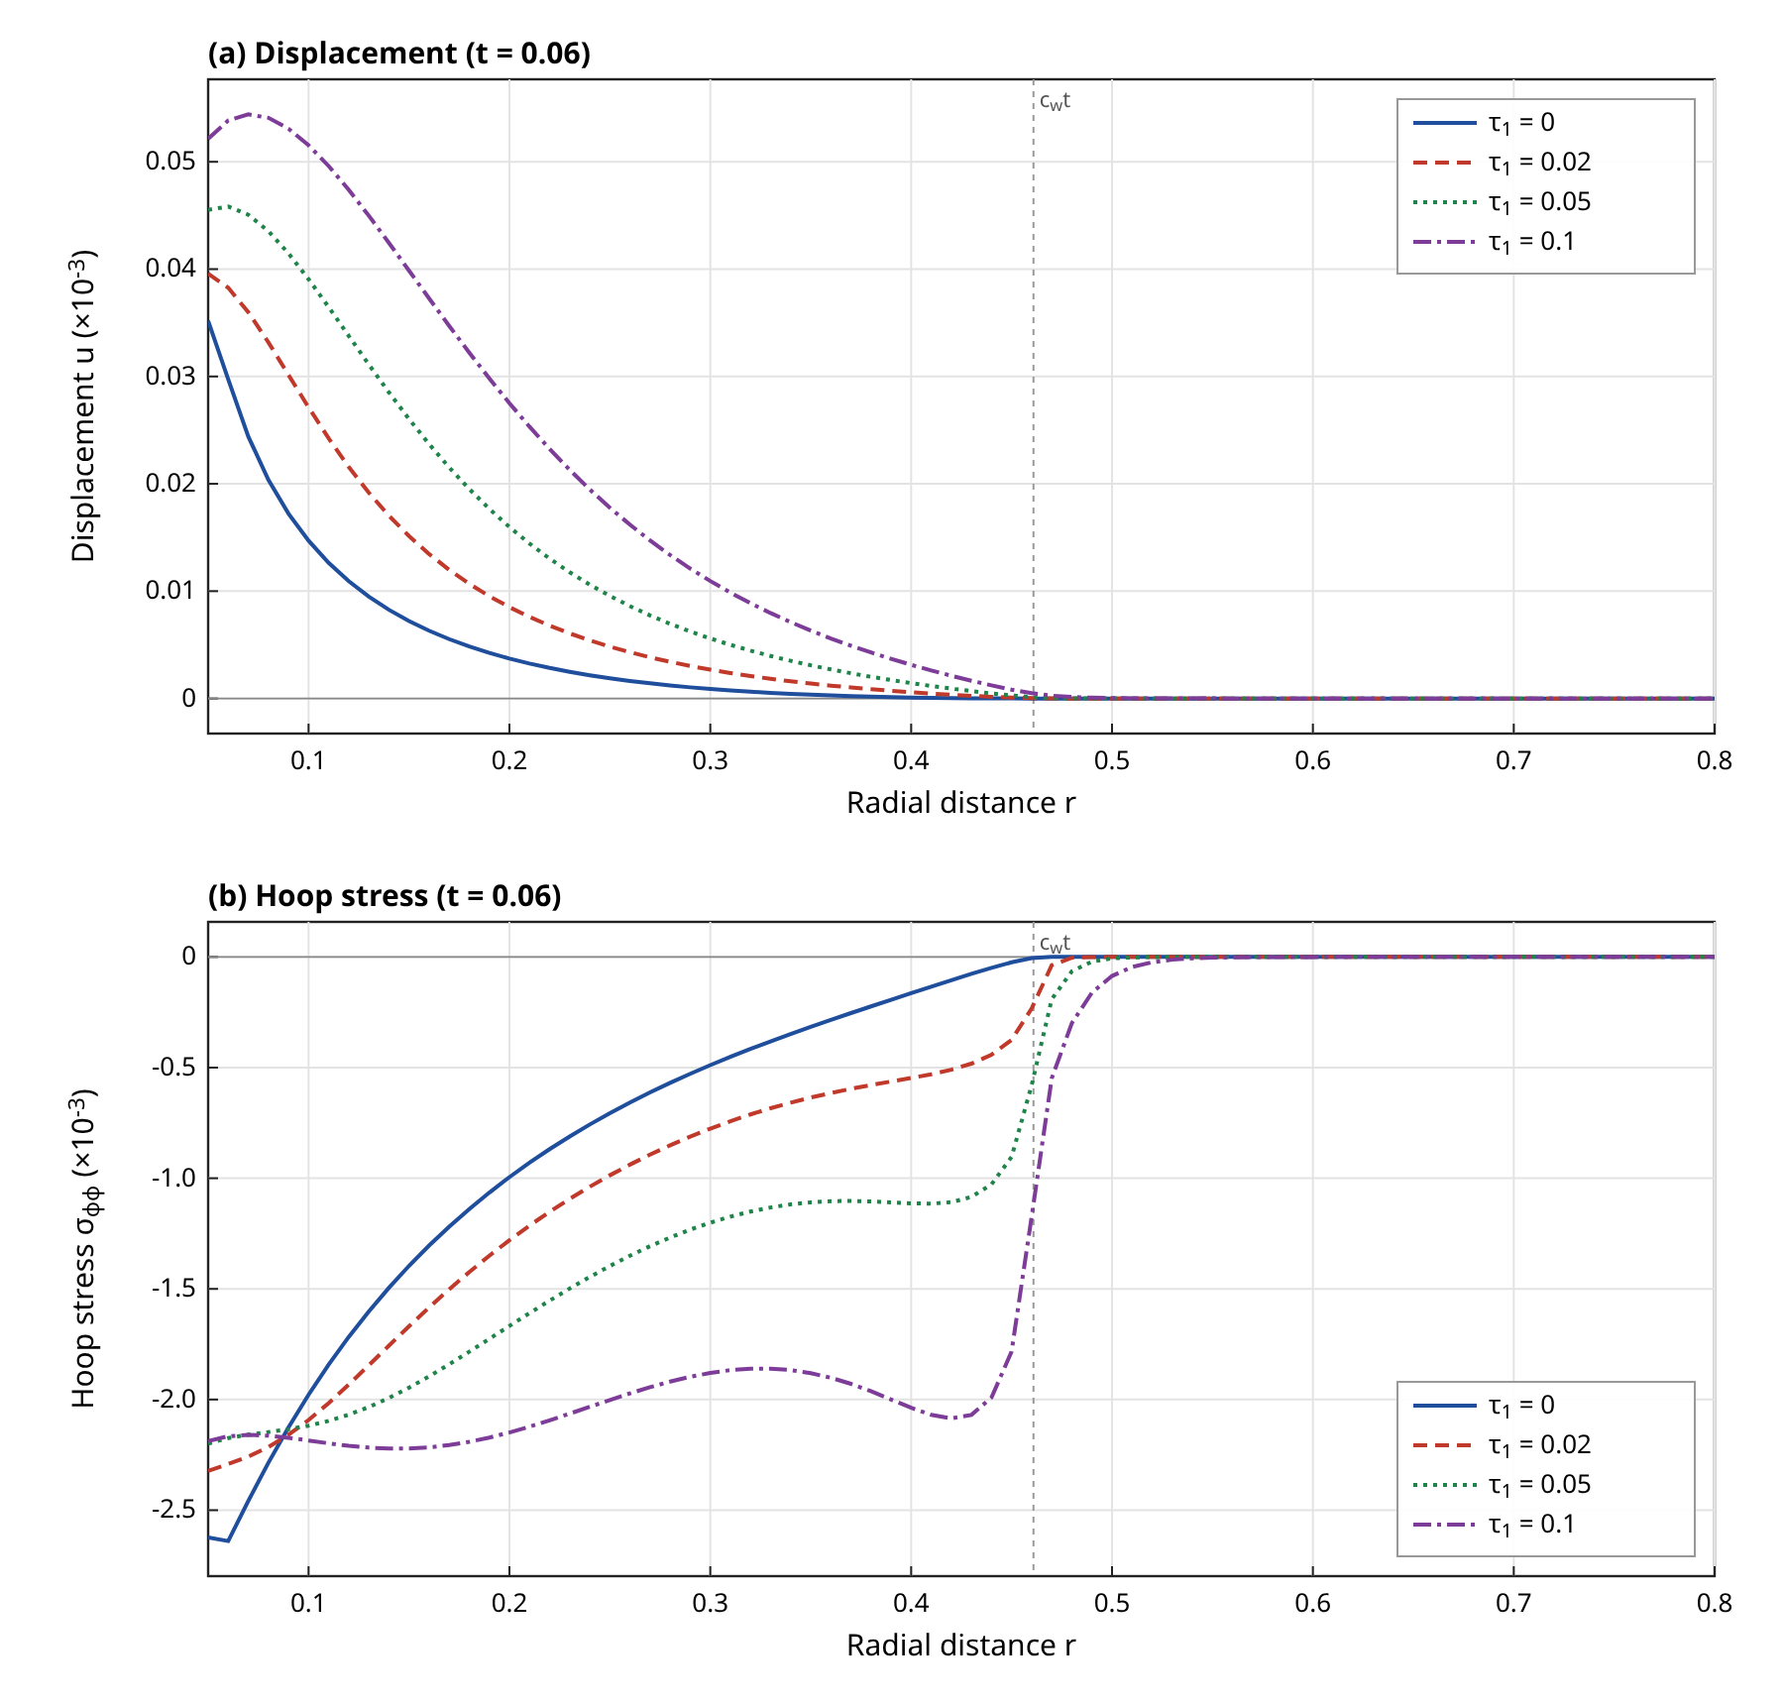
Figure 6. Effect of the strain-rate relaxation parameter $τ_{1}$ on the displacement (a) and hoop stress (b) at $t=0.06$ in the MGL-DPL medium. Computed.

7.4 Comparison of heat conduction models
Figure 7 and Table 4 compare the Fourier, Green–Lindsay type, Lord–Shulman MGL, first-order DPL and second-order DPL models for the same step source and $t=0.06$. The Fourier solution has a smooth diffusive profile with a non-zero temperature at every radius. The Lord–Shulman MGL solution has a front at $r=c_{LS}t=0.421$ and the second-order DPL solution has its front at $r=0.461$, further out by 9.54 per cent because $τ_{T}>τ_{q}/2$ makes the DPL wave faster than the Lord–Shulman wave with the same flux lag. The first-order DPL profile is smooth and has no front, which confirms the parabolic character found in Table 3. At $r=0.2$ the temperatures are 0.109 (Fourier), 0.104 (LS), 0.087 (DPL1) and 0.0946 (DPL2): both lags lower the near-source temperature relative to the Fourier law, and the second-order DPL value lies between the first-order DPL and Lord–Shulman values. The GL type solution has a front close to that of the Lord–Shulman MGL one and a similar temperature profile, but its hoop stress differs: at $r=0.2$ it is -1.8×10⁻³ against -1.72×10⁻³ in the MGL case, and at $r=0.4$ it is -1.2×10⁻³ against -1.19×10⁻³, which reflects the different coupling of the temperature rate and the absence of the strain-rate term. The TPL solution with the base parameters is graphically indistinguishable from the DPL solution; the largest difference of the temperature at the points of Table 4 is below 1 per cent.
Table 4. Comparison of the heat conduction models for a step line source at $t=0.06$ (computed values; number of wavefronts from Table 3).
Model | Flux law (Laplace domain) | Fronts | $θ(0.2)$ | $θ(0.4)$ | $10^{3}σ_{φφ}(0.2)$ | $10^{3}σ_{φφ}(0.4)$
Fourier | $q=−∇θ$ | 0 | 0.109 | 0.0317 | -1.64 | -0.702
GL | Green–Lindsay type | 2 | 0.104 | 0.0136 | -1.8 | -1.2
MGL-LS | $Φ=1+τ_{0}s, Ψ=1$ | 1 | 0.104 | 0.0135 | -1.72 | -1.19
MGL-DPL1 | $Φ=1+τ_{q}s, Ψ=1+τ_{T}s$ | 0 | 0.087 | 0.0178 | -1.68 | -0.571
MGL-DPL2 | $Φ$ second order, $Ψ=1+τ_{T}s$ | 1 | 0.0946 | 0.0155 | -1.67 | -1.11
MGL-TPL | DPL2 plus $K(1+τ_{v}s)/s$ | 1 | 0.0946 | 0.0156 | -1.66 | -1.12
MGL-TPL1 | $Φ=1+τ_{q}s, Ψ=1+Kτ_{v}$ ($τ_{T}=0$) | 1 | 0.104 | 0.0137 | -1.71 | -1.18

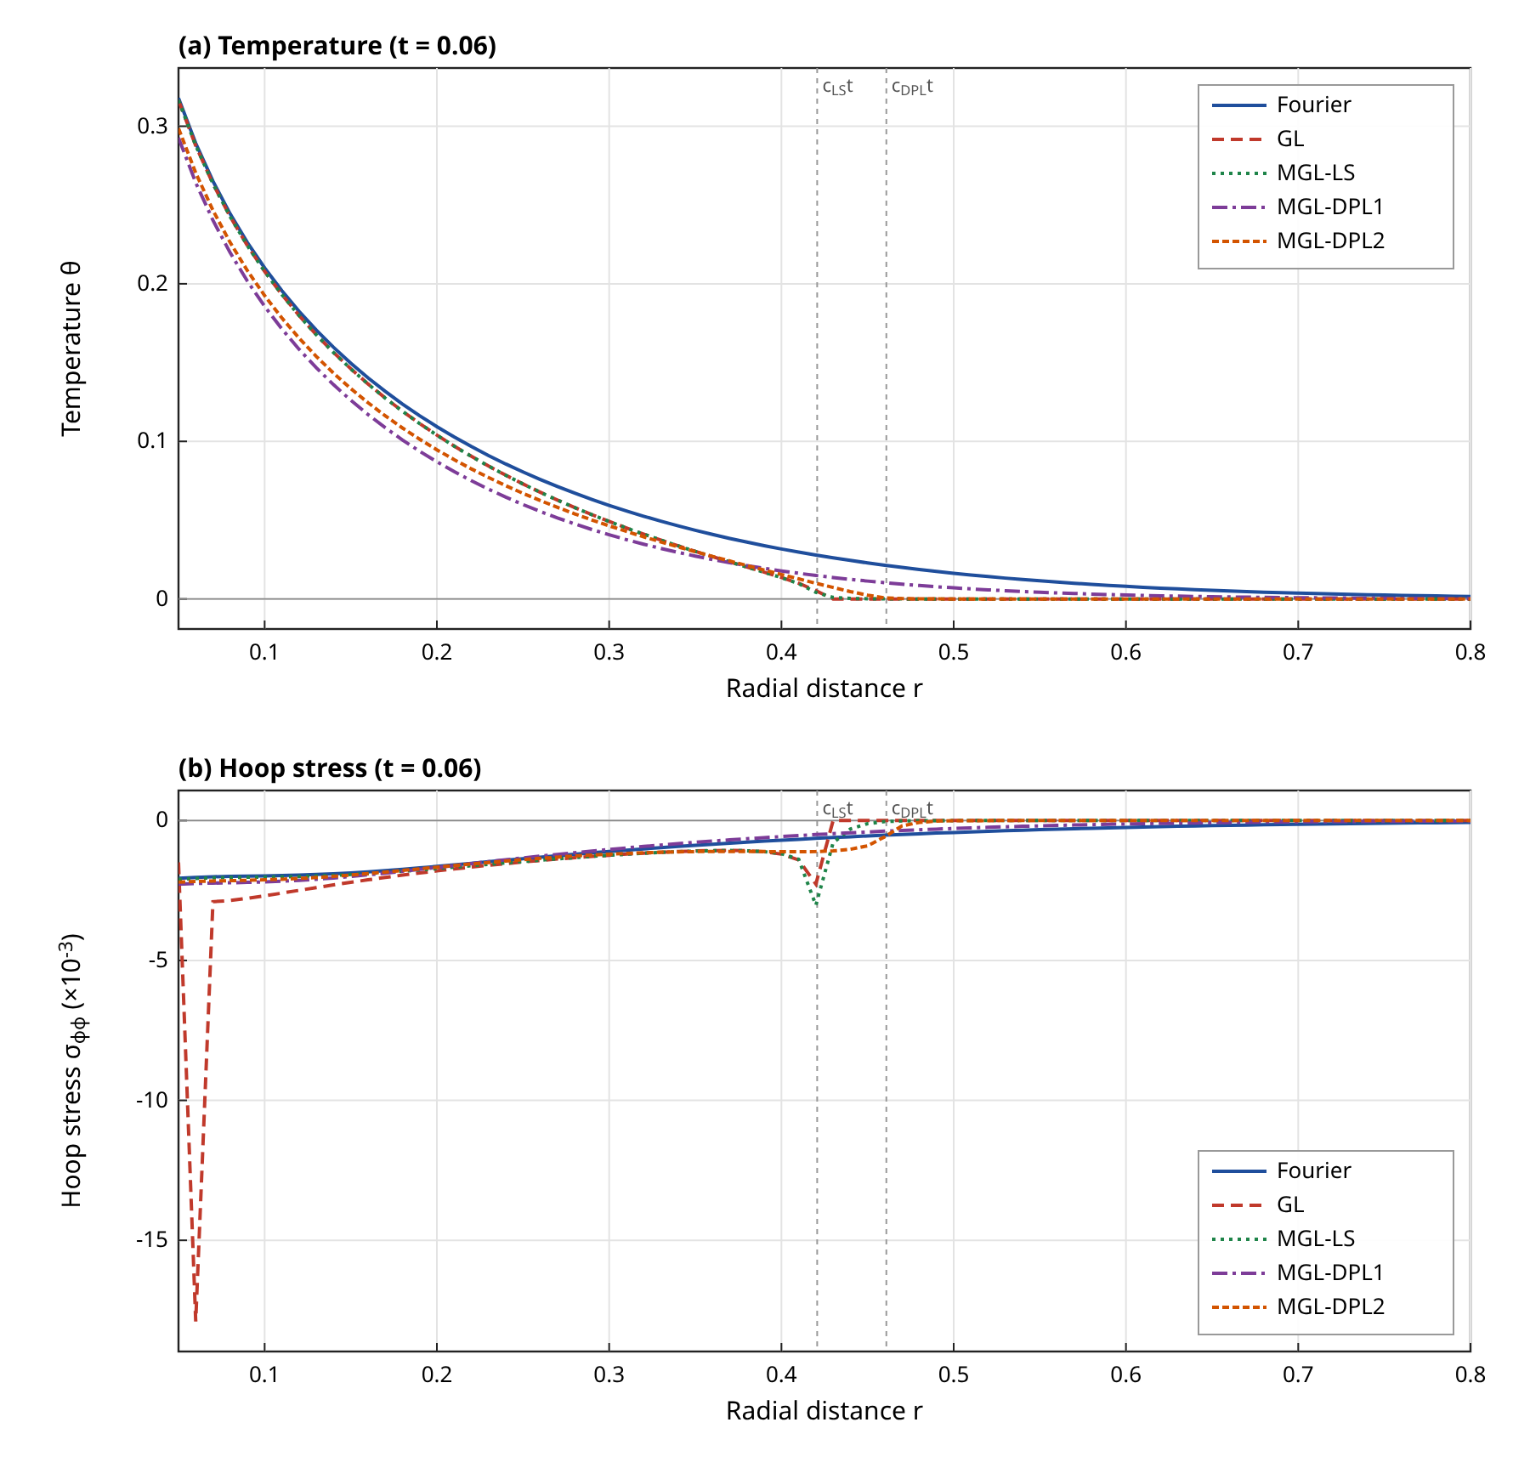
Figure 7. Temperature (a) and hoop stress (b) at $t=0.06$ for the Fourier, GL, Lord–Shulman MGL, first-order DPL and second-order DPL models and a step source. Dashed lines: $c_{LS}t$ and $c_{w}t$. Computed.

7.5 Pulse profiles
Table 5 gives the profiles and Figure 8 shows the temperature and hoop stress histories at $r=0.3$ in the DPL medium. The thermal wave arrives at $t=r/c_{w}=0.0391$ for all profiles that start at $t=0$ with a non-zero value; the computed arrival times (first time at which $|θ|>10^{−4}$) are in Table 6 and agree with this to within the time resolution of the history (0.004). The gamma-type pulse starts with zero source strength and therefore a weaker front, and the sinusoidal train has a zero source at $t=0$ as well. The temperature histories differ strongly after the front. For the rectangular pulse of width 0.04 the temperature at $r=0.3$ peaks at 0.0638 at $t=0.08$ and then decays; for the exponentially decaying source the peak is 0.0406 at $t=0.076$; for the gamma pulse (peak source at $t_{m}=0.03$) it is 0.0671 at $t=0.108$, and the sinusoidal train gives a temperature that oscillates with the period of the source about a slowly rising mean, reaching its largest value 0.0926 at $t=0.252$ within the window. The step source produces a monotonic rise to 0.163 at the end of the window ($t=0.3$). The total heat delivered by a profile is
$E_{p}=Q_{0}\int_{0}^{∞}{f(t) dt}$ (86)
which equals $Q_{0}t_{p}$ for the rectangle, $Q_{0}t_{d}$ for the exponential and $e Q_{0}t_{m}$ for the gamma profile. The hoop stress minimum at $r=0.3$ is almost the same (about $−1.65×10^{−3}$) for the step and the rectangular pulse because it is produced at the front arrival at $t=0.044$ by the source strength present in the first few relaxation times, long before the pulse ends, so a short pulse gives the same front stress as a long one. The end of the rectangular pulse launches an unloading wave that reaches $r=0.3$ near $t=t_{p}+r/c_{w}=0.079$ and reverses the sign of the hoop stress, which then peaks at a positive value of about $0.5×10^{−3}$ at $t=0.084$ (Figure 8b). This is the central consequence of finite wave speed for pulsed sources. The gamma and sinusoidal profiles give smaller front stresses (-1.32×10⁻³ and -1.43×10⁻³) because their source is small at early times.
Table 5. Temporal profiles of the line source ($f_{max}=1$ except for the sinusoidal train, which has mean 1/2) and their transforms.
Profile | $f(t)$ for $t≥0$ | $\overline{F}(s)$ | Parameters | $\int_{0}^{∞}{f} dt$
Step | $1$ | $1/s$ | none | unbounded
Rectangular | $1$ for $t<t_{p}$, else $0$ | $(1−e^{−st_{p}})/s$ | $t_{p}=0.04$ | $t_{p}$
Exponential | $e^{−t/t_{d}}$ | $1/(s+1/t_{d})$ | $t_{d}=0.05$ | $t_{d}$
Gamma type | $(t/t_{m}) e^{1−t/t_{m}}$ | $e t_{m}/(1+t_{m}s)^{2}$ | $t_{m}=0.03$ | $e t_{m}$
Sinusoidal train | $\sin^{2}(πt/P)$ | $ω_{0}^{2}/[2s(s^{2}+ω_{0}^{2})]$ | $P=0.08$ | unbounded

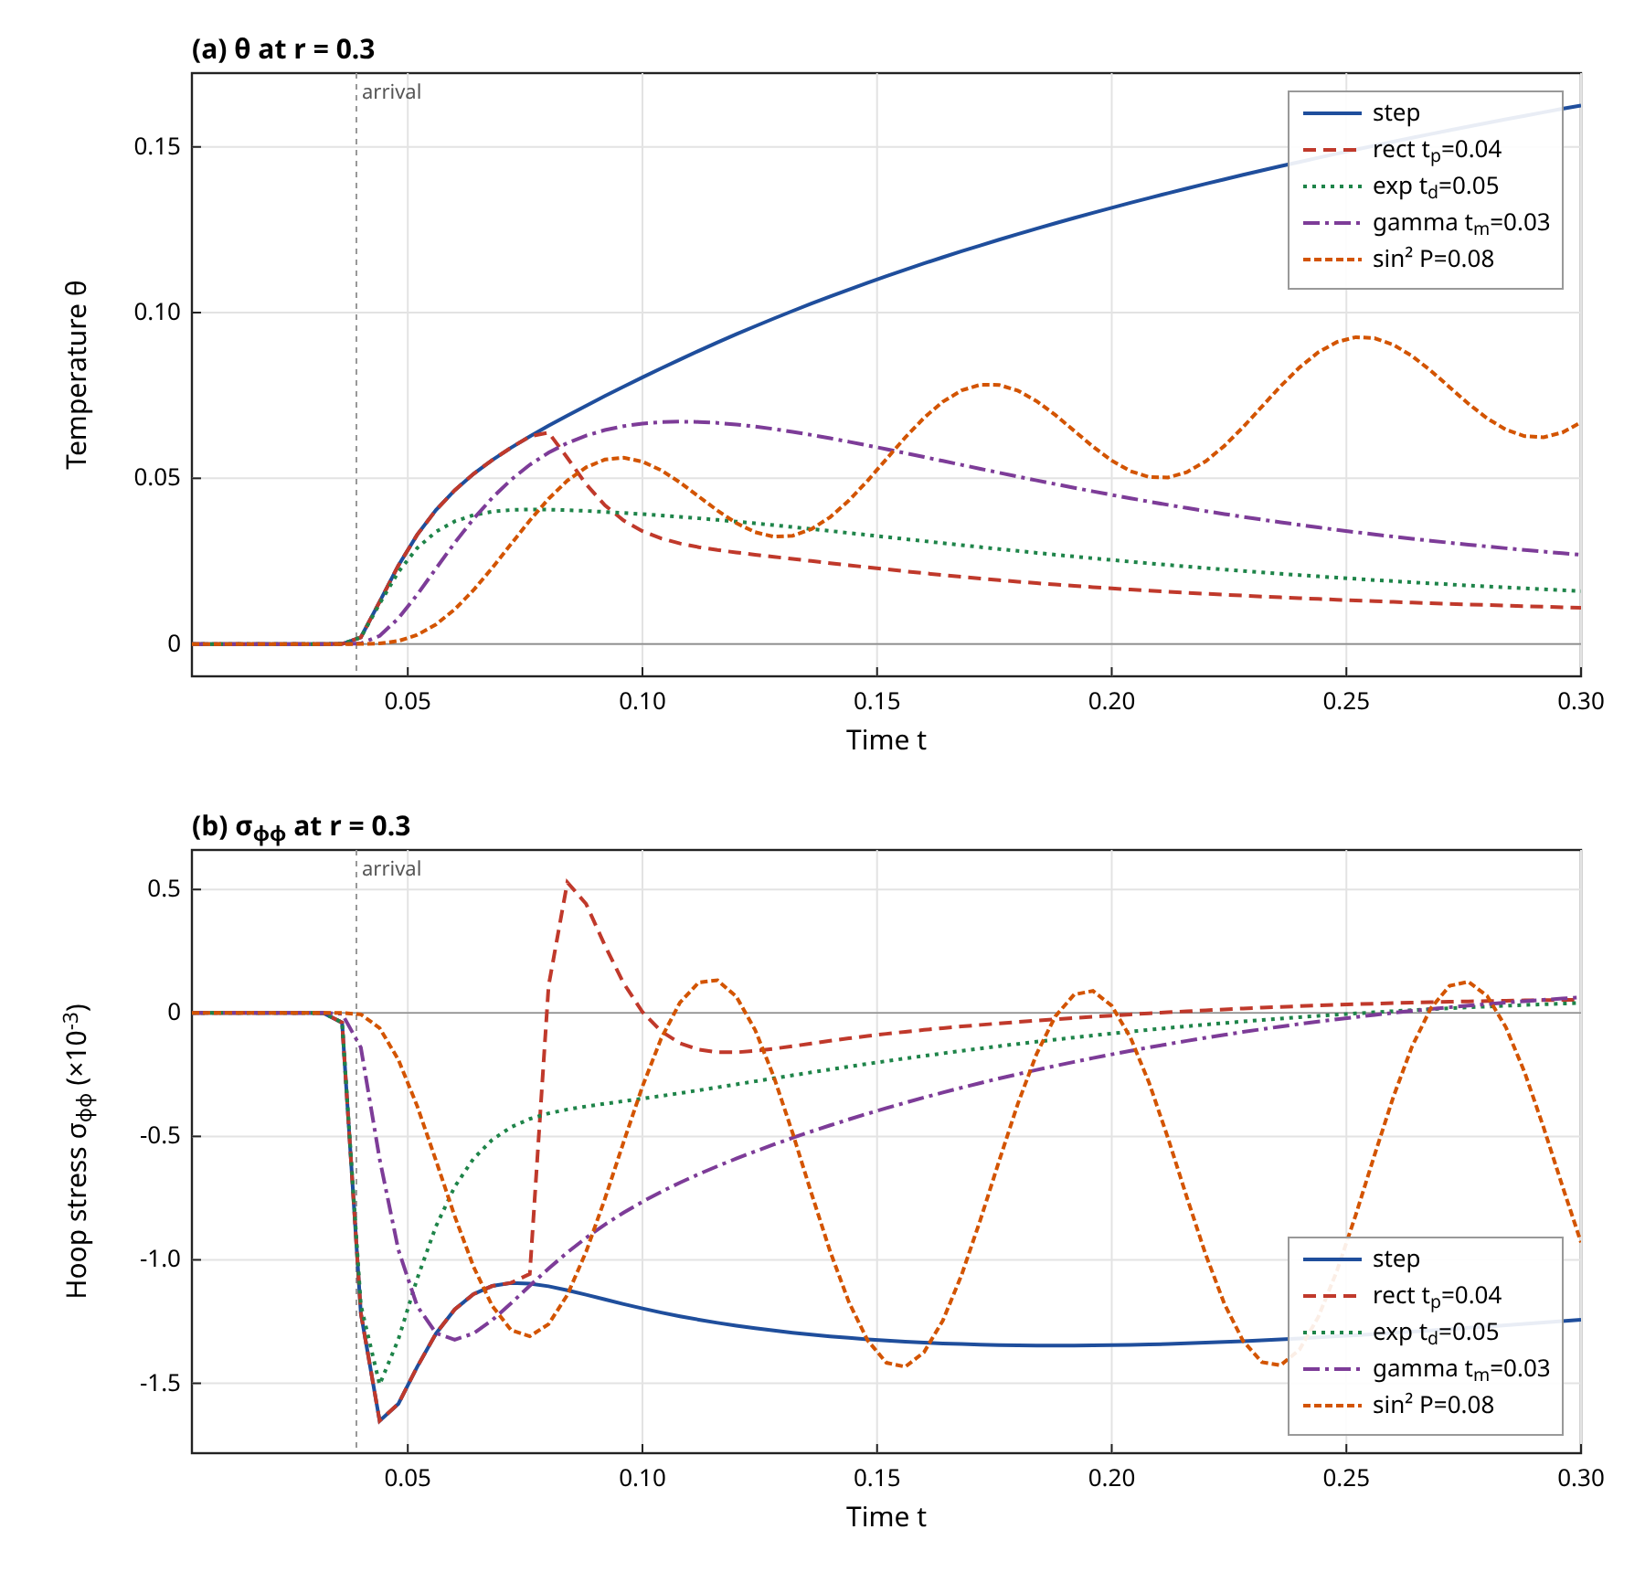
Figure 8. Temperature (a) and hoop stress (b) histories at $r=0.3$ for the five source profiles of Table 5 in the MGL-DPL medium. Vertical line: predicted arrival $r/c_{w}$. Computed ($N=3000$, Wynn acceleration).
Table 6. Computed response summary at $r=0.3$ over $0<t≤0.3$: peak temperature, most negative hoop stress and arrival time ($|θ|>10^{−4}$). Time resolution 0.004.
Case | Peak $θ$ | Time of peak | Min $10^{3}σ_{φφ}$ | Time of min | Arrival
DPL2, step | 0.163 | 0.3 | -1.65 | 0.044 | 0.04
DPL2, rectangle | 0.0638 | 0.08 | -1.65 | 0.044 | 0.04
DPL2, exponential | 0.0406 | 0.076 | -1.5 | 0.044 | 0.04
DPL2, gamma | 0.0671 | 0.108 | -1.32 | 0.06 | 0.04
DPL2, sinusoidal | 0.0926 | 0.252 | -1.43 | 0.156 | 0.044
LS, step | 0.165 | 0.3 | -2.55 | 0.044 | 0.04
DPL1, step | 0.162 | 0.3 | -1.35 | 0.188 | 0.012
TPL, step | 0.161 | 0.3 | -1.66 | 0.044 | 0.04
Fourier, step | 0.166 | 0.3 | -1.35 | 0.176 | 0.008
GL, step | 0.165 | 0.3 | -2.65 | 0.044 | 0.044

Table 6 also contains the Fourier and first-order DPL cases, whose arrival times (0.008 and 0.012) are far smaller than $r/c_{w}$ because the parabolic models have an instantaneous, exponentially small precursor that exceeds the $10^{−4}$ threshold almost immediately. The threshold choice affects these two entries strongly and affects the finite-speed models only by one time step, so the arrival column should be read as a measure of how the precursor exceeds the threshold rather than as a front time for the parabolic models.

7.6 Influence of the lag times and the conductivity rate
Figure 9a varies the temperature-gradient lag at fixed $τ_{q}=0.02$ for values 0.0105, 0.012, 0.02 and 0.04, which give wave speeds 7.2, 7.7, 9.9 and 14.0 from the expression for $c_{w}$. The front moves outwards and the temperature near the front rises: at $r=0.4$ the values are 0.0117, 0.0155, 0.0193 and 0.0208, and at $r=0.6$ the two largest lags give 6.37e-05 and 0.00521 while the others are zero to the printed accuracy. At the same time the near-source temperature falls (at $r=0.1$ it is 0.196, 0.192, 0.175 and 0.144), consistent with a faster wave carrying heat away from the source. Figure 9b varies $τ_{q}$ with the ratio $τ_{T}/τ_{q}=0.6$ fixed; then $c_{w}=1.086 τ_{q}^{−1/2}$ and the speeds are 10.9, 7.7, 6.3 and 5.4. A larger $τ_{q}$ slows the wave, so the temperature at $r=0.4$ is 0.0258, 0.0155, 4.48e-05 and 3.47e-07 for $τ_{q}=0.01$, 0.02, 0.03 and 0.04, and the near-source temperature is lower as well. A longer flux lag therefore slows the front and lowers the temperature at a fixed radius.
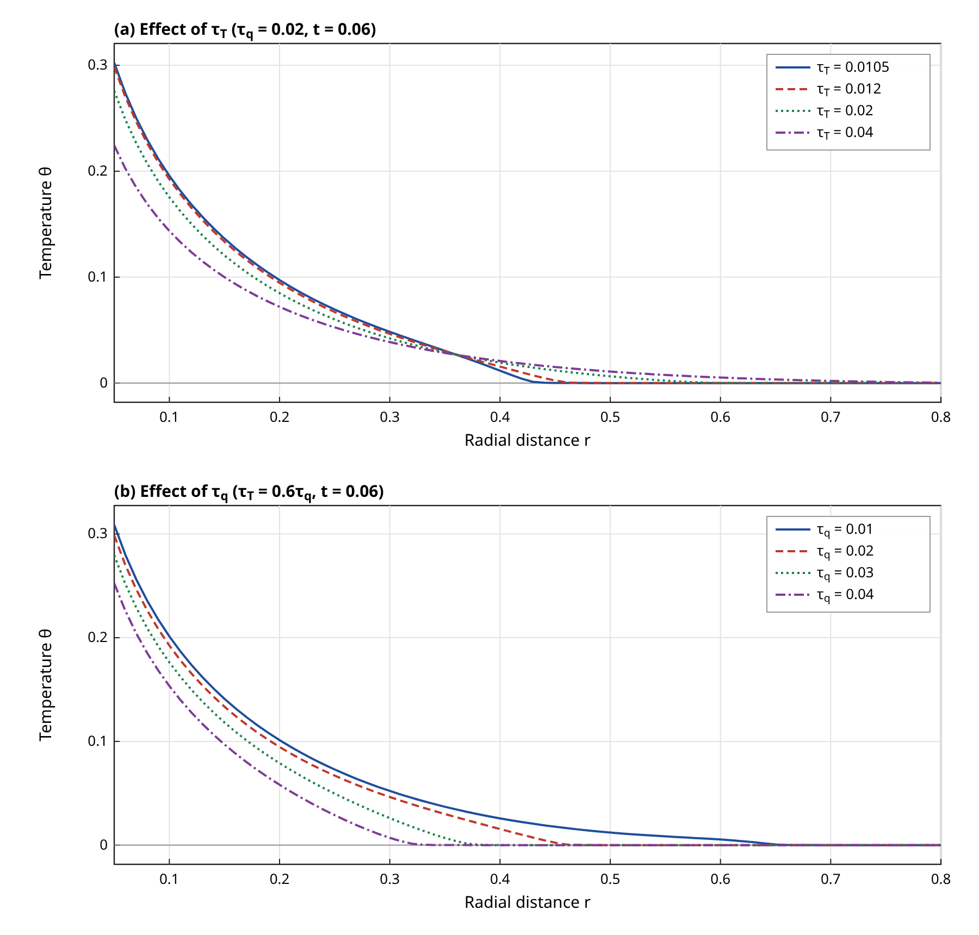
Figure 9. Effect of the temperature-gradient lag $τ_{T}$ at fixed $τ_{q}=0.02$ (a) and of the flux lag $τ_{q}$ at fixed ratio $τ_{T}/τ_{q}=0.6$ (b) on the temperature at $t=0.06$ in the MGL-DPL medium. All cases satisfy $τ_{T}>τ_{q}/2$. Computed.
The three-phase-lag parameters are studied at the later time $t=0.15$, where they matter (Figure 10). The thermal-displacement lag, with $K=0.5$ and $τ_{v}$ in 0, 0.1, 0.3 and 0.5, reduces the temperature near the source (0.267, 0.258, 0.242 and 0.229 at $r=0.1$) and raises it further out (0.02, 0.0206, 0.0217 and 0.0226 at $r=0.7$). Larger values of $τ_{v}$ could not be used: the stability scan of Section 5.2 shows instability for $Kτ_{v}≳0.28$. The conductivity rate, with $τ_{v}=0.03$, shows the same type of redistribution: the temperature at $r=0.1$ is 0.274, 0.272, 0.264 and 0.237 for $K=0$, 0.1, 0.5 and 2, while at $r=0.7$ it is 0.0196, 0.0197, 0.0202 and 0.0219. For the largest $K$ the changes are about 14 per cent near the source and 12 per cent at $r=0.7$, which is consistent with the interpretation of Section 5.3: the conductivity rate converts part of the diffusive tail into a wave-like contribution, and this is a long-time effect. With the base value $K=0.1$ the change from the DPL solution is below 1 per cent at all radii, so the TPL model is, for the base data, a small correction of the DPL model.
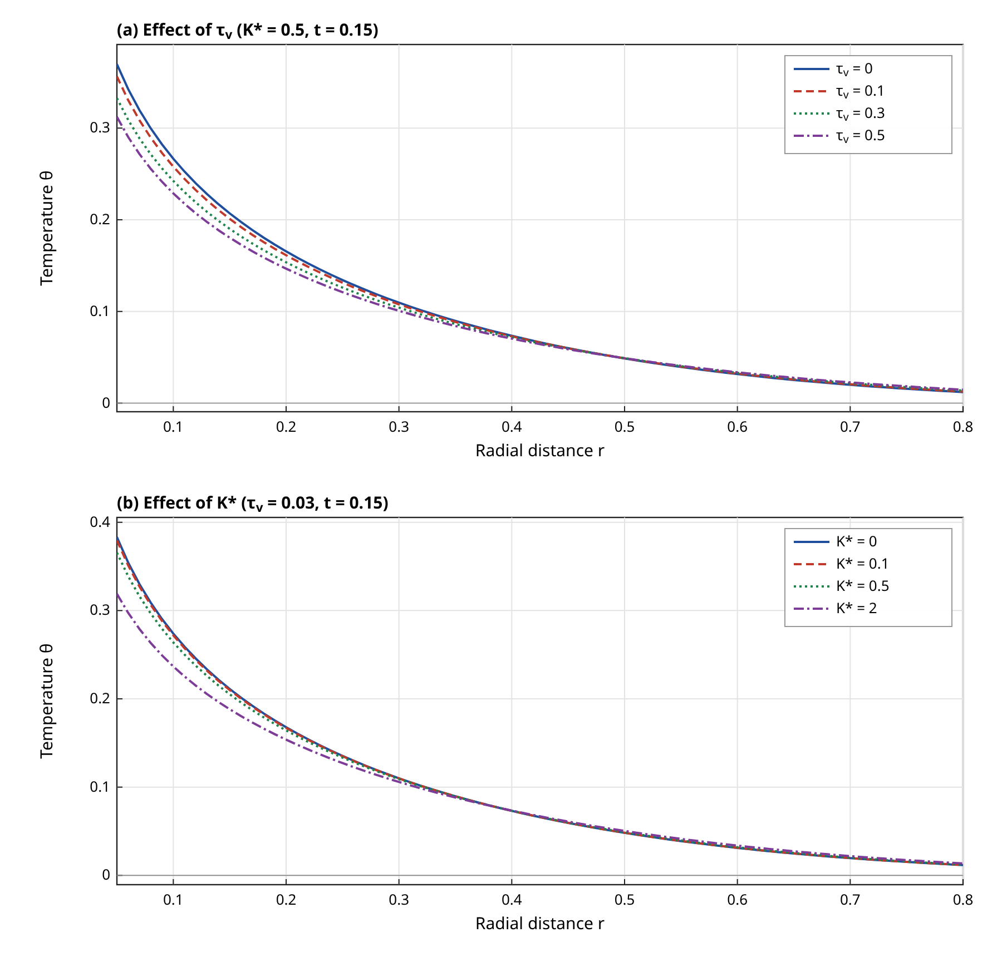
Figure 10. Effect of the thermal-displacement lag $τ_{v}$ at $K=0.5$ (a) and of the conductivity rate $K$ at $τ_{v}=0.03$ (b) on the temperature at $t=0.15$ in the MGL-TPL medium. Parameter sets are inside the stable region ($Kτ_{v}<0.28$). Computed.

7.7 Pulse width and period
Figure 11a shows the temperature at $r=0.3$ for rectangular pulses of width $t_{p}=0.01$, 0.03, 0.06 and 0.12. The peak temperature increases with the width, from 0.0259 to 0.113, but less than proportionally to the delivered energy, because the heat diffuses away while the pulse is on: the energy ratio is 12 whereas the peak ratio is 4.36. The time of the maximum moves from 0.052 to 0.156. For a pulse that is short compared with the arrival time $r/c_{w}=0.039$ the response at $r=0.3$ is essentially the response to an impulse, and it resembles the spectrum of Figure 3b, in which a short pulse excites a broader band. The hoop stress minimum, produced at the front, is -1.65×10⁻³ for the narrowest pulse and -1.65×10⁻³ for the widest one, so the front stress is nearly independent of $t_{p}$ over the whole range tested, from half a flux lag to six flux lags, in agreement with Section 7.5.
Figure 11b gives the hoop stress at $r=0.3$ for sinusoidal pulse trains of period 0.04, 0.08 and 0.16. Within the window the temperature is the cumulative result of the pulses and the stress follows the pulsed source with a delay that corresponds to the transit time of the wave: for $P=0.04$ the strongest compressive stress is -1.58×10⁻³ at $t=0.18$, for $P=0.08$ it is -1.43×10⁻³ at $t=0.156$ and for $P=0.16$ it is -1.19×10⁻³ at $t=0.116$. A shorter period gives a stronger but more rapid oscillation of the stress, since the wave is modulated at a higher frequency, while the temperature level is set by the mean source, which is the same for all periods. The values are those of the computed curves only; no further mechanism was tested.
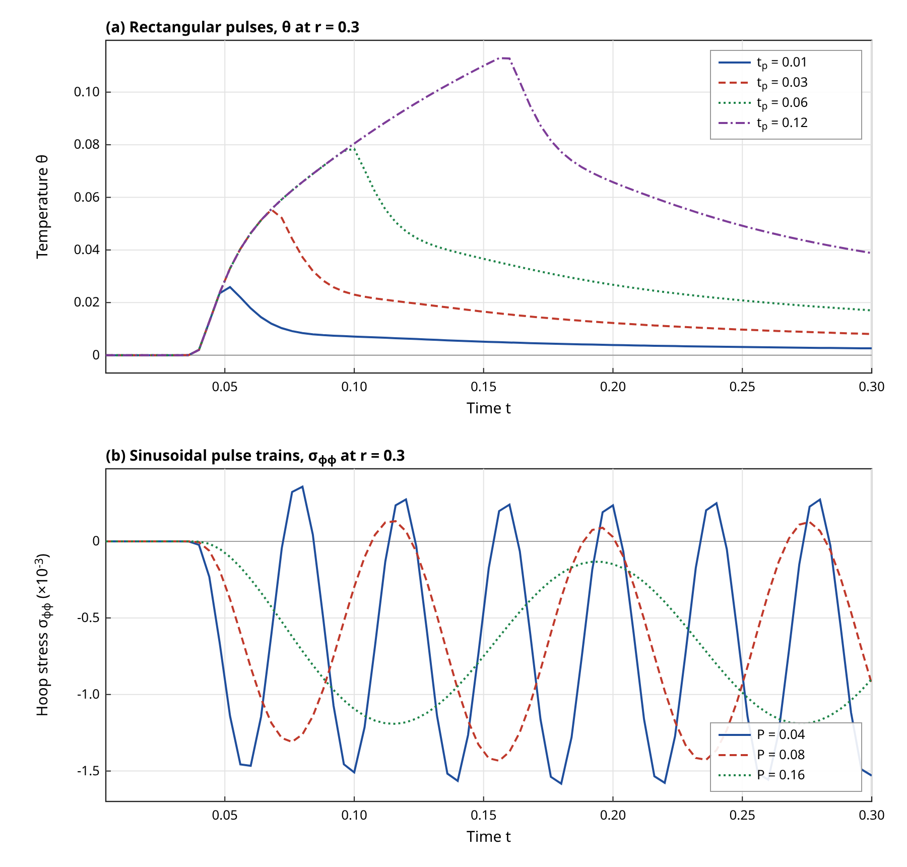
Figure 11. (a) Temperature history at $r=0.3$ for rectangular pulses of width $t_{p}=0.01$, $0.03$, $0.06$ and $0.12$; (b) hoop stress history at $r=0.3$ for sinusoidal pulse trains of period $P=0.04$, $0.08$ and $0.16$; MGL-DPL medium. Computed.

7.8 Moving source
$ℒ_{V}=\frac{max{\left|\frac{1}{2}(σ_{xx}+σ_{yy})\right|}_{V}}{max{\left|\frac{1}{2}(σ_{xx}+σ_{yy})\right|}_{V=0}}$ (87)
Figure 12 shows the temperature and the mean in-plane stress along the line $y=0.2$ at $t=0.1$ for a step-switched line source that moves at $V=0$, 3, 7.7 and 12. The speed 7.7 is the thermal wave speed $c_{w}$ and $V=12$ is supersonic with respect to the thermal wave, with Mach angle $β=arcsin(c_{w}/V)=39.8$ degrees. At $V=0$ the field is symmetric about $x=0$, the temperature peaks at 0.135 and the front, where the temperature falls to 0.2 per cent of its maximum, is at $x=0.7$, close to the value $\sqrt{(c_{w}t)^{2}−y^{2}}=0.74$ expected for the circular front. As $V$ increases the maximum moves with the source (positions 0.2, 0.6, 0.8 for $V=3$, 7.7, 12, to be compared with the source positions 0.3, 0.77, 1.2) and lags behind it, the temperature maximum is slightly lower (0.125 to 0.131 against 0.135), and the field becomes asymmetric: a long trailing tail behind the source and a steep leading edge. For the supersonic case the front in the line $y=0.2$ occurs at $x=1.1$, in line with the Mach-cone prediction $x=Vt−ycotβ=0.96$. The mean in-plane stress has its extreme value at -1.82×10⁻³, -2.18×10⁻³, -6.28×10⁻³ and -10.6×10⁻³, so that the amplification factor of the stress peak is 1.2, 3.4 and 5.8 for $V=3$, 7.7 and 12. The large increase at speeds close to or above $c_{w}$ is the structure of a Mach-type front: successive wavefronts emitted by the moving source overlap and add up along the cone, so that the stress is concentrated there. The stress minimum of the sonic case lies close to the front $x≈Vt$.
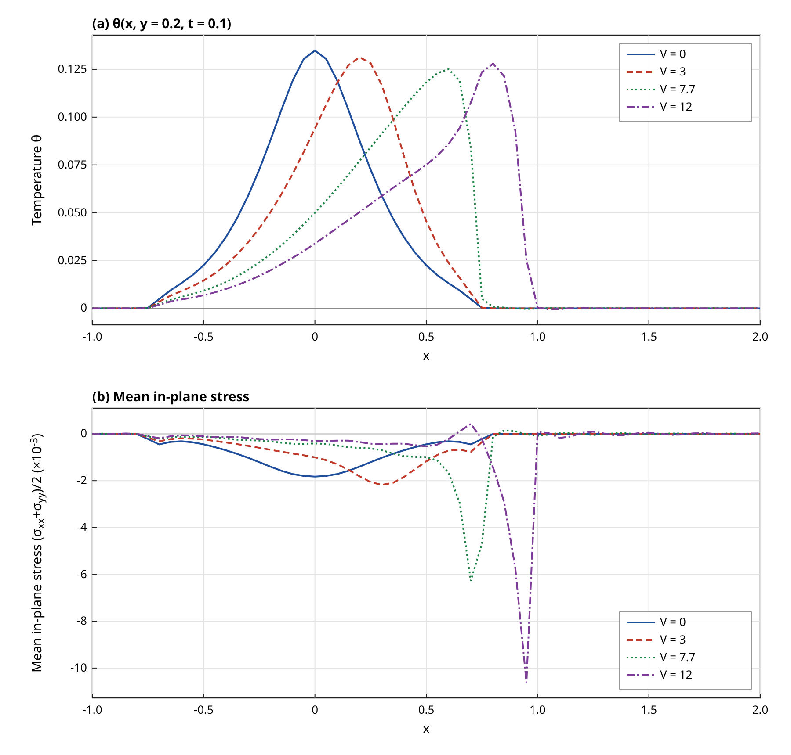
Figure 12. Temperature (a) and mean in-plane stress (b) along $y=0.2$ at $t=0.1$ for a step line source translating at speed $V$ in the MGL-DPL medium ($c_{w}=7.68$). Source positions at $t=0.1$: $x=0$, $0.3$, $0.77$ and $1.2$. Computed by the Fourier–Laplace solution of Section 4 ($N=2000$, $h=0.25$, $ξ_{max}=100$).
The influence of the conduction model on the moving-source response was checked at $V=3$. The Lord–Shulman MGL model gives a maximum temperature of 0.142, higher than the DPL value 0.131, and a front at $x=0.65$ against 0.75 for DPL, because its wave is slower. The TPL model with base parameters gives 0.131 and is again indistinguishable from the DPL model. A moving source that is also a rectangular pulse of width 0.04 (switched off at $t=0.04$ when it is at $x=0.12$) produces a maximum temperature of only 0.0399 at $t=0.1$ and a mean-stress extreme of -0.783×10⁻³, which is a fraction 0.36 of the step value, because the source has been off for 0.06 time units.

7.9 Validation
The validation is summarised in Table 7 and Figure 13. The finite-difference solver agrees with the Laplace solution for the Lord–Shulman MGL case with a rectangular pulse of width 0.03 at $t=0.05$ to 0.18 per cent of the maximum in temperature, 0.06 per cent in displacement and 2.9 and 2.7 per cent in radial and hoop stress. For the step source the corresponding errors are 0.046, 0.038, 1.8 and 1.8 per cent. The temperature agreement is very good; the stress agreement is limited to a few per cent, because the finite-difference scheme smears the stress peak at the front and because the stress is formed from differences of the numerical fields. The residual is a discretisation error rather than a systematic discrepancy, but a refinement study of the finite-difference grid was not carried out, so the quoted figures are the errors at one resolution.
The truncation test of the inversion (Figure 13c) gives a relative difference between $N$ and $N/2$ in the temperature of 6.9e-08 for the DPL model and 0 for the first-order DPL model at $N=4000$ ($≤10^{−15}$ for the parabolic case, since the transforms are smooth). For the Lord–Shulman MGL model the temperature difference is 0.00013, and the hoop stress difference at the points close to the front is as large as 0.11. The hoop stress at the exact front position of the Lord–Shulman model, where it jumps, is therefore uncertain by several per cent; this is a limitation of Fourier-series inversion for discontinuous functions and the Wynn acceleration reduces but does not eliminate it. For the DPL model, whose wave is more attenuated at the front, the hoop stress difference at $N=4000$ is only 0.00016.
The limiting cases give the expected agreement. The DPL model with $τ_{T}=10^{−9}$ and a first-order flux law reproduces the Lord–Shulman MGL solution, which is the solution of [1], with a maximum difference of 5.4e-06 of the maximal temperature at five radii; DPL with $τ_{q}=τ_{T}$ at first order reproduces the Fourier solution (with the physical source convention) to 4e-15; and the TPL model with $K=0$ is identical to the DPL model (difference 0). The Lord–Shulman wave speed 7.012 agrees with the value 7.01 of [1] to the third digit. A direct comparison of field values with the figures of [1] was not made, because those values were not available in numerical form; the agreement therefore concerns the wave speed, the single-wave structure and the location of the stress feature, not the amplitudes.
The far-field check gives $|θ|≤8e−13$ and $|σ|≤1.3e−14$ at $r=1$, 1.5 and 2 for the DPL case, which is zero within the double-precision resolution of the inversion; the global heat-content identity of Section 3.2 holds with relative errors of 0.0038 (Fourier), 0.0064 (Lord–Shulman MGL), 0.0017 (DPL) and 0.0017 (TPL), limited by the radial quadrature of $θ$ on the logarithmic grid used for the check. The moving-source code at $V=0$ reproduces the axisymmetric solution with a relative error of 8.9e-05, 0.00015, 0.00018 and 0.00019 for $h=1$, 0.5, 0.25 and 0.125, respectively. The error does not fall below about $2×10^{−4}$ as $h$ is reduced, so the floor is set by something other than the trapezoidal step, most likely the inversion at the wavefront where the truncation of the Fourier integral and the Wynn acceleration act on slightly different partial sums; this was not investigated further. Two parameter regimes were found to be unstable and were rejected on the basis of the stability scan: second-order DPL with $τ_{T}<τ_{q}/2$ and TPL with $Kτ_{v}>0.28$. In addition, a first test of the Fourier limit showed a 41 per cent discrepancy when the source was not carried through the lag operator, which led to the two source conventions described in Section 2.3.
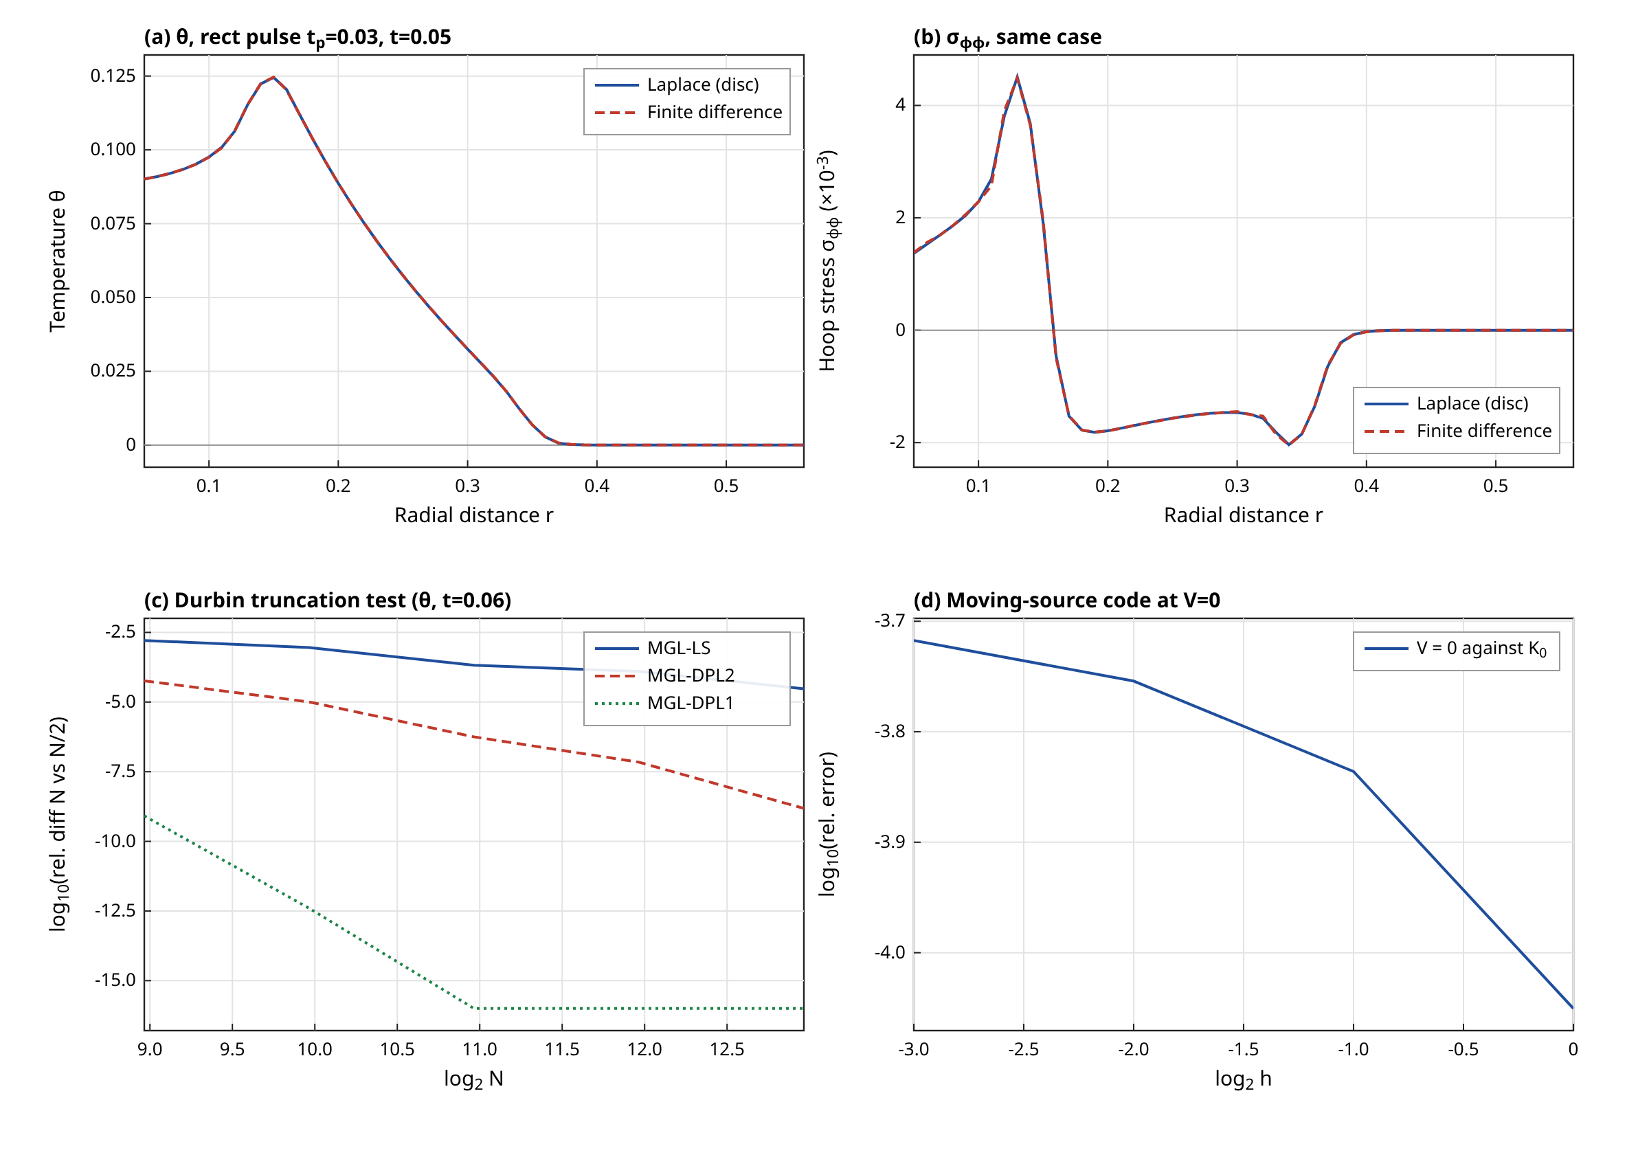
Figure 13. Validation: (a) temperature and (b) hoop stress from the finite-difference solver and from the Laplace solution for a uniform heated disc ($t_{p}=0.03$, $t=0.05$, LS-MGL); (c) Durbin truncation test; (d) moving-source code at $V=0$ against the axisymmetric solution as a function of the quadrature step. Computed.
Table 7. Summary of validation tests (all computed in this work).
Test | Quantity | Result | Verdict
Fourier ($ε=0$) against $E_{1}$ solution | max relative error | 0.0004 | pass
DPL ($τ_{T}→0$, first order) against LS-MGL | max difference / max $θ$ | 5.4e-06 | pass
DPL ($τ_{q}=τ_{T}$) against Fourier | max difference / max $θ$ | 4e-15 | pass
TPL ($K=0$) against DPL2 | max difference | 0 | pass
FD against Laplace, rectangle | error / max, $θ$; $σ_{φφ}$ | 0.0018; 0.027 | pass (stress 2.7 %)
Durbin $N$ against $N/2$, DPL2, $N=4000$ | relative, $θ$; $σ_{φφ}$ | 6.9e-08; 0.00016 | pass
Durbin $N$ against $N/2$, LS-MGL, $N=4000$ | relative, $θ$; $σ_{φφ}$ | 0.00013; 0.11 | marginal at front
Heat-content identity, DPL2 | relative defect | 0.0017 | pass
Heat-content identity, LS-MGL | relative defect | 0.0064 | pass (0.6 %)
Moving source at $V=0$ against $K_{0}$ | max relative error, $h=0.25$ | 0.00018 | pass
Wave speed, DPL2: numerical against formula | $c$ | 7.682 against 7.682 | pass
Wave speed, LS-MGL against [1] | $c$ | 7.012 against 7.01 | pass
Stability scan, $τ_{T}<τ_{q}/2$ | max growth rate | 28.5 | unstable, rejected
Stability scan, TPL $Kτ_{v}>0.28$ | max growth rate ($τ_{v}=1,K=0.5$) | 8.73 | unstable, rejected

8. Limitations
The study has several limitations that bear on how its results should be used. The material data and, above all, the lag times are the nondimensional values of [1] and illustrative choices for the DPL and TPL parameters; they are not measured values for copper, and the corresponding physical times are sub-picosecond, at which a continuum model with a local heat flux law is itself questionable. The DPL and TPL laws are Taylor expansions, and the conclusions on the wave structure depend on the truncation order, as shown in Section 5. A different truncation would change the classification: this paper has not examined higher-order expansions or the delay-differential forms of the laws.
The moving source is a line source in plane strain with constant speed, in an unbounded medium; it has no boundary, no finite beam width and no three-dimensional effects, and it is evaluated at one observation line $y=0.2$ and one time $t=0.1$, so the field maps of a full Mach cone are not shown. The Fourier integral is evaluated for $y>0$ only; the singular line $y=0$ is not accessible by this method as implemented. A radially moving ring source was not computed. The strict dependence of the TPL stability on $Kτ_{v}$ has been determined numerically for one pair of $τ_{q}$ and $τ_{T}$ and no analytical criterion is given.
Numerically, the inversion of discontinuous or nearly discontinuous quantities is limited to a few per cent at the front, as in Table 7, and the finite-difference check has been done for the Lord–Shulman MGL case only, since it was written for the first-order flux law: the second-order DPL and TPL results are validated by the limit checks, the stability analysis, the heat-content identity and by the internal consistency of the $V=0$ comparison, not by an independent time-domain solution. An independent finite-difference solution for those laws would require additional state variables and was not made. Finally, the source convention is the effective-source form of [1]; with the alternative form that passes the source through $Φ(∂_{t})$ the early-time response of the second-order laws would contain impulsive terms and the results would differ near $t=0$.
Regarding reproducibility, every figure and table value was produced by pure-Python code without external numerical libraries: the Bessel functions, the Durbin inversion, the Wynn acceleration, the Aberth root finder used in the stability scan, the finite-difference solver and the Fourier-integral quadrature are all implemented in the accompanying scripts. A pulsed-source field at one time and 76 radii takes about twenty seconds on one core, and a moving-source profile with 61 positions about two minutes, so the whole parametric study runs in under five minutes on eight cores. The cost is dominated by the number of Durbin terms, which is why the quoted truncation tests matter. The Word equations are generated from the same source as the text and were checked by script for the numbering sequence, but the document could not be opened in a word processor in the environment where it was produced, so the visual layout of the equations has been checked only through an independent rendering of the equation markup.
A further point concerns interpretation. The comparisons in Section 7.4 are made at equal flux lag and at lags chosen to be stable, which is a convenient but not a unique way of comparing models; a comparison at equal wave speed, for instance, would give different relative amplitudes near the front. The ordering of the models in the figures should therefore be read as characterising the chosen parameter set, and the qualitative conclusions (existence or absence of a front, direction of the parametric trends, sensitivity of the mechanical field to $τ_{1}$) are the findings that are expected to carry over to other parameter values.

9. Conclusions
MGL thermoelasticity with second-order dual-phase-lag and three-phase-lag heat conduction was solved for an unbounded plane-strain medium with pulsed and moving line heat sources. The following results were obtained.
First, the transform-domain solution is closed form for pulsed sources and semi-analytic (one Fourier integral) for the translating source. The solution contains the Fourier, Lord–Shulman MGL and Green–Lindsay type cases as limits and reproduces the Lord–Shulman MGL wave speed of [1], 7.01 against 7.01, as well as the single-wave structure with a continuous displacement. Second, the asymptotic analysis shows that second-order DPL and TPL laws give one finite-speed wave with $c_{w}=τ_{q}^{−1}\sqrt{2τ_{T}/(1+ε)}$ and a diffusive strain-rate branch, that first-order DPL is parabolic with no wavefront, and that the second-order laws are stable only for $τ_{T}>τ_{q}/2$ and, for TPL, only for $Kτ_{v}$ below about 0.28 for the lags studied. Third, the strain-rate parameter controls the displacement and stress amplitude: between $τ_{1}=0$ and $0.1$ the displacement at $r=0.3$ rises roughly twelve-fold and the hoop stress about four-fold, while the temperature changes by less than 1 per cent. Fourth, the front stress is nearly independent of the pulse duration over the range tested (0.5 to 6 flux lags), whereas the temperature scales sublinearly with the delivered energy. Fifth, the thermal-displacement lag and the conductivity rate mainly redistribute heat at later times and have a small effect for the base data. Sixth, a source moving at or above the thermal wave speed raises the peak in-plane stress by a factor of 3.4 to 5.8 relative to a stationary source at the same observation line, and for supersonic speed the front follows the Mach-cone geometry.
The validation was successful for the temperature (finite-difference error of the order of 0.1 to 0.2 per cent), acceptable for stresses (2 to 3 per cent) and limited at the discontinuous front (several per cent). The paper's quantitative statements apply to the nondimensional parameter set used. Future work should add an independent time-domain solver for the second-order laws, a finite-width and a three-dimensional moving source, a bounded medium with reflections, and measured lag times for real materials.

References
[1] R. V. Singh and S. Mukhopadhyay, "Mathematical significance of strain rate and temperature rate on heat conduction in thermoelastic material due to line heat source," J. Therm. Stresses, vol. 46, no. 11, pp. 1164–1179, 2023. DOI: 10.1080/01495739.2023.2246523
[2] R. V. Singh and S. Mukhopadhyay, "An investigation on strain and temperature rate-dependent thermoelasticity and its infinite speed behavior," J. Therm. Stresses, vol. 43, no. 3, pp. 269–283, 2020. DOI: 10.1080/01495739.2019.1680333
[3] B. Singh, M. Gupta and S. Mukhopadhyay, "On the fundamental solutions for the strain and temperature rate-dependent generalized thermoelasticity theory," J. Therm. Stresses, vol. 43, no. 5, pp. 650–664, 2020. DOI: 10.1080/01495739.2020.1736967
[4] M. Gupta and S. Mukhopadhyay, "Galerkin-type solution for the theory of strain and temperature rate-dependent thermoelasticity," Acta Mech., vol. 230, no. 10, pp. 3633–3643, 2019. DOI: 10.1007/s00707-019-02482-z
[5] O. N. Shivay and S. Mukhopadhyay, "A complete Galerkin's type approach of finite element for the solution of a problem on modified Green–Lindsay thermoelasticity for a functionally graded hollow disk," Eur. J. Mech. A/Solids, vol. 80, p. 103914, 2020. DOI: 10.1016/j.euromechsol.2019.103914
[6] I. M. Tayel and K. Lotfy, "Photothermal effects in semiconductors induced by surface absorption of a uniform laser radiation under modified Green–Lindsay theory," Eur. Phys. J. Plus, vol. 136, no. 9, pp. 1–17, 2021. DOI: 10.1140/epjp/s13360-021-01941-8
[7] R. V. Singh and S. Mukhopadhyay, "Study of wave propagation in an infinite solid due to a line heat source under Moore–Gibson–Thompson thermoelasticity," Acta Mech., vol. 232, no. 12, pp. 4747–4760, 2021. DOI: 10.1007/s00707-021-03073-7
[8] A. E. Abouelregal, I. E. Ahmed, M. E. Nasr, K. M. Khalil, A. Zakria and F. A. Mohammed, "Thermoelastic processes by a continuous heat source line in an infinite solid via Moore–Gibson–Thompson thermoelasticity," Materials, vol. 13, no. 19, p. 4463, 2020. DOI: 10.3390/ma13194463
[9] F. Shakeriaski, M. Ghodrat, J. Escobedo-Diaz and M. Behnia, "Recent advances in generalized thermoelasticity theory and the modified models: a review," J. Comput. Des. Eng., vol. 8, no. 1, pp. 15–35, 2021. DOI: 10.1093/jcde/qwaa082
[10] A. Krysko, J. Awrejcewicz, S. Pavlov, K. Bodyagina and V. Krysko, "Topological optimization of thermoelastic composites with maximized stiffness and heat transfer," Compos. Part B: Eng., vol. 158, pp. 319–327, 2019. DOI: 10.1016/j.compositesb.2018.09.047
[11] A. Babaee and J. Jelovica, "Nonlinear transient thermoelastic response of FGM plate under sudden cryogenic cooling," Ocean Eng., vol. 226, p. 108875, 2021. DOI: 10.1016/j.oceaneng.2021.108875
[12] A. Babaee and J. Jelovica, "Large amplitude vibration of annular and circular functionally graded composite plates under cooling thermal shocks," Thin-Walled Struct., vol. 182, p. 110142, 2023. DOI: 10.1016/j.tws.2022.110142
[13] A. Babaee, M. Sadighi, A. Nikbakht and S. Alimirzaei, "Generalized differential quadrature nonlinear buckling analysis of smart SMA/FG laminated beam resting on nonlinear elastic medium under thermal loading," J. Therm. Stresses, vol. 41, no. 5, pp. 583–607, 2018. DOI: 10.1080/01495739.2017.1408048
[14] Y. J. Yu, Z. N. Xue and X. G. Tian, "A modified Green–Lindsay thermoelasticity with strain rate to eliminate the discontinuity," Meccanica, vol. 53, no. 10, pp. 2543–2554, 2018. DOI: 10.1007/s11012-018-0843-1
[15] R. Quintanilla, "Some qualitative results for a modification of the Green–Lindsay thermoelasticity," Meccanica, vol. 53, no. 14, pp. 3607–3613, 2018. DOI: 10.1007/s11012-018-0889-0
NOTE (not a reference): the manuscript requires 34 references from 2013 to 2026, each with its DOI. Only 15 verified references are listed above (DOIs taken from the reference list of the base paper [1]). 19 more verified references (2013–2026) must be added to reach 34. No DOI was invented, because there was no network access to verify any additional one.

