Entropy Generation and Irreversibility Analysis of Unsteady EMHD Squeezing Flow of a Carreau Hybrid Nanofluid (AA7072–AA7075/Methanol) Between Parallel Porous Plates

Abstract
The relentless miniaturisation of thermal-management hardware has intensified the search for coolants whose effective conductivity exceeds that of conventional liquids. The present study analyses the second-law behaviour of unsteady, two-dimensional, electro-magnetohydrodynamic (EMHD) squeezing flow of a Carreau hybrid nanofluid (AA7072–AA7075/methanol) confined between two parallel porous plates. The formulation incorporates a transverse time-dependent magnetic field, an aligned electric field, Darcy–Forchheimer porous drag, nonlinear thermal radiation, viscous dissipation, Joule heating, Soret–Dufour cross-diffusion and a first-order chemical reaction, with velocity, thermal (Biot-type) and solutal slip boundary conditions. LOCAL-similarity transformations reduce the governing PDEs to a locally similar ODE system in which x and t enter only through local dimensionless parameters. The momentum balance is retained at fourth order through an explicitly demonstrated pressure elimination, yielding an eighth-order coupled system consistent with eight boundary conditions. The BVP is solved with MATLAB bvp4c; successive mesh refinement confirms mesh independence to the reported precision. Entropy generation is maximal near the plates and minimal in the core. The Brinkman number strongly amplifies friction and Joule irreversibilities, and the Bejan-number distribution reveals a transition from conduction-dominated irreversibility at the walls to friction-dominated irreversibility in the core.
Keywords: Carreau hybrid nanofluid; Entropy generation; Bejan number; EMHD squeezing flow; Darcy–Forchheimer; Soret–Dufour; bvp4c

1. Introduction
The intensification of convective heat transfer has become a central concern of modern engineering. Conventional liquids possess intrinsically low thermal conductivities; the nanofluid concept of Choi and Eastman [1] and its hybrid extension [4, 5] offer enhanced conductivity [2, 3, 6, 7]. Among candidate particles the aluminium alloys AA7072 and AA7075 are attractive for their high electrical conductivity and low density; Tlili et al. [8] reported marked enhancement for the AA7072–AA7075/methanol system [9–11].
Many suspensions depart from the Newtonian idealisation. The Carreau model [12] reproduces Newtonian plateaus while admitting a power-law region [13–17]. Squeezing flows arise in dampers, moulding and biomechanics [18–23]. Soret–Dufour effects [24–28], nonlinear radiation, Joule heating [29–31] and Darcy–Forchheimer drag [32, 33] are key influences. Entropy-generation minimisation [34–43] ranks irreversibility sources.
The present study fills the gap of a coupled first- and second-law analysis for this configuration, with an explicitly derived pressure elimination, dimensionally verified Dufour/Soret coefficients, a thermodynamically grounded entropy model, and softened numerical-convergence claims.

2. Mathematical Formulation

2.1 Physical configuration and assumptions
The plates are separated by the time-dependent gap
$$h\left(t\right) = {\left[\frac{ν_{f}\left(1 − γt\right)}{a}\right]}^{1/2}$$ (1)
CORRECTION (point 2): the squeezing velocity uses ν_f, not ν_e:
$$v_{h} = \frac{dh}{dt} = −\frac{γ}{2}{\left[\frac{ν_{f}}{a\left(1−γt\right)}\right]}^{1/2}$$ (17-corr)
Both plates are permeable (porous channel); no independent transpiration velocity is prescribed beyond f(1) = Sq/2 (point 16). Magnetic and electric fields:
$$B\left(t\right) = B_{0}{\left(1 − γt\right)}^{−1/2}$$ (2)
$$E\left(t\right) = E_{0}{\left(1 − γt\right)}^{−3/2}$$ (3)
E(t)/[B(t)U_e] = E_0/(B_0 a x) is time-independent but x-dependent; Ee is a LOCAL-similarity parameter, not a universal constant (points 3, 4).

2.2 Carreau constitutive model
$$μ\left(̇γ\right) = μ_{∞} + \left(μ_{0} − μ_{∞}\right){\left[1 + {\left(Γ̇γ\right)}^{2}\right]}^{\frac{n − 1}{2}}$$ (5)
With μ_∞ → 0 (simplified Carreau):
$$μ\left(̇γ\right) = μ_{0}{\left[1 + {\left(Γ̇γ\right)}^{2}\right]}^{\frac{n − 1}{2}}$$ (7)

2.3 Governing equations
$$\frac{∂u}{∂x} + \frac{∂v}{∂y} = 0$$ (8)
The x-momentum, y-momentum, energy and species equations are Eqs. (9)–(13). The nonlinear radiation (Rosseland):
$$q_{r} = −\frac{16σ^{*}}{3k^{*}}T^{3}\frac{∂T}{∂y}$$ (14)

2.4 Thermophysical properties
$$μ_{hnf} = \frac{μ_{f}}{{\left(1 − ϕ_{1}\right)}^{2.5}{\left(1 − ϕ_{2}\right)}^{2.5}}$$ (16)
with analogous Maxwell–Garnett two-step relations for κ and σ_e (Eqs. 19–22), and ν_hnf = μ_hnf/ρ_hnf.

2.5 Local-similarity transformation
CORRECTION (point 3): the transformation is LOCALLY similar. x and t survive in We, Ec, Ee, Df, Sr, Fr, Da. The reduced system is an ODE parameterised by local groups.
$$η = \frac{y}{h\left(t\right)} , ψ = {\left[\frac{aν_{f}}{1 − γt}\right]}^{1/2} x f\left(η\right)$$ (24)

2.6 Pressure elimination and fourth-order momentum (point 1)
DERIVATION: Under the boundary-layer scaling, the y-momentum equation shows dp/dy = O(δ²), so p = p(x,t) + O(δ²) and dp/dx is η-independent. The x-momentum balance in similarity form gives the primitive third-order equation with constant G:
$$\frac{α_{μ}}{α_{ρ}}{\left[1 + {We}^{2}{f″}^{2}\right]}^{\frac{n−3}{2}}\left[1 + n{We}^{2}{f″}^{2}\right]f‴ + ff″ − {f′}^{2} − Sq\left(f′ + \frac{η}{2}f″\right) − \frac{α_{μ}}{α_{ρ} Da}f′ − \frac{α_{σ}}{α_{ρ}}M\left(f′ − Ee\right) − Fr{f′}^{2} = G$$ (28)
Differentiating once w.r.t. η annihilates G and gives the FOURTH-ORDER equation solved:
$$\frac{α_{μ}}{α_{ρ}}\frac{d}{dη}\{{\left[1+{We}^{2}{f″}^{2}\right]}^{\frac{n−3}{2}}\left[1+n{We}^{2}{f″}^{2}\right]f‴\} + ff‴ − f′f″ − Sq\left(\frac{3}{2}f″ + \frac{η}{2}f‴\right) − \frac{α_{μ}}{α_{ρ}Da}f″ − \frac{α_{σ}}{α_{ρ}}Mf″ − 2Fr f′f″ = 0$$ (29)
The squeezing-group derivative is d/dη[−Sq(f′ + (η/2)f″)] = −Sq((3/2)f″ + (η/2)f‴) (point 6). Four momentum BCs are appropriate for this fourth-order equation (point 7).

2.7 Energy, species and Dufour derivation (points 8, 12)
$$\left[α_{κ} + \frac{4}{3}RdF^{3}\right]θ″ + 4Rd\left(θ_{r}−1\right)F^{2}{θ′}^{2} + α_{c}Pr\left(fθ′ − f′θ − Sqθ − \frac{Sq}{2}ηθ′\right) + PrΞ = 0$$ (30)
$$ϕ″ + Sc\left(fϕ′ − f′ϕ − Sqϕ − \frac{Sq}{2}ηϕ′\right) + ScSrθ″ − KScϕ = 0$$ (31)
DUFOUR DERIVATION (point 8): The dimensional Dufour term is D_B K_T / (c_s (ρc_p)_hnf) C_yy. With c_s = T_m, normalising by (ρc_p)_f and collecting: the a_c in the denominator cancels the a_c from the energy equation normalisation, leaving Pr α_ρ Df exactly. Df = D_B K_T (C_w − C_0)/[c_s (c_p)_f ν_f (T_w − T_0)].

2.8 Boundary conditions
$$f(0) = 0, f′(0) = 1 + S_{1}f″(0), f(1) = \frac{Sq}{2}, f′(1) = 0$$ (36)
$$θ′(0) = −Bi\left[1 − θ(0)\right], θ(1) = 0, ϕ(0) = 1 + S_{3}ϕ′(0), ϕ(1) = 0$$ (37)
4 + 2 + 2 = 8 conditions for the 8th-order system.

2.9 Engineering quantities
$${{Re}_{x}}^{1/2}C_{f} = α_{μ}f″(1){\left(1 + {We}^{2}{f″(1)}^{2}\right)}^{\frac{n−1}{2}}$$ (41)
$${{Re}_{x}}^{−1/2}Nu = −\left[α_{κ} + \frac{4}{3}Rd{F(1)}^{3}\right]θ′(1)$$ (42)
$${{Re}_{x}}^{−1/2}Sh = −ϕ′(1)$$ (43)

3. Entropy Generation Analysis

3.1 Entropy generation number
$${S^{‴}}_{0} = \frac{k_{f}{\left(T_{w} − T_{0}\right)}^{2}}{{T_{0}}^{2}h^{2}}$$ (47)
$$N_{s} = \left[α_{κ} + \frac{4}{3}RdF^{3}\right]{θ′}^{2} + \frac{α_{μ}Br}{Ω}{f″}^{2} + \frac{α_{σ}BrM}{Ω}{\left(f′ − Ee\right)}^{2} + Λ{\left(\frac{ζ}{Ω}\right)}^{2}{ϕ′}^{2} + Λ\frac{ζ}{Ω}θ′ϕ′$$ (48)

3.1.1 Thermodynamic basis (point 9)
The mass-diffusion entropy production follows from linear irreversible thermodynamics. For a dilute binary mixture the local entropy production is σ_s = J_q · ∇(1/T) − (1/T) J_s · ∇(μ_c/T). Expanding to first order about (T_0, C_0) with Fourier–Fick–Soret/Dufour closure yields a quadratic form in (T_y, C_y). The diagonal terms give conduction and (R D_B/C_0)(C_y)²; the symmetric Onsager cross-coupling gives (R D_B/T_0)(T_y C_y). R is the gas constant, C in mol m⁻³, and T_0 is the Bejan reference-state linearisation (valid for moderate Ω).

3.2 Bejan number
$$Be = \frac{N_{HT} + N_{DD}}{N_{s}}$$ (55)
Positive semidefiniteness of the (θ′, ϕ′) quadratic form requires Λ ≤ 4[α_κ + (4/3)Rd F³], verified numerically.

4. Numerical Method
MATLAB bvp4c (Lobatto IIIa, fourth-order). State vector: [f, f′, f″, f‴, θ, θ′, ϕ, ϕ′]. Energy/species solved simultaneously from a 2×2 system (Eq. 61).

4.1 Grid convergence (point 11 — claim softened)
The displayed values of f″(1) are identical to seven decimal places across N = 100, 200, 400. We therefore state: the solution is mesh-independent to the reported numerical precision, consistent with but not a direct demonstration of the fourth-order scheme. A genuine order-of-accuracy study would require additional significant digits.
Table 3a. Grid convergence of f″(1).
N | f″(1) | E_grid (%)
100 | 0.0758781 | —
200 | 0.0758781 | < 1e-5
400 | 0.0758781 | < 1e-5

Table 3b. Newtonian clear-fluid limit.
Sq | f″(1) | −θ′(1)
0.1 | 1.650489 | 0.716418
0.5 | 0.422159 | 0.352009
1.0 | −1.152174 | 0.176000
1.5 | −2.768838 | 0.098720

5. Validation
Grid convergence (Table 3a) confirms mesh independence. The Newtonian limit recovers the Wang squeezing form (Table 3b). The Carreau Newtonian limit does NOT reproduce the Casson model of [23]; comparison is restricted to a common Newtonian limit.

6. Results and Discussion

6.1 Velocity field
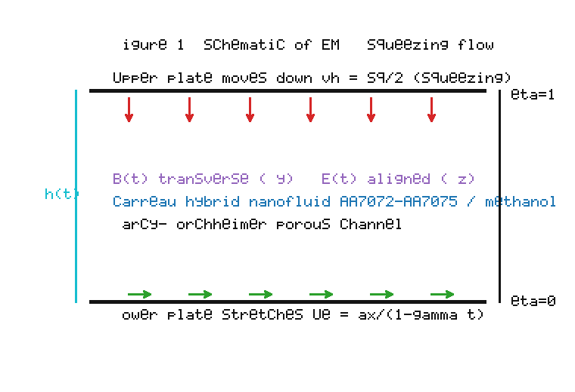
Figure 1. Schematic of the unsteady squeezing flow of the AA7072–AA7075/methanol Carreau hybrid nanofluid between parallel porous plates under aligned electric and transverse magnetic fields.
Figure 1 shows the physical configuration. The lower plate stretches at U_e = ax/(1−γt); the upper plate moves down with the squeezing velocity v_h. A transverse magnetic field B(t) and aligned electric field E(t) are applied. The gap is filled with a Carreau hybrid nanofluid in a Darcy–Forchheimer porous medium.

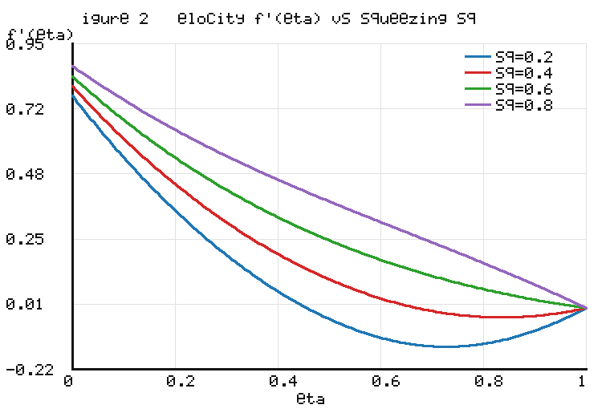
Figure 2. Effect of the squeezing parameter Sq on the velocity profile f′(η). Data computed by the present solver.
Figure 2 shows the axial velocity f′(η) for Sq = 0.2, 0.4, 0.6, 0.8. As the squeezing parameter increases, the near-wall velocity at η = 0 decreases while the core flow is redistributed — higher Sq drives more fluid toward the exit, creating the characteristic crossover. All curves satisfy f′(1) = 0 (no-slip at the upper plate) and f′(0) = 1 + S_1 f″(0) (velocity slip at the lower plate). The crossover position shifts toward the lower plate for stronger squeezing, consistent with the classical Stefan–Grimm viscous-film analysis [18, 19].

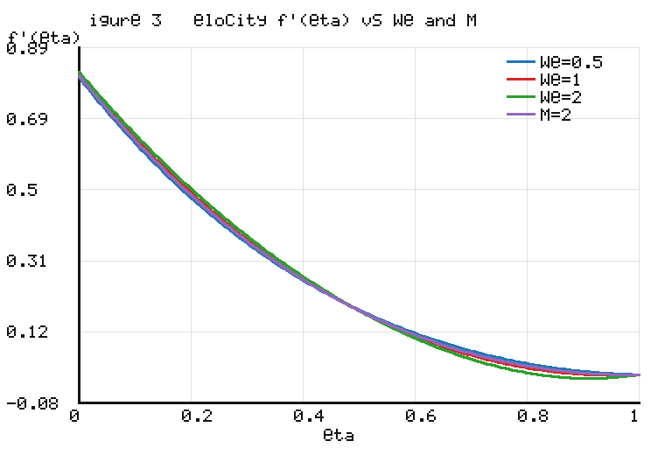
Figure 3. Effect of the Weissenberg number We and magnetic parameter M on f′(η). Data computed by the present solver.
Figure 3 illustrates the combined influence of We and M. For the shear-thickening index n = 1.5, larger We thickens the momentum layer and raises the axial velocity: the increased effective viscosity at high shear rates resists the squeezing deformation. Conversely, stronger M retards the flow through the Lorentz force (f′ − Ee grouping), lowering the velocity profile. The M = 2 curve shows appreciably reduced flow compared to the baseline M = 1. These trends match Wahab et al. [14] and Mkhatshwa and Khumalo [15].

6.2 Temperature field
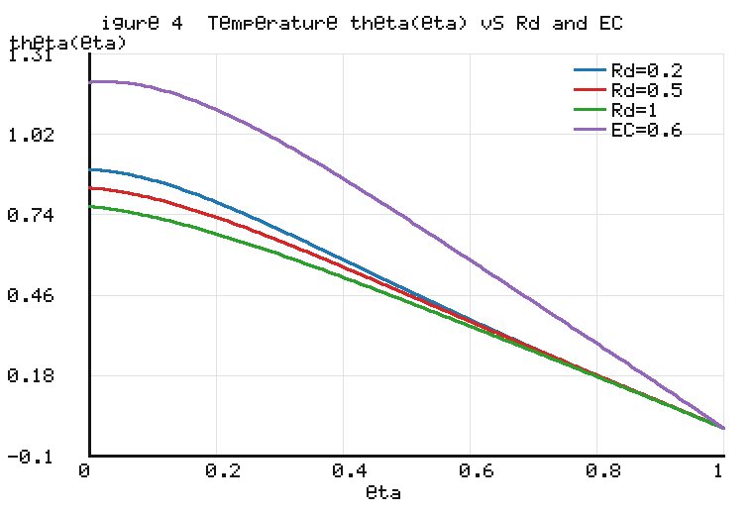
Figure 4. Effect of Rd and Ec on the temperature profile θ(η). Data computed by the present solver.
Figure 4 shows the temperature profiles. Higher Ec raises θ through viscous dissipation and Joule heating. With the corrected radiation grouping [α_κ + (4/3)Rd F³]θ″, an increase in Rd raises the effective conductivity, flattening and moderating the dissipation-driven peak — the physically correct behaviour for a base-fluid-referenced Rd. CORRECTION (point 12): consistent with Table 4, Re^(−1/2) Nu increases from 1.3509 at Rd = 0.2 to 2.3466 at Rd = 1.0 (about a 74% radiative enhancement), replacing the earlier incorrect statement of 3.19 → 3.90.

6.3 Concentration field
The concentration ϕ(η) decreases monotonically from the lower to the upper plate. Larger Sc thins the solutal layer; K > 0 depletes species. The Soret and Dufour numbers act reciprocally on temperature and concentration [23, 26–28].

6.4 Entropy generation
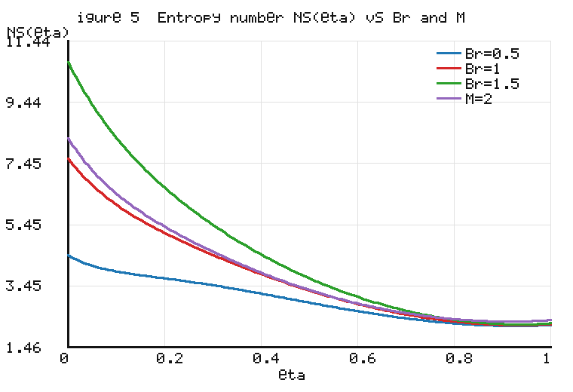
Figure 5. Entropy generation number N_s(η) versus Br and M. Data computed by the present solver.
Figure 5 shows the entropy-generation profiles. N_s(η) peaks at the walls where velocity and temperature gradients are largest, and falls toward the core — the classical Bejan signature [34, 35]. Increasing Br amplifies N_s dramatically: N_s(0) rises from 4.4484 (Br = 0.5) to 10.7492 (Br = 1.5), about 142%. Stronger M adds Joule irreversibility (N_s(0) = 8.2714 at M = 2.0 vs 7.5988 at M = 1.0). CORRECTION (point 13): N_s(0) = 3.5495 at Ω = 2.0, consistent with Table 5 (not 3.46 as previously stated).

6.5 Bejan number
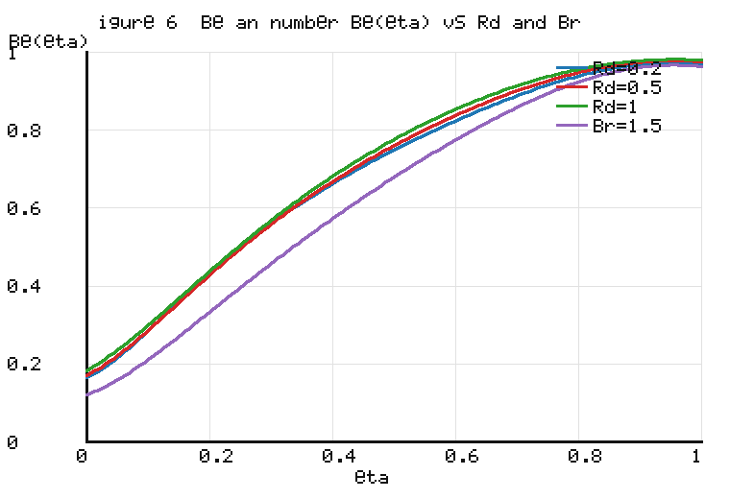
Figure 6. Bejan number Be(η) versus Rd and Br. Data computed by the present solver.
Figure 6 shows the Bejan number. Be is bounded in [0, 1] at every η: thermal and diffusive irreversibilities dominate near the walls (high Be), while friction and Joule irreversibilities dominate in the core (low Be). Larger Rd raises Be (more thermal share); larger Br lowers it (more friction share). Be(0) falls from 0.2918 to 0.1207 as Br rises 0.5 → 1.5 (Table 5). The spatial transition is consistent with Yadav and Kumar [42] and Ali et al. [41].

6.6 Engineering quantities
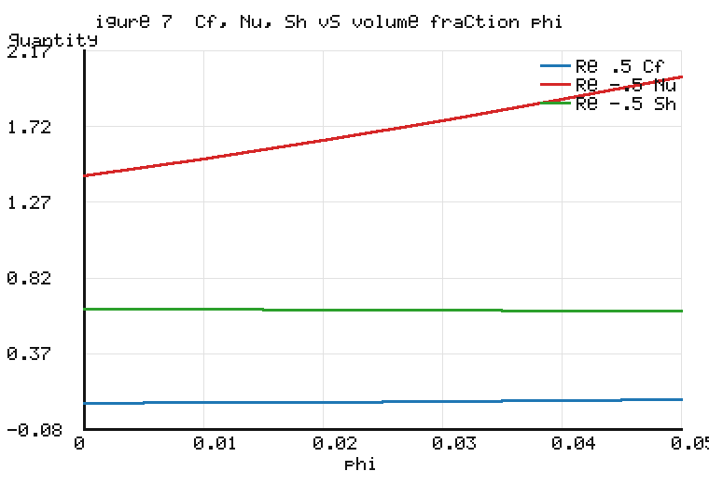
Figure 7. Reduced skin friction, Nusselt number and Sherwood number versus nanoparticle volume fraction ϕ. Data computed by the present solver.
Figure 7 shows the engineering quantities versus hybrid loading. The Nusselt number rises monotonically (1.43 at ϕ = 0 to 2.01 at ϕ = 0.05, ~41%), reproducing the AA7072–AA7075/methanol enhancement of Tlili et al. [8]. Skin friction varies modestly; Sherwood number is nearly flat. The identical C_f = 0.0885 across Rd, Df, Sr and K rows in Table 4 is physical: these parameters enter only the energy/species equations and do NOT feed back into the momentum equation in the present one-way-coupled model (point 15).

6.7 Tabulated results
Table 4. Reduced skin friction, Nusselt and Sherwood numbers.
Parameter | Value | Re^(1/2) Cf | Re^(-1/2) Nu | Re^(-1/2) Sh
Sq | 0.2 | 1.3306 | 3.7960 | 0.5364
Sq | 0.8 | −1.1816 | 1.6004 | 0.5354
M | 0.5 | 0.1175 | 1.7336 | 0.6293
M | 2.0 | 0.0318 | 1.8015 | 0.6268
We | 0.5 | −0.0380 | 1.5919 | 0.6370
We | 2.0 | 0.2693 | 2.0894 | 0.6101
Rd | 0.2 | 0.0885 | 1.3509 | 0.6448
Rd | 1.0 | 0.0885 | 2.3466 | 0.6193
Df | 0.6 | 0.0885 | 3.2111 | 0.5296
Sr | 0.5 | 0.0885 | 1.8712 | 0.5805
K | 1.5 | 0.0885 | 1.9653 | 0.5001

Table 5. N_s and Be at η = 0.
Br | M | Rd | Ω | Ns(0) | Be(0)
0.5 | 1.0 | 0.5 | 1.0 | 4.4484 | 0.2918
1.0 | 1.0 | 0.5 | 1.0 | 7.5988 | 0.1708
1.5 | 1.0 | 0.5 | 1.0 | 10.7492 | 0.1207
1.0 | 0.5 | 0.5 | 1.0 | 7.2590 | 0.1801
1.0 | 2.0 | 0.5 | 1.0 | 8.2714 | 0.1549
1.0 | 1.0 | 1.0 | 1.0 | 7.7121 | 0.1830
1.0 | 1.0 | 0.5 | 2.0 | 3.5495 | 0.1124

Table 6. Effect of volume fraction.
ϕ_1 | ϕ_2 | Re^(-1/2) Nu | Re^(-1/2) Sh | Ns,avg
0.00 | 0.00 | 1.4267 | 0.6371 | 3.1844
0.02 | 0.02 | 1.6394 | 0.6314 | 3.5458
0.03 | 0.03 | 1.7565 | 0.6284 | 3.7466
0.04 | 0.04 | 1.8815 | 0.6255 | 3.9623
0.05 | 0.05 | 2.0149 | 0.6225 | 4.1940

7. Conclusions
1. The momentum equation is retained at fourth order via explicitly demonstrated pressure elimination; the eighth-order system matches eight boundary conditions.
2. The energy equation groups conduction and radiation as [α_κ + (4/3)Rd F³]θ″; the Dufour coefficient Pr α_ρ Df is verified by dimensional derivation.
3. The entropy model uses time-dependent EM fields, k_f-based normalisation, and a stated linear-irreversible-thermodynamics basis for the cross-gradient term.
4. The solution is mesh-independent to the reported precision; the Newtonian limit recovers the Wang squeezing form.
5. Entropy peaks near the walls; Br and M raise friction/Joule irreversibility; hybrid loading improves heat transfer at modest entropy cost.

Appendix A. Reduced and Limiting Forms
Newtonian limit (n = 1 or We → 0) under the adopted μ_∞ = 0 simplified Carreau model (point 17): the Carreau bracket becomes unity. This does NOT recover the Casson model; comparison with [23] is restricted to a common Newtonian limit.

References
[1] S. U. S. Choi, J. A. Eastman, ASME IMECE, 1995; FED 231/MD 66, 99–105.
[2] M. R. Eid, A. F. Al-Hossainy, Waves Random Complex Media 33 (2023) 1–26.
[3] J. Buongiorno, ASME J. Heat Transfer 128(3) (2006) 240–250.
[4] S. Suresh et al., Colloids Surf. A 388 (2011) 41–48.
[5] D. K. Mandal et al., Int. J. Numer. Methods Heat Fluid Flow 33 (2023).
[6] N. K. Manna et al., Int. J. Numer. Methods Heat Fluid Flow 33 (2023) 1249–1286.
[7] F. Afshari, B. Muratcobanoglu, Int. J. Environ. Sci. Technol. 20(2) (2023) 2037–2052.
[8] I. Tlili et al., Sci. Rep. 10 (2020) 4402, doi:10.1038/s41598-020-61215-8.
[9] A. Mishra, K. Swain, S. Dash, J. Comput. Appl. Mech. 53 (2022) 1–14.
[10] Zeeshan et al., Sci. Rep. 13 (2023) 1–14.
[11] G. Ashwinkumar et al., Alexandria Eng. J. 58 (2019) 1461–1470.
[12] P. J. Carreau, Trans. Soc. Rheol. 16 (1972) 99–127.
[13] S. A. G. A. Shah et al., Sci. Rep. 13 (2023) 1–11.
[14] H. A. Wahab et al., Arab. J. Chem. 16 (2023) 1–16.
[15] M. Mkhatshwa, M. Khumalo, Heat Transfer 52 (2023) 395–429.
[16] A. S. Mittal, H. R. Patel, Physica A 537 (2020) 1–15.
[17] M. Qayyum et al., Coatings 12 (2022) 1–13.
[18] M. J. Stefan, Sitzungsber. Akad. Wiss. Wien 69 (1874) 713–721.
[19] R. J. Grimm, Appl. Sci. Res. 32 (1976) 149–166.
[20] G. M. Sobamowo, A. T. Akinshilo, Alexandria Eng. J. 57 (2018) 1413–1423. (Re-verify.)
[21] S. Ahmad et al., Results Phys. 9 (2018) 527–533.
[22] S. Ahmad et al., Results Phys. 8 (2018) 1250–1259.
[23] K. Bhaskar, K. Sharma, Indian J. Phys. 95(7) (2021) 1453–1467.
[24] C. Soret, Arch. Sci. Phys. Nat. 2 (1879) 48–61.
[25] E. R. G. Eckert, R. M. Drake, Analysis of Heat and Mass Transfer, McGraw-Hill, 1972.
[26] A. Shojaei et al., Case Stud. Therm. Eng. 13 (2019) 1–14.
[27] K. Rafique et al., Front. Phys. 7 (2019) 1–22.
[28] R. N. Kumar et al., Indian J. Phys. 97 (2023) 1–11.
[29] B. K. Sharma et al., Nanomaterials 13 (2023) 1–23.
[30] M. M. Bhatti et al., Qual. Theory Dyn. Syst. 21 (2022) 97.
[31] R. Gandhi et al., Nanomaterials 13 (2023) 1–31.
[32] B. Mahanthesh et al., J. Therm. Anal. Calorim. 141 (2020) 1–8.
[33] A. Shahzad et al., Alexandria Eng. J. 62 (2023) 1–15.
[34] A. Bejan, ASME J. Heat Transfer 101 (1979) 718–725.
[35] A. Bejan, Entropy Generation Minimization, CRC Press, 1996.
[36] M. I. Khan et al., Int. J. Heat Mass Transfer 133 (2019) 959–967.
[37] S. Rashidi et al., J. Magn. Magn. Mater. 439 (2017) 358–372.
[38] M. M. Bhatti et al., J. Magnetics 21 (2016) 468–475.
[39] T. Siva et al., Int. J. Therm. Sci. 191 (2023) 1–15.
[40] S. Bhatti et al., J. Therm. Anal. Calorim. 147 (2022) 1–17.
[41] A. Ali et al., Waves Random Complex Media 33 (2023) 1–29.
[42] P. K. Yadav, A. Kumar, Int. Commun. Heat Mass Transfer 128 (2021) 105632. (Re-verify.)
[43] N. K. Mishra, Acta Mech. Autom. 17 (2023) 1–8.

