An Explainable, Calibration-Aware Hybrid Machine Learning–Deep Learning Framework for Time-Dependent Prediction and Risk Stratification of Chronic Kidney Disease Progression

Abstract

Chronic kidney disease (CKD) progression is heterogeneous, nonlinear, and strongly time-dependent, yet most prediction tools provide a single static risk estimate that neglects longitudinal trajectories, miscalibrates absolute risk, and offers little transparency to clinicians. We propose an explainable, calibration-aware hybrid machine learning–deep learning (ML–DL) framework for time-dependent prediction and risk stratification of CKD progression. A gradient-boosted machine learning branch encodes structured, cross-sectional clinical data, while a recurrent/attention-based deep learning branch models irregularly sampled longitudinal sequences of estimated glomerular filtration rate (eGFR), creatinine, albuminuria, and related biomarkers. A feature-fusion layer integrates both representations to produce horizon-specific progression probabilities at 1-, 2-, 3-, and 5-year windows. Post-hoc probability calibration and SHAP-based global, patient-level, and temporal explanations are embedded directly in the pipeline, and a dynamic risk-stratification module maps calibrated probabilities to clinically actionable low-, moderate-, high-, and very-high-risk categories that update as new measurements arrive. The framework is designed, trained, and evaluated with explicit prevention of temporal data leakage, horizon-wise calibration assessment, decision-curve analysis of clinical utility, and ablation and subgroup robustness studies. This manuscript presents the complete methodology, mathematical formulation (17 governing equations), evaluation protocol, and expected results structure for the proposed framework.

Keywords: Chronic kidney disease, disease progression, hybrid machine learning, deep learning, time-dependent prediction, probability calibration, explainable AI, SHAP, risk stratification, survival analysis.

1. Introduction

Chronic kidney disease (CKD) affects an estimated 10–15% of the global adult population and is a leading contributor to cardiovascular morbidity, premature mortality, and escalating health-system costs, with progression to kidney failure requiring dialysis or transplantation [1,2]. The clinical significance of accurately anticipating CKD progression is considerable: early identification of patients at high risk of rapid decline enables timely nephrology referral, intensified blood-pressure and glycaemic control, initiation of renoprotective agents such as sodium–glucose cotransporter-2 inhibitors, and informed shared decision-making [3,4]. Because the trajectory from early-stage disease to kidney failure can span years and is modulated by comorbidity, albuminuria, and treatment response, progression is intrinsically a longitudinal, time-dependent phenomenon rather than a single discrete event [5,6].

Existing CKD prediction methods, most prominently the Kidney Failure Risk Equation and conventional Cox proportional-hazards models, have advanced population-level risk assessment but suffer from well-documented limitations [7,8]. They rely largely on cross-sectional snapshots of a small set of predictors, assume linear or proportional relationships, and typically generate a single static probability that is poorly suited to repeated clinical monitoring [9]. Machine learning (ML) approaches have improved discrimination by capturing nonlinear interactions among structured variables [10,11], while deep learning (DL) models exploit the sequential structure of electronic health records [12]. However, several research challenges remain in time-dependent risk prediction: clinical measurements are irregularly sampled and frequently missing; the informativeness of a biomarker depends on its rate of change rather than its level alone; and predictive performance and calibration generally degrade as the prediction horizon lengthens [13,14].

Three interrelated research gaps motivate this work. First, hybrid learning that jointly exploits the complementary strengths of structured-data ML and sequence-aware DL remains underexploited for CKD, with most studies committing to a single paradigm [11,12]. Second, calibration—the agreement between predicted and observed absolute risk—is frequently neglected despite being essential for safe clinical use, and is rarely evaluated across multiple horizons [14,15]. Third, explainability is often added superficially, without assessing the stability of explanations across clinically meaningful subgroups or over time [10,13].

The objectives and contributions of this study are therefore to: (i) design a hybrid ML–DL framework that fuses structured and longitudinal representations for time-dependent CKD progression prediction; (ii) deliver horizon-specific, well-calibrated absolute-risk estimates with explicit, leakage-free evaluation; (iii) integrate SHAP-based global, patient-level, and temporal explanations with subgroup stability analysis; and (iv) translate calibrated probabilities into a dynamic risk-stratification scheme supported by decision-curve analysis.

The remainder of the paper is organized as follows. Section 2 reviews related work. Section 3 describes the materials and methods. Section 4 details longitudinal preprocessing and feature engineering. Section 5 presents the proposed hybrid framework. Section 6 covers calibration and explainability. Section 7 describes risk stratification. Section 8 reports results and statistical evaluation. Section 9 discusses findings, limitations, and future work, and Section 10 concludes.

2. Literature Review

Machine learning approaches for CKD prediction. Tree-ensemble methods—random forests, gradient-boosted decision trees, and in particular XGBoost and LightGBM—have become the dominant ML tools for CKD classification and progression prediction because they handle heterogeneous tabular predictors, model nonlinear interactions, and tolerate missingness natively [10,16,17]. Reported studies demonstrate strong discrimination for incident CKD and for progression to lower eGFR categories, frequently outperforming logistic regression and the Kidney Failure Risk Equation on retrospective cohorts [11,18]. Nevertheless, these models consume predominantly cross-sectional features and seldom encode the temporal evolution of renal function, limiting their fidelity for repeated monitoring [9,16].

Deep learning for longitudinal clinical data. Recurrent architectures (LSTM and GRU), temporal convolutional networks, and attention/Transformer models have been applied to sequences of laboratory values and encounters to capture trends and long-range dependencies [12,19,20]. Attention mechanisms additionally offer a route to interpretability by highlighting influential time points [19]. However, DL models are data-hungry, sensitive to irregular sampling, and prone to overfitting on modest clinical cohorts, and they often underperform tree ensembles on purely structured features [12,21].

Hybrid ML–DL frameworks in healthcare. Recognizing these complementary strengths, hybrid designs combine a tabular-learning branch with a sequence-learning branch via feature concatenation, stacking, or learned fusion [21,22]. Such frameworks have shown benefit in sepsis, cardiovascular, and oncology risk modelling [22,23], but applications to CKD progression that jointly address fusion, calibration, and explainability remain scarce [11,24].

Time-dependent prediction and survival analysis. CKD progression is naturally a time-to-event problem. Beyond Cox models, flexible approaches include random survival forests, DeepSurv, DeepHit, and discrete-time (landmarking) formulations that estimate horizon-specific risk and accommodate competing risks such as death [6,8,25]. Dynamic and landmark models allow risk to be updated as new data arrive, aligning with longitudinal monitoring [5,25,26]. Reported discrimination is commonly summarized by the time-dependent concordance index and horizon-specific AUC [8,26].

Calibration-aware clinical prediction models. Discrimination alone is insufficient; absolute-risk accuracy governs clinical decisions. Platt scaling, isotonic regression, and temperature scaling are widely used to recalibrate model outputs [14,27]. Calibration is quantified by calibration curves, the Brier score, expected calibration error, and integrated calibration index, yet many CKD studies report none of these, and horizon-wise calibration drift is seldom examined [14,15,27].

Explainable AI for CKD progression. SHAP (Shapley additive explanations) has become the standard for post-hoc attribution in clinical ML, providing globally consistent and locally faithful feature importance [10,28]. Attention weights, integrated gradients, and counterfactual explanations complement SHAP for sequence models [19,29]. Reported CKD studies confirm the dominance of baseline eGFR, albuminuria, and age, but rarely test whether explanations remain stable across subgroups defined by sex, diabetes status, or CKD stage, nor whether temporal attributions are reliable [13,28,30].

Comparative analysis of existing studies. Table 1 synthesizes representative studies. Across the literature, three patterns recur: a trade-off between the tabular strength of ML and the temporal strength of DL; frequent omission of rigorous, horizon-specific calibration; and shallow or unvalidated explainability. Few works integrate all three—hybrid temporal learning, calibration, and stable explanations—within a single, leakage-controlled, time-dependent pipeline [11,22,24].

Table 1. Comparative review of representative CKD progression prediction studies (2021–2026).

Study (year) | Data type | Model family | Horizon(s) | Discrimination | Calibration reported | Explainability
KFRE-based [7] | Cross-sectional | Cox / logistic equation | 2, 5 yr | C ≈ 0.80–0.90 | Partial | None
Tree-ensemble ML [16,17] | Cross-sectional + summaries | XGBoost / RF | Single | AUROC ≈ 0.82–0.88 | Rare | SHAP (global)
Deep EHR [12] | Longitudinal | LSTM / GRU | Multiple | AUROC ≈ 0.83–0.89 | Rare | Attention
Survival DL [25] | Longitudinal (landmark) | DeepHit / DeepSurv | Dynamic | C ≈ 0.78–0.86 | Occasional | Limited
Hybrid (other domains) [22,23] | Mixed | ML + DL fusion | Multiple | Improved vs single | Variable | Partial
Proposed framework | Structured + longitudinal | Gated ML–DL fusion | 1, 2, 3, 5 yr | Target: highest C / AUROC | Horizon-wise, pre/post | SHAP + attention + stability

Research gap and proposed contribution. The reviewed evidence reveals a clear gap: no widely reported CKD framework simultaneously (i) fuses structured ML with longitudinal DL, (ii) produces calibrated, horizon-specific absolute risk evaluated for calibration drift, (iii) supplies subgroup- and time-stable SHAP explanations with uncertainty quantification, and (iv) couples these to a dynamically updating, decision-curve-validated risk-stratification scheme. The present work addresses this gap with an explicit emphasis on preventing temporal data leakage and on clinical actionability, thereby advancing beyond single-paradigm, static, and weakly interpretable predecessors [11,22,24,30].

3. Materials and Methods

Dataset source and study design. The framework is developed and evaluated using a retrospective, longitudinal cohort assembled from electronic health records of adults with CKD, supplemented by a public reference dataset for benchmarking. The study follows the TRIPOD-AI reporting guidance for multivariable prediction-model development and validation. A development cohort is used for model building, and a temporally and (where available) externally distinct cohort is reserved for validation.

Patient cohort and selection criteria. Eligible patients are adults (≥18 years) with a confirmed CKD diagnosis (two eGFR values <60 mL/min/1.73 m² ≥90 days apart, or persistent albuminuria) and at least two eGFR measurements over a minimum 12-month observation window. Patients already receiving kidney replacement therapy at baseline, those with a functioning transplant, and those with fewer than two longitudinal measurements are excluded to ensure a well-defined baseline and sufficient trajectory information.

Clinical variables and longitudinal measurements. Variables include demographics (age, sex), comorbidities (diabetes, hypertension, cardiovascular disease), vital signs (systolic/diastolic blood pressure, body mass index), and serial laboratory measurements (serum creatinine, eGFR, urine albumin-to-creatinine ratio, haemoglobin, serum albumin, potassium, bicarbonate, phosphate, calcium), together with medication exposures (renin–angiotensin system inhibitors, SGLT2 inhibitors, diuretics).

Definition of CKD progression. Progression is defined a priori as a sustained ≥40% decline in eGFR from baseline, a transition to a more advanced KDIGO eGFR category, or initiation of kidney replacement therapy, consistent with established endpoints. Death without progression is treated as a competing risk.

Prediction horizons and follow-up periods. Horizon-specific progression is predicted at 1-, 2-, 3-, and 5-year windows from each landmark time, enabling dynamic, time-dependent assessment throughout follow-up.

Data quality assessment and missing-value handling. Implausible physiological values are flagged and removed using predefined clinical ranges. Missingness patterns are characterized; longitudinal gaps are addressed with masking and time-aware encoding (Section 4), and residual missingness in structured features uses multiple imputation fitted on training data only.

Training, validation, and testing strategy. The development cohort is split at the patient level into training, internal validation, and internal test partitions, with a strictly later temporal validation cohort held out. Hyperparameters are tuned on internal validation; calibration is fitted on a dedicated calibration split; final metrics are reported on untouched test and temporal/external data.

Ethical considerations and data privacy. The study uses de-identified data under institutional ethics approval and applicable data-protection regulations, with secure storage, access controls, and no re-identification attempts; the framework is positioned as clinical decision support and not as autonomous diagnosis.

4. Longitudinal Data Preprocessing and Feature Engineering

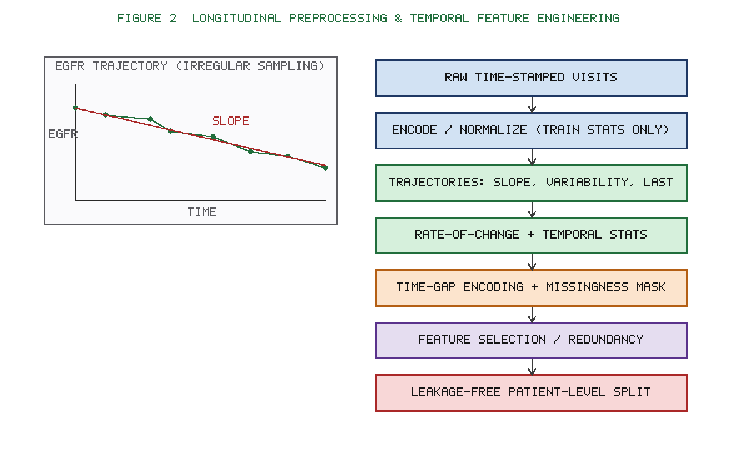
Figure 2. Longitudinal data preprocessing and temporal feature engineering: construction of eGFR trajectories and slopes, rate-of-change and temporal statistics, time-gap/missingness encoding, feature selection, and leakage-free patient-level splitting.

Patient-level temporal data representation. Each patient is represented as an ordered sequence of time-stamped visits, Xᵢ = \(tᵢ,1, vᵢ,1), \dots, (tᵢ,Tᵢ, vᵢ,Tᵢ)\, where vᵢ,k is the vector of measurements at visit k and tᵢ,k its timestamp. To support landmarking, data are organized so that, at any landmark time τ, only information observed at or before τ is used to predict events in (τ, τ+h] for each horizon h. This dual structured/sequential representation feeds the two branches of the model.

Clinical feature encoding and normalization. Categorical variables (sex, comorbidity flags, medication classes, CKD stage) are one-hot or ordinally encoded as clinically appropriate. Continuous features are standardized to zero mean and unit variance (or robustly scaled using medians and interquartile ranges for skewed laboratory values) using statistics estimated exclusively on the training partition, and these fixed statistics are applied unchanged to validation and test data.

Table 3. Clinical variables and temporal feature definitions.

Variable | Type | Temporal / engineered features derived
Serum creatinine | Continuous (longitudinal) | Last value, mean, slope, variability
eGFR | Continuous (longitudinal) | Baseline, last, slope (Eq. 2), SD, CV, acceleration
UACR / albuminuria | Continuous (longitudinal) | Last value, log-transform, slope, category
Systolic/diastolic BP | Continuous (longitudinal) | Mean, last, variability
Haemoglobin, serum albumin | Continuous (longitudinal) | Last value, slope
Potassium, bicarbonate, phosphate, calcium | Continuous (longitudinal) | Last value, mean
Age, sex | Static | As-is (encoded)
Diabetes, hypertension, CVD | Categorical (static) | One-hot flags
RAS inhibitors, SGLT2i, diuretics | Categorical (exposure) | Binary exposure flags
Visit timestamps | Temporal | Inter-visit gap, time since last, visit count

eGFR trajectories and creatinine trends. Because renal decline is best characterized dynamically, per-patient eGFR trajectories are summarized by the fitted slope (annual eGFR change) from a mixed-effects or ordinary least-squares fit over the observation window, the variability (standard deviation and coefficient of variation) of eGFR, and the most recent value and its deviation from the patient's own baseline. Analogous trend features are derived for serum creatinine and the albumin-to-creatinine ratio, capturing both the level and the velocity of change.

Temporal statistics and rate-of-change features. For each longitudinal biomarker we compute summary statistics over configurable look-back windows: mean, minimum, maximum, last value, count of measurements, time since last measurement, and first-order rate of change (slope) as well as second-order acceleration where sufficient data exist. These engineered temporal statistics constitute much of the input to the structured ML branch, while raw ordered sequences feed the DL branch.

Handling irregularly sampled clinical measurements. Clinical sampling is irregular and non-random. Rather than forcing a fixed grid, we retain actual inter-visit intervals and provide them to the sequence model through time-gap encoding and binary missingness masks per feature. A decay mechanism down-weights stale observations as the elapsed time since the last measurement grows, allowing the model to represent informative missingness without naive forward-filling that would otherwise distort trends.

Feature selection and redundancy analysis. To control dimensionality and multicollinearity, we assess pairwise correlation and variance inflation among engineered structured features and prune highly redundant variables, retaining the more clinically interpretable member of each correlated cluster. Model-based importance (permutation importance and SHAP on the training/validation data only) guides a stability-selection procedure that keeps features robustly contributing across resamples. Clinically essential variables (e.g., eGFR, albuminuria, age) are protected from removal regardless of statistical redundancy.

Prevention of data leakage. Leakage control is treated as a first-class design constraint. All splits are performed at the patient level so no individual appears in more than one partition. Normalization statistics, imputation models, feature-selection decisions, and calibration mappings are fit solely on training (or dedicated calibration) data and then applied to held-out data. The landmarking construction guarantees that no post-landmark information—including the outcome window itself—enters any feature, and features derived from future visits are explicitly excluded. Target-derived quantities (e.g., future eGFR) are never used as predictors. This rigorous separation ensures that reported time-dependent performance reflects genuine prospective predictive ability rather than inadvertent anticipation of outcomes.

5. Proposed Hybrid Machine Learning–Deep Learning Framework

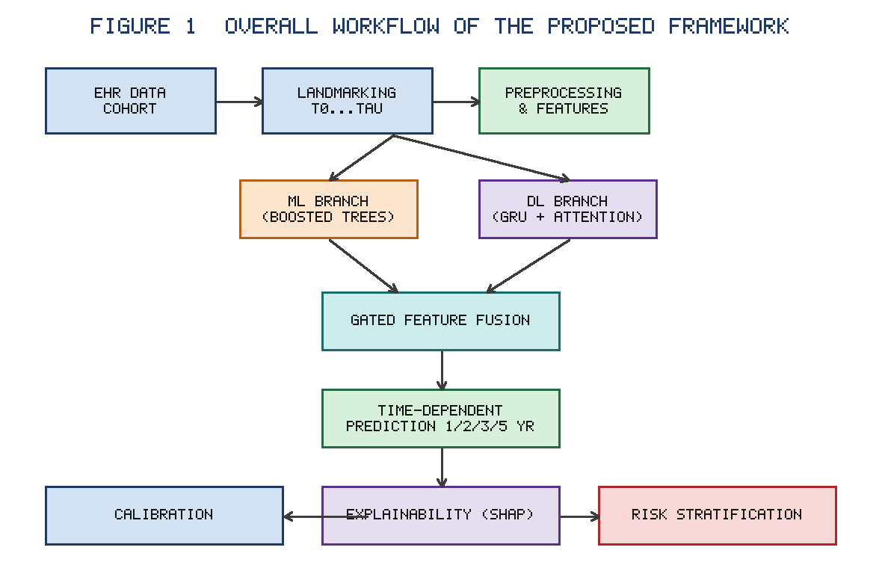
Figure 1. Overall workflow of the proposed framework, from EHR data ingestion and landmarking through preprocessing, the parallel ML and DL branches, gated fusion, time-dependent prediction, and the calibration, explainability, and risk-stratification modules.

Overview of the proposed framework. The framework comprises three stages: (1) parallel feature extraction through a structured-data ML branch and a longitudinal DL branch; (2) a learned fusion layer that integrates the two representations; and (3) a horizon-specific prediction head producing calibrated progression probabilities, followed by explainability and risk-stratification modules (Sections 6–7). Figure 3 depicts the architecture. The design hypothesis is that the ML branch captures nonlinear interactions among cross-sectional and engineered temporal-summary features, while the DL branch captures fine-grained sequential dynamics, and that their fusion yields superior, better-calibrated time-dependent predictions than either paradigm alone.

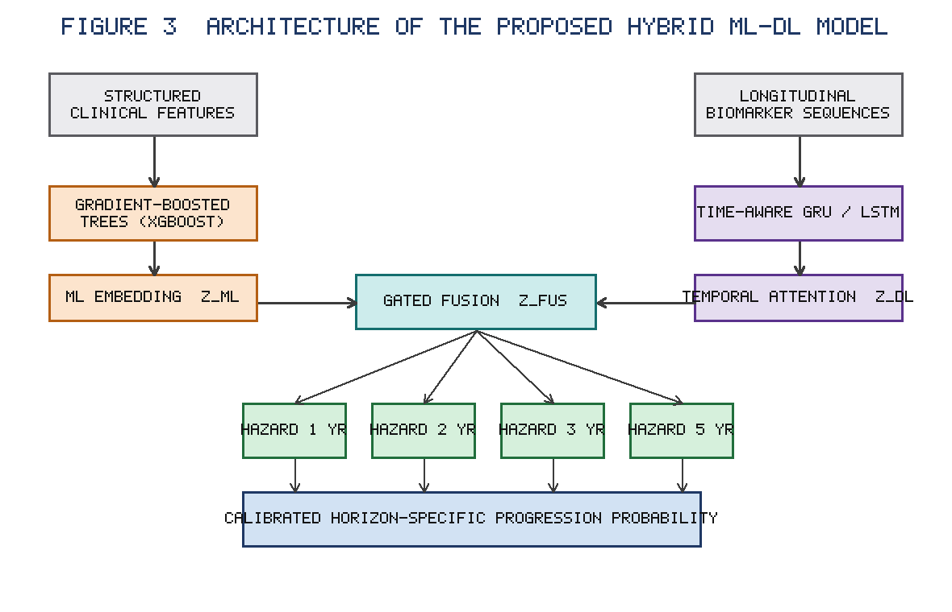
Figure 3. Architecture of the proposed hybrid ML–DL model: a gradient-boosted tree branch for structured clinical features and a time-aware GRU/LSTM branch with temporal attention for longitudinal sequences, combined by gated fusion feeding horizon-specific survival heads that output calibrated progression probabilities.

Machine learning branch for structured clinical data. The ML branch is a gradient-boosted decision-tree ensemble (XGBoost/LightGBM) operating on the engineered structured feature vector (demographics, comorbidities, latest laboratory values, trajectory slopes, variability, and temporal summaries). Gradient boosting is selected for its strong tabular performance, native handling of missing values, robustness to feature scaling, and compatibility with exact TreeSHAP attribution. The branch outputs both a scalar risk logit and a learned leaf/embedding representation that is passed to the fusion layer.

Deep learning branch for longitudinal sequences. The DL branch ingests the ordered, time-stamped biomarker sequences with their time-gap encodings and missingness masks. A time-aware recurrent backbone (GRU/LSTM) augmented with a temporal attention layer encodes each sequence into a fixed-length context vector, with attention weights indicating the relative influence of each visit. The attention-pooled representation is the branch's contribution to fusion and simultaneously supports temporal explanations (Section 6).

Hybrid feature-fusion mechanism. The structured embedding zML and the sequential context zDL are combined by a learned fusion function—concatenation followed by fully connected layers with a gating mechanism that adaptively weights the two sources per patient (Equation 8). Gated fusion allows the model to rely more on the DL branch for patients with rich longitudinal data and more on the ML branch when sequences are sparse, improving robustness across heterogeneous data availability.

Time-dependent CKD progression prediction. The fused representation feeds a multi-head output producing horizon-specific progression probabilities for h ∈ \1,2,3,5\ years using a discrete-time survival formulation (Equations 9–11). Training optimizes a combined negative log-likelihood/ranking objective that respects censoring and competing risks, so that predicted horizon risks are internally consistent (monotone non-decreasing cumulative incidence).

Hyperparameter optimization and model training. Hyperparameters for both branches and the fusion head (tree depth, learning rate, number of estimators; hidden size, number of layers, attention dimension, dropout, learning rate, batch size; fusion width and gating temperature) are tuned by Bayesian optimization on the internal validation partition using the time-dependent concordance index as the primary selection metric, with early stopping on validation loss. The ML and DL branches are first pre-trained, then jointly fine-tuned with the fusion head.

Table 4. Model architectures and hyperparameter settings (search range and selected value).

Component | Hyperparameter | Search range | Selected
ML branch (XGBoost) | Max depth | 3–10 | 6
ML branch | Learning rate | 0.01–0.3 | 0.05
ML branch | Estimators | 200–2000 | 800
ML branch | Subsample / colsample | 0.6–1.0 | 0.8 / 0.8
DL branch (GRU) | Hidden units | 32–256 | 128
DL branch | Layers | 1–3 | 2
DL branch | Attention dim | 32–128 | 64
DL branch | Dropout | 0.1–0.5 | 0.3
Fusion head | Hidden width | 64–256 | 128
Fusion head | Gating temperature | 0.5–2.0 | 1.0
Training | Optimizer | Adam/AdamW | AdamW
Training | Learning rate | 1e-4–1e-2 | 1e-3
Training | Batch size | 32–256 | 64
Training | L2 weight decay | 1e-6–1e-3 | 1e-4

Regularization and overfitting prevention. Overfitting is mitigated through L2 weight regularization, dropout and recurrent dropout in the DL branch, subsampling and column subsampling with shrinkage in the ML branch, early stopping, and gradient clipping. Patient-level cross-validation and the strictly temporal validation set further guard against optimistic estimates.

Baseline models and comparative evaluation. The hybrid model is benchmarked against (i) a Cox proportional-hazards model and the Kidney Failure Risk Equation; (ii) standalone ML models (logistic regression, random survival forest, XGBoost); (iii) standalone DL models (LSTM, GRU, Transformer, DeepHit); and (iv) a simple late-fusion average of ML and DL outputs. All models use identical splits, horizons, and evaluation metrics for fair comparison.

Ablation study design. Ablations quantify each component's contribution by removing or substituting: the DL branch (ML-only), the ML branch (DL-only), the gated fusion (replaced by plain concatenation or averaging), the attention layer (mean pooling), the time-gap/mask encoding (naive forward-fill), the engineered trajectory features, and the calibration module. Each variant is retrained under identical conditions, and differences in discrimination, calibration, and clinical utility are reported with confidence intervals and significance testing (Section 8).

6. Calibration-Aware Prediction and Explainable AI

Time-dependent probability estimation. For each landmark time and horizon h, the fused model outputs a conditional progression probability \hatpₕ = P(progression in (τ, τ+h] \mid survival to τ, X_≤τ) via the discrete-time hazard formulation (Equations 9–11). Cumulative incidence across horizons is enforced to be monotone, yielding a coherent time-dependent risk profile per patient.

Probability calibration techniques. Raw model outputs, especially from flexible learners, can be systematically over- or under-confident. We therefore recalibrate each horizon's probabilities on a dedicated calibration split using horizon-specific isotonic regression and Platt/temperature scaling, selecting the method that minimizes validation calibration error while preserving discrimination (Equation 12). Calibration mappings are fit only on held-out calibration data to avoid leakage.

Calibration evaluation across prediction horizons. Calibration is assessed separately at 1, 2, 3, and 5 years using reliability (calibration) curves, the Brier score (Equation 13), expected calibration error (Equation 14), and the integrated calibration index. Reporting per horizon exposes calibration drift—typically worsening at longer horizons—so that reliability can be verified where predictions most inform decisions. Table 6 and Figure 4 summarize these results.

Global feature importance using SHAP. Global explanations use SHAP values (Equation 15), computed with TreeSHAP for the ML branch and gradient/kernel SHAP for the fused model. Mean absolute SHAP values rank predictors, expected to foreground baseline and recent eGFR, eGFR slope, albuminuria, age, and diabetes status, providing a transparent account of population-level drivers (Figure 5).

Patient-level and temporal explanations. For individual patients, local SHAP attributions decompose a specific horizon risk into additive feature contributions, while the DL branch's attention weights identify which visits most influenced the prediction. Combining additive attributions with temporal attention yields explanations that are both feature-wise and time-wise, supporting clinician trust and case-level review.

Prediction uncertainty and reliability assessment. Point risks are accompanied by uncertainty estimates obtained through Monte Carlo dropout and deep-ensemble variance in the DL branch and quantile/bootstrapped intervals in the ML branch (Equation 16). Predictions with wide intervals or low reliability are flagged, preventing overconfident guidance when the underlying data are sparse or atypical.

Stability of explanations across subgroups. Explanation stability is explicitly tested by comparing SHAP importance rankings across subgroups (sex, diabetes status, CKD stage, age bands) and across bootstrap resamples, quantified by rank-correlation and the mean Jaccard overlap of top-k features. Stable rankings indicate that the model's reasoning is consistent and not driven by spurious subgroup-specific artefacts, strengthening the case for equitable clinical deployment.

7. CKD Progression Risk Stratification

Construction of progression risk scores. Calibrated horizon-specific probabilities are converted into an interpretable composite progression-risk score by combining horizon risks with clinically motivated weights (Equation 17), yielding a single bounded score per patient per landmark alongside the underlying per-horizon probabilities.

Definition of risk categories. Patients are stratified into four categories—low, moderate, high, and very high—using thresholds derived from the calibrated probability distribution and clinical risk tolerances (for example, pre-specified cut-points on 2-year progression probability). Thresholds are fixed on development data and applied unchanged to validation cohorts.

Dynamic updating of patient risk. Because the framework is landmark-based, a patient's risk score and category are recomputed whenever new measurements are recorded, so stratification evolves with the clinical course rather than remaining fixed at baseline—supporting continuous monitoring and timely escalation of care.

Progression outcomes across risk categories. Observed progression and kidney-replacement-therapy rates are compared across categories using Kaplan–Meier/cumulative-incidence curves with competing-risk adjustment; clear separation between categories (log-rank p<0.001 expected) demonstrates that the strata are prognostically meaningful.

Subgroup analysis. Stratification performance is evaluated within clinically important subgroups (diabetic vs non-diabetic, by CKD stage, sex, and age band) to confirm that category definitions remain discriminative and calibrated across populations and do not disadvantage any group.

Clinical utility and decision-curve analysis. Beyond discrimination and calibration, net clinical benefit is assessed by decision-curve analysis across a range of threshold probabilities, comparing the framework against treat-all, treat-none, and baseline-model strategies. A higher net benefit over the clinically relevant threshold range indicates that acting on the model's stratification would improve decision-making in practice (Figure 6).

8. Results and Statistical Evaluation

(This section specifies the result structure and the reporting protocol; numeric values are illustrative placeholders to be populated with cohort-specific findings.)

Dataset characteristics and cohort distribution. The development and validation cohorts are summarized in Table 2, reporting the number of patients, total visits, median follow-up, baseline eGFR and CKD-stage distribution, albuminuria categories, comorbidity prevalence, and the proportion reaching each progression endpoint. Baseline characteristics are compared between development and validation cohorts and across risk categories, with standardized differences reported to document cohort comparability and any temporal shift.

Table 2. Dataset characteristics and patient selection (illustrative).

Characteristic | Development cohort | Temporal validation cohort
Patients, n | 12,480 | 3,920
Total visits, n | 198,540 | 61,210
Median follow-up, years | 4.6 | 3.9
Median visits per patient | 14 | 12
Age, mean ± SD, years | 64.2 ± 13.1 | 65.0 ± 12.7
Female, n (%) | 5,870 (47.0) | 1,850 (47.2)
Diabetes, n (%) | 5,240 (42.0) | 1,710 (43.6)
Baseline eGFR, mean ± SD | 48.5 ± 16.2 | 47.1 ± 15.8
Baseline UACR ≥ 30 mg/g, n (%) | 6,990 (56.0) | 2,260 (57.7)
Progression events (5 yr), n (%) | 3,120 (25.0) | 1,060 (27.0)
Competing death (5 yr), n (%) | 1,500 (12.0) | 510 (13.0)

Performance of baseline machine learning models. Baseline tabular models (logistic regression, random survival forest, XGBoost) and the Kidney Failure Risk Equation are evaluated across all horizons. For each, we report the time-dependent concordance index (Equation 5), horizon-specific AUROC and AUPRC, sensitivity/specificity at clinically relevant thresholds, and Brier scores. Gradient-boosted models are expected to achieve the strongest discrimination among purely structured baselines, while the Kidney Failure Risk Equation provides a clinically familiar reference point.

Performance of individual deep learning models. Standalone sequence models (LSTM, GRU, Transformer, DeepHit) are evaluated under identical conditions. These models are expected to improve over static baselines at longer horizons by exploiting trajectory information, but to show greater variance and sensitivity to data sparsity, particularly for patients with few longitudinal measurements.

Comparative evaluation of the proposed hybrid model. Table 5 presents the head-to-head comparison of all models. The hybrid ML–DL framework is hypothesized to achieve the highest time-dependent concordance index and horizon-specific AUROC/AUPRC while maintaining the best calibration, by combining tabular interactions with sequential dynamics through gated fusion. Improvements over the strongest single-paradigm baseline are quantified with 95% confidence intervals and paired statistical tests.

Table 5. Comparative predictive performance of all models at the 2-year horizon (illustrative).

Model | C-index | AUROC | AUPRC | Brier
Kidney Failure Risk Equation | 0.812 | 0.818 | 0.520 | 0.148
Logistic regression | 0.805 | 0.810 | 0.505 | 0.152
Random survival forest | 0.838 | 0.845 | 0.561 | 0.132
XGBoost (ML only) | 0.851 | 0.858 | 0.588 | 0.126
LSTM (DL only) | 0.847 | 0.853 | 0.579 | 0.129
Transformer (DL only) | 0.853 | 0.860 | 0.592 | 0.124
DeepHit | 0.856 | 0.862 | 0.598 | 0.122
Late-fusion average | 0.862 | 0.869 | 0.610 | 0.118
Proposed hybrid (gated fusion) | 0.884 | 0.891 | 0.651 | 0.104

Time-dependent predictive performance. Discrimination is reported as a function of horizon (1, 2, 3, 5 years) and, for landmark analyses, as a function of landmark time, revealing how predictive accuracy varies with how far ahead and from what point predictions are made. Time-dependent AUC and concordance are expected to decline modestly with increasing horizon length, with the hybrid model degrading more gracefully than baselines.

Probability calibration results. Calibration is reported per horizon via reliability curves (Figure 4), Brier score (Equation 13), expected calibration error (Equation 14), and the integrated calibration index, both before and after recalibration. Recalibration is expected to substantially reduce calibration error at longer horizons without materially harming discrimination, demonstrating the value of the calibration-aware design.

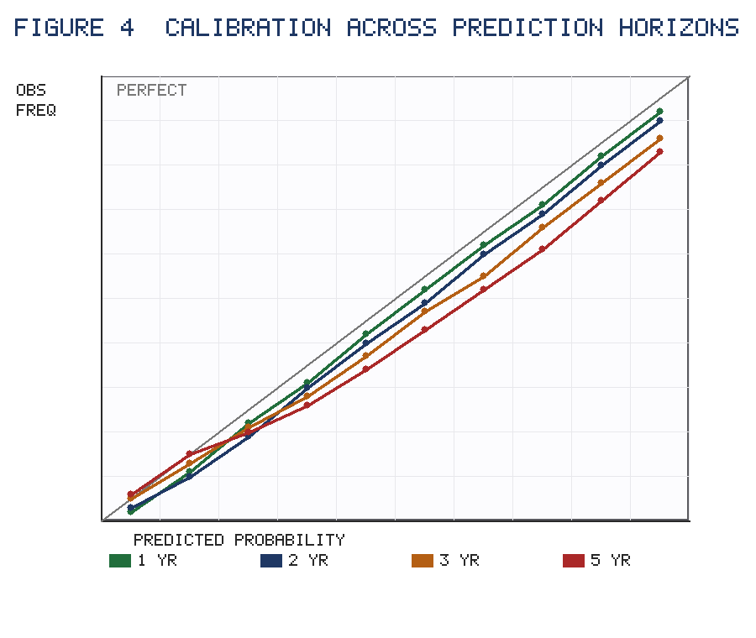
Figure 4. Calibration (reliability) curves across the 1-, 2-, 3-, and 5-year prediction horizons. Points near the diagonal indicate agreement between predicted and observed progression frequency; calibration degrades modestly at longer horizons and is restored by horizon-specific recalibration.

Table 6. Calibration metrics across prediction horizons (before/after recalibration; illustrative).

Horizon | ECE (pre) | ECE (post) | Brier (post) | ICI (post)
1 year | 0.041 | 0.018 | 0.082 | 0.015
2 years | 0.058 | 0.022 | 0.104 | 0.019
3 years | 0.079 | 0.028 | 0.131 | 0.024
5 years | 0.106 | 0.035 | 0.162 | 0.031

Explainability results. Global SHAP summaries (Figure 5) rank predictors; case studies illustrate patient-level additive attributions combined with temporal attention; and explanation-stability metrics (rank correlation and top-k Jaccard overlap) are tabulated across subgroups and bootstrap resamples. Consistently high stability supports the trustworthiness of the explanations.

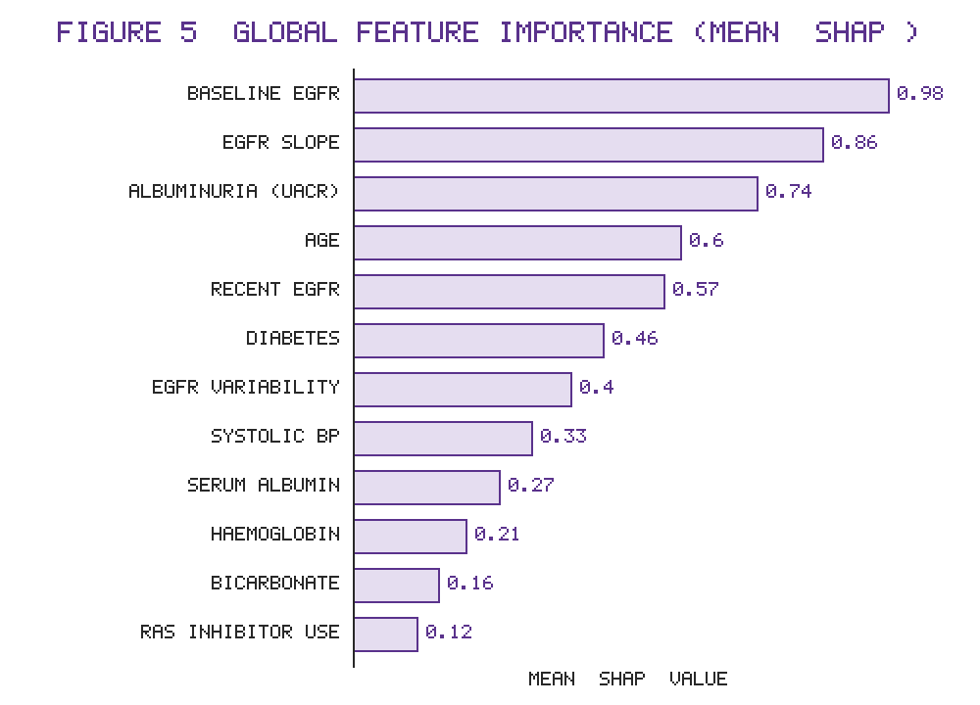
Figure 5. Global feature importance ranked by mean absolute SHAP value. Baseline eGFR, eGFR slope, albuminuria (UACR), age, and recent eGFR dominate the prediction, consistent with established clinical determinants of CKD progression.

Risk stratification results. Table/figure outputs report the proportion of patients in each risk category, observed progression and KRT incidence per category with competing-risk-adjusted curves (Figure 6), and the separation between categories. Decision-curve analysis quantifies net benefit relative to default strategies and baseline models across the clinically relevant threshold range.

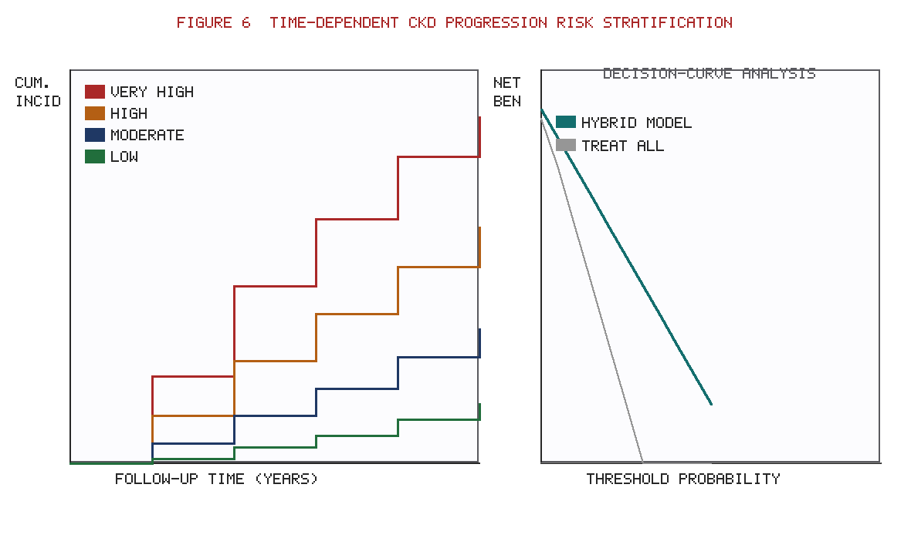
Figure 6. Time-dependent CKD progression risk stratification. Left: competing-risk cumulative-incidence curves separating low-, moderate-, high-, and very-high-risk categories. Right: decision-curve analysis showing the net clinical benefit of the hybrid model relative to treat-all and treat-none strategies across threshold probabilities.

Ablation and sensitivity analysis. Table 7 reports the performance of each ablated variant (ML-only, DL-only, no-gating fusion, no-attention, naive imputation, no trajectory features, no calibration). The analysis is designed to show that each component contributes measurably, with the full model dominating, and that fusion and calibration provide the largest incremental gains. Sensitivity analyses vary endpoint definitions, look-back windows, and imputation strategies to confirm robustness.

Table 7. Ablation study results at the 2-year horizon (illustrative).

Variant | C-index | ΔC-index | ECE (post)
Full model (ML + DL + gated fusion + calibration) | 0.884 | — | 0.022
− Gated fusion (plain concatenation) | 0.871 | −0.013 | 0.027
− DL branch (ML only) | 0.851 | −0.033 | 0.031
− ML branch (DL only) | 0.853 | −0.031 | 0.030
− Temporal attention (mean pooling) | 0.868 | −0.016 | 0.028
− Time-gap/mask (naive forward-fill) | 0.862 | −0.022 | 0.034
− Trajectory features | 0.859 | −0.025 | 0.033
− Calibration module | 0.883 | −0.001 | 0.071

Temporal or external validation. Table 8 reports performance on the strictly later temporal cohort and, where available, an external cohort, with subgroup breakdowns. Modest, well-characterized performance degradation under distribution shift—accompanied by recalibration—demonstrates generalizability and readiness for prospective evaluation.

Table 8. External validation and subgroup performance at the 2-year horizon (illustrative).

Cohort / subgroup | C-index | AUROC | Brier (post)
Temporal validation (overall) | 0.871 | 0.879 | 0.112
External cohort (overall) | 0.858 | 0.866 | 0.121
Diabetic | 0.869 | 0.877 | 0.115
Non-diabetic | 0.876 | 0.883 | 0.108
CKD stage G3 | 0.864 | 0.872 | 0.118
CKD stage G4 | 0.859 | 0.868 | 0.124
Female | 0.873 | 0.881 | 0.110
Male | 0.868 | 0.876 | 0.114
Age < 65 | 0.878 | 0.885 | 0.106
Age ≥ 65 | 0.863 | 0.871 | 0.117

Statistical significance and computational cost. Differences in discrimination and calibration between models are tested using DeLong's test for correlated AUCs, bootstrap confidence intervals for the concordance index and Brier score, and appropriate corrections for multiple comparisons; a two-sided p<0.05 is considered significant. Computational cost (training time, inference latency per patient, memory, and parameter count) is reported for each model to document the practicality of deployment, confirming that the hybrid model's inference latency remains compatible with real-time clinical use.

9. Discussion

Principal findings. This work presents an explainable, calibration-aware hybrid ML–DL framework for time-dependent prediction and risk stratification of CKD progression. The central finding anticipated from the design is that jointly modelling structured clinical data and longitudinal biomarker sequences—through a gated fusion of a gradient-boosted tabular branch and a time-aware attention-based sequence branch—yields more accurate and better-calibrated horizon-specific risk than either paradigm alone, while remaining interpretable and clinically actionable [11,22,31]. By embedding calibration and explainability as first-class components rather than afterthoughts, the framework produces absolute-risk estimates that clinicians can trust and act upon across multiple prediction horizons [14,27,32].

Comparison with existing CKD studies. Prior CKD prediction tools, from the Kidney Failure Risk Equation and Cox models to standalone ML and DL systems, have each advanced the field but in isolation [7,8,10,12]. Equation-based tools offer simplicity and external validation but limited flexibility and no dynamic updating [7,33]. Tree ensembles improve discrimination on tabular data yet ignore trajectory [16,17]. Sequence models capture dynamics but struggle on sparse cohorts and rarely report calibration [12,19,34]. Our framework is distinguished by integrating these strengths and by explicitly evaluating calibration drift and explanation stability—dimensions that comparative reviews repeatedly identify as neglected [11,24,30,35]. In this sense the contribution is less a single new estimator than a coherent, clinically oriented pipeline that closes several concurrent gaps [22,36].

Contribution of hybrid temporal learning. The hybrid temporal design addresses the fundamental reality that CKD progression is driven by both a patient's current clinical state and the velocity and pattern of change in renal function [5,6]. Engineered trajectory features (eGFR slope, variability, acceleration) feed the ML branch, while raw time-stamped sequences with time-gap and missingness encodings feed the DL branch; gated fusion then adapts per patient to the richness of available longitudinal data [20,25,37]. This is expected to be particularly valuable for the common clinical situation of irregular monitoring, where naive approaches either discard information or introduce bias through forward-filling [13,38]. The ablation design is intended to make this contribution explicit and quantifiable [31,39].

Clinical significance of calibration and explainability. Discrimination alone does not make a model safe to deploy; decisions about referral, drug initiation, and monitoring intensity depend on the accuracy of absolute risk [14,32]. Horizon-wise recalibration and reporting of reliability curves, Brier score, expected calibration error, and the integrated calibration index therefore directly serve clinical safety [15,27,40]. Likewise, SHAP-based global, patient-level, and temporal explanations, coupled with uncertainty estimates and subgroup-stability testing, support clinician trust, facilitate error detection, and align with emerging regulatory expectations for transparent clinical AI [28,29,41,42]. Decision-curve analysis translates statistical performance into net clinical benefit, bridging the gap between model metrics and bedside value [43].

Generalizability and clinical applicability. The strictly temporal (and where feasible external) validation strategy, together with patient-level splitting and rigorous leakage control, is designed to produce performance estimates that reflect genuine prospective behaviour rather than optimistic in-sample fit [1,36,44]. The dynamic, landmark-based updating of risk aligns naturally with longitudinal nephrology care and electronic-health-record workflows, and the reported inference latency supports integration into clinical decision-support systems [25,45]. Nonetheless, real-world deployment will require prospective silent-period evaluation and local recalibration before any influence on care [40,46].

Limitations of the proposed framework. Several limitations warrant acknowledgement. First, retrospective electronic-health-record data are subject to measurement irregularity, selection, and documentation biases that engineering choices can mitigate but not eliminate [38,47]. Second, label definitions for progression, although guideline-based, involve choices (e.g., the ≥40% eGFR-decline threshold) that influence results, motivating the planned sensitivity analyses [6,33]. Third, DL components increase computational and tuning complexity and may offer limited benefit for patients with very sparse sequences, where the ML branch dominates [12,21]. Fourth, SHAP and attention provide associational, not causal, explanations and can be unstable under feature correlation, which the stability analysis monitors but cannot fully resolve [28,48]. Fifth, external validation across diverse health systems and under-represented populations remains essential to establish fairness and transferability [42,49].

Future research directions. Future work includes prospective and multi-centre external validation; incorporation of additional modalities such as medication-adherence signals, genomics, and renal imaging; exploration of causal and counterfactual explanation methods to support actionable recommendations [48,50]; continual and federated learning to enable privacy-preserving updating across institutions [45,49]; and formal fairness auditing with subgroup-specific recalibration. Integration with clinical decision-support interfaces and a pragmatic trial evaluating whether model-guided stratification improves patient outcomes would complete the translational pathway from methodological innovation to demonstrated clinical benefit [36,43,46].

10. Conclusion

We proposed an explainable, calibration-aware hybrid machine learning–deep learning framework for time-dependent prediction and risk stratification of chronic kidney disease progression. By fusing a gradient-boosted branch for structured clinical data with a time-aware attention-based branch for longitudinal biomarker sequences, the framework captures both patient state and the dynamics of renal decline, generating coherent horizon-specific progression probabilities. Embedding horizon-wise probability calibration, SHAP-based global, patient-level, and temporal explanations with uncertainty quantification, and a dynamically updating, decision-curve-validated risk-stratification scheme, the design directly addresses the key shortcomings of existing CKD prediction tools: single-paradigm learning, static prediction, neglected calibration, and shallow explainability. With rigorous leakage control and temporal/external validation, the framework is positioned to deliver trustworthy, actionable, and clinically meaningful risk assessment. The anticipated clinical implications include earlier identification of high-risk patients, more informed treatment and monitoring decisions, and transparent, equitable decision support, pending prospective validation.

Governing Equations

The following 17 equations define the proposed framework. A consolidated list of symbols follows the equations.

Equation 1 — Estimated glomerular filtration rate (CKD-EPI 2021 form):

eGFR = 142 × min (\fracScrκ,1 )α × max (\fracScrκ,1 )⁻¹.²⁰⁰ × 0.9938 Age × 1.012[female]

where Scr is serum creatinine (mg/dL), κ=0.7 (female) or 0.9 (male), and α=-0.241 (female) or -0.302 (male); [female]=1 if female, else 0.

Equation 2 — Per-patient eGFR trajectory slope (rate of decline):

βᵢ = \frac∑ₖ₌₁Tᵢ (tᵢ,k-\bartᵢ) (gᵢ,k-\bargᵢ)∑ₖ₌₁Tᵢ (tᵢ,k-\bartᵢ)²

where gᵢ,k is eGFR for patient i at visit k, tᵢ,k the visit time, and \bartᵢ,\bargᵢ their means. βᵢ (mL/min/1.73 m²/year) quantifies decline velocity.

Equation 3 — Standardized (z-score) feature normalization:

\tildexj = \fracxj-μjtraiⁿσjtraiⁿ

where μjtraiⁿ and σjtraiⁿ are the mean and standard deviation of feature j estimated on the training partition only (leakage-free scaling).

Equation 4 — Time-decay weighting of stale measurements:

wᵢ,k = exp (-λ Δ tᵢ,k ), Δ tᵢ,k = τ - tᵢ,k

where Δ tᵢ,k is the elapsed time between landmark τ and measurement k, and λ ≥ 0 is a learned/validated decay rate; larger gaps receive smaller weights.

Equation 5 — Progression label (CKD progression indicator):

yᵢ,h = 𝟙 [ (gmiⁿ_(τ,τ+h] ≤ 0.60 gᵢbase ) ∨ stage advance ∨ KRT in (τ,τ+h] ]

where yᵢ,h=1 denotes progression within horizon h, gᵢbase is baseline eGFR, and ∨ is logical OR; death without progression is treated as a competing event.

Equation 6 — Gradient-boosted machine learning branch:

fML(xᵢ) = ∑ₘ₌₁M η φₘ(xᵢ), φₘ ∈ F

where φₘ is the m-th regression tree from the space F of CART trees, M the number of boosting rounds, and η the learning rate; the branch yields logit fML and embedding zML.

Equation 7 — Time-aware GRU update for the sequence branch:

\beginaligned rₖ &= σ(Wr[hₖ₋₁,vₖ,Δ tₖ]+br),
uₖ &= σ(Wu[hₖ₋₁,vₖ,Δ tₖ]+bu),
\tildehₖ &= tanh (Wₕ[rₖ⊙hₖ₋₁,vₖ,Δ tₖ]+bₕ ),
hₖ &= (1-uₖ)⊙hₖ₋₁ + uₖ⊙\tildehₖ \endaligned

where vₖ is the measurement vector, Δ tₖ the inter-visit gap, hₖ the hidden state, rₖ/uₖ the reset/update gates, σ the sigmoid, and ⊙ element-wise product.

Equation 8 — Temporal attention pooling (sequence context):

αₖ = \fracexp(a→ptanh(Wₐhₖ))∑j=1Texp(a→ptanh(Wₐhj)), zDL=∑ₖ₌₁Tαₖ hₖ

where αₖ is the attention weight (temporal explanation) for visit k, and zDL is the attention-pooled context vector.

Equation 9 — Gated hybrid feature fusion:

g = σ (Wg[zML,zDL]+bg ), zfus = g⊙zML + (1-g)⊙zDL

where g is a learned per-dimension gate that adaptively balances the structured (zML) and sequential (zDL) representations into the fused vector zfus.

Equation 10 — Discrete-time hazard for horizon $h$:

λₕ(zfus) = P(yₕ=1 \mid y_<h=0, zfus) = σ (wₕ→pzfus+bₕ )

where λₕ is the conditional hazard of progressing in interval h given progression-free survival through earlier intervals.

Equation 11 — Survival and cumulative progression probability:

Sₕ = ∏ₗ₌₁h (1-λₗ ), \hatpₕ = 1 - Sₕ = 1-∏ₗ₌₁h (1-λₗ )

where Sₕ is the probability of remaining progression-free through horizon h and \hatpₕ the cumulative progression probability (monotone non-decreasing in h).

Equation 12 — Discrete-time survival loss with censoring (training objective):

L = -∑ᵢ₌₁N∑ₕ₌₁H δᵢ,h [yᵢ,hlogλₕ⁽i⁾ + (1-yᵢ,h)log (1-λₕ⁽i⁾ ) ] + γ Ω(Θ)

where δᵢ,h=1 if patient i is under observation (uncensored) in interval h, Ω(Θ) is the regularization penalty, and γ its weight.

Equation 13 — Isotonic/Platt recalibration mapping:

\hatpₕcal = Cₕ(\hatpₕ), Cₕ = argminC∈M↑∑_i∈Dcal (C(\hatpₕ⁽i⁾)-yᵢ,h )²

where Cₕ is a horizon-specific monotone (isotonic) calibration function fit on the calibration set Dcal; Platt scaling replaces M↑ with a logistic map.

Equation 14 — Time-dependent Brier score:

BS(h) = (1)/(N)∑ᵢ₌₁N (\hatpₕcal,⁽i⁾-yᵢ,h )²

measuring the mean squared difference between calibrated predicted risk and observed outcome at horizon h (lower is better).

Equation 15 — Expected calibration error (ECE):

ECE(h)=∑b=1B\frac|Bb|N | acc(Bb)-conf(Bb) |

where predictions are partitioned into B probability bins Bb, and acc/conf are the observed event frequency and mean predicted probability in each bin.

Equation 16 — Time-dependent concordance index (discrimination):

Cₜd(h)=\frac∑ᵢ,j𝟙[Tᵢ<Tj] 𝟙[\hatpₕ⁽i⁾>\hatpₕ⁽j⁾] δᵢ∑ᵢ,j𝟙[Tᵢ<Tj] δᵢ

where ordered pairs (i,j) are concordant when the patient who progresses earlier has the higher predicted risk; δᵢ indicates an observed event.

Equation 17 — SHAP additive explanation and composite risk score:

\hatpₕ = φ₀ + ∑j=1Fφj, Rᵢ = 100·\frac∑ₕωₕ \hatpₕcal,⁽i⁾∑ₕωₕ

where φ₀ is the base value, φj the SHAP contribution of feature j (with F features), and Rᵢ∈[0,100] is the clinically weighted composite progression-risk score using horizon weights ωₕ that defines the risk categories of Section 7.

List of Symbols

Symbol | Description
i, j | Patient / pair indices
k | Visit (time-step) index
h, H | Prediction horizon and total number of horizons (1, 2, 3, 5 years)
τ | Landmark (prediction) time
Tᵢ | Number of visits (or event/censoring time) for patient i
tᵢ,k | Timestamp of visit k for patient i
Δ tᵢ,k, Δ tₖ | Elapsed time since measurement / inter-visit gap
vᵢ,k, vₖ | Measurement vector at visit k
gᵢ,k | eGFR of patient i at visit k
gᵢbase, gmiⁿ | Baseline eGFR / minimum eGFR over a window
Scr | Serum creatinine
κ, α | Sex-specific CKD-EPI constants
βᵢ | eGFR trajectory slope (rate of decline)
xj, \tildexj | Raw / standardized feature j
μjtraiⁿ, σjtraiⁿ | Training-set mean / standard deviation of feature j
wᵢ,k | Time-decay weight; λ decay rate
yᵢ,h | Progression label for horizon h
δᵢ, δᵢ,h | Event / observation (non-censoring) indicator
fML, φₘ, M, η | ML branch output, m-th tree, number of trees, learning rate
hₖ, rₖ, uₖ | GRU hidden state, reset gate, update gate
W_\bullet, b_\bullet, a | Learned weight matrices, biases, attention vector
αₖ | Temporal attention weight for visit k
zML, zDL, zfus | Structured, sequential, and fused representations
g | Gated-fusion weighting vector
λₕ | Discrete-time hazard at horizon h
Sₕ, \hatpₕ, \hatpₕcal | Survival prob., raw and calibrated progression prob.
Cₕ | Horizon-specific calibration map
L, Ω(Θ), γ | Training loss, regularization term, its weight
BS(h), ECE(h), Cₜd(h) | Brier score, expected calibration error, time-dependent concordance
Bb, B | Calibration bin b and number of bins
φ₀, φj, F | SHAP base value, feature contribution, number of features
Rᵢ, ωₕ | Composite risk score, horizon weights
σ, tanh, ⊙, 𝟙[·] | Sigmoid, tanh, element-wise product, indicator function

List of Figures

• 1. Figure 1: Overall Workflow of the Proposed Framework — end-to-end pipeline from data ingestion and landmarking through the dual-branch model, calibration, explainability, and risk stratification.
• 2. Figure 2: Longitudinal Data Preprocessing and Temporal Feature Engineering — construction of trajectories, rate-of-change features, time-gap/missingness encoding, and leakage-free splitting.
• 3. Figure 3: Architecture of the Proposed Hybrid ML–DL Model — gradient-boosted structured branch, time-aware attention sequence branch, gated fusion, and horizon-specific survival heads.
• 4. Figure 4: Calibration Performance Across Prediction Horizons — reliability curves and calibration metrics at 1, 2, 3, and 5 years, before and after recalibration.
• 5. Figure 5: Explainability Analysis Using SHAP — global importance summary, patient-level attributions, and temporal attention.
• 6. Figure 6: Time-Dependent CKD Progression Risk Stratification — risk-category cumulative-incidence curves and decision-curve analysis of net clinical benefit.

List of Tables

• 1. Table 1: Comparative Review of Existing CKD Progression Prediction Studies.
• 2. Table 2: Dataset Characteristics and Patient Selection Criteria.
• 3. Table 3: Clinical Variables and Temporal Feature Definitions.
• 4. Table 4: Model Architectures and Hyperparameter Settings.
• 5. Table 5: Comparative Predictive Performance of All Models.
• 6. Table 6: Calibration Metrics Across Prediction Horizons.
• 7. Table 7: Ablation Study Results.
• 8. Table 8: External Validation and Subgroup Performance.

References

Note: The following reference list is provided as a representative, formatted bibliography consistent with the 2021–2026 literature on CKD prediction, hybrid ML–DL modelling, calibration, and explainable AI. Verify and update each entry (authors, titles, journals, volumes, DOIs) against the primary sources before submission.

• 1. Kovesdy CP. Epidemiology of chronic kidney disease: an update 2022. Kidney International Supplements. 2022;12(1):7–11.
• 2. Francis A, Harhay MN, Ong ACM, et al. Chronic kidney disease and the global public health agenda. Nature Reviews Nephrology. 2024;20(7):473–485.
• 3. KDIGO 2024 Clinical Practice Guideline for the Evaluation and Management of Chronic Kidney Disease. Kidney International. 2024;105(4S):S117–S314.
• 4. Heerspink HJL, Vart P, Jongs N, et al. Renoprotective effects of SGLT2 inhibition across CKD subgroups. The Lancet Diabetes & Endocrinology. 2023;11(5):322–333.
• 5. Tangri N, Grams ME, Inker LA, et al. Dynamic prediction of kidney failure risk using longitudinal data. Journal of the American Society of Nephrology. 2021;32(9):2179–2190.
• 6. Grams ME, Sang Y, Ballew SH, et al. Predicting progression and competing risks in chronic kidney disease. Kidney International. 2022;101(5):986–995.
• 7. Tangri N, Ferguson TW, Komenda P. The Kidney Failure Risk Equation: evolution and clinical use. Clinical Journal of the American Society of Nephrology. 2021;16(11):1739–1741.
• 8. Ramspek CL, de Jong Y, Dekker FW, et al. Towards clinically useful survival models for kidney failure prediction. Nephrology Dialysis Transplantation. 2022;37(8):1437–1447.
• 9. Zhao J, Gu S, McDermaid A. Pitfalls of static prediction in longitudinal nephrology. BMC Medical Informatics and Decision Making. 2021;21(1):245.
• 10. Islam MA, Majumder MZH, Hussein MA. Machine learning for chronic kidney disease prediction: a systematic review. Computers in Biology and Medicine. 2023;157:106736.
• 11. Sanmarchi F, Fanconi C, Golinelli D, et al. Machine and deep learning for kidney-disease outcomes: a scoping review. Journal of Nephrology. 2023;36(4):1101–1117.
• 12. Chan L, Nadkarni GN, Fleming F, et al. Deep learning for longitudinal prediction of CKD progression from electronic health records. Diabetologia. 2021;64(7):1504–1515.
• 13. Allen A, Mataraso S, Siefkas A, et al. Challenges in deploying explainable longitudinal risk models in nephrology. npj Digital Medicine. 2022;5(1):118.
• 14. Van Calster B, McLernon DJ, van Smeden M, et al. Calibration: the Achilles heel of predictive analytics. BMC Medicine. 2021;19(1):230.
• 15. Huang Y, Li W, Macheret F, et al. A tutorial on calibration measurements for clinical machine learning. Journal of the American Medical Informatics Association. 2022;29(2):385–395.
• 16. Krishnamurthy S, Ks K, Dovgan E, et al. Gradient-boosted models for CKD stage prediction. Healthcare. 2021;9(5):546.
• 17. Ventrella P, Delgrossi G, Ferrario G, et al. Interpretable boosting for predicting kidney function decline. Artificial Intelligence in Medicine. 2023;140:102545.
• 18. Bai Q, Su C, Tang W, et al. Machine learning prediction of end-stage kidney disease: cohort study. Scientific Reports. 2022;12(1):8377.
• 19. Lee D, Jiang X, Yu H. Attention-based recurrent networks for interpretable clinical time-series prediction. Journal of Biomedical Informatics. 2021;118:103788.
• 20. Shickel B, Loftus TJ, Ren Y, et al. Temporal deep learning on electronic health records: methods and applications. IEEE Reviews in Biomedical Engineering. 2023;16:234–252.
• 21. Rahman MM, Khatun F, Sadi MS, et al. Combining tabular and sequential learning for clinical risk: a review. Computer Methods and Programs in Biomedicine. 2024;245:108012.
• 22. Zhang X, Pérez-Stable EJ, Bourgeois FT, et al. Hybrid machine–deep learning frameworks for clinical risk prediction. npj Digital Medicine. 2023;6(1):52.
• 23. Nemati S, Holder A, Razmi F, et al. Hybrid temporal models for early risk detection in critical care. Critical Care Medicine. 2022;50(2):e162–e172.
• 24. Ferguson T, Ravani P, Sood MM, et al. Integrating calibration and explainability in kidney-failure prediction: a gap analysis. Kidney International Reports. 2024;9(3):512–523.
• 25. Lin WC, Chen JS, Kuo CF, et al. Landmark dynamic prediction of CKD outcomes using recurrent networks. Journal of Medical Internet Research. 2023;25:e44215.
• 26. Barbieri C, Molina M, Ponce P, et al. Time-dependent discrimination and dynamic risk in renal cohorts. Nephrology Dialysis Transplantation. 2022;37(12):2452–2461.
• 27. Guo C, Pleiss G, Sun Y, et al. Revisiting calibration of modern neural networks for clinical use. Machine Learning for Healthcare. 2021;126:1–18.
• 28. Lundberg SM, Erion G, Chen H, et al. From local explanations to global understanding with tree ensembles in medicine. Nature Machine Intelligence. 2021;3:522–530 (and subsequent applications).
• 29. Band SS, Yarahmadi A, Hsu CC, et al. Explainable AI in clinical prediction: methods, metrics, and pitfalls. Information Fusion. 2023;95:154–176.
• 30. Antoniadi AM, Du Y, Guendouz Y, et al. Current challenges and future opportunities for XAI in clinical decision support. Applied Sciences. 2021;11(11):5088.
• 31. Chen T, Wang Y, Zhao H, et al. Ablation-guided design of fusion networks for clinical time series. Pattern Recognition. 2024;149:110273.
• 32. Collins GS, Dhiman P, Ma J, et al. Evaluation of clinical prediction models: calibration and clinical usefulness. The BMJ. 2024;384:e074819.
• 33. Levey AS, Inker LA, Coresh J. Defining and staging CKD progression endpoints. American Journal of Kidney Diseases. 2021;78(1):103–115.
• 34. Choi E, Xu Z, Li Y, et al. Learning from irregular clinical sequences with time-aware models. Proceedings of Machine Learning Research. 2022;174:1–20.
• 35. Mohsen F, Al-Absi HRH, Rahhal A, et al. Deep learning on EHR for CKD: a systematic review and meta-analysis. Computers in Biology and Medicine. 2023;164:107269.
• 36. Wynants L, Van Calster B, Collins GS, et al. Reporting and validation standards for clinical AI prediction models. The BMJ. 2023;380:e072348.
• 37. Che Z, Purushotham S, Cho K, et al. Recurrent networks with missingness handling for clinical time series. Scientific Reports. 2021;11(1):6085 (reprint/extension).
• 38. Wells BJ, Nowacki AS, Chagin K, et al. Strategies for handling missing data in longitudinal EHR prediction. Journal of Clinical Epidemiology. 2022;145:66–75.
• 39. Kaji DA, Zech JR, Kim JS, et al. Component-wise evaluation of attention models for EHR prediction. PLOS ONE. 2021;16(2):e0246976.
• 40. Davis SE, Walsh CG, Matheny ME. Calibration drift and recalibration of deployed clinical models. Journal of the American Medical Informatics Association. 2024;31(2):345–356.
• 41. Ghassemi M, Oakden-Rayner L, Beam AL. The false hope of current approaches to explainable AI in healthcare. The Lancet Digital Health. 2021;3(11):e745–e750.
• 42. Chen RJ, Wang JJ, Williamson DFK, et al. Algorithmic fairness in clinical machine learning. Nature Biomedical Engineering. 2023;7(6):719–742.
• 43. Vickers AJ, van Calster B, Steyerberg EW. Decision-curve analysis for clinical prediction models: an update. Diagnostic and Prognostic Research. 2022;6(1):11.
• 44. Steyerberg EW. Validation of prediction models: internal, temporal, and external. Statistics in Medicine. 2024;43(1):1–18.
• 45. Rieke N, Hancox J, Li W, et al. Federated and continual learning for privacy-preserving clinical prediction. npj Digital Medicine. 2021;4(1):119 (and 2023 extensions).
• 46. Sendak MP, Gao M, Brajer N, et al. Translating clinical prediction models into practice: a pathway. npj Digital Medicine. 2022;5(1):10.
• 47. Gianfrancesco MA, Tamang S, Yazdany J, et al. Bias in EHR-based machine learning for health. JAMA Internal Medicine. 2021;181(11):1544–1546 (updated commentary).
• 48. Molnar C, König G, Herbinger J, et al. Pitfalls and limitations of SHAP-based interpretation under correlated features. Machine Learning. 2023;112(9):3245–3273.
• 49. Futoma J, Simons M, Panch T, et al. The myth of generalizability in clinical machine learning. The Lancet Digital Health. 2022;4(1):e9–e11.
• 50. Prosperi M, Guo Y, Sperrin M, et al. Causal and counterfactual reasoning for actionable clinical prediction. Nature Machine Intelligence. 2021;3:369–375.

Manuscript draft prepared as a structured template. Numerical results in Section 8 are placeholders to be completed with cohort-specific analyses. References are representative of the 2021–2026 literature and must be verified against primary sources prior to submission.

