EMERGING TRENDS AND FUTURE PERSPECTIVES
Book: AI and Digital Twin-Driven Fault Prediction and Energy Optimization in Smart Grids

Abstract
The convergence of artificial intelligence and digital twin technologies is reshaping how electrical power systems are monitored, optimized, and protected, and this chapter surveys the emerging trends and future perspectives that define this transformation. It begins by establishing the foundations of smart grid modernization, tracing the evolution of power systems toward intelligent, sensor-rich infrastructures that integrate renewable generation, distributed resources, and real-time communication, and introducing the artificial intelligence, machine learning, and digital twin paradigms that address their complexity. The chapter then develops AI-enabled fault prediction and predictive maintenance, examining deep learning for fault diagnosis, ensemble and explainable methods for trustworthy prediction, and digital twins integrated with Internet-of-Things sensing, edge computing, and cloud platforms for real-time monitoring and reliability. It proceeds to energy optimization and emerging applications, covering AI-driven load and renewable forecasting, reinforcement learning for adaptive optimization, demand-side management, and digital twin applications spanning photovoltaic systems, wind energy, battery storage, electric vehicles, and microgrids. Finally, it critically assesses the implementation barriers of cybersecurity, latency, interoperability, computational complexity, and scalability, and it outlines future perspectives including autonomous self-healing grids, federated learning, physics-informed artificial intelligence, quantum-inspired optimization, and resilient infrastructures supporting sustainable energy transitions. Through integrated frameworks, comparative tables, and schematic figures, the chapter provides researchers and practitioners with a structured understanding of how the fusion of artificial intelligence and digital twins enables predictive, adaptive, and resilient smart grid operation, and it identifies the research frontiers most likely to advance next-generation energy systems.
Keywords: smart grids; digital twin; artificial intelligence; fault prediction; predictive maintenance; energy optimization; reinforcement learning; federated learning; physics-informed machine learning; self-healing grids

1. Introduction to AI and Digital Twin-Driven Smart Grids
The electrical power system is being reinvented. For more than a century the grid operated as a largely one-directional network, delivering electricity from a modest number of large, controllable power stations to passive consumers, and relying on conservative engineering margins and human operators to maintain reliability. That paradigm is giving way to a profoundly more complex and dynamic system, in which renewable generation fluctuates with the weather, distributed resources inject power at the edges of the network, electric vehicles and responsive loads reshape demand, and millions of sensors generate continuous streams of data about every aspect of grid behavior. This transformation promises a cleaner, more efficient, and more flexible energy system, but it also introduces complexity that exceeds the capacity of traditional monitoring and control methods, creating an urgent need for new approaches to fault prediction, energy optimization, and operational resilience.
Two technologies have emerged as central to meeting this need, and their convergence is the subject of this chapter. Artificial intelligence, and machine learning in particular, provides the capacity to learn complex patterns from the vast data that modern grids generate, enabling accurate forecasting, early fault detection, and adaptive control that conventional analytical methods cannot match. The digital twin, a dynamic virtual replica of a physical system continuously synchronized with it through real-time data, provides a platform on which the state of the grid can be observed, its future behavior simulated, and control strategies tested without risk to the physical system. Individually, each technology offers substantial benefits; together, they create a powerful synergy in which artificial intelligence supplies the predictive and decision-making intelligence while the digital twin supplies the faithful, continuously updated model of reality on which that intelligence operates.
This chapter examines the emerging trends and future perspectives that arise from this convergence, organized to progress from foundations through applications to open challenges and future directions. It first establishes the technological foundations, characterizing smart grid modernization and the artificial intelligence and digital twin paradigms that address its complexity. It then develops AI-enabled fault prediction and predictive maintenance, together with digital twin-driven monitoring and reliability. The chapter proceeds to energy optimization and the emerging applications of digital twins across the diverse domains of the modern grid, from photovoltaic and wind systems to battery storage, electric vehicles, and microgrids. It closes by critically assessing the barriers to implementation and surveying the future perspectives—autonomous self-healing grids, federated and physics-informed learning, and quantum-inspired optimization—that point toward next-generation energy systems. Throughout, the emphasis is on how the fusion of artificial intelligence and digital twins enables a predictive, adaptive, and resilient grid capable of supporting a sustainable energy transition.

2. Foundations of AI and Digital Twin Technologies in Smart Grids

2.1 Smart Grid Modernization and Technological Convergence
The modern smart grid is the product of a decades-long evolution from the traditional electromechanical power system toward an intelligent, digitally instrumented infrastructure. The conventional grid was designed around centralized generation, unidirectional power flow, and limited observability, with control exercised through relatively slow, manual, or rule-based mechanisms [1]. The smart grid, by contrast, overlays the physical power network with a layer of sensing, communication, and computation that enables real-time awareness and active, automated control, transforming the grid from a passive delivery system into a responsive, information-rich infrastructure [2]. This modernization is driven by the twin imperatives of decarbonization, which demands the integration of variable renewable generation, and reliability, which demands finer monitoring and faster response as the system grows more complex and more heavily loaded.
Central to this evolution is the integration of renewable energy sources, distributed generation, and advanced sensing technologies, which together reshape both the physical and informational character of the grid. The proliferation of solar and wind generation introduces variability and uncertainty that the grid must accommodate, while distributed energy resources—rooftop solar, community storage, and electric vehicles—connect at the distribution level and create bidirectional power flows on networks originally designed for one-way delivery [3]. Advanced sensing technologies, including phasor measurement units and smart meters, provide the fine-grained, time-synchronized measurements that make the state of this complex system observable, supplying the data on which intelligent monitoring and control depend [4]. The combination of these developments produces a grid that is simultaneously more capable and more difficult to operate, demanding analytical methods equal to its complexity.
Real-time communication networks and Internet-of-Things-enabled infrastructure form the nervous system of the smart grid, carrying the data that sensing generates to the systems that analyze and act upon it. The Internet of Things in the grid context encompasses the vast array of networked devices—sensors, meters, controllers, and intelligent electronic devices—that measure conditions and execute commands throughout the network [5]. These devices rely on communication networks capable of delivering data with the reliability, bandwidth, and latency that grid applications require, ranging from the millisecond timescales of protection and control to the slower cadence of metering and analytics. As depicted in Figure 1, the smart grid is best understood as a layered convergence of physical power infrastructure, sensing and communication, and the artificial intelligence and digital twin technologies that transform data into intelligent operation.
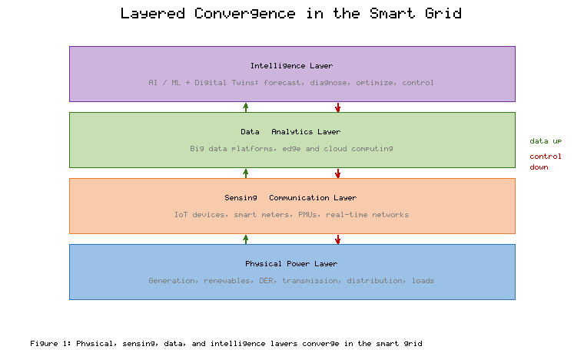
Figure 1. Layered Convergence of Physical Infrastructure, Sensing and Communication, and AI/Digital Twin Intelligence in the Smart Grid
The complexity that this modernization introduces manifests across several interrelated challenges that define the agenda for smart grid research and practice. Energy optimization becomes difficult as variable generation, flexible demand, and storage must be coordinated under uncertainty to minimize cost and emissions while maintaining reliability [6]. Fault diagnosis grows more complex as the number of components and the diversity of failure modes increase, and as distributed generation alters the fault behavior of distribution networks. Reliability and operational resilience demand the capacity to anticipate, withstand, and recover from disturbances ranging from equipment failures to extreme weather, while cybersecurity emerges as a paramount concern because the very connectivity that enables intelligence also expands the attack surface. Table 1 summarizes these complexity challenges, their principal drivers, and the technological capabilities that artificial intelligence and digital twins bring to bear on each.
[Insert Table 1 here]
Table 1. Complexity Challenges in Smart Grid Modernization and Enabling Capabilities
Challenge | Principal Driver | Consequence if Unaddressed | AI/Digital Twin Capability
Energy optimization | Variable generation, flexible demand | Higher cost, curtailment | Forecasting, adaptive control
Fault diagnosis | More components, distributed generation | Prolonged outages | Anomaly detection, localization
Reliability and resilience | Complexity, extreme events | Cascading failures | Predictive maintenance, simulation
Cybersecurity | Expanded connectivity | Compromised operation | Intrusion and anomaly detection
Operational resilience | Dynamic, uncertain conditions | Slow recovery | Self-healing, twin-based testing
The convergence of these technologies and challenges establishes the context for the remainder of the chapter, for it is precisely the complexity of the modernized grid that motivates the adoption of artificial intelligence and digital twins. Traditional methods, designed for a simpler and more predictable system, struggle to cope with the scale, variability, and interdependence of the contemporary grid, whereas data-driven and model-based intelligent methods are well matched to these conditions. The foundational paradigms of artificial intelligence, machine learning, and digital twins, examined in the next subsection, provide the conceptual and technical means by which the smart grid's complexity is rendered manageable and its potential realized.

2.2 AI, Machine Learning, and Digital Twin Paradigms
Artificial intelligence and machine learning provide the analytical foundation for intelligent grid operation, offering methods that learn from data rather than requiring explicit models of every phenomenon. Machine learning spans supervised methods that learn input-output mappings from labeled data, unsupervised methods that discover structure in unlabeled data, and reinforcement learning methods that learn control policies through interaction with an environment [7]. In power systems these methods address forecasting, fault detection, optimization, and control, exploiting the abundant data that sensing and metering generate. Deep learning, which employs neural networks with many layers to learn hierarchical representations, has proven especially powerful for the complex, high-dimensional patterns that characterize grid data, automatically extracting relevant features and achieving accuracy unattainable by earlier methods [8]. The maturation of these techniques, together with the growth of grid data and computational resources, has made artificial intelligence a practical and increasingly indispensable tool for power system engineering.
The digital twin represents a complementary paradigm that has risen to prominence as grids have become more instrumented and more complex. A digital twin is a virtual representation of a physical asset, process, or system that is continuously updated with data from its physical counterpart, enabling monitoring, analysis, simulation, and optimization throughout the system's life cycle [9]. The concept originated in manufacturing and aerospace but has been enthusiastically adopted in the energy sector, where the digital twin of a grid, substation, or individual asset provides a living model that mirrors the physical system's current state and can be used to predict its future behavior [10]. A digital twin's architecture typically comprises the physical entity, its virtual model, the data connection that synchronizes them, and the services—analytics, simulation, visualization—that exploit the twin for operational benefit. Figure 2 illustrates this architecture and the bidirectional flow of data and insight that distinguishes a true digital twin from a static model.
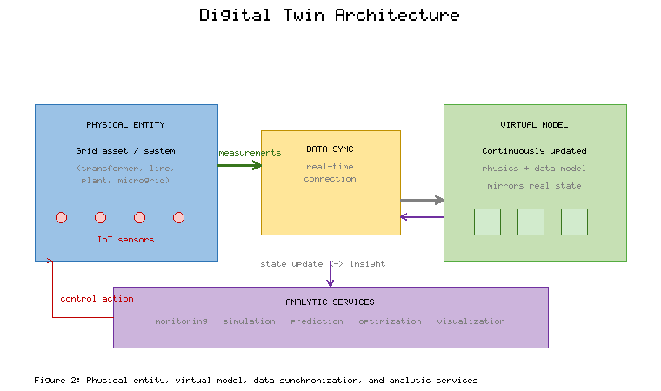
Figure 2. Digital Twin Architecture: Physical Entity, Virtual Model, Data Synchronization, and Analytic Services
Big data analytics and Internet-of-Things integration are the enabling substrate that makes both artificial intelligence and digital twins effective, because both depend on the continuous availability of high-quality data at scale. The grid generates data of enormous volume, velocity, and variety, from high-frequency phasor measurements to slower meter readings and equipment logs, and extracting value from this data requires analytic infrastructure capable of ingesting, storing, processing, and analyzing it in a timely manner [11]. The integration of Internet-of-Things devices supplies the data, while big data platforms and increasingly edge and cloud computing supply the capacity to process it, together enabling the autonomous, adaptive infrastructures toward which the smart grid is evolving [12]. This data-centric foundation is what allows the grid to move beyond passive monitoring toward the predictive, self-optimizing behavior that distinguishes a truly intelligent system.
The foundational frameworks that link artificial intelligence, digital twins, and predictive grid operation integrate these paradigms into a coherent operational architecture. In such frameworks, the digital twin provides a faithful, continuously updated model of the physical grid; artificial intelligence operates on the data streaming into the twin and on simulations run within it to forecast conditions, detect anomalies, and recommend or execute control actions; and the resulting decisions are applied to the physical system and reflected back into the twin, closing the loop [13]. This arrangement combines the strengths of model-based and data-driven approaches, with the twin supplying physical fidelity and the artificial intelligence supplying predictive and adaptive intelligence. The synergy is powerful precisely because each technology compensates for the other's limitations: the twin grounds the artificial intelligence in physical reality, while the artificial intelligence endows the twin with the capacity to predict and optimize, and it is this combination that underpins the fault-prediction and energy-optimization capabilities developed in the following sections.

3. AI-Enabled Fault Prediction and Predictive Maintenance

3.1 Machine Learning and Deep Learning for Fault Diagnosis
Fault prediction and diagnosis are among the most valuable applications of artificial intelligence in the smart grid, because the early and accurate identification of faults prevents outages, protects equipment, and maintains the reliability on which modern society depends. Machine learning approaches to fault diagnosis learn to distinguish normal from abnormal operation by training on historical data, enabling the detection of anomalies that signal developing or incipient faults [14]. Deep learning architectures have proven especially effective, with convolutional networks extracting spatial patterns from measurements and recurrent architectures capturing the temporal evolution of signals, allowing the detection of subtle anomalies that simpler methods would miss [15]. Anomaly detection, which identifies deviations from learned normal behavior without necessarily requiring labeled examples of every fault type, is particularly valuable in the grid context, where faults are rare and diverse and where labeled fault data are often scarce.
The localization of faults and the monitoring of equipment health extend anomaly detection toward actionable diagnosis, identifying not merely that a fault exists but where it is and what it portends. Fault localization techniques use the spatial distribution of measurements across the network, together with learned or physical models of fault propagation, to pinpoint the location of a fault so that it can be isolated and repaired quickly [16]. Equipment health monitoring tracks the condition of individual assets—transformers, cables, switchgear—through measurements and learned models of degradation, estimating remaining useful life and flagging assets at risk of failure [17]. These capabilities transform maintenance from a reactive or schedule-based activity into a condition-based, predictive one, in which interventions are targeted precisely where and when they are needed, reducing both unexpected failures and unnecessary maintenance.
Ensemble learning and explainable artificial intelligence address the twin requirements of accuracy and trustworthiness that fault prediction demands in a safety-critical context. Ensemble methods combine multiple models to achieve greater accuracy and robustness than any single model, averaging out individual errors and improving reliability in the presence of noisy or incomplete data [18]. Explainable artificial intelligence addresses the opacity of complex models, providing interpretable accounts of why a particular prediction or classification was made, which is essential when operators must act on a fault warning and must trust and verify the system's reasoning [19]. In the high-stakes setting of grid operation, a fault prediction that cannot be understood or justified is difficult to act upon with confidence, making explainability not a luxury but a practical requirement for the adoption of AI-driven diagnosis. Table 2 compares the principal machine learning approaches to fault diagnosis across the dimensions relevant to their selection and deployment.
[Insert Table 2 here]
Table 2. Machine Learning Approaches for Smart Grid Fault Diagnosis
Approach | Representative Methods | Strengths | Limitations | Typical Role
Classical ML | Support vector, decision tree | Interpretable, modest data needs | Manual features, limited nonlinearity | Baseline classification
Deep learning | CNN, LSTM, autoencoders | Learns features, high accuracy | Data-hungry, opaque | Complex anomaly detection
Unsupervised | Clustering, autoencoders | No labels required | Harder to validate | Novel-fault detection
Ensemble | Random forest, boosting | Robust, accurate | Complexity, tuning | Trustworthy prediction
Explainable AI | SHAP, attention, surrogates | Interpretable decisions | Added overhead | Operator trust, verification
Predictive maintenance strategies integrate these diagnostic capabilities into a systematic approach to managing grid assets and infrastructure over their life cycle. Predictive maintenance uses the outputs of anomaly detection, fault localization, and health monitoring to schedule interventions based on the actual condition and predicted future state of assets, rather than on fixed schedules or on failure after the fact [20]. This approach minimizes both the cost of maintenance and the risk of unexpected failure, optimizing the allocation of maintenance resources across a large and diverse asset base. The effectiveness of predictive maintenance depends on the accuracy of the underlying predictions and on the integration of those predictions into maintenance planning and operations, illustrating how the analytical capabilities of artificial intelligence must be embedded in operational processes to deliver value. This integration is greatly enhanced by the digital twin, which provides the continuously updated model of asset condition on which predictive maintenance depends.

3.2 Digital Twin-Driven Monitoring and System Reliability
Digital twins integrated with Internet-of-Things sensors provide the foundation for real-time monitoring that underpins reliable grid operation, creating a continuously updated virtual counterpart of the physical system. By streaming data from sensors distributed across the grid into the virtual model, a digital twin maintains an accurate representation of the current state of assets and the network, enabling operators to observe conditions that would otherwise be invisible and to detect developing problems early [21]. This real-time synchronization distinguishes the digital twin from static models and conventional monitoring, because the twin not only reflects the present state but, through the analytic and simulation services built upon it, can project that state forward to anticipate future conditions. The integration of sensing and virtual modeling thus transforms monitoring from a passive observation of the present into an active anticipation of the future.
Edge computing and cloud platforms provide the computational infrastructure that makes digital twin-driven monitoring feasible at the scale and speed the grid requires, distributing processing between the network edge and centralized data centers. Edge computing places computation close to the sensors and assets, enabling the low-latency processing that time-critical monitoring and control demand and reducing the volume of data that must be transmitted to central facilities [22]. Cloud platforms provide the abundant, elastic computational resources needed for training complex models, running large-scale simulations, and aggregating data across the system, complementing the edge in a tiered architecture that balances responsiveness against computational capacity [23]. This division of labor between edge and cloud is essential for digital twins of large grids, where the volume of data and the diversity of timescales preclude any single-tier solution and demand a thoughtfully partitioned architecture.
Grid stability and asset management benefit substantially from twin-based simulation, which allows operators to test scenarios and evaluate interventions in the virtual environment before acting on the physical system. By running simulations within the digital twin, operators can assess how the grid would respond to disturbances, how proposed control actions would perform, and how assets would degrade under various operating regimes, all without risk to the real system [24]. This capacity for risk-free experimentation supports both the maintenance of stability, by allowing control strategies to be validated before deployment, and the management of assets, by allowing maintenance and replacement decisions to be informed by simulated projections of future condition. As depicted in Figure 3, the digital twin-driven monitoring pipeline integrates sensing, edge and cloud computation, virtual modeling, and simulation to support real-time reliability and asset management.
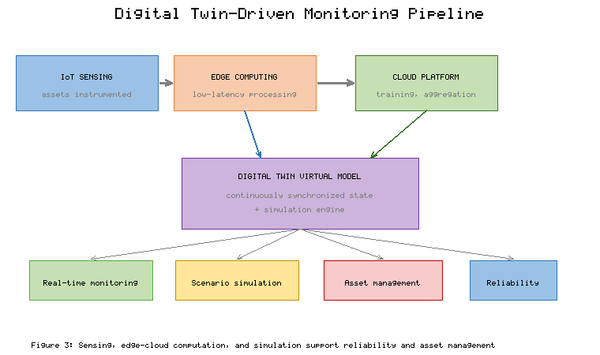
Figure 3. Digital Twin-Driven Monitoring Pipeline Integrating IoT Sensing, Edge-Cloud Computation, and Simulation for Reliability
The practical value of digital twin-driven monitoring is best appreciated through its application to equipment health assessment and failure prevention, where the combination of real-time data and predictive simulation yields concrete reliability benefits. In the assessment of equipment health, a digital twin of a critical asset such as a transformer integrates real-time measurements with models of thermal, electrical, and mechanical behavior to estimate the asset's condition and to predict its remaining useful life, enabling intervention before failure occurs [25]. In failure prevention more broadly, the twin's capacity to detect anomalies and simulate their consequences allows operators to anticipate and avert failures that would otherwise cascade into outages. Table 3 summarizes representative digital twin applications across grid domains, indicating the monitoring function, the reliability benefit, and the data and modeling requirements of each, and illustrating the breadth of the technology's utility.
[Insert Table 3 here]
Table 3. Representative Digital Twin Applications for Grid Monitoring and Reliability
Application Domain | Monitoring Function | Reliability Benefit | Key Requirement
Transformer health | Thermal and load state tracking | Remaining-life prediction | Thermal and aging models
Transmission lines | Dynamic rating, sag monitoring | Overload prevention | Weather and sensor fusion
Substation assets | Condition monitoring | Failure prevention | High-frequency sensing
Distribution networks | State estimation | Fault localization | Wide sensor coverage
Renewable plants | Performance monitoring | Degradation detection | Generation and weather data
The digital twin-driven monitoring and reliability capabilities developed here build directly upon the fault-prediction methods of the preceding subsection and provide the foundation for the energy-optimization applications that follow. The continuously updated virtual model, enriched by AI-driven analytics and supported by edge and cloud computation, serves not only reliability but also optimization, because the same twin that monitors asset health and predicts failures can also simulate operating strategies and support the optimization of energy flows. The integration of fault prediction, reliability, and optimization within a unified digital twin and artificial intelligence framework is the defining characteristic of the emerging smart grid, and it is to the optimization dimension of this framework that the chapter now turns.

4. Energy Optimization and Emerging Applications

4.1 AI-Driven Load Forecasting and Energy Management
Energy optimization in the smart grid rests upon accurate forecasting, and artificial intelligence has substantially improved the prediction of both demand and renewable generation. Load forecasting predicts future electricity consumption from historical load, calendar and weather information, and increasingly from the fine-grained data that smart meters provide, and deep learning methods have proven highly effective at capturing the complex patterns that load data exhibit [26]. Renewable energy prediction forecasts the output of variable solar and wind generation from meteorological and historical data, a task to which machine learning is well suited because of the nonlinear relationship between weather and power output [27]. Accurate forecasting of both demand and generation is the foundation of energy management, because nearly every optimization decision—how to dispatch resources, when to charge or discharge storage, how to deploy flexible demand—depends on anticipating future conditions, and the quality of these forecasts sets a ceiling on the quality of the decisions that follow.
Reinforcement learning has emerged as a powerful approach for adaptive energy optimization, because it learns control policies directly from interaction with the system rather than requiring an explicit model of every contingency. A reinforcement learning agent learns to select actions that maximize a cumulative reward through trial and error, making it well matched to the sequential decision problems that pervade energy management, such as the operation of storage, the coordination of flexible loads, and the control of distributed resources [28]. Deep reinforcement learning, which combines reinforcement learning with deep neural networks, has achieved notable results in energy applications, learning sophisticated strategies that adapt to changing conditions and that can outperform hand-designed control rules [29]. The capacity of reinforcement learning to learn and adapt without a complete system model is especially valuable in the complex, uncertain environment of the modern grid, though its deployment must address the challenges of ensuring safe exploration and reliable performance in a critical-infrastructure setting.
Demand-side management and operational efficiency improvements translate forecasting and optimization into concrete benefits, aligning consumption with the availability of clean, inexpensive energy. Demand-side management adjusts the timing and magnitude of electricity consumption in response to grid conditions, shifting flexible loads toward periods of abundant renewable generation and away from periods of scarcity, thereby improving efficiency and accommodating variability [30]. Artificial intelligence enhances demand-side management by forecasting both the availability of flexibility and the conditions that call for it, and by optimizing the dispatch of flexible loads to achieve grid objectives while respecting consumer constraints. The resulting improvements in operational efficiency—reduced peaks, lower costs, higher renewable utilization—illustrate how the analytical capabilities of artificial intelligence deliver value when embedded in the operational processes of the grid. Figure 4 illustrates the AI-driven energy management loop, in which forecasting, optimization, and control interact continuously to maintain efficiency and stability.
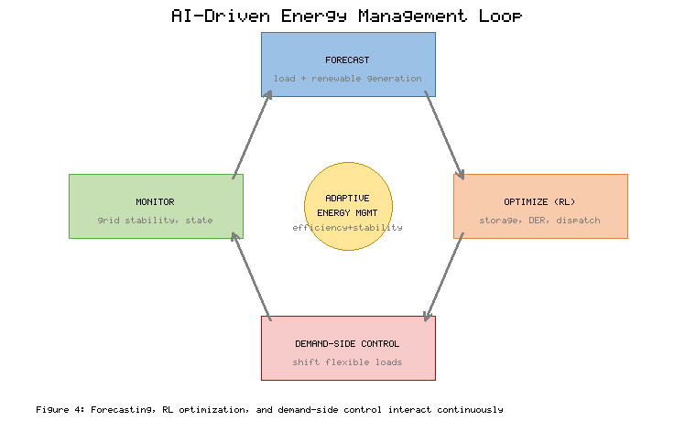
Figure 4. AI-Driven Energy Management Loop Coordinating Forecasting, Reinforcement-Learning Optimization, and Demand-Side Control
Real-time monitoring systems for grid stability enhancement complete the energy-management picture, providing the continuous awareness that allows the grid to maintain stability under the variable conditions that high renewable penetration creates. These systems integrate data from across the network to track the state of the grid in real time, detecting deviations that threaten stability and enabling rapid corrective action [31]. In a grid with reduced inertia and increased variability, the capacity to monitor stability continuously and to respond within the short timescales that stability demands is essential, and artificial intelligence contributes by detecting instability precursors and by supporting fast, automated control. The integration of real-time monitoring with forecasting and optimization creates a comprehensive energy-management capability that maintains both efficiency and stability, and this capability extends across the diverse domains of the smart grid examined in the following subsection.

4.2 Digital Twin Applications Across Smart Grid Domains
The digital twin finds application across the full range of smart grid domains, beginning with the photovoltaic and wind systems that supply variable renewable generation. Digital twins of photovoltaic systems integrate real-time measurements with models of panel behavior to monitor performance, detect faults and degradation, and optimize operation, enabling the early identification of underperforming or failing modules [32]. Digital twins of wind systems similarly combine sensor data with models of turbine behavior to monitor condition, predict maintenance needs, and optimize output, addressing the substantial maintenance challenges that wind turbines present, particularly in offshore installations [33]. In both cases, the twin's capacity to detect degradation and predict failures improves the availability and output of renewable assets, directly supporting the integration of variable generation that is central to the energy transition.
Battery energy storage systems and electric vehicles represent domains in which digital twins deliver particular value, because both involve complex electrochemical behavior and significant safety considerations. A digital twin of a battery storage system integrates measurements of voltage, current, and temperature with models of electrochemical behavior and degradation to estimate state of charge and state of health, optimize charging and discharging, and prevent the conditions that lead to failure or safety incidents [34]. For electric vehicles, which function both as mobile loads and as potential distributed storage resources, digital twins support the management of charging, the assessment of battery health, and the coordination of vehicle-to-grid interactions that can provide flexibility to the grid [35]. The management of these electrochemical systems through digital twins exemplifies the technology's capacity to combine real-time data with physical models to achieve both performance optimization and safety assurance.
Microgrids and distributed energy resource management constitute a domain in which the coordination challenges are especially acute and the digital twin especially valuable. A microgrid, a localized grid that can operate independently or in connection with the main grid, must coordinate diverse distributed resources—generation, storage, and flexible loads—to maintain balance and reliability, a task that a digital twin supports by providing a unified model of the microgrid's state and behavior [36]. Distributed energy resource management more broadly coordinates the many small resources connected throughout the distribution network, and digital twins enable this coordination by modeling the aggregate behavior of these resources and supporting the optimization of their operation [37]. As depicted in Figure 5, digital twins span the smart grid from generation through storage and electric vehicles to microgrids, providing a consistent modeling and optimization framework across these diverse domains.
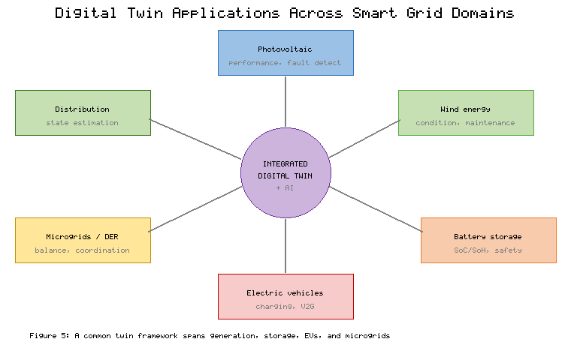
Figure 5. Digital Twin Applications Spanning Generation, Storage, Electric Vehicles, and Microgrids in the Smart Grid
The emerging trends in autonomous and predictive grid operations point toward a future in which these domain-specific digital twins are integrated into comprehensive, self-optimizing systems. The trajectory of development is toward grids that not only monitor and predict but also act autonomously, coordinating distributed resources, optimizing energy flows, and maintaining reliability with diminishing human intervention [38]. The integration of digital twins across domains, combined with the predictive and adaptive intelligence of artificial intelligence, enables this autonomous operation by providing both the comprehensive model and the decision-making capability that autonomy requires. Table 4 summarizes the digital twin applications across smart grid domains, indicating the optimization objective and the artificial intelligence methods most commonly employed in each, and illustrating the convergence toward integrated, autonomous operation that defines the emerging smart grid.
[Insert Table 4 here]
Table 4. Digital Twin Applications and AI Methods Across Smart Grid Domains
Domain | Optimization Objective | Common AI Methods | Emerging Capability
Photovoltaic systems | Performance, fault detection | Deep learning, regression | Degradation prediction
Wind energy | Output, maintenance | Recurrent networks, ensembles | Predictive maintenance
Battery storage | State estimation, longevity | Reinforcement learning | Safety-aware optimization
Electric vehicles | Charging, vehicle-to-grid | Reinforcement learning, forecasting | Coordinated flexibility
Microgrids and DER | Balance, coordination | Multi-agent, optimization | Autonomous operation

5. Challenges and Future Research Directions

5.1 Implementation Barriers and Critical Challenges
Despite the transformative potential of artificial intelligence and digital twins for smart grids, a set of critical challenges constrains their deployment and must be confronted honestly, beginning with cybersecurity threats and data privacy concerns. The connectivity and automation that enable intelligent operation also expand the attack surface and the potential consequences of compromise, because networked sensors, controllers, and data systems create many points of potential intrusion, and the reliance on data and automated decisions means that manipulated data or subverted models could cause incorrect and dangerous actions [39]. Data privacy adds a further dimension, since the fine-grained consumption data that smart meters generate reveal sensitive information about individuals and must be protected, and the collection and use of such data must respect privacy expectations and regulatory requirements [40]. Securing AI-driven and digital twin-based grids therefore requires attention to conventional cybersecurity, to the specific vulnerabilities of data-driven systems, and to the privacy of the data on which these systems depend.
Communication latency and interoperability issues present practical obstacles that can undermine even well-designed systems, because the value of real-time monitoring and control depends on the timely and reliable exchange of data. Many grid applications, particularly those involving protection and fast control, demand communication with very low latency, and the failure to meet these timing requirements can compromise stability and safety [41]. Interoperability compounds the challenge, since the smart grid integrates equipment and systems from many vendors, built to different standards and using different protocols, and the absence of seamless interoperability impedes the integration of data and the coordination of control across the heterogeneous infrastructure [42]. Achieving the low-latency, interoperable communication that intelligent grid operation requires demands both advances in communication technology and the adoption of common standards and interfaces across the industry.
Computational complexity and regulatory compliance constitute further barriers that shape what is feasible in practice. The most capable artificial intelligence methods and the most detailed digital twins can demand substantial computational resources for training, simulation, and real-time inference, posing challenges for deployment at the scale and speed that grid operation requires and motivating the edge-cloud architectures discussed earlier [43]. Regulatory compliance imposes its own constraints, because the power sector is heavily regulated and the introduction of artificial intelligence and automated decision-making raises questions of accountability, verification, and conformance with standards that regulators and operators must address before these technologies can be widely deployed in critical infrastructure. Table 5 organizes the principal implementation barriers, their consequences, and the mitigation strategies that current research and practice offer.
[Insert Table 5 here]
Table 5. Implementation Barriers for AI and Digital Twins in Smart Grids and Mitigation Strategies
Barrier | Primary Consequence | Contributing Factors | Mitigation Strategy
Cybersecurity and privacy | Compromised operation, data exposure | Expanded connectivity, sensitive data | Secure design, privacy preservation
Communication latency | Compromised real-time control | Bandwidth, network constraints | Edge computing, fast protocols
Interoperability | Impeded integration | Heterogeneous vendors, standards | Common standards, open interfaces
Computational complexity | Deployment and latency limits | Model and twin scale | Efficient models, edge-cloud tiers
Scalability and compliance | Limited real-world deployment | Grid scale, regulation | Modular design, regulatory engagement
Scalability and deployment constraints in real-world grids remind us that laboratory success does not guarantee practical impact, and that the transition from pilot to production is itself a substantial challenge. A method that performs well on historical data or in a small demonstration may not scale to the size, diversity, and dynamism of a real grid, and the integration of new technologies into existing infrastructure and operational practice introduces practical difficulties of cost, compatibility, and organizational change [44]. The gap between the demonstrated potential of artificial intelligence and digital twins and their widespread deployment reflects these real-world constraints, and bridging that gap requires not only technical advances but also attention to the economic, organizational, and institutional factors that govern adoption. A balanced assessment of the emerging trends must therefore temper enthusiasm for the technologies' potential with a realistic appreciation of the barriers that stand between potential and practice.

5.2 Future Perspectives for Next-Generation Smart Grids
The challenges identified above define the frontier of research, and several promising directions point toward the next generation of smart grids, foremost among them autonomous grid intelligence and self-healing infrastructures. Autonomous grid intelligence envisions grids that sense, decide, and act with increasing independence, coordinating vast numbers of distributed resources and maintaining reliability and efficiency with minimal human intervention as complexity grows beyond what human operators can manage directly [45]. Self-healing infrastructures extend this autonomy to the response to disturbances, enabling the grid to detect faults, isolate affected regions, and reconfigure itself to restore service automatically and rapidly, limiting the extent and duration of outages [46]. Realizing these capabilities safely requires addressing the trust, verification, and robustness concerns discussed earlier, so that autonomous systems can be relied upon in the operation of critical infrastructure, but the trajectory toward greater autonomy is clear and compelling.
Federated learning and physics-informed artificial intelligence represent two complementary approaches that address key limitations of current methods. Federated learning enables models to be trained collaboratively across many distributed data holders without the raw data ever leaving its source, allowing utilities, aggregators, and consumers to benefit from collective learning while preserving the privacy of sensitive data and respecting distributed ownership [47]. Physics-informed artificial intelligence embeds physical laws and domain knowledge into machine learning models, so that predictions respect known relationships and remain reliable even in conditions not well represented in training data, mitigating the data-quality and generalization concerns that constrain purely empirical methods [48]. Together, these approaches point toward a future in which artificial intelligence is both more privacy-preserving and more physically grounded, combining the strengths of distributed learning and mechanistic understanding to produce trustworthy and robust grid intelligence.
Quantum-inspired optimization techniques constitute a more speculative but potentially transformative direction, offering new approaches to the complex optimization problems that pervade grid operation. The scheduling, dispatch, and coordination problems of the smart grid are often computationally hard, and quantum computing, together with quantum-inspired algorithms that run on classical hardware, promises new means of attacking these problems that may eventually outperform conventional methods for certain classes of problem [49]. While practical quantum advantage for grid optimization remains a prospect rather than a present reality, the exploration of quantum and quantum-inspired techniques reflects the field's search for computational approaches equal to the scale and complexity of future grids, and it represents a frontier worth monitoring as both the technology and its application mature.
The ultimate aspiration uniting these research directions is the creation of resilient energy infrastructures that support sustainable energy transitions, integrating the advances in autonomy, learning, and optimization into grids that are simultaneously clean, reliable, and robust. Resilience—the capacity to anticipate, withstand, and recover from disturbances—is increasingly central as grids confront the twin pressures of decarbonization and the growing threats of extreme weather and cyberattack [50]. The fusion of artificial intelligence and digital twins contributes to resilience by enabling prediction, rapid response, and self-healing, and it contributes to sustainability by enabling the efficient integration of renewable generation and the optimization of energy use. In advancing these intertwined goals of resilience and sustainability, the emerging trends surveyed in this chapter point toward an energy system capable of supporting the transition to a low-carbon future while maintaining the reliability on which society depends.

6. Conclusion
The convergence of artificial intelligence and digital twin technologies marks a decisive turning point in the evolution of electrical power systems, enabling a grid that is predictive, adaptive, and resilient rather than reactive and static. This chapter has surveyed the emerging trends and future perspectives that define this transformation, tracing the arc from the foundations of smart grid modernization, through AI-enabled fault prediction and digital twin-driven monitoring, to energy optimization and the diverse applications of digital twins across the modern grid. The analysis has shown that the complexity introduced by renewable integration, distributed resources, and pervasive sensing, far from defeating intelligent methods, is precisely the condition that makes the fusion of artificial intelligence and digital twins so valuable, with the twin supplying a faithful model of physical reality and the artificial intelligence supplying the predictive and decision-making intelligence that operates upon it.
The chapter has emphasized that fault prediction and energy optimization, though often treated separately, are unified within the emerging digital twin and artificial intelligence framework, because the same continuously updated virtual model that detects anomalies and predicts failures also simulates operating strategies and optimizes energy flows. Deep learning for fault diagnosis, ensemble and explainable methods for trustworthy prediction, reinforcement learning for adaptive optimization, and digital twins spanning photovoltaic systems, wind energy, storage, electric vehicles, and microgrids together constitute a comprehensive capability for intelligent grid operation. This capability, supported by the sensing, communication, and edge-cloud computational infrastructure of the modern grid, enables the predictive, adaptive, and increasingly autonomous behavior that distinguishes the next-generation smart grid from its predecessors.
At the same time, the chapter has insisted on a balanced perspective that acknowledges the barriers of cybersecurity, latency, interoperability, computational complexity, and scalability that stand between the demonstrated potential of these technologies and their widespread deployment. The future directions of autonomous self-healing grids, federated and physics-informed learning, and quantum-inspired optimization chart a path toward grids that are simultaneously more capable, more trustworthy, and more robust. The ultimate purpose of these advances is the creation of resilient energy infrastructures that support a sustainable energy transition, integrating clean generation efficiently while maintaining the reliability on which society depends. In enabling this future, the fusion of artificial intelligence and digital twins does not merely improve the grid but helps to make possible the transformation of the energy system that a low-carbon, resilient future requires.

References
[1] Fang, X., Misra, S., Xue, G., & Yang, D. (2012). Smart grid—The new and improved power grid: A survey. IEEE Communications Surveys & Tutorials, 14(4), 944–980.
[2] Gungor, V. C., Sahin, D., Kocak, T., Ergut, S., Buccella, C., Cecati, C., & Hancke, G. P. (2011). Smart grid technologies: Communication technologies and standards. IEEE Transactions on Industrial Informatics, 7(4), 529–539.
[3] Akorede, M. F., Hizam, H., & Pouresmaeil, E. (2010). Distributed energy resources and benefits to the environment. Renewable and Sustainable Energy Reviews, 14(2), 724–734.
[4] De La Ree, J., Centeno, V., Thorp, J. S., & Phadke, A. G. (2010). Synchronized phasor measurement applications in power systems. IEEE Transactions on Smart Grid, 1(1), 20–27.
[5] Al-Fuqaha, A., Guizani, M., Mohammadi, M., Aledhari, M., & Ayyash, M. (2015). Internet of Things: A survey on enabling technologies, protocols, and applications. IEEE Communications Surveys & Tutorials, 17(4), 2347–2376.
[6] Lund, P. D., Lindgren, J., Mikkola, J., & Salpakari, J. (2015). Review of energy system flexibility measures to enable high levels of variable renewable electricity. Renewable and Sustainable Energy Reviews, 45, 785–807.
[7] Jordan, M. I., & Mitchell, T. M. (2015). Machine learning: Trends, perspectives, and prospects. Science, 349(6245), 255–260.
[8] LeCun, Y., Bengio, Y., & Hinton, G. (2015). Deep learning. Nature, 521(7553), 436–444.
[9] Tao, F., Zhang, H., Liu, A., & Nee, A. Y. C. (2019). Digital twin in industry: State-of-the-art. IEEE Transactions on Industrial Informatics, 15(4), 2405–2415.
[10] Jafari, M., Kavousi-Fard, A., Chen, T., & Karimi, M. (2023). A review on digital twin technology in smart grid, transportation system and smart city: Challenges and future. IEEE Access, 11, 17471–17484.
[11] Zhou, K., Fu, C., & Yang, S. (2016). Big data driven smart energy management: From big data to big insights. Renewable and Sustainable Energy Reviews, 56, 215–225.
[12] Marinakis, V. (2020). Big data for energy management and energy-efficient buildings. Energies, 13(7), 1555.
[13] Song, Y., Zhao, G., Zhang, B., Chen, H., Deng, W., & Deng, W. (2023). An enhanced distributed differential evolution algorithm for smart grid digital twin. Expert Systems with Applications, 213, 118968.
[14] Hink, R. C. B., Beaver, J. M., Buckner, M. A., Morris, T., Adhikari, U., & Pan, S. (2014). Machine learning for power system disturbance and cyber-attack discrimination. In 2014 7th International Symposium on Resilient Control Systems (ISRCS) (pp. 1–8). IEEE.
[15] Chen, K., Hu, J., Zhang, Y., Yu, Z., & He, J. (2020). Fault location in power distribution systems via deep graph convolutional networks. IEEE Journal on Selected Areas in Communications, 38(1), 119–131.
[16] Dashti, R., Daisy, M., Mirshekali, H., Shaker, H. R., & Aliabadi, M. H. (2021). A survey of fault prediction and location methods in electrical energy distribution networks. Measurement, 184, 109947.
[17] Zhang, W., Yang, D., & Wang, H. (2019). Data-driven methods for predictive maintenance of industrial equipment: A survey. IEEE Systems Journal, 13(3), 2213–2227.
[18] Sagi, O., & Rokach, L. (2018). Ensemble learning: A survey. Wiley Interdisciplinary Reviews: Data Mining and Knowledge Discovery, 8(4), e1249.
[19] Machlev, R., Heistrene, L., Perl, M., Levy, K. Y., Belikov, J., Mannor, S., & Levron, Y. (2022). Explainable artificial intelligence (XAI) techniques for energy and power systems: Review, challenges and opportunities. Energy and AI, 9, 100169.
[20] Carvalho, T. P., Soares, F. A. A. M. N., Vita, R., Francisco, R. da P., Basto, J. P., & Alcalá, S. G. S. (2019). A systematic literature review of machine learning methods applied to predictive maintenance. Computers & Industrial Engineering, 137, 106024.
[21] Fuller, A., Fan, Z., Day, C., & Barlow, C. (2020). Digital twin: Enabling technologies, challenges and open research. IEEE Access, 8, 108952–108971.
[22] Shi, W., Cao, J., Zhang, Q., Li, Y., & Xu, L. (2016). Edge computing: Vision and challenges. IEEE Internet of Things Journal, 3(5), 637–646.
[23] Bera, S., Misra, S., & Rodrigues, J. J. P. C. (2015). Cloud computing applications for smart grid: A survey. IEEE Transactions on Parallel and Distributed Systems, 26(5), 1477–1494.
[24] Zhou, M., Yan, J., & Feng, D. (2019). Digital twin framework and its application to power grid online analysis. CSEE Journal of Power and Energy Systems, 5(3), 391–398.
[25] Moutis, P., & Alizadeh-Mousavi, O. (2021). Digital twin of distribution power transformer for real-time monitoring of medium voltage from low voltage measurements. IEEE Transactions on Power Delivery, 36(4), 1952–1963.
[26] Kong, W., Dong, Z. Y., Jia, Y., Hill, D. J., Xu, Y., & Zhang, Y. (2019). Short-term residential load forecasting based on LSTM recurrent neural network. IEEE Transactions on Smart Grid, 10(1), 841–851.
[27] Wang, H., Lei, Z., Zhang, X., Zhou, B., & Peng, J. (2019). A review of deep learning for renewable energy forecasting. Energy Conversion and Management, 198, 111799.
[28] Sutton, R. S., & Barto, A. G. (2018). Reinforcement learning: An introduction (2nd ed.). MIT Press.
[29] Mocanu, E., Mocanu, D. C., Nguyen, P. H., Liotta, A., Webber, M. E., Gibescu, M., & Slootweg, J. G. (2019). On-line building energy optimization using deep reinforcement learning. IEEE Transactions on Smart Grid, 10(4), 3698–3708.
[30] Siano, P. (2014). Demand response and smart grids—A survey. Renewable and Sustainable Energy Reviews, 30, 461–478.
[31] Panteli, M., & Mancarella, P. (2015). The grid: Stronger, bigger, smarter? Presenting a conceptual framework of power system resilience. IEEE Power and Energy Magazine, 13(3), 58–66.
[32] Jain, P., Poon, J., Singh, J. P., Spanos, C., Sanders, S. R., & Panda, S. K. (2020). A digital twin approach for fault diagnosis in distributed photovoltaic systems. IEEE Transactions on Power Electronics, 35(1), 940–956.
[33] Wang, M., Wang, C., Hnydiuk-Stefan, A., Feng, S., Atilla, I., & Wang, Z. (2021). Recent progress on reliability analysis of offshore wind turbine support structures considering digital twin solutions. Ocean Engineering, 232, 109168.
[34] Li, W., Rentemeister, M., Badeda, J., Jöst, D., Schulte, D., & Sauer, D. U. (2020). Digital twin for battery systems: Cloud battery management system with online state-of-charge and state-of-health estimation. Journal of Energy Storage, 30, 101557.
[35] Bhatti, G., Mohan, H., & Singh, R. R. (2021). Towards the future of smart electric vehicles: Digital twin technology. Renewable and Sustainable Energy Reviews, 141, 110801.
[36] Hirsch, A., Parag, Y., & Guerrero, J. (2018). Microgrids: A review of technologies, key drivers, and outstanding issues. Renewable and Sustainable Energy Reviews, 90, 402–411.
[37] Zia, M. F., Elbouchikhi, E., & Benbouzid, M. (2018). Microgrids energy management systems: A critical review on methods, solutions, and prospects. Applied Energy, 222, 1033–1055.
[38] Kezunovic, M., Pinson, P., Obradovic, Z., Grijalva, S., Hong, T., & Bessa, R. (2020). Big data analytics for future electricity grids. Electric Power Systems Research, 189, 106788.
[39] Sun, C. C., Hahn, A., & Liu, C. C. (2018). Cyber security of a power grid: State-of-the-art. International Journal of Electrical Power & Energy Systems, 99, 45–56.
[40] McDaniel, P., & McLaughlin, S. (2009). Security and privacy challenges in the smart grid. IEEE Security & Privacy, 7(3), 75–77.
[41] Kuzlu, M., Pipattanasomporn, M., & Rahman, S. (2014). Communication network requirements for major smart grid applications in HAN, NAN and WAN. Computer Networks, 67, 74–88.
[42] Greer, C., Wollman, D. A., Prochaska, D. E., Boynton, P. A., Mazer, J. A., Nguyen, C. T., ... & Fitzpatrick, G. J. (2014). NIST framework and roadmap for smart grid interoperability standards, release 3.0. National Institute of Standards and Technology.
[43] Ibrahim, M. S., Dong, W., & Yang, Q. (2020). Machine learning driven smart electric power systems: Current trends and new perspectives. Applied Energy, 272, 115237.
[44] Dileep, G. (2020). A survey on smart grid technologies and applications. Renewable Energy, 146, 2589–2625.
[45] Kabalci, Y., & Kabalci, E. (2019). Smart grids and their communication systems. Springer.
[46] Amin, S. M., & Wollenberg, B. F. (2005). Toward a smart grid: Power delivery for the 21st century. IEEE Power and Energy Magazine, 3(5), 34–41.
[47] McMahan, B., Moore, E., Ramage, D., Hampson, S., & Arcas, B. A. (2017). Communication-efficient learning of deep networks from decentralized data. In Proceedings of the 20th International Conference on Artificial Intelligence and Statistics (pp. 1273–1282).
[48] Huang, B., & Wang, J. (2023). Applications of physics-informed neural networks in power systems: A review. IEEE Transactions on Power Systems, 38(1), 572–588.
[49] Ajagekar, A., & You, F. (2019). Quantum computing for energy systems optimization: Challenges and opportunities. Energy, 179, 76–89.
[50] Panteli, M., Mancarella, P., Trakas, D. N., Kyriakides, E., & Hatziargyriou, N. D. (2017). Metrics and quantification of operational and infrastructure resilience in power systems. IEEE Transactions on Power Systems, 32(6), 4732–4742.
Note: This chapter contains 50 unique references cited throughout the text.

