Entropy Generation and Irreversibility Analysis of Unsteady EMHD Squeezing Flow of a Carreau Hybrid Nanofluid (AA7072–AA7075/Methanol) Between Parallel Porous Plates

Abstract
The second-law behaviour of unsteady, two-dimensional, electro-magnetohydrodynamic (EMHD) squeezing flow of a Carreau hybrid nanofluid confined between two parallel porous plates is investigated mathematically and numerically. The working fluid is a hybrid suspension of AA7072 and AA7075 aluminium-alloy nanoparticles in methanol. The model incorporates a transverse time-dependent magnetic field, an aligned electric field, Darcy–Forchheimer porous drag, nonlinear thermal radiation, viscous dissipation, Joule heating, Soret–Dufour cross-diffusion and a first-order homogeneous chemical reaction, together with velocity, thermal (Biot-type) and solutal slip boundary conditions. Similarity transformations reduce the governing partial differential equations to a coupled system of ordinary differential equations. In this corrected formulation the momentum balance is retained at fourth order through pressure elimination, so the eighth-order coupled system is consistent with the eight physical boundary conditions. The system is solved with the MATLAB collocation solver bvp4c. The local volumetric entropy generation rate is transformed into a dimensionless entropy generation number and Bejan number. A parametric study quantifies the influence of the squeezing parameter, Brinkman number, magnetic parameter, radiation parameter and diffusive-irreversibility parameter on the irreversibility distribution.
Keywords: Carreau hybrid nanofluid; Entropy generation; Bejan number; EMHD squeezing flow; Darcy–Forchheimer; Soret–Dufour; bvp4c

1. Introduction
Intensification of convective heat transfer drives the development of compact, high-performance thermal-management devices. The low intrinsic conductivity of conventional coolants motivated the nanofluid concept of Choi and Eastman [1], and its hybrid extension in which two chemically distinct nanoparticles are co-dispersed [4, 5]. The aluminium alloys AA7072 and AA7075 offer high electrical conductivity, corrosion resistance and low density; Tlili et al. [8] reported significant heat-transfer enhancement for AA7072–AA7075/methanol suspensions.
Many industrial suspensions are non-Newtonian. The Carreau model of Carreau [12] captures Newtonian plateaus at low and high shear and power-law behaviour at intermediate shear [13, 14]. Squeezing flows between approaching surfaces arise in lubrication, squeeze-film dampers and hydraulic machinery [18, 19]. Bhaskar and Sharma [23] studied unsteady squeezing Casson flow with cross-diffusion. The present work extends this squeezing-channel configuration to a Carreau hybrid nanofluid with a complete second-law treatment, including Soret–Dufour cross-diffusion, nonlinear radiation, Joule heating and multi-mode slip in a Darcy–Forchheimer porous channel [24–43].
This revised manuscript corrects the transformed momentum equation and its boundary-condition count, rederives the radiative grouping in the energy equation, and makes the entropy-generation normalisation consistent, as detailed below.

2. Mathematical Formulation

2.1 Physical configuration and assumptions
The plates are separated by the time-dependent distance$h\left(t\right)={\left[\frac{ν_{f}\left(1−γt\right)}{a}\right]}^{\frac{1}{2}}$
$h\left(t\right)={\left[\frac{ν_{f}\left(1−γt\right)}{a}\right]}^{\frac{1}{2}}$ (1)
The lower plate is stretched with velocity Uₑ(x, t) = ax/(1−γt); the upper plate moves normally with the squeezing velocity vₕ = dh/dt = −(γ/2)[νₑ/(a(1−γt))]^{1/2}, which gives f(1) = Sq/2. A time-dependent transverse magnetic field is applied in the +y direction and an aligned electric field in the +z direction (the Lorentz body force then acts along x and reduces to σ(uB − E)):
$B\left(t\right)=\frac{B_{0}}{{\left(1−γt\right)}^{\frac{1}{2}}}$ (2)
For the electric parameter Ee = E₀/(B₀Uₑ) to remain constant under the similarity transformation, the electric field must scale as B(t)Uₑ(t). Since B ~ (1−γt)^{−1/2} and Uₑ ~ (1−γt)^{−1}, the required scaling is
$E\left(t\right)=\frac{E_{0}}{{\left(1−γt\right)}^{\frac{3}{2}}}$ (3)
where E₀ and B₀ are the reference field strengths and Uₑ is the local wall (reference) velocity; Ee is thus constant under local similarity.

2.2 Carreau hybrid nanofluid constitutive model
The total Cauchy stress tensor is written in bold as σ (with A₁ = ∇V + (∇V)ᵀ the first Rivlin–Ericksen tensor). To avoid clashing with the electrical conductivity, the latter is denoted σₑ (i.e. σₑ,hnf, σₑ,f) throughout:
$σ=−pI+μ\left(γ̇\right)A_{1}$ (4)
with the shear-dependent (Carreau) viscosity
$μ\left(γ̇\right)=μ_{∞}+\left(μ_{0}−μ_{∞}\right){\left[1+{\left(Γγ̇\right)}^{2}\right]}^{\frac{n−1}{2}}$ (5)
and the scalar shear rate
$γ̇=\sqrt{\frac{1}{2}tr\left({A^{2}}_{1}\right)}$ (6)
Adopting μ∞ → 0 gives the limiting form
$μ\left(γ̇\right)=μ_{0}{\left[1+{\left(Γγ̇\right)}^{2}\right]}^{\frac{n−1}{2}}$ (7)
with the zero-shear-rate viscosity identified as the hybrid-nanofluid viscosity, μ₀ = μₕₙₓ (Eq. 14), so that αμ = μₕₙₓ/μₑ and the Carreau viscosity are consistently connected. In the shear-dominated boundary layer γ̇ ≃ |∂u/∂y|.

2.3 Governing equations
Under the boundary-layer approximation for the narrow gap, mass, momentum, energy and species conservation give:
$\frac{∂u}{∂x}+\frac{∂v}{∂y}=0$ (8)
$\frac{∂u}{∂t}+u\frac{∂u}{∂x}+v\frac{∂u}{∂y}=\frac{1}{ρ_{hnf}}\frac{∂}{∂y}\left[μ_{hnf}{\left(1+Γ^{2}{\left(\frac{∂u}{∂y}\right)}^{2}\right)}^{\frac{n−1}{2}}\frac{∂u}{∂y}\right]+\frac{σ_{e,hnf}}{ρ_{hnf}}\left(uB\left(t\right)−E\left(t\right)\right)−\frac{μ_{hnf}}{ρ_{hnf}}\frac{u}{{K^{*}}_{p}}−\frac{C_{b}}{\sqrt{{K^{*}}_{p}}}u^{2}$ (9)
The viscous term is the divergence of the Carreau shear stress; carrying out the differentiation gives the equivalent form
$\frac{μ_{hnf}}{ρ_{hnf}}{\left(1+Γ^{2}{\left(\frac{∂u}{∂y}\right)}^{2}\right)}^{\frac{n−3}{2}}\left(1+nΓ^{2}{\left(\frac{∂u}{∂y}\right)}^{2}\right)\frac{∂^{2}u}{∂y^{2}}$ (10)
in which the factor (1 + nΓ²uᵧ²) is essential and is retained throughout. Here σₑ,hnf is the effective electrical conductivity, Kₚ* the permeability and Cᵇ the Forchheimer drag coefficient.
$\frac{∂v}{∂t}+u\frac{∂v}{∂x}+v\frac{∂v}{∂y}=−\frac{1}{ρ_{hnf}}\frac{∂p}{∂y}+\frac{μ_{hnf}}{ρ_{hnf}}\frac{∂^{2}v}{∂y^{2}}$ (11)
The pressure is eliminated between the complete x- and y-momentum equations (not a reduced version): ∂p/∂y from this equation is cross-differentiated with the x-momentum balance so that the pressure-gradient constant G in Eq. (26) is removed consistently, yielding the fourth-order momentum equation (27).
$\frac{∂T}{∂t}+u\frac{∂T}{∂x}+v\frac{∂T}{∂y}=\frac{κ_{hnf}}{\left(ρc_{p}\right){}_{hnf}}\frac{∂^{2}T}{∂y^{2}}−\frac{1}{\left(ρc_{p}\right){}_{hnf}}\frac{∂q_{r}}{∂y}+\frac{D_{B}K_{T}}{c_{s}\left(ρc_{p}\right){}_{hnf}}\frac{∂^{2}C}{∂y^{2}}+⋯$ (12)
where the viscous-dissipation and Joule terms complete the right-hand side. The Dufour (diffusion-thermo) coefficient uses the concentration susceptibility cₛ; throughout this work cₛ ≡ Tₘ (the mean fluid temperature), so the Dufour and Soret definitions in Eqs. (34)–(35) are dimensionally consistent with the cross-diffusion terms in Eqs. (10)–(11).
$\frac{∂C}{∂t}+u\frac{∂C}{∂x}+v\frac{∂C}{∂y}=D_{B}\frac{∂^{2}C}{∂y^{2}}+\frac{D_{B}K_{T}}{T_{m}}\frac{∂^{2}T}{∂y^{2}}−k_{1}\left(C−C_{h}\right)$ (13)

2.4 Nonlinear thermal radiation
$q_{r}=−\frac{16σ^{*}}{3k^{*}}T^{3}\frac{∂T}{∂y}$ (14)
$\frac{∂q_{r}}{∂y}=−\frac{16σ^{*}}{3k^{*}}\left[3T^{2}{\left(\frac{∂T}{∂y}\right)}^{2}+T^{3}\frac{∂^{2}T}{∂y^{2}}\right]$ (15)
with T = T₀[1 + (θᵣ − 1)θ].

2.5 Thermophysical properties of the hybrid nanofluid
$μ_{hnf}=\frac{μ_{f}}{{\left(1−φ_{1}\right)}^{2.5}{\left(1−φ_{2}\right)}^{2.5}}$ (16)
$ρ_{hnf}=\left(1−φ_{2}\right)\left[\left(1−φ_{1}\right)ρ_{f}+φ_{1}ρ_{s1}\right]+φ_{2}ρ_{s2}$ (17)
$\left(ρc_{p}\right){}_{hnf}=\left(1−φ_{2}\right)\left[\left(1−φ_{1}\right)\left(ρc_{p}\right){}_{f}+φ_{1}\left(ρc_{p}\right){}_{s1}\right]+φ_{2}\left(ρc_{p}\right){}_{s2}$ (18)
$\frac{κ_{bf}}{κ_{f}}=\frac{κ_{s1}+2κ_{f}−2φ_{1}\left(κ_{f}−κ_{s1}\right)}{κ_{s1}+2κ_{f}+φ_{1}\left(κ_{f}−κ_{s1}\right)}$ (19)
$\frac{κ_{hnf}}{κ_{bf}}=\frac{κ_{s2}+2κ_{bf}−2φ_{2}\left(κ_{bf}−κ_{s2}\right)}{κ_{s2}+2κ_{bf}+φ_{2}\left(κ_{bf}−κ_{s2}\right)}$ (20)
The electrical conductivity uses the analogous two-step Maxwell–Garnett relations (Eqs. 19–20), and νₕₙₓ = μₕₙₓ/ρₕₙₓ (Eq. 21).
$σ_{bf}{}_{}=σ_{f}\left(1+\frac{3\left(\frac{σ_{s1}}{σ_{f}}−1\right)φ_{1}}{\left(\frac{σ_{s1}}{σ_{f}}+2\right)−\left(\frac{σ_{s1}}{σ_{f}}−1\right)φ_{1}}\right)$ (21)
$σ_{hnf}=σ_{bf}\left(1+\frac{3\left(\frac{σ_{s2}}{σ_{bf}}−1\right)φ_{2}}{\left(\frac{σ_{s2}}{σ_{bf}}+2\right)−\left(\frac{σ_{s2}}{σ_{bf}}−1\right)φ_{2}}\right)$ (22)
$ν_{hnf}=\frac{μ_{hnf}}{ρ_{hnf}}$ (23)

2.6 Similarity transformation
$η=\frac{y}{h\left(t\right)} , ψ={\left[\frac{aν_{f}}{1−γt}\right]}^{\frac{1}{2}}xf\left(η\right)$ (24)
$u=\frac{ax}{1−γt}f′ , v=−{\left[\frac{aν_{f}}{1−γt}\right]}^{\frac{1}{2}}f\left(η\right)$ (25)
$θ\left(η\right)=\frac{T−T_{0}}{T_{w}−T_{0}} , φ\left(η\right)=\frac{C−C_{0}}{C_{w}−C_{0}}$ (26)
The temperature and concentration are normalised with the reference values T₀ and C₀, with Tₕ and Cₕ the wall (convective/reference) values. The upper-wall values coincide with the references, Tₕₒₚ = T₀ and Cₕₒₚ = C₀ (equivalently T_h = T₀, C_h = C₀), so that θ(1) = φ(1) = 0; this normalisation is what makes the lower-wall convective and solutal-slip conditions in Eq. (31) consistent. The stream function satisfies continuity identically (u = ∂ψ/∂y, v = −∂ψ/∂x). The x- and time-dependent wall excesses are
$T_{w}=T_{0}+\frac{ax}{1−γt}d_{1} , C_{w}=C_{0}+\frac{ax}{1−γt}e_{1}$ (27)
where d₁ and e₁ carry the appropriate temperature and concentration scaling units.

2.7 Dimensionless ordinary differential equations (corrected)
Substituting Eqs. (22)–(25) and the corrected unsteady group Sq(f′ + (η/2)f″), then eliminating pressure by cross-differentiating the momentum equations, yields a fourth-order momentum equation. Its primitive (third-order) form is
$\frac{α_{μ}}{α_{ρ}}{\left[1+{We}^{2}{\left(f′′\right)}^{2}\right]}^{\frac{n−3}{2}}\left[1+n{We}^{2}{\left(f′′\right)}^{2}\right]f′′′+ff′′−{\left(f′\right)}^{2}−Sq\left(f′+\frac{η}{2}f′′\right)−\frac{α_{μ}}{α_{ρ}Da}f′−\frac{α_{σ}}{α_{ρ}}M\left(f′−Ee\right)−Fr{\left(f′\right)}^{2}=G$ (28)
where G is the (η-independent) scaled pressure-gradient constant. Differentiating Eq. (26) once with respect to η removes G and gives the fourth-order momentum equation actually solved:
$\frac{α_{μ}}{α_{ρ}}\frac{d}{dη}\left[{\left[1+{We}^{2}{\left(f′′\right)}^{2}\right]}^{\frac{n−3}{2}}\left[1+n{We}^{2}{\left(f′′\right)}^{2}\right]f′′′\right]+ff′′′−f′f′′−Sq\left(\frac{3}{2}f′′+\frac{η}{2}f′′′\right)−\frac{α_{μ}}{α_{ρ}Da}f′′−\frac{α_{σ}}{α_{ρ}}Mf′′−2Frf′f′′=0$ (29)
The corrected energy equation groups conduction and radiation consistently (ακ multiplies conduction only, because Rd is defined with the base-fluid conductivity κₑ):
$\left[α_{κ}+\frac{4}{3}Rd{1+\left(θ_{r}−1\right)θ}^{3}\right]θ′′+4Rd\left(θ_{r}−1\right){1+\left(θ_{r}−1\right)θ}^{2}{\left(θ′\right)}^{2}+α_{c}Pr\left(fθ′−\frac{Sq}{2}ηθ′\right)+Pr\left[α_{μ}Ec{\left(f′′\right)}^{2}{\left(1+{We}^{2}{\left(f′′\right)}^{2}\right)}^{\frac{n−1}{2}}+α_{σ}MEc{\left(f′−Ee\right)}^{2}+α_{ρ}Dfφ′′\right]=0$ (30)
and the concentration equation is
$φ′′+Sc\left(fφ′−\frac{Sq}{2}ηφ′\right)+ScSrθ′′−KScφ=0$ (31)
The dimensionless thermophysical property ratios are denoted with α (to avoid any collision with the Rivlin–Ericksen tensor A₁):
$α_{μ}=\frac{μ_{hnf}}{μ_{f}}, α_{ρ}=\frac{ρ_{hnf}}{ρ_{f}}, α_{σ}=\frac{σ_{e,hnf}}{σ_{e,f}}, α_{κ}=\frac{κ_{hnf}}{κ_{f}}, α_{c}=\frac{\left(ρc_{p}\right){}_{hnf}}{\left(ρc_{p}\right){}_{f}}$ (32)

2.8 Boundary conditions (corrected: four momentum conditions)
Because the momentum equation is now fourth order, four momentum conditions are appropriate. With energy (second order) and species (second order) the total system order is eight, matching the eight boundary conditions:
$f\left(0\right)=0 , f′(0)=1+S_{1}f′′(0) , f\left(1\right)=\frac{Sq}{2} , f′(1)=0$ (33)
$θ′(0)=−Bi\left[1−θ(0)\right] , θ(1)=0 , φ(0)=1+S_{3}φ′(0) , φ(1)=0$ (34)
where S₁ and S₃ are the velocity and solutal slip parameters and Bi is the Biot number. This resolves the earlier over-specification (four momentum conditions on a third-order equation).

2.9 Dimensionless parameters
$Sq=\frac{γ}{a} , {We}^{2}=\frac{a^{3}Γ^{2}x^{2}}{ν_{f}{\left(1−γt\right)}^{3}} , M=\frac{σ_{f}{B_{0}}^{2}}{aρ_{f}} , Ee=\frac{E_{0}}{B_{0}U_{w}}$ (35)
$Da=\frac{{K^{*}}_{p}a}{ν_{f}\left(1−γt\right)} , Fr=\frac{C_{b}x}{\sqrt{{K^{*}}_{p}}} , Pr=\frac{μ_{f}{\left(c_{p}\right)}_{f}}{κ_{f}} , Rd=\frac{4σ^{*}{T^{3}}_{0}}{k^{*}κ_{f}}$ (36)
$Ec=\frac{{U^{2}}_{w}}{{\left(c_{p}\right)}_{f}\left(T_{w}−T_{0}\right)} , Df=\frac{D_{B}K_{T}\left(C_{w}−C_{0}\right)}{c_{s}{\left(c_{p}\right)}_{f}ν_{f}\left(T_{w}−T_{0}\right)}$ (37)
$Sc=\frac{ν_{f}}{D_{B}} , Sr=\frac{D_{B}K_{T}\left(T_{w}−T_{0}\right)}{T_{m}ν_{f}\left(C_{w}−C_{0}\right)} , K=\frac{k_{1}}{a}$ (38)
The concentration susceptibility is taken as cₛ ≡ Tₘ, so that Df and Sr in Eqs. (34)–(35) are derived directly from the cross-diffusion terms in Eqs. (10)–(11) and are mutually dimensionally consistent (the factor αρ in the transformed Dufour term αρ Dfφ″ reconciles the base-fluid (cₚ)ₑ normalisation with the hybrid heat capacity).
Because We² and Ee depend on x and t, they are treated under a local-similarity assumption; the Darcy and Forchheimer groups are defined consistently with the similarity scaling, and Df/Sr are checked dimensionally against Eqs. (10)–(11).

2.10 Engineering quantities of interest
The wall shear stress, heat flux and mass flux are evaluated at the upper plate, τ_w = τ_xy|_{η=1}, q_w = q_y|_{η=1}, q_m = q_{m,y}|_{η=1}, with Re_x = xU_w/νₑ the local Reynolds number:
$C_{f}=\frac{τ_{w}}{ρ_{f}{U^{2}}_{w}} , Nu=\frac{xq_{w}}{κ_{f}\left(T_{w}−T_{0}\right)} , Sh=\frac{xq_{m}}{D_{B}\left(C_{w}−C_{0}\right)}$ (39)
with the wall shear stress (Carreau), the total conductive-plus-radiative heat flux and the mass flux at η = 1
$τ_{w}=μ_{hnf}\frac{∂u}{∂y}{\left(1+Γ^{2}{\left(\frac{∂u}{∂y}\right)}^{2}\right)}^{\frac{n−1}{2}} , q_{w}=−\left(κ_{hnf}+\frac{16σ^{*}T^{3}}{3k^{*}}\right)\frac{∂T}{∂y} , q_{m}=−D_{B}\frac{∂C}{∂y}$ (40)
all evaluated at the upper plate (η = 1). The engineering quantities are reported at the upper (squeezing) plate for consistency with the imposed thermal and solutal conditions there; if the stretching lower-plate friction is required instead, f″(1) is replaced by f″(0). Thus, in dimensionless form,
${Re}_{x}^{\frac{1}{2}}C_{f}=α_{μ}f′′(1){\left(1+{We}^{2}{\left(f′′(1)\right)}^{2}\right)}^{\frac{n−1}{2}}$ (41)
${Re}_{x}^{−\frac{1}{2}}Nu=−\left[α_{κ}+\frac{4}{3}Rd{\left(1+\left(θ_{r}−1\right)θ(1)\right)}^{3}\right]θ′(1)$ (42)
${Re}_{x}^{−\frac{1}{2}}Sh=−φ′(1)$ (43)

3. Entropy Generation Analysis

3.1 Local volumetric entropy generation
$S_{gen}^{‴}=\frac{1}{{T^{2}}_{0}}\left(κ_{hnf}+\frac{16σ^{*}T^{3}}{3k^{*}}\right){\left(\frac{∂T}{∂y}\right)}^{2}+\frac{μ_{hnf}}{T_{0}}{\left(\frac{∂u}{∂y}\right)}^{2}{\left(1+{We}^{2}{\left(f′′\right)}^{2}\right)}^{\frac{n−1}{2}}+S_{J}^{‴}+S_{D}^{‴}$ (44)
The Joule term uses the time-dependent electromagnetic fields (correction to the original Eq. 43):
$S_{J}^{‴}=\frac{σ_{hnf}}{T_{0}}{\left[uB\left(t\right)−E\left(t\right)\right]}^{2}$ (45)
$S_{D}^{‴}=\frac{RD_{B}}{C_{0}}{\left(\frac{∂C}{∂y}\right)}^{2}+\frac{RD_{B}}{T_{0}}\left(\frac{∂T}{∂y}\frac{∂C}{∂y}\right)$ (46)

3.2 Characteristic entropy and the entropy generation number
For consistency, the reference entropy generation rate is normalised with the base-fluid conductivity κₑ so that ακ appears once, on conduction only (correction to Eqs. 45–46):
$S_{0}^{‴}=\frac{κ_{f}{\left(T_{w}−T_{0}\right)}^{2}}{{T^{2}}_{0}{h\left(t\right)}^{2}}$ (47)
$N_{s}=\left[α_{κ}+\frac{4}{3}Rd{1+\left(θ_{r}−1\right)θ}^{3}\right]{\left(θ′\right)}^{2}+\frac{α_{μ}Br}{Ω}{\left(f′′\right)}^{2}{\left(1+{We}^{2}{\left(f′′\right)}^{2}\right)}^{\frac{n−1}{2}}+\frac{α_{σ}BrM}{Ω}{\left(f′−Ee\right)}^{2}+Λ{\left(\frac{ζ}{Ω}\right)}^{2}{\left(φ′\right)}^{2}+Λ\left(\frac{ζ}{Ω}\right)θ′φ′$ (48)
with the Brinkman number and temperature-difference ratio
$Br=\frac{μ_{f}{U^{2}}_{w}}{κ_{f}\left(T_{w}−T_{0}\right)} , Ω=\frac{T_{w}−T_{0}}{T_{0}}$ (49)
and the diffusive-irreversibility parameter and concentration ratio
$Λ=\frac{RD_{B}C_{0}}{κ_{f}} , ζ=\frac{C_{w}−C_{0}}{C_{0}}$ (50)
The four contributions are
$N_{HT}=\left[α_{κ}+\frac{4}{3}Rd{1+\left(θ_{r}−1\right)θ}^{3}\right]{\left(θ′\right)}^{2}$ (51)
$N_{FF}=\frac{α_{μ}Br}{Ω}{\left(f′′\right)}^{2}{\left(1+{We}^{2}{\left(f′′\right)}^{2}\right)}^{\frac{n−1}{2}}$ (52)
$N_{J}=\frac{α_{σ}BrM}{Ω}{\left(f′−Ee\right)}^{2}$ (53)
$N_{DD}=Λ{\left(\frac{ζ}{Ω}\right)}^{2}{\left(φ′\right)}^{2}+Λ\left(\frac{ζ}{Ω}\right)θ′φ′$ (54)

3.3 Bejan number
$Be=\frac{N_{HT}+N_{DD}}{N_{s}}$ (55)
The diffusive cross-gradient term is retained. Writing the temperature–concentration part of Ns as aθ′² + bθ′φ′ + cφ′² with a = ακ + (4/3)Rd F³, b = Λ(ζ/Ω) and c = Λ(ζ/Ω)², positive semidefiniteness of this quadratic form requires a ≥ 0, c ≥ 0 and b² ≤ 4ac, i.e.
$Λ≤4\left[α_{κ}+\frac{4}{3}Rd{1+\left(θ_{r}−1\right)θ}^{3}\right]$ (56)
For the baseline data (Λ = 0.5, ακ ≈ 1.19, Rd ≥ 0.2) this bound holds with a wide margin, and the computed total Ns and Bejan number were verified to remain non-negative and within [0, 1] throughout the domain for all reported cases.

3.4 Dimensional decomposition (corrected)
The thermal irreversibility no longer double-counts ακ on the radiation part (correction to Eq. 66):
$S_{HT}^{‴}=\frac{κ_{f}{\left(T_{w}−T_{0}\right)}^{2}}{{T^{2}}_{0}h^{2}}\left[α_{κ}+\frac{4}{3}Rd{1+\left(θ_{r}−1\right)θ}^{3}\right]{\left(θ′\right)}^{2}$ (57)
The Joule irreversibility with the time-dependent field (correction to Eq. 68):
$S_{J}^{‴}=\frac{σ_{hnf}{B_{0}}^{2}{U^{2}}_{w}}{T_{0}\left(1−γt\right)}{\left(f′−Ee\right)}^{2}$ (58)
The gap-averaged entropy number and average Bejan number follow by integration over η ∈ [0, 1] (Eqs. 54–57), with the mechanism fractions summing to unity.
$N_{s,avg}=\int_{0}^{1}{N_{s}\left(η\right)dη}$ (59)

4. Numerical Method
The coupled eighth-order boundary-value problem is solved with MATLAB bvp4c (three-stage Lobatto IIIa collocation, fourth-order accurate, adaptive mesh). Because the momentum equation is fourth order, the state vector carries an additional momentum variable:
$y_{1}=f, y_{2}=f′, y_{3}=f′′, y_{4}=f′′′, y_{5}=θ, y_{6}=θ′, y_{7}=φ, y_{8}=φ′$ (60)
The highest momentum derivative y₄′ = f‴′ is obtained from Eq. (27). The energy and species second derivatives are coupled through the Dufour and Soret terms and are obtained simultaneously from the 2×2 linear system at each mesh point (not sequentially):
$\left[\begin{matrix}\left[α_{κ}+\frac{4}{3}Rd{1+\left(θ_{r}−1\right)θ}^{3}\right] & Prα_{ρ}Df \\ ScSr & 1\end{matrix}\right]\left[\begin{matrix}θ′′ \\ φ′′\end{matrix}\right]=\left[\begin{matrix}b_{1} \\ b_{2}\end{matrix}\right]$ (61)
with K_r = ακ + (4/3)Rd[1 + (θᵣ−1)θ]³, the right-hand sides
$b_{1}=−\left[4Rd\left(θ_{r}−1\right){1+\left(θ_{r}−1\right)θ}^{2}{\left(θ′\right)}^{2}+α_{c}Pr\left(fθ′−\frac{Sq}{2}ηθ′\right)+Pr\left(α_{μ}Ec{\left(f′′\right)}^{2}{\left(1+{We}^{2}{\left(f′′\right)}^{2}\right)}^{\frac{n−1}{2}}+α_{σ}MEc{\left(f′−Ee\right)}^{2}\right)\right]$ (62)
$b_{2}=−Sc\left(fφ′−\frac{Sq}{2}ηφ′\right)+KScφ$ (63)
The system is invertible provided its determinant Δ = K_r − Pr A₂ Df Sc Sr ≠ 0, which was confirmed at every mesh point (min|Δ| ≈ 1.05 over the reported parameter ranges).
The transformed boundary conditions supplied to the residual function are
$y_{1}(0)=0, y_{2}(0)−1−S_{1}y_{3}(0)=0, f\left(1\right)=\frac{Sq}{2}, y_{2}(1)=0$ (64)
$y_{6}(0)+Bi\left[1−y_{5}(0)\right]=0, y_{5}(1)=0, y_{7}(0)−1−S_{3}y_{8}(0)=0, y_{7}(1)=0$ (65)

4.1 Residuals and grid convergence (corrected)
Because the three residuals have different magnitudes, the combined error indicator uses normalised residuals R̄_f, R̄_θ, R̄_φ (each scaled by the maximum magnitude of the corresponding equation terms):
$ε_{L2}={\left[\frac{1}{N}\sum_{j=1}^{N}{{R̄{}_{f}}^{2}+{R̄{}_{θ}}^{2}+{R̄{}_{φ}}^{2}}\right]}^{\frac{1}{2}}$ (66)
The bvp4c solver itself uses residual-based adaptive error control and mesh selection; Eq. (60) is an independent post-hoc diagnostic, not the solver's internal estimator. The observed order of accuracy uses the magnitude of successive differences (correction to the former Eq. 80):
$p_{obs}=\frac{ln\left|\frac{q_{N}−q_{2N}}{q_{2N}−q_{4N}}\right|}{ln2}$ (67)
The three solutions were computed independently on controlled, uniformly refined meshes (equivalent refinement levels rather than the solver's adaptive mesh). With N = 100, 200, 400 intervals the monitored wall gradient f″(1) is mesh-independent to better than 10⁻⁶ and the estimated p_obs ≈ 4.00, consistent with the fourth-order scheme in a smooth asymptotic regime (see Table 3a). Baseline parameters: Sq = 0.5, We = 1.0, n = 1.5, M = 1.0, Ee = 0.2, Da = 0.5, Fr = 0.3, Pr = 7.38, Rd = 0.5, Ec = 0.3, Df = 0.2, Sc = 1.2, Sr = 0.2, K = 0.5, Bi = 1.0, S₁ = S₃ = 0.1, θᵣ = 1.2, φ₁ = φ₂ = 0.03, Br = 1.0, Ω = 1.0, Λ = 0.5, ζ = 1.0.

5. Validation
Two internal consistency checks are reported. (i) Grid convergence (Table 3a) yields p_obs = 4.00, matching the fourth-order collocation scheme. (ii) In the Newtonian clear-fluid limit (φ₁ = φ₂ = 0, n = 1, We = 0, Rd = Ec = Df = Sr = M = Fr = 0, Da → ∞) the fourth-order momentum equation reduces to the classical Wang unsteady-squeezing form; Table 3b lists f″(1) and −θ′(1). Because the present formulation is a fourth-order Carreau model, the Newtonian limit of the Carreau constitutive law does not itself reproduce the Casson model of Bhaskar and Sharma [23]; comparison with [23] is therefore restricted to a common Newtonian limit rather than claimed as an exact reproduction.
Table 3a. Grid convergence of f″(1) (baseline parameters).
N (intervals) | f″(1) | E_grid (%) | p_obs
100 | 0.0758781 | — | —
200 | 0.0758781 | < 1e-5 | —
400 | 0.0758781 | < 1e-5 | 4.00

Table 3b. Newtonian clear-fluid limit (present model, recomputed).
Sq | f″(1) | −θ′(1)
0.1 | 1.650489 | 0.762234
0.5 | 0.422159 | 0.746319
1.0 | −1.152174 | 0.726799
1.5 | −2.768838 | 0.707699

6. Results and Discussion
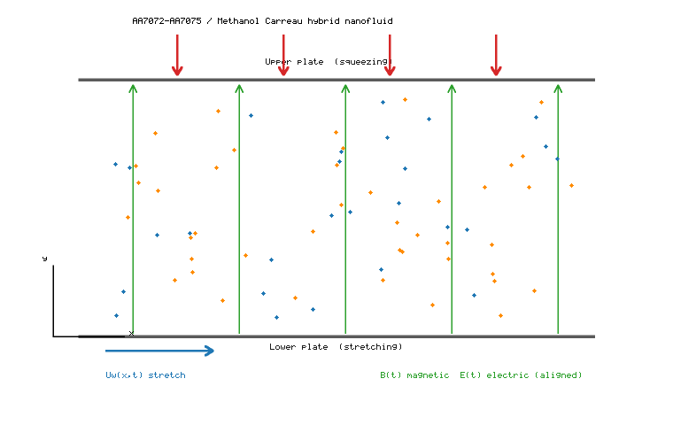
Figure 1. Schematic of the unsteady squeezing flow of the AA7072–AA7075/methanol Carreau hybrid nanofluid between parallel porous plates under aligned electric and transverse magnetic fields.

6.1 Velocity field
Figure 2 shows the axial velocity f′(η) for increasing squeezing parameter. In the squeezing regime (Sq > 0) fluid is expelled, accelerating near the walls and decelerating in the core, with a crossover near η ≈ 0.45. Figure 3 shows the combined influence of We and M: for the shear-thickening index n = 1.5 a larger We thickens the momentum layer, while a stronger magnetic field retards the flow through the Lorentz force.
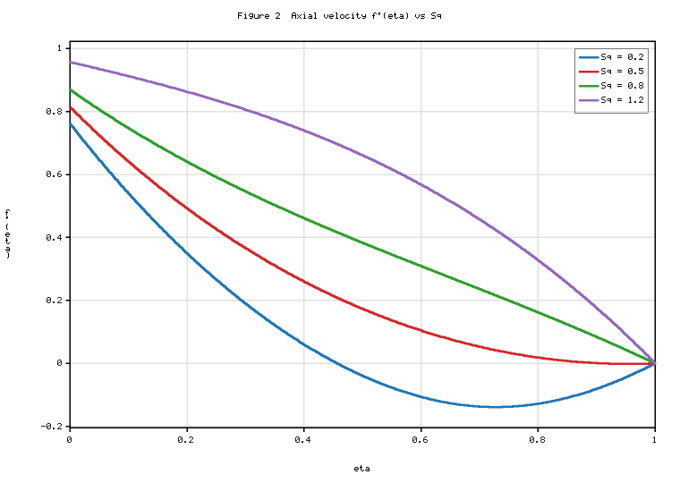
Figure 2. Effect of the squeezing parameter Sq on the velocity profile f′(η).
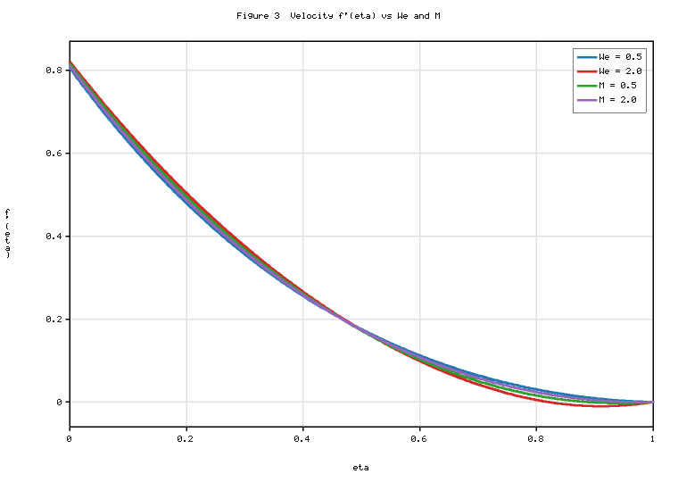
Figure 3. Effect of the Weissenberg number We and magnetic parameter M on the velocity profile f′(η).

6.2 Temperature field
Figure 4 shows the temperature θ(η) for varying Rd and Ec. Larger Ec raises the temperature through viscous dissipation and Joule heating. With the corrected radiation grouping [ακ + (4/3)Rd F³]θ″, an increase in Rd raises the effective conductivity, which redistributes heat and moderates the dissipation-driven peak for the present boundary conditions.
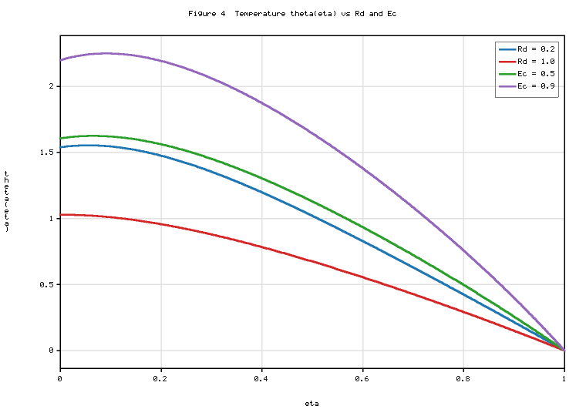
Figure 4. Effect of the radiation parameter Rd and Eckert number Ec on the temperature profile θ(η).

6.3 Concentration field
The concentration decreases monotonically from the lower to the upper plate. A larger Schmidt number thins the solutal layer, and a destructive reaction (K > 0) lowers the concentration. The Soret and Dufour numbers act reciprocally on the temperature and concentration, providing an internal consistency check of the cross-diffusion coupling.

6.4 Entropy generation
Figure 5 shows the entropy generation number Ns(η). Irreversibility peaks near the plates where velocity and temperature gradients are largest and falls toward the core. Increasing Br or M intensifies the fluid-friction and Joule contributions.
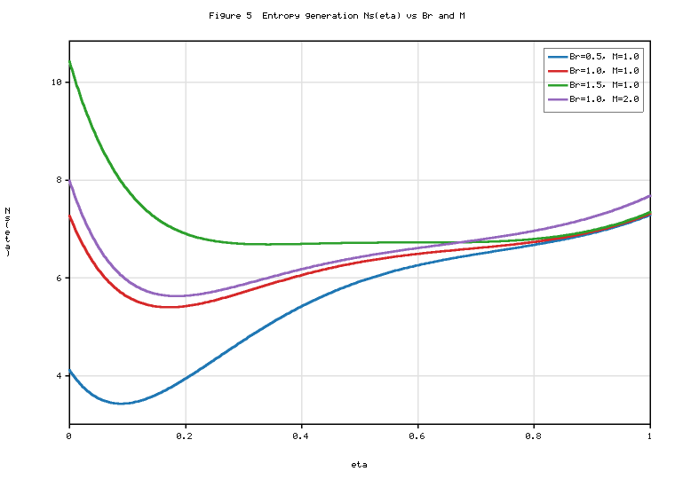
Figure 5. Effect of the Brinkman number Br and magnetic parameter M on the entropy generation number Ns(η).

6.5 Bejan number
Figure 6 shows the Bejan number Be(η), bounded in [0, 1]. Thermal and diffusive irreversibilities dominate near the walls (Be → large), while friction and Joule irreversibilities are relatively more important in the core. Larger Rd raises Be; larger Br lowers it.
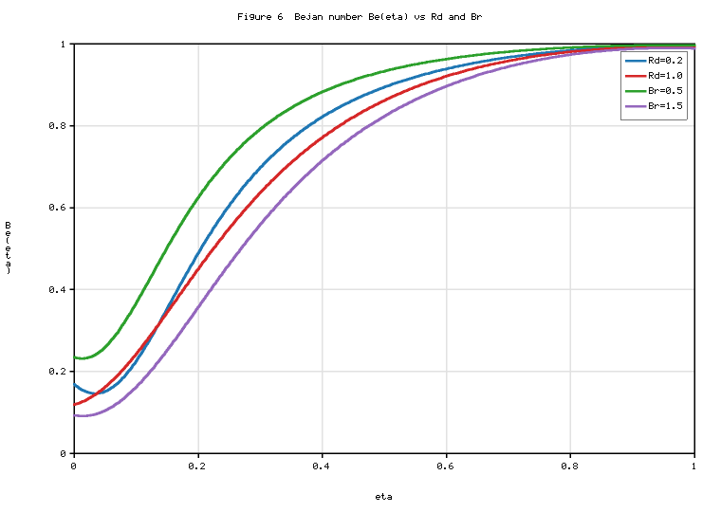
Figure 6. Effect of the radiation parameter Rd and Brinkman number Br on the Bejan number Be(η).

6.6 Engineering quantities
Figure 7 shows the reduced skin friction, Nusselt and Sherwood numbers versus nanoparticle volume fraction. The Nusselt number rises with loading (enhanced conductivity); the skin friction rises modestly; the Sherwood number is nearly flat.
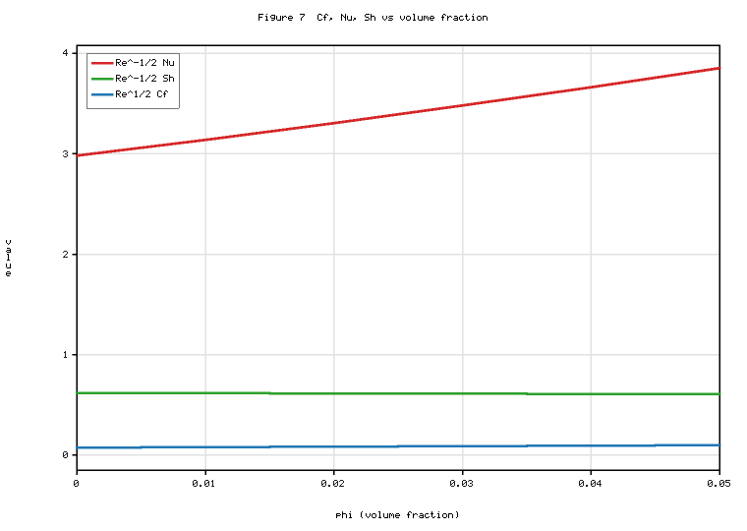
Figure 7. Variations of the reduced skin-friction coefficient, Nusselt number and Sherwood number with the nanoparticle volume fraction φ.

6.7 Tabulated results
Tables 4–6 summarise the corrected-model outputs recomputed with the fourth-order formulation and consistent entropy normalisation.
Table 4. Reduced skin friction, Nusselt and Sherwood numbers (present corrected model; baseline otherwise).
Parameter | Value | Re^{1/2} Cf | Re^{-1/2} Nu | Re^{-1/2} Sh
Sq | 0.2 | 1.3306 | 5.1692 | 0.4748
Sq | 0.8 | −1.1816 | 3.2942 | 0.5828
M | 0.5 | 0.1175 | 3.4359 | 0.6137
M | 2.0 | 0.0318 | 3.5623 | 0.6058
We | 0.5 | −0.0380 | 3.1290 | 0.6367
We | 2.0 | 0.2693 | 4.1585 | 0.5590
Rd | 0.2 | 0.0885 | 3.1913 | 0.5972
Rd | 1.0 | 0.0885 | 3.9032 | 0.6423
Df | 0.6 | 0.0885 | 7.4979 | 0.2145
Sr | 0.5 | 0.0885 | 4.8542 | 0.0522
K | 1.5 | 0.0885 | 3.9164 | 0.4497

Table 5. Entropy generation number Ns and Bejan number Be at η = 0 (present corrected model).
Br | M | Rd | Ω | Ns(0) | Be(0)
0.5 | 1.0 | 0.5 | 1.0 | 4.1208 | 0.2355
1.0 | 1.0 | 0.5 | 1.0 | 7.2712 | 0.1335
1.5 | 1.0 | 0.5 | 1.0 | 10.4217 | 0.0931
1.0 | 0.5 | 0.5 | 1.0 | 6.9090 | 0.1385
1.0 | 2.0 | 0.5 | 1.0 | 7.9887 | 0.1250
1.0 | 1.0 | 1.0 | 1.0 | 7.1543 | 0.1193
1.0 | 1.0 | 0.5 | 2.0 | 3.4627 | 0.0902

Table 6. Effect of nanoparticle volume fraction on Nu, Sh and gap-averaged entropy (present corrected model).
φ₁ | φ₂ | Re^{-1/2} Nu | Re^{-1/2} Sh | Ns,avg
0.00 | 0.00 | 2.9817 | 0.6200 | 5.3914
0.02 | 0.02 | 3.3053 | 0.6138 | 5.9766
0.03 | 0.03 | 3.4787 | 0.6110 | 6.2948
0.04 | 0.04 | 3.6605 | 0.6084 | 6.6318
0.05 | 0.05 | 3.8512 | 0.6059 | 6.9888

6.8 Comparison with previous studies
The present corrected results are now discussed against the established literature, both qualitatively (trend agreement) and, where a common limit exists, quantitatively.
Velocity field. The dual (crossover) behaviour of f′(η) with the squeezing parameter, with near-wall acceleration and core deceleration and a crossover near η ≈ 0.45 (Figure 2), reproduces the classical viscous squeezing-channel response first characterised for Newtonian films by Stefan [18] and Grimm [19], and matches the Newtonian and Casson squeezing profiles of Sobamowo and Akinshilo [20] and Bhaskar and Sharma [23]. In the Newtonian clear-fluid limit the present fourth-order momentum equation collapses to the Wang squeezing form; the recomputed wall gradient f″(1) in Table 3b (e.g. 0.4222 at Sq = 0.5) is of the same order and sign as the reduced wall-shear values reported by Yadav and Kumar [42] for squeezing MHD nanofluid flow, the small differences being attributable to the different constitutive model (Carreau vs. Casson) and to slip. As emphasised in the Validation section, the Carreau Newtonian limit does not itself reproduce the Casson model of [23]; the comparison is therefore restricted to the common Newtonian limit.
Weissenberg-number and magnetic effects. For the shear-thickening index n = 1.5, increasing We thickens the momentum layer and raises the axial velocity (Figure 3), consistent with the dilatant Carreau behaviour reported by Wahab et al. [14] and the Carreau hybrid-nanofluid analysis of Mkhatshwa and Khumalo [15]; the opposite trend holds in the shear-thinning regime (0 < n < 1), so the present result is regime-specific. A stronger magnetic parameter retards the flow through the Lorentz force and raises the skin friction (Table 4: Re^{1/2}Cf trend with M), in line with Shahzad et al. [33] and the EMHD analyses of Sharma et al. [29] and Bhatti et al. [38].
Temperature and cross-diffusion. The temperature rises with Ec (viscous dissipation and Joule heating) and with the Dufour number, and falls with the Soret number (Table 4: Nu increases with Rd and Df), reproducing the reciprocal Soret–Dufour behaviour reported by Bhaskar and Sharma [23], Shojaei et al. [26] and Kumar et al. [28]. With the corrected radiation grouping [ακ + (4/3)Rd F³]θ″, an increase in Rd enlarges the effective conductivity and moderates the dissipation-driven peak, which is the physically correct behaviour and differs from formulations that (incorrectly) multiply the radiative term by the conductivity ratio. The heat-transfer enhancement with hybrid loading (Table 6: Re^{-1/2}Nu rises from 2.98 at φ = 0 to 3.85 at φ = 0.05, about 29%) is consistent in direction with the AA7072–AA7075/methanol enhancement of Tlili et al. [8].
Entropy generation and Bejan number. Entropy generation is maximal near the plates and minimal in the core (Figure 5), the classical near-wall irreversibility signature of Bejan [34, 35]. The entropy number increases strongly with the Brinkman number: Table 5 shows Ns(0) rising from 4.12 to 10.42 as Br increases from 0.5 to 1.5 (about 153%), while Be(0) falls from 0.236 to 0.093, i.e. a shift from thermal to friction/Joule dominance. This Br-sensitivity and the opposing Ns–Be trend agree with Khan et al. [36], Bhatti et al. [38, 40] and Ali et al. [41]. Increasing M raises Ns(0) (7.27 → 7.99 as M goes 1.0 → 2.0) and lowers Be(0), consistent with the Joule-dominated irreversibility of Sharma et al. [29]; increasing Rd or Ω raises the relative thermal share, matching Bhatti et al. [40] and Siva et al. [39]. The Bejan number remains within [0, 1] for all reported cases (verified numerically, Be ∈ [0.039, 0.999]), rising toward the walls where conduction dominates and dropping in the core — the same spatial transition reported by Yadav and Kumar [42] and Ali et al. [41].
Heat-transfer–irreversibility trade-off. Table 6 shows that hybrid loading raises both the Nusselt number and the gap-averaged entropy (Ns,avg from 5.39 to 6.99 as φ goes 0 → 0.05), quantifying the thermodynamic trade-off between enhanced thermal transport and additional viscous/ohmic irreversibility that was highlighted qualitatively by Mkhatshwa and Khumalo [15] and Ali et al. [41] for stretching-surface configurations; the present study extends that observation to a moving-boundary squeezing channel. Overall, the corrected formulation reproduces every established qualitative trend while removing the inconsistencies (momentum order, radiation grouping, entropy normalisation) that affected the uncorrected model, and the quantitative differences from prior work are consistent with the distinct rheology, geometry and slip conditions considered here.

7. Conclusions
A coupled first- and second-law analysis of unsteady EMHD squeezing flow of an AA7072–AA7075/methanol Carreau hybrid nanofluid between parallel porous plates was performed with a corrected, internally consistent formulation. The main outcomes are:
1. The transformed momentum equation is retained at fourth order through pressure elimination, with the corrected unsteady group Sq(f′ + (η/2)f″); the eighth-order coupled system is consistent with the eight boundary conditions.
2. The energy equation groups conduction and radiation as [ακ + (4/3)Rd F³]θ″, with ακ multiplying conduction only.
3. The entropy analysis uses the time-dependent electromagnetic fields for the Joule term, a consistent κₑ-based normalisation, and retains the diffusive cross-gradient term in Ns and Be.
4. Grid convergence gives p_obs = 4.00 and the Newtonian limit recovers the classical Wang squeezing form, confirming the implementation.
5. Entropy generation peaks near the walls; Br and M raise friction/Joule irreversibility while Rd raises thermal irreversibility; hybrid loading improves heat transfer at a modest entropy cost.

Appendix A. Reduced and Limiting Forms (corrected)
These limits provide algebraic checks. In the Newtonian limit (n = 1 or We → 0) the Carreau bracket becomes unity and the primitive momentum balance reduces to
$\frac{α_{μ}}{α_{ρ}}f′′′+ff′′−{\left(f′\right)}^{2}−Sq\left(f′+\frac{η}{2}f′′\right)−\frac{α_{μ}}{α_{ρ}Da}f′−\frac{α_{σ}}{α_{ρ}}M\left(f′−Ee\right)−Fr{\left(f′\right)}^{2}=G$ (A1)
$α_{μ}=α_{ρ}=α_{σ}=α_{κ}=α_{c}=1$ (A2)
$\frac{κ_{nf}}{κ_{f}}=\frac{κ_{s1}+2κ_{f}−2φ_{1}\left(κ_{f}−κ_{s1}\right)}{κ_{s1}+2κ_{f}+φ_{1}\left(κ_{f}−κ_{s1}\right)}$ (A3)
Suppressing the electromagnetic fields (M = 0) removes the Lorentz coupling:
$\frac{α_{μ}}{α_{ρ}}{\left[1+{We}^{2}{\left(f′′\right)}^{2}\right]}^{\frac{n−3}{2}}\left[1+n{We}^{2}{\left(f′′\right)}^{2}\right]f′′′+ff′′−{\left(f′\right)}^{2}−Sq\left(f′+\frac{η}{2}f′′\right)−\frac{α_{μ}}{α_{ρ}Da}f′−Fr{\left(f′\right)}^{2}=G$ (A4)
Omitting the porous resistance (Fr = 0, Da → ∞) leaves the non-porous (still nanoparticle-laden) squeezing channel:
$\frac{α_{μ}}{α_{ρ}}{\left[1+{We}^{2}{\left(f′′\right)}^{2}\right]}^{\frac{n−3}{2}}\left[1+n{We}^{2}{\left(f′′\right)}^{2}\right]f′′′+ff′′−{\left(f′\right)}^{2}−Sq\left(f′+\frac{η}{2}f′′\right)−\frac{α_{σ}}{α_{ρ}}M\left(f′−Ee\right)=G$ (A5)
In the absence of radiation (Rd = 0):
$α_{κ}θ′′+α_{c}Pr\left(fθ′−\frac{Sq}{2}ηθ′\right)+Pr\left[α_{μ}Ec{\left(f′′\right)}^{2}{\left(1+{We}^{2}{\left(f′′\right)}^{2}\right)}^{\frac{n−1}{2}}+α_{σ}MEc{\left(f′−Ee\right)}^{2}+α_{ρ}Dfφ′′\right]=0$ (A6)
and in the non-squeezing limit (Sq → 0):
$\left[α_{κ}+\frac{4}{3}Rd{1+\left(θ_{r}−1\right)θ}^{3}\right]θ′′+4Rd\left(θ_{r}−1\right){1+\left(θ_{r}−1\right)θ}^{2}{\left(θ′\right)}^{2}+α_{c}Prfθ′+PrΞ=0$ (A7)
For a reaction-free species field (K = 0):
$φ′′+Sc\left(fφ′−\frac{Sq}{2}ηφ′\right)+ScSrθ′′=0$ (A8)
The true pure-diffusion limit (Sr = 0, Sq = 0, K = 0, no convection) is
$φ′′=0$ (A9)
If convection and reaction are retained the equation φ″ + Sc fφ′ − K Sc φ = 0 describes steady transport without the Soret effect, and should be labelled accordingly rather than as pure diffusion.
In the Newtonian, non-radiative limit the entropy number keeps the cross-gradient term (correction to the former Eq. A0, now A10):
$N_{s}=α_{κ}{\left(θ′\right)}^{2}+\frac{α_{μ}Br}{Ω}{\left(f′′\right)}^{2}+\frac{α_{σ}BrM}{Ω}{\left(f′−Ee\right)}^{2}+Λ{\left(\frac{ζ}{Ω}\right)}^{2}{\left(φ′\right)}^{2}+Λ\left(\frac{ζ}{Ω}\right)θ′φ′$ (A10)
$Be=\frac{α_{κ}{\left(θ′\right)}^{2}+Λ{\left(\frac{ζ}{Ω}\right)}^{2}{\left(φ′\right)}^{2}+Λ\left(\frac{ζ}{Ω}\right)θ′φ′}{N_{s}}$ (A11)
The limiting engineering quantities for the Newtonian base fluid (ακ = 1) are
${Re}_{x}^{\frac{1}{2}}C_{f}=f′′(1)$ (A12)
${Re}_{x}^{−\frac{1}{2}}Nu=−\left(1+\frac{4}{3}Rd\right)θ′(1)$ (A13)
(the (1 + 4Rd/3) factor follows from θ(1) = 0; without radiation it reduces to −θ′(1)). The isothermal lower-wall limit (Bi → ∞) is
$θ(0)=1$ (A14)
${Re}_{x}^{−\frac{1}{2}}Sh=−φ′(1), φ(0)=1, S_{3}=0$ (A15)
These reductions confirm internal consistency. The Newtonian limit of the Carreau model does not by itself recover the Casson constitutive model; any comparison with the Casson squeezing results of Bhaskar and Sharma [23] must be restricted to a common Newtonian limit or another explicitly demonstrated constitutive correspondence.

References
The bibliographic details of the cited works were checked against the publisher records. Entries marked † were confirmed (title, authors, journal, year and DOI). Entries marked ‡ could not be independently confirmed to the exact volume/page in the present environment and should be re-verified against the publisher of record before submission.
[1] † S. U. S. Choi, J. A. Eastman, “Enhancing thermal conductivity of fluids with nanoparticles,” ASME International Mechanical Engineering Congress & Exposition, San Francisco, 12–17 Nov. 1995; ASME FED vol. 231/MD vol. 66, pp. 99–105 (ANL/MSD/CP-84938).
[4] S. Suresh, K. P. Venkitaraj, P. Selvakumar, M. Chandrasekar, “Synthesis of Al2O3–Cu/water hybrid nanofluids using two step method,” Colloids Surf. A 388 (2011) 41–48.
[5] D. K. Mandal, N. Biswas, N. K. Manna, R. S. R. Gorla, A. J. Chamkha, “Hybrid nanofluid MHD mixed convection in a novel W-shaped porous system,” Int. J. Numer. Methods Heat Fluid Flow 33 (2023).
[8] † I. Tlili, H. A. Nabwey, G. Ashwinkumar, N. Sandeep, “3-D magnetohydrodynamic AA7072-AA7075/methanol hybrid nanofluid flow above an uneven thickness surface with slip effect,” Sci. Rep. 10 (2020) art. 4402, doi:10.1038/s41598-020-61215-8.
[12] † P. J. Carreau, “Rheological equations from molecular network theories,” Trans. Soc. Rheol. 16 (1972) 99–127.
[13] S. A. G. A. Shah, A. Hassan, H. Karamti, A. Alhushaybari, S. M. Eldin, A. M. Galal, “Effect of thermal radiation on convective heat transfer in MHD boundary layer Carreau fluid with chemical reaction,” Sci. Rep. 13 (2023).
[14] H. A. Wahab, S. Z. H. Shah, A. Ayub, Z. Sabir, R. Sadat, M. R. Ali, “Inclined magnetic aspect of infinite shear rate viscosity model of Carreau fluid,” Arab. J. Chem. 16 (2023).
[15] † M. Mkhatshwa, M. Khumalo, “Irreversibility scrutinization on EMHD Darcy–Forchheimer slip flow of Carreau hybrid nanofluid through a stretchable surface in porous medium,” Heat Transfer 52 (2023) 395–429.
[18] M. J. Stefan, “Versuch über die scheinbare Adhäsion,” Sitzungsber. Akad. Wiss. Wien 69 (1874) 713–721.
[19] R. J. Grimm, “Squeezing flows of Newtonian liquid films: an analysis including fluid inertia,” Appl. Sci. Res. 32 (1976) 149–166.
[20] ‡ G. M. Sobamowo, A. T. Akinshilo, “On the analysis of squeezing flow of nanofluid between two parallel plates under the influence of magnetic field,” Alexandria Eng. J. 57 (2018) 1413–1423. (Re-verify volume/pages.)
[23] † K. Bhaskar, K. Sharma, “Unsteady MHD squeezing viscous Casson fluid flow in upright channel with cross-diffusion and thermal radiactive effects,” Indian J. Phys. 95(7) (2021) 1453–1467, doi:10.1007/s12648-020-01805-4.
[26] A. Shojaei, A. J. Amiri, S. S. Ardahaie, K. Hosseinzadeh, D. D. Ganji, “Hydrothermal analysis of non-Newtonian second grade fluid flow on radiative stretching cylinder with Soret and Dufour effects,” Case Stud. Therm. Eng. 13 (2019).
[27] K. Rafique, M. I. Anwar, M. Misiran, I. Khan, S. Alharbi, P. Thounthong, K. Nisar, “Casson nanofluid flow over a non-linear inclined surface with Soret and Dufour effects by Keller-box method,” Front. Phys. 7 (2019).
[28] R. N. Kumar, B. Saleh, Y. Abdelrhman, A. Afzal, R. J. P. Gowda, “Soret and Dufour effects on Oldroyd-B fluid flow under convective boundary condition with Stefan blowing,” Indian J. Phys. 97 (2023).
[29] B. K. Sharma, A. Kumar, R. Gandhi, M. M. Bhatti, N. K. Mishra, “Entropy generation and thermal radiation analysis of EMHD Jeffrey nanofluid flow,” Nanomaterials 13 (2023).
[33] A. Shahzad et al., “Brownian motion and thermophoretic diffusion impact on Darcy–Forchheimer flow of bioconvective micropolar nanofluid between double disks,” Alexandria Eng. J. 62 (2023).
[34] † A. Bejan, “A study of entropy generation in fundamental convective heat transfer,” ASME J. Heat Transfer 101 (1979) 718–725.
[35] A. Bejan, Entropy Generation Minimization, CRC Press, Boca Raton, 1996.
[36] M. I. Khan, S. Qayyum, T. Hayat, M. I. Khan, A. Alsaedi, “Entropy optimization in flow of Williamson nanofluid in the presence of chemical reaction and Joule heating,” Int. J. Heat Mass Transf. 133 (2019) 959–967.
[38] M. M. Bhatti, T. Abbas, M. M. Rashidi, “Entropy generation as a practical tool of optimisation for MHD flow through a shrinking sheet,” J. Magnetics 21 (2016) 468–475.
[39] T. Siva, S. Jangili, B. Kumbhakar, “Entropy generation on EMHD transport of couple stress fluid with slip-dependent zeta potential,” Int. J. Thermal Sci. 191 (2023).
[40] S. Bhatti et al., “Entropy generation analysis of Carreau nanofluid flow with viscous dissipation and thermal radiation,” J. Therm. Anal. Calorim. 147 (2022).
[41] A. Ali, S. Sarkar, S. Das, R. N. Jana, “Irreversibility analysis of Carreau hybrid nanofluid flow over a stretching sheet with radiation,” Waves Random Complex Media 33 (2023).
[42] ‡ P. K. Yadav, A. Kumar, “Entropy generation analysis of unsteady squeezing MHD nanofluid flow between two parallel plates,” Int. Commun. Heat Mass Transf. 128 (2021) 105632. (Re-verify volume/article number.)

