RENEWABLE ENERGY INTEGRATION AND FORECASTING
Book: AI-Enabled Smart Grids for Energy Optimization and Fault Prediction

Abstract
The transition toward low-carbon electricity systems has placed renewable energy integration and accurate forecasting at the center of modern power system engineering. This chapter examines how artificial intelligence transforms the integration of variable renewable generation into smart grids, progressing from the physical foundations of renewable resources through data-driven forecasting to intelligent energy management and the open challenges that remain. It begins by characterizing solar photovoltaic, wind, hybrid, and distributed energy resources, and by analyzing the intermittency and variability that complicate grid stability and distribution optimization. It then surveys the machine learning paradigms—artificial neural networks, deep learning, long short-term memory networks, and ensemble and hybrid architectures—that underpin contemporary energy analytics. The chapter develops the forecasting of renewable generation and electricity demand in detail, together with the Internet-of-Things sensing, smart metering, and weather-data fusion that supply the real-time information these models require. It proceeds to intelligent energy management, covering AI-driven demand response, storage optimization, load balancing, and predictive control, and then explores emerging technologies including digital twins, reinforcement learning, federated learning, and explainable artificial intelligence for decentralized and trustworthy grid operation. Finally, it critically assesses the challenges of forecasting-error propagation, data quality, computational complexity, cybersecurity, and integration constraints, and outlines future directions spanning probabilistic forecasting, physics-informed machine learning, and autonomous grid control. Through integrated frameworks, comparative tables, and schematic figures, the chapter provides researchers and practitioners with a structured understanding of how AI enables efficient renewable utilization, reduced carbon emissions, and resilient, sustainable energy transitions.
Keywords: renewable energy integration; smart grids; solar and wind forecasting; deep learning; long short-term memory; demand response; energy storage; digital twins; reinforcement learning; probabilistic forecasting

1. Introduction to AI-Enabled Renewable Energy Integration
The electricity grid is undergoing the most profound transformation since its inception, driven by the global imperative to decarbonize energy supply and by the rapid proliferation of renewable generation. Where power systems were once built around a small number of large, controllable, fossil-fueled plants whose output could be dispatched on demand, they are increasingly populated by vast numbers of solar and wind installations whose output depends on the weather and cannot be commanded at will. This shift from dispatchable to variable generation, and from centralized to distributed resources, has created a set of operational challenges that conventional grid-management methods, designed for a predictable and controllable supply, are poorly equipped to address. The central question for modern power system engineering is how to integrate large quantities of variable renewable energy while maintaining the reliability, stability, and efficiency that society expects of its electricity supply.
Artificial intelligence has emerged as the decisive enabling technology for meeting this challenge. The variability and uncertainty that characterize renewable generation are precisely the conditions under which data-driven methods excel, because machine learning can discover complex, nonlinear relationships between weather, time, and power output that defy simple analytical description, and can learn these relationships directly from the abundant data that modern grids generate. Accurate forecasting of renewable generation and electricity demand, intelligent coordination of storage and flexible loads, and adaptive control of a grid whose state changes continuously all depend on the capacity to anticipate and respond to conditions that are inherently probabilistic. This chapter develops the thesis that artificial intelligence is not merely a useful addition to the renewable-integration toolkit but the technology that makes high-penetration renewable grids operable at all.
The chapter is organized to follow the logical flow from physical foundations to intelligent operation and future prospects. It first establishes the foundations of renewable energy integration, characterizing the resources and the integration challenges they pose, and introducing the artificial intelligence paradigms that address them. It then develops AI-driven forecasting of generation and demand, together with the sensing and data infrastructure that feeds these models. The chapter proceeds to intelligent energy management, examining demand response, storage optimization, load balancing, and predictive control, before surveying the emerging technologies—digital twins, reinforcement learning, federated learning, and explainable artificial intelligence—that are reshaping decentralized energy management. It closes by critically assessing the challenges that remain and the research directions most likely to advance the field. Throughout, the emphasis is on how each technical capability contributes to the overarching goals of efficient renewable utilization, reduced carbon emissions, and a resilient, sustainable energy transition.

2. Foundations of Renewable Energy Integration in Smart Grids

2.1 Renewable Energy Sources and Grid Integration Challenges
The portfolio of renewable energy resources that modern grids must accommodate is dominated by solar photovoltaic and wind generation, complemented by hybrid systems and a growing array of distributed energy resources. Solar photovoltaic systems convert sunlight directly into electricity through semiconductor devices, producing power that follows the diurnal and seasonal cycles of solar irradiance and that fluctuates on timescales of seconds to hours as clouds pass overhead [1]. Wind energy generation harnesses the kinetic energy of moving air through turbines whose output scales with the cube of wind speed, making it highly sensitive to meteorological conditions and variable across timescales from gusts to seasonal wind patterns [2]. Hybrid renewable systems combine two or more resources, most commonly solar and wind, to exploit the partial complementarity of their generation profiles and thereby smooth the aggregate output, while distributed energy resources encompass the many small generation and storage units—rooftop solar, community batteries, electric vehicles—connected at the distribution level rather than to the transmission backbone [3].
The defining characteristic that distinguishes renewable generation from conventional power is intermittency and variability, and understanding its causes and patterns is essential to managing its consequences. Variability refers to the continuous fluctuation of output as the underlying resource changes, while intermittency denotes the more abrupt and sometimes prolonged interruptions that occur when, for instance, a cloud bank shades a solar farm or wind speeds fall below a turbine's cut-in threshold [4]. These fluctuations arise from the fundamentally weather-dependent nature of the resources and exhibit characteristic patterns across multiple timescales: sub-second to minute fluctuations that affect power quality, hourly to daily cycles that follow weather and the diurnal rhythm, and seasonal variations that influence long-term energy balance. The spatial distribution of resources matters as well, since geographically dispersed generation experiences less correlated variability than concentrated generation, so that aggregation across a wide area naturally smooths the combined output.
The implications of this variability for grid stability are substantial and multifaceted, because the power system must maintain an instantaneous balance between generation and demand to keep frequency and voltage within narrow operating limits. Conventional grids relied on the large rotating masses of synchronous generators to provide inertia that resists sudden frequency changes, but inverter-connected renewable resources contribute little or no such inertia, reducing the system's natural resilience to disturbances [5]. High renewable penetration therefore creates challenges for frequency regulation, voltage control, and the maintenance of adequate reserves, and it can lead to situations in which renewable output must be curtailed because it exceeds what the grid can safely absorb. Figure 1 illustrates the architecture of a renewable-integrated smart grid, showing how variable generation, storage, flexible loads, and intelligent control interact within a system that must continuously reconcile supply and demand.
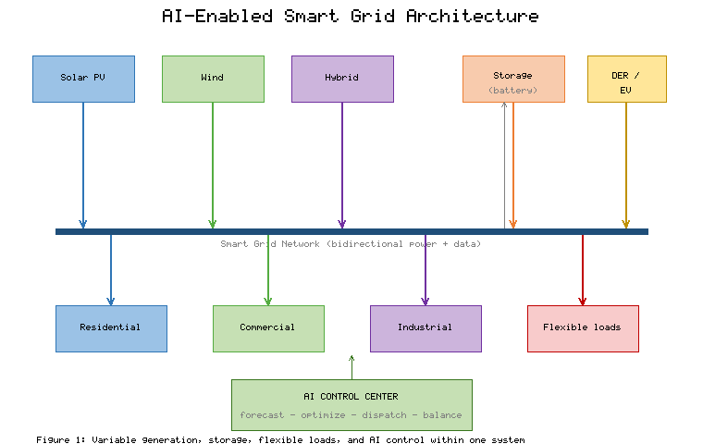
Figure 1. Architecture of an AI-Enabled Smart Grid Integrating Variable Renewable Generation, Storage, and Flexible Loads
Energy management under high renewable penetration confronts difficulties that extend well beyond instantaneous stability, encompassing the scheduling, dispatch, and coordination of a far more complex and uncertain system than traditional grids presented. Operators must decide how to commit and dispatch resources hours to days ahead under uncertainty about how much renewable energy will actually be available, how to deploy limited storage and flexibility to greatest effect, and how to manage the bidirectional power flows that distributed generation creates on networks originally designed for one-way delivery [6]. The economic dimension compounds the technical one, since renewable energy's near-zero marginal cost reshapes electricity markets and complicates the provision of the reserves and flexibility that a variable system requires. Table 1 summarizes the principal renewable resources, their variability characteristics, and the integration challenges each presents, providing a comparative foundation for the analytical methods developed in the remainder of the chapter.
[Insert Table 1 here]
Table 1. Characteristics and Integration Challenges of Principal Renewable Energy Resources
Resource | Primary Driver | Dominant Variability Timescale | Key Integration Challenge | Mitigation Emphasis
Solar photovoltaic | Solar irradiance | Seconds to diurnal | Cloud-induced ramps, no night output | Forecasting, storage
Wind | Wind speed | Minutes to seasonal | Cubic sensitivity, low inertia | Forecasting, reserves
Hybrid solar-wind | Combined weather | Smoothed aggregate | Coordination, sizing | Complementarity, control
Distributed resources | Local generation and demand | Highly variable, local | Bidirectional flows, visibility | Smart metering, coordination
Forecasting uncertainty lies at the heart of the renewable-integration problem, because nearly every operational decision depends on anticipating future generation and demand, and errors in those anticipations propagate through the entire chain of grid operations [7]. When forecasts overestimate renewable availability, operators may schedule insufficient conventional or stored reserves, risking shortfalls that threaten reliability; when forecasts underestimate it, operators may commit excessive reserves, incurring unnecessary cost and potentially curtailing clean energy. The impact of forecasting uncertainty on power distribution optimization is thus direct and consequential: the quality of the forecast sets a ceiling on the quality of the dispatch, the storage schedule, and the demand-response deployment that follow. This recognition motivates the central role that artificial intelligence plays in renewable integration, for it is the improvement of forecasts and the intelligent management of residual uncertainty that most directly determine how much renewable energy a grid can reliably and economically absorb.

2.2 AI and Machine Learning Paradigms for Smart Grids
Artificial intelligence and machine learning provide the analytical foundation for managing the complexity and uncertainty of renewable-integrated grids, offering methods that learn patterns from data rather than requiring explicit analytical models of every phenomenon. Machine learning encompasses a spectrum of approaches, from supervised methods that learn to map inputs to known outputs, through unsupervised methods that discover structure in unlabeled data, to reinforcement learning methods that learn control policies through interaction with an environment [8]. In energy systems, these methods address tasks ranging from forecasting and anomaly detection to optimization and control, exploiting the vast quantities of data that smart meters, sensors, and weather services now generate. The appeal of machine learning in this domain stems from its capacity to capture the nonlinear, high-dimensional, and time-varying relationships that characterize power systems with high renewable penetration, relationships that are often intractable to conventional physics-based modeling alone.
Artificial neural networks form the core of many modern energy analytics, providing flexible function approximators capable of learning complex mappings from historical data. A neural network composes layers of simple computational units whose connection weights are adjusted during training to minimize prediction error, and with sufficient data and appropriate architecture such networks can approximate highly nonlinear relationships [9]. Deep learning extends this principle through networks with many layers that learn hierarchical representations, automatically extracting features at increasing levels of abstraction and thereby reducing the need for manual feature engineering [10]. In the context of renewable forecasting, deep networks can learn to relate raw meteorological and temporal inputs to power output directly, discovering the relevant features from data rather than relying on handcrafted predictors.
Among deep architectures, recurrent networks and in particular long short-term memory networks are especially well suited to the sequential, time-dependent data that dominate energy applications. Long short-term memory networks incorporate gated memory cells that allow them to retain information over extended time horizons while mitigating the vanishing-gradient problem that afflicts simple recurrent networks, making them effective at capturing the temporal dependencies in generation and demand time series [11]. This capacity to model how past conditions influence future values is precisely what renewable forecasting requires, since the output of a solar or wind plant at any moment depends on the recent trajectory of weather and on the time of day and year. As depicted in Figure 2, the long short-term memory cell processes a sequence of inputs through its gating mechanisms, maintaining a memory state that enables it to learn long-range temporal patterns relevant to energy forecasting.
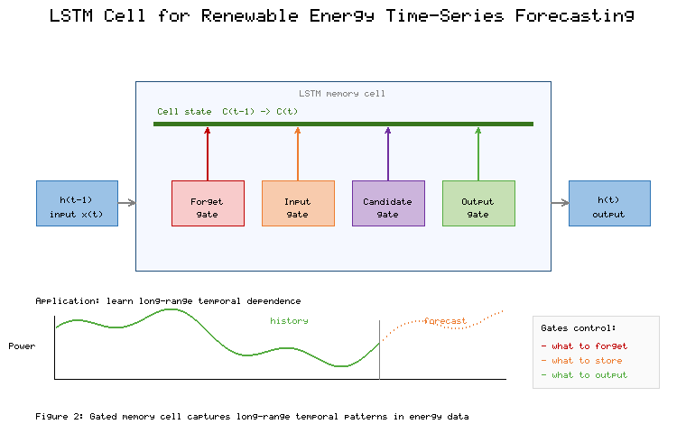
Figure 2. Structure of a Long Short-Term Memory Cell and Its Application to Renewable Energy Time-Series Forecasting
Ensemble learning and hybrid forecasting models often outperform any single method by combining the strengths of multiple approaches and averaging out their individual weaknesses. Ensemble methods such as random forests and gradient-boosted trees aggregate the predictions of many base learners to achieve greater accuracy and robustness than any one learner alone, and they have proven highly effective for both generation and demand forecasting [12]. Hybrid models go further by integrating fundamentally different techniques—for instance, combining a physics-based or statistical model with a machine learning model, or coupling a signal-decomposition method with a neural network—so that each component addresses the aspect of the problem to which it is best suited [13]. These composite architectures reflect a pragmatic recognition that no single method is universally optimal and that the heterogeneous, multi-scale nature of energy data rewards the thoughtful combination of complementary approaches.
The overarching role of artificial intelligence in the smart grid is to enhance reliability and operational efficiency by transforming the abundant data of a modern grid into actionable insight and automated decision. Reliable operation depends on anticipating disturbances, detecting faults, and maintaining balance under uncertainty, all of which AI methods support by providing accurate forecasts, early warnings, and adaptive control [14]. Operational efficiency depends on dispatching resources, scheduling storage, and coordinating flexible loads optimally, tasks for which AI-driven optimization and prediction are increasingly indispensable. By closing the loop from sensing through prediction to decision and action, artificial intelligence enables the smart grid to behave as an adaptive, self-optimizing system rather than a passively managed one, a capability that becomes essential as renewable penetration rises and the margin for error narrows.

3. AI-Driven Forecasting and Data Integration

3.1 Forecasting Models for Renewable Generation and Demand
The forecasting of renewable generation is the single most important analytical capability for high-penetration grids, and artificial intelligence has dramatically improved the accuracy achievable across the relevant time horizons. Solar photovoltaic forecasting predicts future power output from a combination of historical generation data, meteorological variables such as irradiance, temperature, and cloud cover, and temporal features that encode the diurnal and seasonal cycles [15]. Machine learning models, and deep learning models in particular, have been shown to outperform traditional statistical and physical approaches for solar forecasting, especially at the intra-day and intra-hour horizons where cloud-induced variability dominates and where the nonlinear relationship between atmospheric conditions and output is difficult to capture analytically [16]. The choice of forecast horizon shapes the choice of method and inputs, with very short-term forecasts relying heavily on recent observations and sky imagery, and longer-term forecasts depending increasingly on numerical weather prediction.
Wind energy forecasting presents analogous challenges and has similarly benefited from data-driven methods, though the cubic dependence of power on wind speed makes it especially sensitive to forecast errors in the underlying meteorology. Models predict wind power from historical generation, wind speed and direction, and other atmospheric variables, and the most effective approaches frequently employ recurrent architectures that capture the temporal evolution of wind conditions [17]. Because small errors in forecast wind speed translate into large errors in forecast power, wind forecasting places a premium on accurate meteorological inputs and on methods that can quantify and propagate the resulting uncertainty. Both solar and wind forecasting illustrate a general principle that the appropriate modeling strategy depends on the forecast horizon, the available data, and the tolerance for error of the downstream application, a principle that argues against one-size-fits-all solutions.
Electricity demand forecasting is the essential complement to generation forecasting, since the grid must balance the two, and it has a long history that machine learning has substantially advanced. Demand, or load, forecasting predicts future electricity consumption from historical load, calendar information, weather, and increasingly from the fine-grained data that smart meters provide [18]. Deep learning approaches, including long short-term memory and related recurrent architectures, have proven effective at capturing the complex patterns in load data, which reflect the superposition of daily routines, weekly cycles, seasonal weather effects, and longer-term trends [19]. The rise of distributed generation and flexible demand has made load forecasting more challenging, because consumption at the distribution level is increasingly shaped by behind-the-meter solar and by responsive loads, blurring the once-clear distinction between generation and demand and requiring forecasts that account for their interaction.
Hybrid forecasting architectures that combine multiple AI techniques represent the state of the art for both generation and demand prediction, reflecting the recognition that different methods capture different aspects of the forecasting problem. A common and effective strategy decomposes a complex signal into components of differing frequency or character and applies specialized models to each, reassembling the component forecasts into a final prediction that is more accurate than any monolithic model could achieve [20]. Other hybrid designs combine the pattern-learning strength of neural networks with the interpretability and stability of statistical models, or fuse physics-based numerical weather prediction with data-driven correction, so that domain knowledge and learned patterns reinforce one another. Table 2 compares the principal forecasting model families across the dimensions most relevant to their selection and deployment in renewable-integrated grids.
[Insert Table 2 here]
Table 2. Comparison of AI-Based Forecasting Model Families for Renewable Generation and Demand
Model Family | Representative Methods | Strengths | Limitations | Typical Application
Statistical | ARIMA, exponential smoothing | Interpretable, fast, stable | Limited nonlinearity | Baselines, short-term load
Classical ML | Support vector, random forest | Robust, handles tabular data | Manual feature engineering | Day-ahead generation/demand
Deep learning | CNN, LSTM, transformers | Captures nonlinear temporal patterns | Data-hungry, less transparent | Intra-day solar and wind
Ensemble | Gradient boosting, stacking | High accuracy, robust | Complexity, tuning effort | Competition-grade forecasts
Hybrid | Decomposition + neural network | Best-in-class accuracy | Design and integration cost | High-value operational forecasts
The rigorous evaluation of forecasting models under uncertainty is indispensable, because a forecast is useful only insofar as its accuracy and its limitations are understood by those who rely on it. Standard error metrics such as root-mean-square error, mean absolute error, and mean absolute percentage error quantify average performance, but they do not capture the full picture for decision-making under uncertainty, where the distribution and timing of errors matter as much as their average magnitude [21]. Probabilistic evaluation, which assesses not only point forecasts but the quality of predicted uncertainty intervals, is increasingly recognized as essential for grid applications, since operators must manage risk rather than merely minimize average error. Evaluation must also be honest about the conditions under which a model was tested, since performance on historical data under favorable conditions may not generalize to the extreme or unusual events that most threaten grid reliability, and it is precisely these events for which accurate forecasting is most valuable.

3.2 IoT, Smart Metering, and Real-Time Data Systems
The forecasting and control capabilities that artificial intelligence provides depend entirely on data, and the Internet of Things together with smart metering constitutes the sensory infrastructure that supplies it. The Internet of Things in the energy context refers to the networked sensors and devices distributed throughout the grid that measure electrical quantities, environmental conditions, and equipment status, and that communicate this information to the systems that analyze and act upon it [22]. Smart meters, deployed at the premises of consumers and distributed generators, provide fine-grained, time-resolved measurements of consumption and, increasingly, of local generation, transforming the visibility that operators have into the state of the distribution network [23]. This proliferation of sensing converts the grid from a system observed only at a few aggregate points into one instrumented at fine spatial and temporal resolution, generating the data streams on which data-driven methods depend.
The fusion of weather forecasting data with grid measurements is a particularly important form of data integration for renewable applications, because the weather is the dominant driver of renewable generation. Numerical weather prediction provides forecasts of irradiance, wind, temperature, and related variables that serve as essential inputs to generation forecasting models, and the quality of these meteorological inputs often sets the limit on the achievable accuracy of the generation forecast [24]. Effective data fusion combines these weather forecasts with historical generation data, real-time sensor measurements, and satellite or sky-imagery observations, allowing models to exploit complementary information sources and to correct systematic biases in any single source. The integration of heterogeneous data of differing resolution, latency, and reliability is itself a substantial technical challenge, requiring careful handling of missing values, synchronization, and quality control before the data can be used for prediction or control.
Advanced energy management systems bring these data streams together to enable real-time monitoring and decision-making across the grid. An energy management system collects and processes data from across the network, presents operators with a coherent view of system state, and increasingly incorporates AI-driven analytics that detect anomalies, forecast conditions, and recommend or execute control actions [25]. At the distribution level, these systems coordinate distributed energy resources, manage the bidirectional power flows that rooftop solar and storage create, and support the active management that high renewable penetration demands. The evolution from passive monitoring toward active, intelligent management is a defining trend, as energy management systems increasingly close the loop between observation and action rather than merely informing human operators. Figure 3 depicts the data flow in an AI-enabled smart grid, tracing the path from distributed sensing through data fusion and analytics to forecasting, decision, and control.
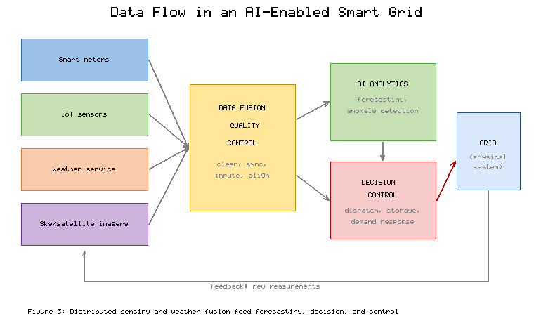
Figure 3. Data Flow in an AI-Enabled Smart Grid: From Distributed Sensing and Weather Fusion to Forecasting and Control
Intelligent grid operations enabled by data-driven analytics represent the culmination of this sensing and integration infrastructure, as the grid becomes capable of anticipating conditions and responding autonomously. Data-driven analytics support a wide range of operational functions, including the detection and diagnosis of faults, the prediction of equipment failures, the optimization of power flow, and the coordination of distributed resources, each of which contributes to a more reliable and efficient system [26]. The real-time character of these analytics is essential, because many grid phenomena evolve on timescales too short for human intervention, requiring automated systems that can sense, decide, and act within seconds. Table 3 summarizes the principal data sources and infrastructure components that underpin intelligent grid operations, indicating the role each plays in the overall data-to-decision pipeline and the considerations that govern its use.
[Insert Table 3 here]
Table 3. Data Sources and Infrastructure for Intelligent Grid Operations
Component | Data Provided | Temporal Resolution | Role in Pipeline | Principal Challenge
Smart meters | Consumption, local generation | Minutes to sub-hourly | Demand visibility, forecasting input | Privacy, data volume
IoT sensors | Electrical and equipment status | Seconds to minutes | Monitoring, fault detection | Reliability, calibration
Weather services | Irradiance, wind, temperature | Minutes to hours | Generation forecasting input | Forecast accuracy, latency
Satellite/sky imagery | Cloud cover, movement | Seconds to minutes | Very short-term solar forecasting | Processing complexity
SCADA/EMS | Aggregate system state | Seconds | System-wide coordination | Integration, legacy systems
The data infrastructure described here is the foundation upon which all subsequent intelligent management rests, and its quality and completeness directly determine the quality of the decisions that follow. Just as the accuracy of a forecast is bounded by the quality of its inputs, the effectiveness of demand response, storage optimization, and predictive control is bounded by the richness and reliability of the data that inform them. The sensing, metering, and data-fusion systems of this section thus provide the essential substrate for the intelligent energy management examined next, in which the predictions and real-time awareness that data-driven methods afford are translated into concrete control actions that balance the grid, exploit flexibility, and accommodate the variability of renewable generation.

4. Intelligent Energy Management and Control Strategies

4.1 AI-Enabled Demand Response and Storage Optimization
Intelligent energy management converts the forecasts and real-time awareness that data-driven methods provide into actions that balance supply and demand, and demand response is among the most powerful of these actions. Demand response refers to the adjustment of electricity consumption in response to grid conditions, prices, or signals, shifting flexible loads away from periods of scarcity and toward periods of abundant, often renewable, supply [27]. Artificial intelligence enhances demand response by forecasting both the availability of flexibility and the conditions that call for it, by learning the consumption patterns and preferences of participants, and by optimizing the dispatch of flexible loads to achieve grid objectives while respecting consumer constraints [28]. In a renewable-rich grid, AI-driven demand response becomes a means of aligning consumption with generation, absorbing surplus renewable energy when it is plentiful and relieving stress when it is scarce, thereby increasing the fraction of renewable energy the system can usefully employ.
Energy storage is the essential counterpart to demand response in managing renewable variability, and its optimal operation is a problem to which artificial intelligence is well matched. Storage systems, most prominently batteries but also including pumped hydro, thermal, and other technologies, absorb energy when generation exceeds demand and release it when demand exceeds generation, effectively decoupling the timing of renewable generation from that of consumption [29]. The optimization of storage operation—deciding when to charge, when to discharge, and how to trade off competing objectives such as energy arbitrage, reserve provision, and battery longevity—is a complex sequential decision problem under uncertainty, for which forecasting and AI-driven optimization provide powerful tools [30]. Effective storage optimization depends on accurate forecasts of future generation, demand, and prices, illustrating again how the forecasting capabilities developed earlier feed directly into the management actions that follow.
Load balancing in smart grids distributes demand and generation across the network and across time so as to avoid overloads, minimize losses, and maintain stability, and it increasingly relies on intelligent, automated coordination. In a grid with many distributed resources and flexible loads, load balancing becomes a high-dimensional coordination problem that benefits from AI methods capable of managing many variables and constraints simultaneously [31]. By coordinating the charging of electric vehicles, the operation of storage, and the dispatch of flexible loads, intelligent load balancing smooths the net demand that the grid must serve, reducing the peaks that drive infrastructure costs and the variability that challenges stability. Figure 4 illustrates how AI-enabled energy management coordinates forecasting, demand response, storage, and load balancing within a closed control loop that continuously adapts to changing grid conditions.
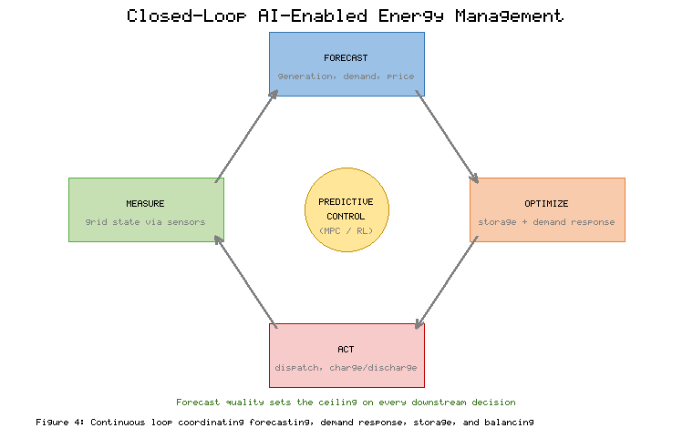
Figure 4. Closed-Loop AI-Enabled Energy Management Coordinating Forecasting, Demand Response, Storage, and Load Balancing
Predictive control strategies unify forecasting and optimization into a coherent framework for intelligent grid operation, acting on predictions of future conditions rather than merely reacting to present ones. Model predictive control, in particular, repeatedly solves an optimization problem over a receding horizon using forecasts of future generation and demand, implementing the first action of the resulting plan and then repeating the process as new information arrives [32]. This approach naturally incorporates forecasts, constraints, and multiple objectives, and it has proven effective for coordinating storage, demand response, and other flexible resources in renewable-integrated grids. The quality of predictive control depends directly on the quality of the forecasts that drive it, reinforcing the theme that accurate prediction is the foundation of effective management, and that improvements in forecasting translate into improvements in every downstream control function.

4.2 Emerging AI Technologies for Decentralized Energy Management
Beyond the established methods of forecasting and control, a set of emerging artificial intelligence technologies is reshaping how decentralized energy systems are managed, beginning with the digital twin. A digital twin is a dynamic virtual replica of a physical system, continuously updated with real-time data, that enables simulation, analysis, and optimization of the physical system without disturbing its operation [33]. For smart grids, digital twins support the simulation of operating scenarios, the testing of control strategies, and the assessment of resilience to disturbances, allowing operators to anticipate problems and evaluate responses in a risk-free virtual environment before acting in the real one [34]. By mirroring the physical grid in software and keeping that mirror current, digital twins provide a platform for proactive management and for the training and validation of the AI methods that control the grid.
Reinforcement learning has emerged as a particularly promising approach for adaptive energy management, because it learns control policies directly from interaction rather than requiring an explicit model of the system. A reinforcement learning agent learns to take actions that maximize a cumulative reward through trial and error, making it well suited to sequential decision problems such as storage operation, demand response, and grid control where the consequences of actions unfold over time [35]. Deep reinforcement learning, which combines reinforcement learning with deep neural networks, has achieved notable results in energy applications, learning sophisticated control strategies that adapt to changing conditions and that can outperform hand-designed rules [36]. The capacity of reinforcement learning to learn and adapt without a precise system model is especially valuable for decentralized grids whose complexity and variability defy complete analytical description, though its deployment must contend with the challenges of ensuring safe exploration and reliable performance.
Federated learning addresses a fundamental tension in decentralized energy systems between the value of data for training AI models and the privacy and ownership concerns that restrict its sharing. In federated learning, models are trained collaboratively across many distributed data holders without the raw data ever leaving its source, as each participant computes model updates locally and only these updates, not the underlying data, are aggregated into a shared model [37]. For energy systems, this approach allows utilities, aggregators, and consumers to benefit from collective learning—for instance, to build better forecasting models—while preserving the privacy of sensitive consumption data and respecting the distributed ownership of grid assets [38]. As depicted in Figure 5, federated learning enables decentralized participants to contribute to a shared model while retaining their local data, aligning the technical architecture of learning with the distributed, privacy-sensitive structure of modern energy systems.
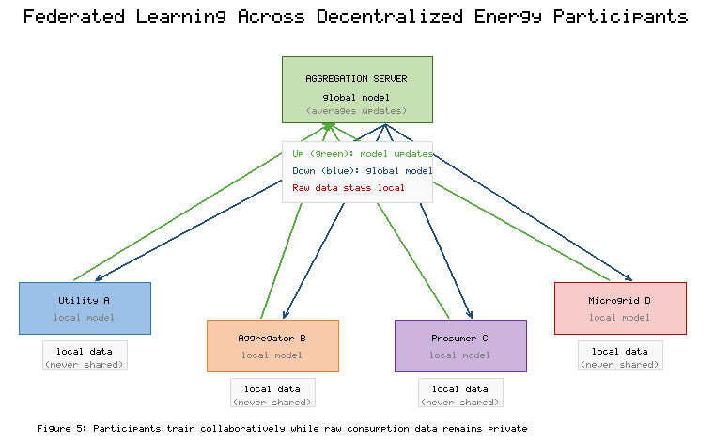
Figure 5. Federated Learning Across Decentralized Energy Participants Preserving Local Data Privacy
Explainable artificial intelligence is the final emerging technology considered here, and it addresses the critical need for trust and accountability in AI-driven grid decisions. As AI methods assume greater responsibility for consequential decisions in the operation of critical infrastructure, the opacity of complex models such as deep neural networks becomes a serious concern, because operators, regulators, and consumers must be able to understand and trust the decisions that affect reliability and cost [39]. Explainable AI encompasses methods that render the behavior of models interpretable, whether by using inherently transparent models or by providing post-hoc explanations of complex ones, so that the reasoning behind a forecast or control action can be examined and validated [40]. In the high-stakes context of grid operation, explainability supports the detection of errors, the satisfaction of regulatory requirements, and the building of the confidence that is a prerequisite for the wider adoption of AI, making it an essential complement to the predictive and control capabilities developed throughout the chapter.

5. Challenges, Evaluation, and Future Directions

5.1 Critical Challenges in AI-Enabled Renewable Integration
Despite the transformative potential of artificial intelligence for renewable integration, a set of critical challenges constrains its effectiveness and must be confronted honestly, beginning with the propagation of forecasting errors through grid operations. Because forecasts drive scheduling, dispatch, storage operation, and control, errors in those forecasts do not remain isolated but propagate and sometimes amplify through the chain of decisions that depend on them [41]. A generation forecast that proves too optimistic can cascade into inadequate reserves, emergency actions, and compromised reliability, while systematic biases can lead to persistent inefficiency. Managing this propagation requires not only more accurate forecasts but also decision processes that are robust to the errors that inevitably remain, which in turn demands that forecasts honestly characterize their own uncertainty rather than presenting point predictions as if they were certain.
Data quality and computational complexity present practical obstacles that can undermine even well-designed AI systems. The data-driven methods at the heart of modern grid analytics are only as good as the data they consume, and real-world grid data are frequently incomplete, noisy, erroneous, or inconsistent, reflecting sensor failures, communication losses, and the heterogeneity of legacy and modern equipment [42]. Poor data quality degrades model performance and can produce misleading predictions, making data cleaning, validation, and imputation essential but often underappreciated components of any deployment. Computational complexity compounds the difficulty, because the most capable AI methods can demand substantial computational resources for training and, in some cases, for real-time inference, posing challenges for deployment at the scale and speed that grid operation requires. Table 4 organizes the principal challenges, their consequences, and the mitigation strategies that current research and practice offer.
[Insert Table 4 here]
Table 4. Critical Challenges in AI-Enabled Renewable Integration and Mitigation Strategies
Challenge | Primary Consequence | Contributing Factors | Mitigation Strategy
Forecasting-error propagation | Reserve shortfalls, inefficiency | Uncertainty, horizon length | Probabilistic forecasts, robust dispatch
Data quality | Degraded, misleading predictions | Sensor faults, missing data | Cleaning, validation, imputation
Computational complexity | Deployment and latency limits | Model size, data volume | Efficient models, edge computing
Cybersecurity risk | Compromised operation, safety | Expanded attack surface | Secure design, anomaly detection
Integration constraints | Limited renewable absorption | Grid capacity, inertia, policy | Flexibility, storage, market reform
Cybersecurity risks in AI-driven smart grids constitute a challenge of growing severity, because the same connectivity and automation that enable intelligent operation also expand the attack surface and the potential consequences of compromise. The proliferation of networked sensors, meters, and control systems creates many points of potential intrusion, and the reliance on data and automated decisions means that manipulated data or subverted models could cause incorrect and potentially dangerous actions [43]. AI systems introduce their own specific vulnerabilities, including adversarial attacks that manipulate inputs to induce erroneous outputs and data-poisoning attacks that corrupt the training process, threats that are especially concerning in the context of critical infrastructure. Securing AI-driven grids therefore requires attention not only to conventional cybersecurity but also to the particular risks that data-driven and automated systems introduce, and to the resilience of grid operation under attack.
Grid integration constraints and operational barriers remind us that the challenge of renewable integration is not solely computational but also physical, economic, and institutional. The physical capacity of transmission and distribution networks, the reduction of system inertia as synchronous generators are displaced, and the limits of existing protection and control schemes all constrain how much variable renewable energy a grid can absorb regardless of how good its forecasts and controls become [44]. Economic and regulatory structures, including market designs that may not adequately value flexibility and reliability, and policies that shape investment and operation, further influence the pace and extent of integration. Recognizing these constraints is essential for a balanced understanding, because artificial intelligence, for all its power, operates within a physical and institutional system whose limits it can help to manage but cannot simply transcend.

5.2 Future Research Directions and Sustainable Energy Transitions
The challenges identified above define the frontier of research, and several promising directions are poised to advance AI-enabled renewable integration, foremost among them the shift toward probabilistic forecasting. Whereas traditional point forecasts predict a single expected value, probabilistic forecasts characterize the full distribution of possible outcomes, quantifying the uncertainty that is inherent in renewable generation and demand [45]. This richer representation of uncertainty is precisely what grid operators need to manage risk, because it enables decisions that explicitly account for the likelihood and consequences of different outcomes rather than treating a single prediction as certain. The maturation of probabilistic methods, including techniques that produce calibrated prediction intervals and scenario ensembles, represents one of the most consequential directions for improving the robustness of grid operation under uncertainty, directly addressing the error-propagation challenge identified earlier.
Physics-informed machine learning is a second major direction, seeking to combine the pattern-learning power of data-driven methods with the reliability and generalization that physical principles provide. Purely data-driven models can produce predictions that violate physical laws or that fail to generalize beyond the conditions seen in training, whereas physics-informed approaches embed physical constraints and domain knowledge into the learning process, so that models respect known relationships and remain reliable even in unusual conditions [46]. In energy applications, incorporating the physics of power systems, meteorology, and device behavior into machine learning models promises forecasts and controls that are both accurate and trustworthy, mitigating the data-quality and generalization concerns that constrain purely empirical methods [47]. This fusion of physics and data reflects a broader trend toward hybrid intelligence that leverages the complementary strengths of mechanistic understanding and learned patterns.
Adaptive energy management and autonomous grid control represent the longer-term trajectory of the field, toward grids that sense, decide, and act with increasing independence as complexity grows beyond what human operators can manage directly. Advances in reinforcement learning, digital twins, and real-time optimization point toward grids capable of continuously adapting their operation to changing conditions, coordinating vast numbers of distributed resources, and maintaining reliability and efficiency with minimal human intervention [48]. Realizing this vision safely requires addressing the trust, verification, and robustness concerns discussed earlier, so that autonomous systems can be relied upon in the operation of critical infrastructure. The path toward autonomy is therefore incremental, expanding the scope of automated decision-making as confidence in its safety and performance is established through the explainability, physics-informed reliability, and rigorous evaluation that research is advancing.
The ultimate purpose of these technical advances is to enable a sustainable energy transition, and artificial intelligence contributes to this goal by making possible the efficient utilization of renewable resources, the reduction of carbon emissions, and the resilience of the energy system. By improving forecasts, optimizing the use of storage and flexibility, and enabling higher renewable penetration, AI increases the fraction of electricity that can be supplied from clean sources and reduces the curtailment of renewable energy and the reliance on fossil-fueled backup [49]. These contributions support the decarbonization of the power sector that is central to addressing climate change, and they extend to the broader electrification of transport, heating, and industry that a sustainable transition requires [50]. Table 5 maps the principal future research directions onto the challenges they address and the sustainability outcomes they support, synthesizing the chapter's analysis into a forward-looking agenda.
[Insert Table 5 here]
Table 5. Future Research Directions, Challenges Addressed, and Sustainability Outcomes
Research Direction | Challenge Addressed | Technical Contribution | Sustainability Outcome
Probabilistic forecasting | Error propagation, uncertainty | Calibrated uncertainty quantification | Robust, risk-aware operation
Physics-informed ML | Data quality, generalization | Physically consistent predictions | Reliable high-penetration grids
Adaptive/autonomous control | Complexity, scale | Self-optimizing coordination | Efficient renewable utilization
Explainable and secure AI | Trust, cybersecurity | Interpretable, resilient decisions | Trustworthy critical infrastructure
Federated and edge learning | Privacy, computation | Decentralized, efficient learning | Scalable distributed participation

6. Conclusion
Renewable energy integration and forecasting stand at the heart of the transition to a sustainable electricity system, and artificial intelligence has proven to be the enabling technology that makes high-penetration renewable grids operable. This chapter has traced the full arc of the subject, from the physical foundations of variable renewable resources and the integration challenges they pose, through the machine learning paradigms that address them, to the forecasting, data integration, and intelligent management that translate those paradigms into operational capability. The analysis has shown that the variability and uncertainty of solar, wind, hybrid, and distributed resources, far from being obstacles that defeat data-driven methods, are precisely the conditions under which artificial intelligence delivers its greatest value, by learning the complex relationships between weather, time, and power that conventional methods cannot capture and by managing the residual uncertainty that remains.
The chapter has emphasized that forecasting is the foundational capability upon which all intelligent management rests, and that its quality sets a ceiling on the quality of every downstream decision, from dispatch and storage operation to demand response and predictive control. The sensing and data infrastructure of the Internet of Things, smart metering, and weather-data fusion supplies the information these methods require, while the emerging technologies of digital twins, reinforcement learning, federated learning, and explainable artificial intelligence are extending the reach of intelligent management toward decentralized, adaptive, and trustworthy operation. Together, these capabilities enable the smart grid to behave as an adaptive, self-optimizing system, closing the loop from sensing through prediction to decision and action in a manner that becomes increasingly essential as renewable penetration rises and the margin for error narrows.
At the same time, the chapter has insisted on a balanced view that acknowledges the challenges of forecasting-error propagation, data quality, computational complexity, cybersecurity, and the physical, economic, and institutional constraints within which any technology must operate. The future directions of probabilistic forecasting, physics-informed machine learning, and adaptive autonomous control, supported by explainable and secure artificial intelligence and by decentralized learning, chart a path toward grids that are simultaneously more capable and more trustworthy. The ultimate purpose of these advances is the efficient utilization of renewable resources, the reduction of carbon emissions, and the resilience of the energy system, outcomes that are central to addressing climate change. In enabling these outcomes, artificial intelligence does not merely optimize the grid but helps to make possible the sustainable energy transition on which a low-carbon future depends.

References
[1] Luque, A., & Hegedus, S. (2011). Handbook of photovoltaic science and engineering (2nd ed.). John Wiley & Sons.
[2] Burton, T., Jenkins, N., Sharpe, D., & Bossanyi, E. (2011). Wind energy handbook (2nd ed.). John Wiley & Sons.
[3] Akorede, M. F., Hizam, H., & Pouresmaeil, E. (2010). Distributed energy resources and benefits to the environment. Renewable and Sustainable Energy Reviews, 14(2), 724–734.
[4] Ela, E., Milligan, M., & Kirby, B. (2011). Operating reserves and variable generation (NREL/TP-5500-51978). National Renewable Energy Laboratory.
[5] Milano, F., Dörfler, F., Hug, G., Hill, D. J., & Verbič, G. (2018). Foundations and challenges of low-inertia systems. In 2018 Power Systems Computation Conference (PSCC) (pp. 1–25). IEEE.
[6] Lund, P. D., Lindgren, J., Mikkola, J., & Salpakari, J. (2015). Review of energy system flexibility measures to enable high levels of variable renewable electricity. Renewable and Sustainable Energy Reviews, 45, 785–807.
[7] Hong, T., Pinson, P., Fan, S., Zareipour, H., Troccoli, A., & Hyndman, R. J. (2016). Probabilistic energy forecasting: Global Energy Forecasting Competition 2014 and beyond. International Journal of Forecasting, 32(3), 896–913.
[8] Jordan, M. I., & Mitchell, T. M. (2015). Machine learning: Trends, perspectives, and prospects. Science, 349(6245), 255–260.
[9] Haykin, S. (2009). Neural networks and learning machines (3rd ed.). Pearson Prentice Hall.
[10] LeCun, Y., Bengio, Y., & Hinton, G. (2015). Deep learning. Nature, 521(7553), 436–444.
[11] Hochreiter, S., & Schmidhuber, J. (1997). Long short-term memory. Neural Computation, 9(8), 1735–1780.
[12] Dietterich, T. G. (2000). Ensemble methods in machine learning. In Multiple Classifier Systems (pp. 1–15). Springer.
[13] Ahmad, T., Zhang, H., & Yan, B. (2020). A review on renewable energy and electricity requirement forecasting models for smart grid and buildings. Sustainable Cities and Society, 55, 102052.
[14] Zhang, D., Han, X., & Deng, C. (2018). Review on the research and practice of deep learning and reinforcement learning in smart grids. CSEE Journal of Power and Energy Systems, 4(3), 362–370.
[15] Antonanzas, J., Osorio, N., Escobar, R., Urraca, R., Martinez-de-Pison, F. J., & Antonanzas-Torres, F. (2016). Review of photovoltaic power forecasting. Solar Energy, 136, 78–111.
[16] Wang, H., Lei, Z., Zhang, X., Zhou, B., & Peng, J. (2019). A review of deep learning for renewable energy forecasting. Energy Conversion and Management, 198, 111799.
[17] Wang, X., Guo, P., & Huang, X. (2011). A review of wind power forecasting models. Energy Procedia, 12, 770–778.
[18] Hong, T., & Fan, S. (2016). Probabilistic electric load forecasting: A tutorial review. International Journal of Forecasting, 32(3), 914–938.
[19] Kong, W., Dong, Z. Y., Jia, Y., Hill, D. J., Xu, Y., & Zhang, Y. (2019). Short-term residential load forecasting based on LSTM recurrent neural network. IEEE Transactions on Smart Grid, 10(1), 841–851.
[20] Qian, Z., Pei, Y., Zareipour, H., & Chen, N. (2019). A review and discussion of decomposition-based hybrid models for wind energy forecasting applications. Applied Energy, 235, 939–953.
[21] Hyndman, R. J., & Koehler, A. B. (2006). Another look at measures of forecast accuracy. International Journal of Forecasting, 22(4), 679–688.
[22] Al-Fuqaha, A., Guizani, M., Mohammadi, M., Aledhari, M., & Ayyash, M. (2015). Internet of Things: A survey on enabling technologies, protocols, and applications. IEEE Communications Surveys & Tutorials, 17(4), 2347–2376.
[23] Alahakoon, D., & Yu, X. (2016). Smart electricity meter data intelligence for future energy systems: A survey. IEEE Transactions on Industrial Informatics, 12(1), 425–436.
[24] Sweeney, C., Bessa, R. J., Browell, J., & Pinson, P. (2020). The future of forecasting for renewable energy. Wiley Interdisciplinary Reviews: Energy and Environment, 9(2), e365.
[25] Vázquez-Canteli, J. R., & Nagy, Z. (2019). Reinforcement learning for demand response: A review of algorithms and modeling techniques. Applied Energy, 235, 1072–1089.
[26] Ozay, M., Esnaola, I., Yarman Vural, F. T., Kulkarni, S. R., & Poor, H. V. (2016). Machine learning methods for attack detection in the smart grid. IEEE Transactions on Neural Networks and Learning Systems, 27(8), 1773–1786.
[27] Siano, P. (2014). Demand response and smart grids—A survey. Renewable and Sustainable Energy Reviews, 30, 461–478.
[28] Antonopoulos, I., Robu, V., Couraud, B., Kirli, D., Norbu, S., Kiprakis, A., ... & Wattam, S. (2020). Artificial intelligence and machine learning approaches to energy demand-side response: A systematic review. Renewable and Sustainable Energy Reviews, 130, 109899.
[29] Luo, X., Wang, J., Dooner, M., & Clarke, J. (2015). Overview of current development in electrical energy storage technologies and the application potential in power system operation. Applied Energy, 137, 511–536.
[30] Weitzel, T., & Glock, C. H. (2018). Energy management for stationary electric energy storage systems: A systematic literature review. European Journal of Operational Research, 264(2), 582–606.
[31] Molina-García, A., Bouffard, F., & Kirschen, D. S. (2011). Decentralized demand-side contribution to primary frequency control. IEEE Transactions on Power Systems, 26(1), 411–419.
[32] Parisio, A., Rikos, E., & Glielmo, L. (2014). A model predictive control approach to microgrid operation optimization. IEEE Transactions on Control Systems Technology, 22(5), 1813–1827.
[33] Tao, F., Zhang, H., Liu, A., & Nee, A. Y. C. (2019). Digital twin in industry: State-of-the-art. IEEE Transactions on Industrial Informatics, 15(4), 2405–2415.
[34] Brosinsky, C., Westermann, D., & Krebs, R. (2018). Recent and prospective developments in power system control centers: Adopting the digital twin technology concept. In 2018 IEEE International Energy Conference (ENERGYCON) (pp. 1–6). IEEE.
[35] Sutton, R. S., & Barto, A. G. (2018). Reinforcement learning: An introduction (2nd ed.). MIT Press.
[36] Mocanu, E., Mocanu, D. C., Nguyen, P. H., Liotta, A., Webber, M. E., Gibescu, M., & Slootweg, J. G. (2019). On-line building energy optimization using deep reinforcement learning. IEEE Transactions on Smart Grid, 10(4), 3698–3708.
[37] McMahan, B., Moore, E., Ramage, D., Hampson, S., & Arcas, B. A. (2017). Communication-efficient learning of deep networks from decentralized data. In Proceedings of the 20th International Conference on Artificial Intelligence and Statistics (pp. 1273–1282).
[38] Saputra, Y. M., Hoang, D. T., Nguyen, D. N., Dutkiewicz, E., Mueck, M. D., & Srikanteswara, S. (2019). Energy demand prediction with federated learning for electric vehicle networks. In 2019 IEEE Global Communications Conference (GLOBECOM) (pp. 1–6). IEEE.
[39] Arrieta, A. B., Díaz-Rodríguez, N., Del Ser, J., Bennetot, A., Tabik, S., Barbado, A., ... & Herrera, F. (2020). Explainable artificial intelligence (XAI): Concepts, taxonomies, opportunities and challenges toward responsible AI. Information Fusion, 58, 82–115.
[40] Machlev, R., Heistrene, L., Perl, M., Levy, K. Y., Belikov, J., Mannor, S., & Levron, Y. (2022). Explainable artificial intelligence (XAI) techniques for energy and power systems: Review, challenges and opportunities. Energy and AI, 9, 100169.
[41] Bessa, R. J., Möhrlen, C., Fundel, V., Siefert, M., Browell, J., Haglund El Gaidi, S., ... & Kariniotakis, G. (2017). Towards improved understanding of the applicability of uncertainty forecasts in the electric power industry. Energies, 10(9), 1402.
[42] Wang, Y., Chen, Q., Hong, T., & Kang, C. (2019). Review of smart meter data analytics: Applications, methodologies, and challenges. IEEE Transactions on Smart Grid, 10(3), 3125–3148.
[43] Sun, C. C., Hahn, A., & Liu, C. C. (2018). Cyber security of a power grid: State-of-the-art. International Journal of Electrical Power & Energy Systems, 99, 45–56.
[44] Kroposki, B., Johnson, B., Zhang, Y., Gevorgian, V., Denholm, P., Hodge, B. M., & Hannegan, B. (2017). Achieving a 100% renewable grid: Operating electric power systems with extremely high levels of variable renewable energy. IEEE Power and Energy Magazine, 15(2), 61–73.
[45] Gneiting, T., & Katzfuss, M. (2014). Probabilistic forecasting. Annual Review of Statistics and Its Application, 1, 125–151.
[46] Karniadakis, G. E., Kevrekidis, I. G., Lu, L., Perdikaris, P., Wang, S., & Yang, L. (2021). Physics-informed machine learning. Nature Reviews Physics, 3(6), 422–440.
[47] Huang, B., & Wang, J. (2023). Applications of physics-informed neural networks in power systems: A review. IEEE Transactions on Power Systems, 38(1), 572–588.
[48] Glavic, M., Fonteneau, R., & Ernst, D. (2017). Reinforcement learning for electric power system decision and control: Past considerations and perspectives. IFAC-PapersOnLine, 50(1), 6918–6927.
[49] Rolnick, D., Donti, P. L., Kaack, L. H., Kochanski, K., Lacoste, A., Sankaran, K., ... & Bengio, Y. (2022). Tackling climate change with machine learning. ACM Computing Surveys, 55(2), 1–96.
[50] International Energy Agency. (2021). Net zero by 2050: A roadmap for the global energy sector. International Energy Agency.
Note: This chapter contains 50 unique references cited throughout the text.

