Graded Assignment: Weeks 1-6 — Final Output
Student ID: STU2024001
Deliverables: IDCard.html, IDCard_styles.css, StudentApp.html, StudentApp.js
The <title> of every HTML file is set to the Student ID and each source file contains a Student-ID comment, so it appears in the browser tab in the live screenshots.
Question 1 — Student Identity Card
Output Screenshot
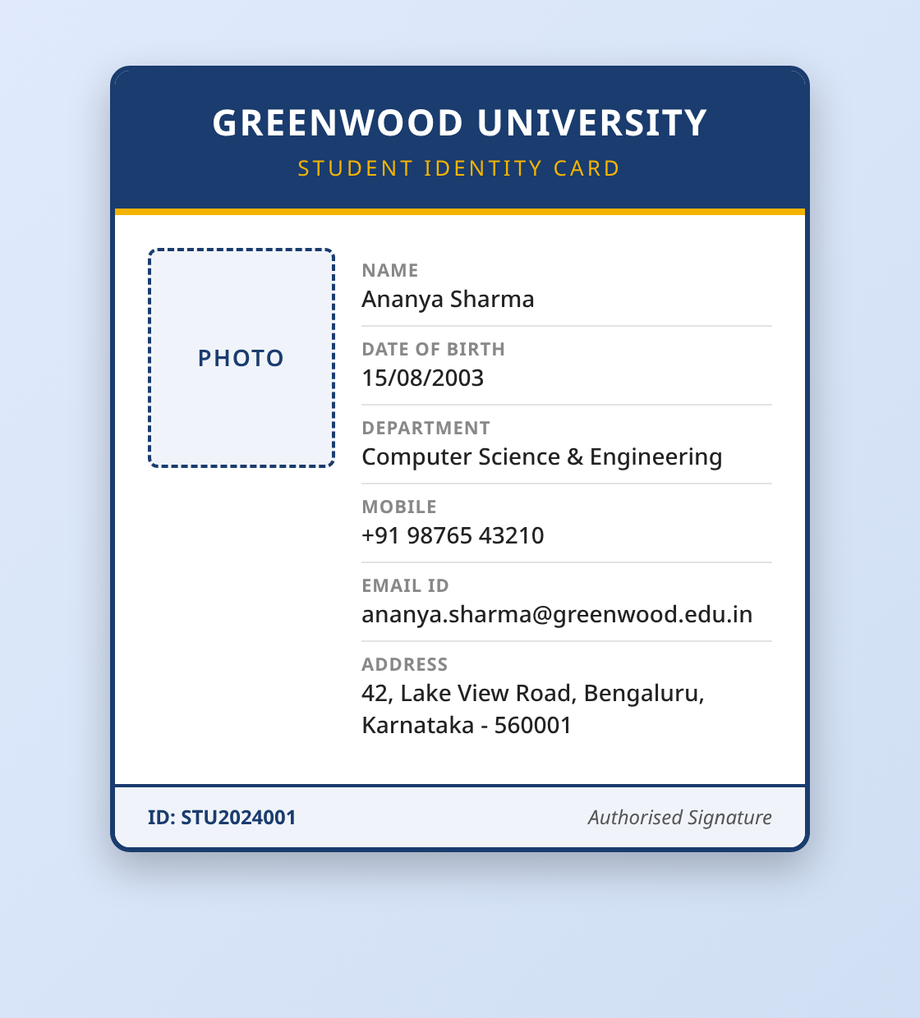
Figure 1: IDCard.html rendered in the browser (name, DOB, photo placeholder, department, mobile, email, address; Student ID in the footer).
Source Code
IDCard.html
<!DOCTYPE html>
<!--
=====================================================================
Graded Assignment (Weeks 1-6) - Question 1
Student Identity Card
Student ID: STU2024001 <-- replace with your real Student ID
=====================================================================
-->
<html lang="en">

<head>
<meta charset="UTF-8" />
<!-- Make the card responsive on mobile + desktop -->
<meta name="viewport" content="width=device-width, initial-scale=1.0" />

<!-- The page title is set to the Student ID so it is visible in screenshots -->
<title>STU2024001</title>

<!-- Link the external CSS file to this HTML document -->
<link rel="stylesheet" href="IDCard_styles.css" />
</head>

<body>
<!-- =============================================================
Main container that holds the whole identity card
============================================================== -->
<div class="id-card">

<!-- Card header with the institution name -->
<header class="card-header">
<h1>GREENWOOD UNIVERSITY</h1>
<p class="sub-title">Student Identity Card</p>
</header>

<!-- Card body: photograph on the left, details on the right -->
<div class="card-body">

<!-- Photograph section (placeholder box for the photo) -->
<div class="photo-section">
<!-- Self-contained placeholder standing in for the student photo -->
<div class="photo" role="img" aria-label="Student Photograph">
<span>PHOTO</span>
</div>
</div>

<!-- Details section with all student information -->
<div class="details-section">
<ul class="details-list">
<li>
<span class="label">Name</span>
<span class="value">Ananya Sharma</span>
</li>
<li>
<span class="label">Date of Birth</span>
<span class="value">15/08/2003</span>
</li>
<li>
<span class="label">Department</span>
<span class="value">Computer Science &amp; Engineering</span>
</li>
<li>
<span class="label">Mobile</span>
<span class="value">+91 98765 43210</span>
</li>
<li>
<span class="label">Email ID</span>
<span class="value">ananya.sharma@greenwood.edu.in</span>
</li>
<li>
<span class="label">Address</span>
<span class="value">42, Lake View Road, Bengaluru, Karnataka - 560001</span>
</li>
</ul>
</div>
</div>

<!-- Card footer with a signature line -->
<footer class="card-footer">
<span class="footer-id">ID: STU2024001</span>
<span class="signature">Authorised Signature</span>
</footer>
</div>
</body>

</html>

IDCard_styles.css
/* =====================================================================
Graded Assignment (Weeks 1-6) - Question 1
Stylesheet for the Student Identity Card
Student ID: STU2024001
=====================================================================
This file demonstrates:
- Element selectors (body, h1, ul, li, img ...)
- Class selectors (.id-card, .label, .value ...)
- ID-style targeting via descendant/class combinations
- Font styling (family, size, weight)
- Borders to separate card sections
- Responsive layout using a media query
===================================================================== */

/* ---------- Element selector: page background & base font ---------- */
body {
font-family: "Segoe UI", Tahoma, Geneva, Verdana, sans-serif;
background: linear-gradient(135deg, #e0eafc, #cfdef3);
margin: 0;
padding: 40px 15px;
display: flex;
justify-content: center;
align-items: flex-start;
min-height: 100vh;
}

/* ---------- Class selector: the main ID card container ---------- */
.id-card {
width: 420px;
max-width: 100%;
background: #ffffff;
border: 3px solid #1a3c6e; /* strong outer border for the whole card */
border-radius: 12px;
box-shadow: 0 10px 25px rgba(0, 0, 0, 0.25);
overflow: hidden;
}

/* ---------- Card header ---------- */
.card-header {
background: #1a3c6e;
color: #ffffff;
text-align: center;
padding: 16px 10px;
border-bottom: 4px solid #f4b400; /* accent border under the header */
}

/* Element selector for the heading inside the header */
.card-header h1 {
margin: 0;
font-size: 22px;
font-weight: 700;
letter-spacing: 1px;
}

.card-header .sub-title {
margin: 4px 0 0;
font-size: 13px;
font-weight: 400;
text-transform: uppercase;
letter-spacing: 2px;
color: #f4b400;
}

/* ---------- Card body: photo + details side by side ---------- */
.card-body {
display: flex;
gap: 16px;
padding: 20px;
}

/* ---------- Photograph placeholder ---------- */
.photo-section {
flex: 0 0 auto;
}

.photo {
width: 110px;
height: 130px;
border: 2px dashed #1a3c6e; /* dashed border to show it is a placeholder */
border-radius: 6px;
background: #f0f4fa;
display: flex;
align-items: center;
justify-content: center;
color: #1a3c6e;
font-size: 14px;
font-weight: 600;
letter-spacing: 1px;
}

/* ---------- Details list ---------- */
.details-section {
flex: 1 1 auto;
}

/* Element selector: remove default list styling */
.details-list {
list-style: none;
margin: 0;
padding: 0;
}

/* Each detail row gets a thin separating border */
.details-list li {
padding: 6px 0;
border-bottom: 1px solid #e3e3e3; /* separates each piece of information */
font-size: 14px;
line-height: 1.4;
}

/* The last row should not have a bottom border */
.details-list li:last-child {
border-bottom: none;
}

/* Class selector: field labels */
.label {
display: block;
font-size: 11px;
font-weight: 700;
text-transform: uppercase;
letter-spacing: 0.5px;
color: #888;
}

/* Class selector: field values */
.value {
display: block;
font-size: 14px;
font-weight: 500;
color: #222;
}

/* ---------- Card footer ---------- */
.card-footer {
display: flex;
justify-content: space-between;
align-items: center;
padding: 10px 20px;
background: #f0f4fa;
border-top: 2px solid #1a3c6e; /* border separating footer from body */
font-size: 12px;
}

.footer-id {
font-weight: 700;
color: #1a3c6e;
}

.signature {
font-style: italic;
color: #555;
}

/* =====================================================================
Responsive design: stack photo above details on small screens
===================================================================== */
@media (max-width: 480px) {
.card-body {
flex-direction: column;
align-items: center;
text-align: center;
}

.details-list li {
text-align: left;
}

.card-header h1 {
font-size: 18px;
}
}

Question 2 — Student ID Card Application Form
Output Screenshots
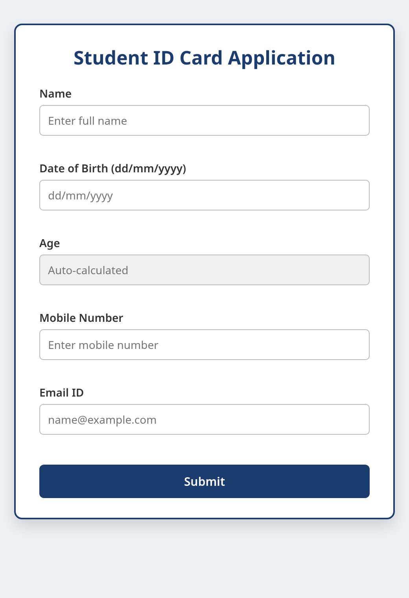
Figure 2: StudentApp.html application form (Name, DOB, read-only Age, Mobile, Email, Submit).
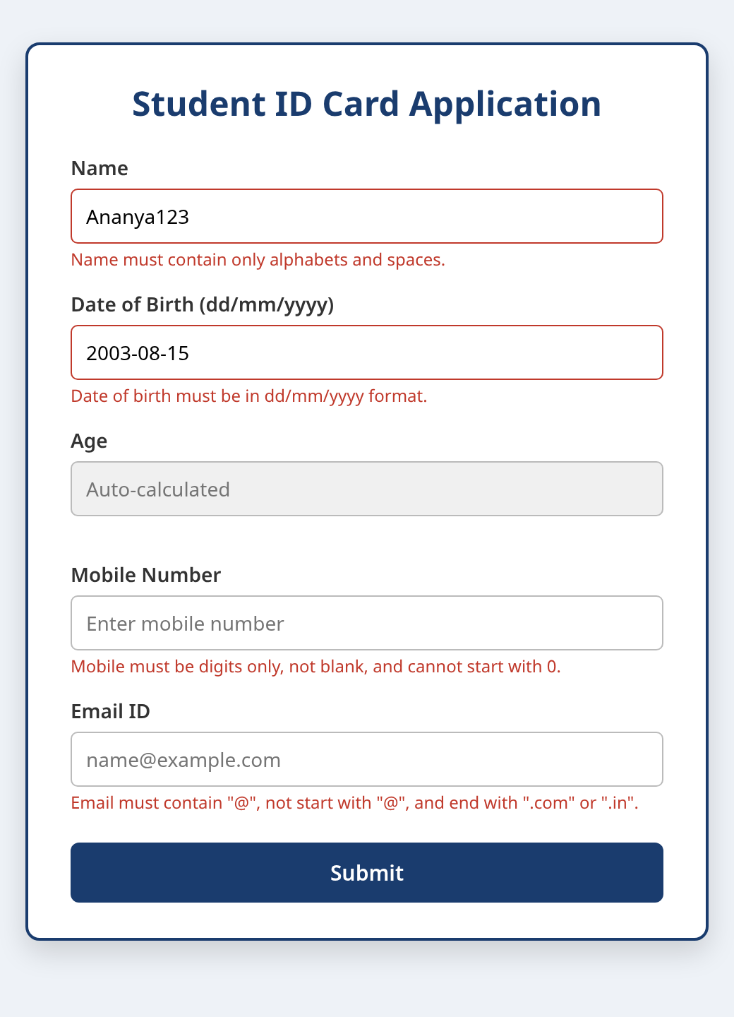
Figure 3: onfocusout validation in action — invalid name, wrong date format, and the mobile/email rules shown as error messages.
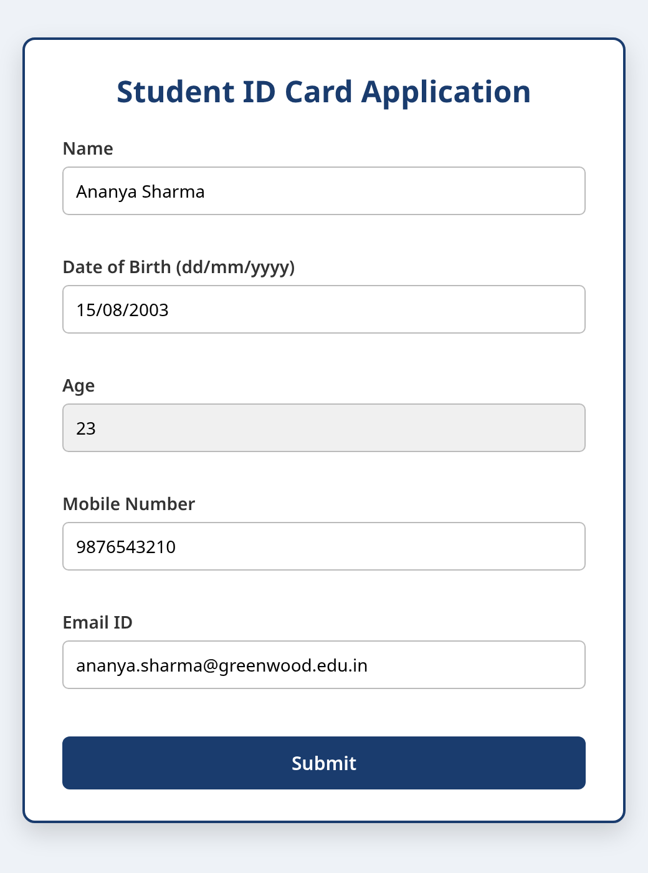
Figure 4: Form completed with valid data; Age is auto-calculated from the date of birth.
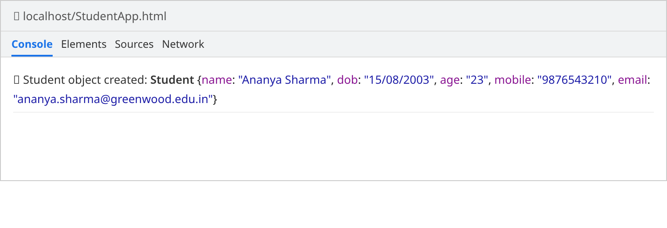
Figure 5: On submit a Student class object is created and printed via console.log.
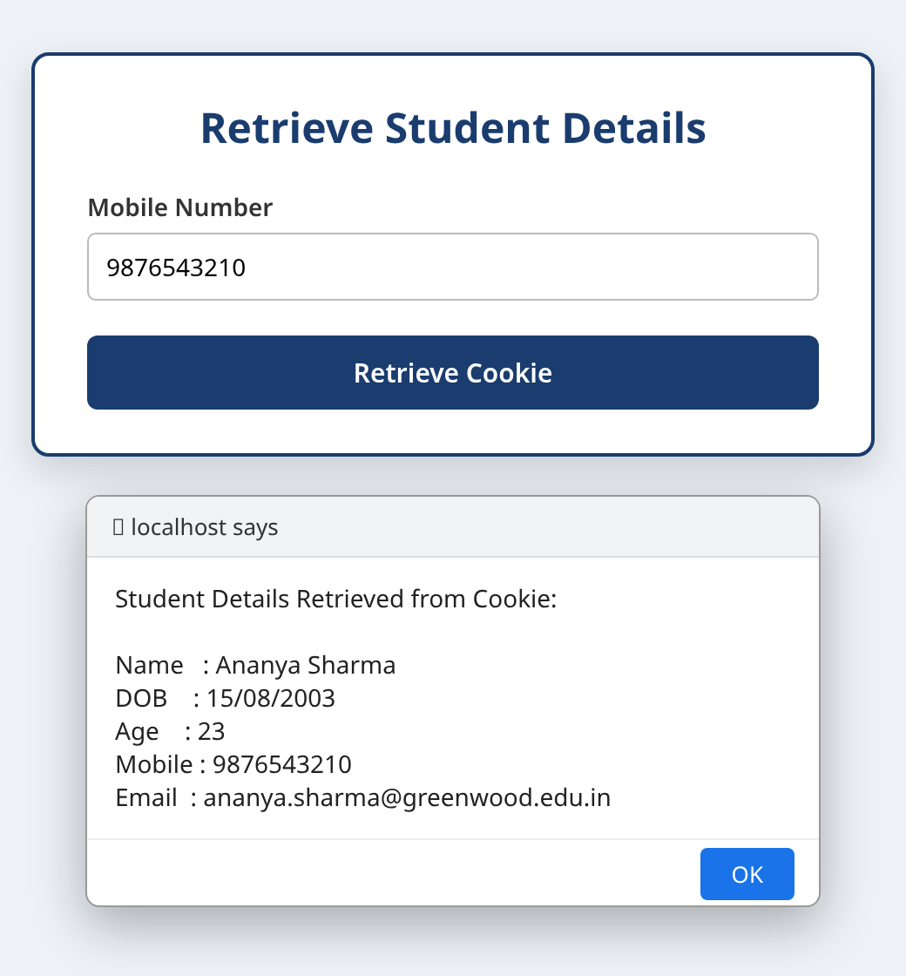
Figure 6: Retrieve page — the mobile number reads the cookie and shows the stored student details in an alert.
Source Code
StudentApp.html
<!DOCTYPE html>
<!--
=====================================================================
Graded Assignment (Weeks 1-6) - Question 2
Student ID Card Application Form
Student ID: STU2024001 <-- replace with your real Student ID
=====================================================================
-->
<html lang="en">

<head>
<meta charset="UTF-8" />
<meta name="viewport" content="width=device-width, initial-scale=1.0" />

<!-- Page title set to the Student ID so it is visible in screenshots -->
<title>STU2024001</title>

<!-- Minimal inline styling just to make the form readable -->
<style>
body {
font-family: "Segoe UI", Tahoma, sans-serif;
background: #eef2f7;
margin: 0;
padding: 30px 15px;
display: flex;
justify-content: center;
}

.card {
background: #fff;
width: 420px;
max-width: 100%;
padding: 25px 30px;
border: 2px solid #1a3c6e;
border-radius: 10px;
box-shadow: 0 8px 20px rgba(0, 0, 0, 0.15);
}

h2 {
text-align: center;
color: #1a3c6e;
margin-top: 0;
}

label {
display: block;
margin-top: 14px;
font-weight: 600;
font-size: 14px;
color: #333;
}

input {
width: 100%;
padding: 9px 10px;
margin-top: 5px;
border: 1px solid #bbb;
border-radius: 5px;
font-size: 14px;
box-sizing: border-box;
}

input[readonly] {
background: #f0f0f0;
}

.error {
color: #c0392b;
font-size: 12px;
min-height: 15px;
display: block;
margin-top: 3px;
}

button {
width: 100%;
margin-top: 20px;
padding: 11px;
background: #1a3c6e;
color: #fff;
border: none;
border-radius: 6px;
font-size: 15px;
font-weight: 600;
cursor: pointer;
}

button:hover {
background: #16325c;
}

.hidden {
display: none;
}
</style>
</head>

<body>

<!-- =============================================================
PAGE 1 : Student application form
============================================================== -->
<div class="card" id="formPage">
<h2>Student ID Card Application</h2>

<form id="studentForm" onsubmit="return submitForm(event)">

<!-- Name field -->
<label for="name">Name</label>
<input type="text" id="name" name="name"
onfocusout="validateName()" placeholder="Enter full name" />
<span class="error" id="nameError"></span>

<!-- Date of birth field -->
<label for="dob">Date of Birth (dd/mm/yyyy)</label>
<input type="text" id="dob" name="dob"
onfocusout="validateDob()" placeholder="dd/mm/yyyy" />
<span class="error" id="dobError"></span>

<!-- Age field (read-only, auto-calculated) -->
<label for="age">Age</label>
<input type="text" id="age" name="age" readonly placeholder="Auto-calculated" />
<span class="error" id="ageError"></span>

<!-- Mobile number field -->
<label for="mobile">Mobile Number</label>
<input type="text" id="mobile" name="mobile"
onfocusout="validateMobile()" placeholder="Enter mobile number" />
<span class="error" id="mobileError"></span>

<!-- Email ID field -->
<label for="email">Email ID</label>
<input type="text" id="email" name="email"
onfocusout="validateEmail()" placeholder="name@example.com" />
<span class="error" id="emailError"></span>

<button type="submit">Submit</button>
</form>
</div>

<!-- =============================================================
PAGE 2 : Retrieve details from the cookie
(shown only after a successful submission)
============================================================== -->
<div class="card hidden" id="retrievePage">
<h2>Retrieve Student Details</h2>

<label for="retrieveMobile">Mobile Number</label>
<input type="text" id="retrieveMobile" placeholder="Enter mobile number" />

<button type="button" onclick="retrieveCookie()">Retrieve Cookie</button>
</div>

<!-- Link the external JavaScript file -->
<script src="StudentApp.js"></script>
</body>

</html>

StudentApp.js
/* =====================================================================
Graded Assignment (Weeks 1-6) - Question 2
JavaScript validation, Student class, and cookie handling
Student ID: STU2024001
=====================================================================
Contents:
1. Field validation functions (fire on the "onfocusout" event)
2. Student class used to build an object from the form fields
3. Cookie store (on submit) and cookie retrieve (on button click)
===================================================================== */

/* =====================================================================
1. VALIDATION FUNCTIONS
Each function returns true/false and shows an inline error message.
===================================================================== */

/* ---- Name: only alphabets and spaces, must not be blank ---- */
function validateName() {
const field = document.getElementById("name");
const error = document.getElementById("nameError");
const value = field.value.trim();

// Regular expression: one or more letters/spaces only
const namePattern = /^[A-Za-z ]+$/;

if (value === "") {
error.textContent = "Name cannot be blank.";
return false;
}
if (!namePattern.test(value)) {
error.textContent = "Name must contain only alphabets and spaces.";
return false;
}

error.textContent = "";
return true;
}

/* ---- Date of Birth: must be in dd/mm/yyyy format, not blank ---- */
function validateDob() {
const field = document.getElementById("dob");
const error = document.getElementById("dobError");
const value = field.value.trim();

// dd/mm/yyyy : 2 digits / 2 digits / 4 digits
const dobPattern = /^(\d{2})\/(\d{2})\/(\d{4})$/;

if (value === "") {
error.textContent = "Date of birth cannot be blank.";
document.getElementById("age").value = "";
return false;
}

const match = value.match(dobPattern);
if (!match) {
error.textContent = "Date of birth must be in dd/mm/yyyy format.";
document.getElementById("age").value = "";
return false;
}

// Basic range check on day and month
const day = parseInt(match[1], 10);
const month = parseInt(match[2], 10);
if (day < 1 || day > 31 || month < 1 || month > 12) {
error.textContent = "Please enter a valid day and month.";
document.getElementById("age").value = "";
return false;
}

error.textContent = "";
// Once the date is valid, calculate the age automatically
calculateAge(match);
return true;
}

/* ---- Age: calculated from the date of birth (read-only field) ---- */
function calculateAge(match) {
const day = parseInt(match[1], 10);
const month = parseInt(match[2], 10);
const year = parseInt(match[3], 10);

const birthDate = new Date(year, month - 1, day);
const today = new Date();

let age = today.getFullYear() - birthDate.getFullYear();

// Adjust if the birthday has not occurred yet this year
const monthDiff = today.getMonth() - birthDate.getMonth();
if (monthDiff < 0 || (monthDiff === 0 && today.getDate() < birthDate.getDate())) {
age--;
}

document.getElementById("age").value = age >= 0 ? age : "";
}

/* ---- Mobile: digits [0-9] only, not blank, cannot start with 0 ---- */
function validateMobile() {
const field = document.getElementById("mobile");
const error = document.getElementById("mobileError");
const value = field.value.trim();

// First digit 1-9, followed by any digits
const mobilePattern = /^[1-9][0-9]*$/;

if (value === "" || !mobilePattern.test(value)) {
error.textContent =
"Mobile must be digits only, not blank, and cannot start with 0.";
field.value = ""; // Rule: clear the field on error
return false;
}

error.textContent = "";
return true;
}

/* ---- Email: must contain "@", not begin with "@", end with .com/.in ---- */
function validateEmail() {
const field = document.getElementById("email");
const error = document.getElementById("emailError");
const value = field.value.trim();

const hasAt = value.includes("@");
const startsWithAt = value.startsWith("@");
const endsCorrectly = value.endsWith(".com") || value.endsWith(".in");

if (!hasAt || startsWithAt || !endsCorrectly) {
error.textContent =
'Email must contain "@", not start with "@", and end with ".com" or ".in".';
field.value = ""; // Rule: clear the field on error
return false;
}

error.textContent = "";
return true;
}

/* =====================================================================
2. STUDENT CLASS
Used to bundle all form fields into a single object.
===================================================================== */
class Student {
constructor(name, dob, age, mobile, email) {
this.name = name;
this.dob = dob;
this.age = age;
this.mobile = mobile;
this.email = email;
}

// Convert the student object into a string for cookie storage
toCookieString() {
return JSON.stringify(this);
}
}

/* =====================================================================
3. COOKIE HELPERS
===================================================================== */

/* Store a cookie with a given name, value and lifetime (in days) */
function setCookie(cookieName, value, days) {
const date = new Date();
date.setTime(date.getTime() + days * 24 * 60 * 60 * 1000);
const expires = "expires=" + date.toUTCString();
// encodeURIComponent keeps the JSON safe inside the cookie
document.cookie =
cookieName + "=" + encodeURIComponent(value) + ";" + expires + ";path=/";
}

/* Read a cookie by name; returns the decoded value or null */
function getCookie(cookieName) {
const target = cookieName + "=";
const parts = document.cookie.split(";");
for (let part of parts) {
part = part.trim();
if (part.indexOf(target) === 0) {
return decodeURIComponent(part.substring(target.length));
}
}
return null;
}

/* =====================================================================
FORM SUBMISSION
Validate everything, build the Student object, store it in a cookie,
log it to the console, and move to the retrieve page.
===================================================================== */
function submitForm(event) {
event.preventDefault(); // stop the page from reloading

// Run every validation; all must pass
const valid =
validateName() &
validateDob() &
validateMobile() &
validateEmail();

if (!valid) {
alert("Please correct the highlighted fields before submitting.");
return false;
}

// Build the object from the form using the Student class
const student = new Student(
document.getElementById("name").value.trim(),
document.getElementById("dob").value.trim(),
document.getElementById("age").value.trim(),
document.getElementById("mobile").value.trim(),
document.getElementById("email").value.trim()
);

// Requirement: display the object details in the console log
console.log("Student object created:", student);

// Store the object (as JSON) inside a cookie for 7 days.
// The mobile number is also stored separately as the lookup key.
setCookie("studentData", student.toCookieString(), 7);
setCookie("studentMobile", student.mobile, 7);

// "Navigate" to the next page by swapping the visible sections
document.getElementById("formPage").classList.add("hidden");
document.getElementById("retrievePage").classList.remove("hidden");

return false;
}

/* =====================================================================
RETRIEVE DETAILS FROM COOKIE
The user types a mobile number; if it matches the stored one,
the saved student details are shown in an alert.
===================================================================== */
function retrieveCookie() {
const enteredMobile = document.getElementById("retrieveMobile").value.trim();
const storedData = getCookie("studentData");

if (!storedData) {
alert("No student record was found in the cookie.");
return;
}

const student = JSON.parse(storedData);

if (enteredMobile === student.mobile) {
const message =
"Student Details Retrieved from Cookie:\n\n" +
"Name : " + student.name + "\n" +
"DOB : " + student.dob + "\n" +
"Age : " + student.age + "\n" +
"Mobile : " + student.mobile + "\n" +
"Email : " + student.email;
alert(message);
} else {
alert("No matching record found for mobile number: " + enteredMobile);
}
}

