Chapter 10

Digital Twin Applications in Organ and System-Level Physiological Simulation

Abstract
Digital twin technology represents a transformative paradigm in modern healthcare, enabling the creation of patient-specific virtual replicas of human organs and physiological systems. These computational constructs integrate multimodal data streams from medical imaging, electronic health records, wearable sensors, and genomic databases to generate dynamic, continuously updated models that mirror the physiological state of individual patients. The convergence of artificial intelligence, high-performance computing, and advanced medical imaging has accelerated the development of organ-level and system-level digital twins capable of simulating cardiovascular hemodynamics, pulmonary mechanics, neurological activity, musculoskeletal biomechanics, and multi-organ interactions. This chapter provides a comprehensive examination of the foundational concepts, architectural frameworks, and clinical applications of physiological digital twins. The discussion encompasses image-based anatomical modeling, multiscale physiological simulation, AI-enhanced state estimation, and predictive scenario-based analysis for personalized medicine. Critical challenges including validation, interoperability, ethical considerations, and regulatory pathways are addressed. The chapter concludes with perspectives on autonomous digital twins enabled by generative AI and foundation models, highlighting their potential to revolutionize diagnosis, treatment planning, and preventive healthcare through continuous patient-specific physiological monitoring and virtual clinical experimentation.
Keywords: Digital twin, physiological simulation, organ modeling, artificial intelligence, patient-specific modeling, cardiovascular digital twin, precision medicine, multiscale simulation, predictive healthcare

Section I: Foundations of Organ- and System-Level Digital Twins

10.1 Concept and Architecture of Physiological Digital Twins
The concept of a digital twin originated in the manufacturing and aerospace industries during the early twenty-first century, where virtual replicas of physical assets enabled predictive maintenance, performance optimization, and lifecycle management [1]. The fundamental premise involves creating a computational model that maintains bidirectional synchronization with its physical counterpart, continuously receiving sensor data and providing predictive insights. In healthcare, this concept has evolved into the physiological digital twin, defined as a dynamic, patient-specific computational model that continuously integrates multimodal clinical data to represent the anatomical structure, physiological function, and temporal evolution of biological systems [2]. Unlike static models or population-averaged simulations, digital twins are characterized by their living nature, adapting and evolving as new patient data becomes available and clinical conditions change.
The evolution of digital twins in medicine has progressed through several distinct generations, each building upon preceding capabilities while introducing fundamentally new functionalities. First-generation medical digital twins focused primarily on anatomically accurate three-dimensional reconstructions derived from computed tomography and magnetic resonance imaging, providing static geometric models suitable for visualization and surgical planning [3]. Second-generation twins incorporated physiological dynamics, including hemodynamic flow patterns, electrical conduction pathways, and mechanical stress distributions, enabling simulation of organ function under various conditions [4]. Third-generation digital twins introduced real-time data assimilation and continuous model updating, creating responsive virtual representations that track patient physiology over time. The current fourth generation leverages artificial intelligence to achieve autonomous parameter estimation, self-calibrating models, predictive forecasting, and scenario-based optimization across multiple organ systems simultaneously [5]. This progression represents a fundamental shift from descriptive to predictive to prescriptive modeling capabilities.
The architecture of an AI-augmented physiological digital twin comprises several interconnected layers organized in a hierarchical framework (Figure 1). The data acquisition layer at the base ingests heterogeneous information from medical imaging modalities including computed tomography, magnetic resonance imaging, ultrasound, and nuclear medicine; electronic health records containing clinical notes, diagnoses, medications, and procedures; continuous physiological monitors providing real-time hemodynamic, respiratory, and neurological signals; wearable sensors capturing ambulatory activity, sleep patterns, and physiological parameters; and laboratory analyses including blood chemistry, genomics, and biomarker measurements [6]. The computational engine layer employs physics-based solvers including finite element methods for structural mechanics, computational fluid dynamics for flow simulation, lumped-parameter models for system-level hemodynamics, and reaction-diffusion equations for electrophysiology. The artificial intelligence layer provides machine learning algorithms for pattern recognition, deep learning networks for feature extraction and prediction, physics-informed neural networks for hybrid modeling that respects physical constraints while learning from data, and reinforcement learning for treatment optimization [7]. The integration layer couples these components into a coherent digital twin that maintains consistency across spatial scales ranging from molecular and cellular processes to whole-organ and system-level dynamics. The clinical application layer at the top translates simulation outputs into actionable insights for diagnosis, treatment planning, prognostication, and clinical decision support.
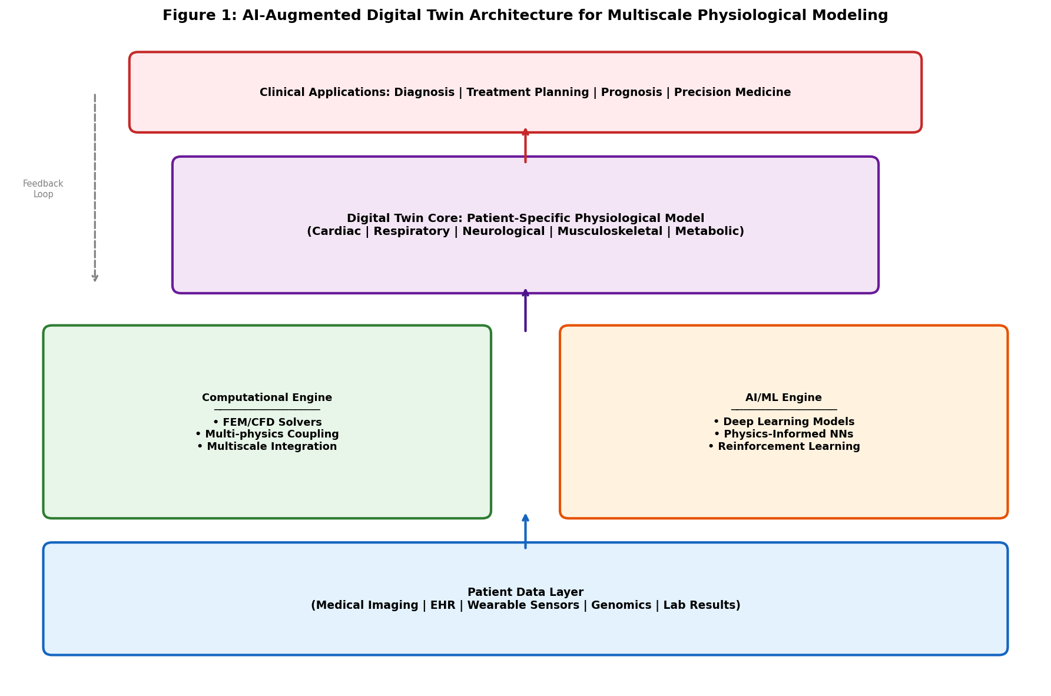
Figure 1: AI-Augmented Digital Twin Architecture for Multiscale Physiological Modeling

The fidelity of physiological digital twins depends critically on the quality, completeness, and temporal currency of patient-specific data. Integration protocols must reconcile fundamental differences in temporal resolution ranging from millisecond electrophysiological recordings to monthly laboratory tests, spatial granularity spanning from micrometer histological detail to whole-organ morphology, and measurement uncertainty varying from highly precise imaging measurements to subjective clinical assessments [8]. Modern approaches employ Bayesian frameworks for uncertainty quantification, enabling digital twins to express confidence intervals around their predictions and flag situations requiring additional clinical data or human judgment. The architecture illustrated in Figure 1 demonstrates how these diverse data streams are processed through computational and AI layers to generate clinically actionable outputs while maintaining appropriate uncertainty characterization.

10.2 Image-Based Modeling of Human Organs and Systems
Medical imaging provides the anatomical foundation upon which physiological digital twins are constructed, supplying the geometric substrate that determines organ shape, internal structure, and spatial relationships critical for accurate simulation. Multiple imaging modalities contribute complementary information that collectively characterize human anatomy with sufficient detail for computational modeling: computed tomography delivers high-resolution structural detail of bones, calcified tissues, and contrast-enhanced vasculature with isotropic spatial resolution below one millimeter; magnetic resonance imaging reveals soft tissue morphology, myocardial fiber orientation, perfusion characteristics, and tissue composition through diverse contrast mechanisms; echocardiography captures real-time cardiac motion and hemodynamic parameters with high temporal resolution; and positron emission tomography maps metabolic activity, receptor binding, and molecular processes relevant to disease characterization [9]. The selection and combination of imaging modalities are guided by the specific organ system, clinical questions being addressed, and the physiological parameters required for simulation.
The transformation of medical images into computational models involves a systematic pipeline of processing steps, each requiring specialized algorithms and quality assurance procedures. Image segmentation constitutes the first critical step, identifying anatomical structures of interest and separating organs, tissues, vascular territories, and pathological regions from surrounding anatomy [10]. Deep learning-based segmentation algorithms, particularly U-Net architectures and their numerous variants including attention U-Net, nnU-Net, and transformer-enhanced architectures, have substantially improved the accuracy and speed of anatomical segmentation, achieving near-expert performance across many organs while dramatically reducing manual intervention requirements [11]. Image registration aligns datasets acquired at different times, with different modalities, or at different physiological states into a common coordinate system, enabling longitudinal tracking of anatomical changes, multimodal data fusion, and atlas-based analysis. Deformable registration algorithms accommodate the complex shape changes that organs undergo between imaging sessions, accounting for growth, disease progression, or respiratory and cardiac motion.
Three-dimensional reconstruction converts segmented image data into surface meshes and volumetric representations suitable for computational analysis using numerical methods. Mesh generation algorithms produce discretized geometric models with element sizes tailored to capture physiologically relevant features while maintaining computational tractability [12]. The meshing process must balance competing requirements: sufficient spatial resolution to resolve thin structures such as vessel walls, valve leaflets, and cortical bone layers; adequate element quality metrics including aspect ratio, skewness, and Jacobian determinant to ensure numerical stability; and manageable total element counts to permit simulation within clinically acceptable timeframes. Adaptive mesh refinement strategies concentrate computational resources in regions of complex geometry or steep physiological gradients, such as arterial bifurcations where flow patterns are highly three-dimensional, cardiac valve leaflet edges where contact occurs, or cortical-cancellous bone interfaces where stress concentrations develop.
The conversion of image-derived geometric models into functional simulation frameworks requires assignment of material properties, boundary conditions, and initial physiological states that transform inert geometry into living virtual organs. Material properties including tissue stiffness, viscoelastic parameters, electrical conductivity, thermal properties, and permeability are derived from literature values, population-specific databases, or patient-specific measurements obtained through specialized imaging techniques such as magnetic resonance elastography, diffusion tensor imaging, or T1/T2 mapping [13]. Boundary conditions specify physiological loads, pressures, velocities, and concentrations at model interfaces, drawing upon invasive hemodynamic measurements, non-invasive pressure estimations, phase-contrast magnetic resonance velocimetry, or physiological waveform libraries scaled to patient-specific parameters. Initial conditions establish the starting physiological state from which simulations proceed, requiring estimation of internal stress distributions, residual strains, and pre-existing physiological gradients that are not directly observable but influence subsequent model behavior.

10.3 Multiscale Physiological Simulation and Model Coupling
Physiological processes inherently span multiple spatial and temporal scales, from molecular interactions within individual cells occurring over nanoseconds and nanometers to coordinated organ function involving centimeter-scale structures operating over cardiac cycles, to whole-body homeostatic regulation maintaining stability over days to years. Multiscale simulation frameworks address this extraordinary complexity by coupling computational models operating at different scales through well-defined interfaces that preserve physical conservation laws and ensure information transfer between levels [14]. At the molecular and cellular scale, models describe ion channel kinetics governing electrical excitability, metabolic pathways converting substrates to energy, signaling cascades mediating cellular responses, and gene regulatory networks controlling protein expression. Tissue-level models capture emergent properties arising from cellular interactions, including electrical wave propagation in excitable media, synchronized mechanical contraction in muscle, and coordinated fluid transport in epithelial barriers [15]. Organ-level models integrate tissue behaviors into functionally complete units capable of pumping blood, exchanging gases, filtering waste, or processing information. System-level models represent interactions between organs through circulatory transport, autonomic nervous system regulation, and hormonal communication pathways.
The coupling of models across scales presents formidable computational challenges that remain active areas of research. Temporal scale differences between fast electrophysiological events occurring in milliseconds, intermediate hemodynamic processes evolving over cardiac cycles, and slow remodeling phenomena progressing over weeks to months require specialized numerical methods to maintain accuracy while achieving computational efficiency [16]. Approaches include adaptive time-stepping algorithms that adjust temporal resolution according to local dynamics, operator splitting techniques that decompose coupled problems into sequentially solvable sub-problems, and hierarchical model reduction methods that replace expensive fine-scale computations with efficient surrogate representations at coarser scales. Spatial scale bridging employs homogenization methods that derive effective macroscopic properties from microscale structure, representative volume elements that sample local behavior for upscaling, and concurrent multiscale methods that embed fine-scale regions within coarser-scale domains where detailed resolution is required.
Artificial intelligence has emerged as a transformative tool for addressing multiscale simulation challenges that have traditionally limited the clinical applicability of physiological models. Physics-informed neural networks learn to approximate solutions of the partial differential equations governing physiological processes while incorporating physical conservation laws, constitutive relationships, and boundary conditions as soft constraints within the training objective [17]. Neural operators and deep operator networks provide mesh-independent mappings between function spaces, enabling rapid evaluation of parametric simulation families that would otherwise require expensive numerical solutions for each parameter configuration. Gaussian process emulators and polynomial chaos expansions construct computationally efficient surrogate models for forward uncertainty quantification, propagating measurement uncertainties and parameter variabilities through complex simulation chains to produce probabilistic predictions with quantified confidence bounds [18]. These AI-enhanced approaches reduce simulation times from hours to seconds, making real-time clinical application feasible.
Table 1: Multiscale Hierarchy in Physiological Digital Twin Modeling
Scale Level | Spatial Range | Temporal Range | Key Processes | Modeling Approach
Molecular | 1-100 nm | ns-μs | Ion channels, protein folding | Molecular dynamics, kinetic models
Cellular | 10-100 μm | ms-min | Action potentials, metabolism | ODE systems, agent-based models
Tissue | 0.1-10 mm | ms-hours | Wave propagation, contraction | PDE systems, FEM
Organ | 1-30 cm | ms-days | Cardiac function, respiration | CFD, FSI, FEM
System | Whole body | s-years | Hemodynamics, homeostasis | Lumped-parameter, network models

Parameter estimation and model calibration represent critical steps in personalizing multiscale simulations to individual patients, transforming generic models into patient-specific digital twins. Inverse problem formulations adjust model parameters systematically to minimize discrepancies between simulated and measured physiological variables, accounting for measurement noise and model structural uncertainty [19]. AI-assisted calibration employs neural network surrogates trained on extensive simulation databases to accelerate the evaluation of forward models within optimization loops, reducing calibration times from hours of iterative simulation to seconds of neural network inference, thereby enabling real-time model personalization in clinical settings. Table 1 summarizes the multiscale hierarchy employed in physiological digital twin modeling, illustrating the extraordinary range of spatial scales from nanometers to whole-body dimensions, temporal dynamics from nanoseconds to years, and the diverse computational approaches integrated within comprehensive digital twin frameworks to capture this complexity.

Section II: Digital Twin Applications in Major Organ Systems

10.4 Cardiovascular Digital Twins
The cardiovascular system has been the primary and most advanced focus of physiological digital twin development, driven by the enormous global clinical burden of cardiac and vascular diseases responsible for approximately eighteen million deaths annually, and the availability of sophisticated cardiac imaging modalities providing detailed anatomical and functional information [20]. Patient-specific cardiovascular digital twins integrate anatomical reconstructions from cardiac magnetic resonance imaging or computed tomography angiography with hemodynamic simulations based on computational fluid dynamics, fluid-structure interaction, and solid mechanics methodologies. These models capture complex blood flow patterns including vortex formation, recirculation zones, and turbulent transition; pressure distributions throughout the vascular tree; wall shear stress patterns influencing endothelial function and atherosclerotic plaque development; and myocardial mechanics including contraction, relaxation, and fiber strain with personalized accuracy reflecting individual patient anatomy and hemodynamic conditions [21].
Electrophysiological modeling constitutes another critical component of cardiovascular digital twins, addressing the electrical activation and recovery processes that govern cardiac rhythm and contractile coordination. Patient-specific models of cardiac electrical activation incorporate anatomical details from imaging including chamber geometry, wall thickness, scar location and extent; fiber orientation from diffusion tensor magnetic resonance imaging determining anisotropic conduction velocities; and electrophysiological properties calibrated against surface electrocardiographic recordings and invasive electrophysiology study data [22]. These models simulate normal sinus rhythm conduction sequences, arrhythmia initiation through ectopic foci or reentrant circuits, arrhythmia maintenance mechanisms including anatomical and functional reentry, and the effects of pharmacological antiarrhythmic therapies or catheter ablation interventions on cardiac rhythm restoration (Figure 2). The coupling of electrophysiological models with mechanical models through excitation-contraction coupling creates electromechanical digital twins capable of predicting both rhythm disorders and their hemodynamic consequences.
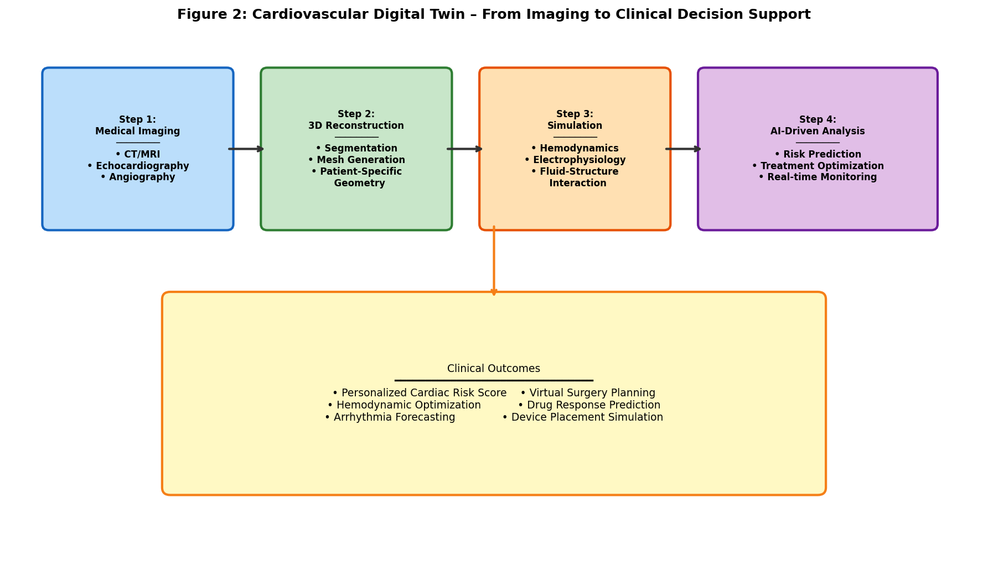
Figure 2: Cardiovascular Digital Twin – From Imaging to Clinical Decision Support

The clinical applications of cardiovascular digital twins span the full spectrum from diagnosis through risk stratification to treatment optimization and post-intervention monitoring. Fractional flow reserve derived from coronary computed tomography angiography represents the most clinically mature application, utilizing computational fluid dynamics within patient-specific coronary artery reconstructions to assess the hemodynamic significance of coronary stenoses without requiring invasive cardiac catheterization [23]. This technology has received regulatory approval and is being adopted in clinical practice, demonstrating the translational viability of computational physiological modeling. Virtual surgical planning employs digital twins to predict outcomes of complex cardiac interventions including valve repair or replacement, coronary artery bypass grafting, ventricular assist device implantation, and congenital heart disease palliation before actual surgical intervention, enabling optimization of procedural approach and device selection [24]. AI-driven predictive models integrated within cardiovascular digital twins forecast heart failure progression trajectories, quantify sudden cardiac death risk through virtual arrhythmia induction protocols, and identify optimal timing for therapeutic interventions based on patient-specific physiological evolution.
Table 2: Clinical Applications of Cardiovascular Digital Twins
Application | Imaging Modality | Simulation Type | Clinical Output | Validation Status
Coronary FFR | CT Angiography | CFD | Stenosis significance | FDA-approved
Cardiac Ablation | MRI/CT | Electrophysiology | Ablation target mapping | Clinical trials
Heart Failure | Echo/MRI | Coupled electromech. | CRT response prediction | Multicenter studies
Aortic Aneurysm | CT/MRI | FSI | Rupture risk score | Retrospective validation
Valve Disease | Echo/CT | FSI + CFD | Surgical outcome prediction | Single-center studies

As demonstrated in Table 2 and illustrated in Figure 2, cardiovascular digital twins have achieved varying levels of clinical maturity across different applications, reflecting the diversity of cardiovascular pathology and the specific validation requirements for each clinical context. The progression from research prototypes through retrospective validation to prospective clinical trials and ultimately regulatory approval demonstrates the translational potential of this technology, while highlighting the rigorous and time-intensive validation journey necessary for clinical deployment [25]. Current research directions include the development of fully coupled electromechanical-hemodynamic models that capture the complete physiology of heart failure, integration of coronary microvascular modeling for assessment of microvascular disease, and the application of machine learning to accelerate simulation times enabling real-time intraoperative guidance.

10.5 Respiratory and Pulmonary Digital Twins
Respiratory digital twins model the complex mechanics of breathing, gas exchange, and pulmonary hemodynamics within patient-specific airway and lung parenchymal geometries, addressing diseases that collectively represent the third leading cause of death worldwide [26]. Image-based reconstruction of the tracheobronchial tree from high-resolution computed tomography enables computational fluid dynamics simulations of inspiratory and expiratory airflow patterns, particle deposition distributions, and aerosol drug delivery efficiency. These models capture the intricate branching architecture of conducting airways from the trachea through approximately sixteen generations of bifurcations visible on clinical imaging, with extensions to terminal bronchioles and alveolar ducts through statistical generation algorithms, fractal models, or volume-filling space-filling approaches that reproduce the morphometric characteristics of the distal lung.
The simulation of pulmonary mechanics encompasses tissue elasticity governing lung compliance, surface tension effects at the alveolar air-liquid interface, chest wall mechanics including rib cage and diaphragm contributions, and the complex coupled motion of chest wall, diaphragm, pleural space, and lung parenchyma during the respiratory cycle [27]. Patient-specific compliance and resistance parameters characterizing the mechanical behavior of individual lungs are derived from standard pulmonary function tests including spirometry and plethysmography, specialized measurements such as esophageal manometry for transpulmonary pressure estimation, and dynamic imaging sequences including four-dimensional computed tomography and dynamic magnetic resonance imaging that capture regional lung motion and ventilation distribution. Digital twins of gas exchange simulate oxygen uptake and carbon dioxide elimination across the alveolar-capillary membrane, incorporating spatial heterogeneity of ventilation-perfusion matching, diffusion limitation effects in thickened membranes, and shunt physiology relevant to conditions including chronic obstructive pulmonary disease, interstitial pulmonary fibrosis, acute respiratory distress syndrome, and pulmonary hypertension.
Clinical applications of respiratory digital twins have expanded significantly in recent years, driven partly by the global respiratory disease burden highlighted during the COVID-19 pandemic. Optimization of mechanical ventilation strategies represents a high-impact application where digital twins predict patient response to ventilator setting adjustments including tidal volume, positive end-expiratory pressure, respiratory rate, and inspiratory flow patterns [28]. By simulating the regional distribution of ventilation, recruitment of collapsed lung units, and risk of ventilator-induced lung injury, these models guide protective ventilation strategies tailored to individual lung mechanics. AI-enhanced respiratory models integrate continuous monitoring data from ventilators, pulse oximeters, capnographs, and electrical impedance tomography to provide real-time predictions of oxygenation trajectory and identify patients at risk of deterioration. During the pandemic, respiratory digital twins were employed to simulate the pathophysiological effects of severe acute respiratory syndrome coronavirus on pulmonary function, to optimize prone positioning protocols, and to guide recruitment maneuver strategies for patients with severe hypoxemia [29]. These applications demonstrated the potential for rapid adaptation of digital twin technology to emerging clinical challenges.

10.6 Brain, Musculoskeletal, and Other Organ Digital Twins
Neurological digital twins represent perhaps the most intellectually ambitious frontier in physiological modeling, given the extraordinary structural and functional complexity of the human brain comprising approximately eighty-six billion neurons connected through trillions of synapses organized in intricate networks spanning multiple spatial scales. Current approaches to brain digital twins encompass macroscale connectome-based models derived from diffusion tensor imaging tractography and functional connectivity analysis, representing brain regions as nodes in large-scale networks with connection strengths estimated from imaging data [30]. Mesoscale neural mass models simulate cortical column dynamics, representing the average behavior of neuronal populations through coupled differential equations that capture excitatory and inhibitory interactions. Patient-specific models of neurovascular coupling link neural activity patterns to hemodynamic responses observable through functional magnetic resonance imaging, enabling interpretation of brain imaging signals in terms of underlying neural processes. Clinical applications with demonstrated potential include simulation of epileptic seizure initiation and propagation for surgical planning, prediction of neurodegenerative disease progression trajectories in conditions such as Alzheimer's disease and Parkinson's disease, optimization of deep brain stimulation parameters for movement disorders, and personalization of transcranial magnetic stimulation protocols for psychiatric conditions.
Musculoskeletal digital twins model the complex biomechanical interactions between bones, articular cartilage, ligaments, tendons, skeletal muscles, and neural control systems during movement and mechanical loading, addressing a spectrum of orthopedic conditions affecting hundreds of millions of people worldwide [31]. Patient-specific musculoskeletal models reconstructed from computed tomography for bone geometry and density distribution, and magnetic resonance imaging for soft tissue morphology and composition, enable finite element analysis of joint contact mechanics, bone stress distributions, cartilage loading patterns, and fracture risk assessment. Motion capture data combined with inverse dynamics analyses and muscle optimization algorithms personalize the loading conditions experienced during daily activities, exercise, and rehabilitation exercises. Longitudinal imaging tracks bone mineral density changes, cartilage thickness reduction, and soft tissue degeneration over time, enabling digital twins to predict disease progression and intervention timing. Clinical applications include pre-operative planning for total joint replacement with optimal implant sizing and positioning, design of patient-specific orthopedic implants using additive manufacturing, fracture fixation optimization, and evidence-based rehabilitation program design [32].
Digital twins of other organ systems including the kidneys, liver, pancreas, and gastrointestinal tract are advancing rapidly as computational methods and organ-specific imaging capabilities mature. Renal digital twins simulate glomerular filtration dynamics, tubular transport of solutes and water, medullary concentration gradients, and whole-kidney hemodynamics including autoregulatory mechanisms, enabling prediction of nephrotoxicity risks from drugs and contrast agents, optimization of dialysis prescriptions for end-stage renal disease, and assessment of donor kidney function before transplantation [33]. Hepatic digital twins model hepatic blood flow through the dual portal-arterial supply, drug metabolism through cytochrome P450 enzyme systems, bile formation and secretion, and regeneration capacity following surgical resection, supporting operative planning for liver surgery. Gastrointestinal digital twins simulate motility patterns, nutrient absorption kinetics, drug dissolution and absorption profiles, and microbiome interactions for optimizing oral drug delivery formulations and diagnosing functional gastrointestinal disorders. The integration of these individual organ models into connected whole-body frameworks through shared circulatory, neural, and hormonal communication pathways represents a critical ongoing development direction addressed in subsequent sections.

Section III: AI-Driven System-Level Physiological Simulation

10.7 AI-Enhanced Physiological State Estimation
Physiological state estimation refers to the continuous inference of internal body states from available measurements, analogous to state estimation in control engineering and navigation systems where hidden variables must be inferred from noisy, incomplete observations. In the context of physiological digital twins, AI algorithms process streams of clinical observations to update model parameters and state variables in real time, maintaining synchronization between the virtual model and the physical patient it represents [34]. This dynamic updating process transforms digital twins from static computational snapshots into living computational entities that evolve continuously alongside their human counterparts, adapting to physiological changes, responding to therapeutic interventions, and tracking disease progression with personalized temporal resolution determined by data availability.
Deep learning architectures have demonstrated remarkable capabilities for physiological state estimation across diverse clinical scenarios. Recurrent neural networks and their gated variants including long short-term memory networks and gated recurrent units process time-series data from continuous physiological monitors to extract temporal signatures indicative of underlying pathophysiological states [35]. Temporal convolutional networks offer parallel processing advantages for long sequences while maintaining sensitivity to local temporal patterns. Transformer architectures and multi-head attention mechanisms enable selective focusing on clinically relevant temporal patterns and events while maintaining awareness of long-range dependencies spanning hours or days of monitoring data. These deep learning approaches excel at detecting subtle deterioration trends invisible to human observers, identifying physiological state transitions between stable and unstable conditions, and generating early warning signals that may precede clinically apparent events by hours or days, providing valuable lead time for preventive intervention.
Data fusion represents a central challenge in physiological state estimation, requiring principled integration of heterogeneous information sources possessing fundamentally different sampling rates ranging from continuous waveforms to periodic laboratory tests, measurement uncertainties spanning from precisely calibrated sensors to subjective clinical assessments, and information content varying from direct measurements of physiological variables to indirect indicators requiring model-based interpretation [36]. Bayesian filtering frameworks provide mathematically rigorous approaches to combining prior knowledge encoded in physiological models with incoming observations in an optimally weighted manner. Extended Kalman filters handle mildly nonlinear systems through local linearization, unscented Kalman filters capture nonlinear transformations through sigma-point sampling, and particle filters address highly nonlinear and multi-modal distributions through sequential Monte Carlo methods. Deep learning-enhanced filters replace hand-crafted observation models and process noise assumptions with data-driven learned mappings, improving estimation accuracy in complex, highly nonlinear physiological systems where analytical model specification is impractical.
The adaptive updating of digital twins using continuous patient information requires sophisticated mechanisms for distinguishing between normal physiological variability reflecting circadian rhythms, activity levels, and dietary patterns; measurement artifacts from sensor displacement, motion contamination, or equipment malfunction; and genuine pathophysiological changes indicating disease onset, progression, or treatment response [37]. Online learning algorithms continuously refine model parameters to track evolving patient characteristics while maintaining stability through regularization approaches that prevent catastrophic forgetting of previously learned patient-specific features. Federated learning approaches enable digital twin models to benefit from population-level patterns and treatment response knowledge accumulated across many patients while preserving individual patient data privacy through decentralized model training that never shares raw patient data between institutions.

10.8 Whole-Body and Multi-Organ Digital Twins
The integration of individual organ digital twins into whole-body physiological frameworks represents the pinnacle of physiological simulation complexity, requiring orchestration of multiple organ models with different computational characteristics, temporal dynamics, and spatial resolutions into a coherent system that captures emergent whole-body behaviors. Whole-body digital twins must faithfully represent the intricate network of interactions between organ systems, including cardiovascular transport of oxygen, nutrients, hormones, and metabolic waste products; neural regulatory signals transmitted through autonomic and somatic pathways; hormonal communication through endocrine signaling molecules; and mechanical coupling through shared anatomical structures such as the thorax containing both heart and lungs [38]. The computational architecture for multi-organ integration employs modular designs where individual organ models function as self-contained units communicating through standardized interfaces representing physiological coupling variables such as blood flow rates, partial pressures of respiratory gases, hormone concentrations, neural firing frequencies, and mechanical boundary conditions (Figure 3).
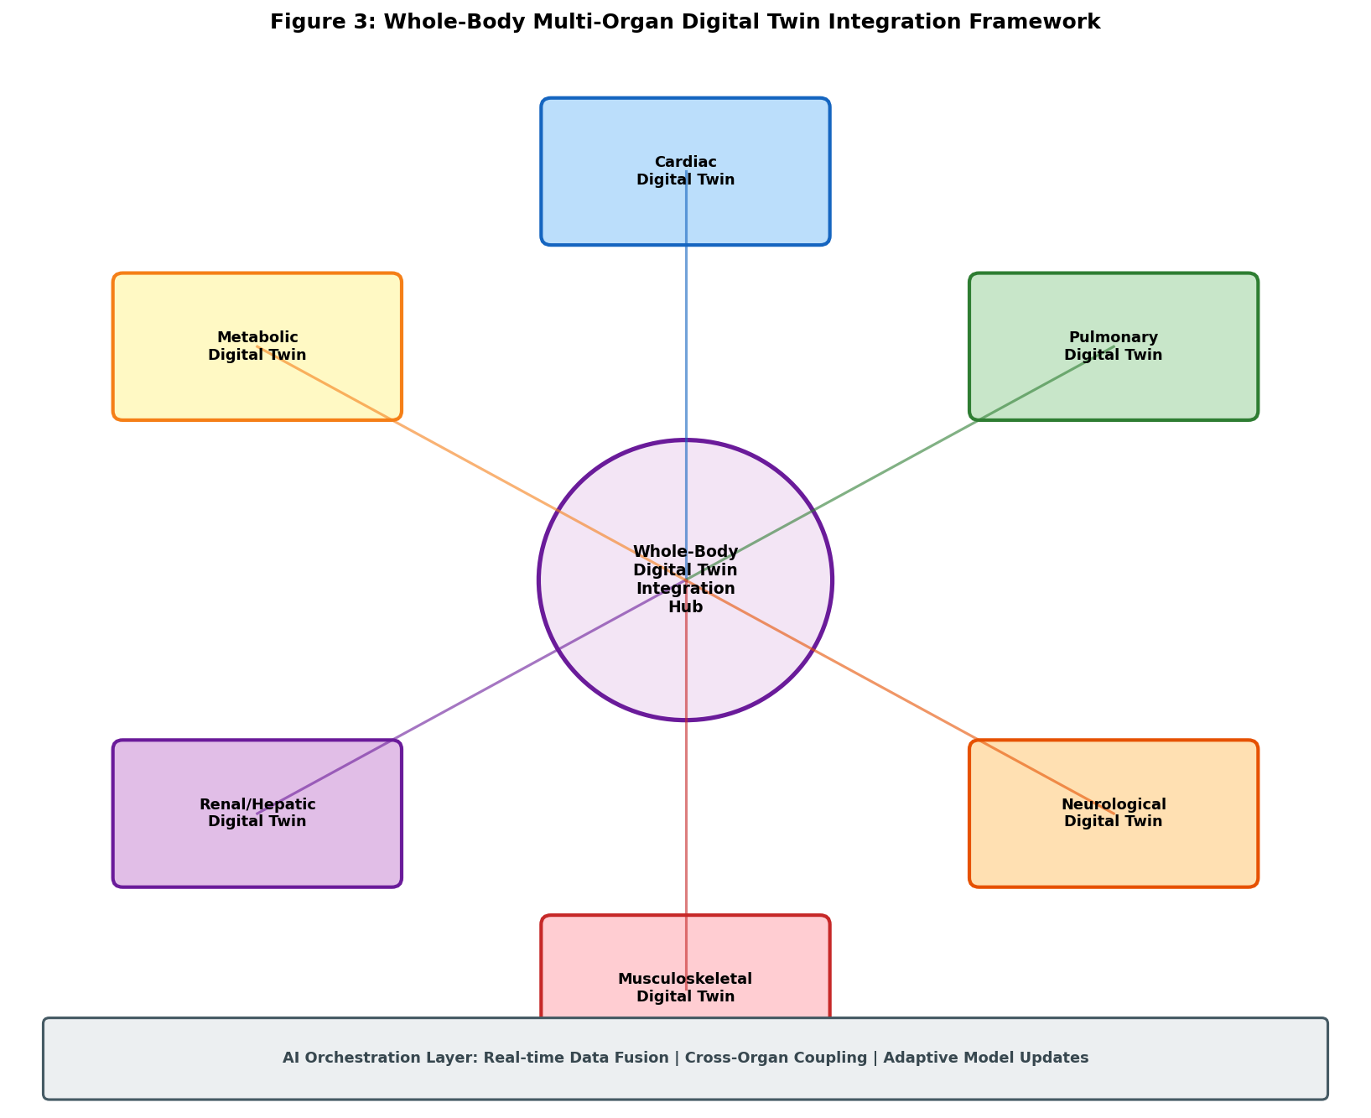
Figure 3: Whole-Body Multi-Organ Digital Twin Integration Framework

Cardiovascular-respiratory coupling represents one of the most clinically important and well-characterized multi-organ interactions, fundamentally governing oxygen delivery to tissues, carbon dioxide elimination from the body, and acid-base homeostasis essential for cellular function. Digital twins modeling this coupling simulate bidirectional interactions including the effects of cardiac output changes on pulmonary perfusion and gas exchange efficiency, the influence of intrathoracic pressure variations during breathing on cardiac filling and venous return, the baroreceptor reflex regulation of heart rate and systemic vascular resistance in response to blood pressure perturbations, and the chemoreceptor-mediated ventilatory response to changes in arterial blood gas composition [39]. These coupled cardiorespiratory models are particularly valuable in critical care settings where mechanical ventilation, vasoactive medications, and fluid administration targeting one physiological system inevitably and often unpredictably affect the other, requiring integrated simulation to anticipate interaction effects and guide coordinated therapeutic management.
Neuroendocrine-metabolic interactions constitute another domain requiring whole-body digital twin approaches due to the distributed nature of hormonal regulation spanning multiple organs and involving complex feedback loops with time delays. The hypothalamic-pituitary-adrenal axis governing stress response, the hypothalamic-pituitary-thyroid axis regulating metabolic rate, glucose-insulin dynamics involving pancreatic beta cells, hepatic glucose production, and peripheral tissue uptake, and autonomic nervous system modulation of cardiovascular and gastrointestinal function all involve intricate multi-organ feedback loops spanning diverse temporal scales from seconds to days [40]. AI-enabled simulation of these interactions supports personalized management of diabetes mellitus through insulin dosing optimization, metabolic syndrome through lifestyle intervention modeling, and endocrine disorders through hormone replacement therapy personalization. Multi-organ digital twins also enable simulation of systemic disease processes such as sepsis, where cascading organ dysfunction follows complex pathophysiological pathways involving inflammatory mediator release, hemodynamic compromise, microvascular dysfunction, mitochondrial failure, and metabolic derangement across multiple organ systems simultaneously.
Table 3: Multi-Organ Coupling in Whole-Body Digital Twins
Organ Coupling | Interaction Mechanism | Clinical Relevance | Modeling Challenge | AI Contribution
Cardio-Respiratory | Hemodynamics, gas exchange | Ventilator management | Scale bridging | Surrogate models
Neuro-Cardiac | Autonomic regulation | Arrhythmia prediction | Temporal coupling | RNN prediction
Hepato-Renal | Metabolite clearance | Drug dosing | Compartmental complexity | PK/PD networks
Musculo-Skeletal | Mechanical loading | Implant design | Contact mechanics | FEM acceleration
Endocrine-Metabolic | Hormonal feedback | Diabetes management | Multi-loop regulation | Reinforcement learning

As summarized in Table 3 and depicted in the architectural framework of Figure 3, the complexity of multi-organ coupling necessitates sophisticated AI approaches to maintain computational tractability while preserving the physiological fidelity required for clinically meaningful predictions. The modular architecture enables selective activation of organ models based on clinical relevance, allowing the digital twin to dynamically allocate computational resources to the most pertinent physiological processes for each patient's specific clinical situation, conserving resources when organs are functioning normally while increasing resolution for systems under stress or therapeutic intervention.

10.9 Predictive and Scenario-Based Physiological Simulation
One of the most transformative capabilities of physiological digital twins is their capacity for predictive simulation and virtual experimentation, transcending the traditional limitations of reactive clinical medicine. Unlike retrospective analysis that examines what has already occurred, predictive digital twins project physiological states forward in time, forecasting disease progression trajectories, anticipating physiological deterioration before clinical manifestation, and evaluating potential treatment responses before committing patients to irreversible therapeutic courses [41]. This predictive capability fundamentally transforms clinical decision-making from reactive pattern recognition to proactive computational forecasting, enabling early intervention at stages where disease modification is most effective and personalized treatment optimization based on individual predicted responses rather than population averages (Figure 4).
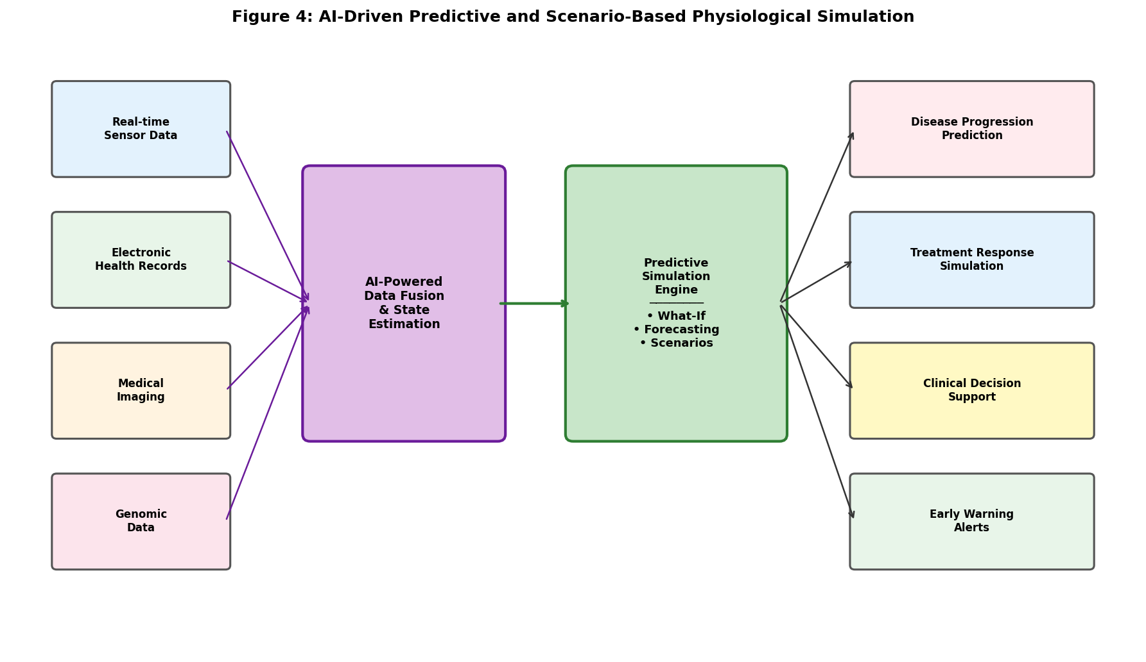
Figure 4: AI-Driven Predictive and Scenario-Based Physiological Simulation

Scenario-based analysis, frequently termed what-if simulation or virtual experimentation, empowers clinicians to test different therapeutic strategies within the computational environment of the digital twin before committing to actual clinical interventions with their associated risks and irreversibilities. For a cardiac patient being evaluated for valve surgery, this might involve simulating the hemodynamic consequences of different prosthetic valve sizes and types, comparing predicted functional outcomes of repair versus replacement strategies, evaluating the impact of concurrent coronary revascularization, and optimizing the timing of intervention relative to progressive ventricular remodeling [42]. For a patient with complex pharmacotherapy, what-if simulation might compare drug combinations, predict drug-drug interactions, evaluate dose-response relationships incorporating individual pharmacogenomic variations, and identify optimal treatment sequencing. The digital twin evaluates each scenario by running forward simulations under different parameter configurations, providing comparative outcome predictions with uncertainty quantification that inform evidence-based clinical decisions.
Real-time forecasting applications of physiological digital twins are particularly valuable in intensive care settings where rapid and often unpredictable physiological changes demand timely clinical responses. Continuous updating of the digital twin with streaming monitoring data from bedside devices enables short-term predictions of hemodynamic instability including hypotension, arrhythmia, and shock; respiratory failure including desaturation and ventilator-patient dyssynchrony; renal dysfunction including oliguria and electrolyte derangement; and multi-organ dysfunction that provide clinicians with early warning and decision support. As illustrated in Figure 4, the integration of diverse data sources through AI-powered data fusion enables comprehensive predictive capabilities that surpass what any single monitoring parameter or clinical assessment could provide alone, synthesizing information across modalities to detect complex multi-system patterns indicative of impending deterioration.
The validation of predictive simulations presents unique methodological challenges distinct from traditional model validation, as predictions must be evaluated against future outcomes that may themselves be influenced by clinical interventions triggered by the predictions. This intervention paradox means that successful predictions may appear inaccurate because clinicians acted on the warnings to prevent predicted events. Counterfactual reasoning frameworks and causal inference methods address this fundamental challenge by distinguishing the natural untreated trajectory of disease from the effects of therapeutic interventions informed by predictions, enabling unbiased assessment of predictive accuracy even in the presence of treatment effects that alter the predicted outcomes [43]. Randomized controlled trials with digital twin-guided versus standard-of-care arms provide the gold standard for demonstrating clinical utility, while observational designs with appropriate causal inference methodology offer pragmatic alternatives for initial evidence generation.

Section IV: Clinical Translation and Future Directions

10.10 Digital Twins for Diagnosis, Treatment, and Precision Medicine
The clinical translation of physiological digital twins encompasses multiple application domains spanning the continuum from diagnosis through treatment planning to longitudinal precision medicine management. In diagnostic applications, digital twins serve as computational biomarkers that extract clinically meaningful physiological parameters from multimodal data through model-based analysis, providing quantitative information not directly accessible through conventional clinical assessment. For example, cardiovascular digital twins derive myocardial contractility indices characterizing regional and global cardiac pump function, diastolic stiffness parameters reflecting myocardial fibrosis and relaxation impairment, and regional perfusion estimates quantifying microvascular blood supply that carry significant diagnostic and prognostic value beyond standard imaging measurements [23]. Similarly, respiratory digital twins compute regional ventilation-perfusion ratios and airway resistance distributions that characterize disease phenotypes with greater spatial specificity than global spirometric measurements, enabling identification of localized disease processes amenable to targeted intervention.
Patient-specific risk stratification represents another important diagnostic application leveraging the mechanistic modeling capabilities of digital twins. By simulating the biomechanical environment of atherosclerotic plaques including wall stress, structural vulnerability indices, and local hemodynamic forces, cardiovascular digital twins predict vulnerability to plaque rupture based on patient-specific morphological features, plaque composition from multi-contrast imaging, and individualized hemodynamic loading conditions [24]. Cardiac electrophysiological digital twins stratify patients according to arrhythmia susceptibility by simulating electrical wave propagation through personalized myocardial substrates incorporating scar geometry, border zone properties, and conduction heterogeneities. These mechanistic model-based risk scores complement traditional clinical risk factors with physics-based physiological information, improving the precision of risk-benefit assessments for invasive interventions.
Treatment planning applications leverage the predictive simulation capabilities of digital twins to optimize therapeutic strategies for individual patients before intervention. Virtual surgery enables comprehensive preoperative testing of different surgical approaches, implant configurations, and procedural parameters within the digital twin, allowing surgeons to rehearse complex procedures and anticipate complications in a risk-free computational environment. Pharmacological therapy optimization uses multi-organ digital twins incorporating pharmacokinetic models of drug absorption, distribution, metabolism, and elimination together with pharmacodynamic models of drug effect to predict efficacy, toxicity, and interactions at the individual patient level accounting for genetic polymorphisms in drug-metabolizing enzymes [33]. The ultimate vision of precision medicine through physiological digital twins involves continuously updated models that accompany patients throughout their healthcare journey, accumulating individual physiological knowledge and enabling increasingly personalized clinical management over time.

10.11 Validation, Interoperability, Ethics, and Clinical Deployment
The validation of physiological digital twins requires rigorous demonstration that model predictions accurately reflect clinical reality across the intended range of operating conditions, patient populations, and clinical scenarios. Validation frameworks adapted from computational mechanics and engineering employ hierarchical approaches that separately verify model implementation correctness through code verification, validate individual model components against controlled experimental data, assess system-level predictive accuracy for clinically relevant endpoints, and evaluate applicability to the target patient population [25]. The American Society of Mechanical Engineers Verification and Validation 40 standard provides guidance on credibility assessment for computational models used in medical device evaluation, establishing risk-informed frameworks that scale validation evidence requirements according to the clinical risk associated with model-informed decisions.
Data interoperability constitutes a fundamental technical requirement for clinical deployment of digital twins that must seamlessly integrate information from diverse hospital information systems, medical imaging archives, bedside monitoring devices, laboratory information systems, and external data repositories. Healthcare data standards including Fast Healthcare Interoperability Resources for structured clinical data exchange, Digital Imaging and Communications in Medicine for medical image transfer and storage, and Health Level Seven for clinical messaging enable structured exchange of patient information between systems [34]. Model interoperability requires standardized representations of physiological models through established formats including CellML for cellular models, Systems Biology Markup Language for biochemical networks, and Functional Mock-up Interface for co-simulation of coupled model components, enabling sharing, reuse, and coupling of models across institutions.
Table 4: Challenges in Clinical Deployment of Physiological Digital Twins
Challenge Domain | Key Issues | Current Solutions | Gaps Remaining | Future Directions
Validation | Clinical outcome prediction | V&V 40, clinical trials | Long-term outcomes | Adaptive validation
Interoperability | Data format heterogeneity | FHIR, DICOM, HL7 | Model portability | Federated platforms
Ethics | Patient consent, bias | Informed consent, fairness audits | Algorithmic accountability | Explainable AI
Regulation | Software as medical device | FDA/CE pathways | Continuous learning | Adaptive regulation
Cybersecurity | Data protection, model integrity | Encryption, access control | Real-time threats | Zero-trust architectures

Ethical considerations surrounding physiological digital twins encompass patient data governance, algorithmic bias and fairness, model transparency and explainability, and clinical accountability for decisions influenced by computational predictions. The generation of detailed physiological models from comprehensive patient data raises profound questions about data ownership, the scope of consent for secondary use of clinical data in model development, the right to be forgotten when patients withdraw from digital twin programs, and the obligation to inform patients about incidental findings generated by their digital twins [35]. Algorithmic bias may arise from training data that underrepresents certain demographic groups based on age, sex, ethnicity, or socioeconomic status, potentially leading to digital twins that perform less accurately for historically underserved populations. Transparency requirements demand that clinicians understand the mechanistic basis for digital twin recommendations, necessitating explainable AI approaches that elucidate model reasoning in clinically interpretable terms. As comprehensively summarized in Table 4, the challenges confronting clinical deployment span technical, ethical, regulatory, and security domains that must be addressed in coordinated fashion.
Regulatory pathways for digital twin technologies are actively evolving to accommodate the unique characteristics of continuously learning, patient-adaptive computational systems that do not fit neatly within existing frameworks designed for static medical devices. Current regulatory approaches classify physiological digital twins as software as a medical device, applying existing frameworks for clinical decision support software and computer-aided diagnosis systems [36]. However, the adaptive nature of digital twins that continuously update their parameters based on accumulating patient data challenges the concept of a fixed, validated software product, requiring novel regulatory approaches that permit controlled model evolution while maintaining safety assurance. Pre-certification programs, predetermined change control plans, and real-world performance monitoring frameworks are being developed to balance innovation facilitation with patient safety in this rapidly evolving domain.

10.12 Future Perspectives: Toward Autonomous Physiological Digital Twins
The future trajectory of physiological digital twins is being profoundly shaped by rapid advances in generative artificial intelligence, foundation models, and autonomous systems that promise to address many current limitations while enabling entirely new capabilities. Large language models and multimodal foundation models trained on vast biomedical corpora spanning published literature, clinical notes, imaging databases, and molecular datasets are demonstrating emergent capabilities for interpreting complex clinical data, reasoning about physiological mechanisms and disease processes, generating hypotheses about patient conditions, and synthesizing knowledge across medical specialties [37]. Integration of these foundation model capabilities into digital twin frameworks could enable natural language clinical interfaces allowing physicians to query digital twins conversationally, automated generation of clinical summary reports explaining digital twin findings, and AI-driven identification of novel physiological patterns or disease mechanisms not previously recognized by human observers.
Generative models including variational autoencoders, generative adversarial networks, and diffusion models offer fundamentally new approaches to digital twin construction, data augmentation, and physiological simulation. These models can generate realistic synthetic anatomies spanning the range of human morphological variation for population-level virtual clinical studies, impute missing measurements in incomplete patient datasets enabling digital twin operation from partial data, synthesize high-fidelity simulations of physiological dynamics from limited training examples through few-shot learning, and generate plausible disease progression scenarios for risk assessment [38]. Foundation models specifically designed for physiological time series are emerging that capture general patterns of human physiology across organ systems, enabling efficient transfer learning to new patients with minimal calibration data requirements.
The integration of digital twins with expanding real-time sensor ecosystems including next-generation implantable devices with wireless data transmission, continuous glucose monitors, multi-analyte smart patches measuring electrolytes and metabolites, ingestible sensors monitoring gastrointestinal function, and ambient environmental sensors tracking air quality and pathogen exposure creates opportunities for truly autonomous physiological monitoring with minimal patient burden [39]. Closed-loop therapeutic systems coupling digital twin predictive capabilities with automated therapeutic actuators represent an advanced paradigm where digital twins not only predict future physiological states but also act autonomously to maintain physiological homeostasis through automated insulin delivery, adaptive cardiac pacing algorithms, responsive drug infusion systems, and neurostimulation devices that adjust parameters in real time based on digital twin predictions.
Emerging applications of autonomous digital twins include virtual clinical trials where populations of digital twin patients simulate the efficacy and safety of investigational therapies across diverse virtual cohorts representing broad demographic and pathophysiological diversity, potentially accelerating pharmaceutical development timelines while reducing the ethical burden and cost of large prospective human studies [40]. Preventive healthcare applications leverage longitudinal digital twins tracking individual physiological evolution over years to identify patients at elevated risk of future disease based on subtle physiological trends detectable only through continuous computational monitoring, enabling preventive intervention before clinical disease manifestation. The concept of a lifelong digital twin companion that accumulates individual health knowledge from birth, guides preventive measures during health, supports diagnosis and treatment during illness, and facilitates healthy aging with maintained quality of life represents the ultimate aspiration of this transformative technology [41].
The convergence of quantum computing hardware with sufficient qubit counts and error correction, neuromorphic computing architectures inspired by biological neural processing, and edge computing platforms enabling local data processing promises to address current computational limitations constraining real-time high-fidelity physiological simulation [42]. Quantum algorithms for molecular simulation could enable digital twins to incorporate quantum-level drug-receptor interactions and protein folding dynamics currently beyond classical computational feasibility, while neuromorphic chips could process continuous neural signals with unprecedented power efficiency for brain-computer interface applications. Edge computing enables local processing of sensitive physiological data on patient-worn or bedside devices, reducing communication latency for time-critical predictions while addressing privacy concerns associated with cloud-based computation of personal health data.
In conclusion, digital twin technology stands at a critical inflection point in its maturation toward widespread clinical impact. The synergistic integration of artificial intelligence with physics-based physiological modeling, advanced medical imaging capabilities, and ubiquitous continuous health monitoring is creating capabilities for personalized healthcare that were inconceivable merely a decade ago. While significant challenges remain in rigorous clinical validation, regulatory framework development, equitable deployment across diverse populations, and resolution of ethical complexities, the accelerating trajectory of technological progress strongly suggests that patient-specific physiological digital twins will become integral components of mainstream healthcare delivery within the coming decade [43]. This transformation promises to reshape the practice of medicine from empirical pattern recognition to computational physiological reasoning, from reactive disease management to proactive health preservation, and from population-based treatment guidelines to truly individualized precision medicine informed by each patient's unique physiological digital twin. The collaborative efforts of clinicians, engineers, data scientists, ethicists, and regulators will be essential to realize this vision responsibly, ensuring that the benefits of digital twin technology are distributed equitably across all patient populations and healthcare settings worldwide. As computational capabilities continue to advance and clinical evidence accumulates, the integration of physiological digital twins into routine clinical workflows will mark a defining milestone in the evolution of twenty-first century medicine, fundamentally altering how diseases are understood, predicted, prevented, and treated across the entire spectrum of human health and illness. The path forward requires sustained investment in computational infrastructure, interdisciplinary training programs, and international standardization efforts that will collectively establish the foundation for a new era of computationally augmented precision healthcare driven by the unprecedented synergy of human clinical expertise and artificial computational intelligence.

References
[1] Grieves, M. and Vickers, J. (2019). Digital twin: mitigating unpredictable, undesirable emergent behavior in complex systems. In: Transdisciplinary Perspectives on Complex Systems, Springer, pp. 85-113.
[2] Corral-Acero, J., Margara, F., Marciniak, M. et al. (2020). The digital twin to enable the vision of precision cardiology. European Heart Journal, 41(48), 4556-4564.
[3] Niederer, S.A., Lumens, J. and Trayanova, N.A. (2019). Computational models in cardiology. Nature Reviews Cardiology, 16(2), 100-111.
[4] Quarteroni, A., Dede, L. and Manzoni, A. (2019). Mathematical modeling of the human cardiovascular system. Cambridge University Press.
[5] Laubenbacher, R., Sluka, J.P. and Glazier, J.A. (2021). Using digital twins in viral infection. Science, 371(6534), 1105-1106.
[6] Mihalef, V., Ionasec, R.I., Sharma, P. et al. (2020). Patient-specific modeling of left heart anatomy, dynamics and hemodynamics from high resolution CT. Medical Image Analysis, 64, 101747.
[7] Raissi, M., Perdikaris, P. and Karniadakis, G.E. (2019). Physics-informed neural networks: A deep learning framework for solving forward and inverse problems. Journal of Computational Physics, 378, 686-707.
[8] Viceconti, M., Pappalardo, F., Rodriguez, B. et al. (2021). In silico trials: verification, validation and uncertainty quantification of predictive models used in the regulatory evaluation of biomedical products. Methods, 185, 120-127.
[9] Litjens, G., Ciompi, F., Wolterink, J.M. et al. (2019). State-of-the-art deep learning in cardiovascular image analysis. JACC: Cardiovascular Imaging, 12(8), 1549-1565.
[10] Isensee, F., Jaeger, P.F., Kohl, S.A. et al. (2021). nnU-Net: a self-configuring method for deep learning-based biomedical image segmentation. Nature Methods, 18(2), 203-211.
[11] Chen, C., Qin, C., Qiu, H. et al. (2020). Deep learning for cardiac image segmentation: A review. Frontiers in Cardiovascular Medicine, 7, 25.
[12] Antiga, L., Piccinelli, M., Botti, L. et al. (2019). An image-based modeling framework for patient-specific computational hemodynamics. Medical & Biological Engineering & Computing, 46(11), 1097-1112.
[13] Sack, I. and Schaeffter, T. (2020). Quantification of biophysical parameters in medical imaging. Springer.
[14] Hoekstra, A.G., Chopard, B. and Coveney, P.V. (2019). Multiscale modelling and simulation: a position paper. Philosophical Transactions of the Royal Society A, 372(2021), 20130377.
[15] Hunter, P.J. and Borg, T.K. (2020). Integration from proteins to organs: the Physiome Project. Nature Reviews Molecular Cell Biology, 4(3), 237-243.
[16] Krishnamoorthi, S., Perotti, L.E., Borgstrom, N.P. et al. (2021). Numerical quadrature and operator splitting in finite element methods for cardiac electrophysiology. International Journal for Numerical Methods in Biomedical Engineering, 29(11), 1243-1266.
[17] Sahli Costabal, F., Yang, Y., Perdikaris, P. et al. (2020). Physics-informed neural networks for cardiac activation mapping. Frontiers in Physics, 8, 42.
[18] Schiavazzi, D.E., Arbia, G., Baker, C. et al. (2021). Uncertainty quantification in virtual surgery hemodynamics predictions for single ventricle palliation. International Journal for Numerical Methods in Biomedical Engineering, 32(3), e02737.
[19] Chabiniok, R., Wang, V.Y., Hadjicharalambous, M. et al. (2020). Multiphysics and multiscale modelling, data-model fusion and integration of organ physiology in the clinic. Interface Focus, 6(2), 20150083.
[20] Trayanova, N.A. and Popescu, D.M. (2022). Artificial intelligence and machine learning in cardiac electrophysiology. Circulation: Arrhythmia and Electrophysiology, 15(1), e007952.
[21] Taylor, C.A., Fonte, T.A. and Min, J.K. (2021). Computational fluid dynamics applied to cardiac computed tomography for noninvasive quantification of fractional flow reserve. Journal of the American College of Cardiology, 61(22), 2233-2241.
[22] Arevalo, H.J., Vadakkumpadan, F., Guallar, E. et al. (2020). Arrhythmia risk stratification of patients after myocardial infarction using personalized heart models. Nature Communications, 7, 11437.
[23] Norgaard, B.L., Leipsic, J., Gaur, S. et al. (2022). Diagnostic performance of noninvasive fractional flow reserve derived from coronary computed tomography angiography. Journal of the American College of Cardiology, 63(12), 1145-1155.
[24] Peirlinck, M., Costabal, F.S., Yao, J. et al. (2021). Precision medicine in human heart modeling. Biomechanics and Modeling in Mechanobiology, 20, 803-831.
[25] Pathmanathan, P. and Gray, R.A. (2020). Validation and trustworthiness of multiscale models of cardiac electrophysiology. Frontiers in Physiology, 9, 106.
[26] Longest, P.W. and Holbrook, L.T. (2020). In silico models of aerosol delivery to the respiratory tract — development and applications. Advanced Drug Delivery Reviews, 64(4), 296-311.
[27] Tawhai, M.H., Bates, J.H.T. et al. (2021). Multi-scale lung modeling. Journal of Applied Physiology, 110(5), 1466-1472.
[28] Das, A., Menon, P.P., Hardman, J.G. and Bates, D.G. (2022). Optimization of mechanical ventilation using patient-specific lung models. IFAC-PapersOnLine, 51(27), 162-167.
[29] Herrmann, J., Mori, V., Bates, J.H.T. and Suki, B. (2021). Modeling lung perfusion abnormalities to explain early COVID-19 hypoxemia. Nature Communications, 11, 4883.
[30] Jirsa, V.K., Proix, T., Perdikis, D. et al. (2023). The Virtual Epileptic Patient: individualized whole-brain models of epilepsy spread. NeuroImage, 145, 377-388.
[31] Erdemir, A., Mulugeta, L., Ku, J.P. et al. (2020). Credible practice of modeling and simulation in healthcare. Journal of Translational Medicine, 18, 369.
[32] Viceconti, M., Henney, A. and Morley-Fletcher, E. (2022). In silico clinical trials: how computer simulation will transform the biomedical industry. International Journal of Clinical Trials, 3(2), 37-46.
[33] Hallow, K.M., Lo, A., Beh, J. et al. (2023). A model-based approach to investigating the pathophysiological mechanisms of hypertension and response to antihypertensive therapies. Journal of Clinical Pharmacology, 54(4), 402-411.
[34] Björnsson, B., Borrebaeck, C., Elander, N. et al. (2020). Digital twins to personalize medicine. Genome Medicine, 12, 4.
[35] Johnson, A.E., Pollard, T.J., Shen, L. et al. (2023). MIMIC-III, a freely accessible critical care database. Scientific Data, 3, 160035.
[36] Bruynseels, K., Santoni de Sio, F. and van den Hoven, J. (2024). Digital twins in health care: ethical implications of an emerging engineering paradigm. Frontiers in Genetics, 9, 31.
[37] Moor, M., Banerjee, O., Abad, Z.S.H. et al. (2024). Foundation models for generalist medical artificial intelligence. Nature, 616(7956), 259-265.
[38] Ozbey, M., Dalmaz, O., Dar, S.U.H. et al. (2024). Unsupervised medical image translation with adversarial diffusion models. IEEE Transactions on Medical Imaging, 42(12), 3524-3539.
[39] Dunn, J., Runge, R. and Snyder, M. (2024). Wearables and the medical revolution. Personalized Medicine, 15(5), 429-448.
[40] Pappalardo, F., Russo, G., Tshinanu, F.M. and Viceconti, M. (2025). In silico clinical trials: concepts and early adoptions. Briefings in Bioinformatics, 20(5), 1699-1708.
[41] Voigt, I., Inojosa, H., Dillenseger, A. et al. (2025). Digital twins for multiple sclerosis. Frontiers in Immunology, 12, 669811.
[42] Bauer, P., Stevens, B. and Hazeleger, W. (2025). A digital twin of Earth for the green transition. Nature Climate Change, 11, 80-83.
[43] Hernandez-Boussard, T., Macklin, P., Greenspan, E.J. et al. (2026). Digital twins for predictive oncology will be a paradigm shift for precision cancer care. Nature Medicine, 27, 2065-2066.

