Application of Manifolds in General Relativity and Cosmology
Amman Jakhar 1, * and Sachin Kalsi 1
1 Department of Mechanical Engineering, Chandigarh University, Mohali, Punjab-140301
* Corresponding Email: ammanjakhar5000734@gmail.com

Abstract
In this chapter, the author discusses the essential use of differential geometry, especially that of manifolds, in the development of basic concepts of general relativity and modern cosmology. The conceptual framework starts with a model of spacetime as a four-dimensional Lorentzian manifold (a pseudo-Riemannian space with the metric of signature (-,+,+,+)): these are the geometric ground on which all physical interactions take place. It is in this structure that causal relationships, geodesic motions and the very concept of curvature are naturally formulated. The focus of the discussion is the application of tensor analysis and differential forms to express Einstein's field equations, which elegantly relate the curvature of space-time, described by the Einstein Tensor, to the distribution of matter and energy, described by the stress-energy Tensor. The chapter explores the geometric character of this manifold and the consequences it has for gravitational phenomena from the bending of light to the behaviour of black holes. In addition, the story continues through cosmological implications, such as specific manifold geometries in the basis of standard cosmological models. Based on assumptions of homogeneity and isotropy, the Friedmann-Lemaître-Robertson-Walker (FLRW) metric is explored to describe an expanding universe, cosmic microwave background and the effects of dark energy. Finally, to solve more complex problems such as cosmological perturbation theory and brane-world scenarios, advanced geometric tools, such as the vielbein formalism, and the Gauss-Codazzi equations, are introduced as well, demonstrating the ever-present connection between modern geometric analysis and the latest cosmological research.
Keywords: Lorentzian Manifold, General Relativity, Cosmology, Differential Geometry, Einstein Field Equations

1. Spacetime as a Differentiable Lorentzian Manifold
The revolution that Albert Einstein initiated in 1915 was as much geometric as it was physical: gravity ceased to be a force propagating through a fixed stage and became instead a manifestation of the curvature of the stage itself [1]. To make this idea precise, one requires a mathematical object rich enough to carry the notions of smoothness, distance, causality and curvature, yet flexible enough to accommodate the absence of any preferred coordinate system. The differentiable manifold is exactly such an object, and the recognition that spacetime is best modelled as a four-dimensional manifold equipped with a Lorentzian metric is the conceptual keystone on which the entire edifice of general relativity is built [2]. This section develops the geometric vocabulary — charts, tangent spaces, tensors and differential forms — that the remainder of the chapter relies upon, and explains why a manifold, rather than a vector space, is the natural home for gravitational physics [3].

1.1 From Coordinate Charts to a Coordinate-Free Description
An n-dimensional differentiable manifold M is, informally, a topological space that looks locally like Euclidean space R^n. More carefully, M is covered by an atlas of coordinate charts, each of which is a homeomorphism from an open subset of M to an open subset of R^n, with the requirement that wherever two charts overlap the transition map between them is smooth [4]. This deceptively simple definition captures a profound physical intuition: a local observer can always set up laboratory coordinates in a small neighbourhood and describe events as ordered quadruples of numbers, but there is in general no single coordinate system that covers the whole of spacetime without singularity or ambiguity [5]. The manifold framework therefore builds in from the outset the principle of general covariance — the demand that physical laws be expressible in a form independent of the arbitrary choice of chart [1]. Any statement that depends on a particular coordinate labelling is, in this view, a statement about our description rather than about nature.
The strength of the manifold concept lies in the smooth reconciliation of these overlapping local pictures into a coherent global whole. Where two charts cover the same region, the smoothness of their transition functions guarantees that the notions of differentiability, of smooth curves, and of smooth functions are well defined independently of which chart one happens to use [6]. Figure 1 illustrates this construction: two overlapping coordinate patches on a curved two-dimensional surface are shown together with the transition map that relates them, alongside the tangent plane erected at a representative point. This picture, though drawn in two dimensions for clarity, encodes the essential machinery that operates identically in the four dimensions of physical spacetime [3].
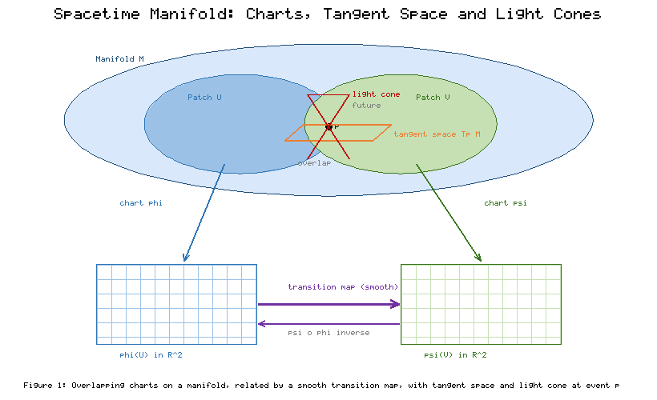
Figure 1: A differentiable manifold covered by two overlapping coordinate charts related by a smooth transition map, with the tangent space and light-cone structure erected at a representative event.

1.2 Tangent Spaces, Vectors and the Metric
At each point p of the manifold one attaches a tangent space T_pM, the vector space of all possible velocities of curves passing through p [4]. Because the manifold is generally curved, tangent spaces at different points are genuinely distinct vector spaces; there is no canonical way to compare a vector at one event with a vector at another without additional structure. This is not a technical inconvenience but the geometric origin of gravitation itself, as the discussion of parallel transport and curvature in Section 2 will make clear [2]. A vector may be regarded intrinsically as a directional derivative operator acting on smooth functions, a definition that avoids any reference to coordinates while reproducing the familiar component transformation law under a change of chart [6].
The additional structure that promotes a bare differentiable manifold to a model of spacetime is the metric tensor g, a smooth, symmetric, non-degenerate bilinear form defined on each tangent space [7]. In Riemannian geometry the metric is positive definite and measures ordinary lengths and angles; in relativity, however, the metric is Lorentzian, carrying the signature (-,+,+,+) [3]. This single sign is responsible for the entire causal architecture of the theory. The metric sorts tangent vectors into three physically distinct classes — timelike, null and spacelike — according to whether the squared interval they define is negative, zero or positive [8]. Timelike vectors describe the possible worldlines of massive particles, null vectors trace the propagation of light, and spacelike vectors connect events that no signal can join. Table 1 summarises the core geometric objects introduced in this section together with their physical roles, providing a reference map for the tensors and operators that recur throughout the chapter.
Table 1: Core geometric objects on a spacetime manifold and their physical interpretation.
Geometric Object | Symbol | Type / Rank | Physical Role
Manifold | M | 4-dimensional set | The set of all spacetime events
Tangent space | T_pM | Vector space at p | Instantaneous velocities and directions at an event
Metric tensor | g_ab | Symmetric (0,2) | Defines intervals, causal structure, proper time
Levi-Civita connection | Gamma^a_bc | Connection coefficients | Rule for parallel transport and covariant differentiation
Riemann tensor | R^a_bcd | (1,3) tensor | Intrinsic curvature; tidal effects and geodesic deviation
Ricci tensor / scalar | R_ab , R | (0,2) / scalar | Trace of curvature entering the field equations
Einstein tensor | G_ab | Symmetric (0,2) | Divergence-free curvature coupled to matter
Stress-energy tensor | T_ab | Symmetric (0,2) | Distribution of matter, energy and momentum

1.3 The Light-Cone Structure and Causality
Because the Lorentzian metric distinguishes timelike from spacelike directions at every point, it endows each event with a light cone: the locus of null directions separating the future and past that the event can causally influence or be influenced by [8]. The collection of these cones across the manifold constitutes the causal structure of spacetime, and much of the deep global theory of relativity — the singularity theorems, the definition of black-hole horizons, the notion of global hyperbolicity — is really a study of how these cones fit together [9]. In flat Minkowski space the cones are rigid and uniformly oriented; in a curved spacetime they tilt and deform from event to event, and it is precisely this tilting that encodes the presence of gravitating matter. Figure 1 accordingly also depicts the light cones attached to representative events, emphasising that the causal ordering they define is an intrinsic geometric feature independent of any coordinate system.
A crucial subtlety is that the causal structure is preserved under conformal rescalings of the metric, so that the cones capture the "which events can talk to which" information while discarding the metric scale that fixes proper times and lengths [9]. This separation between causal (conformal) and metric information underlies the Penrose diagram technique for visualising infinity and horizons, and it clarifies why null geodesics — the paths of light — occupy such a privileged role in probing spacetime geometry. A spacetime in which every inextendible causal curve meets a suitable spacelike surface exactly once is called globally hyperbolic, a condition that guarantees the deterministic evolution of physical fields from initial data [10]. Global hyperbolicity is the geometric expression of predictability, and it is quietly assumed in most of the cosmological modelling developed in Section 3.

1.4 Tensors and Differential Forms as the Language of Physics
To formulate physical laws on a manifold in a coordinate-independent way, one needs objects that transform in a definite, geometric fashion under changes of chart. Tensors are exactly these objects: multilinear maps on copies of the tangent and cotangent spaces whose components transform by the appropriate products of Jacobian matrices [6]. The metric, the curvature and the stress-energy content of spacetime are all tensors, and the assertion that a tensor equation holds in one coordinate system implies it holds in all of them — the mathematical embodiment of general covariance [11]. This is why Einstein's equations, once written tensorially, automatically respect the equivalence of all observers.
Differential forms provide a complementary and remarkably economical description. A differential p-form is a totally antisymmetric tensor, and the exterior derivative, the wedge product and integration over submanifolds combine to give a calculus that unifies the classical theorems of vector analysis and generalises them to arbitrary dimension [12]. In electromagnetism the entire content of Maxwell's equations collapses into two statements about a single two-form and its exterior derivative, a compression that reveals the topological character of charge conservation [7]. As Section 4 will show, differential forms and the associated Cartan structure equations also furnish the most efficient route to computing curvature in the tetrad formalism [12]. The recurring lesson, already visible in Table 1, is that the right geometric language does not merely restate physics more compactly; it exposes structure — conservation laws, invariants, causal relations — that coordinate-bound formulations tend to obscure [13].

1.5 Why a Manifold and Not a Vector Space
It is worth pausing to ask why the elaborate apparatus of manifolds is necessary at all, when the special relativity that preceded Einstein's gravitational theory managed comfortably with the flat vector space of Minkowski. The answer is the equivalence principle, the empirical observation — traceable to Galileo and refined by Einstein into a foundational postulate — that all bodies fall with the same acceleration in a gravitational field regardless of their composition [1]. This universality means that gravitation can be locally abolished by passing to a freely falling frame, in which the effects of gravity disappear over a small enough region and the physics of special relativity is recovered [2]. A uniform gravitational field could, in principle, be described on a flat vector space; but real gravitational fields are non-uniform, and the impossibility of transforming them away everywhere at once is precisely the statement that spacetime is curved rather than flat [11].
A manifold accommodates this situation exactly, because it is locally indistinguishable from flat space yet globally curved. The freely falling frames are the local charts in which the metric reduces to Minkowski form and the connection coefficients vanish at a point, while the non-vanishing of the curvature tensor — which cannot be made zero by any coordinate choice — is the invariant signature of a genuine gravitational field [3]. This is why the tidal forces of Section 2, encoded in the Riemann tensor, are the true physical content of gravity, and why a vector-space formulation is fundamentally inadequate: it cannot represent a geometry that is flat in the small but curved in the large [13]. The manifold is thus not an arbitrary mathematical embellishment but the minimal structure consistent with the equivalence principle and the observed non-uniformity of gravity. With this vocabulary in place, we turn to the way curvature governs gravitation.

2. Curvature, Einstein's Field Equations and Gravitational Phenomena
Having established spacetime as a Lorentzian manifold, we now confront the central dynamical question of the theory: how does the distribution of matter and energy determine the geometry, and how does that geometry in turn dictate the motion of matter? The answer is encoded in the interplay between the connection, which tells us how to transport vectors, and the curvature, which measures the failure of that transport to be path-independent [2]. Einstein's field equations weld these geometric notions to the physical stress-energy of matter, and their solutions describe everything from the deflection of starlight to the event horizons of black holes [14].

2.1 Parallel Transport, the Connection and the Riemann Tensor
On a curved manifold there is no automatic way to compare vectors at different points, so one must specify a connection — a rule for parallel transport that defines the covariant derivative [4]. Among the infinitely many possible connections, the metric singles out a unique one, the Levi-Civita connection, characterised by two natural requirements: it preserves the metric under transport, and it is torsion-free [5]. Its components, the Christoffel symbols, are built from first derivatives of the metric and encode the manner in which the coordinate basis vectors twist and stretch from point to point. Geodesics — the straightest possible curves, along which the tangent vector is parallel transported into itself — are defined entirely by this connection and represent the worldlines of freely falling particles [3].
Curvature enters when one asks what happens to a vector carried around a closed loop. On a flat manifold it returns unchanged; on a curved one it returns rotated, and the infinitesimal version of this rotation is measured by the Riemann curvature tensor [6]. The Riemann tensor is the complete, coordinate-independent measure of gravitational tidal effects: it appears directly in the equation of geodesic deviation, which describes how two nearby freely falling particles accelerate towards or away from one another [2]. This tidal interpretation is physically decisive, because it distinguishes genuine gravitation, which cannot be removed by any coordinate change, from the pseudo-forces that merely reflect an accelerating frame [1]. Figure 2 depicts geodesic deviation on a curved surface alongside the schematic balance of Einstein's equation, making concrete the notion that curvature is what neighbouring geodesics feel.
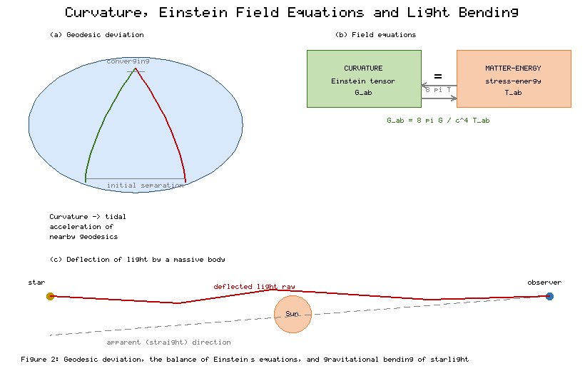
Figure 2: Left, two initially parallel geodesics converging on a curved manifold to illustrate geodesic deviation and tidal curvature; right, the schematic balance of Einstein's field equations relating the Einstein tensor to the stress-energy tensor, and the deflection of a light ray grazing a massive body.

2.2 The Einstein Field Equations
Contracting the Riemann tensor yields the Ricci tensor and, contracting once more, the Ricci scalar; from these Einstein assembled the tensor that now bears his name [14]. The Einstein tensor G_ab is a specific combination of the Ricci tensor and scalar constructed so that its covariant divergence vanishes identically — a purely geometric fact known as the contracted Bianchi identity [3]. This vanishing divergence is not a mathematical curiosity but the very reason the tensor is suited to physics: the stress-energy tensor T_ab, which encodes the density and flux of energy and momentum, is itself divergence-free by virtue of local conservation laws [7]. Einstein's field equations equate these two divergence-free objects, asserting that G_ab is proportional to T_ab, with the constant of proportionality fixed by demanding agreement with Newtonian gravity in the weak-field, slow-motion limit [2].
The elegance of this statement conceals formidable content. The field equations are a system of ten coupled, non-linear partial differential equations for the ten independent components of the metric, and their non-linearity reflects the physical fact that gravitational energy itself gravitates [4]. John Wheeler's celebrated aphorism — that matter tells spacetime how to curve, and curved spacetime tells matter how to move — captures the reciprocal, self-consistent character of the theory precisely because the same metric appears on both sides of the causal chain [2]. Table 2 collects the classic solutions and experimental tests of the field equations, tabulating the geometric prediction against the observed effect and thereby framing the phenomenology discussed in the remainder of this section. The addition of a cosmological constant term, consistent with the divergence-free requirement, provides the only freedom to modify the equations without abandoning their geometric foundation, a point that will prove central to cosmology [14].
Table 2: Classic solutions and experimental confirmations of general relativity.
Phenomenon | Governing Geometry | Prediction | Observational Status
Perihelion precession of Mercury | Schwarzschild metric | 43 arcsec/century anomaly | Confirmed, matches to high precision
Deflection of starlight | Null geodesics near the Sun | 1.75 arcsec at the solar limb | Confirmed (1919 eclipse and after)
Gravitational redshift | Time dilation in g_00 | Frequency shift in a potential well | Confirmed (Pound-Rebka and others)
Gravitational waves | Linearised curvature perturbations | Transverse strain propagating at c | Detected directly in 2015
Black-hole shadow | Photon sphere of Kerr/Schwarzschild | Dark region ringed by light | Imaged in 2019

2.3 Black Holes and the Bending of Light
The first exact, non-trivial solution of the field equations was found by Karl Schwarzschild within months of the theory's publication: the spherically symmetric vacuum geometry surrounding an isolated mass [15]. This solution exhibits two remarkable radii — the event horizon, beyond which no causal curve can escape to infinity, and the photon sphere, where light can orbit on unstable circular null geodesics [16]. The Schwarzschild geometry underlies the classic solar-system tests catalogued in Table 2, including the anomalous perihelion precession of Mercury and the gravitational redshift of light climbing out of a potential well [17]. The rotating generalisation, discovered by Roy Kerr, describes the stationary geometry of a spinning black hole and is believed to model the astrophysical black holes that populate galactic centres [18].
Perhaps the most iconic prediction is the bending of light. Because photons follow null geodesics of the curved metric, a ray grazing the Sun is deflected by an angle twice that predicted by a naive Newtonian calculation, and the confirmation of this figure during the 1919 solar eclipse transformed general relativity from a mathematical hypothesis into empirically grounded physics [19]. Modern gravitational lensing exploits the same geometry on cosmic scales, using the distortion of background galaxies to map the distribution of intervening mass, including dark matter that emits no light of its own [17]. The direct detection of gravitational waves in 2015, ripples in the curvature of spacetime radiated by merging black holes, opened an entirely new observational window and provided a stringent test of the strong-field, dynamical regime of the theory [20]. The subsequent imaging of the shadow cast by the supermassive black hole at the heart of the galaxy M87 rendered the photon sphere and event horizon, long abstract features of Table 2, into a literal photograph [21]. Together these results, all traceable to the geometry of geodesics and curvature depicted in Figure 2, establish general relativity as the most thoroughly vindicated theory of gravitation available.

2.4 The Weak-Field Limit and Energy Conditions
For all its geometric grandeur, the theory must reduce to Newtonian gravity in the regime where the latter is known to work — weak fields and slow motions — and this correspondence is what fixes the numerical constant in the field equations [11]. In the weak-field limit the metric is written as the flat Minkowski background plus a small perturbation, the field equations linearise, and the time-time component of the perturbation is found to play the role of the Newtonian gravitational potential, with the geodesic equation reducing to Newton's second law under an inverse-square force [2]. This recovery is not merely a consistency check; it demonstrates that the curvature language subsumes the older theory as a limiting case while extending it into regimes — strong fields, high velocities, dynamical spacetimes — where Newtonian gravity fails entirely [14]. The same linearised analysis, applied to the transverse traceless part of the perturbation, yields the wave equation whose solutions are the gravitational waves later detected directly, confirming that ripples in curvature propagate at the speed of light [20].
Because the field equations allow essentially any geometry to be generated by a suitable stress-energy tensor, physical reasonableness must be imposed through supplementary restrictions known as energy conditions [8]. These conditions — the weak, strong, dominant and null variants — encode intuitions such as the non-negativity of locally measured energy density and the causal propagation of energy flux, and they are the crucial ingredients in the singularity theorems that establish the inevitability of spacetime singularities under broad circumstances [4]. Whether these conditions hold universally is far from settled: quantum fields can violate them locally, and the dark energy discussed in Section 3 appears to violate the strong energy condition on cosmological scales, a fact intimately connected to the accelerating expansion [14]. The energy conditions therefore mark the boundary between the well-understood classical geometry catalogued in Table 2 and the frontier where quantum effects and exotic matter demand a broader framework. We now turn from local gravitational phenomena to the geometry of the cosmos as a whole.

3. Manifold Geometries in Cosmology: The FLRW Universe
Cosmology asks the field equations to describe not an isolated star or black hole but the universe in its entirety. This ambition would be hopeless were it not for a powerful simplifying observation: on sufficiently large scales the distribution of matter appears both homogeneous, the same at every location, and isotropic, the same in every direction [14]. Elevated to a working postulate, this cosmological principle drastically constrains the admissible geometry of spacetime and leads, almost uniquely, to the Friedmann-Lemaître-Robertson-Walker family of manifolds that forms the backbone of the standard cosmological model [22].

3.1 Symmetry, the Cosmological Principle and the FLRW Metric
The requirement that space be homogeneous and isotropic about every point is a statement about the symmetry group acting on the spatial slices of spacetime, and the geometry of such maximally symmetric three-dimensional spaces is exhausted by exactly three possibilities distinguished by the sign of their constant curvature [23]. The spatial sections may be positively curved and closed like the surface of a hypersphere, flat and infinite like ordinary Euclidean space, or negatively curved and open with hyperbolic geometry [24]. The full spacetime is then built by stacking these spatial slices along a cosmic time direction, allowing their overall scale to change while their intrinsic shape is preserved. The single function that governs this scaling is the scale factor, whose growth or decay describes the expansion or contraction of the universe [25]. Figure 3 renders the three candidate spatial geometries as the familiar closed, flat and open surfaces and pairs them with representative curves for the evolving scale factor, providing an intuitive picture of the metric that the following equations make precise.
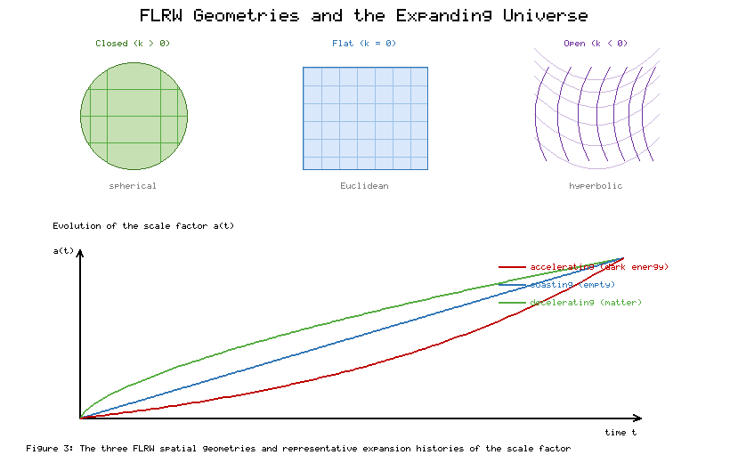
Figure 3: The three maximally symmetric spatial geometries of the FLRW model — positively curved (closed), flat, and negatively curved (open) — shown alongside representative trajectories of the scale factor a(t) for decelerating, coasting and accelerating expansion histories.
The resulting FLRW line element expresses the proper interval between neighbouring events in terms of cosmic time, the scale factor and comoving spatial coordinates that are carried along with the expansion [24]. A defining feature is the distinction between comoving distance, which remains fixed for objects moving with the cosmic flow, and physical distance, which grows in proportion to the scale factor. This distinction resolves a persistent conceptual confusion: cosmological redshift is not a Doppler shift due to galaxies flying through space, but a stretching of the wavelength of light in step with the expansion of space itself [26]. Table 3 assembles the principal parameters of the FLRW framework, from the Hubble parameter that quantifies the current expansion rate to the density parameters that apportion the cosmic energy budget, and these quantities anchor the quantitative discussion that follows.
Table 3: Principal parameters of the standard FLRW cosmological model.
Parameter | Symbol | Meaning | Approximate Value
Scale factor | a(t) | Relative size of the universe; a=1 today | 1 at present epoch
Hubble parameter | H = a-dot / a | Fractional expansion rate | ~67-73 km/s/Mpc today
Matter density parameter | Omega_m | Fraction of critical density in matter | ~0.31
Dark-energy density parameter | Omega_Lambda | Fraction in the cosmological constant | ~0.69
Curvature parameter | Omega_k | Fraction attributed to spatial curvature | ~0 (spatially flat)
Radiation density parameter | Omega_r | Fraction in radiation | ~9 x 10^-5

3.2 The Friedmann Equations and the Expanding Universe
Inserting the symmetric FLRW metric into Einstein's field equations reduces the ten coupled partial differential equations to a pair of ordinary differential equations for the scale factor, known as the Friedmann equations [22]. The first relates the square of the expansion rate to the total energy density and the spatial curvature; the second governs the acceleration or deceleration of the expansion in terms of both the density and the pressure of the cosmic contents [27]. Together with an equation of state specifying how pressure depends on density for each component — pressureless matter, radiation, or a cosmological constant — these equations determine the entire expansion history of the universe [28]. The concept of a critical density emerges naturally: the density that renders the spatial geometry exactly flat, against which all other densities are conveniently measured as the dimensionless density parameters.
Historically, the discovery that the equations do not admit a static solution proved momentous. Edwin Hubble's observation that distant galaxies recede with velocities proportional to their distance provided direct empirical evidence that the universe is expanding, transforming the FLRW models from mathematical curiosities into a description of physical reality [26]. Running the expansion backwards implies a hot, dense beginning, the hot Big Bang, whose thermal relic radiation we detect today [29]. The relative simplicity of the Friedmann equations, a direct consequence of the manifold's high symmetry, is what makes precision cosmology possible: a handful of parameters, tightly constrained by observation, suffices to trace the universe from a fraction of a second after the beginning to the present day [27].

3.3 The Cosmic Microwave Background and Dark Energy
Among the most powerful confirmations of the FLRW picture is the cosmic microwave background, the relic radiation released when the expanding, cooling universe first became transparent to light [29]. Its spectrum is that of a nearly perfect blackbody, and its temperature is remarkably uniform across the entire sky, providing striking observational support for the homogeneity and isotropy assumed at the outset [30]. Yet the tiny fluctuations in this temperature, at the level of a few parts in a hundred thousand, are equally important: they are the seeds from which galaxies and clusters later grew, and their detailed statistical pattern encodes the values of the cosmological parameters with extraordinary precision [30]. The analysis of these fluctuations requires the perturbation theory developed in Section 4, in which small departures from the perfectly symmetric FLRW geometry are treated as fields propagating on the smooth background.
The most surprising cosmological discovery of recent decades is that the expansion of the universe is not slowing under the mutual gravitational attraction of its contents, as intuition would suggest, but accelerating [31]. Observations of distant supernovae, calibrated as standard candles, revealed that the universe crossed over from deceleration to acceleration in the relatively recent past, implying the presence of a pervasive component with negative pressure that drives space apart [31]. Within the geometric framework this component is most economically represented by the cosmological constant, the very term Einstein had introduced and later regretted, which reappears as the dominant contribution to the present energy budget and is catalogued as dark energy in Table 3 [32]. Whether dark energy is truly a constant vacuum energy or a slowly evolving field remains among the deepest open questions, and the concordance model that emerges — a spatially flat FLRW universe dominated today by dark energy with a substantial admixture of cold dark matter — is the framework within which essentially all contemporary cosmological data, including the precise measurements summarised through Figure 3, are interpreted [30].

3.4 Cosmic Distances, Horizons and the Thermal History
The expansion of space complicates the very notion of distance, and the FLRW geometry forces a careful distinction among several operationally distinct measures. Because light emitted by a distant galaxy travels through an expanding manifold, the luminosity distance inferred from an object's apparent brightness and the angular-diameter distance inferred from its apparent size diverge from one another and from the naive comoving separation, each depending on the full expansion history through the scale factor [28]. It was precisely the luminosity distance of supernovae, plotted against redshift, that revealed the accelerating expansion, and the reconciliation of these distance measures is a routine but conceptually rich exercise in FLRW geometry [26]. The finite speed of light combined with the finite age of the expanding universe also implies the existence of horizons: a particle horizon bounding the region from which signals could ever have reached us, and an event horizon bounding the region we will ever be able to influence [27].
Tracing the FLRW model backwards yields a definite thermal history whose milestones are among the most successful predictions in physics. In the first few minutes the universe was hot and dense enough for nuclear reactions to synthesise the light elements, and the predicted primordial abundances of helium and deuterium agree with observation across many orders of magnitude, providing a stringent probe of the expansion rate at that epoch [29]. As expansion cooled the plasma, electrons and protons combined into neutral atoms and the universe became transparent, releasing the microwave background discussed above [27]. The extraordinary uniformity of that radiation across regions that could not have been in causal contact — the horizon problem — motivated the theory of cosmic inflation, an early epoch of accelerated expansion that stretches a tiny causally connected patch to encompass the observable universe and simultaneously seeds the density fluctuations through amplified quantum effects [14]. Inflation is a hypothesis about the geometry of the very early manifold, and testing it through the statistics of the perturbations discussed next remains a central goal of observational cosmology [29]. Addressing its finer structure demands the advanced geometric machinery to which we now turn.

4. Advanced Geometric Tools and Contemporary Directions
The symmetric FLRW model and the isolated black-hole solutions are triumphs of the manifold picture, but the frontier of gravitational research lives in the regime where exact symmetry breaks down or where spacetime itself is embedded in a larger structure. Treating small inhomogeneities, coupling gravity consistently to spinor fields, dissecting spacetime into evolving spatial slices, and contemplating universes as membranes in higher dimensions all require geometric tools more refined than the metric and Christoffel symbols alone [33]. This closing section surveys the vielbein formalism, the Gauss-Codazzi equations, cosmological perturbation theory and brane-world scenarios, and shows how each extends the reach of differential geometry into modern theoretical cosmology.

4.1 The Vielbein Formalism and Differential Forms
The metric formulation of relativity works with coordinate bases whose vectors are generally neither orthogonal nor of unit length. The vielbein — or tetrad in four dimensions — replaces this coordinate basis at each point with an orthonormal frame, a set of basis vectors with respect to which the metric takes the simple constant form of flat Minkowski space [12]. This apparently modest change of perspective has two decisive consequences. First, it makes the local equivalence principle manifest: in the orthonormal frame the laws of physics reduce, at each event, to those of special relativity, so that the gravitational field is fully captured by how the frames rotate as one moves from event to event [7]. Second, and more technically, it is indispensable for describing fermions, since spinor fields cannot be defined with respect to coordinate bases and require the local Lorentz structure that the vielbein supplies [33].
In the tetrad approach the connection is repackaged as a set of connection one-forms, and Cartan's two structure equations express torsion and curvature as exterior derivatives of the vielbein and connection forms respectively [12]. This differential-forms formulation, foreshadowed in Section 1, converts the laborious index manipulations of the Christoffel approach into compact algebraic operations on forms, and it dramatically streamlines the computation of curvature for explicit metrics. Table 4 organises these advanced formalisms side by side, listing for each its essential geometric idea and its principal domain of application, so that the reader can situate the vielbein among the broader toolkit. Figure 4 complements this by depicting an orthonormal tetrad carried along a worldline, alongside the hypersurface embedding and brane configurations discussed below.
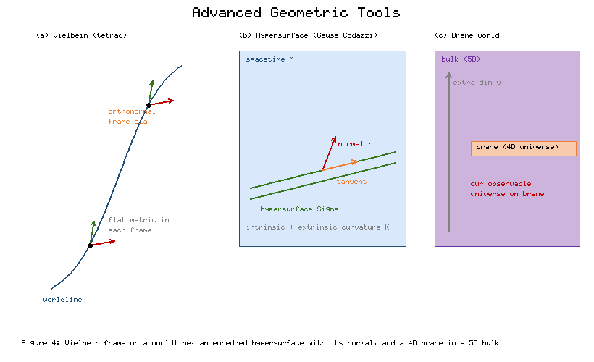
Figure 4: Advanced geometric constructions — an orthonormal vielbein (tetrad) frame carried along a worldline, a three-dimensional spacelike hypersurface embedded in spacetime with its unit normal and extrinsic curvature (Gauss-Codazzi setting), and a four-dimensional brane embedded in a higher-dimensional bulk.
Table 4: Advanced geometric formalisms and their applications in gravitation and cosmology.
Formalism | Core Geometric Idea | Principal Application
Vielbein / tetrad | Orthonormal frame field at each point | Coupling spinors to gravity; local Lorentz symmetry
Differential forms / Cartan | Antisymmetric tensors, exterior calculus | Efficient curvature computation; conservation laws
Gauss-Codazzi equations | Relating intrinsic and extrinsic curvature | Hypersurfaces, initial-value problem, junctions
Cosmological perturbation theory | Fields on a symmetric background | CMB anisotropies; growth of structure
Brane-world (Randall-Sundrum) | 4D brane in higher-dimensional bulk | Hierarchy problem; modified cosmology

4.2 Hypersurfaces and the Gauss-Codazzi Equations
Many of the most important constructions in relativity involve slicing the four-dimensional manifold into a family of three-dimensional spatial hypersurfaces, whether to pose the gravitational initial-value problem, to define energy and momentum, or to formulate numerical simulations of merging black holes [4]. The geometry of such a hypersurface has two complementary aspects: its intrinsic curvature, measured by the metric induced upon it, and its extrinsic curvature, which describes how it bends within the enclosing spacetime [5]. The Gauss-Codazzi equations are the fundamental relations that tie these together, expressing components of the ambient four-dimensional Riemann tensor in terms of the intrinsic and extrinsic curvatures of the slice [12]. They are, in effect, the compatibility conditions that any embedded surface must satisfy, and they generalise to spacetime the classical surface theory of Gauss.
These equations do far more than organise a bookkeeping exercise. They are the geometric heart of the Hamiltonian, or ADM, formulation of general relativity, in which the spatial metric and the extrinsic curvature play the roles of configuration and momentum, and they thereby underpin canonical approaches to quantum gravity as well as the numerical relativity that models gravitational-wave sources [33]. As Table 4 records, the same equations govern the junction conditions across a thin shell of matter or a domain wall, dictating how the extrinsic curvature is permitted to jump in the presence of a surface energy density [34]. This junction technology is exactly what the brane-world models exploit, and Figure 4 illustrates the embedding of such a hypersurface within a higher-dimensional space.

4.3 Cosmological Perturbation Theory and Brane Worlds
The smooth FLRW universe of Section 3 is only a first approximation; the real universe is threaded with galaxies, clusters and voids that represent departures from perfect homogeneity. Cosmological perturbation theory treats these structures as small fluctuations of the metric and matter fields on the symmetric background, linearising the field equations so that each fluctuation mode evolves independently [33]. A central achievement of the theory is the careful separation of genuine physical perturbations from mere coordinate artefacts, since a naive choice of how to identify points between the perturbed and background manifolds can manufacture spurious fluctuations — a gauge problem whose resolution requires gauge-invariant combinations of the perturbation variables [33]. This machinery is what connects the primordial fluctuations generated in the very early universe to the temperature anisotropies of the cosmic microwave background and the observed clustering of matter, and it is indispensable to interpreting the precision data behind Table 3.
Brane-world scenarios represent a more radical extension of the manifold picture, in which the observable four-dimensional universe is a hypersurface, or brane, embedded in a higher-dimensional bulk spacetime [35]. In the influential model proposed by Randall and Sundrum, a single extra dimension with a strongly warped geometry can account for the enormous disparity between the electroweak and gravitational energy scales, offering a geometric resolution of the hierarchy problem [35]. Gravity in such models is governed by the higher-dimensional field equations projected onto the brane through precisely the Gauss-Codazzi relations of Section 4.2, which is why the junction conditions play so prominent a role and why the effective cosmology on the brane can differ from standard FLRW dynamics at high energies [34]. As catalogued in Table 4 and sketched in Figure 4, these models modify the early-universe expansion in testable ways and illustrate how the language of embedded manifolds continues to generate genuinely new physics.

4.4 The Initial-Value Problem and Numerical Relativity
The dynamical content of Einstein's equations is most transparent when the theory is recast as an evolution problem: given the geometry of an initial spatial slice, how does it develop in time? The Gauss-Codazzi framework of the previous subsection provides exactly the tools required, decomposing the field equations into a set of constraint equations that the initial data on the slice must satisfy and a set of evolution equations that propagate the spatial metric and its extrinsic curvature forward [4]. The constraints are the geometric analogue of the divergence conditions of electromagnetism, and a deep result guarantees that if they hold on the initial slice they continue to hold throughout the evolution, so that the vast physical content of general relativity can be encoded in freely specifiable initial data supplemented by these consistency conditions [12]. This ADM decomposition, resting entirely on the manifold's foliation into hypersurfaces, is the conceptual bridge between the four-dimensional, covariant picture emphasised throughout this chapter and the practical business of solving the equations.
The payoff has been spectacular in the field of numerical relativity, where the evolution equations are discretised and integrated on supercomputers to model the violent merger of black holes and neutron stars [33]. For decades such simulations were plagued by instabilities rooted in subtle features of the manifold formulation — the freedom to choose coordinates, the propagation of constraint violations, and the appearance of singularities inside horizons — and their eventual taming required reformulations of the evolution equations guided by geometric insight into their mathematical structure [12]. The resulting waveform predictions were indispensable to the interpretation of the gravitational-wave detections, since extracting a signal from detector noise relies on matching it against a bank of theoretically computed templates [20]. Thus the abstract geometry of embedded hypersurfaces, catalogued alongside the other advanced formalisms in Table 4, has become a working tool of observational astrophysics, closing the loop between the deepest structure of the theory and the data now streaming from gravitational-wave observatories.

4.5 Concluding Remarks
The narrative of this chapter has been, at its core, the story of a single mathematical idea unfolding across ever wider physical domains. The differentiable manifold, endowed with a Lorentzian metric, furnishes the arena in which causality and proper time acquire meaning; the Levi-Civita connection and the Riemann tensor translate the geometry into the tidal forces we recognise as gravity; and Einstein's field equations bind that curvature to the matter that generates it [2]. From this geometric seed grow the black holes and light-bending phenomena confirmed by increasingly precise observation, the expanding FLRW universe with its microwave afterglow and its puzzling dark energy, and the advanced constructions — vielbeins, the Gauss-Codazzi equations, perturbation theory and brane worlds — that carry the theory to its contemporary frontiers [14]. What is most striking is the economy of it all: a compact set of geometric principles, faithfully applied, reproduces phenomena spanning sixty orders of magnitude in scale [1]. The manifold is not merely a convenient bookkeeping device for relativity and cosmology; it is, as far as our best evidence reveals, the very fabric of which physical reality is woven, and the ongoing dialogue between differential geometry and gravitational physics shows every sign of remaining as fertile in the future as it has been over the past century [3].

References
[1] A. Einstein, "Die Grundlage der allgemeinen Relativitätstheorie," Annalen der Physik, vol. 354, no. 7, pp. 769-822, 1916.
[2] C. W. Misner, K. S. Thorne, and J. A. Wheeler, Gravitation. San Francisco, CA: W. H. Freeman, 1973.
[3] S. M. Carroll, Spacetime and Geometry: An Introduction to General Relativity. San Francisco, CA: Addison-Wesley, 2004.
[4] R. M. Wald, General Relativity. Chicago, IL: University of Chicago Press, 1984.
[5] M. P. do Carmo, Riemannian Geometry. Boston, MA: Birkhäuser, 1992.
[6] J. M. Lee, Introduction to Smooth Manifolds, 2nd ed. New York, NY: Springer, 2013.
[7] M. Nakahara, Geometry, Topology and Physics, 2nd ed. Bristol, UK: Institute of Physics Publishing, 2003.
[8] B. O'Neill, Semi-Riemannian Geometry with Applications to Relativity. New York, NY: Academic Press, 1983.
[9] R. Penrose, "Conformal Treatment of Infinity," in Relativity, Groups and Topology, C. DeWitt and B. DeWitt, Eds. New York, NY: Gordon and Breach, 1964, pp. 565-584.
[10] R. Geroch, "Domain of Dependence," Journal of Mathematical Physics, vol. 11, no. 2, pp. 437-449, 1970.
[11] B. F. Schutz, A First Course in General Relativity, 2nd ed. Cambridge, UK: Cambridge University Press, 2009.
[12] Y. Choquet-Bruhat, General Relativity and the Einstein Equations. Oxford, UK: Oxford University Press, 2009.
[13] T. Frankel, The Geometry of Physics: An Introduction, 3rd ed. Cambridge, UK: Cambridge University Press, 2011.
[14] S. Weinberg, Gravitation and Cosmology: Principles and Applications of the General Theory of Relativity. New York, NY: John Wiley & Sons, 1972.
[15] K. Schwarzschild, "Über das Gravitationsfeld eines Massenpunktes nach der Einsteinschen Theorie," Sitzungsberichte der Königlich Preussischen Akademie der Wissenschaften, pp. 189-196, 1916.
[16] S. Chandrasekhar, The Mathematical Theory of Black Holes. Oxford, UK: Oxford University Press, 1983.
[17] C. M. Will, "The Confrontation between General Relativity and Experiment," Living Reviews in Relativity, vol. 17, no. 4, 2014.
[18] R. P. Kerr, "Gravitational Field of a Spinning Mass as an Example of Algebraically Special Metrics," Physical Review Letters, vol. 11, no. 5, pp. 237-238, 1963.
[19] F. W. Dyson, A. S. Eddington, and C. Davidson, "A Determination of the Deflection of Light by the Sun's Gravitational Field," Philosophical Transactions of the Royal Society A, vol. 220, pp. 291-333, 1920.
[20] B. P. Abbott et al. (LIGO Scientific and Virgo Collaborations), "Observation of Gravitational Waves from a Binary Black Hole Merger," Physical Review Letters, vol. 116, no. 6, 061102, 2016.
[21] Event Horizon Telescope Collaboration, "First M87 Event Horizon Telescope Results. I. The Shadow of the Supermassive Black Hole," Astrophysical Journal Letters, vol. 875, L1, 2019.
[22] A. Friedmann, "Über die Krümmung des Raumes," Zeitschrift für Physik, vol. 10, no. 1, pp. 377-386, 1922.
[23] G. Lemaître, "Un univers homogène de masse constante et de rayon croissant," Annales de la Société Scientifique de Bruxelles, vol. 47, pp. 49-59, 1927.
[24] H. P. Robertson, "Kinematics and World-Structure," Astrophysical Journal, vol. 82, pp. 284-301, 1935.
[25] A. G. Walker, "On Milne's Theory of World-Structure," Proceedings of the London Mathematical Society, vol. 42, no. 1, pp. 90-127, 1937.
[26] E. Hubble, "A Relation between Distance and Radial Velocity among Extra-Galactic Nebulae," Proceedings of the National Academy of Sciences, vol. 15, no. 3, pp. 168-173, 1929.
[27] S. Dodelson, Modern Cosmology. San Diego, CA: Academic Press, 2003.
[28] P. J. E. Peebles, Principles of Physical Cosmology. Princeton, NJ: Princeton University Press, 1993.
[29] V. Mukhanov, Physical Foundations of Cosmology. Cambridge, UK: Cambridge University Press, 2005.
[30] Planck Collaboration, "Planck 2018 Results. VI. Cosmological Parameters," Astronomy & Astrophysics, vol. 641, A6, 2020.
[31] A. G. Riess et al., "Observational Evidence from Supernovae for an Accelerating Universe and a Cosmological Constant," Astronomical Journal, vol. 116, no. 3, pp. 1009-1038, 1998.
[32] P. J. E. Peebles and B. Ratra, "The Cosmological Constant and Dark Energy," Reviews of Modern Physics, vol. 75, no. 2, pp. 559-606, 2003.
[33] V. F. Mukhanov, H. A. Feldman, and R. H. Brandenberger, "Theory of Cosmological Perturbations," Physics Reports, vol. 215, no. 5-6, pp. 203-333, 1992.
[34] R. Maartens and K. Koyama, "Brane-World Gravity," Living Reviews in Relativity, vol. 13, no. 5, 2010.
[35] L. Randall and R. Sundrum, "A Large Mass Hierarchy from a Small Extra Dimension," Physical Review Letters, vol. 83, no. 17, pp. 3370-3373, 1999.

