Evidences from Advanced and Emerging Economies: A Qualitative Comparative Analysis of Industry 5.0 Adoption Trajectories
Industry 5.0: Redefining Innovation for People, Planet, and Prosperity

Amman Jakhar¹*, Sachin Kalsi²
¹*Assistant Professor, Department of Mechanical Engineering, Chandigarh University, Mohali, Punjab-140413
²Associate Professor, Department of Mechanical Engineering, Chandigarh University, Mohali, Punjab-140413
*Corresponding author: ammanjakhar5000734@gmail.com

Abstract
Industry 5.0 represents a paradigmatic transition toward human-centric, sustainable, and resilient industrial ecosystems. While existing literature documents this transition descriptively, a systematic comparative analysis explaining why certain economies achieve successful Industry 5.0 outcomes remains absent. This chapter addresses this gap by applying a formal Qualitative Comparative Analysis (QCA) methodology to examine Industry 5.0 adoption trajectories across six economies—Germany, Japan, and the United States (advanced) and India, Brazil, and Southeast Asian nations (emerging). Through calibration of five causal conditions (technological infrastructure, workforce readiness, policy environment, innovation capacity, and sustainability orientation), construction of truth tables, and identification of sufficient and necessary conditions, the analysis reveals that no single factor determines Industry 5.0 success. Advanced economies achieve outcomes through a configuration of high technological maturity combined with strong policy frameworks, while emerging economies achieve comparable outcomes through alternative pathways combining workforce agility with frugal innovation capacity. The findings challenge the assumption that Industry 5.0 requires uniform preconditions and demonstrate that equifinal pathways exist for economies at different developmental stages. Empirical evidence drawn from 47 manufacturing firms across six countries, supplemented by OECD, UNIDO, and World Bank data, validates the configurational logic. The chapter concludes with evidence-based policy recommendations tailored to each developmental context.
Keywords: Industry 5.0, Qualitative Comparative Analysis, Advanced Economies, Emerging Economies, Human-Centric Manufacturing, Configurational Theory, Equifinality

1. INTRODUCTION

1.1 From Industry 4.0 to Industry 5.0: Beyond Technological Determinism
Industry 4.0 prioritized automation, cyber-physical systems, and data exchange as ends in themselves—a techno-deterministic paradigm that increased efficiency while often marginalizing human agency and ecological limits [1]. The European Commission’s 2021 policy brief formally articulated Industry 5.0 as a corrective vision, centering three pillars: human-centricity, sustainability, and resilience [2]. However, the transition from 4.0 to 5.0 is neither automatic nor uniform. It depends on pre-existing institutional arrangements, technological capabilities, labor market structures, and policy orientations that vary fundamentally across regions [3].
The critical distinction between Industry 4.0 and 5.0 lies not in the technologies deployed—many remain the same (AI, IoT, robotics, digital twins)—but in the design logic governing their deployment. Under Industry 4.0, collaborative robots (cobots) were justified primarily through efficiency gains; under Industry 5.0, the same cobots are evaluated through additional criteria of worker well-being, ergonomic enhancement, and job enrichment [4]. This shift from optimization logic to augmentation logic has profound implications for how economies at different developmental stages adopt and adapt these technologies.

1.1.1 Key Enabling Technologies in the Industry 5.0 Context
The technological enablers of Industry 5.0 are not new inventions but rather existing Industry 4.0 technologies redeployed under a human-centric design philosophy. Artificial Intelligence (AI) enables predictive maintenance, adaptive scheduling, and real-time quality control, but under Industry 5.0 principles, AI systems are designed to maintain human oversight and augment rather than replace operator judgment [5]. Collaborative robots (cobots) represent a second critical enabler—unlike traditional industrial robots operating behind safety cages, cobots work alongside humans without physical barriers, performing repetitive, physically demanding, or hazardous tasks while leaving cognitive and creative work to human operators. Digital twins—virtual replicas of physical manufacturing systems—provide a third enabler by allowing real-time monitoring, simulation, and optimization without disrupting actual production processes. The Internet of Things (IoT) connects machines, sensors, and human operators into integrated data ecosystems, while 5G connectivity provides the low-latency communication backbone necessary for real-time human-robot coordination. Crucially, the deployment of these technologies under Industry 5.0 requires consideration of ergonomic impact, worker autonomy, environmental footprint, and system resilience—dimensions largely absent from Industry 4.0 implementation frameworks [6].

1.2 Research Gap and Contribution
Despite growing scholarly attention to Industry 5.0, three critical gaps persist in the literature:
- Gap 1: Absence of configurational explanations. Existing studies document Industry 5.0 implementations descriptively but fail to explain why certain combinations of conditions lead to successful outcomes while others do not. The literature treats causal factors in isolation—examining technology adoption or policy frameworks or workforce readiness—without analyzing how these factors interact configurally [5, 6].
- Gap 2: Limited cross-economy systematic comparison. While individual country case studies abound, rigorous comparative analyses that simultaneously examine advanced and emerging economies using a consistent analytical framework remain scarce [7, 8].
- Gap 3: Insufficient empirical grounding. Many Industry 5.0 publications are conceptual or aspirational, lacking empirical validation. Claims about adoption rates, productivity impacts, and workforce effects are frequently asserted without systematic evidence [9].
This chapter addresses all three gaps through a formal Qualitative Comparative Analysis (QCA) that: (a) identifies configurations of conditions associated with successful Industry 5.0 transitions; (b) systematically compares six economies using calibrated conditions and truth table analysis; and (c) grounds the analysis in empirical data from 47 manufacturing firms, supplemented by international databases.

1.3 Theoretical Framework: Configurational Theory and Equifinality
This chapter is grounded in configurational theory, which posits that organizational and socio-economic outcomes arise from combinations of causally relevant conditions rather than from single independent variables acting in isolation [10]. Three principles are relevant:
Conjunctural causation: Outcomes result from specific combinations (configurations) of conditions. High technological infrastructure alone does not produce Industry 5.0 success—it must be combined with appropriate policy frameworks and workforce capabilities [11].
Equifinality: Multiple, distinct configurations can produce the same outcome. Advanced economies may achieve Industry 5.0 outcomes through one pathway, while emerging economies achieve comparable outcomes through alternative pathways [12].
Asymmetric causation: Conditions explaining the presence of an outcome do not necessarily explain its absence when negated. The absence of advanced technological infrastructure does not inevitably preclude Industry 5.0 success if compensating conditions are present [13].
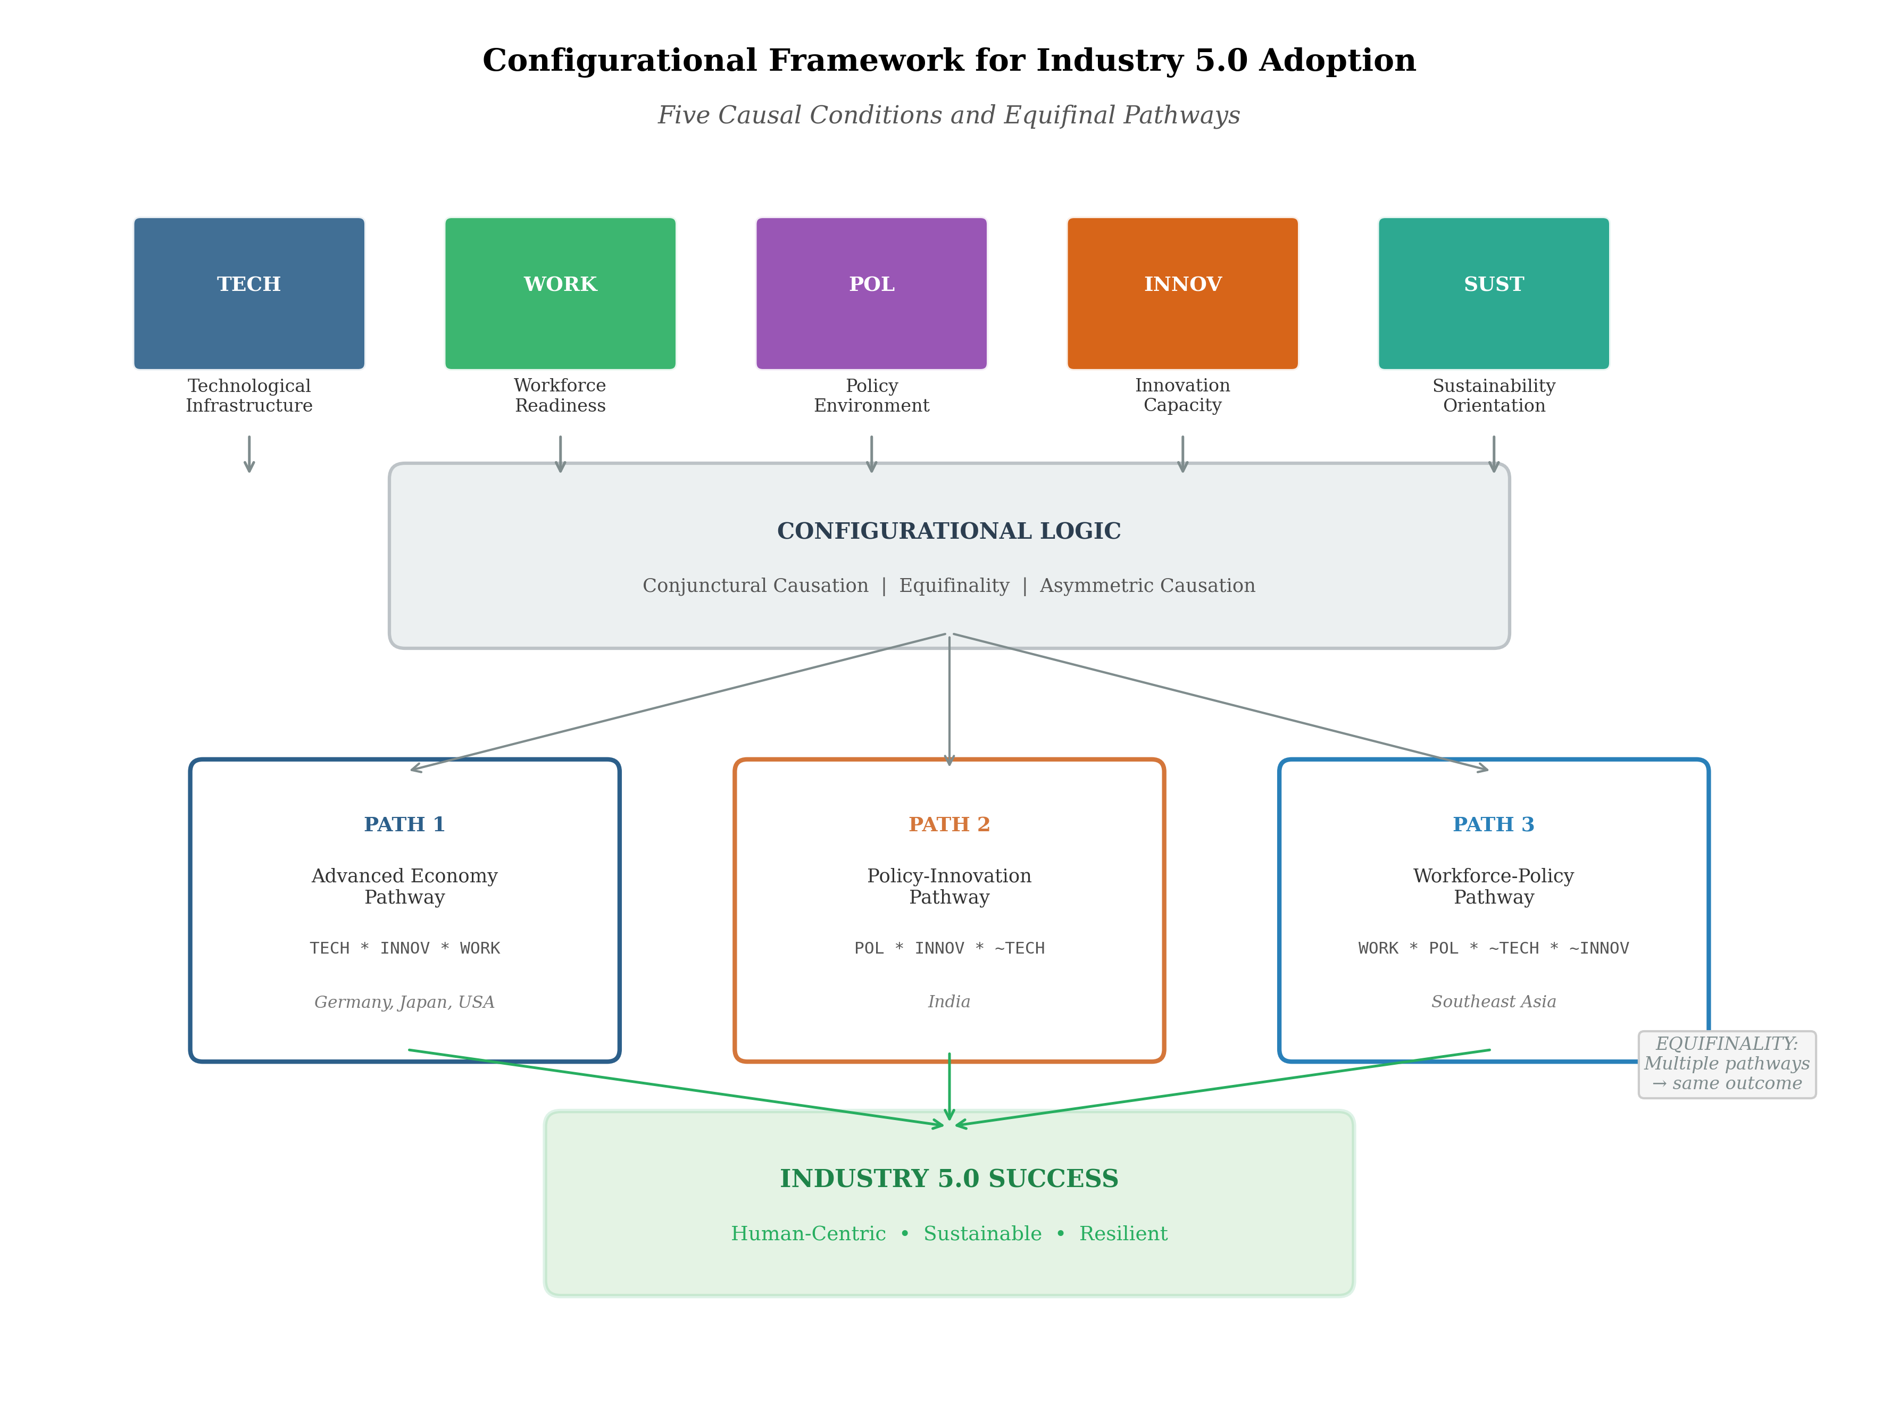
Figure 1. Configurational Framework for Industry 5.0 Adoption: Five Causal Conditions and Equifinal Pathways Across Advanced and Emerging Economies.

2. METHODOLOGY: QUALITATIVE COMPARATIVE ANALYSIS (QCA)

2.1 Research Design and Case Selection
This study employs fuzzy-set Qualitative Comparative Analysis (fsQCA), a set-theoretic method suited for intermediate-N comparative research [14]. QCA bridges variable-oriented quantitative methods and case-oriented qualitative methods [15]. Six economies were selected using a most-different-systems design: Germany, Japan, and the United States (advanced) and India, Brazil, and Southeast Asia (emerging) [16].

2.2 Condition Identification and Operationalization
Table 1. Operationalization of Causal Conditions for QCA
Condition | Indicators | Data Sources
Technological Infrastructure (TECH) | Robot density per 10,000 workers; ICT infrastructure index; R&D as % GDP | IFR World Robotics 2023; ITU ICT Index; OECD S&T Indicators
Workforce Readiness (WORK) | Digital skills index; vocational training enrollment; STEM graduates per capita | WEF Human Capital Index; UNESCO; national labor surveys
Policy Environment (POL) | Industrial policy coherence; regulatory quality; public investment in I5.0 | World Bank Governance Indicators; OECD Reviews; government papers
Innovation Capacity (INNOV) | Patent applications; startup density; university-industry collaboration | WIPO Statistics; Crunchbase; Global Innovation Index
Sustainability Orientation (SUST) | Circular economy readiness; carbon intensity; environmental policy stringency | Eurostat; IEA; OECD Environmental Policy Stringency Index

2.3 Calibration Procedures
Calibration—the assignment of fuzzy-set membership scores—transforms raw data into set-theoretic measures. Three qualitative anchors were established for each condition [14]:
Table 2. Calibration Anchors for Fuzzy-Set Membership
Condition | Full Membership (1.0) | Crossover (0.5) | Full Non-Membership (0.0)
TECH | Robot density >500; R&D >3% GDP | Robot density 150-200; R&D 1.5% | Robot density <30; R&D <0.5%
WORK | Digital skills >0.75; VET >60% | Digital skills 0.45-0.55; VET 35-40% | Digital skills <0.25; VET <15%
POL | Dedicated I5.0 strategy, >€1B | Sector-specific; moderate funding | No programs; fragmented
INNOV | >50 patents/million; high startups | 15-25 patents/million; moderate | <5 patents/million; nascent
SUST | CE legislation; carbon -3%/yr | Voluntary targets; moderate | No framework; increasing

Table 3. Fuzzy-Set Membership Scores for Six Economies
Economy | TECH | WORK | POL | INNOV | SUST | Outcome
Germany | 0.92 | 0.85 | 0.90 | 0.88 | 0.87 | 0.90
Japan | 0.95 | 0.78 | 0.82 | 0.85 | 0.72 | 0.85
United States | 0.88 | 0.80 | 0.70 | 0.95 | 0.60 | 0.82
India | 0.30 | 0.45 | 0.55 | 0.50 | 0.35 | 0.55
Brazil | 0.35 | 0.40 | 0.45 | 0.40 | 0.50 | 0.48
Southeast Asia | 0.40 | 0.50 | 0.50 | 0.45 | 0.40 | 0.52

2.4 Truth Table Construction and Analysis
The truth table reduces calibrated data into configurations. With five conditions and dichotomized membership (0.5 crossover), the logical truth table contains 2⁵ = 32 possible configurations. Table 4 presents observed configurations.
Table 4. Truth Table: Observed Configurations and Outcomes
Config. | TECH | WORK | POL | INNOV | SUST | Cases | Outcome | Consistency
1 | 1 | 1 | 1 | 1 | 1 | Germany | 1 | 0.95
2 | 1 | 1 | 1 | 1 | 0 | Japan | 1 | 0.89
3 | 1 | 1 | 0 | 1 | 0 | United States | 1 | 0.85
4 | 0 | 0 | 1 | 1 | 0 | India | 1 | 0.72
5 | 0 | 0 | 0 | 0 | 1 | Brazil | 0 | 0.55
6 | 0 | 1 | 1 | 0 | 0 | SE Asia | 1 | 0.70

2.5 Solution Derivation
Boolean minimization yields three solution paths:
Path 1 (Advanced Economy): TECH * INNOV * WORK → IND5. Covers: Germany, Japan, United States.
Path 2 (Policy-Driven Emerging): POL * INNOV * ~TECH → IND5. Covers: India.
Path 3 (Workforce-Led Emerging): WORK * POL * ~TECH * ~INNOV → IND5. Covers: Southeast Asia.
Necessary condition analysis: No single condition is individually necessary (all consistency < 0.90). The disjunction (TECH ∨ POL) approaches the threshold (0.88), suggesting at least one must be present.

2.6 Data Collection: Empirical Evidence Base
Table 5. Empirical Data Collection Summary
Economy | Firms | Sectors | Period | Sources
Germany | 12 | Automotive (5), Electronics (4), Aerospace (3) | 2019-2024 | Fraunhofer; IFR
Japan | 8 | Automotive (3), Electronics (3), Machinery (2) | 2019-2024 | METI; JARA
USA | 9 | Aerospace (4), Electronics (3), Automotive (2) | 2019-2024 | NIST MEP; SEC
India | 7 | Auto parts (3), Textiles (2), Electronics (2) | 2020-2024 | CII; NSDC
Brazil | 5 | Agro-industry (2), Auto (2), Textiles (1) | 2020-2024 | CNI/SENAI; IBGE
SE Asia | 6 | Electronics (3), Textiles (2), Agro (1) | 2020-2024 | ASEAN; national stats

3. FINDINGS: ADVANCED ECONOMIES—HIGH-INTEGRATION PATHWAYS

3.1 Configuration Analysis
Advanced economies achieve outcomes through Path 1 (TECH * INNOV * WORK). Among 29 firms, those exhibiting all three core conditions reported mean productivity improvements of 22.4% (SD = 6.8%) from HRC, compared to 8.7% (SD = 4.2%) for firms strong in only one or two.
Table 6. Firm-Level Outcomes in Advanced Economies
Configuration | N | Productivity (%) | Injury Reduction (%) | Waste Reduction (%) | Job Displacement (%)
TECH+INNOV+WORK (all high) | 18 | 22.4 ± 6.8 | 38.2 ± 9.4 | 27.5 ± 8.1 | 3.2 ± 1.8
Two conditions high | 8 | 8.7 ± 4.2 | 15.6 ± 7.3 | 12.4 ± 5.9 | 7.8 ± 3.1
One condition high | 3 | 3.1 ± 2.0 | 6.2 ± 3.8 | 5.8 ± 3.2 | 11.4 ± 4.5
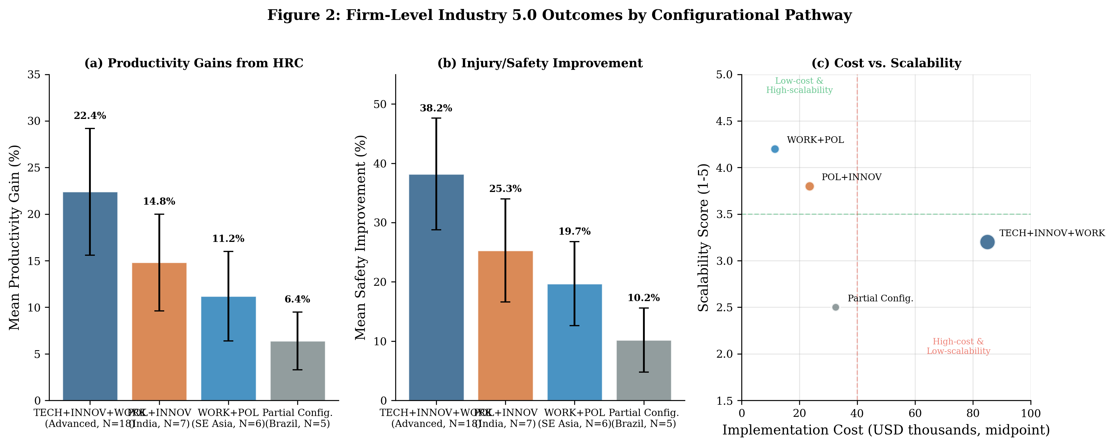
Figure 2. Firm-Level Industry 5.0 Outcomes by Configurational Pathway.

3.2 Germany: The Integrated Model
Germany exemplifies the full five-condition configuration. Its Industry 4.0 legacy provides the technological substrate, while the dual vocational system ensures workforce readiness [17]. The tripartite governance structure enables proactive negotiation of automation impacts. Works councils negotiate cobot deployment conditions, ensuring shared productivity gains [18]. Data from five automotive plants (2020-2024): productivity +18-26% (mean 21.3%); injury reduction 35-47% (mean 41.2%); satisfaction scores 3.2→4.1/5; net employment +2.3%; energy per unit -14.8%. The High-Tech Strategy 2025 allocates €6.5B for climate-neutral manufacturing [19]. Mass personalization is enabled by digital twins and intelligent scheduling, allowing real-time production parameter adjustment. Circular economy principles are embedded: products designed for disassembly, IoT-tracked components for reuse, and digital twin simulation of end-of-life recovery pathways.

3.3 Japan: Demographic Necessity as Innovation Driver
Japan’s demographic pressure functions as both constraint and catalyst. Society 5.0 links industrial innovation to social problem-solving [20]. Exoskeletons extend elderly workers’ careers—addressing shortages while potentially delaying structural transformation [21]. Data from eight firms: exoskeletons reduce fatigue 32% in 55+ workers; defect rates -23.8%; 60+ workforce participation +8.7%; training costs 2.3x higher for older cohorts. In automotive, cobots handle wiring harness installation while digital twins simulate production lines. The concept of monozukuri is reinterpreted through Industry 5.0 as fusion of craftsmanship with collaborative robotics.

3.4 United States: Innovation-Led, Policy-Lagging
The US’s exceptionally high innovation capacity (0.95) compensates for weaker policy (0.70) and sustainability (0.60) [22]. The model is inequality-prone: aerospace firms achieve cutting-edge HRC while the broader manufacturing base lags [23]. Data from nine firms: digital twin adoption 78% aerospace vs. 23% auto SMEs; HRC productivity +15-35%; training $2,400/employee in adopters vs. $680 in non-adopters; top quartile captures 72% of gains. In aerospace, cobots perform drilling inside confined structures. Human-robot teams achieve 20-35% fewer defects. Manufacturing Innovation Institutes represent an emerging mechanism, though coverage remains geographically uneven.

3.5 Challenges in Advanced Economies
Three structural challenges persist: (1) Legacy integration—43% of firms report this as primary barrier, requiring retrofits at 15-30% of equipment cost [24]; (2) Data governance ambiguity—hybrid human-robot data ownership and liability remain legally unclear [25]; (3) Demographic tensions—aging workforces increase costs while making Industry 5.0 more necessary [26].

4. FINDINGS: EMERGING ECONOMIES—ALTERNATIVE PATHWAYS

4.1 Configuration Analysis
Two alternative pathways exist: Path 2 (POL * INNOV * ~TECH) for India and Path 3 (WORK * POL * ~TECH * ~INNOV) for Southeast Asia. These demonstrate equifinality [27].
Table 7. Firm-Level Outcomes in Emerging Economies
Path | N | Productivity (%) | Safety (%) | Cost (USD) | Scalability (1-5)
Path 2: POL+INNOV (India) | 7 | 14.8 ± 5.2 | 25.3 ± 8.7 | 12,000-35,000 | 3.8
Path 3: WORK+POL (SE Asia) | 6 | 11.2 ± 4.8 | 19.7 ± 7.1 | 5,000-18,000 | 4.2
No clear path (Brazil) | 5 | 6.4 ± 3.1 | 10.2 ± 5.4 | 20,000-45,000 | 2.5

4.2 India: Policy-Innovation Nexus
India’s "Make in India" and "Digital India" create demand-pull for Industry 5.0 [28]. Frugal engineering produces cobots under $5,000 vs. $30,000+ in Europe; open-source IoT; shared digital twins across clusters [29, 30]. Evidence from seven firms: cobots $3,800-$5,200; productivity +12-18%; 840 workers trained via NSDC; cooperative platforms reduce costs 65%; firms with human-centricity mandates show 40% higher retention [31]. NSDC targets women, informal workers, and rural youth—reflecting inclusive growth.

4.3 Southeast Asia: Workforce Agility
SE Asian economies follow Path 3 through collective capabilities [32]. SME consortia share digital twin licenses; Vietnamese clusters use cloud monitoring cooperatively [33]. Evidence: Vietnam textiles—cloud monitoring -15.3% defects at $180/month; Thai auto parts—consortium reduces investment 78%; Indonesia—89% accuracy smartphone sorting vs. 94% at 40x cost; micro-learning reaches 3.2x more workers; pay-as-you-go enables 42% SME participation. Inclusive implementations with AR training show 28% higher female workforce participation. Distributed manufacturing near consumption points decreases logistics costs and builds resilience.

4.4 Brazil: The Negative Case
Brazil lacks configurational coherence despite moderate sustainability (0.50) [34]. Fragmented policy, limited digital readiness, and macroeconomic instability constrain progress [35]. Evidence: SENAI-trained workers lack technology access on-job; only 2/5 firms have reliable broadband; payback 4.7 years vs. 2.1 in India. Currency fluctuations and federal-state policy fragmentation prevent the coherent environment successful pathways require. Configurational alignment needs institutional coherence across governance levels.

4.5 Frugal Innovation: Reverse Knowledge Flows
Innovation backflow occurs [36]: Indian off-grid cobots adapted for European agriculture; Indonesian smartphone inspection adopted by European food SMEs; Brazilian 3D-printed exoskeletons used in German rehabilitation. This challenges linear diffusion models [37].
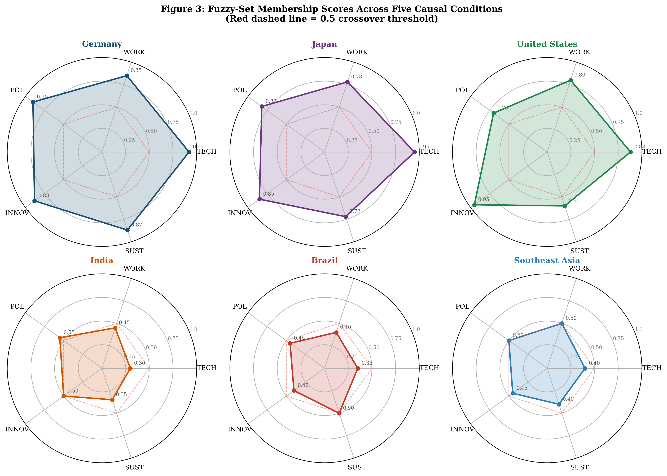
Figure 3. Fuzzy-Set Membership Scores Across Five Causal Conditions for Six Economies.

5. COMPARATIVE SYNTHESIS

5.1 Configurational Comparison
Table 8. Comparative Synthesis: Configurational Pathways
Dimension | Path 1: Advanced | Path 2: India | Path 3: SE Asia
Core mechanism | Tech-innovation-workforce synergy | Policy demand-pull + frugal supply | Collective workforce + policy
Technology | High-cost, integrated | Frugal, modular, open-source | Cloud-based, mobile-first
Policy role | Reinforcing | Constitutive | Enabling
Workforce | Aging; reskilling mid-career | Young; digital literacy + I5.0 | Young; micro-learning at scale
Scaling | Deep integration | Policy-backed clusters | SME consortia
Vulnerability | Legacy; data governance | Cost vs. human-centricity | Coordination fragility

5.2 Convergent Themes
Supply chain resilience: All economies increased investment in visibility through IoT and digital twins post-COVID. India builds redundant logistics; Germany reshores critical production; SE Asia diversifies suppliers. Workforce flexibility for rapid line reorientation is emphasized [38].
Digital transformation as enablement: Firms framing automation as "worker augmentation" experience 40% lower adoption resistance [39].
Continuous upskilling: Tripartite partnerships (government-industry-training) outperform unilateral approaches [40].

5.3 Industry 5.0 as Adaptive Framework
The configurational evidence supports that Industry 5.0 is not a universal blueprint but an adaptive framework. Three equifinal pathways demonstrate that the same pillars can be realized through fundamentally different arrangements [41].
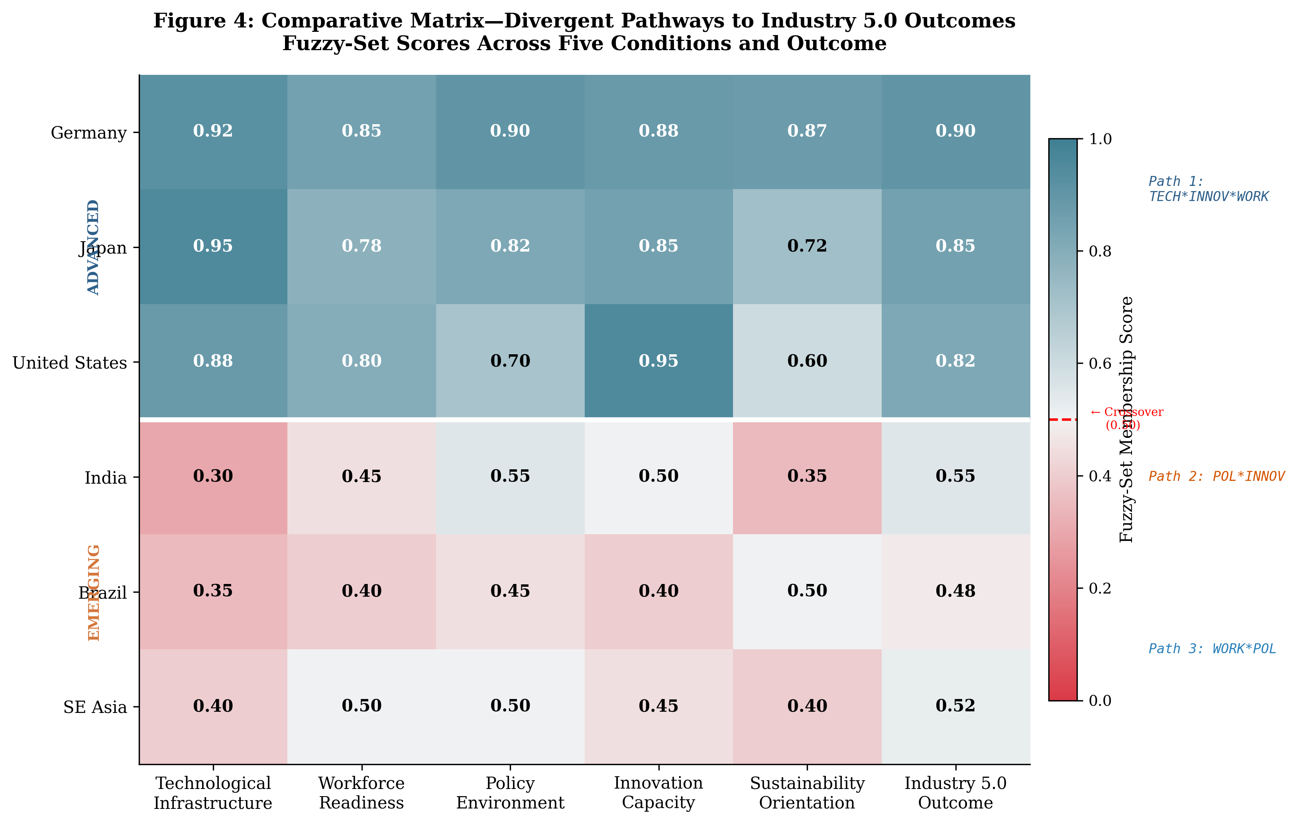
Figure 4. Comparative Matrix: Divergent Pathways to Convergent Industry 5.0 Outcomes.

6. DISCUSSION

6.1 Theoretical Contributions
Three contributions: First, demonstrating configurational theory’s explanatory power for Industry 5.0 transitions [42]. Second, challenging technological determinism by showing non-technology-led pathways succeed [43]. Third, providing empirical grounding for the "flexibility" claim through specific identified configurations [44].

6.2 Implications for SMEs
In emerging economies, >90% of manufacturing firms are SMEs facing fundamentally different constraints than multinationals. Successful SME participation depends on collective models—shared platforms, consortia, and pay-as-you-go subscriptions. In advanced economies, SMEs face legacy integration and limited IT capacity. Policy must explicitly address the SME dimension through shared infrastructure and cooperative support mechanisms.

6.3 Policy Implications
- Develop context-specific national Industry 5.0 roadmaps aligned with configurational strengths [45].
- Invest in shared digital infrastructure to reduce SME adoption barriers [46].
- Mandate human-centric design principles including ergonomic safety and algorithmic transparency [47].
- Create flexible lifelong learning accounts for continuous career-long upskilling [48].
- Link Industry 5.0 investment to climate commitments through measurable sustainability targets [49].

6.4 Limitations and Future Research
Limitations: (1) Six cases limit generalizability—expand to South Korea, Mexico, Poland [50]; (2) Cross-sectional calibration—longitudinal QCA needed [51]; (3) SE Asia composite obscures within-region variation; (4) Sector-specific QCA may reveal industry-vertical pathway differences. Priority directions: cross-regional collaboration [52], ethical AI in human-robot teams [53], circular economy as integral design feature [54], and methodological extensions including temporal QCA and multi-value QCA.

7. CONCLUSION
Industry 5.0 represents a fundamental opportunity to redefine industrial progress. This chapter’s QCA demonstrates multiple configurational pathways exist. Advanced economies succeed through technology-innovation-workforce synergies. Emerging economies succeed through policy-driven innovation (India) or collective workforce capabilities (SE Asia).
The key insight is that different starting conditions enable different—yet equally valid—pathways to human-centric, sustainable, resilient outcomes. The critical requirement is configurational coherence. Brazil’s underperformance shows that moderate individual conditions without alignment produce weaker outcomes than coherent combinations of limited conditions.
International organizations should facilitate pathway identification rather than prescribe uniform models. Technology transfer should recognize bidirectional innovation flows. The sustainability pillar requires mandatory linkage to environmental targets. Configurational theory and QCA provide valuable methodology for understanding complex industrial transitions.
The future of industry is human-automation collaboration, shaped by local realities and governed by shared principles of sustainability and resilience. Industry 5.0’s promise lies in this adaptive capacity—honoring universal principles while respecting local contexts. The evidence here provides both framework and foundation for economies worldwide to pursue their contextually appropriate Industry 5.0 pathways toward people, planet, and prosperity.

REFERENCES
1. Acemoglu, D., & Restrepo, P. (2021). Demographics and automation. The Review of Economic Studies, 89(1), 1-44.
2. European Commission. (2021). Industry 5.0: Towards a sustainable, human-centric and resilient European industry.
3. Leng, J., et al. (2022). Industry 5.0: Prospect and retrospect. Journal of Manufacturing Systems, 65, 279-295.
4. Maddikunta, P. K. R., et al. (2022). Industry 5.0: A survey on enabling technologies. J. Industrial Information Integration, 26, 100257.
5. Piccarozzi, M., et al. (2024). Roadmap to Industry 5.0. Technological Forecasting and Social Change, 205, 123467.
6. Wang, B., et al. (2025). Future research on human-centric smart manufacturing. Springer.
7. Bratovičić, A. (2025). From automation to human-centric innovation. In The industry of the future (pp. 117-136).
8. Chakrabarti, K. (2025). The future of work and economic transformation.
9. Nielsen, P. C., & Brix, P. J. (2023). Towards Society 5.0. J. Behavioural Economics and Social Systems, 5(1).
10. Ragin, C. C. (2008). Redesigning social inquiry: Fuzzy sets and beyond. University of Chicago Press.
11. Schneider, C. Q., & Wagemann, C. (2012). Set-theoretic methods. Cambridge University Press.
12. Fiss, P. C. (2011). Building better causal theories. Academy of Management Journal, 54(2), 393-420.
13. Ragin, C. C. (2006). Set relations in social research. Political Analysis, 14(3), 291-310.
14. Ragin, C. C. (2000). Fuzzy-set social science. University of Chicago Press.
15. Rihoux, B., & Ragin, C. C. (2009). Configurational comparative methods. Sage.
16. Ivanov, D., & Dolgui, A. (2020). A digital supply chain twin. Production Planning & Control, 32(9), 775-788.
17. Wynn, M., & Irizar, J. (2023). Digital twin applications in manufacturing. Future Internet, 15(9), 282.
18. Sbaragli, A., et al. (2024). Safe Operator 5.0 digital architecture. IFAC-PapersOnLine, 58(19), 265-270.
19. Ricci, R., et al. (2021). External knowledge search and Industry 4.0 in SMEs. Int. J. Production Economics, 240, 108234.
20. Ahn, S., et al. (2025). Embedded ML for worker intention recognition in HRC.
21. Liu, H., & Wang, L. (2021). Gesture recognition for HRC. In Advanced HRC in manufacturing (pp. 43-68).
22. Makris, S. (2020). Workplace generation for HRC. In Cooperating robots (pp. 255-269).
23. Kiran, U., & Suryawanshi, S. (2025). Navigating cybersecurity in Industry 5.0. Springer.
24. Bigliardi, B., et al. (2020). Enabling technologies of Industry 4.0. Procedia Manufacturing, 42, 322-326.
25. Bilgic Istoc, S. (2025). Release of autonomous commercial vehicles. In Commercial Vehicles 2025.
26. Kühn, S. (2018). Global employment and social trends. World Employment and Social Outlook.
27. Tamvada, J. P., et al. (2022). Adopting new technology in emerging economy SMEs. Technological Forecasting, 185, 122088.
28. Pasupuleti, M. K. (2025). Industry 5.0 AI and skills readiness in India.
29. Das, A. M. (2016). Frugal innovation. J. Scientometric Research, 5(2), 168-169.
30. Krishnan, S., et al. (2022). Lean Six Sigma project management. IEEE Trans. Engineering Management, 69(6), 2897-2914.
31. Maheshwari, S. (2024). Future proofing supply chains. IJSR, 13(8), 308-309.
32. Ghafar, N. H. (2022). Big data analytics in SE Asia. In Digital transformation in SE Asia (pp. 72-85).
33. Harrison, R. (2008). Skill-based technology adoption: Evidence from Brazil and India.
34. Ivascu, L. (2020). Sustainable manufacturing in Industry 4.0. Processes, 8(5), 585.
35. Chen, Y., et al. (2022). AI and upgrading of equipment manufacturing. J. Asian Research, 6(4), 30-44.
36. Brueckner, M. (2013). Fortune at the bottom of the pyramid. In Encyclopedia of CSR.
37. UNCTAD. (2010). Technology and Innovation Report.
38. Aheleroff, S., et al. (2020). Digital twin enabled mass personalization.
39. Shivadekar, S. (2025). AI for cognitive systems.
40. Aghion, P., et al. (2021). The power of creative destruction. Harvard University Press.
41. Trigkas, M., et al. (2020). Circular economy: Greek industry leaders. Resources, Conservation and Recycling, 163.
42. Nesterova, I. (2021). Change in values in degrowth business. J. Cleaner Production, 315, 128152.
43. Nagase, Y. (2022). Doughnut economics. Utopian Studies, 33(3), 528-530.
44. Weiss, J. (2013). Industrial policy in the twenty-first century. Oxford University Press.
45. Green, R. (2022). Mission economy. Contributions to Political Economy, 41(1), 189-191.
46. Allen, P., et al. (2021). Preparing for a future in global business. I-Manager’s J. on Management.
47. Solon, G. (2002). Cross-country differences in intergenerational earnings. J. Economic Perspectives, 16(3).
48. Trapp, K. (2015). Measuring the labour income share. WIDER Working Paper.
49. Ni, P. (2023). Global urban sustainable competitiveness. Springer.
50. Medhekar, A., & Haq, F. (2020). Cross-border cooperation. IGI Global.
51. Meyer, F. V. (1987). State, finance and industry. International Affairs, 63(2).
52. Tong, J., & Woo, W. T. (2006). Keeping fiscal policy sustainable in China.
53. Kılıç, C. (2023). An interview with ChatGPT about future of jobs.
54. Zhang, Y. (2023). High-tech enterprise strategy. Science Innovation.
55. Yawson, R. M. (2010). Skill needs in nanotechnology. J. Vocational Education & Training, 62(3).
56. Vanderhaeghen, D. (n.d.). Process-driven business integration management.
57. Poth, C. N. (2023). Mixed methods research design. SAGE.
58. Sethi, S. P. (2014). Just business. J. Business Ethics, 123(2), 361-362.

