Internet of Things (IoT) & Smart Cities

Abstract
The Internet of Things (IoT) represents a transformative paradigm that is fundamentally reshaping urban environments into intelligent, responsive, and sustainable ecosystems. This chapter provides a comprehensive examination of IoT architecture and its integration within smart city frameworks, encompassing the full technology stack from perception layers through edge, fog, and cloud computing paradigms. The discussion extends to advanced communication technologies including 5G/6G networks, Low-Power Wide-Area Networks (LPWAN), mesh topologies, and Time-Sensitive Networking (TSN) protocols that form the backbone of urban connectivity. The chapter explores artificial intelligence, machine learning, and digital twin technologies as enabling tools for intelligent urban management. Practical applications across smart transportation, energy systems, water distribution, waste management, and environmental monitoring are examined in detail. Furthermore, the chapter addresses critical challenges in governance, cybersecurity, privacy, interoperability, and citizen-centric service delivery. Strategic pathways for future development including AI-driven autonomous city management, blockchain-based trust frameworks, and resilient human-centric urban models are presented. The analysis synthesizes current research findings and industry developments to provide a holistic perspective on how IoT technologies can deliver competitive advantage while ensuring sustainability, equity, and resilience in urban environments.
Keywords: Internet of Things, Smart Cities, Edge Computing, Digital Twins, 5G/6G, Urban Infrastructure, Artificial Intelligence, Cybersecurity, Sustainable Development, Autonomous Systems

1. IoT Architecture and Digital Transformation of Smart Cities
The digital transformation of urban environments through Internet of Things technologies represents one of the most significant sociotechnical shifts of the twenty-first century. As global urbanization continues to accelerate, with projections indicating that 68% of the world population will reside in cities by 2050, the imperative for intelligent urban management systems becomes increasingly urgent. IoT-enabled smart cities leverage interconnected sensors, advanced computing architectures, and artificial intelligence to optimize resource utilization, enhance service delivery, improve environmental sustainability, and elevate quality of life for urban inhabitants. This section examines the foundational architectural elements that enable smart city functionality, from the physical sensing layer through distributed computing paradigms to the communication technologies that bind these elements into cohesive systems.

1.1 IoT Architecture: Sensors, Connectivity, Edge-Fog-Cloud Computing
The Internet of Things (IoT) architecture for smart cities represents a sophisticated multi-layered framework designed to seamlessly integrate billions of heterogeneous devices into cohesive urban intelligence systems [1]. At the foundation lies the perception layer, comprising diverse sensors, actuators, and embedded systems that continuously monitor urban parameters including temperature, humidity, air quality, traffic flow, noise levels, and structural integrity [2]. Modern IoT sensors have evolved significantly, with micro-electromechanical systems (MEMS) achieving unprecedented miniaturization while maintaining accuracy levels exceeding 99.5% for critical measurements [3]. The proliferation of low-cost sensor nodes, now available at sub-dollar price points, has enabled massive-scale deployments with cities like Barcelona deploying over 19,500 sensors across metropolitan infrastructure [4].
The edge computing layer represents the first tier of computational intelligence, positioned at or near data generation sources to enable real-time processing with latencies below 10 milliseconds [5]. Edge nodes perform critical functions including data filtering, anomaly detection, and local decision-making without requiring round-trip communication to centralized servers. This architectural approach reduces backbone network traffic by 60-75% while enabling time-critical applications such as autonomous vehicle coordination and emergency response systems [6]. The fog computing layer extends this distributed intelligence by providing intermediate processing capabilities at regional aggregation points, typically co-located with telecommunications infrastructure [7]. Fog nodes facilitate data fusion from multiple edge sources, perform pattern recognition across geographic clusters, and manage load balancing to optimize resource utilization. The cloud computing layer provides virtually unlimited computational resources for big data analytics, artificial intelligence model training, and long-term data archival [8]. This hierarchical architecture, illustrated in Figure 1, enables smart cities to process an estimated 2.5 quintillion bytes of urban data daily while maintaining service quality across diverse application requirements.
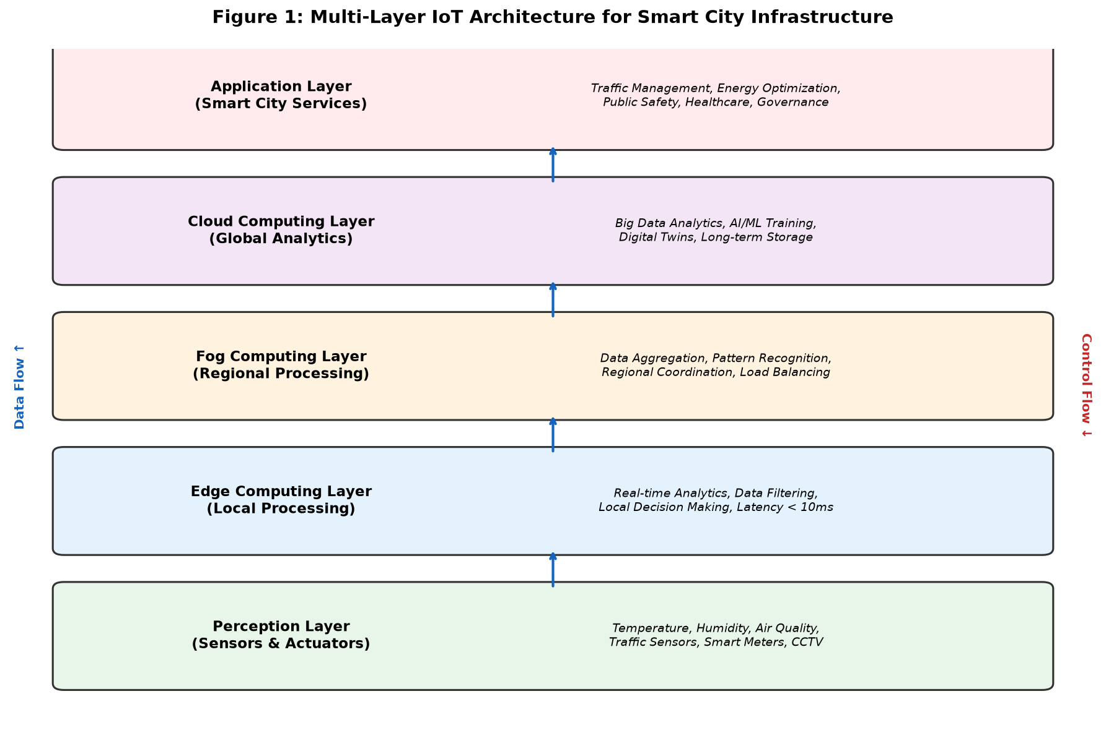
Figure 1: Multi-Layer IoT Architecture for Smart City Infrastructure
The convergence of edge, fog, and cloud computing within IoT architectures has given rise to the concept of computational continuum, where processing tasks are dynamically allocated based on latency requirements, data sensitivity, and available resources [9]. Modern smart city platforms employ container orchestration frameworks such as Kubernetes adapted for IoT workloads, enabling seamless migration of computational tasks across architectural layers. Research indicates that optimized task offloading algorithms can reduce overall system energy consumption by 40-55% compared to cloud-only architectures while maintaining quality-of-service guarantees [10]. The integration of hardware security modules at each architectural layer ensures end-to-end data integrity, with trusted execution environments providing isolated processing for sensitive urban data including citizen biometrics and financial transactions.
The scalability of IoT architectures is fundamentally dependent on efficient resource management across the computing continuum. Microservices architectures decompose monolithic smart city applications into independently deployable components, each optimized for specific operational requirements. Service mesh technologies provide observability, traffic management, and security policies across distributed IoT microservices without requiring application-level modifications. The adoption of serverless computing paradigms at the edge layer enables event-driven processing of IoT data streams with automatic scaling from zero to millions of concurrent invocations, eliminating the need for pre-provisioned infrastructure. Digital data management strategies employ tiered storage architectures where hot data resides at the edge for immediate access, warm data is maintained in fog-layer databases for recent analytics, and cold data is archived in cost-efficient cloud storage for historical analysis and compliance requirements. This architectural sophistication enables smart cities to manage the exponential growth in IoT data volumes, projected to reach 79.4 zettabytes globally by 2025, while controlling infrastructure costs and maintaining responsive service delivery to urban stakeholders.
Emerging paradigms in IoT architecture include intent-based networking, where administrators specify desired outcomes rather than explicit configurations, and the network autonomously adapts to achieve stated objectives. Software-defined IoT architectures decouple the control plane from the data plane, enabling centralized policy management across heterogeneous device populations while maintaining distributed data processing for performance optimization. The concept of computing-aware networking integrates real-time awareness of computational resource availability into routing decisions, ensuring that IoT data flows are directed to processing nodes with available capacity. These architectural innovations collectively enable smart city IoT deployments to achieve the scalability, reliability, and performance characteristics required for mission-critical urban applications while maintaining the flexibility to accommodate rapidly evolving technology landscapes and expanding application requirements.

1.2 5G/6G, LPWAN, Mesh Networks, and Time-Sensitive Networking
Communication infrastructure forms the nervous system of smart city ecosystems, with diverse network technologies serving distinct application requirements across the urban landscape [11]. Fifth-generation (5G) cellular networks provide three fundamental service categories: enhanced Mobile Broadband (eMBB) delivering peak speeds of 20 Gbps, Ultra-Reliable Low-Latency Communications (URLLC) achieving latencies below 1 millisecond with 99.999% reliability, and massive Machine-Type Communications (mMTC) supporting up to one million connected devices per square kilometer [12]. These capabilities enable previously impossible applications including real-time holographic urban planning, remote surgical procedures in smart hospitals, and vehicle-to-everything (V2X) communications for autonomous transportation systems. The emerging sixth-generation (6G) networks, anticipated for commercial deployment by 2030, promise terahertz-band communications with data rates exceeding 1 Tbps, sub-microsecond latency, and integrated sensing-communication capabilities [13].
Low-Power Wide-Area Networks (LPWAN) address the requirements of massive-scale sensor deployments where devices must operate for 10-15 years on a single battery while transmitting data over distances of 5-15 kilometers [14]. LoRaWAN technology has emerged as the dominant LPWAN protocol for smart city applications, with global deployments exceeding 170 countries and supporting diverse use cases from smart parking to environmental monitoring. Narrowband IoT (NB-IoT) leverages existing cellular infrastructure to provide carrier-grade reliability with deep indoor penetration, achieving coverage gains of 20 dB over conventional LTE [15]. The communication network topology for smart cities, as depicted in Figure 2, illustrates the complementary nature of these technologies in creating comprehensive urban connectivity.
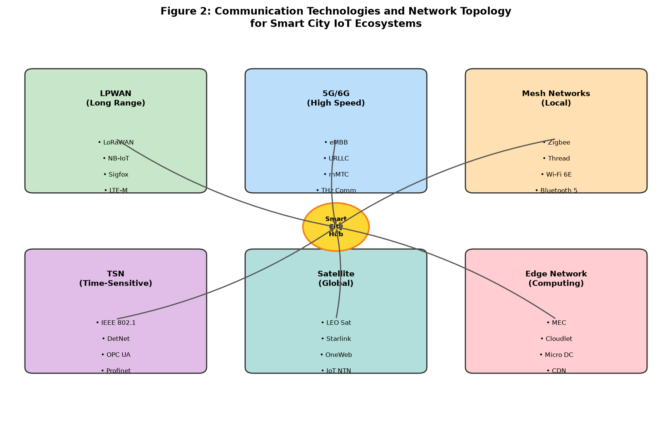
Figure 2: Communication Technologies and Network Topology for Smart City IoT Ecosystems
Mesh networking protocols including Zigbee, Thread, and Wi-Fi 6E enable local device-to-device communication with self-healing capabilities essential for resilient urban infrastructure [16]. These networks dynamically reconfigure routing paths in response to node failures, maintaining connectivity even under adverse conditions. Time-Sensitive Networking (TSN) standards, defined by IEEE 802.1 working groups, provide deterministic communication guarantees required for industrial IoT applications within smart city contexts [17]. TSN enables bounded latency, zero congestion loss, and precise time synchronization across heterogeneous network segments, making it essential for applications such as synchronized traffic signal control and distributed energy resource coordination. Table 1 presents a comparative analysis of key communication technologies deployed in smart city environments.
The heterogeneous nature of smart city communication requirements necessitates sophisticated network orchestration frameworks that dynamically allocate connectivity resources based on application needs. Network slicing technology, a cornerstone of 5G architecture, enables the creation of logically isolated virtual networks on shared physical infrastructure, each tailored for specific smart city service categories. A critical communications slice may guarantee sub-millisecond latency for autonomous vehicle coordination, while a massive IoT slice optimizes for connection density supporting millions of environmental sensors per square kilometer. Non-terrestrial networks (NTN) integrating Low Earth Orbit (LEO) satellite constellations with terrestrial IoT infrastructure provide ubiquitous coverage including rural peri-urban areas and disaster-affected zones where ground-based infrastructure is unavailable or damaged. The convergence of communication and sensing capabilities in future networks enables passive environmental monitoring through signal analysis, where communication waveforms simultaneously carry data and sense the physical environment, creating a pervasive sensing fabric that augments dedicated IoT sensor deployments without additional hardware investment.

Table 1: Comparative Analysis of Smart City Communication Technologies
Technology | Range | Data Rate | Latency | Power | Key Application
5G NR | 1-10 km | 20 Gbps | <1 ms | High | Autonomous vehicles, AR/VR
LoRaWAN | 5-15 km | 50 kbps | 1-2 s | Ultra-low | Environmental sensors
NB-IoT | 10-35 km | 250 kbps | 1.5-10 s | Very low | Smart metering
Zigbee | 10-100 m | 250 kbps | 15 ms | Low | Building automation
Wi-Fi 6E | 50-100 m | 9.6 Gbps | <5 ms | Medium | High-density venues
TSN/Ethernet | 100 m | 10 Gbps | <10 us | Medium | Industrial control

1.3 AI, Machine Learning, and Digital Twins for Intelligent Urban Systems
Artificial intelligence and machine learning constitute the cognitive engine of smart city ecosystems, transforming raw sensor data into actionable urban intelligence [18]. Deep learning architectures, particularly convolutional neural networks (CNNs) and transformer models, have demonstrated exceptional performance in urban analytics tasks including traffic prediction with 94% accuracy, air quality forecasting achieving mean absolute errors below 5 micrograms per cubic meter, and anomaly detection in critical infrastructure with false positive rates under 0.1% [19]. Federated learning paradigms enable collaborative model training across distributed urban IoT nodes without centralizing sensitive data, addressing privacy concerns while maintaining model accuracy within 2-3% of centralized approaches [20]. Reinforcement learning algorithms optimize real-time urban operations including traffic signal timing, energy distribution, and emergency resource allocation, with studies demonstrating 25-35% improvements in system efficiency compared to traditional rule-based approaches [21].
Digital twin technology creates high-fidelity virtual replicas of physical urban infrastructure, enabling simulation, prediction, and optimization without disrupting real-world operations [22]. City-scale digital twins integrate data from thousands of IoT sensors to maintain real-time representations of traffic networks, utility systems, building energy performance, and environmental conditions. Singapore's Virtual Singapore project exemplifies this approach, creating a semantically enriched 3D model of the entire city-state that supports urban planning, emergency response simulation, and policy evaluation [23]. The convergence of digital twin technology with generative AI enables scenario planning capabilities where urban planners can simulate the impacts of infrastructure modifications, climate events, or policy changes before implementation. Research indicates that digital twin-enabled predictive maintenance reduces infrastructure failure rates by 45-60% while extending asset lifespans by 20-30% [24]. The integration of these technologies within the IoT architecture creates a self-learning urban ecosystem capable of continuous optimization, as illustrated in the applications framework shown in Figure 3.
The application of explainable AI (XAI) in smart city contexts addresses the critical challenge of transparency in algorithmic urban governance. Decision support systems that recommend policy actions based on IoT data must provide interpretable justifications that city administrators and elected officials can understand, evaluate, and communicate to constituents. Attention mechanisms in transformer architectures enable identification of which IoT data streams most significantly influence predictions, creating audit trails for automated decisions. Graph neural networks (GNNs) have emerged as particularly effective for modeling the networked structure of urban systems, capturing spatial dependencies between infrastructure components and propagating information across topological relationships. Transfer learning approaches enable models trained on data-rich cities to be adapted for resource-constrained municipalities, democratizing access to advanced AI capabilities regardless of local data availability or technical expertise. The convergence of these AI approaches with comprehensive IoT sensing creates urban intelligence systems that not only detect current conditions but anticipate future states with sufficient lead time for proactive intervention, fundamentally shifting urban management from reactive to predictive paradigms.

2. IoT Applications for Intelligent and Sustainable Urban Infrastructure
The translation of IoT architectural capabilities into practical urban applications represents the critical value creation stage of smart city development. While the preceding section established the technological foundations, this section examines how these capabilities are deployed across key urban domains to deliver tangible improvements in efficiency, sustainability, and citizen well-being. The applications discussed span transportation systems that move people and goods, energy and utility networks that sustain urban metabolism, and environmental monitoring systems that safeguard public health. Each domain demonstrates unique IoT integration patterns while contributing to the holistic optimization of urban systems through data sharing and cross-domain intelligence. The economic justification for IoT investment in urban infrastructure rests on demonstrable returns including reduced operational costs, improved asset utilization, decreased environmental externalities, and enhanced citizen satisfaction with public services. Global smart city market projections indicate compound annual growth rates exceeding 25% through 2030, driven by urbanization pressures, climate imperatives, and technological maturation that collectively create compelling business cases for IoT-enabled urban transformation across diverse economic and geographic contexts.

2.1 Smart Transportation, Connected Vehicles, and Intelligent Traffic Management
Smart transportation represents the most visible and economically significant application domain for IoT in urban environments, with global investment exceeding $130 billion annually [25]. Intelligent Traffic Management Systems (ITMS) leverage networks of inductive loop detectors, video analytics cameras, radar sensors, and connected vehicle data to optimize traffic flow across metropolitan road networks. Adaptive signal control technologies such as SCOOT and SCATS dynamically adjust signal timing based on real-time demand, achieving traffic delay reductions of 20-40% compared to fixed-time plans [26]. The integration of vehicle-to-infrastructure (V2I) communication enables proactive traffic management, with connected vehicles receiving speed advisories and route recommendations that collectively reduce congestion by 15-25% during peak periods.
Connected and autonomous vehicles (CAVs) represent the frontier of smart transportation, with IoT sensor fusion combining LiDAR, radar, cameras, and V2X communications to achieve Society of Automotive Engineers (SAE) Level 4-5 automation [27]. Urban deployments of autonomous shuttle services in cities including Helsinki, Singapore, and Dubai have demonstrated the viability of driverless public transportation in controlled environments. Mobility-as-a-Service (MaaS) platforms integrate multimodal transportation options including public transit, ride-sharing, bike-sharing, and micro-mobility through unified IoT-enabled booking and payment systems [28]. Smart parking solutions employing magnetometer sensors and computer vision reduce parking search time by 43%, decreasing associated emissions by an estimated 30% in dense urban cores. The comprehensive application of IoT across transportation domains is visualized in Figure 3, demonstrating the interconnected nature of smart city services.
Electric vehicle (EV) charging infrastructure managed through IoT platforms represents a critical intersection of smart transportation and smart energy systems. Intelligent charging stations equipped with bidirectional power electronics enable vehicle-to-grid (V2G) services where parked EVs serve as distributed energy storage assets, providing grid balancing services during peak demand periods. IoT-based fleet management systems optimize routing, scheduling, and maintenance for public transit and commercial vehicle fleets, with telematics data enabling predictive maintenance that reduces vehicle downtime by 30-45%. Drone-based delivery systems, operating as extensions of smart transportation networks, leverage IoT infrastructure for airspace management, autonomous navigation, and integration with ground-based logistics systems. The evolution toward cooperative intelligent transportation systems (C-ITS) enables real-time information exchange between vehicles, infrastructure, and vulnerable road users, with studies indicating potential reductions of 25-40% in traffic fatalities through cooperative collision avoidance and intersection management systems.
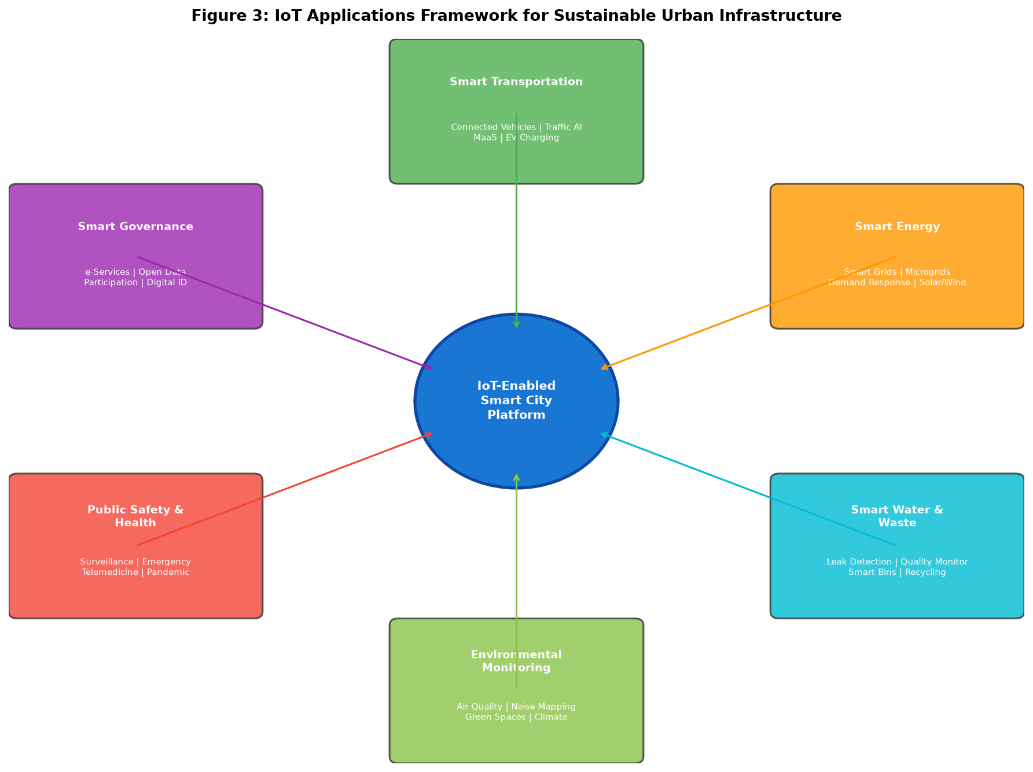
Figure 3: IoT Applications Framework for Sustainable Urban Infrastructure

2.2 Smart Energy, Grids, Water Distribution, and Waste Management
IoT-enabled smart energy systems are revolutionizing urban utility management through intelligent monitoring, automated control, and predictive optimization of generation, distribution, and consumption assets [29]. Advanced Metering Infrastructure (AMI) deployments provide bidirectional communication between utilities and consumers at 15-minute intervals, enabling dynamic pricing signals, demand response programs, and granular consumption analytics. Smart grid technologies integrate distributed energy resources including rooftop solar installations, battery storage systems, and electric vehicle charging infrastructure into cohesive microgrids capable of autonomous operation during grid disruptions [30]. IoT sensors deployed across distribution networks enable real-time fault detection and isolation, reducing outage durations by 50-70% through automated switching and self-healing capabilities. Table 2 presents the key performance metrics achieved by IoT deployments across urban utility sectors.

Table 2: IoT Performance Metrics Across Urban Utility Sectors
Utility Sector | IoT Technology | Key Metric | Improvement | ROI Period
Electricity | Smart Meters/AMI | Peak Demand Reduction | 15-25% | 3-5 years
Water Supply | Acoustic Sensors | Leak Detection Rate | 85-95% | 2-4 years
Gas Distribution | IoT Monitors | Leak Response Time | 70% faster | 3-6 years
Waste Collection | Fill-level Sensors | Collection Efficiency | 30-40% | 1-3 years
Street Lighting | Smart Controls | Energy Savings | 50-70% | 2-4 years
District Heating | Flow Sensors | Distribution Loss | 20-35% reduction | 4-7 years

Smart water management systems employ IoT sensor networks to monitor pressure, flow, quality, and acoustic signatures across distribution infrastructure, enabling early detection of leaks that traditionally account for 25-35% of treated water losses in aging urban networks [31]. Real-time water quality monitoring using multi-parameter probes provides continuous assessment of turbidity, pH, chlorine residual, and microbial indicators, enabling rapid response to contamination events. Smart waste management solutions integrate ultrasonic fill-level sensors in collection containers with route optimization algorithms, reducing collection vehicle mileage by 30-40% and associated emissions proportionally [32]. Pneumatic waste collection systems in new urban developments eliminate surface-level waste containers entirely, with IoT-controlled vacuum networks transporting waste underground to central processing facilities.
Building energy management systems (BEMS) represent a significant application of IoT for urban sustainability, given that buildings account for approximately 40% of total urban energy consumption and 33% of greenhouse gas emissions. IoT-enabled BEMS integrate sensors for occupancy detection, thermal comfort monitoring, lighting level assessment, and equipment performance tracking with AI-driven control algorithms that continuously optimize heating, ventilation, air conditioning, and lighting systems. Deep reinforcement learning approaches to building control have demonstrated energy savings of 20-35% while maintaining or improving occupant comfort compared to conventional rule-based systems. District-level energy optimization coordinates individual building systems with shared resources including combined heat and power plants, thermal storage, and shared renewable generation assets. The integration of weather forecasting, occupancy prediction, and energy market pricing into IoT-enabled building management creates anticipatory systems that pre-condition spaces during low-cost periods and participate in demand response programs during grid stress events, transforming buildings from passive energy consumers into active grid resources that contribute to overall urban energy resilience and efficiency.

2.3 Environmental Monitoring, Pollution Control, and Urban Public Health
IoT-based environmental monitoring networks provide unprecedented spatial and temporal resolution for tracking urban environmental quality, enabling evidence-based interventions to protect public health [33]. Dense networks of low-cost air quality sensors measuring particulate matter (PM2.5, PM10), nitrogen dioxide, ozone, and volatile organic compounds create hyperlocal pollution maps that reveal micro-environmental variations invisible to traditional sparse monitoring stations. Machine learning algorithms calibrate and fuse data from heterogeneous sensor types to achieve reference-grade accuracy while maintaining the spatial coverage advantages of distributed networks [34]. Cities implementing comprehensive IoT air quality monitoring have achieved 15-25% reductions in population exposure to harmful pollutants through targeted interventions including dynamic traffic restrictions, industrial emission alerts, and citizen notification systems.
Urban noise mapping through IoT acoustic sensor networks characterizes the spatiotemporal distribution of environmental noise, informing urban planning decisions and enabling enforcement of noise regulations [35]. Integration of environmental monitoring with public health surveillance systems enables rapid identification of exposure-disease relationships, supporting predictive health analytics. The COVID-19 pandemic accelerated deployment of IoT-enabled public health infrastructure including thermal screening systems, occupancy monitoring for social distancing enforcement, and indoor air quality systems with real-time ventilation optimization [36]. Wearable IoT devices and smartphone-based sensing platforms enable citizen science approaches to environmental monitoring, democratizing data collection while enhancing spatial coverage beyond what fixed infrastructure alone can achieve.
The integration of satellite remote sensing with ground-based IoT networks creates multi-scale environmental monitoring systems that combine the spatial coverage of orbital platforms with the temporal resolution and measurement specificity of in-situ sensors. Urban heat island monitoring through networks of temperature sensors, combined with satellite thermal imagery and computational fluid dynamics models, enables targeted interventions including reflective surface installations, strategic tree planting, and water feature deployment in heat-vulnerable neighborhoods. Biodiversity monitoring using acoustic sensors, camera traps, and environmental DNA sampling stations tracks urban ecosystem health, informing conservation strategies within metropolitan environments. The application of IoT to urban agriculture, including vertical farming facilities with comprehensive environmental control systems, contributes to food security while reducing transportation-related emissions associated with conventional supply chains. These environmental monitoring capabilities, when integrated with public health databases and epidemiological models, enable predictive health impact assessments that quantify the benefits of environmental interventions in terms of reduced hospitalizations, improved life expectancy, and economic productivity gains, providing robust cost-benefit justifications for continued investment in smart city environmental infrastructure.

3. Smart Governance, Security, and Citizen-Centric Services
The deployment of IoT infrastructure across urban environments creates both unprecedented opportunities for improved governance and significant challenges in security, privacy, and equitable access. Smart governance leverages IoT-generated intelligence to enhance public administration, improve emergency response capabilities, and enable evidence-based policymaking. However, the same data collection capabilities that enable intelligent governance also create surveillance risks, privacy vulnerabilities, and potential for algorithmic discrimination that must be addressed through robust technical safeguards and governance frameworks. This section examines the dual nature of IoT-enabled governance, exploring both its transformative potential and the essential protections required to maintain democratic values and citizen trust in an increasingly data-rich urban environment. The balance between security and freedom, between efficiency and privacy, represents perhaps the defining challenge of smart city development, requiring thoughtful engagement from technologists, policymakers, civil society organizations, and citizens themselves to establish norms and boundaries that reflect societal values.

3.1 IoT-Enabled Governance, Public Safety, and Emergency Response
IoT technologies are transforming urban governance by enabling data-driven decision-making, improving service delivery efficiency, and enhancing transparency in public administration [37]. Smart city platforms aggregate data from diverse IoT sources to provide city administrators with comprehensive operational dashboards that visualize real-time urban performance across multiple dimensions including mobility, energy consumption, environmental quality, and public safety. These integrated command centers, exemplified by Rio de Janeiro's Centro de Operacoes and Dubai's Pulse Platform, enable coordinated multi-agency responses to urban events ranging from traffic incidents to natural disasters [38]. Predictive analytics applied to historical IoT data enables proactive governance approaches, with machine learning models forecasting infrastructure maintenance needs, crime hotspots, and demand patterns for public services with lead times of days to weeks.
Public safety applications of IoT encompass intelligent surveillance systems, gunshot detection networks, flood early warning systems, and structural health monitoring of critical infrastructure [39]. Computer vision algorithms processing feeds from city-wide camera networks enable automated detection of security threats, traffic violations, and emergency situations, with response time improvements of 40-60% compared to human-only monitoring. IoT-enabled emergency response systems integrate caller location data, connected building fire alarms, vehicle telematics, and hospital capacity information to optimize dispatching and resource allocation. Table 3 summarizes key smart governance applications and their measured impacts across leading smart city implementations. The interconnected nature of these systems, as shown in Figure 1, demonstrates how the layered IoT architecture supports diverse governance applications through a unified technology platform.
Disaster resilience through IoT infrastructure represents a critical public safety application, with sensor networks providing early warning capabilities for floods, earthquakes, landslides, and severe weather events. Seismic sensor arrays deployed across urban areas enable earthquake early warning systems that provide seconds to minutes of advance notice, triggering automated protective actions including elevator positioning, gas supply shutdown, and bridge closure. Flood monitoring systems combine river level sensors, rainfall gauges, drainage network monitors, and hydrological models to provide spatially explicit inundation forecasts with lead times of hours to days. IoT-enabled building structural health monitoring systems continuously assess the integrity of critical infrastructure including bridges, tunnels, and high-rise buildings through vibration analysis, strain measurement, and tilt detection, enabling condition-based maintenance that prevents catastrophic failures. The integration of these diverse safety systems through unified IoT platforms enables cascading event management, where the detection of an initial trigger such as an earthquake automatically activates secondary monitoring systems, initiates evacuation protocols, and pre-positions emergency response resources based on predicted impact patterns.

Table 3: Smart Governance Applications and Measured Impacts
Application Domain | IoT Infrastructure | City Example | Key Impact | Scale
Traffic Management | Sensors + AI cameras | Singapore | 25% congestion reduction | City-wide
Crime Prevention | Surveillance + Analytics | Chicago | 30% faster response | 700+ sensors
Emergency Response | Integrated IoT platform | Rio de Janeiro | 40% response improvement | Metro area
Infrastructure Mgmt | Structural sensors | Amsterdam | 45% maintenance savings | 1200+ bridges
Energy Governance | Smart grid IoT | Copenhagen | 42% carbon reduction | City-wide
Citizen Services | Multi-channel IoT | Seoul | 35% satisfaction increase | 10M citizens

3.2 Data Security, Privacy, Interoperability, and Scalable IoT Ecosystems
The massive scale and heterogeneity of smart city IoT deployments create unprecedented cybersecurity challenges, with attack surfaces expanding exponentially as billions of devices connect to urban networks [39]. IoT devices, often constrained in computational resources, present vulnerabilities that adversaries exploit through botnet recruitment, man-in-the-middle attacks, and firmware manipulation. The Mirai botnet attack of 2016, which compromised over 600,000 IoT devices, demonstrated the catastrophic potential of unsecured IoT infrastructure [40]. Modern security frameworks for smart city IoT employ defense-in-depth strategies incorporating device identity management through Public Key Infrastructure (PKI), network segmentation using software-defined networking, encrypted communications via lightweight cryptographic protocols (e.g., DTLS, OSCORE), and behavioral analytics for anomaly detection. Zero-trust architectures eliminate implicit trust between network segments, requiring continuous verification of device identity and authorization for every data transaction [41].
Privacy preservation in IoT-enabled smart cities requires balancing the analytical value of urban data against citizens' fundamental rights to privacy and data protection. Differential privacy mechanisms inject calibrated noise into aggregated datasets to prevent re-identification of individual behavior patterns while maintaining statistical utility for urban analytics [41]. Homomorphic encryption enables computation on encrypted data, allowing cloud-based analytics without exposing raw sensor readings to service providers. The European General Data Protection Regulation (GDPR) and similar frameworks globally impose strict requirements on IoT data processing, necessitating privacy-by-design approaches in smart city system architectures. Interoperability challenges arise from the fragmented IoT ecosystem comprising hundreds of competing protocols, data formats, and vendor-specific platforms. Standards-based approaches including FIWARE NGSI-LD, oneM2M, and W3C Web of Things provide semantic interoperability layers that enable cross-domain data exchange and application portability across smart city platforms [42].
Scalability of IoT ecosystems demands architectural approaches that accommodate exponential growth in device populations without proportional increases in management complexity or infrastructure costs. Autonomous device management platforms employing AI-driven operations (AIOps) automate device provisioning, configuration, monitoring, and lifecycle management across millions of heterogeneous IoT endpoints. Digital twin-based device management creates virtual representations of physical devices, enabling remote diagnostics, over-the-air firmware updates, and predictive failure detection without physical access to deployed equipment. The economic sustainability of large-scale IoT deployments requires careful consideration of total cost of ownership including device procurement, connectivity subscriptions, data storage, computational resources, and ongoing maintenance. Shared IoT infrastructure models, where multiple city departments and third-party service providers utilize common sensor networks and communication infrastructure, reduce per-application costs while maximizing data reuse. The establishment of urban IoT testbeds and sandboxes enables controlled experimentation with new technologies and applications before full-scale deployment, reducing risks associated with technology adoption while building institutional capacity for IoT system management.

3.3 Digital Inclusion, Citizen Participation, and Responsible Data Governance
The success of smart city initiatives ultimately depends on inclusive design that ensures equitable access to IoT-enabled services across all demographic groups, avoiding the creation of digital divides that exacerbate existing social inequalities [37]. Digital inclusion strategies must address barriers including affordability of connected devices, digital literacy requirements for service access, language and cultural accessibility, and physical accessibility for persons with disabilities. Participatory design methodologies involving citizens in the co-creation of IoT services ensure that technology deployments align with community needs and values rather than imposed technocratic visions. Living lab approaches, as exemplified by Barcelona's Superblocks program and Amsterdam's Smart Citizens Lab, demonstrate how citizen engagement can drive innovation while building social acceptance of IoT technologies [38].
Responsible data governance frameworks establish transparent rules for the collection, processing, sharing, and retention of urban IoT data, ensuring accountability and public trust [39]. Data trusts and cooperatives represent emerging governance models where citizens collectively control the use of their data, receiving tangible benefits from its exploitation while maintaining veto rights over unacceptable uses. Open data initiatives make non-sensitive urban IoT datasets publicly available, enabling civic innovation, academic research, and commercial service development. The integration of communication technologies illustrated in Figure 2 must be accompanied by robust governance frameworks that ensure these powerful connectivity capabilities serve public interests while protecting individual rights. Ethical AI frameworks guide the development and deployment of algorithmic decision-making systems within smart city contexts, requiring explainability, fairness auditing, and human oversight of consequential automated decisions [40].
The concept of data sovereignty extends responsible governance to the municipal level, where cities assert control over urban data assets generated within their jurisdiction regardless of the nationality of technology providers. Municipal data platforms aggregate and curate IoT data from public and private sources, creating authoritative urban data repositories that support evidence-based policymaking. Data impact assessments, analogous to environmental impact assessments, evaluate the potential consequences of new IoT deployments on privacy, equity, and social cohesion before approval. Algorithmic accountability mechanisms require regular auditing of automated decision systems for bias, discrimination, and error patterns, with results published transparently and remediation mandated for identified issues. These governance innovations collectively ensure that the enormous power of IoT-enabled urban intelligence serves democratic values and public interest, building the social license necessary for continued technology adoption while preventing the emergence of techno-authoritarian urban governance models that prioritize efficiency over rights.

4. Future Directions and Strategic Pathways for IoT-Enabled Smart Cities
The trajectory of IoT-enabled smart city development points toward increasingly sophisticated, autonomous, and integrated urban systems that fundamentally redefine the relationship between citizens, technology, and urban infrastructure. Emerging technologies including artificial general intelligence, quantum computing, advanced robotics, and brain-computer interfaces will expand the capabilities of urban IoT systems far beyond current implementations. Simultaneously, evolving societal expectations around sustainability, equity, transparency, and democratic participation will shape how these technologies are deployed and governed. This section explores the strategic pathways available to cities as they navigate toward increasingly intelligent urban futures, examining the technological enablers, governance innovations, and design philosophies that will determine whether smart cities fulfill their promise of sustainable human flourishing.

4.1 AI-Driven Autonomous Cities, Edge Intelligence, and Predictive Urban Management
The evolution toward AI-driven autonomous cities represents the next frontier in smart city development, where urban systems achieve self-optimization capabilities through advanced machine intelligence operating at the network edge [42]. Edge AI processors, incorporating neural processing units (NPUs) with performance exceeding 100 TOPS (Tera Operations Per Second), enable complex inference tasks including real-time video analytics, natural language processing, and predictive modeling to execute locally without cloud dependencies. This architectural evolution, illustrated in the strategic roadmap presented in Figure 4, transforms IoT infrastructure from passive data collection systems into active intelligent agents capable of autonomous decision-making within defined operational boundaries. Neuromorphic computing architectures, inspired by biological neural systems, promise orders-of-magnitude improvements in energy efficiency for edge AI workloads, enabling always-on intelligence in battery-powered IoT devices [42].
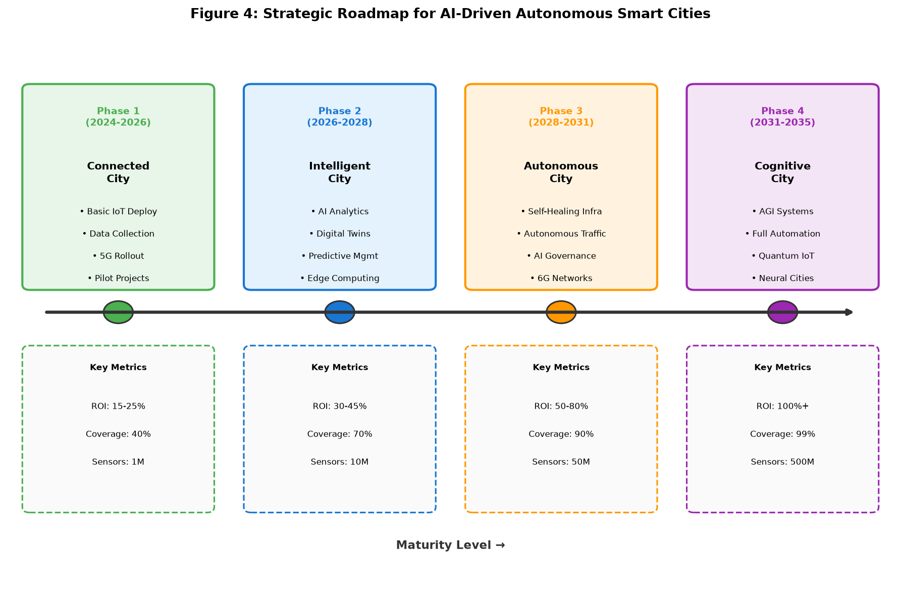
Figure 4: Strategic Roadmap for AI-Driven Autonomous Smart Cities
Predictive urban management leverages digital twins enhanced with generative AI capabilities to simulate and optimize city operations across multiple time horizons [22]. Short-term predictions (minutes to hours) enable real-time traffic routing, energy load balancing, and emergency response optimization. Medium-term forecasts (days to weeks) support infrastructure maintenance scheduling, event planning, and resource procurement. Long-term projections (months to years) inform capital investment decisions, urban expansion planning, and climate adaptation strategies. The convergence of large language models with urban IoT data enables natural language interfaces for city management, allowing administrators to query complex urban datasets and receive synthesized insights through conversational interaction [24]. Swarm intelligence algorithms coordinate fleets of autonomous urban robots for tasks including last-mile delivery, infrastructure inspection, and environmental cleanup, operating as extensions of the IoT sensor network with actuation capabilities.
The transition toward autonomous city operations introduces novel challenges in system reliability, fail-safe mechanisms, and human oversight architectures. Safety-critical autonomous systems require formal verification of decision algorithms, with mathematical proofs ensuring that automated actions remain within defined safety envelopes under all possible input conditions. Graceful degradation architectures ensure that autonomous systems revert to safe states when confronted with unprecedented situations, maintaining essential services while alerting human operators to intervene. The concept of shared autonomy enables graduated automation levels, where IoT systems handle routine decisions independently while escalating complex or sensitive situations to human decision-makers through intuitive interfaces that present relevant context and recommended actions. Quantum computing integration with smart city IoT infrastructure promises transformative capabilities in optimization problems that are computationally intractable for classical systems, including large-scale traffic network optimization, portfolio optimization for distributed energy resources, and cryptographic protocols for securing IoT communications against future quantum attacks.

4.2 Blockchain, Trust, and Transparent Digital Urban Ecosystems
Blockchain and distributed ledger technologies (DLT) address fundamental trust challenges in smart city IoT ecosystems by providing immutable, transparent, and decentralized record-keeping for urban transactions and data provenance [40]. Smart contracts automate multi-party agreements in areas including peer-to-peer energy trading, automated insurance claims processing, and supply chain verification for municipal procurement. Blockchain-based identity management systems provide self-sovereign digital identities that enable citizens to control access to their personal data across smart city services without relying on centralized identity providers [41]. The strategic roadmap shown in Figure 4 positions blockchain integration as a critical enabler for the transition from intelligent to autonomous city operations.
Decentralized IoT data marketplaces built on blockchain infrastructure enable transparent and fair exchange of urban data assets between public agencies, private companies, and citizens [40]. These platforms employ token economics to incentivize data sharing while ensuring equitable value distribution among contributors. Blockchain-based voting and governance systems enable secure digital democracy, allowing citizens to participate in urban planning decisions through tamper-proof digital referenda. The convergence of blockchain with IoT creates opportunities for decentralized autonomous organizations (DAOs) in urban governance, where community-owned infrastructure operates according to collectively agreed smart contract rules [41]. However, challenges remain in blockchain scalability, energy consumption of consensus mechanisms, and regulatory frameworks governing decentralized urban systems. Table 4 presents a comparative analysis of blockchain platforms evaluated for smart city IoT applications.
The implementation of trusted execution environments (TEEs) in conjunction with blockchain technology addresses the oracle problem in smart city IoT applications, ensuring that real-world sensor data feeding into smart contracts is authentic and untampered. Verifiable credentials issued through blockchain-based identity systems enable privacy-preserving authentication for smart city services, where citizens prove eligibility for services without revealing unnecessary personal information. Supply chain transparency enabled by IoT-blockchain integration provides citizens with verifiable information about the provenance of municipal procurement, from construction materials to food served in public institutions. Carbon credit tokenization and automated verification through IoT environmental sensors create transparent markets for emissions reductions, incentivizing private sector investment in urban sustainability initiatives. The maturation of layer-2 scaling solutions and energy-efficient consensus mechanisms addresses earlier concerns about blockchain sustainability, making decentralized approaches viable for the transaction volumes characteristic of city-scale IoT deployments processing millions of events daily.
Interoperability between blockchain platforms and legacy municipal IT systems presents implementation challenges that require middleware solutions and standardized application programming interfaces. Regulatory uncertainty surrounding cryptocurrency, decentralized finance, and tokenized assets creates risks for municipalities exploring blockchain-based urban services, necessitating close engagement with regulatory bodies during pilot deployments. The governance of blockchain protocols themselves introduces meta-governance challenges, where decisions about protocol upgrades, parameter adjustments, and dispute resolution mechanisms must align with democratic accountability principles. Despite these challenges, the trajectory toward blockchain integration in smart city infrastructure appears well-established, with major technology companies, standards organizations, and international development agencies actively supporting research and pilot deployments across diverse urban contexts from advanced economies to rapidly urbanizing developing nations.

Table 4: Blockchain Platforms for Smart City IoT Applications
Platform | Consensus | TPS | IoT Suitability | Smart City Use Case
Ethereum 2.0 | Proof of Stake | 100,000+ | Medium | DeFi, Digital Identity
Hyperledger Fabric | PBFT | 20,000+ | High | Supply Chain, Governance
IOTA Tangle | DAG/Coordinator | 1,000+ | Very High | Microtransactions, Data Market
Algorand | Pure PoS | 46,000+ | High | Carbon Credits, Payments
Polkadot | NPoS | 1,500+ | Medium-High | Cross-chain Interop
Hedera Hashgraph | Asynchronous BFT | 10,000+ | High | Audit Trails, IoT Data

4.3 Resilient, Sustainable, and Human-Centric Smart City Models for Competitive Advantage
The ultimate vision for IoT-enabled smart cities transcends technological optimization to encompass resilient, sustainable, and human-centric urban models that deliver enduring competitive advantage for cities and their inhabitants [41]. Urban resilience frameworks leverage IoT infrastructure to enhance city capacity for absorbing shocks, adapting to changing conditions, and transforming in response to systemic challenges including climate change, pandemic events, and economic disruptions. IoT-enabled climate adaptation strategies include real-time flood monitoring and automated response systems, urban heat island mitigation through smart green infrastructure management, and predictive models for extreme weather impacts on critical infrastructure [42]. Circular economy principles integrated with IoT systems enable material flow tracking, waste stream optimization, and industrial symbiosis facilitation, where one organization's waste becomes another's input through automated marketplace matching.
Sustainability metrics embedded within IoT platforms provide real-time tracking of progress toward Sustainable Development Goals (SDGs) at the urban level, enabling evidence-based sustainability governance [41]. Carbon accounting systems leveraging IoT data from energy meters, transportation sensors, and industrial monitors provide granular emissions inventories that support carbon trading and offset verification. Nature-based solutions enhanced with IoT monitoring, including smart urban forests, green roofs with automated irrigation, and constructed wetlands with water quality sensors, demonstrate the integration of ecological and technological approaches to urban sustainability [43]. The human-centric design philosophy ensures that technology serves as an enabler of human flourishing rather than a mechanism of surveillance and control, with IoT systems designed to enhance personal agency, community connection, and quality of life [43].
The concept of regenerative cities extends sustainability beyond minimizing harm to actively restoring ecological systems through IoT-optimized interventions. Smart green infrastructure networks equipped with soil moisture sensors, species identification cameras, and microclimate monitors create data-driven approaches to urban ecology that maximize biodiversity outcomes per unit of green space investment. Circular economy platforms leveraging IoT tracking of material flows, product lifecycles, and waste streams enable industrial symbiosis at urban scales, where algorithmic matching connects waste generators with potential consumers of secondary materials in real-time markets. Social sustainability metrics including community cohesion indicators, access equity measurements, and well-being indices ensure that technological optimization does not come at the cost of social fabric, with IoT systems designed to strengthen rather than replace human connections and community institutions.
The economic models underpinning smart city investments are evolving from traditional capital expenditure frameworks to platform-based approaches that generate recurring value through data monetization, efficiency gains, and innovation ecosystem development. Public-private partnerships structured around outcome-based contracts align incentives between technology providers and municipal governments, ensuring that IoT deployments deliver measurable public value rather than merely technological sophistication. The concept of city-as-a-platform enables municipalities to provide foundational IoT infrastructure upon which private sector innovators build value-added services, creating economic multiplier effects that justify public investment in connectivity and data infrastructure. International benchmarking and knowledge sharing through networks such as the Open and Agile Smart Cities initiative accelerate learning and reduce implementation risks by enabling cities to adapt proven approaches from peer municipalities while avoiding documented pitfalls and failure modes.
Workforce development and human capital strategies are essential complements to technological investment in smart cities. The transition to IoT-enabled urban management creates demand for new skills in data science, systems integration, cybersecurity, and human-computer interaction design, requiring educational institutions and workforce development programs to evolve accordingly. Citizen digital literacy programs ensure that residents can effectively utilize IoT-enabled services and participate meaningfully in data governance decisions. The economic displacement risks associated with automation of urban services must be addressed through proactive transition support, reskilling programs, and inclusive economic development strategies that ensure smart city benefits are broadly shared rather than concentrated among technology-skilled populations.
Competitive advantage for smart cities derives not merely from technology deployment but from the creation of innovation ecosystems that attract talent, investment, and entrepreneurship [43]. IoT infrastructure serves as a platform upon which diverse stakeholders including startups, research institutions, and civic organizations build novel services and solutions. Open innovation approaches, supported by standardized IoT APIs and open data platforms, lower barriers to entry for urban technology development. Cities that successfully balance technological advancement with social inclusion, environmental sustainability, and democratic governance position themselves for long-term prosperity in an increasingly urbanized and digitized world [43]. The strategic integration of all technological layers discussed throughout this chapter, from the foundational IoT architecture presented in Figure 1 through the communication networks of Figure 2, the applications framework of Figure 3, and the evolutionary roadmap of Figure 4, creates a comprehensive blueprint for cities pursuing digital transformation that serves both economic competitiveness and human well-being.

5. Conclusion
This chapter has presented a comprehensive analysis of the Internet of Things and its transformative role in creating intelligent, sustainable, and human-centric smart cities. The multi-layered IoT architecture, encompassing perception, edge, fog, cloud, and application layers, provides the technological foundation upon which diverse urban services are constructed and integrated [1, 2]. The critical importance of communication infrastructure, from LPWAN technologies serving massive sensor deployments to 5G/6G networks enabling ultra-reliable low-latency applications, has been demonstrated as the connective tissue that unifies disparate urban systems into coherent digital ecosystems [11-17]. The integration of artificial intelligence, machine learning, and digital twin technologies transforms raw IoT data streams into actionable urban intelligence, enabling predictive and eventually autonomous management of city operations across transportation, energy, water, waste, and environmental domains [18-24].
The practical applications examined across smart transportation, energy systems, water distribution, waste management, and environmental monitoring demonstrate that IoT technologies have progressed beyond experimental deployments to deliver measurable benefits at urban scale [25-36]. Connected and autonomous vehicles, intelligent traffic management, smart grids, and precision environmental monitoring represent mature applications delivering documented improvements in efficiency, sustainability, and quality of life. However, the realization of these benefits depends critically on addressing challenges in cybersecurity, privacy preservation, interoperability, and digital inclusion that can undermine public trust and limit adoption if not proactively managed [37-42]. The governance frameworks, security architectures, and citizen engagement strategies discussed provide essential complements to technological capabilities, ensuring that smart city development serves democratic values and equitable outcomes.
Looking forward, the convergence of edge intelligence, blockchain-based trust systems, and human-centric design principles points toward a future of increasingly autonomous yet accountable urban management [42, 43]. The strategic roadmap from connected to cognitive cities provides a phased approach that enables cities to build capabilities incrementally while managing risks and maintaining citizen engagement throughout the transformation journey. Success in this endeavor requires not only technological excellence but also institutional innovation, cross-sector collaboration, and unwavering commitment to sustainability, equity, and democratic governance. Cities that achieve this balance will secure enduring competitive advantage in attracting talent, investment, and innovation while delivering superior quality of life for their inhabitants. The IoT-enabled smart city thus represents not merely a technological achievement but a comprehensive reimagining of urban civilization for the challenges and opportunities of the twenty-first century.
The research and implementation landscape continues to evolve rapidly, with new technological capabilities, governance models, and application domains emerging continuously. The frameworks and architectures described in this chapter provide foundational understanding, but practitioners must remain attentive to emerging developments in quantum computing, artificial general intelligence, advanced materials, and biotechnology that may fundamentally alter smart city possibilities within the coming decade. Equally important is ongoing attention to social dynamics, political contexts, and cultural factors that shape technology adoption and determine whether smart city investments translate into genuine improvements in human welfare and urban sustainability. The interdisciplinary nature of smart city development demands collaboration across engineering, computer science, urban planning, social science, economics, and public administration to realize the full potential of IoT-enabled urban transformation while safeguarding the values and rights that define thriving democratic societies. Ultimately, the measure of smart city success lies not in the sophistication of deployed technology but in the demonstrable improvement of outcomes for urban residents across dimensions of health, prosperity, environmental quality, social connection, safety, and personal fulfillment, ensuring that the enormous investments in urban IoT infrastructure generate lasting returns for all segments of the urban population.

References
[1] Zanella, A., Bui, N., Castellani, A., Vangelista, L., & Zorzi, M. (2014). Internet of Things for smart cities. IEEE Internet of Things Journal, 1(1), 22-32.
[2] Gubbi, J., Buyya, R., Marusic, S., & Palaniswami, M. (2013). Internet of Things (IoT): A vision, architectural elements, and future directions. Future Generation Computer Systems, 29(7), 1645-1660.
[3] Al-Fuqaha, A., Guizani, M., Mohammadi, M., Aledhari, M., & Ayyash, M. (2015). Internet of Things: A survey on enabling technologies, protocols, and applications. IEEE Communications Surveys & Tutorials, 17(4), 2347-2376.
[4] Cisco Systems. (2023). Barcelona Smart City: IoT deployment case study. Cisco Smart City Solutions White Paper.
[5] Shi, W., Cao, J., Zhang, Q., Li, Y., & Xu, L. (2016). Edge computing: Vision and challenges. IEEE Internet of Things Journal, 3(5), 637-646.
[6] Satyanarayanan, M. (2017). The emergence of edge computing. Computer, 50(1), 30-39.
[7] Bonomi, F., Milito, R., Zhu, J., & Addepalli, S. (2012). Fog computing and its role in the internet of things. Proceedings of the First MCC Workshop on Mobile Cloud Computing, 13-16.
[8] Dastjerdi, A.V., & Buyya, R. (2016). Fog computing: Helping the Internet of Things realize its potential. Computer, 49(8), 112-116.
[9] Moreschini, S., Pecorelli, F., Li, X., & Nikkola, V. (2022). Cloud continuum: The definition. IEEE Access, 10, 131876-131886.
[10] Mao, Y., You, C., Zhang, J., Huang, K., & Letaief, K.B. (2017). A survey on mobile edge computing. IEEE Communications Surveys & Tutorials, 19(4), 2322-2358.
[11] Lin, J., Yu, W., Zhang, N., Yang, X., Zhang, H., & Zhao, W. (2017). A survey on internet of things: Architecture, enabling technologies, security and privacy. IEEE Internet of Things Journal, 4(5), 1125-1142.
[12] Agiwal, M., Roy, A., & Saxena, N. (2016). Next generation 5G wireless networks: A comprehensive survey. IEEE Communications Surveys & Tutorials, 18(3), 1617-1655.
[13] Saad, W., Bennis, M., & Chen, M. (2020). A vision of 6G wireless systems: Applications, trends, technologies, and open research problems. IEEE Network, 34(3), 134-142.
[14] Raza, U., Kulkarni, P., & Sooriyabandara, M. (2017). Low power wide area networks: An overview. IEEE Communications Surveys & Tutorials, 19(2), 855-873.
[15] Wang, Y.P.E., Lin, X., Adhikary, A., Grovlen, A., Sui, Y., & Blankenship, Y. (2017). A primer on 3GPP narrowband internet of things. IEEE Communications Magazine, 55(3), 117-123.
[16] Darroudi, S.M., & Gomez, C. (2017). Bluetooth low energy mesh networks: A survey. Sensors, 17(7), 1467.
[17] Finn, N., Thubert, P., Voit, E., & Bellagamba, E. (2019). Deterministic networking architecture. IETF RFC 8655.
[18] Mohammadi, M., Al-Fuqaha, A., Sorour, S., & Guizani, M. (2018). Deep learning for IoT big data and streaming analytics. IEEE Communications Surveys & Tutorials, 20(4), 2923-2960.
[19] Zhang, J., Zheng, Y., & Qi, D. (2017). Deep spatio-temporal residual networks for citywide crowd flows prediction. Proceedings of AAAI Conference on Artificial Intelligence, 31(1), 1655-1661.
[20] McMahan, B., Moore, E., Ramage, D., Hampson, S., & Arcas, B.A. (2017). Communication-efficient learning of deep networks from decentralized data. Proceedings of AISTATS, 54, 1273-1282.
[21] Wei, H., Zheng, G., Yao, H., & Li, Z. (2018). IntelliLight: A reinforcement learning approach for intelligent traffic light control. Proceedings of ACM SIGKDD, 2496-2505.
[22] Batty, M. (2018). Digital twins. Environment and Planning B: Urban Analytics and City Science, 45(5), 817-820.
[23] National Research Foundation Singapore. (2024). Virtual Singapore: A 3D city model platform for knowledge sharing and collaboration. NRF Technical Report.
[24] Fuller, A., Fan, Z., Day, C., & Barlow, C. (2020). Digital twin: Enabling technologies, challenges and open research. IEEE Access, 8, 108952-108971.
[25] McKinsey Global Institute. (2023). Smart cities: Digital solutions for a more livable future. McKinsey & Company Report.
[26] Guo, J., Huang, W., & Williams, B.M. (2014). Adaptive Kalman filter approach for stochastic short-term traffic flow rate prediction. Transportation Research Part C, 43, 50-64.
[27] Badue, C., Guidolini, R., Carneiro, R.V., et al. (2021). Self-driving cars: A survey. Expert Systems with Applications, 165, 113816.
[28] Jittrapirom, P., Caiati, V., Feneri, A.M., et al. (2017). Mobility as a service: A critical review of definitions, assessments of schemes, and key challenges. Urban Planning, 2(2), 13-25.
[29] Fang, X., Misra, S., Xue, G., & Yang, D. (2012). Smart grid - The new and improved power grid: A survey. IEEE Communications Surveys & Tutorials, 14(4), 944-980.
[30] Tuballa, M.L., & Abundo, M.L. (2016). A review of the development of smart grid technologies. Renewable and Sustainable Energy Reviews, 59, 710-725.
[31] Puust, R., Kapelan, Z., Savic, D.A., & Koppel, T. (2010). A review of methods for leakage management in pipe networks. Urban Water Journal, 7(1), 25-45.
[32] Gutierrez, J.M., Jensen, M., Henius, M., & Riaz, T. (2015). Smart waste collection system based on location intelligence. Procedia Computer Science, 61, 120-127.
[33] Kumar, P., Morawska, L., Martani, C., et al. (2015). The rise of low-cost sensing for managing air pollution in cities. Environment International, 75, 199-205.
[34] Concas, F., Mineraud, J., Lagerspetz, E., et al. (2021). Low-cost outdoor air quality monitoring and sensor calibration: A survey and critical analysis. ACM Computing Surveys, 54(3), 1-44.
[35] Mydlarz, C., Sharma, M., Lockerman, Y., Steers, B., Silva, C., & Bello, J.P. (2019). The life of a New York City noise sensor network. Sensors, 19(6), 1415.
[36] Nasajpour, M., Pouriyeh, S., Parizi, R.M., Dorodchi, M., Valero, M., & Arabnia, H.R. (2020). Internet of Things for current COVID-19 and future pandemics: An exploratory study. Journal of Healthcare Informatics Research, 4(4), 325-364.
[37] Meijer, A., & Bolivar, M.P.R. (2016). Governing the smart city: A review of the literature on smart urban governance. International Review of Administrative Sciences, 82(2), 392-408.
[38] Kitchin, R. (2014). The real-time city? Big data and smart urbanism. GeoJournal, 79(1), 1-14.
[39] Frustaci, M., Pace, P., Aloi, G., & Fortino, G. (2018). Evaluating critical security issues of the IoT world. IEEE Internet of Things Journal, 5(4), 2483-2495.
[40] Novo, O. (2018). Blockchain meets IoT: An architecture for scalable access management in IoT. IEEE Internet of Things Journal, 5(2), 1184-1195.
[41] Bibri, S.E., & Krogstie, J. (2017). Smart sustainable cities of the future: An extensive interdisciplinary literature review. Sustainable Cities and Society, 31, 183-212.
[42] Deng, S., Zhao, H., Fang, W., Yin, J., Dustdar, S., & Zomaya, A.Y. (2020). Edge intelligence: The confluence of edge computing and artificial intelligence. IEEE Internet of Things Journal, 7(8), 7457-7469.
[43] Yigitcanlar, T., Kamruzzaman, M., Foth, M., et al. (2019). Can cities become smart without being sustainable? A systematic review of the literature. Sustainable Cities and Society, 45, 348-365.

