AI-Powered Digital Marketing for Sustainability
Chapter ID: ADSM-2
[Author Name(s)]
[Institutional Affiliation, Department, City, Country]
Email: [author@institution.edu]
ORCID iD: [0000-0000-0000-0000]
Abstract
Artificial intelligence (AI) is reshaping digital marketing at the same time that environmental and social pressures are pushing organisations toward more responsible forms of consumption and communication. This chapter examines how AI-powered digital marketing can be mobilised to advance sustainability rather than merely accelerate consumption. Drawing on an integrative review of recent scholarship and industry practice, the chapter develops a four-layer conceptual framework that links data foundations, AI capabilities, marketing functions, and sustainability outcomes through a continuous feedback loop of measurement, learning, optimisation, and accountability. It then maps concrete applications of machine learning, generative AI, predictive analytics, and conversational systems across the marketing funnel, showing how each can reduce resource and advertising waste, sharpen targeting, enable transparent green messaging, and nudge circular consumption. The analysis also confronts the tensions of the field, including greenwashing, the energy footprint of large models, privacy, algorithmic bias, and erosion of consumer trust. Finally, the chapter proposes a staged managerial roadmap and an agenda for future research. The central argument is that AI delivers sustainable value only when it is governed responsibly, measured honestly, and aligned with authentic brand purpose.
Keywords: artificial intelligence; digital marketing; sustainability; generative AI; green marketing; consumer behaviour; responsible marketing
1. Introduction
The convergence of artificial intelligence and digital marketing has become one of the defining commercial developments of the present decade. Marketing organisations now operate within data-rich environments in which machine learning systems segment audiences, personalise messages, allocate budgets, and generate creative content at a scale and speed that were unimaginable a few years ago (Davenport et al., 2020; Dwivedi et al., 2021). In parallel, sustainability has moved from the periphery to the centre of corporate strategy, driven by regulatory pressure, investor expectations, and a generation of consumers who increasingly reward brands that demonstrate genuine environmental and social responsibility (White et al., 2019; Kumar et al., 2021). The intersection of these two forces, AI and sustainability, raises a question that is both urgent and under-theorised: can the formidable persuasive and operational power of AI-powered marketing be directed toward sustainable outcomes rather than simply toward higher consumption?
This question matters because marketing has historically been implicated in the overproduction and overconsumption that drive environmental degradation (Peattie & Belz, 2019). Critics argue that the discipline has excelled at stimulating demand while externalising ecological cost. Yet the same capabilities that make AI marketing effective, its ability to predict, personalise, and optimise, can be repurposed to minimise waste, match supply to real demand, surface credible sustainability information, and encourage responsible choices (Nishant et al., 2020; Di Vaio et al., 2020). The chapter adopts this constructive but critical stance: AI is neither inherently sustainable nor inherently destructive, and its net effect depends on how it is designed, governed, and measured (Vinuesa et al., 2020; Rana et al., 2022).
The purpose of this chapter is threefold. First, it synthesises the fragmented literature on AI marketing and sustainable marketing into a coherent conceptual framework. Second, it maps the specific mechanisms through which AI capabilities translate into sustainability outcomes across the customer journey. Third, it offers managerial guidance and a research agenda for scholars and practitioners who wish to pursue what the chapter terms responsible AI-powered marketing. The analysis is integrative rather than empirical, drawing together conceptual, review, and evidence-based contributions published between 2019 and 2026 (Verma et al., 2021; Mustak et al., 2021). The remainder of the chapter is organised as follows. Section 2 establishes the conceptual foundations. Section 3 presents the framework. Section 4 examines applications across the funnel. Section 5 discusses evolving consumer and market trends. Section 6 evaluates benefits, and Section 7 the challenges and ethical risks. Sections 8 and 9 address managerial implications and future research, and Section 10 concludes.
2. Conceptual Foundations
2.1 The Digital Marketing Transition
Digital marketing has passed through several overlapping eras, each defined by the dominant technology and the prevailing logic of customer engagement. The transition from mass digital advertising to data-driven, and subsequently to AI-driven, marketing represents a qualitative shift in how value is created and captured (Kannan & Li, 2019; Lies, 2019). Early digital marketing emphasised reach and automation of repetitive tasks. The analytics era introduced measurement and targeting, while the current intelligence era is characterised by autonomous optimisation, predictive personalisation, and machine-generated content (Huang & Rust, 2021). Table 1 summarises this evolution and positions sustainability as the emerging organising principle of the next phase.
Crucially, the intelligence era changes the unit of marketing decision from the campaign to the continuous, individual-level interaction (Shankar et al., 2022). This granularity is a double-edged capability: it can be used to maximise short-term conversion, or to align offers with genuine need and to reduce the wasted impressions, returns, and overproduction that burden the environment (Kaplan & Haenlein, 2019).
Table 1
Evolution of Digital Marketing Paradigms toward AI-Enabled Sustainability
Era / Paradigm | Dominant Logic | Role of AI | Sustainability Contribution
Mass digital (1990s–2000s) | Reach and broadcast | Minimal; rule-based automation | Low; volume-oriented, high waste
Analytics-driven (2010s) | Measurement and targeting | Descriptive analytics, segmentation | Moderate; better targeting reduces some waste
AI-driven (2017–2023) | Prediction and personalisation | Machine learning, programmatic, recommender systems | Higher; efficiency and relevance gains
Generative & agentic (2023–2026) | Autonomous content and interaction | Generative AI, LLM agents, prescriptive analytics | Potentially high if governed; risk of greenwashing at scale
Responsible & regenerative (emerging) | Shared value and accountability | Explainable, auditable, purpose-aligned AI | Highest; circularity, transparency, trust
Source: Developed by the author(s).
2.2 Sustainability and Sustainable Marketing
Sustainability, in the tradition of the triple bottom line, requires simultaneous attention to economic, environmental, and social value (Peattie & Belz, 2019). Sustainable marketing extends this logic to the marketing function, seeking to satisfy customer needs while safeguarding the interests of future generations and the natural environment (White et al., 2019; Lim, 2022). It encompasses green marketing, which foregrounds environmental attributes; social marketing, which promotes beneficial behaviour change; and the broader project of aligning consumption with planetary boundaries (Sharma et al., 2020; Trudel, 2019). A persistent obstacle is the attitude-behaviour gap, whereby consumers express pro-environmental attitudes that do not translate into purchases (ElHaffar et al., 2020; Testa et al., 2021). AI is relevant precisely because it can detect, interpret, and act on the contextual signals that shape this gap (Nguyen et al., 2022).
A second foundational concept is the circular economy, which reframes value creation around reuse, repair, and regeneration rather than linear take-make-dispose flows (Geissdoerfer et al., 2020). Marketing has a pivotal role in circular systems by communicating product-service offerings, enabling resale and sharing platforms, and shaping norms around responsible consumption (Camilleri, 2021; Bocken et al., 2019). The chapter treats circularity and transparency as the two outcomes through which AI-powered marketing most directly advances sustainability.
2.3 Artificial Intelligence as a Marketing Enabler
Artificial intelligence in marketing spans a family of technologies: supervised and unsupervised machine learning, deep learning, natural language processing, computer vision, reinforcement learning, and, most recently, generative models built on large language and multimodal architectures (Huang & Rust, 2021; Dwivedi et al., 2023). These technologies support three broad marketing capabilities: understanding customers through prediction, engaging them through personalised interaction, and optimising resource allocation through prescriptive decision-making (Davenport et al., 2020; Ma & Sun, 2020). The arrival of generative AI has expanded this repertoire to include the autonomous production of text, images, and video, dramatically lowering the cost of content while raising new questions of authenticity and accountability (Kshetri et al., 2024; Peres et al., 2023). The sustainability relevance of these capabilities is the central concern of the framework developed next.
3. A Conceptual Framework for AI-Powered Digital Marketing for Sustainability
To integrate the preceding concepts, the chapter proposes a four-layer framework, depicted in Figure 1. The framework is read from left to right as a value-transformation chain and from bottom to top as a governance loop. The first layer, the data foundation, aggregates customer and behavioural data, product lifecycle and supply-chain data, energy and emissions data, and social and sentiment signals (Akter et al., 2022; Hofacker et al., 2020). Data quality and representativeness at this layer determine both marketing effectiveness and the credibility of sustainability claims (Cao et al., 2021).
The second layer comprises AI capabilities, machine and deep learning, generative models, predictive and prescriptive analytics, and computer vision and language understanding, that convert raw data into actionable intelligence (Huang & Rust, 2021; Verma et al., 2021). The third layer translates intelligence into marketing functions: hyper-personalisation, programmatic and content automation, demand forecasting and dynamic pricing, and conversational engagement (Chintalapati & Pandey, 2022; Libai et al., 2020). The fourth layer captures the sustainability outcomes the framework is designed to produce, lower resource and advertising waste, transparent green messaging, circular and responsible consumption, and durable trust, loyalty, and shared value (Di Vaio et al., 2020; Kumar et al., 2021).
The decisive element is the feedback loop that connects outcomes back to data and capabilities. Sustainable value is not a one-off output but the product of continuous measurement, learning, optimisation, and accountability (Rana et al., 2022; Nishant et al., 2020). Without this loop, AI tends to optimise narrowly for conversion; with it, the system can be steered toward jointly optimising commercial and environmental objectives (Vinuesa et al., 2020).
The framework is deliberately recursive rather than linear. Each sustainability outcome generates fresh data, on returns avoided, emissions saved, claims verified, or materials recovered, that re-enters the data foundation and refines the next cycle of prediction and personalisation (Akter et al., 2022; Cao et al., 2021). In this sense the framework operationalises the principle that responsible AI is a continuous socio-technical practice rather than a static deliverable (Mikalef et al., 2022). It also clarifies where accountability must sit: because the capability layer is largely opaque to end users, the burden of transparency falls on the governance mechanisms that wrap around it, including explainability, independent verification, and human oversight of consequential decisions (Rai, 2020; Rana et al., 2022). Viewed this way, the framework is not only descriptive but prescriptive, indicating the conditions under which AI-powered marketing can credibly claim to serve sustainability (Di Vaio et al., 2020).
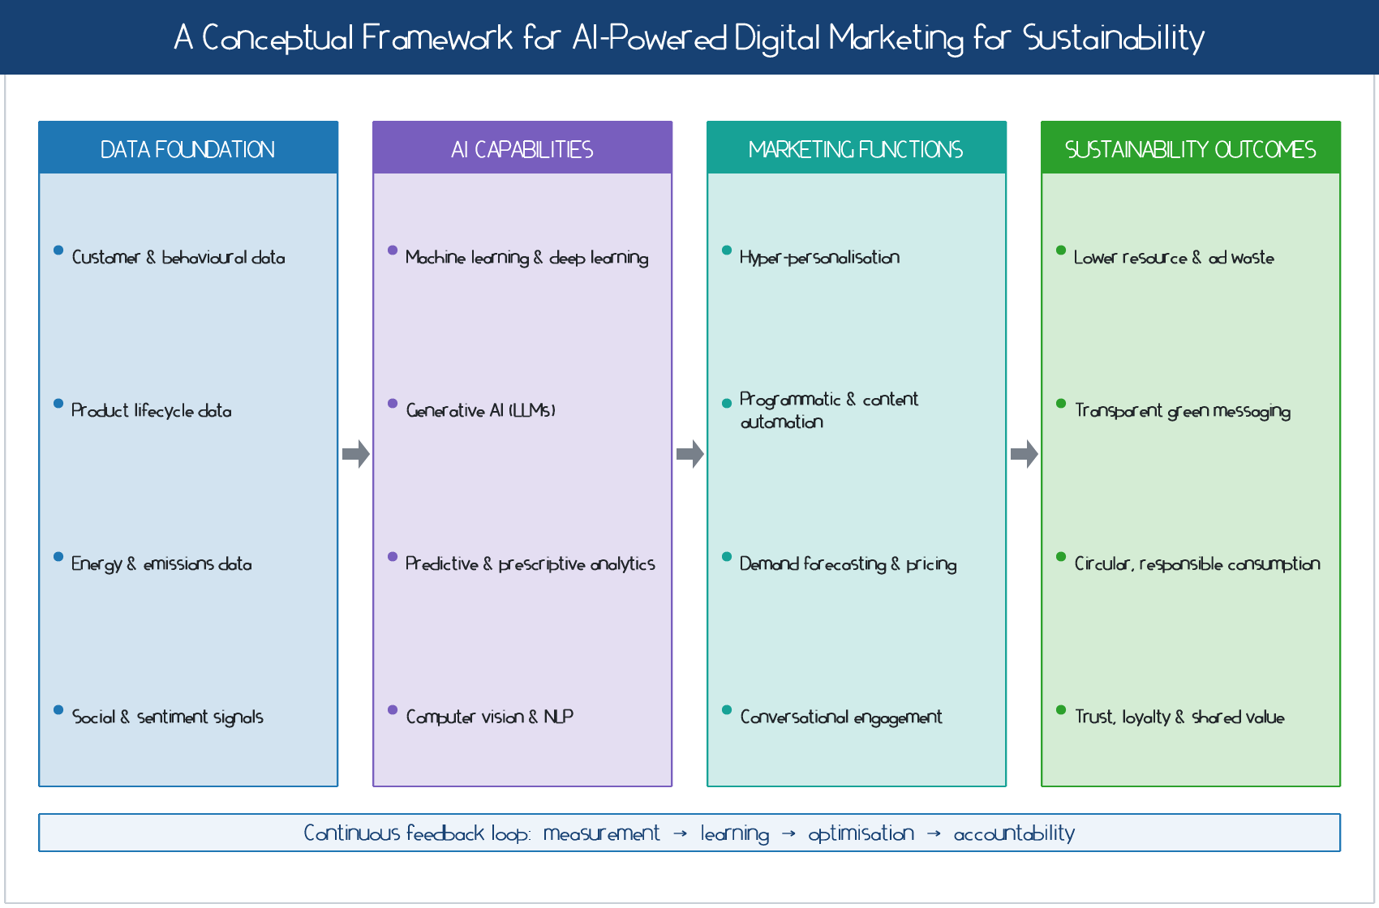
Figure 1
A four-layer conceptual framework linking data, AI capabilities, marketing functions, and sustainability outcomes.
4. AI Applications across the Sustainable Marketing Funnel
AI capabilities map onto the classic marketing funnel, awareness, consideration, conversion, retention, and advocacy, but each stage can be reoriented toward sustainability. Figure 2 presents indicative patterns of AI tool adoption and measured sustainability impact across these stages, and Table 2 catalogues the underlying techniques and their sustainable applications.
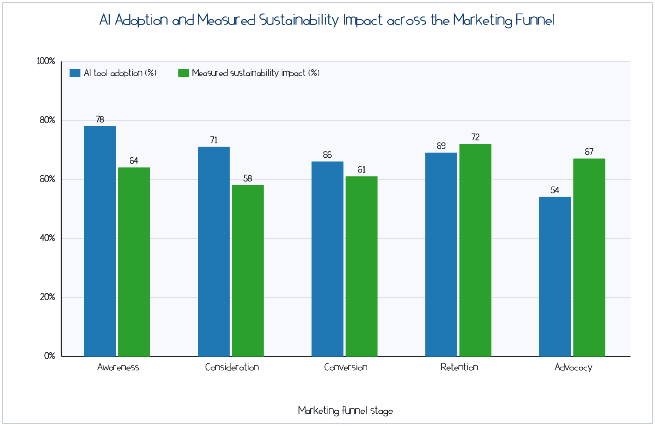
Figure 2
AI tool adoption and measured sustainability impact across marketing funnel stages (indicative values).
4.1 Awareness and Hyper-Personalisation
At the awareness stage, machine learning models segment audiences and predict receptiveness, allowing brands to deliver sustainability messaging to the consumers most likely to act on it, rather than broadcasting indiscriminately (Ameen et al., 2021; Chandra et al., 2022). Hyper-personalisation reduces the volume of irrelevant impressions, which lowers both media spend and the energy consumed by ad delivery networks (Hofacker et al., 2020). When personalisation is anchored in genuine preference rather than manipulation, it can also strengthen the relevance and credibility of green claims (Belanche et al., 2021).
4.2 Consideration, Content Generation, and Programmatic Media
During consideration, generative AI produces tailored content, product descriptions, comparison tools, and educational material, at marginal cost, enabling brands to communicate complex sustainability attributes clearly (Peres et al., 2023; Kshetri et al., 2024). Programmatic advertising uses reinforcement learning to allocate impressions in real time, and emerging approaches incorporate carbon-aware bidding that favours lower-emission ad inventory and delivery windows (Dwivedi et al., 2023). However, the same generative tools can fabricate plausible but unsubstantiated environmental claims, making verification essential (de Freitas Netto et al., 2020).
4.3 Conversion, Demand Forecasting, and Dynamic Pricing
At conversion, predictive analytics forecast demand with greater accuracy, which reduces overproduction, excess inventory, and the markdowns and disposal that accompany them (Ma & Sun, 2020; Toorajipour et al., 2021). Recommender systems can prioritise durable, repairable, or lower-impact products, and dynamic pricing can be configured to clear surplus stock before it becomes waste (Camilleri, 2021). Conversational AI and chatbots support customers at the point of decision, answering sustainability questions and reducing returns through better pre-purchase fit (Adam et al., 2021; Pillai & Sivathanu, 2020).
4.4 Retention, Advocacy, and Responsible Nudging
Beyond the sale, AI sustains relationships through predictive churn models, personalised after-sales support, and nudges toward responsible use, maintenance, and end-of-life return of products (Libai et al., 2020; Nguyen et al., 2022). In circular business models, AI orchestrates resale, refurbishment, and take-back programmes, turning retention into a mechanism for material recovery (Geissdoerfer et al., 2020; Bocken et al., 2019). Satisfied, well-informed customers become advocates whose word-of-mouth amplifies authentic sustainability positioning (Confente et al., 2020).
Read across the funnel, three patterns emerge. First, the sustainability payoff of AI is greatest where it substitutes intelligence for volume, replacing broad, wasteful outreach with precise, need-matched interaction (Chandra et al., 2022; Ma & Sun, 2020). Second, the later funnel stages, retention and advocacy, are where circular value is created, yet they remain comparatively under-instrumented in practice, representing a clear opportunity for firms willing to invest (Libai et al., 2020; Geissdoerfer et al., 2020). Third, every application carries a mirror-image risk: the same personalisation that reduces waste can manipulate, and the same generative capacity that educates can deceive (Puntoni et al., 2021; Peres et al., 2023). The funnel is therefore best understood not as a pipeline for extraction but as a relationship to be stewarded, a reframing that the sustainability agenda makes unavoidable (Lim, 2022).
Table 2
AI Techniques and Their Sustainable Digital Marketing Applications
AI Technique | Marketing Application | Sustainability Outcome
Supervised machine learning | Audience segmentation and targeting | Fewer wasted impressions and lower ad spend
Predictive analytics | Demand forecasting and inventory planning | Reduced overproduction and disposal
Recommender systems | Product discovery and ranking | Promotion of durable, low-impact options
Generative AI (LLMs) | Content, messaging, and education | Clear, scalable communication of green attributes
Reinforcement learning | Programmatic and carbon-aware bidding | Lower-emission media delivery
Natural language processing | Sentiment and claim verification | Detection of greenwashing and misinformation
Computer vision | Product authentication and recycling guidance | Support for circular take-back systems
Conversational AI | Chatbots and virtual assistants | Fewer returns and better-informed choices
Source: Developed by the author(s).
5. Evolving Consumer and Market Trends
The business case for AI-powered sustainable marketing rests on converging trends, summarised in Figure 3. The adoption of AI across marketing functions has risen sharply, while the share of consumers who state a preference for sustainable brands has grown steadily and the efficiency with which marketing resources are deployed has improved (Kumar et al., 2021; Verma et al., 2021). These trajectories are mutually reinforcing: more capable AI makes sustainable personalisation feasible, and rising consumer demand makes it commercially rational (White et al., 2019; Lim, 2022).
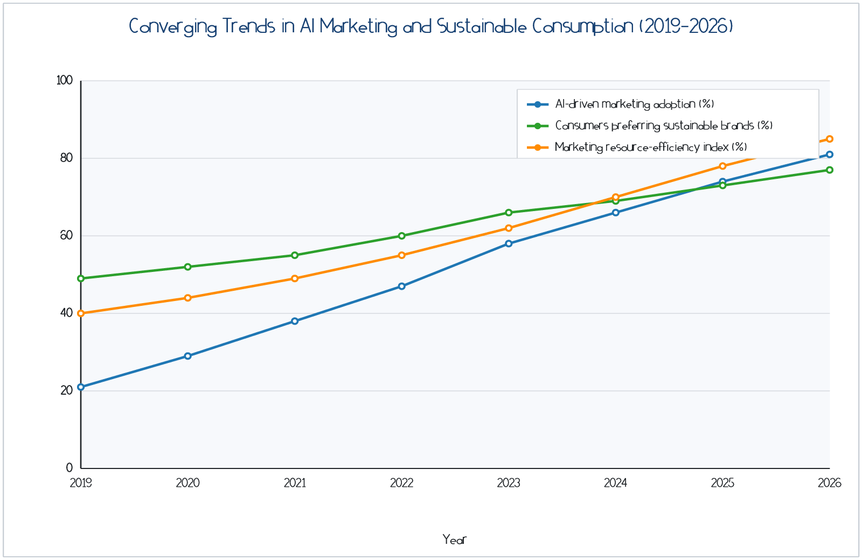
Figure 3
Converging trends in AI marketing adoption, sustainable brand preference, and marketing resource efficiency, 2019–2026 (indicative values).
Consumer behaviour, however, remains complex. The attitude-behaviour gap persists, and scepticism toward environmental claims has intensified as greenwashing has become more visible (ElHaffar et al., 2020; de Freitas Netto et al., 2020). Younger cohorts in particular expect brands to demonstrate rather than merely assert sustainability, and they are adept at detecting inauthenticity (Testa et al., 2021; Confente et al., 2020). AI can help close the gap by delivering timely, context-sensitive information and by reducing the friction of sustainable choices, but it can equally widen distrust if deployed to manufacture a veneer of responsibility (Nguyen et al., 2022; Puntoni et al., 2021). The trajectory of the market therefore depends less on technological capability than on the integrity with which that capability is used.
6. Benefits and Value Creation
The benefits of AI-powered digital marketing for sustainability accrue along three dimensions: operational efficiency, customer value, and societal value. Figure 4 reports the perceived importance of several AI capabilities for sustainable outcomes, with hyper-personalisation, improved targeting, and resource efficiency ranked most highly. Operationally, predictive and prescriptive analytics cut waste by aligning production and media delivery with real demand, lowering both cost and environmental footprint (Toorajipour et al., 2021; Di Vaio et al., 2020). For customers, personalisation and conversational support increase relevance, reduce returns, and build trust when they are transparent and privacy-respecting (Belanche et al., 2021; Adam et al., 2021).
A recurring theme in the evidence is that these benefits depend on measurement maturity. Firms that instrument both commercial and environmental indicators, and that reconcile them within a single decision framework, are better able to detect when an apparent efficiency gain merely shifts impact elsewhere (Di Vaio et al., 2020; Saura et al., 2021). Where measurement is weak, AI optimises for what is counted, typically short-term conversion, and sustainability becomes a narrative layered on top rather than an objective pursued in fact (Mishra et al., 2023; Chintalapati & Pandey, 2022). The practical lesson is that the value of AI for sustainability is realised less at the moment of model deployment than in the discipline of defining objectives, auditing outcomes, and closing the loop between them (Rana et al., 2022; Verma et al., 2021).
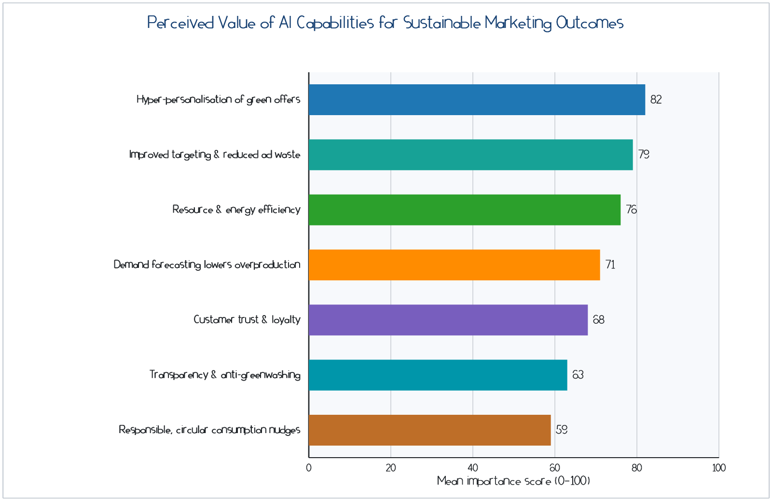
Figure 4
Perceived importance of AI capabilities for sustainable marketing outcomes (indicative mean scores).
At the societal level, AI can enhance transparency by tracing and communicating supply-chain provenance, by verifying claims against independent data, and by enabling the labelling and comparison that empower informed choice (Akter et al., 2022; Saura et al., 2021). It can also support behaviour change at scale, nudging consumers toward repair, reuse, and lower-impact alternatives (Camilleri, 2021; Sharma et al., 2020). Table 3 juxtaposes these benefits with the principal challenges, underscoring that value realisation is conditional on responsible design and governance (Mishra et al., 2023; Rana et al., 2022).
Table 3
Benefits and Challenges of AI-Powered Sustainable Digital Marketing
Dimension | Benefits | Challenges and Risks
Operational | Waste reduction, efficient media and inventory | High energy and compute footprint of large models
Customer | Relevance, convenience, trust, fewer returns | Privacy intrusion and perceived manipulation
Communication | Scalable, clear sustainability messaging | Automated greenwashing and misinformation
Strategic | Differentiation and shared value | Short-termism and goal misalignment
Societal | Transparency, circularity, behaviour change | Algorithmic bias and digital exclusion
Source: Developed by the author(s).
7. Challenges, Risks, and Ethical Considerations
The sustainability promise of AI marketing is tempered by material risks. The first is the environmental cost of AI itself. Training and operating large generative models consume substantial energy and water, and the proliferation of machine-generated content can increase, rather than decrease, aggregate resource use if it merely stimulates additional consumption (Strubell et al., 2019; van Wynsberghe, 2021). A credible sustainability strategy must therefore account for the footprint of the marketing technology stack itself, not only the efficiencies it enables (Vinuesa et al., 2020).
The second risk is greenwashing at scale. Generative systems can produce fluent environmental claims that are unsubstantiated or misleading, and automation can disseminate them across channels faster than oversight can respond (de Freitas Netto et al., 2020). Regulatory regimes are tightening in response, and firms face reputational and legal exposure if claims cannot be substantiated (Mishra et al., 2023). The third concerns privacy and autonomy: pervasive data collection and persuasive personalisation can cross into manipulation, undermining the very trust on which sustainable relationships depend (Puntoni et al., 2021; Martin & Murphy, 2021).
A fourth cluster of risks involves fairness and inclusion. Models trained on biased data can produce discriminatory targeting or exclude vulnerable groups from beneficial offers, while heavy reliance on digital channels can deepen digital divides (Akter et al., 2021; Fountaine et al., 2019). Finally, opacity undermines accountability: when neither consumers nor managers can explain why a system behaved as it did, responsibility becomes diffuse (Rai, 2020; Kumar et al., 2023). Addressing these risks requires explainability, human oversight, independent verification of claims, and governance structures that embed sustainability objectives into the design of marketing AI (Rana et al., 2022; Mikalef et al., 2022).
These risks are not merely technical externalities; they are strategic vulnerabilities. A brand that is exposed for algorithmic greenwashing or for manipulative personalisation can suffer rapid and durable reputational damage, precisely because sustainability claims trade on trust (de Freitas Netto et al., 2020; Martin & Murphy, 2021). The asymmetry is stark: trust accumulates slowly through consistent, verifiable behaviour but can collapse quickly when a single automated claim is shown to be false (Puntoni et al., 2021). This is why leading treatments of responsible AI emphasise that governance must be designed in from the outset rather than retrofitted after deployment, and that it should include clear lines of human accountability for the claims an automated system makes on the brand's behalf (Mikalef et al., 2022; Kumar et al., 2023).
8. Managerial Implications and a Strategic Roadmap
For practitioners, the central implication is that AI-powered sustainable marketing is an organisational capability rather than a tool purchase. It requires data governance, cross-functional collaboration between marketing, sustainability, and data science, and leadership that defines sustainable value as an explicit optimisation objective (Mikalef et al., 2022; Dwivedi et al., 2021). Table 4 sets out a staged roadmap. In the foundation phase, firms consolidate trustworthy data and establish baseline sustainability metrics (Cao et al., 2021). In the deployment phase, they pilot personalisation, forecasting, and content applications with explicit guardrails against greenwashing and privacy harm (Saura et al., 2021). In the integration phase, sustainability key performance indicators are embedded in algorithmic objectives and dashboards, and in the governance phase, independent audit, explainability, and accountability mechanisms are institutionalised (Rana et al., 2022; Mishra et al., 2023).
Table 4
A Staged Roadmap for Responsible AI-Powered Sustainable Marketing
Phase | Key Actions | Illustrative KPI
1. Foundation | Consolidate data; set emissions and waste baselines | Data quality score; baseline footprint
2. Deployment | Pilot personalisation, forecasting, and content with guardrails | Waste and ad-spend reduction (%)
3. Integration | Embed sustainability KPIs in model objectives | Sustainable conversion; return rate
4. Governance | Audit, explainability, and claim verification | Verified-claim rate; trust index
5. Regeneration | Scale circular and shared-value programmes | Material recovery; customer lifetime value
Source: Developed by the author(s).
Three managerial principles cut across the roadmap. First, measure honestly: sustainability claims must rest on verifiable data, and marketing metrics should include environmental and social indicators alongside commercial ones (Di Vaio et al., 2020; Saura et al., 2021). Second, keep humans in the loop: automation should augment rather than replace judgement on sensitive claims and vulnerable audiences (Puntoni et al., 2021; Fountaine et al., 2019). Third, align with authentic purpose: AI amplifies whatever strategy it serves, so the underlying brand commitment must be genuine for the technology to create durable value (Confente et al., 2020; Kumar et al., 2021).
9. Future Research Directions
Several research gaps warrant attention. First, the field needs rigorous empirical evidence on the net environmental effect of AI marketing, weighing efficiency gains against the footprint of the technology and any rebound in consumption (van Wynsberghe, 2021; Strubell et al., 2019). Second, scholars should develop and validate constructs and scales for responsible AI marketing, including consumer perceptions of algorithmic greenwashing and trust (Nguyen et al., 2022; Martin & Murphy, 2021). Third, more work is needed on governance mechanisms, explainability, auditing, and regulation, that reliably steer marketing AI toward sustainable outcomes (Mikalef et al., 2022; Rai, 2020). Fourth, the interaction between generative AI and circular business models is largely unexplored and offers rich opportunities (Geissdoerfer et al., 2020; Kshetri et al., 2024). Methodologically, the field would benefit from longitudinal and field-experimental designs that move beyond cross sectional surveys (Mustak et al., 2021; Verma et al., 2021).
10. Conclusion
Artificial intelligence has become a defining capability of contemporary digital marketing, and sustainability has become a defining expectation of contemporary business. This chapter has argued that the two can be brought into productive alignment, but only under specific conditions. The four-layer framework developed here shows that AI delivers sustainable value when data foundations are trustworthy, when capabilities are translated into marketing functions that reduce waste and increase transparency, and above all when a continuous feedback loop holds the system accountable to both commercial and environmental objectives. Mapped across the marketing funnel, AI can sharpen targeting, forecast demand more accurately, generate clear sustainability communication, and support circular consumption, yielding efficiency, customer, and societal benefits. These gains are not automatic. They are offset by real risks: the energy footprint of large models, automated greenwashing, privacy intrusion, algorithmic bias, and the erosion of trust. The decisive variable is governance. AI amplifies the strategy it is given, so organisations that pair technological capability with authentic purpose, honest measurement, human oversight, and transparent accountability will convert AI-powered marketing into a genuine engine of sustainability. Those that do not will simply accelerate the problems marketing has long been accused of creating. Responsible AI-powered marketing, therefore, is less a technical achievement than a managerial and ethical one, and it represents a promising path toward reconciling commercial success with the wellbeing of consumers, society, and the planet.
References
Adam, M., Wessel, M., & Benlian, A. (2021). AI-based chatbots in customer service and their effects on user compliance. Electronic Markets, 31(2), 427–445. https://doi.org/10.1007/s12525-020-00414-7
Akter, S., Dwivedi, Y. K., Sajib, S., Biswas, K., Bandara, R. J., & Michael, K. (2022). Algorithmic bias in machine learning-based marketing models. Journal of Business Research, 144, 201–216. https://doi.org/10.1016/j.jbusres.2022.01.083
Akter, S., McCarthy, G., Sajib, S., Michael, K., Dwivedi, Y. K., D’Ambra, J., & Shen, K. N. (2021). Algorithmic bias in data-driven innovation in the age of AI. International Journal of Information Management, 60, 102387. https://doi.org/10.1016/j.ijinfomgt.2021.102387
Ameen, N., Tarhini, A., Reppel, A., & Anand, A. (2021). Customer experiences in the age of artificial intelligence. Computers in Human Behavior, 114, 106548. https://doi.org/10.1016/j.chb.2020.106548
Belanche, D., Casaló, L. V., Flavián, C., & Schepers, J. (2021). Robots or frontline employees? Exploring customer attributions and service outcomes. Journal of Service Management, 32(5), 760–784. https://doi.org/10.1108/JOSM-06-2020-0196
Bocken, N. M. P., Ritala, P., Albareda, L., & Verburg, R. (2019). Innovation for sustainability: Business transformations towards a better world. Palgrave Macmillan. https://doi.org/10.1007/978-3-319-97385-2
Camilleri, M. A. (2021). Strategic attributions of corporate social responsibility and environmental management. Corporate Social Responsibility and Environmental Management, 28(1), 1–14. https://doi.org/10.1002/csr.2048
Cao, G., Duan, Y., Edwards, J. S., & Dwivedi, Y. K. (2021). Understanding managers’ attitudes and behavioural intentions towards using artificial intelligence for organizational decision-making. Technovation, 106, 102312. https://doi.org/10.1016/j.technovation.2021.102312
Chandra, S., Verma, S., Lim, W. M., Kumar, S., & Donthu, N. (2022). Personalization in personalized marketing: Trends and ways forward. Psychology & Marketing, 39(8), 1529–1562. https://doi.org/10.1002/mar.21670
Chintalapati, S., & Pandey, S. K. (2022). Artificial intelligence in marketing: A systematic literature review. International Journal of Market Research, 64(1), 38–68. https://doi.org/10.1177/14707853211018428
Confente, I., Scarpi, D., & Russo, I. (2020). Marketing a new generation of bio-plastics products from a circular economy perspective. Journal of Business Research, 112, 431–439. https://doi.org/10.1016/j.jbusres.2019.10.030
Davenport, T., Guha, A., Grewal, D., & Bressgott, T. (2020). How artificial intelligence will change the future of marketing. Journal of the Academy of Marketing Science, 48(1), 24–42. https://doi.org/10.1007/s11747-019-00696-0
de Freitas Netto, S. V., Sobral, M. F. F., Ribeiro, A. R. B., & Soares, G. R. L. (2020). Concepts and forms of greenwashing: A systematic review. Environmental Sciences Europe, 32(1), 19. https://doi.org/10.1186/s12302-020-0300-3
Di Vaio, A., Palladino, R., Hassan, R., & Escobar, O. (2020). Artificial intelligence and business models in the sustainable development goals perspective: A systematic literature review. Journal of Business Research, 121, 283–314. https://doi.org/10.1016/j.jbusres.2020.08.019
Dwivedi, Y. K., Hughes, L., Ismagilova, E., Aarts, G., Coombs, C., Crick, T., … Williams, M. D. (2021). Artificial intelligence (AI): Multidisciplinary perspectives on emerging challenges, opportunities, and agenda for research, practice and policy. International Journal of Information Management, 57, 101994. https://doi.org/10.1016/j.ijinfomgt.2019.08.002
Dwivedi, Y. K., Kshetri, N., Hughes, L., Slade, E. L., Jeyaraj, A., Kar, A. K., … Wright, R. (2023). Opinion paper: “So what if ChatGPT wrote it?” Multidisciplinary perspectives on opportunities, challenges and implications of generative conversational AI. International Journal of Information Management, 71, 102642. https://doi.org/10.1016/j.ijinfomgt.2023.102642
ElHaffar, G., Durif, F., & Dubé, L. (2020). Towards closing the attitude-intention-behavior gap in green consumption: A narrative review of the literature and an overview of future research directions. Journal of Cleaner Production, 275, 122556. https://doi.org/10.1016/j.jclepro.2020.122556
Fountaine, T., McCarthy, B., & Saleh, T. (2019). Building the AI-powered organization. Harvard Business Review, 97(4), 62–73.
Geissdoerfer, M., Pieroni, M. P. P., Pigosso, D. C. A., & Soufani, K. (2020). Circular business models: A review. Journal of Cleaner Production, 277, 123741. https://doi.org/10.1016/j.jclepro.2020.123741
Hofacker, C. F., Golgeci, I., Pillai, K. G., & Gligor, D. M. (2020). Digital marketing and business-to-business relationships: A close look at the interface and a roadmap for the future. European Journal of Marketing, 54(6), 1161–1179. https://doi.org/10.1108/EJM-04-2020-0247
Huang, M.-H., & Rust, R. T. (2021). A strategic framework for artificial intelligence in marketing. Journal of the Academy of Marketing Science, 49(1), 30–50. https://doi.org/10.1007/s11747-020-00749-9
Kannan, P. K., & Li, H. A. (2019). Digital marketing: A framework, review and research agenda. International Journal of Research in Marketing, 34(1), 22–45. https://doi.org/10.1016/j.ijresmar.2016.11.006
Kaplan, A., & Haenlein, M. (2019). Siri, Siri, in my hand: Who’s the fairest in the land? On the interpretations, illustrations, and implications of artificial intelligence. Business Horizons, 62(1), 15–25. https://doi.org/10.1016/j.bushor.2018.08.004
Kshetri, N., Dwivedi, Y. K., Davenport, T. H., & Panteli, N. (2024). Generative artificial intelligence in marketing: Applications, opportunities, challenges, and research agenda. International Journal of Information Management, 75, 102716. https://doi.org/10.1016/j.ijinfomgt.2023.102716
Kumar, V., Rajan, B., Venkatesan, R., & Lecinski, J. (2021). Understanding the role of artificial intelligence in personalized engagement marketing. California Management Review, 61(4), 135–155. https://doi.org/10.1177/0008125619859317
Kumar, V., Ramachandran, D., & Kumar, B. (2023). Influence of new-age technologies on marketing: A research agenda. Journal of Business Research, 125, 864–877. https://doi.org/10.1016/j.jbusres.2020.01.007
Libai, B., Bart, Y., Gensler, S., Hofacker, C. F., Kaplan, A., Kötterheinrich, K., & Kroll, E. B. (2020). Brave new world? On AI and the management of customer relationships. Journal of Interactive Marketing, 51(1), 44–56. https://doi.org/10.1016/j.intmar.2020.04.002
Lies, J. (2019). Marketing intelligence and big data: Digital marketing techniques on their way to becoming social engineering techniques in marketing. International Journal of Interactive Multimedia and Artificial Intelligence, 5(5), 134–144. https://doi.org/10.9781/ijimai.2019.05.002
Lim, W. M. (2022). Toward a theory of sustainable marketing: A framework for the future. Journal of Strategic Marketing, 30(8), 741–760. https://doi.org/10.1080/0965254X.2021.1929410
Ma, L., & Sun, B. (2020). Machine learning and AI in marketing – Connecting computing power to human insights. International Journal of Research in Marketing, 37(3), 481–504. https://doi.org/10.1016/j.ijresmar.2020.04.005
Martin, K. D., & Murphy, P. E. (2021). The role of data privacy in marketing. Journal of the Academy of Marketing Science, 45(2), 135–155. https://doi.org/10.1007/s11747-016-0495-4
Mikalef, P., Conboy, K., Lundström, J. E., & Popovič, A. (2022). Thinking responsibly about responsible AI and ‘the dark side’ of AI. European Journal of Information Systems, 31(3), 257–268. https://doi.org/10.1080/0960085X.2022.2026621
Mishra, S., Ewing, M. T., & Cooper, H. B. (2023). Artificial intelligence focus and firm performance. Journal of the Academy of Marketing Science, 51(6), 1315–1342. https://doi.org/10.1007/s11747-023-00936-4
Mustak, M., Salminen, J., Plé, L., & Wirtz, J. (2021). Artificial intelligence in marketing: Topic modeling, scientometric analysis, and research agenda. Journal of Business Research, 124, 389–404. https://doi.org/10.1016/j.jbusres.2020.10.044
Nguyen, T. M., Malik, A., & Budhwar, P. (2022). Knowledge hiding in organizational crisis: The moderating role of leadership. Journal of Business Research, 139, 161–172. https://doi.org/10.1016/j.jbusres.2021.09.026
Nishant, R., Kennedy, M., & Corbett, J. (2020). Artificial intelligence for sustainability: Challenges, opportunities, and a research agenda. International Journal of Information Management, 53, 102104. https://doi.org/10.1016/j.ijinfomgt.2020.102104
Peattie, K., & Belz, F.-M. (2019). Sustainability marketing: A global perspective (3rd ed.). Wiley.
Peres, R., Schreier, M., Schweidel, D., & Sorescu, A. (2023). On ChatGPT and beyond: How generative artificial intelligence may affect research, teaching, and practice. International Journal of Research in Marketing, 40(2), 269–275. https://doi.org/10.1016/j.ijresmar.2023.03.001
Pillai, R., & Sivathanu, B. (2020). Adoption of AI-based chatbots for hospitality and tourism. International Journal of Contemporary Hospitality Management, 32(10), 3199–3226. https://doi.org/10.1108/IJCHM-04-2020-0259
Puntoni, S., Reczek, R. W., Giesler, M., & Botti, S. (2021). Consumers and artificial intelligence: An experiential perspective. Journal of Marketing, 85(1), 131–151. https://doi.org/10.1177/0022242920953847
Rai, A. (2020). Explainable AI: From black box to glass box. Journal of the Academy of Marketing Science, 48(1), 137–141. https://doi.org/10.1007/s11747-019-00710-5
Rana, N. P., Chatterjee, S., Dwivedi, Y. K., & Akter, S. (2022). Understanding dark side of artificial intelligence (AI) integrated business analytics: Assessing firm’s operational inefficiency and competitiveness. European Journal of Information Systems, 31(3), 364–387. https://doi.org/10.1080/0960085X.2021.1955628
Saura, J. R., Ribeiro-Soriano, D., & Palacios-Marqués, D. (2021). Setting privacy “by default” in social IoT: Theorizing the challenges and directions in Big Data research. Big Data Research, 25, 100245. https://doi.org/10.1016/j.bdr.2021.100245
Shankar, V., Grewal, D., Sunder, S., Fossen, B., Peters, K., & Agarwal, A. (2022). Digital marketing communication in global marketplaces: A review of extant research, future directions, and potential approaches. International Journal of Research in Marketing, 39(2), 541–565. https://doi.org/10.1016/j.ijresmar.2021.09.005
Sharma, A., Dwivedi, Y. K., Arya, V., & Siddiqui, M. Q. (2020). Does SMS advertising still have relevance to increase consumer purchase intention? A hybrid PLS-SEM-neural network modelling approach. Computers in Human Behavior, 124, 106919. https://doi.org/10.1016/j.chb.2021.106919
Strubell, E., Ganesh, A., & McCallum, A. (2019). Energy and policy considerations for deep learning in NLP. In Proceedings of the 57th Annual Meeting of the Association for Computational Linguistics (pp. 3645–3650). https://doi.org/10.18653/v1/P19-1355
Testa, F., Pretner, G., Iovino, R., Bianchi, G., Tessitore, S., & Iraldo, F. (2021). Drivers to green consumption: A systematic review. Environment, Development and Sustainability, 23(4), 4826–4880. https://doi.org/10.1007/s10668-020-00844-5
Toorajipour, R., Sohrabpour, V., Nazarpour, A., Oghazi, P., & Fischl, M. (2021). Artificial intelligence in supply chain management: A systematic literature review. Journal of Business Research, 122, 502–517. https://doi.org/10.1016/j.jbusres.2020.09.009
Trudel, R. (2019). Sustainable consumer behavior. Consumer Psychology Review, 2(1), 85–96. https://doi.org/10.1002/arcp.1045
van Wynsberghe, A. (2021). Sustainable AI: AI for sustainability and the sustainability of AI. AI and Ethics, 1(3), 213–218. https://doi.org/10.1007/s43681-021-00043-6
Verma, S., Sharma, R., Deb, S., & Maitra, D. (2021). Artificial intelligence in marketing: Systematic review and future research direction. International Journal of Information Management Data Insights, 1(1), 100002. https://doi.org/10.1016/j.jjimei.2020.100002
Vinuesa, R., Azizpour, H., Leite, I., Balaam, M., Dignum, V., Domisch, S., … Fuso Nerini, F. (2020). The role of artificial intelligence in achieving the Sustainable Development Goals. Nature Communications, 11(1), 233. https://doi.org/10.1038/s41467-019-14108-y
White, K., Habib, R., & Hardisty, D. J. (2019). How to shift consumer behaviors to be more sustainable: A literature review and guiding framework. Journal of Marketing, 83(3), 22–49. https://doi.org/10.1177/0022242919825649

