AI-Driven Contract Analytics and Automated Regulatory Compliance

Abstract
The accelerating integration of artificial intelligence into legal practice is fundamentally reshaping how organizations manage contractual relationships and ensure regulatory compliance. This chapter provides a comprehensive examination of AI-driven contract analytics and automated regulatory compliance systems, encompassing the foundational technologies, architectural frameworks, and practical applications that define this rapidly evolving field. Beginning with the evolution of artificial intelligence in legal practice, the chapter explores how natural language processing, machine learning, deep learning, and large language models are being deployed to automate contract review, clause extraction, risk identification, and obligation mapping. The discussion extends to AI-assisted contract drafting, negotiation support, due diligence, and contract performance monitoring, highlighting how intelligent systems enable proactive dispute prevention and lifecycle management. The chapter then examines automated regulatory compliance and RegTech, including real-time compliance monitoring, anomaly detection, risk-based alerting, and sector-specific applications across finance, healthcare, insurance, and corporate governance. Critical challenges including algorithmic bias, explainability, data privacy, cybersecurity, and professional responsibility are analyzed alongside governance frameworks for human-AI collaboration. Finally, the chapter explores emerging developments in generative AI, autonomous legal agents, and the future trajectory of intelligent RegTech systems, providing a forward-looking perspective on how these technologies will continue to transform legal service delivery and regulatory governance.
Keywords: Artificial Intelligence, Contract Analytics, Regulatory Compliance, Natural Language Processing, RegTech, Legal Technology, Machine Learning, Contract Lifecycle Management, Compliance Automation, Generative AI

1. Foundations of AI-Driven Legal Analytics

1.1 Evolution of Artificial Intelligence in Legal Practice
The legal profession has undergone a profound technological transformation over the past decade, transitioning from conventional document management and manual research methodologies to sophisticated AI-enabled analytics platforms capable of processing millions of documents with unprecedented speed and accuracy [1]. The emergence of deep learning architectures, particularly transformer-based models, has revolutionized legal text processing by capturing complex linguistic dependencies and contextual relationships within legal documents [2]. These models demonstrated remarkable performance improvements in tasks such as legal judgment prediction, contract clause classification, and regulatory text interpretation [3]. The subsequent development of large language models (LLMs) such as GPT-4, Claude, and domain-specific legal models has further expanded the boundaries of what AI can accomplish in legal practice, enabling generation of legal text, summarization of complex documents, and interactive legal reasoning [4].
The adoption trajectory of AI in legal practice has been characterized by distinct phases: initial skepticism and resistance, followed by cautious experimentation, and more recently, widespread strategic adoption driven by competitive pressures and client demands for efficiency [5]. Major law firms and corporate legal departments now routinely deploy AI systems for document review, due diligence, contract analysis, and compliance monitoring, with market analysts projecting the global legal AI market to exceed $37 billion by 2028 [6]. This growth reflects a fundamental recognition that AI technologies can deliver substantial improvements in accuracy, consistency, and cost-effectiveness compared to purely manual approaches [7].
The convergence of several enabling technologies has accelerated this transformation: advances in computing hardware (particularly GPU-accelerated processing), the availability of large-scale legal datasets for model training, improvements in cloud infrastructure enabling on-demand scalability, and the maturation of transfer learning techniques that allow general-purpose language models to be fine-tuned for specific legal tasks [2]. Furthermore, the increasing digitization of legal proceedings, regulatory filings, and contractual agreements has created vast repositories of structured and unstructured legal data amenable to AI analysis [8].
The regulatory technology (RegTech) dimension of legal AI has experienced particularly rapid growth, driven by the exponential increase in regulatory requirements across virtually all industries and jurisdictions. Organizations operating in multiple regulatory environments face the challenge of simultaneously complying with hundreds or thousands of regulatory requirements that are frequently updated, creating a compliance management challenge of extraordinary scale and complexity. AI-powered regulatory compliance systems address this challenge by automating the identification, interpretation, and operationalization of regulatory requirements, enabling organizations to maintain continuous compliance rather than relying on periodic manual assessments that inevitably leave gaps in coverage.
The legal AI ecosystem has evolved to encompass a diverse range of participants including established legal technology providers, innovative startups, major technology companies entering the legal market, and law firms developing proprietary AI capabilities. This competitive landscape has accelerated innovation, with new capabilities emerging rapidly across the full spectrum of legal AI applications. Investment in legal AI startups has grown substantially, with venture capital funding in legal technology exceeding $3.4 billion in 2023, reflecting strong investor confidence in the transformative potential of AI in legal services. The growing maturity of the legal AI market is evidenced by the increasing adoption of AI platforms across organizations of all sizes, the development of industry standards for legal AI performance evaluation, and the emergence of specialized legal AI governance frameworks that address the unique challenges of deploying AI in legal contexts.

1.2 Natural Language Processing and Legal Knowledge Representation
The evolution of AI in legal practice has also been significantly influenced by the development of specialized legal AI benchmarks and evaluation frameworks that enable systematic assessment of model performance across diverse legal tasks. Datasets such as CUAD for contract understanding, LegalBench for reasoning tasks, and CaseHOLD for case law analysis have provided standardized evaluation criteria that drive improvements in model architecture and training methodology [9]. The availability of these benchmarks has accelerated progress by enabling direct comparison between competing approaches and identifying areas where existing models fall short of the accuracy and reliability required for production deployment in legal practice.
Natural Language Processing (NLP) constitutes the technological backbone of AI-driven legal analytics, providing the computational methods necessary to interpret, analyze, and generate legal text [9]. Legal language presents unique challenges for NLP systems due to its specialized vocabulary, complex syntactic structures, frequent use of cross-references, and the critical importance of precise interpretation where subtle differences in wording can carry significant legal consequences [3]. Contemporary legal NLP systems employ a multi-layered approach that combines syntactic parsing, semantic analysis, named entity recognition, relation extraction, and discourse-level understanding to achieve comprehensive legal document comprehension [10].
Information extraction techniques play a central role in contract analytics, enabling automated identification and extraction of key contractual elements including parties, obligations, rights, conditions, dates, monetary values, and governing law provisions [11]. Named entity recognition models specialized for legal text can identify and classify entities such as organizations, jurisdictions, regulatory bodies, and legal concepts with accuracy levels approaching those of trained legal professionals [10]. Relation extraction methods further enable the identification of semantic relationships between extracted entities, constructing structured representations of contractual obligations and their interconnections [12].
Knowledge graphs have emerged as a powerful framework for representing legal knowledge, capturing the complex web of relationships between legal concepts, regulations, contractual terms, and organizational entities [13]. These graph-based representations enable sophisticated reasoning about legal obligations, facilitating tasks such as compliance gap analysis, regulatory impact assessment, and cross-jurisdictional comparison [14]. Legal ontologies provide the formal conceptual framework upon which these knowledge graphs are built, defining the types of entities, relationships, and constraints relevant to specific legal domains [13].
Large language models represent the most recent advancement in legal NLP, demonstrating remarkable capabilities in legal text understanding, generation, and reasoning [15]. Models fine-tuned on legal corpora have shown strong performance across diverse legal tasks including contract review, legal question answering, case outcome prediction, and regulatory interpretation [16]. However, the application of LLMs in legal contexts raises important concerns regarding hallucination (generation of plausible but incorrect legal statements), lack of transparency in reasoning, and the difficulty of ensuring that generated outputs conform to specific jurisdictional requirements [17]. As illustrated in Figure 1, the architecture of modern AI-driven contract analytics platforms integrates multiple NLP components within a layered framework designed to process legal documents from raw text to actionable insights.
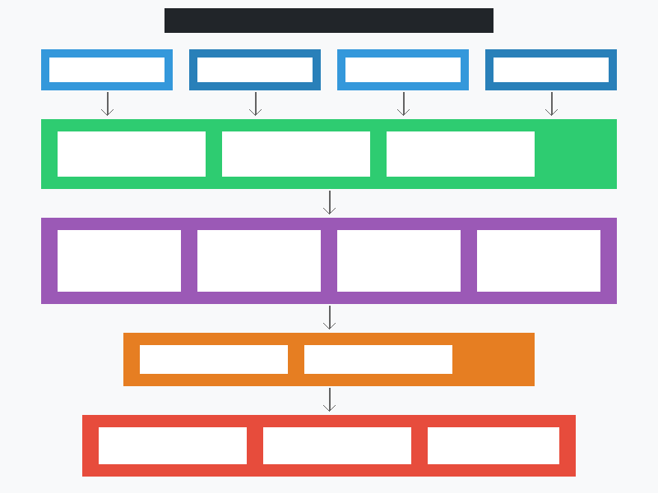
Figure 1. Architecture of an AI-Driven Contract Analytics Platform showing the layered framework from data acquisition through NLP processing, AI/ML engines, knowledge repositories, to decision-support interfaces.

1.3 Architecture of Intelligent Contract and Compliance Systems
Modern legal AI systems are distinguished from earlier rule-based legal technology by their ability to handle the inherent ambiguity and context-dependence of legal language. Unlike rigid rule-based systems that require explicit encoding of every legal principle, machine learning approaches can generalize from training examples to handle novel situations, adapting to different contract types, regulatory regimes, and organizational contexts without complete reprogramming [19]. This adaptability is particularly valuable in legal practice where the diversity of documents, jurisdictions, and commercial arrangements makes comprehensive rule encoding impractical. The combination of pre-trained language models with task-specific fine-tuning has proven especially effective, enabling rapid deployment of legal AI systems that maintain general language understanding while developing specialized competence in specific legal domains such as commercial contracts, regulatory compliance, or litigation support [2].
The architecture of intelligent contract and compliance systems encompasses multiple interconnected components designed to support the full lifecycle of contract management and regulatory compliance [18]. As depicted in Figure 1, these systems typically follow a layered architecture comprising data acquisition, document processing, analytical engines, knowledge repositories, and user-facing decision-support interfaces [8]. The data acquisition layer handles the ingestion of diverse document types including contracts, regulatory texts, corporate policies, correspondence, and structured data from enterprise systems [18].
The document processing layer employs optical character recognition (OCR), document layout analysis, and text extraction technologies to convert raw documents into machine-processable formats [19]. Advanced preprocessing techniques including document segmentation, section identification, and metadata extraction prepare documents for downstream analytical processing. The analytical engine layer houses the core AI/ML models responsible for clause extraction, risk scoring, obligation identification, compliance assessment, and anomaly detection [20].
Knowledge repositories serve as the institutional memory of these systems, storing extracted contract data, regulatory requirements, compliance rules, historical patterns, and organizational policies in structured formats that support querying, reasoning, and continuous learning [13]. The decision-support interface provides legal professionals, compliance officers, and business stakeholders with intuitive dashboards, alerts, reports, and recommendation engines that translate AI-generated insights into actionable intelligence [21]. Table 1 summarizes the key components and their functions within an integrated contract analytics and compliance platform.
Integration and interoperability considerations are critical in the architecture of intelligent contract and compliance systems, as these platforms must interface with diverse enterprise systems including enterprise resource planning (ERP) systems, customer relationship management (CRM) platforms, document management systems, email archives, and regulatory filing systems. Application programming interfaces (APIs) and middleware layers facilitate data exchange between the AI analytics platform and existing organizational infrastructure, enabling bidirectional information flow that enriches AI analysis with contextual business data while embedding AI-generated insights into operational workflows. The scalability requirements of these systems necessitate cloud-native architectures capable of handling variable workloads, from routine daily monitoring to peak demand periods such as regulatory filing deadlines or large-scale due diligence exercises. Security architecture must address the highly sensitive nature of legal and compliance data, incorporating encryption at rest and in transit, role-based access controls, comprehensive audit logging, and data residency compliance to meet the stringent security requirements of legal and regulated industries.
The evolution of these architectures toward microservices-based designs enables modular deployment and independent scaling of individual components, facilitating gradual adoption and customization to organizational requirements. Containerization and orchestration technologies support deployment flexibility across on-premises, cloud, and hybrid environments, accommodating the data sovereignty and security preferences of different organizations. The architectural maturity of modern contract analytics platforms reflects the transition from experimental prototypes to enterprise-grade production systems capable of supporting mission-critical legal and compliance operations.
Table 1. Key Components of AI-Driven Contract Analytics and Compliance Systems
Component Layer | Key Technologies | Primary Functions | Output
Data Acquisition | APIs, Web Scrapers, OCR, Connectors | Document ingestion, format conversion, metadata tagging | Normalized document corpus
Document Processing | NLP Pipelines, Layout Analysis, Tokenization | Text extraction, segmentation, entity recognition | Structured document representations
AI/ML Analytics Engine | Transformers, CNN, BERT, GPT, Rules Engines | Clause classification, risk scoring, compliance checking | Risk scores, classifications, alerts
Knowledge Repository | Knowledge Graphs, Ontologies, Vector DBs | Storage, reasoning, pattern matching, retrieval | Queryable legal knowledge base
Decision Support Interface | Dashboards, APIs, Reporting Tools | Visualization, alerting, recommendations, workflow | Actionable intelligence for stakeholders

2. AI-Driven Contract Analytics and Contract Lifecycle Management
Contract lifecycle management (CLM) encompasses the entire process of managing contracts from initial request through drafting, negotiation, execution, performance monitoring, and eventual termination or renewal. Traditional CLM processes are characterized by fragmentation across multiple systems, departments, and personnel, resulting in inefficiencies, inconsistencies, and elevated risk exposure. AI-driven contract analytics addresses these challenges by providing an integrated, intelligent layer that spans the entire contract lifecycle, automating routine tasks, identifying risks and opportunities, and providing decision-makers with data-driven insights that improve both the speed and quality of contract-related decisions [21]. The transformation enabled by AI extends beyond mere process automation to fundamentally reshape how organizations understand, manage, and derive value from their contractual relationships.

2.1 Automated Contract Review, Clause Extraction, and Risk Identification
Automated contract review represents one of the most mature and impactful applications of AI in legal practice, with commercial platforms now capable of analyzing thousands of contracts simultaneously and extracting key provisions with accuracy rates exceeding 90% for well-defined clause types [22]. These systems employ a combination of rule-based methods, supervised machine learning classifiers, and deep learning models to identify and categorize contractual clauses across multiple taxonomies including obligation type, risk level, commercial significance, and legal enforceability [11].
Clause extraction algorithms typically operate through a pipeline architecture that first segments contracts into individual provisions, then classifies each provision according to pre-defined taxonomies, and finally extracts structured data elements from within each clause [23]. Advanced systems incorporate contextual understanding, recognizing that the meaning and risk implications of a clause depend not only on its text but also on its relationship to other contract provisions, the identity of the counterparty, the applicable jurisdiction, and the commercial context [24]. Machine learning models trained on large corpora of annotated contracts can identify subtle patterns indicative of problematic clauses, including unusual liability limitations, broad indemnification requirements, restrictive termination conditions, and ambiguous force majeure provisions [22].
Risk identification extends beyond individual clause analysis to encompass holistic contract risk assessment, evaluating the overall risk profile of a contract based on the aggregate effect of its provisions, identified gaps or missing protections, inconsistencies between related clauses, and deviation from organizational standards or market norms [25]. AI systems can benchmark contracts against templates, industry standards, and historical portfolios to highlight deviations that may require negotiation attention [26]. Furthermore, predictive analytics models trained on historical contract performance data can estimate the likelihood of disputes, breaches, or financial losses associated with specific contractual configurations, enabling risk-informed decision-making during contract negotiation and approval [20].
The integration of these capabilities into the contract review workflow delivers significant efficiency gains, with studies reporting time reductions of 60-80% compared to manual review for routine contracts, while simultaneously improving consistency and reducing the likelihood of overlooked risks [27]. As shown in Figure 2, the AI-driven contract lifecycle management workflow encompasses five interconnected stages, each augmented by specialized AI components that collectively enable end-to-end intelligent contract management.
The technological infrastructure supporting automated contract review has matured significantly, with modern platforms offering cloud-based deployment, API integration with existing enterprise systems, and customizable machine learning models that can be trained on organization-specific contract corpora. Transfer learning approaches enable rapid deployment by adapting pre-trained legal language models to specific organizational contexts, reducing the data requirements for achieving production-quality performance. The integration of active learning techniques further improves model performance over time, as human reviewer feedback is systematically incorporated into model training, creating a virtuous cycle of continuous improvement that progressively reduces the need for human intervention in routine contract review tasks.
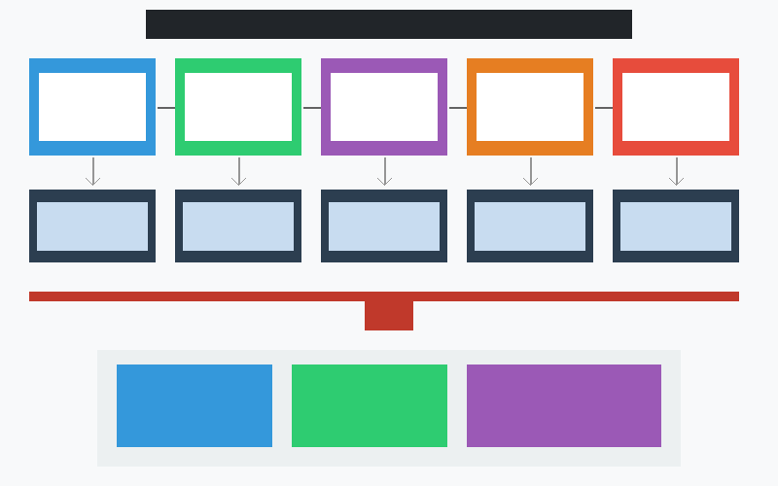
Figure 2. AI-Driven Contract Lifecycle Management Workflow illustrating the five stages (Drafting, Review, Negotiation, Execution, Monitoring) with integrated AI components and analytics dashboard.

2.2 AI-Assisted Contract Drafting, Negotiation, and Due Diligence
The economic impact of AI-enabled contract review has been documented across multiple industry sectors, with financial services, pharmaceutical, and technology companies reporting the most significant return on investment from contract analytics deployments. Cost savings arise not only from reduced legal review time but also from improved risk identification that prevents costly disputes and contractual breaches. Organizations deploying AI contract review at scale report annual savings ranging from hundreds of thousands to millions of dollars, depending on contract volume and complexity, with payback periods typically measured in months rather than years [27]. The quality improvements are equally significant, with AI systems identifying risk patterns and contractual inconsistencies that human reviewers frequently miss due to fatigue, time pressure, or the sheer volume of documents requiring analysis.
Generative AI has introduced transformative capabilities in contract drafting, enabling the automated generation of contract text that conforms to organizational standards, incorporates jurisdiction-specific requirements, and addresses the commercial terms specified by business stakeholders [28]. Modern AI-assisted drafting systems operate through template-based generation augmented by contextual customization, where base templates are dynamically modified based on transaction parameters, counterparty risk profiles, and regulatory requirements [29]. These systems can generate first drafts of standard commercial agreements in minutes rather than hours, while maintaining consistency with organizational precedents and incorporating lessons learned from historical negotiations [27].
AI-powered negotiation support extends the drafting capability by providing real-time analysis of proposed redlines and modifications, assessing their legal and commercial implications, suggesting alternative language that may be more acceptable to both parties, and predicting likely counterparty responses based on historical negotiation patterns [30]. As depicted in Figure 2, the negotiation stage of the contract lifecycle is augmented by AI systems that maintain institutional knowledge about negotiation positions, fallback provisions, and deal-specific constraints [28]. These systems can also identify negotiation leverage points by analyzing the relative importance of specific terms to each party based on historical data and industry benchmarks [30].
In the context of due diligence, AI systems have demonstrated particular value in processing the large volumes of contracts that characterize merger and acquisition transactions, joint ventures, and corporate reorganizations [31]. AI-powered due diligence platforms can simultaneously review thousands of contracts, identifying material provisions, change-of-control implications, assignment restrictions, consent requirements, and other provisions critical to transaction planning [32]. These platforms provide structured summaries and exception reports that enable legal teams to focus their attention on the most significant issues, substantially reducing the time and cost of due diligence exercises while improving thoroughness [31].
Document comparison capabilities further enhance the negotiation process by automatically identifying differences between contract versions, categorizing changes by significance, and highlighting provisions where the parties remain in disagreement [33]. Advanced comparison tools go beyond simple text differencing to provide semantic comparison, identifying situations where different language may express similar legal effect, or conversely, where similar language may have different implications due to contextual differences [33].

2.3 Contract Performance Monitoring and Dispute Prevention
The shift from reactive contract management to proactive performance monitoring represents one of the most significant value propositions of AI-driven contract analytics. Traditional contract management approaches typically rely on manual calendar reminders, periodic reviews, and ad hoc exception handling, resulting in missed deadlines, overlooked renewal opportunities, and delayed responses to counterparty performance issues. AI-powered monitoring fundamentally transforms this paradigm by providing continuous, automated surveillance of contractual obligations across the entire contract portfolio, ensuring that nothing falls through the cracks regardless of portfolio size or complexity [34]. The economic value of proactive monitoring is substantial, with organizations reporting significant reductions in penalty payments, missed revenue from auto-renewed unfavorable contracts, and dispute resolution costs.
Contract performance monitoring represents a critical yet historically under-resourced aspect of contract management, where AI technologies offer substantial improvements in proactive obligation tracking, deadline management, and early identification of potential breaches [34]. Intelligent monitoring systems continuously track contractual obligations including payment schedules, delivery timelines, service-level agreement metrics, insurance requirements, reporting obligations, and renewal conditions, generating alerts when deadlines approach or when performance indicators suggest potential non-compliance [34].
Predictive analytics applied to contract performance data enables organizations to identify contracts and counterparties with elevated risk of future disputes or breaches, based on patterns observed in historical performance data, financial indicators, market conditions, and behavioral signals [26]. These predictive models can assess factors such as payment history, communication patterns, market stress indicators, and organizational changes to generate risk scores that prioritize contracts requiring enhanced monitoring or proactive intervention [35]. Table 2 presents a comparative analysis of AI capabilities across different contract lifecycle stages.
Table 2. AI Capabilities Across Contract Lifecycle Stages
Lifecycle Stage | AI Capability | Key Metrics | Risk Reduction
Drafting | Template generation, clause recommendation, compliance checking | 70-85% time reduction | Standardization errors reduced by 90%
Review | Clause extraction, risk scoring, deviation analysis | 60-80% time reduction | Missed risks reduced by 75%
Negotiation | Redline analysis, alternative language suggestion, outcome prediction | 40-60% time reduction | Suboptimal terms reduced by 50%
Execution | Signature tracking, condition verification, counterparty validation | 50-70% time reduction | Execution errors reduced by 85%
Monitoring | Obligation tracking, breach prediction, renewal management | 80-95% coverage improvement | Missed deadlines reduced by 90%

Early dispute resolution is facilitated by AI systems that can identify emerging disagreements before they escalate into formal disputes, analyzing communication patterns, performance deviations, and contextual factors to recommend appropriate intervention strategies [35]. These systems can suggest mediation approaches, identify relevant contractual dispute resolution mechanisms, and provide legal teams with the analytical foundation needed for effective negotiation of emerging issues [36]. The integration of AI into contract performance monitoring thus transforms contract management from a predominantly reactive discipline into a proactive, intelligence-driven function that maximizes contract value while minimizing risk exposure [34].
Smart contract technologies represent an emerging intersection between AI-driven contract analytics and automated performance monitoring, where contractual obligations encoded in self-executing code can be automatically monitored, verified, and enforced without human intervention. While current smart contract implementations primarily address relatively simple conditional obligations, the integration of AI capabilities with smart contract platforms enables increasingly sophisticated automated monitoring of complex contractual conditions. Natural language processing systems can translate traditional contract provisions into executable smart contract logic, while AI monitoring systems can assess compliance with performance standards that require qualitative evaluation rather than simple binary verification. The combination of AI analytics with blockchain-based smart contracts creates a powerful framework for transparent, automated, and auditable contract performance management that reduces disputes through objective, verifiable performance assessment.

3. Automated Regulatory Compliance and RegTech
Regulatory technology (RegTech) has emerged as a critical subdomain within the broader financial technology ecosystem, specifically focused on leveraging advanced technologies to address the challenges of regulatory compliance more efficiently and effectively than traditional approaches [38]. The RegTech sector has experienced explosive growth since 2019, driven by the combination of increasing regulatory complexity, rising compliance costs, and the demonstrated capability of AI technologies to automate labor-intensive compliance processes [37]. Modern RegTech platforms integrate AI, cloud computing, big data analytics, and natural language processing to deliver compliance solutions that are simultaneously more comprehensive, more accurate, and more cost-effective than their manual predecessors.

3.1 AI-Based Regulatory Monitoring and Obligation Mapping
The regulatory landscape confronting modern organizations is characterized by extraordinary complexity, with financial institutions alone subject to approximately 300 million pages of regulatory text globally, with over 200 regulatory changes published daily across major jurisdictions [37]. This regulatory deluge makes manual compliance monitoring increasingly untenable, driving the adoption of AI-based regulatory monitoring systems that can automatically identify, analyze, and classify regulatory changes relevant to an organization's operations [38]. These systems employ sophisticated NLP techniques to parse regulatory publications, extract actionable requirements, and map them to organizational policies, processes, and controls [39].
Obligation mapping represents a particularly challenging aspect of regulatory compliance, requiring the translation of high-level regulatory requirements into specific organizational obligations that can be assigned, tracked, and verified [14]. AI systems approach this challenge through a combination of regulatory text analysis, organizational structure mapping, and knowledge graph construction that links regulatory requirements to affected business units, processes, systems, and individuals [40]. As illustrated in Figure 3, the regulatory compliance monitoring framework integrates multiple data sources and analytical components to provide continuous, real-time compliance assessment across the organization.
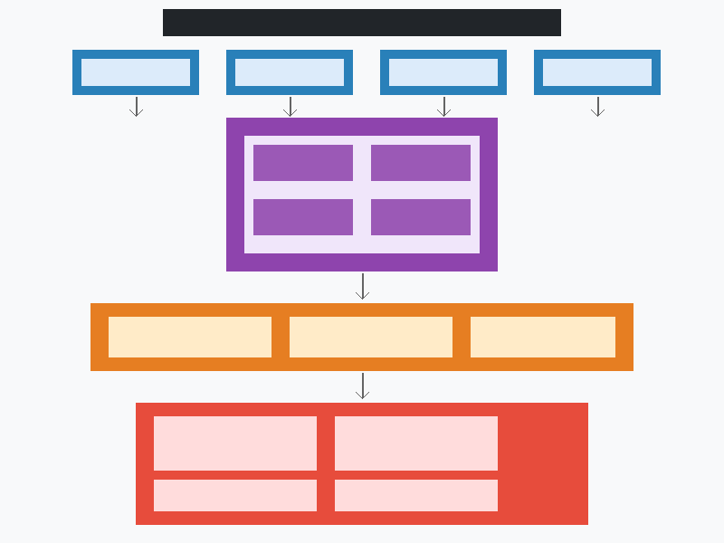
Figure 3. Real-Time Regulatory Compliance Monitoring Framework showing the integration of regulatory sources, AI processing hub, risk assessment layer, and alert/response systems.
Advanced regulatory monitoring systems incorporate machine learning models that learn organizational relevance patterns over time, progressively improving their ability to identify which regulatory changes are most pertinent to the organization's specific activities, jurisdictions, and risk profile [40]. These systems can also perform cross-jurisdictional analysis, identifying conflicts or inconsistencies between regulatory requirements in different jurisdictions where the organization operates, and flagging situations where compliance with one requirement may create tension with another [39]. The continuous nature of AI-based regulatory monitoring ensures that organizations maintain awareness of evolving requirements without the delays inherent in periodic manual reviews, significantly reducing the window of vulnerability between regulatory change and organizational response [38].
The implementation of AI-based regulatory monitoring systems requires careful consideration of data architecture, integration protocols, and organizational change management. Regulatory data sources vary significantly in format, structure, and update frequency, necessitating sophisticated data normalization and harmonization pipelines that can accommodate the heterogeneity of regulatory information across different jurisdictions and regulatory bodies. Natural language understanding capabilities must be supplemented by domain expertise encoded in regulatory ontologies and taxonomies that enable the system to correctly interpret regulatory intent and identify applicable organizational obligations. The challenge of regulatory ambiguity, where the same regulatory text may support multiple interpretations, requires AI systems to provide confidence scores and alternative interpretations rather than definitive answers, supporting rather than supplanting human expert judgment in resolving interpretive questions.
Regulatory change impact assessment extends the monitoring function by evaluating the organizational implications of identified regulatory changes, estimating the scope of affected business processes, systems, and personnel, and recommending appropriate response actions. AI systems can prioritize regulatory changes based on their potential impact magnitude, implementation urgency, and alignment with existing organizational compliance gaps, enabling compliance teams to allocate their limited resources effectively. The integration of regulatory monitoring with contract analytics capabilities creates powerful synergies, as regulatory changes may affect contractual obligations, necessitating contract amendments, renegotiation, or enhanced monitoring of specific contractual provisions that may be affected by evolving regulatory requirements.

3.2 Real-Time Compliance Monitoring, Risk Detection, and Alerts
The operational deployment of regulatory monitoring systems also necessitates careful attention to model governance, including version control for NLP models, systematic performance monitoring to detect accuracy degradation over time, and defined processes for model retraining as regulatory language and requirements evolve. The dynamic nature of regulatory environments means that models trained on historical regulatory text may become less effective as regulatory language styles, terminology, and structural conventions change. Continuous learning architectures that incrementally update model parameters based on newly processed regulatory content, while maintaining performance on previously learned requirements, represent an active area of research and development in the RegTech domain [40].
Real-time compliance monitoring leverages AI and advanced analytics to continuously assess an organization's compliance status across multiple dimensions, detecting potential violations, anomalies, and emerging risks before they materialize into regulatory breaches or enforcement actions [41]. As shown in Figure 3, these systems integrate data from diverse sources including transaction records, communication systems, employee activities, third-party interactions, and market data to construct a comprehensive real-time picture of compliance status [41]. Machine learning models trained on historical compliance data and known violation patterns can identify subtle indicators of potential non-compliance that would be invisible to rule-based systems or periodic manual reviews [42].
Anomaly detection algorithms play a central role in identifying unusual patterns that may indicate compliance failures, fraud, or control breakdowns [42]. These algorithms employ techniques including statistical outlier detection, clustering-based anomaly identification, deep learning autoencoders, and graph-based methods that can identify suspicious patterns in complex transaction networks [43]. The challenge of false positive management is addressed through multi-stage filtering approaches that combine multiple detection methods, contextual enrichment, and risk-based prioritization to ensure that alerts reaching compliance officers represent genuine risks requiring attention [43].
Risk-based alerting frameworks ensure that compliance resources are directed toward the highest-priority issues, incorporating factors such as regulatory severity, potential financial impact, likelihood of enforcement action, and reputational risk into alert prioritization algorithms [44]. Predictive compliance analytics extend beyond detection of current violations to forecast future compliance risks based on trend analysis, leading indicators, and scenario modeling, enabling proactive remediation before violations occur [44]. Table 3 presents a framework for AI-based compliance risk detection methods and their applications across different risk categories.
Table 3. AI-Based Compliance Risk Detection Methods and Applications
Risk Category | Detection Method | AI Technique | Application Domain
Transaction Anomalies | Pattern deviation analysis | Deep learning autoencoders, Isolation forests | AML, Fraud detection, Market abuse
Regulatory Breaches | Rule engine + ML classification | NLP classifiers, Knowledge graphs | Financial regulation, Data protection
Control Failures | Process mining + anomaly detection | Graph neural networks, Sequence models | Operational risk, Internal controls
Conduct Risk | Communication surveillance | NLP sentiment analysis, Network analysis | Employee misconduct, Insider trading
Third-Party Risk | Entity screening + relationship mapping | Entity resolution, Link analysis | Sanctions, Supply chain compliance
Reporting Failures | Deadline tracking + data quality analysis | Time-series models, Data validation ML | Regulatory reporting, Tax compliance

3.3 Sectoral Applications of Intelligent Compliance Systems
The application of AI-driven compliance systems varies significantly across industry sectors, reflecting differences in regulatory intensity, data availability, transaction complexity, and the maturity of existing compliance infrastructure. Each sector presents unique challenges and opportunities for AI-enabled compliance, requiring specialized models, domain-specific ontologies, and tailored integration approaches that account for sector-specific regulatory frameworks, business processes, and risk profiles [37]. The following examination of sectoral applications illustrates both the breadth of AI compliance deployment and the sector-specific considerations that shape implementation strategies.
The financial services sector represents the most advanced domain for AI-driven compliance, driven by the combination of intensive regulatory scrutiny, high transaction volumes, and the significant financial penalties associated with compliance failures [38]. Anti-money laundering (AML) compliance has been particularly transformed by AI, with machine learning models capable of identifying suspicious transaction patterns with substantially higher accuracy and lower false-positive rates compared to traditional rule-based systems [42]. Customer due diligence, sanctions screening, market abuse detection, and prudential compliance monitoring all benefit from AI capabilities that can process the scale and complexity of modern financial operations [37].
Healthcare compliance presents unique challenges related to patient privacy, clinical safety, and the intersection of multiple regulatory frameworks including HIPAA, FDA regulations, and state-level requirements [45]. AI systems in healthcare compliance monitor electronic health records access patterns, clinical trial documentation, adverse event reporting, billing practices, and pharmaceutical marketing activities to ensure conformity with applicable regulations [45]. The sensitivity of healthcare data requires that compliance AI systems incorporate robust privacy-preserving techniques and maintain comprehensive audit trails [46].
Insurance compliance encompasses regulatory requirements related to policy administration, claims handling, actuarial practices, solvency requirements, and consumer protection [43]. AI-driven compliance systems in insurance monitor pricing fairness, claims decisions, underwriting practices, and policyholder communications for compliance with anti-discrimination requirements, unfair trade practice regulations, and market conduct standards [44]. Corporate governance compliance benefits from AI systems that monitor board composition, executive compensation, conflict of interest disclosures, related-party transactions, and shareholder communications for conformity with securities regulations and listing requirements [41].
International trade compliance represents a particularly complex domain where AI systems must navigate export control regulations, trade sanctions, customs requirements, and anti-corruption laws across multiple jurisdictions simultaneously [37]. AI-powered trade compliance platforms integrate real-time screening of transactions, parties, and goods against multiple sanctions lists and export control classifications, while also monitoring for patterns indicative of trade-based money laundering or sanctions evasion [42].
Environmental, social, and governance (ESG) compliance represents an emerging domain where AI-driven compliance systems are increasingly deployed to monitor organizational adherence to sustainability reporting requirements, carbon emission regulations, supply chain due diligence obligations, and human rights standards. The complexity of ESG regulatory frameworks, which span multiple jurisdictions and encompass diverse reporting standards including the EU Taxonomy, TCFD recommendations, and SEC climate disclosure rules, creates significant compliance challenges that benefit from AI-enabled monitoring and reporting capabilities. AI systems can analyze vast quantities of operational data to assess compliance with environmental thresholds, identify supply chain risks related to forced labor or environmental degradation, and generate the comprehensive disclosures required by evolving ESG regulatory frameworks.
Data protection and privacy compliance, particularly under comprehensive frameworks such as the EU General Data Protection Regulation (GDPR), the California Consumer Privacy Act (CCPA), and similar legislation worldwide, presents compliance challenges that are well-suited to AI-enabled solutions. AI-powered privacy compliance platforms can automatically discover and classify personal data across organizational systems, assess processing activities against regulatory requirements, monitor data flows for compliance with transfer restrictions, and manage data subject requests at scale. The recursive challenge of using AI (which processes data) to ensure data protection compliance requires careful architectural design that ensures the compliance system itself operates within regulatory boundaries while effectively monitoring organizational data processing activities.

4. Governance, Challenges, and Future Directions
As AI technologies become increasingly embedded in legal analytics and regulatory compliance systems, the governance challenges associated with their deployment grow in both complexity and urgency. The stakes involved in legal and compliance decisions, combined with the opacity of many AI systems and the potential for systematic errors, demand robust governance frameworks that address ethical considerations, ensure accountability, protect fundamental rights, and maintain public confidence in the integrity of legal processes and regulatory oversight [46]. The challenges examined in this section span technical, ethical, legal, and organizational dimensions, reflecting the multifaceted nature of responsible AI deployment in high-stakes professional domains.

4.1 Ethical, Legal, and Security Challenges of AI in Legal Analytics
The rapid proliferation of AI in legal analytics has outpaced the development of comprehensive regulatory and ethical frameworks governing its use, creating a governance gap that poses risks to legal professionals, their clients, and the broader justice system. While several jurisdictions have introduced or proposed AI-specific legislation, including the EU Artificial Intelligence Act and various national AI strategies, the legal profession has been relatively slow to develop profession-specific standards addressing the unique challenges of AI deployment in legal contexts [46]. The absence of clear professional standards creates uncertainty regarding the boundaries of acceptable AI use, the level of human supervision required, and the allocation of liability when AI-assisted legal services produce erroneous or harmful outcomes.
The deployment of AI in legal analytics raises profound ethical, legal, and security challenges that must be carefully addressed to maintain public trust, professional standards, and the integrity of legal outcomes [46]. Algorithmic bias represents a particularly significant concern, as AI models trained on historical legal data may perpetuate or amplify existing biases in legal practice, potentially leading to discriminatory outcomes in contract terms, compliance assessments, or risk evaluations [47]. Bias can manifest through multiple pathways including biased training data, proxy variables that correlate with protected characteristics, and optimization objectives that inadvertently disadvantage certain groups [47].
Explainability and transparency present fundamental challenges for AI systems operating in legal contexts where decisions must be justifiable and subject to scrutiny [48]. The opacity of deep learning models conflicts with legal requirements for reasoned decision-making, creating tension between the performance advantages of complex models and the need for interpretable outputs that legal professionals can validate and explain to clients, courts, and regulators [48]. Emerging approaches to explainable AI (XAI) in legal contexts include attention visualization, feature importance analysis, counterfactual explanations, and natural language rationale generation, though none yet fully resolves the fundamental tension between model complexity and interpretability [46].
Data privacy and cybersecurity considerations are paramount given the sensitive nature of legal documents and compliance data processed by AI systems [45]. Contract analytics platforms necessarily access highly confidential commercial information, while compliance systems process personal data subject to data protection regulations [46]. The challenge of maintaining data security while enabling the data access necessary for effective AI analysis requires sophisticated approaches including federated learning, differential privacy, secure multi-party computation, and robust access control frameworks [49]. The phenomenon of hallucination in generative AI models poses particular risks in legal contexts where incorrect statements may have serious consequences, requiring robust validation mechanisms and appropriate limits on autonomous AI decision-making [17].
Professional responsibility considerations further complicate the deployment of AI in legal practice. Lawyers have ethical obligations to provide competent representation, maintain client confidentiality, exercise independent professional judgment, and supervise non-lawyer assistants, all of which require careful interpretation in the context of AI-assisted legal work. The question of whether AI-generated legal analysis constitutes the unauthorized practice of law when provided without adequate attorney supervision remains an active area of professional responsibility debate. Regulatory bodies across multiple jurisdictions are developing guidance on the ethical use of AI in legal practice, establishing requirements for disclosure, supervision, competence, and accountability that legal professionals must satisfy when incorporating AI tools into their practice. The tension between innovation and professional responsibility requires thoughtful frameworks that enable the benefits of AI adoption while preserving the fundamental ethical obligations that define the legal profession.

4.2 Human-AI Collaboration and Governance Frameworks
The design of effective human-AI collaboration models in legal analytics requires understanding the complementary strengths of human legal professionals and AI systems. Human professionals bring contextual judgment, ethical reasoning, creative problem-solving, client relationship management, and the ability to navigate ambiguous situations where legal principles conflict or where novel circumstances lack clear precedent [5]. AI systems contribute speed, scale, consistency, pattern recognition across large datasets, and freedom from cognitive biases such as anchoring, availability heuristic, and confirmation bias that affect human decision-making. The optimal allocation of tasks between human and AI actors depends on factors including task complexity, stakes involved, available training data, regulatory requirements for human oversight, and the current state of AI capability in the relevant domain [7].
Effective human-AI collaboration in legal analytics requires carefully designed governance frameworks that define the respective roles, responsibilities, and boundaries of human and AI actors within legal workflows [5]. The concept of human-in-the-loop (HITL) processing has emerged as a foundational principle, ensuring that AI systems augment rather than replace human judgment in consequential legal decisions, with human professionals retaining oversight, validation, and ultimate decision-making authority [48]. As illustrated in Figure 4, governance frameworks for human-AI collaboration in legal analytics define clear interfaces between human expertise and AI capabilities across multiple functional domains.
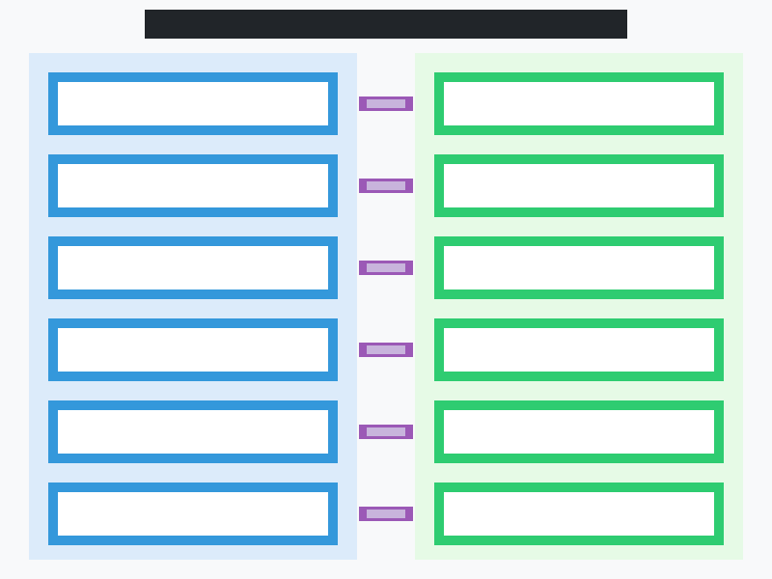
Figure 4. Human-AI Collaboration Governance Framework for Legal Analytics showing the parallel domains of human expertise and AI capabilities connected through governance bridge mechanisms.
Governance frameworks for legal AI must address multiple dimensions including model validation and testing protocols, performance monitoring and quality assurance, error handling and escalation procedures, audit trail requirements, and mechanisms for continuous improvement based on feedback from legal professionals [49]. The framework depicted in Figure 4 emphasizes the bidirectional nature of human-AI collaboration, where human expertise informs AI model development and calibration while AI capabilities enhance human analytical capacity and decision quality [48].
Accountability mechanisms must clearly allocate responsibility for AI-assisted legal outcomes, addressing questions of professional liability when AI systems contribute to legal advice, contract drafting, or compliance determinations [5]. Professional responsibility standards require that lawyers maintain competence in understanding AI system capabilities and limitations, exercise appropriate supervision over AI-generated outputs, and ensure that the use of AI does not compromise the quality of legal services or client interests [7]. Validation protocols for AI-generated legal outputs should include systematic testing against known correct outcomes, comparison with expert human judgments, and ongoing monitoring of real-world performance to detect degradation or drift [49].
Organizational governance structures for legal AI should include dedicated oversight bodies responsible for AI risk assessment, policy development, incident response, and stakeholder communication [46]. These structures must balance the need for innovation and efficiency gains with appropriate risk management, ensuring that AI deployment proceeds in a controlled manner with adequate safeguards against potential harms [47]. Table 4 presents a comprehensive governance framework for AI deployment in legal analytics and compliance contexts.
Table 4. Governance Framework for AI in Legal Analytics and Compliance
Governance Dimension | Key Requirements | Implementation Mechanisms | Oversight Body
Model Validation | Accuracy testing, bias assessment, edge case evaluation | Pre-deployment testing suites, benchmark datasets, adversarial testing | AI Governance Committee
Performance Monitoring | Ongoing accuracy tracking, drift detection, user satisfaction | Automated monitoring dashboards, periodic human review, feedback loops | Legal Operations Team
Accountability | Clear responsibility allocation, professional liability management | Decision audit trails, human sign-off requirements, insurance coverage | General Counsel / CLO
Transparency | Explainability of outputs, disclosure to affected parties | XAI methods, documentation standards, client communication protocols | Ethics Committee
Data Governance | Privacy compliance, data quality, access controls, retention policies | Data classification, encryption, access logging, retention automation | Data Protection Officer
Continuous Improvement | Model updates, retraining, incorporation of feedback | Version control, A/B testing, user feedback integration, retraining pipelines | AI Engineering Team

4.3 Generative AI, Autonomous Legal Agents, and the Future of RegTech
The transition from analytical AI to generative and agentic AI in legal technology represents a qualitative shift in the nature of human-machine collaboration within legal practice. While analytical AI systems augment human capabilities by processing information at scale and identifying patterns invisible to manual review, generative and agentic AI systems operate more autonomously, producing original legal work product and making preliminary decisions that previously required human intellectual engagement [4]. This transition raises fundamental questions about the nature of legal work, the value proposition of legal professionals, and the appropriate boundaries of AI autonomy in a domain where errors can have profound consequences for individuals, organizations, and societal institutions [15]. Understanding and navigating this transition requires legal professionals to develop new competencies in AI oversight, output validation, and responsible technology governance that complement traditional legal skills.
The emergence of generative AI represents a watershed moment for legal technology, introducing capabilities that extend far beyond the analytical functions of earlier AI systems to encompass creative, generative, and reasoning capabilities with profound implications for legal practice [15]. Large language models capable of generating coherent, contextually appropriate legal text are already being deployed for contract drafting, legal research summarization, memo writing, and correspondence generation, with quality that in many instances approaches or matches that of junior legal professionals [4]. The continued advancement of these models, combined with techniques such as retrieval-augmented generation (RAG) that ground model outputs in verified legal knowledge, promises further improvements in accuracy and reliability [16].
Autonomous legal agents represent the next frontier, combining generative AI capabilities with planning, tool use, and autonomous decision-making to perform complex legal tasks with minimal human intervention [15]. These agents can decompose complex legal problems into subtasks, access relevant knowledge sources, perform analytical steps, and synthesize results into coherent legal work product [4]. In the compliance domain, autonomous agents could potentially manage routine regulatory reporting, conduct preliminary compliance assessments, and coordinate responses to regulatory inquiries, freeing human compliance professionals to focus on complex judgment calls and strategic decision-making [6].
The future of RegTech is characterized by several convergent trends including the integration of AI with blockchain for immutable compliance records, the development of regulatory sandboxes that enable controlled experimentation with AI-driven compliance approaches, the emergence of machine-readable regulation that facilitates automated compliance checking, and the growing adoption of supervisory technology (SupTech) by regulators themselves [38]. The concept of compliance-as-code, where regulatory requirements are expressed in machine-executable formats, represents a potential paradigm shift that could enable real-time, automated verification of regulatory compliance without the interpretive ambiguity inherent in natural language regulation [40].
Cross-border regulatory harmonization efforts, facilitated by AI-enabled analysis of regulatory similarities and differences across jurisdictions, may gradually reduce the compliance burden associated with multi-jurisdictional operations [39]. The development of federated compliance networks, where organizations can share compliance intelligence while preserving confidentiality, represents another promising direction that could improve collective regulatory compliance while reducing individual organizational costs [49]. However, the realization of these advanced capabilities requires continued progress in addressing the technical, ethical, and governance challenges discussed throughout this chapter, ensuring that the transformative potential of AI in legal analytics and regulatory compliance is realized in a manner that maintains the fundamental principles of justice, accountability, and the rule of law [46].
The regulatory environment governing AI in legal practice is itself evolving rapidly, with jurisdictions worldwide developing AI-specific legislation, professional conduct rules, and industry standards that will shape the boundaries of permissible AI deployment in legal contexts. The EU Artificial Intelligence Act, national AI strategies in the United States, United Kingdom, Singapore, and other jurisdictions, and profession-specific guidance from bar associations and legal regulators are collectively creating an emerging governance landscape that organizations must navigate as they expand their use of AI in contract analytics and regulatory compliance [47].
The convergence of generative AI with domain-specific legal knowledge represents perhaps the most promising near-term development trajectory, with retrieval-augmented generation systems demonstrating the ability to ground AI outputs in verified legal authority while maintaining the fluency and reasoning capabilities of large language models. These hybrid systems address the hallucination challenge by constraining generation within the bounds of retrieved legal sources, while providing citations and provenance information that enable human verification of AI-generated legal analysis. The development of increasingly sophisticated legal reasoning capabilities within AI systems, including analogical reasoning, statutory interpretation, and multi-factor balancing tests, suggests that future AI legal agents may be capable of handling increasingly complex analytical tasks that currently require significant human expertise.
Looking further ahead, the integration of AI legal analytics with broader organizational intelligence systems promises to create comprehensive decision-support environments where legal considerations are seamlessly integrated into business decision-making processes. Rather than treating legal analysis as a separate, siloed function, future systems may embed legal awareness throughout organizational workflows, automatically identifying legal implications of business decisions, flagging compliance risks in real-time, and suggesting legally optimal courses of action. This vision of pervasive legal intelligence represents a fundamental reimagining of the relationship between legal function and business operations, with AI serving as the connective tissue that ensures legal considerations are consistently and comprehensively addressed across all organizational activities. The ultimate success of this vision will depend not only on technical advances in AI capabilities but also on the development of appropriate governance frameworks, professional standards, and societal consensus regarding the proper role of AI in legal decision-making.
In conclusion, AI-driven contract analytics and automated regulatory compliance represent a transformative development in legal practice that is already delivering substantial benefits in terms of efficiency, accuracy, and risk management. The technologies examined in this chapter, spanning natural language processing, machine learning, knowledge representation, and generative AI, collectively enable a new paradigm of intelligent legal operations where routine analytical tasks are automated, human expertise is augmented by AI capabilities, and organizational compliance is maintained through continuous, intelligent monitoring. While significant challenges remain in areas of bias, transparency, security, and governance, the trajectory of development suggests that these challenges will be progressively addressed through the combination of technical innovation, regulatory guidance, and professional standards evolution, ultimately realizing the full potential of AI to enhance the quality, accessibility, and efficiency of legal services and regulatory compliance.

References
[1] Surden, H. (2019). Artificial intelligence and law: An overview. Georgia State University Law Review, 35(4), 1305-1337.
[2] Chalkidis, I., Fergadiotis, M., Malakasiotis, P., and Androutsopoulos, I. (2020). LEGAL-BERT: The muppets straight out of law school. Findings of EMNLP 2020, 2898-2904.
[3] Nay, J.J., Karamardian, D., Lawsky, S.B., et al. (2024). Large language models as tax attorneys: A case study in legal capabilities emergence. Artificial Intelligence and Law, 32(1), 79-113.
[4] Choi, J.H., Hickman, K.E., Monahan, A.B., and Schwarcz, D. (2024). ChatGPT goes to law school. Journal of Legal Education, 71(3), 387-400.
[5] McGinnis, J.O. and Pearce, R.G. (2019). The great disruption: How machine intelligence will transform the role of lawyers in the delivery of legal services. Fordham Law Review, 82(6), 3041-3066.
[6] Grand View Research (2024). Legal AI Market Size, Share and Trends Analysis Report 2024-2030. Market Research Report.
[7] Sako, M. (2020). Artificial intelligence and the future of professional work. Communications of the ACM, 63(4), 25-27.
[8] Dale, R. (2019). Law and word order: NLP in legal tech. Natural Language Engineering, 25(1), 211-217.
[9] Bommarito, M.J. and Katz, D.M. (2021). GPT takes the bar exam. arXiv preprint arXiv:2212.14402.
[10] Zhong, H., Xiao, C., Tu, C., et al. (2020). How does NLP benefit legal system: A summary of legal artificial intelligence. ACL 2020, 5218-5230.
[11] Hendrycks, D., Burns, C., Chen, A., and Ball, S. (2021). CUAD: An expert-annotated NLP dataset for legal contract review. NeurIPS Datasets and Benchmarks Track.
[12] Savelka, J. and Ashley, K.D. (2021). Discovering explanatory sentences in legal case decisions using pre-trained language models. ICAIL 2021, 181-185.
[13] Mimouni, N. and Bhatt, P. (2022). Knowledge graphs for legal text analytics: A systematic literature review. Journal of Knowledge Management, 26(3), 702-725.
[14] Akhigbe, B., Norta, A., Pijpker, T., and Draheim, D. (2023). Regulatory compliance by design using knowledge graphs. Information Systems Frontiers, 25(4), 1471-1494.
[15] Wang, L., Ma, C., Feng, X., et al. (2024). A survey on large language model based autonomous agents. Frontiers of Computer Science, 18(6), 186345.
[16] Trautmann, D., Petrova, A., and Schiber, F. (2022). Legal prompt engineering for multilingual legal judgement prediction. arXiv preprint arXiv:2212.02199.
[17] Dahl, M., Magesh, V., Suzgun, M., and Ho, D.E. (2024). Large legal fictions: Profiling legal hallucinations in large language models. Journal of Legal Analysis, 16(1), 64-93.
[18] Weber, R.H. and Weber, R. (2020). Internet of Things: Legal Perspectives. Springer.
[19] Chowdhary, K.R. (2020). Natural Language Processing. In: Fundamentals of Artificial Intelligence. Springer, 603-649.
[20] Medvedeva, M., Vols, M., and Wieling, M. (2020). Using machine learning to predict decisions of the European Court of Human Rights. Artificial Intelligence and Law, 28, 237-266.
[21] Susskind, R. (2023). Tomorrow's Lawyers: An Introduction to Your Future. 3rd Edition. Oxford University Press.
[22] Chalkidis, I., Androutsopoulos, I., and Aletras, N. (2019). Neural legal judgment prediction in English. ACL 2019, 4317-4323.
[23] Tuggener, D., von Daniken, C., Perez, T., et al. (2020). LEDGAR: A large-scale multi-label corpus for text classification of legal provisions in contracts. LREC 2020, 1235-1241.
[24] Borchmann, L., Wisniewski, D., Gretkowski, A., et al. (2020). Contract discovery: Dataset and a few-shot semantic retrieval challenge with competitive baselines. Findings of EMNLP, 4254-4268.
[25] Salaun, A., Amariles, D.R., and Bourcier, D. (2022). AI and contract risk management: Measuring deviations from standard contracts. Artificial Intelligence and Law, 30(3), 405-433.
[26] Dayarathna, K. and Perera, R. (2022). AI-assisted contract review: A taxonomy and evaluation framework. Legal Information Management, 22(2), 113-129.
[27] McKinsey and Company (2023). The State of AI in Legal: How AI is Reshaping Legal Work. McKinsey Global Institute Report.
[28] Bommasani, R., Hudson, D.A., Adeli, E., et al. (2022). On the opportunities and risks of foundation models. arXiv preprint arXiv:2108.07258.
[29] Fries, M. and Paal, B.P. (2023). Smart Contracts and Automated Legal Applications. De Gruyter.
[30] Westermann, H., Savelka, J., and Benyekhlef, K. (2023). LLM-based systems for legal case analysis. JURIX 2023, 175-184.
[31] Armour, J. and Sako, M. (2020). AI-enabled business models in legal services: From traditional law firms to next-generation law companies. Journal of Professions and Organization, 7(1), 27-46.
[32] Casetext (2023). CoCounsel: AI legal assistant powered by GPT-4. Technical White Paper.
[33] Williams, R., Kontiainen, P., and Betts, K. (2022). Semantic document comparison for legal texts. ICAIL 2022, 258-267.
[34] World Commerce and Contracting (2023). The State of Contract Management 2023: Benchmarks and Best Practices. Annual Report.
[35] Donahue, K. and Kleinberg, J. (2022). Model transparency in contract analytics: Challenges and solutions. ACM FAccT, 2069-2079.
[36] Carneiro, D., Novais, P., Andrade, F., Zeleznikow, J., and Neves, J. (2019). Using machine learning for online dispute resolution. International Journal of Online Dispute Resolution, 6(1), 14-32.
[37] Thomson Reuters (2023). Cost of Compliance 2023. Regulatory Intelligence Report.
[38] Butler, T. and O'Brien, L. (2019). Understanding RegTech for digital regulatory compliance. In: Disrupting Finance. Palgrave Macmillan, 85-102.
[39] Becker, M. and Gimpel, H. (2023). AI-based regulatory change management: A framework for automated obligation mapping. MIS Quarterly Executive, 22(1), 45-68.
[40] Brummer, C. and Yadav, Y. (2019). Fintech and the innovation trilemma. Georgetown Law Journal, 107(2), 235-307.
[41] Yang, D. and Li, M. (2022). Automated compliance checking using AI and big data analytics: A systematic review. Journal of Financial Compliance, 5(4), 325-341.
[42] Hilal, W., Gadsden, S.A., and Yawney, J. (2022). Financial fraud: A review of anomaly detection techniques and recent advances. Expert Systems with Applications, 193, 116429.
[43] Bao, Y., Hilary, G., and Ke, B. (2022). Artificial intelligence and fraud detection. In: Innovative Technology at the Interface of Finance and Operations. Springer, 223-247.
[44] PricewaterhouseCoopers (2024). Global Risk Survey 2024: Navigating an Age of Continuous Reinvention. PwC Report.
[45] Gerke, S., Minssen, T., and Cohen, G. (2020). Ethical and legal challenges of artificial intelligence-driven healthcare. In: Artificial Intelligence in Healthcare. Academic Press, 295-336.
[46] Pasquale, F. (2020). New Laws of Robotics: Defending Human Expertise in the Age of AI. Harvard University Press.
[47] Kleinberg, J., Ludwig, J., Mullainathan, S., and Sunstein, C.R. (2019). Discrimination in the age of algorithms. Journal of Legal Analysis, 10, 113-174.
[48] Rudin, C. (2019). Stop explaining black box machine learning models for high stakes decisions and use interpretable models instead. Nature Machine Intelligence, 1(5), 206-215.
[49] Kairouz, P., McMahan, H.B., Avent, B., et al. (2021). Advances and open problems in federated learning. Foundations and Trends in Machine Learning, 14(1-2), 1-210.

