Chapter 11
Failure Analysis of Welded Joints and Structures
Lochan Sharma (Corresponding author)
[Affiliation and email to be completed by author]

Abstract
Welded joints are the most common sites of structural failure in fabricated metallic assemblies because welding introduces metallurgical gradients, residual stresses, and geometric stress concentrations that rarely exist in the parent material. This chapter presents a systematic treatment of the failure analysis of welded joints and structures, spanning the dominant damage mechanisms, the investigative methodology used to establish root cause, and the preventive measures that follow from a completed analysis. Beginning from the metallurgy of the weld and the heat-affected zone (HAZ), the chapter examines brittle and ductile fracture, fatigue cracking at the weld toe and root, hydrogen-induced cold cracking, stress-corrosion cracking, and high-temperature creep damage of the Type IV kind. A structured failure-analysis workflow is described, integrating visual examination, fractography, non-destructive testing (NDT), metallographic sectioning, and numerical stress analysis. Four tables summarise weld discontinuities, failure modes, NDT method selection, and mitigation strategies, while four figures illustrate weld zone nomenclature, the failure-analysis workflow, the fatigue stress-life behaviour of welded details, and fractographic signatures. The chapter closes by connecting rigorous failure analysis to sustainable, resource-efficient manufacturing: every avoided failure conserves the embodied energy, material, and emissions of the structure it would have destroyed.
Keywords: welded joints; failure analysis; fatigue; hydrogen-induced cracking; stress-corrosion cracking; creep; fractography; non-destructive testing; residual stress; structural integrity
11.1 Introduction
Welding is the dominant permanent joining process in modern manufacturing, underpinning pressure vessels, pipelines, ships, bridges, offshore platforms, power-plant components, and the great majority of structural steelwork. Its economic advantage is also its principal liability: by fusing metal locally and allowing it to solidify and cool under constraint, welding creates a region whose microstructure, mechanical properties, and internal stress state differ sharply from the surrounding parent metal. Failures in fabricated structures therefore cluster at and around welds far more often than their fraction of the total material volume would suggest. Understanding why welded joints fail, and how to read the evidence a failure leaves behind, is consequently a core competency for designers, fabricators, inspectors, and integrity engineers.
The historical record makes the point vividly. The brittle fractures of the all-welded Liberty ships during the Second World War, in which more than a thousand vessels suffered cracking and several broke completely in two, demonstrated that a sound weld deposited in a notch-sensitive steel can still precipitate catastrophic failure when low temperature, stress concentration, and residual stress coincide. Those failures drove the development of fracture mechanics and of toughness requirements that remain embedded in modern codes. The lesson generalises: welded failures are seldom the result of a single cause but of an interaction between material condition, joint geometry, fabrication quality, service loading, and environment.
The economic and human stakes reinforce the technical ones. Failures of welded pressure equipment, pipelines, and structures can injure or kill, interrupt production, and impose remediation and litigation costs that dwarf the price of the component. Equally, the credibility of a failure analysis depends on its objectivity: the investigator must follow the evidence rather than defend a design, a fabricator, or an operator. The methodology described later in this chapter is, in large part, a set of safeguards against the natural human tendency to reach a conclusion first and gather supporting evidence afterwards. A sound analysis is reproducible, in the sense that an independent expert given the same evidence would reach the same root cause.
This chapter provides a structured account of the failure analysis of welded joints and structures. It is organised to mirror the way a competent investigation actually proceeds. First, the metallurgical architecture of a weld is established, because every failure mode is ultimately rooted in the microstructure and stress state the welding process leaves behind. The principal failure mechanisms are then treated in turn: fracture (brittle and ductile), fatigue, hydrogen-induced cracking, stress-corrosion cracking, and creep. A dedicated section sets out the investigative methodology, from the first site visit through fractography, NDT, metallography, and numerical analysis to the written root-cause conclusion. Mitigation and prevention are addressed throughout and consolidated near the end. Finally, the chapter situates failure analysis within the theme of sustainable manufacturing, arguing that failure prevention is among the most effective forms of resource conservation available to the welding engineer.
Before proceeding it is useful to fix terminology. A failure is any condition in which a component or structure ceases to perform its intended function; it need not involve complete separation, since a leak, an unacceptable distortion, or a crack discovered before fracture are all failures in the engineering sense. The root cause is the fundamental reason the failure occurred, distinct from the immediate or proximate cause and from the many contributing factors that may have made the failure more likely or more severe. A failure mechanism is the physical process, such as fatigue or stress-corrosion cracking, by which damage accumulated. Keeping these terms distinct is essential, because a report that confuses a contributing factor with the root cause will recommend the wrong corrective action. Throughout this chapter the emphasis is on welded joints in metallic, and principally ferrous, structures, since these dominate industrial practice, although the methodology applies equally to welded aluminium, titanium, and advanced alloys.
11.2 Metallurgy of the Welded Joint
A fusion weld is not a homogeneous addition of metal but a locally re-melted and re-solidified region surrounded by material that has been thermally cycled without melting. Three zones are conventionally distinguished, and each is associated with characteristic failure behaviour.
The fusion zone (FZ) is the region that reached a temperature above the liquidus and solidified from the melt. Its chemistry is a blend of parent metal and filler, and its microstructure is a casting structure: columnar grains growing epitaxially from the fusion boundary toward the weld centreline, with solidification segregation of alloying and impurity elements. Depending on cooling rate and composition the FZ may contain acicular ferrite, which is desirable for toughness, or coarse grain-boundary and Widmanstaetten ferrite, which is not. Solidification cracking, porosity, and slag entrapment originate here, and the as-cast structure generally has lower toughness than wrought parent metal of the same composition. Multi-pass welds add a further layer of complexity, because each subsequent pass partially re-heats and re-transforms the passes beneath it; the reheated regions can be tougher, through grain refinement, or more brittle, through local hardening, depending on the thermal cycle. The fraction of reheated to as-deposited weld metal is therefore one of the variables a failure analyst considers when a crack path appears to follow particular weld beads. Fusion-zone toughness is also sensitive to oxygen and nitrogen pickup, inclusion content, and the balance of ferrite and austenite in stainless deposits, all of which trace back to consumable choice and shielding integrity [1].
The heat-affected zone (HAZ) is the parent metal adjacent to the fusion boundary that was heated to temperatures high enough to alter its microstructure but below the liquidus. Because temperature falls steeply with distance from the weld, the HAZ is itself a gradient of sub-regions, as shown in Figure 11.1. Immediately next to the fusion line lies the coarse-grained HAZ (CGHAZ), where peak temperatures approach melting and prior-austenite grains grow large; in hardenable steels this region can transform to hard, crack-sensitive martensite on cooling and is frequently the lowest-toughness location in the entire joint [2, 3]. Moving outward, the fine-grained HAZ (FGHAZ) and the intercritical HAZ (ICHAZ) experience progressively lower peaks; the FGHAZ and ICHAZ are, as discussed later, the preferred sites for Type IV creep cracking in high-temperature ferritic steels [4, 5, 6]. The HAZ cannot be refined by choice of filler because it is parent metal; it can only be controlled through heat input, preheat, and post-weld heat treatment [1, 7].
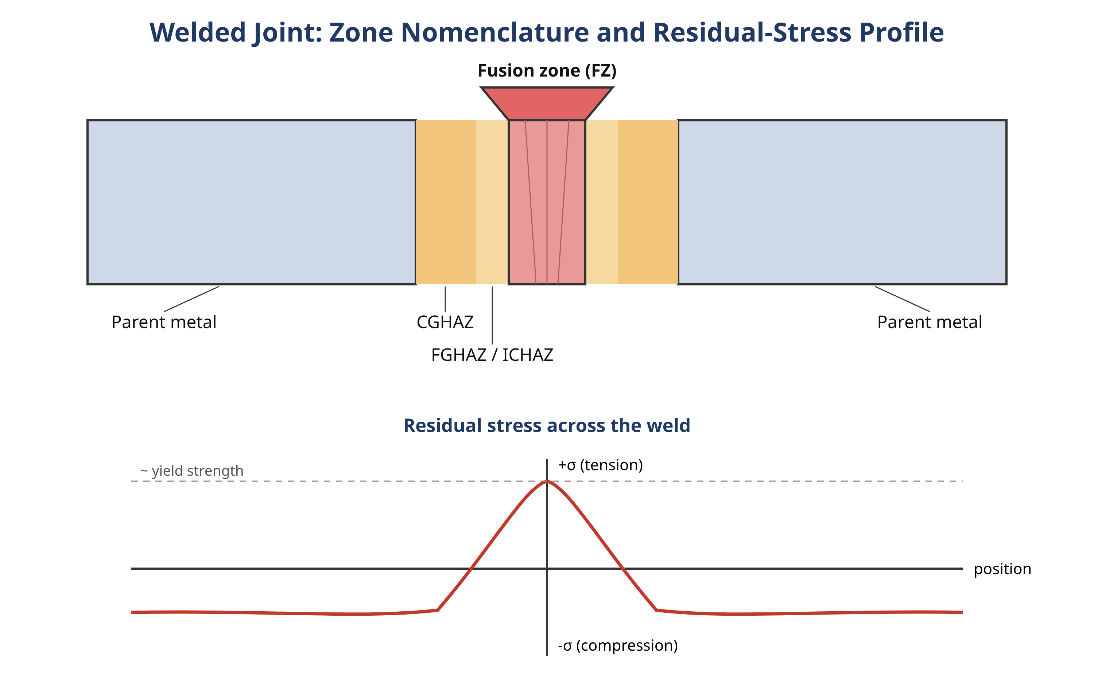
Figure 11.1 Nomenclature of the welded joint showing the fusion zone (FZ), the coarse-, fine-, and intercritical heat-affected zones (CGHAZ, FGHAZ, ICHAZ), and the parent metal, with a schematic through-thickness residual-stress profile (tensile near the weld, balanced by compression farther away).
Non-uniform heating and cooling, combined with the constraint of the surrounding cold structure and with volume changes from solid-state phase transformations, leave the completed weld in a state of self-equilibrating residual stress. Longitudinal residual stresses in and near the weld frequently reach the yield strength of the material in tension, balanced by compression farther away [7, 8]. These stresses are consequential for every failure mode discussed in this chapter: they add to applied stress in driving fatigue crack growth, they supply the sustained tensile stress that stress-corrosion and hydrogen cracking require, and they contribute to brittle fracture by raising the local stress at a notch. Distortion, the dimensional counterpart of residual stress, can force misalignment that introduces secondary bending stresses at the joint. Weld sequencing, heat-input control, and post-weld heat treatment are the principal levers for managing both [9]. Figure 11.1 shows the zone nomenclature and the typical through-thickness residual-stress profile.
A growing fraction of modern fabrication involves dissimilar-metal welds and advanced alloy systems, and these amplify the metallurgical complexity described above. When a ferritic steel is joined to an austenitic steel, the joint spans a step change in composition, coefficient of thermal expansion, and creep strength; carbon migration across the fusion boundary during high-temperature service can produce a soft, decarburised band on one side and a hard carburised band on the other, both of which become preferential failure sites [10]. Welding of high-entropy and other advanced alloys introduces fusion-zone and HAZ behaviour that is still being characterised, and the structure-property relationships that govern failure in these systems cannot be assumed identical to those of conventional steels [11]. For the failure analyst the practical message is that the location and character of the weakest link must be established for the specific material combination, not inferred from experience with homogeneous joints.
11.3 Classification of Weld Discontinuities and Defects
A discontinuity is any interruption in the typical structure of a weld; it becomes a defect only when it is severe enough to render the joint unfit for its intended service according to the governing acceptance criteria. This distinction matters in failure analysis, because the mere presence of a discontinuity does not prove it caused the failure. The analyst must demonstrate a mechanistic link between the feature and the crack that actually propagated.
Weld discontinuities are conventionally grouped as planar or volumetric. Planar discontinuities, such as lack of fusion, lack of penetration, and cracks, present a sharp crack-like tip and are by far the most damaging because they act as ready-made initiation sites for fatigue and fracture. Volumetric discontinuities, such as porosity, slag, and undercut, are generally more tolerable because they lack a sharp tip, although undercut at the weld toe is dangerous precisely because it sharpens an already-critical geometric transition. Table 11.1 summarises the principal discontinuities, their usual causes, and their significance to failure. The weld toe and the weld root deserve particular emphasis: they combine geometric stress concentration with peak residual stress and, often, with microstructural notches, which is why the overwhelming majority of service fatigue cracks in welded structures initiate at one or the other [12, 13].
Table 11.1 Principal weld discontinuities, their causes, and significance to failure.
Discontinuity | Type | Typical cause | Significance to failure
Solidification (hot) crack | Planar | High restraint; low-melting segregates at centreline | Sharp initiation site; reduces load-bearing section
Hydrogen (cold) crack | Planar | Diffusible hydrogen + hard HAZ + stress | Delayed; initiates brittle or fatigue failure in CGHAZ
Lack of fusion / penetration | Planar | Low heat input; poor technique/fit-up | Acts as pre-existing crack; dominates fatigue root failure
Porosity | Volumetric | Gas entrapment; contamination; moisture | Generally tolerable unless clustered or near surface
Slag inclusion | Volumetric | Incomplete interpass cleaning | Stress raiser; reduces effective throat
Undercut | Planar-like | Excessive current/travel speed | Sharpens weld-toe notch; promotes fatigue initiation

The distribution of discontinuity types is strongly influenced by the welding process. Manual arc processes are more prone to slag inclusions and start-stop defects, gas-shielded processes to porosity when shielding is disturbed, and high-energy-density processes to narrow, deep fusion zones in which lack of fusion can be difficult to detect. Friction stir welding, a solid-state process, avoids solidification cracking and porosity altogether but introduces its own characteristic flaws such as root defects and wormholes when process parameters are not optimised, and its fatigue performance is governed by these features together with the residual-stress field [14]. Recognising the process-specific signature of a discontinuity helps the analyst reconstruct the fabrication history and identify where control broke down.
11.4 Fracture of Welded Joints
Fracture is the separation of a body into two or more parts under stress. In welded joints it takes two broad forms, brittle and ductile, each with its own driving conditions, preferred location, and fractographic signature. These, together with the other mechanisms treated later in this chapter, are summarised for ready comparison in Table 11.2, which the analyst can use as a first-pass diagnostic key.
Table 11.2 Dominant failure mechanisms of welded joints and their diagnostic signatures.
Mechanism | Driving conditions | Preferred location | Fractographic signature
Brittle fracture | Low temperature; notch; high/residual stress | CGHAZ / weld toe | Cleavage facets; chevrons; little deformation
Ductile overload | Load above capacity; reduced section | Weakest ligament | Equiaxed microvoid dimples; shear lips
Fatigue | Cyclic stress; stress concentration | Weld toe / weld root | Beach marks (macro); striations (micro)
Hydrogen-induced cracking | Diffusible H; hard microstructure; stress | CGHAZ | Flat, quasi-cleavage; intergranular facets; fisheyes
Stress-corrosion cracking | Tensile stress + specific environment | Near-weld / sensitised HAZ | Branched cracks; little gross deformation
Creep (Type IV) | Elevated temperature + sustained stress + time | FGHAZ / ICHAZ | Intergranular cavitation and microcracks

Brittle fracture is the sudden propagation of a crack at a stress below the general yield strength, with little or no preceding plastic deformation. In steels it occurs by transgranular cleavage and is promoted by three conditions acting together: a sharp notch or crack, a high tensile stress (including residual stress), and a material in its low-toughness, low-temperature regime. Welded structures assemble all three with unfortunate ease. The CGHAZ supplies a low-toughness microstructure, the weld toe supplies the notch, and residual stress supplies tensile loading even before service loads are applied. Of the discontinuities listed in Table 11.1, the planar flaws (cracks and lack of fusion) are the most dangerous initiators of brittle fracture because they present a ready-made sharp crack tip. The Liberty-ship failures remain the canonical example: notch-sensitive steel, hatch-corner stress concentrations, cold North-Atlantic service, and welded construction that allowed a crack to run uninterrupted across plate boundaries [15]. Modern design guards against brittle fracture by specifying minimum Charpy or crack-tip-opening-displacement toughness at the lowest service temperature, by limiting flaw sizes through NDT, and by selecting steels whose ductile-to-brittle transition lies well below service temperature. The strong size effect in impact brittle fracture means that thick sections are more vulnerable than thin ones at the same temperature, a factor the analyst must weigh when interpreting a failure [16].
Ductile fracture proceeds by the nucleation, growth, and coalescence of microvoids, typically around inclusions or second-phase particles, and is accompanied by substantial plastic deformation. On the fracture surface it produces a dimpled morphology, which is the fractographer's signature of overload and contrasts sharply with the cleavage facets of brittle fracture; both appear side by side in Figure 11.2. A purely ductile overload failure of a weld usually indicates that the joint was loaded beyond its design intent, or that a cross-sectional area was lost to prior cracking or corrosion until the remaining ligament could no longer carry the load. In the latter case the ductile final fracture is only the last chapter of a longer story, and the analyst's task is to find the slow crack-growth region that preceded it.
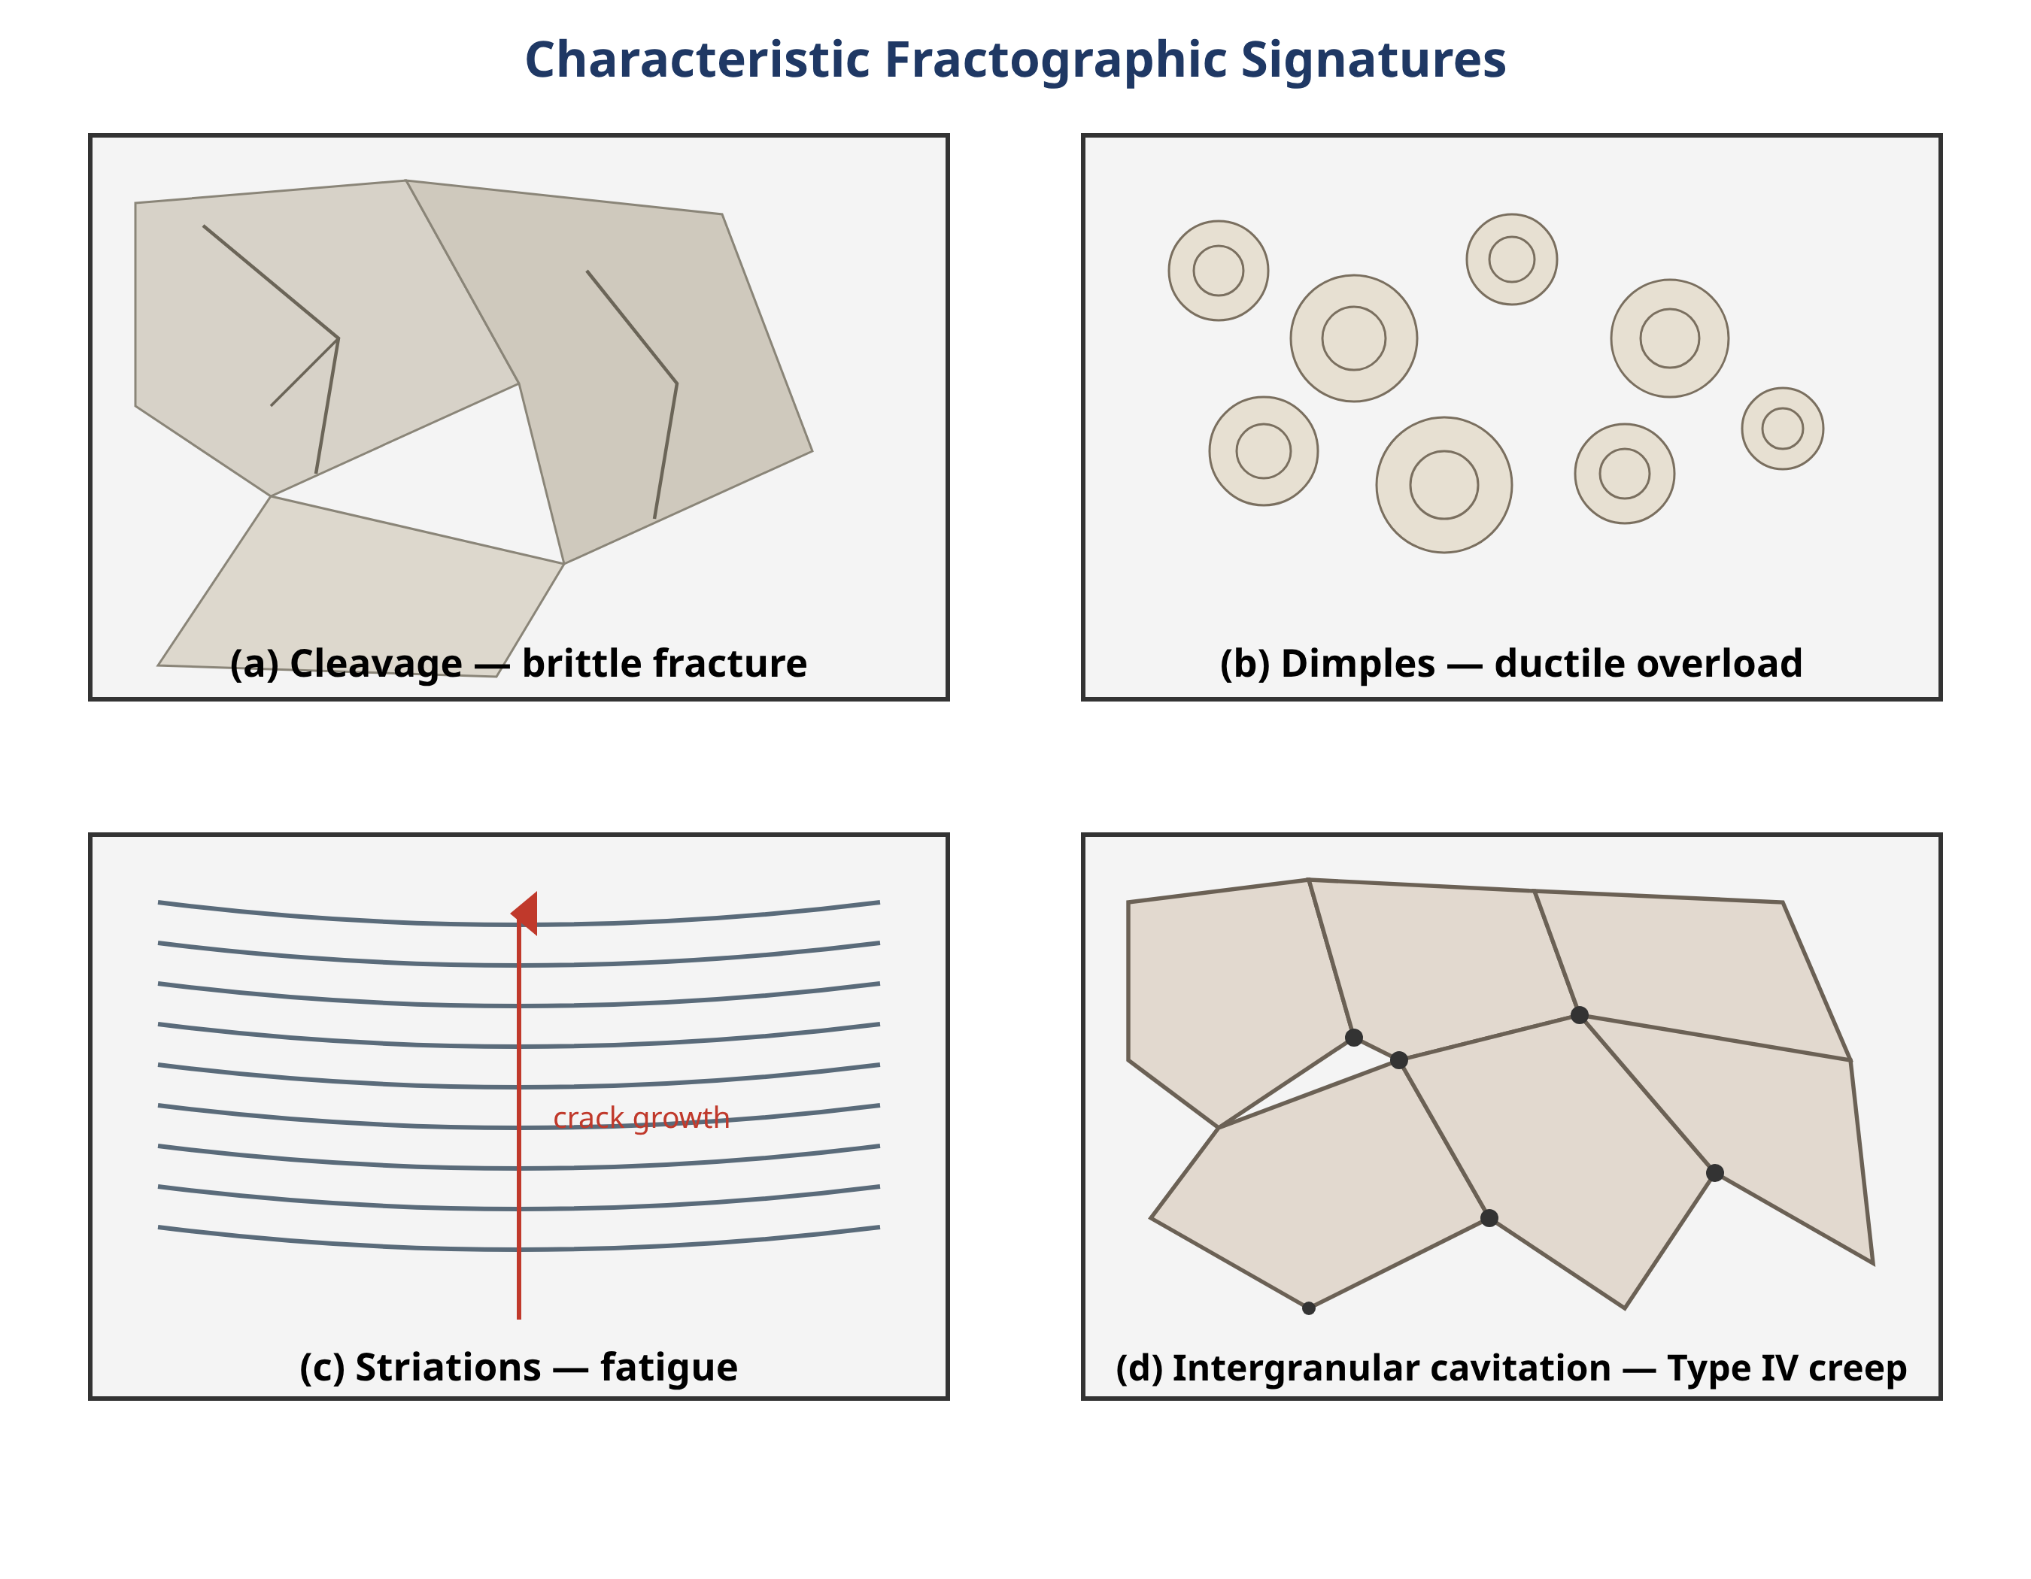
Figure 11.2 Representative fractographic signatures used in diagnosis: (a) cleavage facets of brittle fracture; (b) microvoid dimples of ductile overload; (c) striations of fatigue crack growth; (d) intergranular cavitation characteristic of Type IV creep.
Fracture mechanics provides the quantitative link between flaw size, stress, and material toughness. The stress-intensity factor characterises the crack-tip field in the linear elastic regime, and fast fracture occurs when it reaches the material's fracture toughness. For the elastic-plastic conditions typical of tough structural steel, crack-tip-opening displacement and the J-integral are used instead. Engineering-critical-assessment procedures codified in fitness-for-service standards combine these parameters with a failure-assessment diagram that treats brittle fracture and plastic collapse as competing limits. For the failure analyst, fracture mechanics answers two questions: was the flaw that was found large enough to be critical under the stresses present, and how long would a sub-critical flaw have taken to grow to that size.
11.5 Fatigue of Welded Joints and Structures
Fatigue is the progressive, localised, and permanent structural damage that occurs when a material is subjected to fluctuating stresses. It is the single most common cause of in-service failure of welded structures, because the stress concentrations and tensile residual stresses inherent to welds dramatically reduce fatigue strength relative to the parent metal [12, 17].
Three features conspire to make the weld the fatigue-critical location. First, the abrupt geometric transition at the weld toe and the embedded notch at an incompletely penetrated root both concentrate stress. Second, welding leaves near-yield tensile residual stress at exactly these locations, so the local mean stress is high regardless of the applied load ratio; this is why the fatigue strength of as-welded joints is often treated as independent of applied mean stress in design codes. Third, welds inevitably contain small crack-like discontinuities at the toe and root, so much of the conventional crack-initiation life is already consumed and the fatigue life is dominated by crack propagation. The practical consequence is that a smooth, polished parent-metal specimen and an as-welded joint of the same steel can differ in fatigue strength by a factor of several [17].
Fatigue cracks in welded joints initiate predominantly at the weld toe or the weld root. Toe cracking is driven by the external geometric notch and is the more common mode in fully penetrated joints. Root cracking governs load-carrying fillet and partial-penetration joints, where the unfused root acts as a sharp internal crack; root failure is more difficult to detect and more sensitive to throat size and weld quality, which makes it the more insidious of the two [13, 18]. Distinguishing toe from root initiation in a failed joint is an important diagnostic step, because the two point to different design or fabrication deficiencies.
Several complementary methods are used to assess welded fatigue. The nominal-stress approach assigns each structural detail to a fatigue class, each class defined by an S-N curve giving allowable stress range against number of cycles; this is the basis of the widely used recommendations of the International Institute of Welding [19]. Because nominal stress is ambiguous in complex geometry, the structural or hot-spot stress approach extrapolates the surface stress to the weld toe and uses a single reference curve. The notch-stress and fracture-mechanics approaches go further, modelling the local notch or treating the weld as a cracked body and integrating a crack-growth law to predict propagation life [20, 21]. Finite-element analysis underlies the latter two and is now routinely used to extract hot-spot stresses, incorporate residual-stress fields and their relaxation under load, and assess multiaxial and variable-amplitude loading [21, 22, 23]. Figure 11.3 illustrates the characteristic S-N behaviour of a welded detail compared with parent metal.
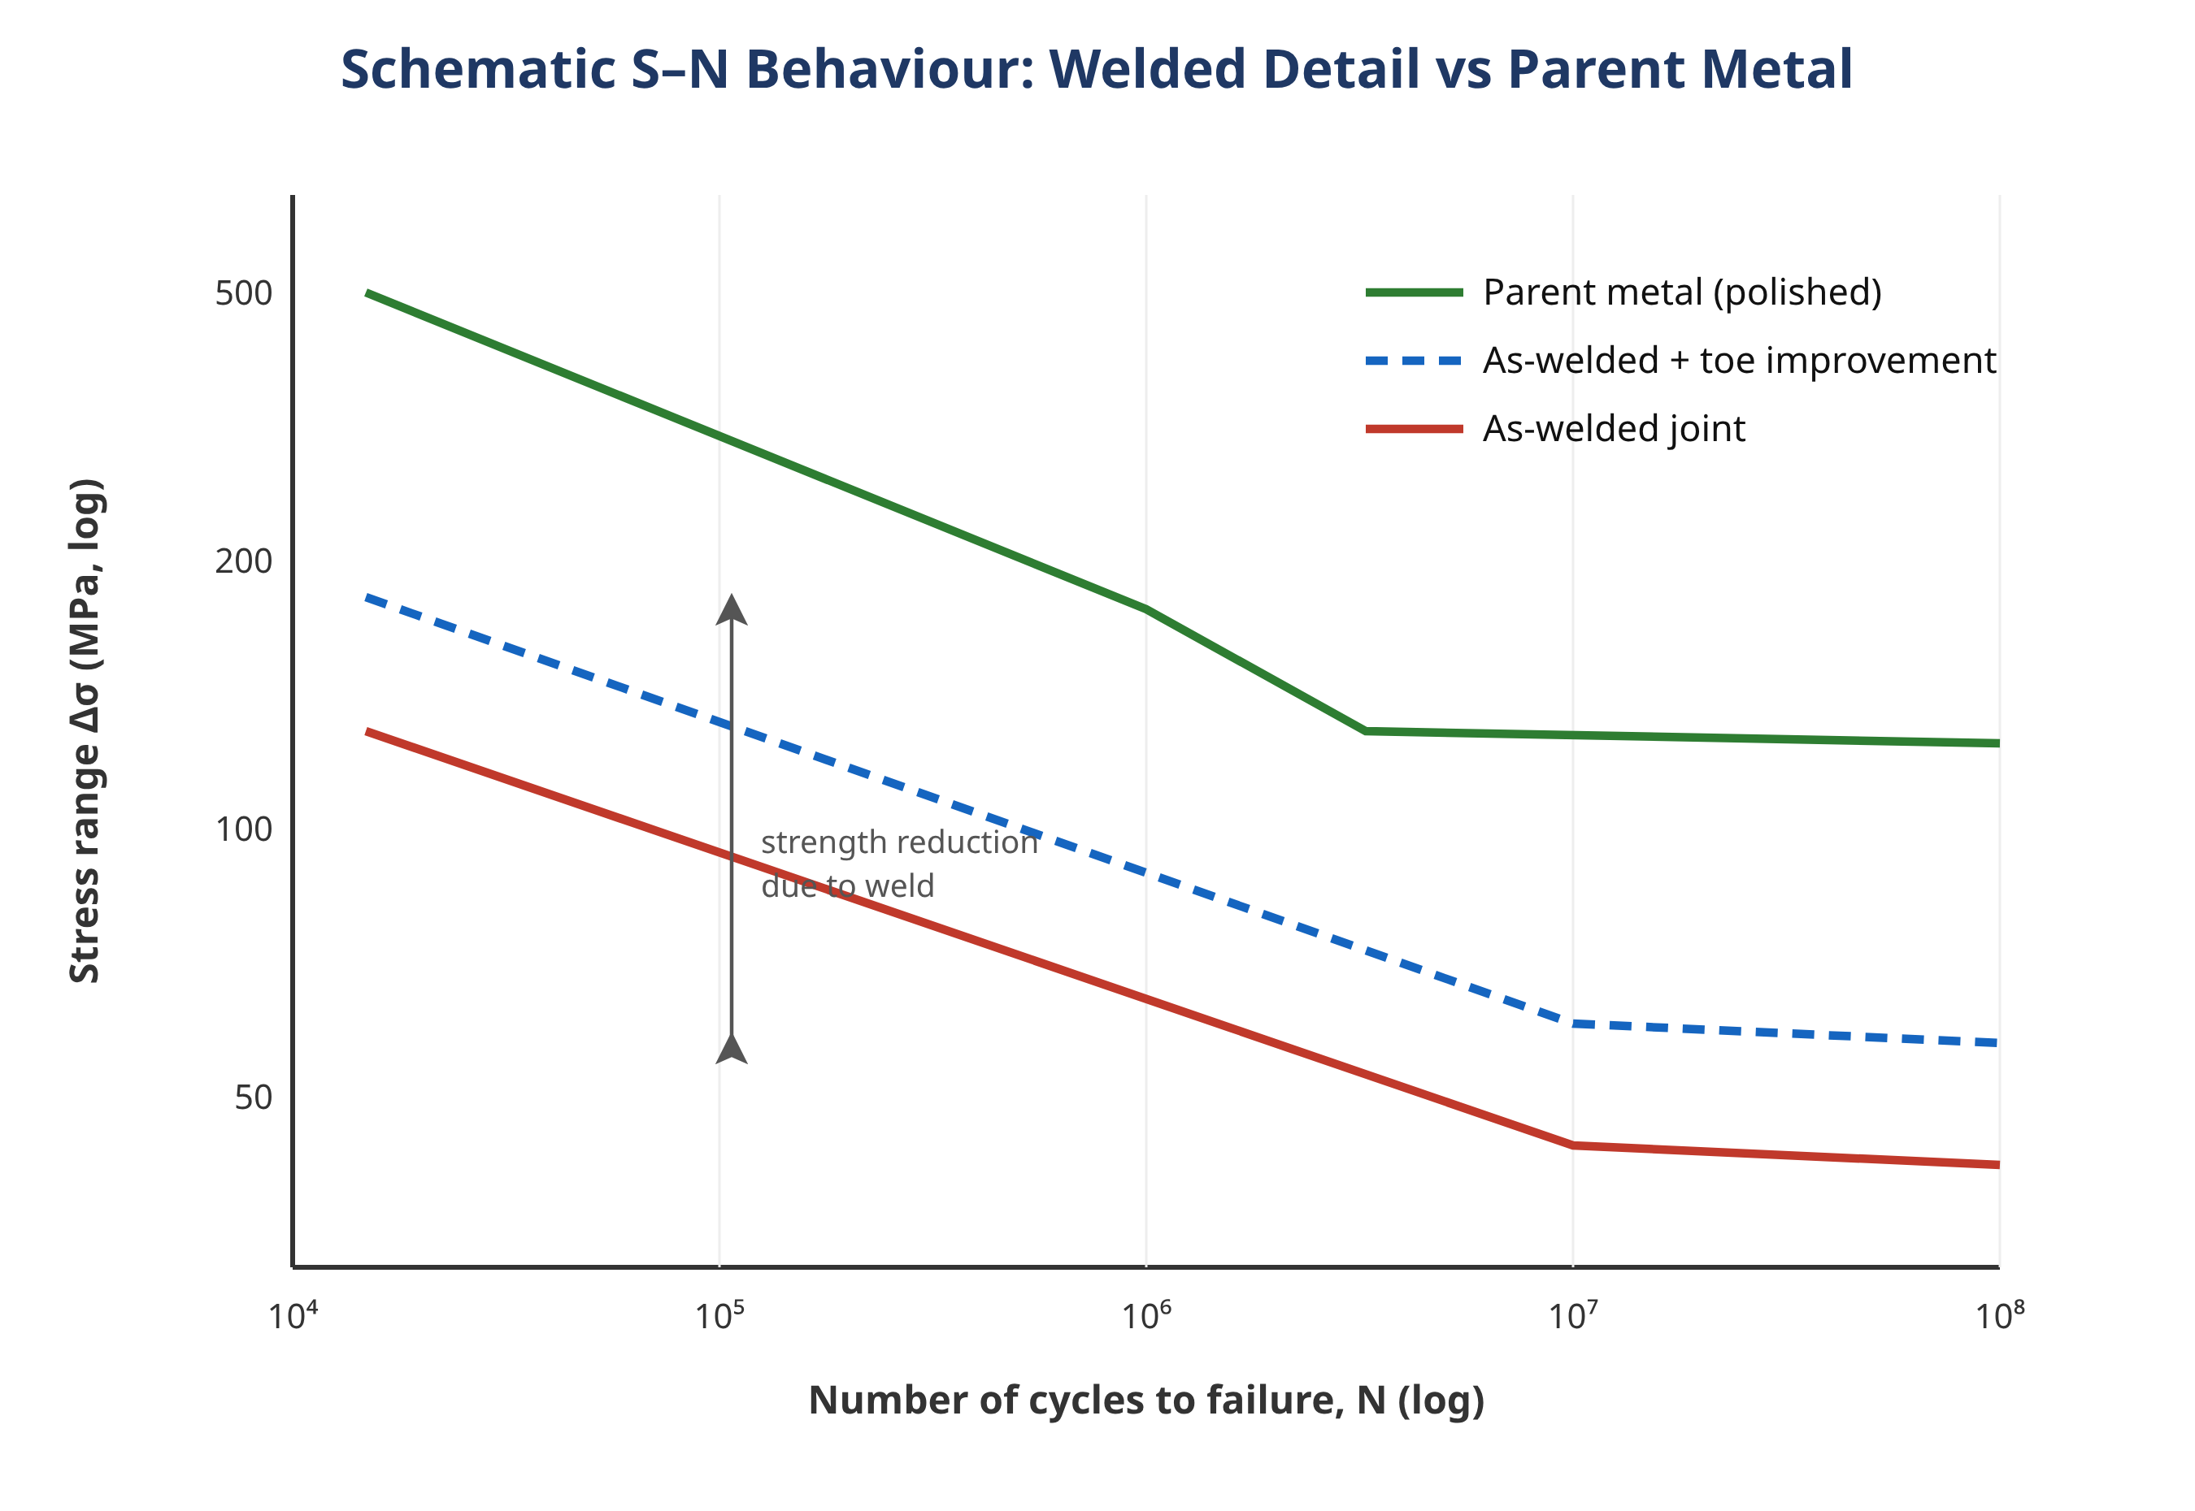
Figure 11.3 Schematic stress-range versus cycles-to-failure (S-N) behaviour of an as-welded detail compared with polished parent metal, illustrating the large reduction in fatigue strength and the effect of a post-weld toe-improvement treatment.
Because fatigue life is dominated by the weld toe condition, post-weld improvement techniques that reshape or compressively stress the toe can substantially extend life. Burr grinding and TIG dressing remove toe discontinuities and reduce the geometric stress concentration; hammer, needle, and high-frequency mechanical impact (HFMI) peening introduce beneficial compressive residual stress that opposes crack opening [24]. These methods are most effective on joints that would otherwise fail from the toe and offer little benefit where root failure governs, reinforcing the importance of correctly diagnosing the initiation site. The upward shift such treatments produce in the S-N response is indicated by the improved curve in Figure 11.3, which lies between the as-welded and parent-metal curves.
Real structures rarely experience the constant-amplitude loading of a laboratory test. Service load spectra combine cycles of many different amplitudes, and damage accumulation is conventionally estimated with a linear cumulative-damage rule in which the fractions of life consumed at each stress level are summed. The method is convenient but approximate; the sequence of loads, the relaxation of welding residual stress under the largest cycles, and the behaviour of small cycles below the constant-amplitude fatigue limit all introduce deviations that have caused unexpected service failures [21, 25]. Many welded joints also experience multiaxial stress states, for example the combination of axial, bending, and torsional loading in a bogie frame or a tubular node, and the non-proportional variation of these components over a cycle can reduce fatigue life below what any single-axis assessment would predict [23]. Modern finite-element-based assessments extract the full stress tensor history at the critical location and apply a multiaxial criterion, which is particularly important when a failure analysis must explain why a joint cracked at a stress the designer believed to be safe [22, 23].
A common service scenario illustrates the diagnostic chain. A load-carrying fillet-welded attachment on a cyclically loaded member is found cracked after a service life well short of design. Macroscopic examination reveals beach marks emanating from the unfused weld root rather than from the toe, and sectioning shows the throat to be undersized relative to the drawing. Scanning electron microscopy confirms fatigue striations, and stress analysis shows that the reduced throat raised the root stress range enough to account for the observed life. The root cause is thus a fabrication deviation (insufficient throat) acting on a design that placed a fatigue-sensitive partial-penetration joint in a load-carrying role; the recommendations follow directly, namely a full-penetration detail or an increased, inspected throat, and a review of welder qualification [13, 18]. The example underscores why toe-versus-root discrimination and quantitative stress analysis are indispensable rather than optional.
11.6 Environmentally Assisted Cracking
Hydrogen-induced cracking (HIC), also called cold cracking or delayed cracking, requires the simultaneous presence of diffusible hydrogen, a susceptible (usually hard, martensitic) microstructure, tensile stress, and temperatures near ambient. Hydrogen enters the weld from moisture, contaminated consumables, or the service environment, diffuses to regions of high triaxial stress such as the CGHAZ, and embrittles the lattice so that cracking occurs at stresses well below the normal fracture strength [26, 27]. The term delayed cracking reflects the fact that the crack may appear hours or days after welding, once hydrogen has had time to accumulate. In sour and high-pressure hydrogen service, HIC and its stress-oriented variant (SOHIC) are leading causes of pipeline and pressure-vessel weld failure, and welding residual stress is frequently the dominant stress source [28, 29, 30]. Galvanic coupling between weld and parent metal in corrosive media can accelerate hydrogen charging and localise cracking at the weld [31]. Prevention centres on low-hydrogen consumables and practice, preheat to promote hydrogen diffusion out of the joint, control of HAZ hardness through heat input and composition, and post-weld heat treatment to temper hard microstructures and relax residual stress [7, 26].
Stress-corrosion cracking (SCC) is the growth of cracks under the combined action of a sustained tensile stress and a specific corrosive environment, in a material that would resist either agency acting alone. Welded austenitic stainless steels are especially vulnerable: chloride-containing environments attack the near-weld region, where residual stress supplies the tensile component and weld sensitisation (chromium-carbide precipitation that depletes the adjacent matrix of chromium) supplies local susceptibility [32, 33]. Chloride-induced SCC of stainless weldments is a recognised integrity threat in process plant, nuclear dry-storage canisters, and marine service [24, 34]. SCC failures are often insidious because the cracks are fine, highly branched, and carry little gross deformation, so the structure gives little warning before a through-wall leak or rupture. Multi-factor cases, in which pitting initiates a crack that then propagates by SCC under the influence of residual stress and flow, are common and require careful disentangling [35]. Mitigation includes selecting resistant alloys, reducing residual stress by heat treatment or peening, solution annealing to reverse sensitisation, and excluding the aggressive species where possible [24, 33].
Two contrasting cases illustrate how environmental cracking is diagnosed. In the first, a welded 316L stainless-steel stack in a mining operation leaked and cracked near its welds after only a year in service. Metallographic sectioning revealed fine, branched cracks initiating at the weld region and propagating transgranularly, the classic morphology of chloride-induced stress-corrosion cracking; residual stress from welding supplied the tensile component, and the chloride-bearing environment supplied the chemistry [32]. The analysis distinguished the root cause (chloride SCC of a sensitised, residually stressed weld) from the contributing factors (material selection and lack of stress relief) and recommended a more resistant alloy, solution annealing, and reduction of residual stress. In the second case, a high-strength pipeline weld in sour service cracked without any overload event. Hardness traverses showed an excessively hard coarse-grained HAZ, and the fracture surface displayed flat, quasi-cleavage facets consistent with hydrogen-induced cracking; the hydrogen source was the sour environment and the stress was largely residual [28, 29]. Here the recommendations centred on reducing HAZ hardness through heat-input and preheat control and on post-weld heat treatment. The two cases share a structure, residual stress plus environment plus susceptible microstructure, but differ in the specific mechanism, and only the combined metallographic and fractographic evidence separates them.
11.7 High-Temperature Creep Failure
Components that operate at elevated temperature, such as steam headers, superheater tubing, and reformer piping in power and petrochemical plant, fail by creep: the slow, time-dependent accumulation of strain under stresses below the yield strength. In welded high-chromium ferritic steels the creep weak link is a specific sub-region of the HAZ, and the resulting failure mode is known as Type IV cracking. It occurs in the fine-grained and intercritical HAZ, where the thermal cycle produced a microstructure that coarsens and loses creep strength preferentially during long-term service; creep cavities nucleate around precipitate particles, link into microcracks, and ultimately cause fracture with relatively little overall cross-weld strain, which limits the warning the component gives [4, 5, 6]. Type IV cracking is the principal life-limiting mechanism for weldments in modern 9-12% Cr creep-strength-enhanced ferritic steels and has repeatedly caused premature failure of components designed on the basis of parent-metal creep data [6, 36]. Dissimilar-metal welds, which join ferritic to austenitic steels and superimpose a sharp chemical and thermal-expansion mismatch on the creep problem, present an additional set of interface-driven failure modes [10]. Management of creep life relies on appropriate post-weld heat treatment, realistic (weld-strength-reduction-factored) design stresses, and periodic in-service inspection for cavitation damage [4, 36].
Preventing creep failure of weldments therefore demands an integrated approach. Appropriate post-weld heat treatment restores a more stable HAZ microstructure and relaxes residual stress, though it cannot wholly eliminate the Type IV weak zone [4]. Design stresses are reduced by weld-strength-reduction factors derived from cross-weld creep testing, so that the component is not operated at a stress the HAZ cannot sustain for the intended life [6, 36]. In service, periodic inspection targets the HAZ specifically, using replication to detect the earliest creep cavitation and ultrasonic methods to find developed microcracks, feeding a remaining-life assessment that schedules repair or replacement before a leak or rupture occurs [36]. For dissimilar-metal welds the additional risk of interface failure, driven by carbon migration and thermal-expansion mismatch, means that the joint design, filler selection, and inspection strategy must be considered together rather than treated as a standard like-for-like weld [10].
11.8 Methodology of Welded-Joint Failure Analysis
A credible failure analysis is a disciplined, evidence-led investigation that moves from observation to hypothesis to verified root cause, and finally to recommendations that prevent recurrence. The sequence below, summarised in Figure 11.4, is deliberately ordered so that non-destructive evidence is preserved before any destructive step is taken.
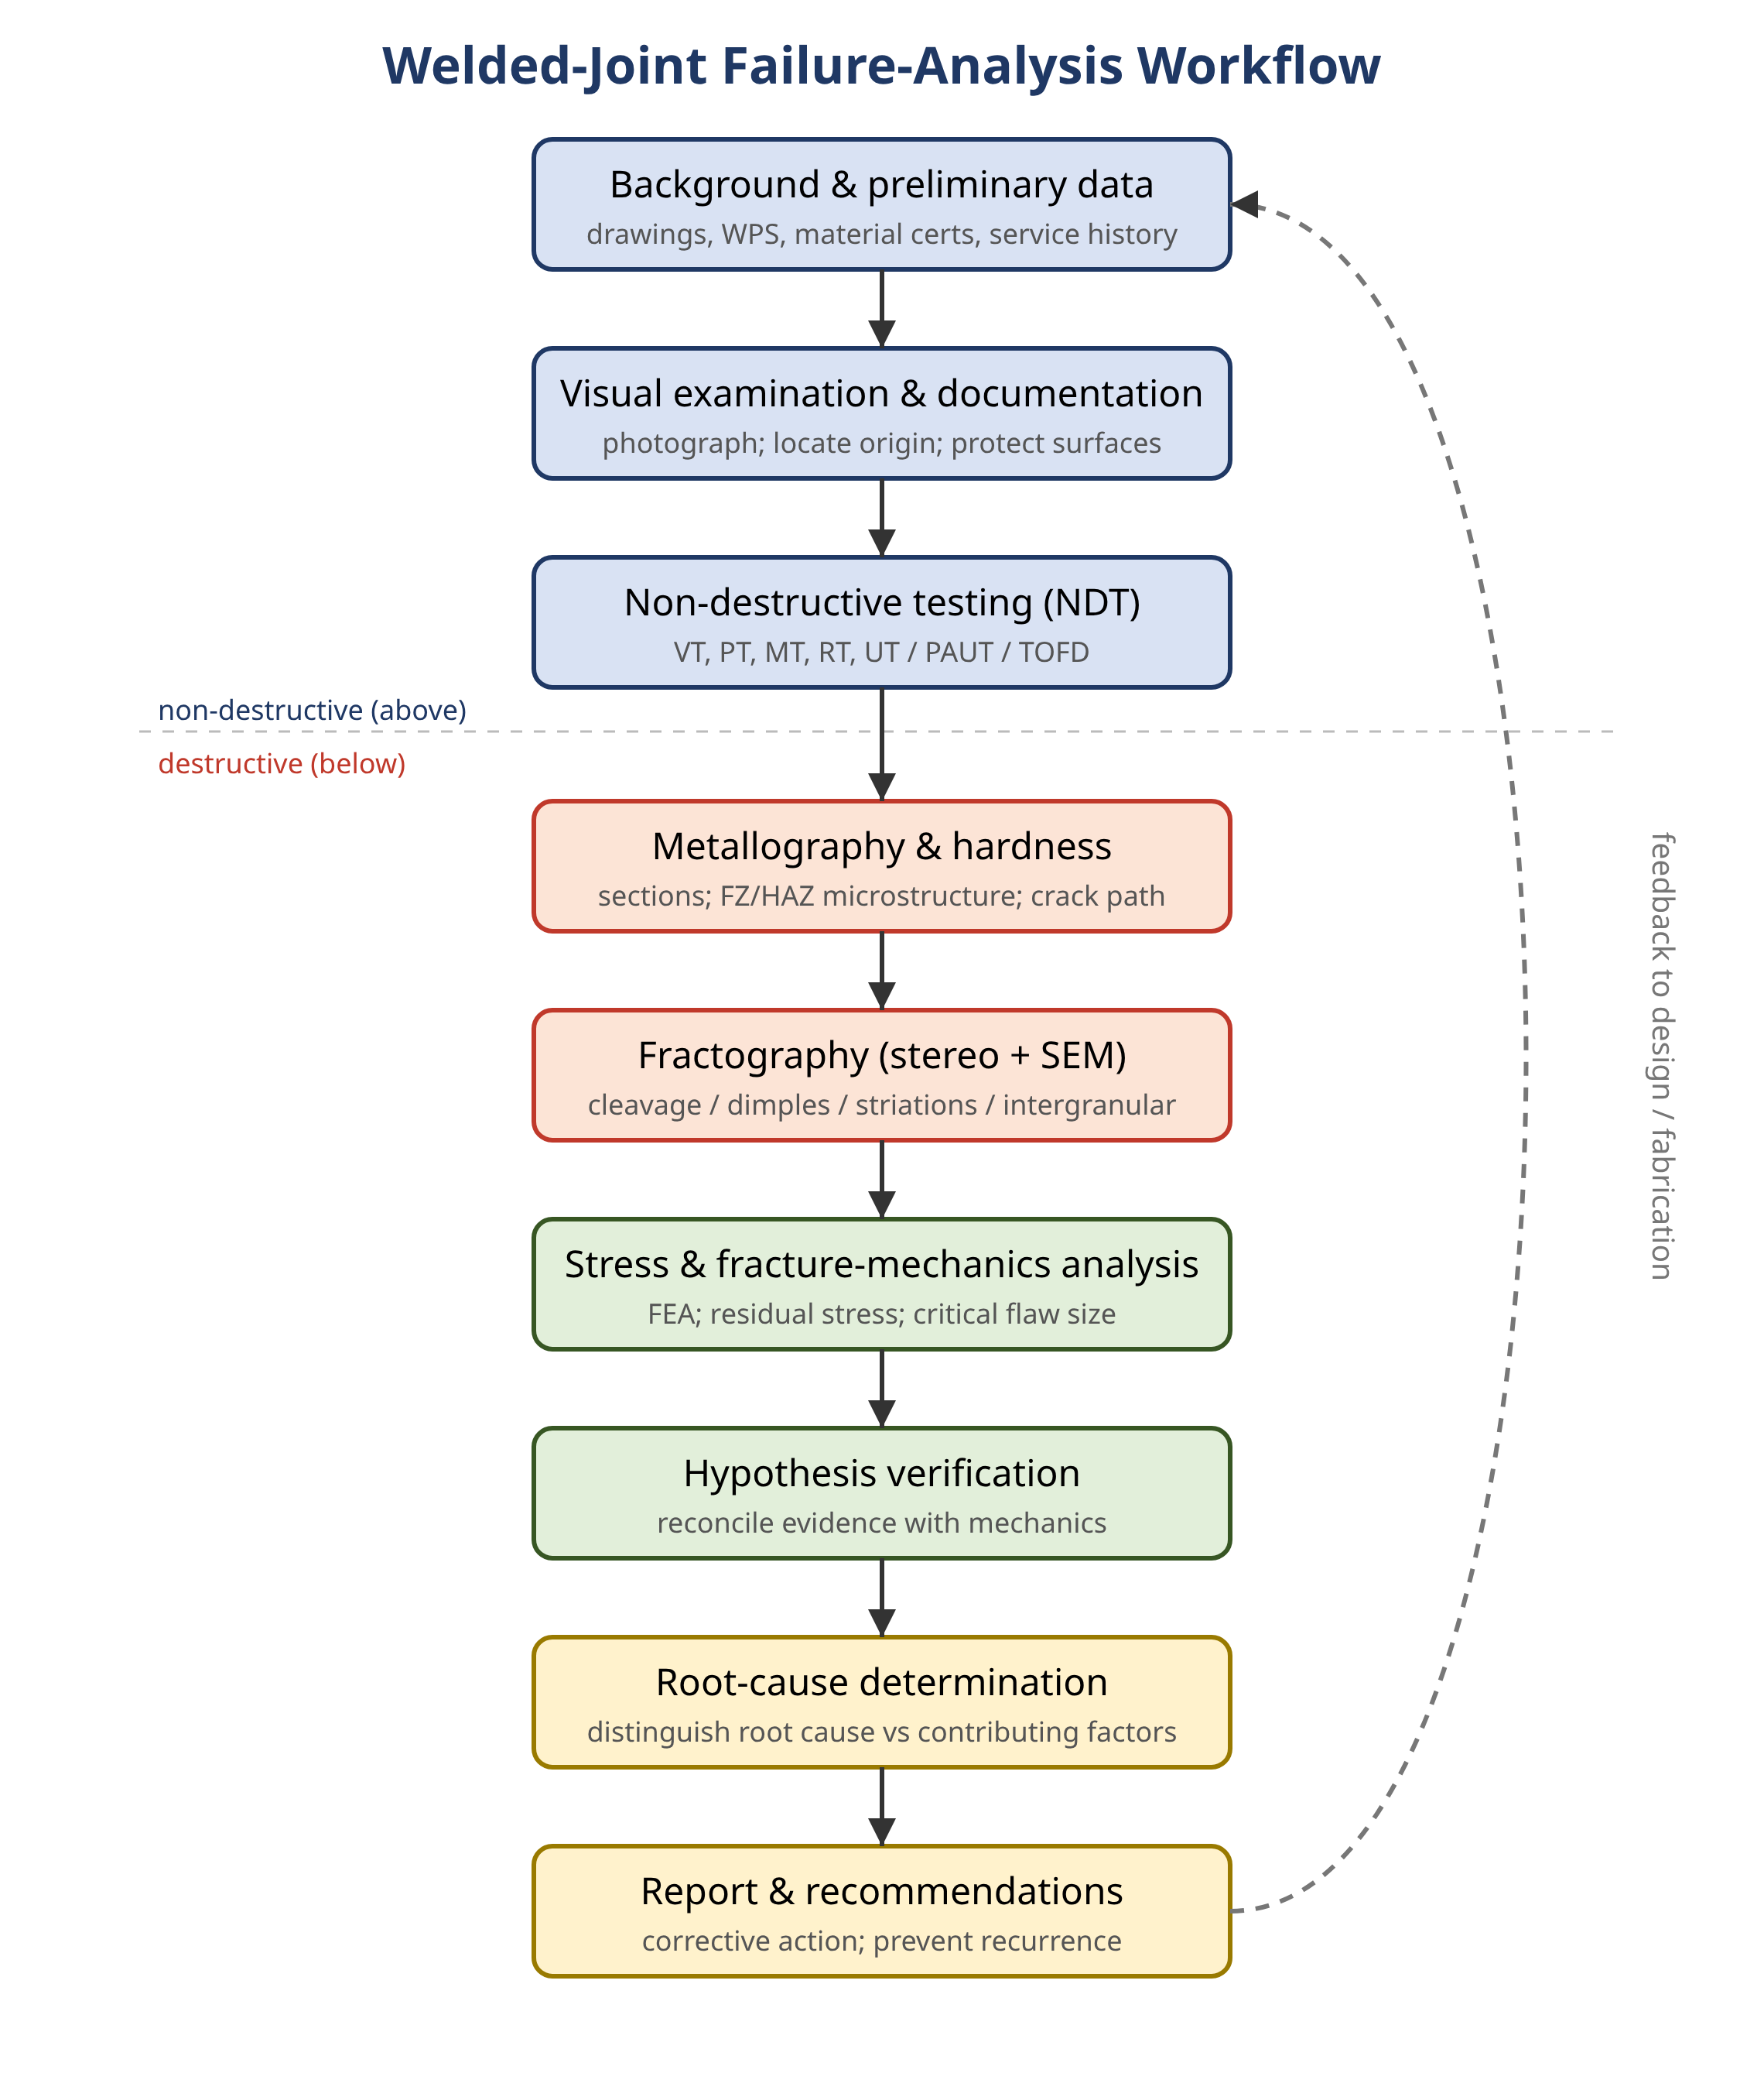
Figure 11.4 The welded-joint failure-analysis workflow, ordered so that non-destructive evidence (background data, visual examination, NDT) is preserved before destructive steps (metallography, fractography), culminating in stress analysis, root-cause determination, and recommendations.
11.8.1 Background and visual examination
The investigation begins before the broken part is touched. The analyst assembles the design drawings and weld procedure specifications, the material certificates, the fabrication and inspection records, the service history including loads, temperatures and environment, and the circumstances of the failure itself. This context frames every subsequent observation and guards against the common error of fitting the evidence to a premature conclusion.
On-site and laboratory visual examination, thoroughly photographed, records the location and orientation of the crack relative to the weld, the presence of corrosion products or deposits, gross distortion, and any secondary damage. The fracture origin can often be located at this stage from macroscopic features such as beach marks and chevron patterns. Fracture surfaces must be protected from mechanical and corrosive damage, and the mating faces should never be fitted back together, as this destroys the very features the fractographer needs.
11.8.2 Non-destructive testing
NDT maps the extent of cracking and reveals sub-surface discontinuities without compromising later examination. The principal methods, compared in Table 11.3, are visual, liquid-penetrant, and magnetic-particle testing for surface and near-surface flaws, and radiographic and ultrasonic testing for internal flaws [37, 38]. Modern ultrasonic techniques such as phased array and time-of-flight diffraction provide accurate flaw sizing that feeds directly into a fracture-mechanics assessment, and eddy-current and advanced imaging methods extend detection to coated and difficult-access welds [38, 39]. The field is increasingly augmented by automated, machine-learning-based defect recognition [40, 41]. Method selection depends on the material, the expected flaw type and orientation, and access.
Table 11.3 Comparison of common non-destructive testing methods for weld inspection.
Method | Detects | Flaw location | Key strengths | Key limitations
Visual (VT) | Surface flaws, profile, undercut | Surface | Fast, low cost, no consumables | Surface only; operator dependent
Liquid penetrant (PT) | Surface-breaking cracks/porosity | Surface | Simple; any non-porous material | Surface-breaking only; messy
Magnetic particle (MT) | Surface and near-surface cracks | Surface/near-surface | Sensitive to fine cracks | Ferromagnetic materials only
Radiography (RT) | Volumetric flaws; some planar | Internal | Permanent image; volumetric | Poor for tight planar flaws; safety
Ultrasonic (UT/PAUT/TOFD) | Planar and volumetric flaws | Internal/surface | Accurate sizing; depth of penetration | Skill-intensive; coupling needed
Eddy current (ET) | Surface/near-surface cracks | Surface/near-surface | No couplant; coated welds | Conductive materials; shallow depth

The reliability of NDT is itself a quantity the analyst must respect. Every method has a probability of detection that depends on flaw size, type, and orientation, and a sizing accuracy that propagates directly into any fitness-for-service calculation. A planar flaw oriented unfavourably to the ultrasonic beam, or a tight crack invisible to radiography, can be missed entirely, which is why critical welds are often examined by more than one complementary method [37, 38]. Phased-array ultrasonic testing steers and focuses the beam electronically to improve detection and imaging, while time-of-flight diffraction measures crack height from diffracted signals with accuracy well suited to crack-growth assessment [38]. For welds beneath coatings or with restricted access, eddy-current and emerging electromagnetic and imaging techniques extend coverage where conventional methods struggle [39]. The increasing use of automated feature extraction and machine-learning classification promises more consistent interpretation and a searchable record of inspection data, although such systems must be validated against known flaws before their output is trusted in a safety case [40, 41].
11.8.3 Metallography and fractography
Sections taken through the weld and through the crack, when mounted, polished, and etched, reveal the FZ, HAZ, and parent-metal microstructures, the weld profile, and the path of the crack relative to the microstructure. Whether a crack runs through the CGHAZ, along a fusion boundary, or through the FGHAZ is often decisive in identifying the mechanism. Hardness traverses across the weld quantify the HAZ condition: an excessively hard CGHAZ points to hydrogen-cracking susceptibility, while softening in the intercritical region is consistent with creep and Type IV damage [2, 4].
Fractography, the examination of fracture surfaces, is the most direct route to the failure mechanism. The unaided eye and the stereomicroscope establish the macroscopic picture, while the scanning electron microscope resolves the microscopic morphology. The four signatures illustrated in Figure 11.2 form the core diagnostic vocabulary: cleavage facets indicate brittle transgranular fracture; equiaxed dimples indicate ductile overload; regularly spaced striations are the fingerprint of fatigue crack growth; and intergranular separation points to embrittlement, creep cavitation, or environmental attack [42]. Each of these morphologies in Figure 11.2 maps directly onto a mechanism row of Table 11.2, so fractography and the diagnostic key are used together. Quantitative and increasingly automated image-analysis methods now assist in classifying these morphologies objectively [42]. Energy-dispersive spectroscopy in the SEM identifies corrosion products and inclusions that may have initiated the crack.
11.8.4 Stress analysis and root-cause verification
The physical evidence is finally reconciled with the mechanics. Analytical or finite-element stress analysis establishes whether the stresses present, including residual stress, were sufficient to drive the observed crack from the flaw that was found, and over what time or number of cycles [21, 22, 43]. A root cause is accepted only when the proposed mechanism is consistent with the fractography, the metallography, the material condition, and the calculated stresses. The investigation concludes with a written report that states the root cause, distinguishes it from contributing factors, and makes specific recommendations. As the feedback loop in Figure 11.4 indicates, those recommendations should flow back into design and fabrication practice so that the same failure is designed out rather than merely repaired.
11.8A Fitness-for-Service and Remaining-Life Assessment
Not every flaw detected in a welded structure warrants immediate repair, and not every failure analysis ends with scrapping the component. Fitness-for-service (FFS) assessment provides the quantitative basis for deciding whether a structure containing a known flaw can continue to operate safely, and for how long. The assessment combines the flaw size and position established by NDT, the material toughness and tensile properties, and the applied and residual stresses, within a failure-assessment-diagram framework that treats brittle fracture and plastic collapse as competing limits. Where the flaw is sub-critical, a crack-growth analysis, by fatigue, creep, or environmental mechanisms as appropriate, estimates the remaining life and sets a re-inspection interval [21, 36]. For high-temperature components the remaining-life calculation must account explicitly for Type IV creep damage accumulation in the HAZ, since parent-metal creep data would be non-conservative [6, 36]. FFS thus closes the loop between failure analysis and asset management: the mechanisms identified in an investigation define the damage model, and the damage model governs the inspection and repair strategy that prevents the next failure. The accuracy of the whole exercise rests on the quality of the input data, which is why the choice of inspection method from among those compared in Table 11.3, and in particular flaw sizing by advanced ultrasonic methods together with realistic residual-stress estimates, is so important [7, 38].
Where repair is chosen, the repair weld is itself a new joint with its own HAZ, residual stresses, and potential for the same mechanisms that caused the original failure; repairs performed without preheat or post-weld heat treatment have been a recurrent source of repeat failures. A disciplined repair therefore follows a qualified procedure, removes the damaged material completely as confirmed by NDT, and is itself inspected. The failure analyst's recommendations should address the repair as carefully as the original design, because an inadequate repair simply resets the clock on the same failure process [7, 9].
11.9 Mitigation and Prevention
The value of a failure analysis lies in the recurrence-prevention it enables. The measures, consolidated in Table 11.4, map onto the mechanisms discussed above. Design measures reduce stress concentration by improving joint geometry, avoiding load-carrying partial-penetration welds where fatigue governs, and specifying adequate toughness for the service temperature and section thickness. Material and consumable selection ensures weld and HAZ properties appropriate to the environment, including low-hydrogen consumables and SCC-resistant alloys. Fabrication controls, including preheat, interpass-temperature and heat-input limits, and qualified welders and procedures, govern the as-deposited quality. Post-weld heat treatment relaxes residual stress and tempers hard microstructures, addressing hydrogen cracking, SCC, and brittle fracture at once. Post-weld improvement by grinding or peening extends fatigue life at the toe [24]. Finally, inspection and condition monitoring, both at fabrication and in service, detect flaws before they reach critical size and underpin fitness-for-service decisions [37, 38, 39].
Table 11.4 Mitigation measures mapped to the failure mechanisms they address.
Measure | Category | Mechanisms addressed
Improve joint geometry; reduce stress concentration | Design | Fatigue; brittle fracture
Avoid load-carrying partial-penetration welds | Design | Root fatigue failure
Specify toughness for temperature and thickness | Material | Brittle fracture
Low-hydrogen consumables and practice | Fabrication | Hydrogen-induced cracking
Preheat and interpass / heat-input control | Fabrication | Hydrogen cracking; HAZ properties
Post-weld heat treatment (PWHT) | Post-weld | Residual stress; SCC; HIC; brittle fracture
Toe grinding / TIG dressing / HFMI peening | Post-weld | Fatigue (weld-toe initiation)
SCC-resistant alloy selection; solution anneal | Material | Stress-corrosion cracking
In-service inspection and condition monitoring | Inspection | All (detect before critical)

The most durable prevention acts at the design stage, before any metal is cut, and the full set of design, material, fabrication, post-weld, and inspection measures is consolidated against the mechanisms they address in Table 11.4. The designer who understands the failure modes of welds will route primary load paths through parent metal rather than across welds where possible, place welds in regions of low stress and low stress gradient, avoid intersecting welds and abrupt section changes that stack stress concentrations, and choose full-penetration details for fatigue-critical and fracture-critical joints. Toughness requirements are set from the minimum service temperature and the governing section thickness, recognising the size effect that makes thick sections more susceptible to brittle fracture [16]. For high-temperature service the design stress is reduced by a weld-strength-reduction factor that acknowledges the Type IV weakness of the HAZ, rather than relying on parent-metal creep strength [6]. These choices cost little on the drawing board and are far cheaper than the inspection, repair, and replacement that their omission eventually demands.
Design intent is only realised if fabrication is controlled. Qualified welding procedures fix the essential variables, heat input, preheat, interpass temperature, consumable, and technique, within ranges proven to deliver acceptable HAZ hardness, toughness, and freedom from cracking [7]. Welder qualification ensures the procedures are executed as written. Low-hydrogen consumables, properly baked and stored, together with adequate preheat, are the primary defence against hydrogen cracking, while heat-input limits protect HAZ toughness and control distortion [7, 26]. Weld sequencing is planned to balance residual stress and minimise distortion, which in turn reduces the secondary stresses that drive later cracking [9]. Finally, post-weld heat treatment, where specified, simultaneously relaxes residual stress and tempers hard microstructures, addressing several mechanisms at once; its omission or incorrect application is a recurrent root cause in service failures [7].
11.10 Failure Analysis and Sustainable Manufacturing
Within the theme of this volume, it is worth making explicit the link between failure analysis and sustainability. A welded structure embodies the energy of ore reduction, alloying, forming, and joining, together with the emissions associated with all of these. When such a structure fails prematurely, that embodied energy and material is lost, the structure must be rebuilt at the same environmental cost again, and the failure itself may release pollutants or demand energy-intensive remediation. Failure analysis is therefore not merely a tool of safety and economics but a direct contributor to resource efficiency: each failure mechanism correctly diagnosed and designed out extends service life, reduces the frequency of replacement, and avoids the waste of reactive repair. The same levers that prevent failure, namely sound design, appropriate material selection, controlled heat input, and judicious post-weld treatment, also tend to reduce consumable consumption and energy use in fabrication, aligning structural integrity with the green-joining objectives of sustainable welding technology [1, 7, 9].
11.11 Conclusions
Welded joints fail at the intersection of metallurgy, mechanics, and environment. The weld and its heat-affected zone introduce microstructural gradients, residual stresses, and stress concentrations that make the joint the most probable site of failure in a fabricated structure. The dominant mechanisms, brittle and ductile fracture, fatigue, hydrogen-induced cracking, stress-corrosion cracking, and creep, each leave characteristic evidence on the fracture surface and in the microstructure, and a disciplined investigative methodology that preserves and then systematically interrogates that evidence can establish root cause with confidence. The combination of fractography, NDT, metallography, and numerical stress analysis is the core toolkit, and modern automated and data-driven methods are extending its reach. Because every avoided failure preserves the embodied resources of the structure it would have destroyed, rigorous failure analysis is an essential enabler of safe, economical, and sustainable welded construction. The continuing challenge is to feed the lessons of each analysis back into design, material selection, and fabrication practice, so that the same failure is never diagnosed twice.
Looking ahead, several developments are reshaping the discipline. Data-driven and machine-learning methods are being applied to automate flaw recognition in NDT, to classify fracture morphology objectively, and to predict fatigue and creep life from sensor data, though each must be validated before it is relied upon in a safety case. Numerical welding simulation increasingly predicts residual stress and distortion at the design stage, allowing failure-prone configurations to be identified and corrected before fabrication. Advances in high-resolution and in-situ characterisation are clarifying the mechanisms of hydrogen embrittlement, environmental cracking, and creep cavitation at the scale at which they operate. None of these advances removes the need for disciplined, evidence-led investigation; rather, they sharpen the tools the analyst brings to it. The enduring principle is that the welded joint is the structure's most probable point of failure, and that understanding why it fails is the surest route to making it fail less often.
References
[1] Effects of Heat Input on Microstructure, Corrosion and Mechanical Characteristics of Welded Austenitic and Duplex Stainless Steels: A Review. (2017). Metals, 7(2), 39. https://doi.org/10.3390/met7020039
[2] Embrittlement Fracture Behavior and Mechanical Properties in Heat-Affected Zone of Welded Maraging Steel. (2024). Materials, 17(2), 440. https://doi.org/10.3390/ma17020440
[3] Effect of high welding heat input on the microstructure and low-temperature toughness of heat affected zone in magnesium-treated EH36 steel. (2024). Scientific Reports, 14, 19562. https://doi.org/10.1038/s41598-024-70562-9
[4] Shrestha, S. L., et al. (2021). Effect of Postweld Heat Treatments on Type IV Creep Failure in the Intercritical Heat-Affected Zone of 10% Cr Martensitic Steel Welded with Haynes 282 Filler. Metals, 11(5), 726. https://doi.org/10.3390/met11050726
[5] Study on Type IV Cracking Behavior of T92/Super304H Dissimilar Steel Welded Joints in Long-Term Service. (2024). Materials, 17(23), 5888. https://doi.org/10.3390/ma17235888
[6] Abe, F. (2011). Type IV Creep Damage Behavior in Gr.91 Steel Welded Joints. Metallurgical and Materials Transactions A, 42, 3763-3774. https://doi.org/10.1007/s11661-011-0967-6
[7] A comprehensive review of residual stresses in carbon steel welding: formation mechanisms, mitigation strategies, and advanced post-weld heat treatment techniques. (2025). International Journal of Advanced Manufacturing Technology. https://doi.org/10.1007/s00170-025-15088-8
[8] Francis, J. A., Bhadeshia, H. K. D. H., & Withers, P. J. (2007). Welding residual stresses in ferritic power plant steels. Materials Science and Technology, 23(9), 1009-1020. https://doi.org/10.1179/174328407X213116
[9] Navigating weld sequencing: effects on distortion, residual stress distribution, and microstructural evolution. (2026). Welding in the World. https://doi.org/10.1007/s40194-025-02320-y
[10] Type IV Damage Evolution during Creep of 316LN SS-P91 Steel Dissimilar Weld Joint. (2023). Journal of Materials Engineering and Performance. https://doi.org/10.1007/s11665-023-08189-6
[11] Welding of High Entropy Alloys - A Review. (2019). Entropy, 21(4), 431. https://doi.org/10.3390/e21040431
[12] Review of Fatigue Assessment Approaches for Welded Marine Joints and Structures. (2022). Metals, 12(6), 1010. https://doi.org/10.3390/met12061010
[13] Fatigue life evaluation of root failure in welded joints based on displacement around the weld root. (2026). Welding in the World. https://doi.org/10.1007/s40194-025-02293-y
[14] He, L., et al. (2018). Fatigue of Friction Stir Welded Aluminum Alloy Joints: A Review. Applied Sciences, 8(12), 2626. https://doi.org/10.3390/app8122626
[15] Prawoto, Y., et al. (2016). Technical Problem Identification for the Failures of the Liberty Ships. Challenges, 7(2), 20. https://doi.org/10.3390/challe7020020
[16] Mechanics of structural size effect in impact brittle fracture of steels and consequent scaling laws for fracture. (2024). Proceedings of the Royal Society A, 480(2286), 20230497. https://doi.org/10.1098/rspa.2023.0497
[17] Very High Cycle Fatigue of Welds: A Review. (2023). Metals, 13(11), 1860. https://doi.org/10.3390/met13111860
[18] Fatigue life prediction of spot-welded joints using a novel indentation technique for precise elastoplastic characterization of weld zones. (2025). International Journal of Fatigue. https://doi.org/10.1016/j.ijfatigue.2025.108847
[19] Hobbacher, A. F. (2009). The new IIW recommendations for fatigue assessment of welded joints and components - A comprehensive code recently updated. International Journal of Fatigue, 31(1), 50-58. https://doi.org/10.1016/j.ijfatigue.2008.04.002
[20] Fatigue Assessment of Weathering Steel Welded Joints Based on Fracture Mechanics and Machine Learning. (2026). Buildings, 16(2), 399. https://doi.org/10.3390/buildings16020399
[21] The Fatigue Life Prediction of Welded Joints in Orthotropic Steel Bridge Decks Considering Weld-Induced Residual Stress and Its Relaxation Under Vehicle Loads. (2025). Buildings, 15(10), 1644. https://doi.org/10.3390/buildings15101644
[22] Failure Analysis of Resistance Spot-Welded Structure Using XFEM: Lifetime Assessment. (2023). Applied Sciences, 13(19), 10923. https://doi.org/10.3390/app131910923
[23] Multiaxial Fatigue Assessment of Railway Bogie Welded Joints. (2026). Applied Sciences, 16(8), 3935. https://doi.org/10.3390/app16083935
[24] Peening Techniques for Mitigating Chlorine-Induced Stress Corrosion Cracking of Dry Storage Canisters for Nuclear Applications. (2025). Materials, 18(2), 438. https://doi.org/10.3390/ma18020438
[25] Life Prediction Method of Dissimilar Lightweight Materials Welded Joints with Precrack under Coupled Impact-Fatigue Loading. (2022). Materials, 15(14), 5077. https://doi.org/10.3390/ma15145077
[26] Garcia, D. B., et al. (2026). Hydrogen-Induced Cracking Susceptibility of API 5L X100 Steel Welded Joint. Materials, 19(14), 3114. https://doi.org/10.3390/ma19143114
[27] Wang, W., et al. (2023). Hydrogen-Induced Cracking in CGHAZ of Welded X80 Steel under Tension Load. Metals, 13(7), 1325. https://doi.org/10.3390/met13071325
[28] Jia, Y., Xue, H., & Wang, Z. (2025). Research on hydrogen induced cracking behavior and service performance of metal pipeline material. Frontiers in Materials, 12, 1668151. https://doi.org/10.3389/fmats.2025.1668151
[29] Failure Analysis of Stress-Oriented Hydrogen-Induced Cracking of 20# Steel Welded Joints in an Acrylonitrile-Containing Medium Environment. (2026). Journal of Failure Analysis and Prevention. https://doi.org/10.1007/s11668-026-02499-2
[30] Impact of Environmental Hydrogen Pressure on Fracture Toughness and Fracture Behavior of X65 Pipeline Steel Welded Joints. (2026). Journal of Manufacturing and Materials Processing, 10(7), 256. https://doi.org/10.3390/jmmp10070256
[31] Hydrogen-Induced Cracking Caused by Galvanic Corrosion of Steel Weld in a Sour Environment. (2021). Materials, 14(18), 5282. https://doi.org/10.3390/ma14185282
[32] Failure Analysis of a Welded 316L Stainless-Steel Stack with Premature Damage Due to Stress-Corrosion Cracking. (2024). Journal of Failure Analysis and Prevention. https://doi.org/10.1007/s11668-024-01990-y
[33] Analysis, Assessment, and Mitigation of Stress Corrosion Cracking in Austenitic Stainless Steels in the Oil and Gas Sector: A Review. (2024). Surfaces, 7(3), 589-642. https://doi.org/10.3390/surfaces7030040
[34] Stress Corrosion Cracking Susceptibility of 304L Substrate and 308L Weld Metal Exposed to a Salt Spray. (2017). Materials, 10(2), 187. https://doi.org/10.3390/ma10020187
[35] Investigation of Multi-Factor Stress Corrosion Cracking Failure of Safe-End Feedwater Lines of Submarine Power System. (2024). Materials, 17(6), 1381. https://doi.org/10.3390/ma17061381
[36] Prediction of Residual Life of In-Service P91 Steel Joints Based on Fracture Behavior. (2024). Materials, 17(12), 2789. https://doi.org/10.3390/ma17122789
[37] A Review of Non-Destructive Testing (NDT) Techniques for Defect Detection: Application to Fusion Welding and Future Wire Arc Additive Manufacturing Processes. (2022). Materials, 15(10), 3697. https://doi.org/10.3390/ma15103697
[38] Ultrasonic Nondestructive Evaluation of Welded Steel Infrastructure. (2026). Applied Sciences, 16(7), 3206. https://doi.org/10.3390/app16073206
[39] Recent Advances in Non-Destructive Testing Technology for Coated Steel Structure Welds. (2025). Sensors, 25(22), 6923. https://doi.org/10.3390/s25226923
[40] Research on weld seam feature extraction and defect identification technology. (2024). Nondestructive Testing and Evaluation. https://doi.org/10.1080/10589759.2024.2405062
[41] In situ detection of welding defects: a review. (2022). Welding in the World, 66, 611-628. https://doi.org/10.1007/s40194-021-01229-6
[42] Fracture mode classification by texture analysis of fracture surface scanning electron microscope images. (2022). Science and Technology of Advanced Materials: Methods, 2(1), 127-141. https://doi.org/10.1080/27660400.2022.2065185
[43] Comparison of Finite Element Methods in Fusion Welding Processes - A Review. (2020). Metals, 10(1), 75. https://doi.org/10.3390/met10010075
Declaration of Generative AI Use
During the preparation of this work the author used an AI-based assistant to help structure the manuscript, draft prose, and compile and format references. After using this tool, the author reviewed and edited the content as needed and takes full responsibility for the content of the publication. [Author to confirm, edit, and retain or amend this statement in line with Elsevier's current generative-AI policy.]

