Bio-Integrated Urban Tourism: Green Infrastructure

Abstract
Urban tourism is undergoing a profound transformation as cities confront the intertwined pressures of climate change, biodiversity loss, resource scarcity, and rising visitor expectations for meaningful, responsible travel. Bio-integrated urban tourism represents an emerging paradigm that positions living systems, ecological processes, and regenerative design at the centre of how tourism destinations are planned, built, and managed. Rather than treating nature as a backdrop or an amenity to be consumed, this approach embeds green and blue infrastructure into the fabric of the tourism city so that visitor experiences actively contribute to ecological restoration, climate resilience, and community well-being. This chapter develops a comprehensive account of bio-integrated urban tourism organised around four thematic pillars. It first establishes the conceptual foundations of bio-integration and regenerative tourism, tracing the shift from conventional, extractive models toward nature-positive practice and clarifying the reciprocal relationship between urban tourism and living systems. It then examines design strategies for bio-integrated tourism infrastructure, spanning nature-based solutions, biophilic architecture, green mobility networks, and circular construction. The third pillar explores the role of computational innovation—digital twins, artificial intelligence, the Internet of Things, and geographic information systems—in monitoring, optimising, and governing smart green infrastructure. The final pillar addresses future directions in governance, community participation, and performance measurement, considering how regenerative cities and adaptive ecological infrastructure can deliver climate-positive tourism. Throughout, the chapter integrates ecological, technological, social, and economic perspectives to argue that the future of urban tourism lies not in minimising harm but in generating net-positive value for both people and the living planet. The synthesis offered here is intended to guide planners, designers, technologists, and policymakers toward resilient, inclusive, and nature-positive tourism destinations that treat living systems and human flourishing as inseparable objectives.

1. Foundations of Bio-Integrated Urban Tourism

1.1 Concept and Evolution of Bio-Integrated Tourism
The concept of bio-integrated urban tourism arises at the confluence of several evolving fields: sustainable tourism, ecological urbanism, regenerative design, and green infrastructure planning. At its core, bio-integration refers to the deliberate weaving of living systems—vegetation, soils, water bodies, microbial communities, and the animals that depend on them—into the built environment such that ecological function and human activity reinforce one another rather than compete [1]. In the tourism context, this means designing destinations where the movement, dwelling, and recreation of visitors are supported by, and in turn support, thriving urban ecosystems. The paradigm departs decisively from earlier models in which environmental considerations were treated as constraints to be mitigated after the fact, or as marketing gestures layered onto fundamentally extractive operations [1]. Instead, bio-integration proposes that living systems become the organising logic of destination design, informing decisions about form, materials, movement, and management from the outset rather than being appended at the end of the process.
Regenerative tourism extends the more familiar notion of sustainability in a significant and demanding way. Whereas sustainability aims to reduce negative impacts and maintain the status quo, regeneration seeks to leave places measurably healthier, more biodiverse, and more resilient than before tourism arrived [2]. A regenerative destination is one in which each increment of visitation contributes to the restoration of degraded habitats, the replenishment of aquifers, the sequestration of carbon, and the strengthening of community capacity. This reframing transforms the visitor from a consumer of finite resources into a participant in ecological and social renewal, and it obliges destination managers to define success in terms of net-positive outcomes rather than reduced harm [2]. The distinction matters because it changes the questions that planners ask: not merely how to limit damage, but how tourism can actively contribute to the flourishing of the places that host it.
The principles of bio-integration can be distilled into several interlocking commitments. The first is systemic thinking: recognising that a tourism destination is embedded within nested ecological, hydrological, and social systems whose boundaries extend well beyond the property line, and whose behaviour cannot be understood by examining components in isolation [3]. The second is co-evolution: designing infrastructure that adapts alongside the living systems it hosts, accommodating growth, succession, and seasonal change rather than freezing the landscape into a fixed and ultimately brittle state. The third is reciprocity: ensuring that flows of energy, water, nutrients, and information move in mutually beneficial cycles between the human and non-human components of the destination [3]. The fourth is place-specificity: tailoring interventions to local climate, ecology, culture, and community aspirations rather than importing standardised solutions that ignore the particular character of a place. Taken together, these principles reframe the destination as a living organism to be cultivated rather than a machine to be operated.
The relationship between urban tourism and living systems is inherently bidirectional. Cities that attract visitors do so, in part, because of the sensory and psychological richness that living landscapes provide—the shade of mature trees, the sound of moving water, the colour and fragrance of flowering plants, and the presence of birds and pollinators [4]. These qualities are not incidental to the tourism experience but central to it, shaping how visitors feel, what they remember, and whether they return. Yet high visitor volumes can also stress these very systems through trampling, pollution, habitat fragmentation, noise, and the intensification of the urban heat island effect [5]. Bio-integrated design seeks to resolve this tension by distributing ecological assets throughout the destination, dispersing visitor pressure across a wider area, and engineering landscapes that are robust enough to absorb use while continuing to deliver the ecosystem services on which both people and wildlife depend.
The transition from conventional to nature-positive tourism has been propelled by several converging forces. Climate volatility has exposed the fragility of destinations dependent on stable weather and predictable seasons, while the accelerating loss of biodiversity has heightened public awareness of nature's value and vulnerability [5]. Simultaneously, a growing segment of travellers actively seeks experiences that align with their environmental values, creating market demand for destinations that can demonstrate genuine ecological credentials rather than superficial claims. Policy frameworks at municipal, national, and international levels increasingly reward or require nature-positive practice, further accelerating the shift [6]. Together these dynamics have moved bio-integration from a niche aspiration championed by a handful of pioneers toward a mainstream expectation for competitive, future-ready destinations. The chapters that follow build on this foundation, examining in turn the ecological, design, computational, and governance dimensions of the paradigm.

1.2 Urban Green Infrastructure and Tourism
Urban green infrastructure comprises the interconnected network of natural and semi-natural spaces, features, and systems that deliver ecological, social, and economic benefits within cities. For tourism, this infrastructure constitutes both attraction and life-support system, shaping the character of a destination while quietly performing the environmental work that keeps it habitable and appealing [7]. Understanding the typology of green infrastructure is therefore essential to designing bio-integrated tourism, because each element offers a distinct combination of ecological function, experiential value, and spatial requirement that must be balanced within the constraints of the dense urban environment.
Parks, green corridors, urban forests, and greenways form the backbone of the green network. Large parks function as destination anchors, offering space for events, recreation, and contemplation while providing critical habitat and cooling across a substantial area [7]. Green corridors and greenways link these anchors, enabling both wildlife movement and the low-impact circulation of visitors on foot or by bicycle, and thereby knitting the destination together into a coherent whole. Urban forests—whether formal plantings, remnant woodlands, or restored canopies—deliver disproportionate benefits in carbon storage, air purification, and temperature regulation, and they lend destinations a sense of maturity and permanence that visitors find deeply appealing [8]. The strategic configuration of these elements determines how effectively a city can absorb tourism pressure while sustaining ecological integrity, and it is precisely this configuration that bio-integrated planning seeks to optimise.
Green roofs, vertical gardens, and vegetated façades extend living systems onto and into the built form itself, a strategy of particular value in dense urban cores where ground-level space is scarce and expensive. Green roofs transform otherwise inert surfaces into functioning habitats that retain stormwater, insulate buildings, and provide amenity space with elevated views that can themselves become attractions [9]. Vertical gardens and vegetated façades soften the appearance of walls, buffer noise, filter particulates, and cool adjacent air through evapotranspiration. For hotels, visitor centres, and cultural venues, these features double as memorable design signatures that communicate a destination's environmental commitments to arriving guests, turning the building envelope into a statement of intent [9]. Their successful integration requires careful attention to structural loading, irrigation, plant selection, and long-term maintenance regimes, without which they risk becoming costly failures rather than assets.
Blue-green infrastructure integrates water features—rivers, canals, ponds, wetlands, and constructed water systems—with vegetated landscapes to create multifunctional environments of exceptional value to tourism. Waterfronts and restored river corridors consistently rank among the most cherished urban tourism assets, combining recreational appeal with flood management, microclimate regulation, and rich biodiversity [10]. The deliberate coupling of water and vegetation amplifies ecological performance: riparian planting stabilises banks and filters runoff, while open water moderates temperature and supports aquatic and avian life. Integrated urban landscapes that knit together streets, plazas, parks, and waterways into a coherent living matrix offer visitors continuous, legible, and immersive experiences of urban nature, rather than isolated fragments encountered by chance [7]. This continuity is a hallmark of mature bio-integrated destinations, where nature is not confined to designated reserves but permeates the everyday fabric of the city.

1.3 Ecological Functions of Urban Tourism Landscapes
Beyond their aesthetic and recreational value, urban tourism landscapes perform a suite of ecological functions that underpin the long-term viability of the destination. Making these functions explicit is central to the bio-integrated approach, because it reframes green space not as decorative expenditure but as productive infrastructure delivering quantifiable returns across environmental, social, and economic dimensions [11]. Figure 1 summarises the relative magnitude of several of these co-benefits as observed across a range of bio-integrated tourism interventions, illustrating that the value of green infrastructure is both substantial and multifaceted.
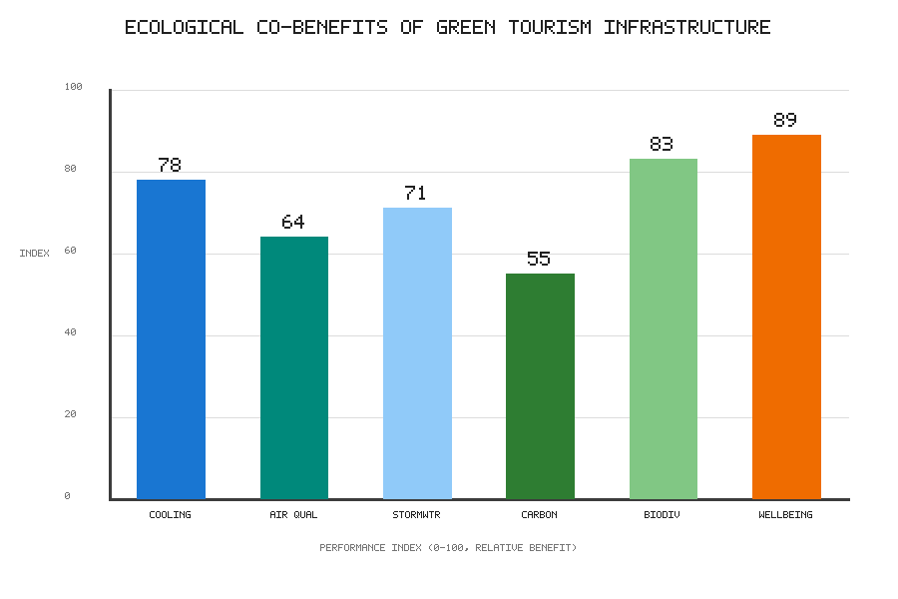
Figure 1. Relative ecological and experiential co-benefits of green tourism infrastructure (indicative performance index, 0–100).
Biodiversity conservation and habitat connectivity are foundational functions of the urban tourism landscape. Well-designed tourism landscapes can serve as refugia and stepping stones for urban wildlife, supporting pollinators, birds, and small mammals whose presence enriches the visitor experience while sustaining the ecological processes on which the wider environment depends [11]. Connectivity is decisive in this regard: isolated patches of habitat support far less biodiversity than networks linked by corridors that permit movement, foraging, and genetic exchange between populations [12]. Tourism greenways, when designed with ecological continuity in mind, can simultaneously guide visitors and function as wildlife conduits, demonstrating the multifunctionality that defines successful bio-integration and yielding a return on space that single-purpose infrastructure cannot match.
Urban cooling, air purification, and stormwater management address some of the most pressing environmental challenges facing tourism cities today. Vegetation cools the urban environment through shading and evapotranspiration, mitigating the heat island effect that can render destinations uncomfortable or even dangerous during the heat waves that climate change is making more frequent and intense [13]. Trees and other plants filter airborne particulates and gaseous pollutants, improving the air quality that visitors and residents alike breathe. Permeable, vegetated surfaces absorb and slow stormwater, reducing flood risk and easing pressure on drainage systems during the intense rainfall events that are becoming more common [13]. These regulating services directly protect the physical assets and experiential qualities on which tourism depends, and their value rises as climatic extremes intensify.
Carbon sequestration and climate resilience represent the longer-horizon ecological contributions of tourism landscapes. Urban vegetation and healthy soils capture and store carbon, allowing destinations to offset a portion of tourism's emissions within their own boundaries and to contribute, however modestly, to global mitigation efforts [14]. More broadly, the diversity and redundancy embedded in well-functioning green infrastructure confer resilience, enabling destinations to absorb shocks—droughts, storms, heat waves, and disease outbreaks—and to recover more rapidly than places dependent on brittle, single-function systems [14]. The relative strength of these services is not uniform, however, and the pattern shown in Figure 1 underscores that well-being and biodiversity benefits can rival or exceed the more commonly cited regulating services, a finding with direct implications for how destinations prioritise investment. Table 1 presents a structured comparison of these principal ecosystem services alongside their tourism relevance and representative performance indicators, providing a reference framework that destinations can adapt to their own contexts and monitoring capacities.
Table 1. Ecological functions of urban tourism landscapes and their representative indicators.
Ecological Function | Primary Mechanism | Tourism Relevance | Representative Indicator
Biodiversity conservation | Habitat provision and connectivity | Enriches wildlife encounters and sense of place | Species richness; habitat connectivity index
Urban cooling | Shading and evapotranspiration | Protects visitor comfort during heat waves | Air temperature reduction (degrees C)
Air purification | Filtration of particulates and gases | Improves air quality of the visitor environment | Particulate concentration (micrograms per cubic metre)
Stormwater management | Infiltration and retention | Reduces flood disruption to attractions | Runoff volume reduction (percentage)
Carbon sequestration | Uptake by vegetation and soils | Offsets a share of destination emissions | Carbon stored (tonnes per hectare)
Climate resilience | Diversity and redundancy | Sustains operations through shocks | Recovery time after disturbance

It is worth emphasising that these ecological functions are mutually reinforcing rather than independent. A single well-designed intervention—say, a restored urban stream lined with native vegetation—can simultaneously cool its surroundings, filter pollutants, store carbon, manage stormwater, provide habitat, and offer a restorative setting for visitors. This bundling of benefits is precisely what makes bio-integrated approaches economically attractive: the cost of the intervention is justified not by any single function but by the sum of many, and the value delivered compounds as the living system matures. Conventional grey infrastructure, by contrast, typically performs a single function and depreciates from the moment of installation. Recognising and accounting for this bundled, appreciating value is one of the most important shifts in thinking that bio-integrated tourism demands of planners, investors, and destination managers alike.

1.4 Human–Nature Interaction in Urban Tourism
The ultimate purpose of bio-integrated urban tourism is to enrich the reciprocal relationship between people and nature within the destination. Human–nature interaction is not a peripheral outcome but a central design objective, shaping both the quality of visitor experiences and the depth of environmental stewardship that tourism can cultivate over time [15]. Attending to this relationship deliberately, rather than leaving it to chance, distinguishes bio-integrated destinations from those that merely happen to contain green space.
Biophilic experiences and visitor well-being draw on the well-established human affinity for living systems, an affinity rooted in evolutionary history and expressed across cultures. Exposure to nature reduces stress, restores attention, improves mood, and enhances the sense of restoration that travellers actively seek when they leave the routines of daily life [15]. Destinations that maximise opportunities for meaningful contact with vegetation, water, natural light, and wildlife therefore deliver superior visitor satisfaction while simultaneously contributing to public health. Biophilic design principles—prospect and refuge, sensory variability, natural analogues, and connection with natural systems—provide a practical vocabulary for translating this affinity into the physical form of streets, buildings, and public spaces, ensuring that the restorative potential of nature is realised rather than merely gestured toward [16].
Nature-based recreation and environmental awareness link enjoyment with learning in a way that few other tourism experiences achieve. Activities such as walking, cycling, birdwatching, and paddling immerse visitors in living landscapes and foster the direct, embodied experiences that build ecological literacy and care [17]. Interpretive design, citizen-science opportunities, and well-crafted narratives can transform a pleasant outing into a formative encounter that reshapes attitudes and behaviours long after the visit ends, extending the influence of the destination far beyond its boundaries. In this way, bio-integrated tourism becomes a vehicle for cultivating the environmental constituency on which broader sustainability transitions ultimately depend, quietly building public support for the protection of nature.
Designing inclusive and accessible green tourism spaces ensures that the benefits of urban nature are equitably distributed rather than captured by the privileged few. Too often, high-quality green space is concentrated in affluent districts, reproducing patterns of environmental injustice and excluding the very communities that might benefit most from access to nature [17]. Bio-integrated tourism, if it is to be genuinely regenerative, must extend access across age, ability, income, and cultural background, through universal design, multilingual interpretation, affordable or free access, and meaningful engagement with local communities [18]. Inclusivity is not merely an ethical imperative but a practical strategy for building the broad-based support that sustains green infrastructure over the long term, since spaces that serve everyone are more likely to be valued, defended, and maintained by the whole community.

2. Design Strategies for Bio-Integrated Tourism Infrastructure

2.1 Nature-Based Solutions for Tourism Development
Nature-based solutions (NbS) harness the capacities of living systems to address societal challenges while simultaneously benefiting biodiversity and human well-being. In tourism development, NbS offer a means of providing the functional infrastructure a destination requires—drainage, cooling, water treatment, erosion control—through ecological rather than purely engineered means, yielding co-benefits that conventional grey infrastructure cannot match [19]. This dual character, delivering both function and ecological value from the same investment, makes NbS especially well suited to the multifunctional ambitions of bio-integrated tourism.
Wetlands, rain gardens, and bioswales exemplify the nature-based approach in tangible form. Constructed and restored wetlands treat wastewater and stormwater biologically, creating rich habitats and attractive landscape features that can themselves become tourism assets and interpretive opportunities [19]. Rain gardens and bioswales—shallow, vegetated depressions that capture and filter runoff—integrate seamlessly into streetscapes, car parks, and plazas, managing water at its source while greening the visitor environment and reducing the burden on downstream systems. These features demonstrate how essential infrastructure can be delivered in forms that are simultaneously ecological, functional, and experientially rewarding, dissolving the traditional distinction between utility and amenity.
Natural drainage and water-sensitive urban design reconceive the way destinations handle water across the entire site rather than at isolated points. Rather than channelling rainfall rapidly into pipes and away from the destination, water-sensitive design slows, spreads, and infiltrates it through a distributed network of permeable surfaces, swales, retention basins, and vegetated channels [20]. This reduces flood risk, recharges groundwater, sustains vegetation through dry periods, and creates dynamic waterscapes that respond visibly to weather—an increasingly valued dimension of place experience. For tourism destinations facing more erratic precipitation under a changing climate, water-sensitive design functions simultaneously as an adaptation strategy and as an amenity that deepens the visitor's connection to natural cycles.
Ecosystem-based approaches to tourism infrastructure situate individual interventions within a coherent understanding of the wider ecosystem and its dynamics. Rather than optimising each element in isolation, this approach considers how coastal dunes, urban forests, wetlands, and green corridors function together to provide protection, regulation, and habitat at the landscape scale [21]. For tourism, ecosystem-based planning helps ensure that development enhances rather than degrades the natural capital on which the destination's appeal ultimately rests, aligning short-term investment with long-term resilience. It also encourages collaboration across administrative and property boundaries, since ecosystems rarely respect the lines drawn on planning maps, and their management therefore demands cooperation among many actors.
A recurring lesson from the practice of nature-based solutions is that their success depends heavily on the quality of design, establishment, and ongoing stewardship rather than on the choice of technology alone. A constructed wetland that is poorly sized, badly planted, or left unmaintained will fail to deliver its promised benefits and may become a liability, whereas the same intervention, carefully executed and properly cared for, can outperform its engineered alternative for decades while improving over time. This sensitivity to execution has important implications for the tourism sector, which is not always equipped with the ecological expertise that nature-based solutions require. Bridging this capability gap—through training, partnership with ecologists and landscape architects, and the development of clear maintenance protocols—is therefore a practical prerequisite for scaling nature-based solutions across tourism destinations rather than confining them to a handful of showcase projects.

2.2 Biophilic Architecture and Urban Tourism Spaces
Biophilic architecture brings the principles of human–nature connection directly into the buildings and spaces that host tourism. It treats vegetation, water, light, and natural materials not as decorative finishes applied to a completed structure but as integral, functional components of the architecture itself, shaping how buildings perform environmentally and how they feel to inhabit [22]. This integration marks a decisive advance over conventional sustainable building, which often reduces environmental performance to technical efficiency alone.
The integration of vegetation, daylight, water, and natural materials transforms the interior and immediate exterior environments of tourism buildings in profound ways. Planted atria, courtyards, and terraces bring living systems into daily contact with guests; generous daylighting reduces energy demand while improving well-being and circadian health; water features cool and humidify the air and provide restorative sensory experiences; and natural materials such as timber and stone connect occupants to place and season [22]. Together these elements create environments that feel restorative and distinctive, differentiating a destination in a crowded and competitive market while simultaneously reducing its operational footprint—a rare alignment of commercial and environmental interest that bio-integrated design deliberately cultivates.
Living façades and adaptive building envelopes extend biophilic performance to the building skin, the interface between interior comfort and external climate. Vegetated façades insulate, shade, and cool while supporting biodiversity and sequestering carbon, and adaptive envelopes—responsive shading, operable openings, and dynamic glazing—allow buildings to modulate their relationship with the external climate in real time rather than relying on energy-intensive mechanical systems [23]. For hotels and visitor centres, such envelopes reduce energy consumption and enhance comfort while signalling environmental intent to guests and passers-by alike, turning the building's very surface into a demonstration of the values the destination espouses.
Design principles for hotels, resorts, and visitor centres bring these ideas together into building typologies that anchor the tourism experience and set the tone for the wider destination. A bio-integrated hotel might combine a green roof for amenity and stormwater management, a living façade for cooling and biodiversity, daylit and naturally ventilated interiors, on-site water reuse, and interpretive features that make its environmental systems legible to curious guests [24]. Visitor centres, as the interpretive heart of many destinations, are especially powerful sites for demonstrating bio-integration, modelling the practices they seek to promote and turning the building itself into an educational exhibit that teaches through experience rather than instruction alone. Such buildings function as both infrastructure and pedagogy, embodying the message they convey.

2.3 Green Mobility and Connected Tourism Networks
The way visitors move through a destination profoundly shapes its environmental footprint and the quality of the experience it offers. Green mobility reorients tourism transport away from private, high-emission vehicles toward active, shared, and low-carbon modes, weaving movement into the green infrastructure network itself so that travelling between attractions becomes part of the experience rather than a burden to be endured [25]. This reorientation addresses one of the largest and most stubborn sources of tourism's environmental impact.
Walking and cycling infrastructure forms the foundation of green mobility and the most direct expression of its principles. Well-designed pedestrian networks and protected cycle routes allow visitors to explore at a human pace, encountering the sensory richness of the destination directly while producing no emissions and imposing minimal ecological burden [25]. When these routes are aligned with green corridors and waterfronts, movement becomes an experience in its own right, dispersing visitors across the destination and relieving pressure on congested hotspots that suffer when everyone converges on the same few sites. Figure 2 situates green mobility within the broader framework linking living systems, computational innovation, and governance, showing how mobility choices ripple through the wider system of the destination.
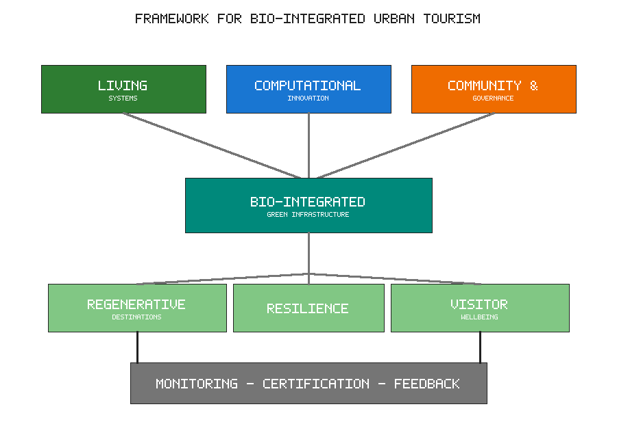
Figure 2. Conceptual framework for bio-integrated urban tourism linking inputs, core infrastructure, outcomes, and feedback.
Electric and low-carbon public transportation addresses the longer trips and accessibility needs that active modes alone cannot serve, extending the reach of car-free tourism to those who cannot or prefer not to walk and cycle. Electric buses, trams, shuttles, and shared micromobility connect arrival points, accommodation, and attractions without the emissions and congestion of private vehicles, and they make the destination accessible to a broader range of visitors [26]. Integrated ticketing, real-time information, and seamless interchange between modes make low-carbon travel convenient and attractive, which is essential if it is to displace car use in practice rather than merely in principle; convenience, more than exhortation, determines how people actually choose to move.
Green corridors connecting tourism destinations operate at the metropolitan and regional scale, linking individual sites into coherent networks that transcend the boundaries of any single locality. These corridors combine ecological connectivity with recreational routes, enabling wildlife movement and long-distance walking and cycling while stitching together the destination's attractions into a legible and navigable whole [27]. By coupling mobility with habitat, green corridors embody the multifunctionality central to bio-integration and extend its benefits beyond individual sites to the wider urban region, demonstrating that the principles of bio-integrated tourism apply at every scale from the building to the metropolis. The integrated framework in Figure 2 makes clear that mobility, living systems, and governance are not separate concerns but interdependent facets of a single system, and that decisions taken in one domain reverberate through the others in ways that reward coordinated planning and penalise fragmentation.

2.4 Circular and Regenerative Tourism Infrastructure
Circular and regenerative infrastructure closes the loops of energy, water, and materials that conventional tourism leaves open, transforming waste streams into resources and aligning the physical fabric of the destination with the regenerative ambition articulated at the outset of this chapter [28]. Where the linear model takes, makes, and discards, the circular model retains value within the system, reducing both the demand for virgin inputs and the burden of waste.
Renewable energy integration decarbonises the operation of tourism infrastructure and reduces its exposure to volatile fossil-fuel markets. On-site generation through building-integrated photovoltaics, solar thermal systems, and, where appropriate, wind and geothermal resources reduces reliance on imported energy while offering opportunities for interpretation and guest engagement [28]. Coupled with storage and smart demand management, renewable systems can render tourism facilities largely self-sufficient in energy, insulating them from price volatility and supply disruption while advancing climate goals and demonstrating environmental leadership to guests who increasingly notice and value such commitments.
Water reuse and waste-to-resource systems tackle the substantial water and waste footprints that tourism generates, particularly in the water-stressed regions where many popular destinations are located. Greywater recycling, rainwater harvesting, and the treatment and reuse of wastewater dramatically reduce demand on municipal supplies and protect the receiving waters that are often themselves tourism assets [29]. Organic waste can be composted or digested to produce soil amendments and biogas, while thoughtful design and procurement minimise the generation of waste in the first place. These systems turn what were once liabilities and disposal costs into productive inputs, embodying circular principles at the scale of the destination and reducing its dependence on external resource flows.
Low-carbon materials and circular construction practices address the significant embodied emissions of tourism development, a dimension often overlooked when attention focuses solely on operational energy. Selecting materials with low embodied carbon—timber from sustainably managed forests, recycled content, and locally produced elements—reduces the climate cost of building before a single guest arrives [29]. Designing for disassembly, adaptability, and reuse extends the useful life of structures and components, keeping materials in circulation and avoiding the waste and emissions of premature demolition that a rapidly changing tourism market can otherwise provoke. Table 2 summarises the principal design strategies discussed in this section together with their environmental and experiential benefits, offering a concise reference for practitioners weighing options.
Table 2. Design strategies for bio-integrated tourism infrastructure and their benefits.
Design Strategy | Example Interventions | Environmental Benefit | Experiential Benefit
Nature-based solutions | Wetlands, rain gardens, bioswales | Water treatment, flood control, habitat | Dynamic waterscapes and interpretation
Biophilic architecture | Green roofs, living facades, atria | Energy savings, cooling, biodiversity | Restorative, distinctive interiors
Green mobility | Walking, cycling, electric transit | Emission and congestion reduction | Human-paced, immersive exploration
Circular systems | Water reuse, renewables, low-carbon materials | Reduced resource demand and waste | Visible sustainability leadership

3. Computational Innovation and Smart Green Infrastructure

3.1 Digital Twins for Bio-Integrated Urban Tourism
Computational innovation is rapidly expanding the capacity to design, monitor, and manage bio-integrated tourism infrastructure with precision and foresight that were previously unattainable. Among these tools, digital twins occupy a central position, offering dynamic virtual replicas of the physical destination that can be interrogated, tested, and optimised in ways that the physical world alone does not permit [30]. The digital twin thus becomes a laboratory in which the future of the destination can be rehearsed before it is built.
Virtual modelling of tourism landscapes creates a computational representation of the destination's physical form, ecological systems, and human activity within a single coherent environment. A digital twin integrates spatial data, sensor feeds, and simulation models to mirror the living state of the destination, allowing managers to visualise conditions, understand interactions, and anticipate change across systems that are ordinarily studied in isolation [30]. For bio-integrated tourism, such models can represent the growth of vegetation, the movement of water, the flow of visitors, and the performance of building systems together, revealing the interdependencies that determine whether an intervention succeeds or fails.
Real-time monitoring of environmental performance transforms the digital twin from a static model into a living dashboard that reflects the current state of the destination moment by moment. Continuous streams of data on temperature, humidity, air and water quality, soil moisture, energy use, and visitor numbers allow the twin to reflect present conditions and to flag deviations from expected performance before they become serious [31]. This visibility enables proactive management—adjusting irrigation, redirecting visitor flows, or fine-tuning building systems—before small problems escalate into failures or ecological harm, shifting management from a reactive to an anticipatory posture.
Scenario simulation for sustainable urban development leverages the digital twin to explore possible futures without committing resources to untested interventions. By altering parameters—adding vegetation, changing mobility patterns, or imposing projected climate stresses—planners can test the consequences of interventions in silico, comparing options against ecological, experiential, and economic criteria and identifying unintended consequences early [31]. This capacity to rehearse the future reduces the risk of costly mistakes and supports the adaptive, evidence-based decision-making that regenerative destinations require if they are to navigate an uncertain and rapidly changing environment.

3.2 Artificial Intelligence and Data-Driven Ecological Design
Artificial intelligence amplifies the value of the data generated across bio-integrated tourism infrastructure, extracting patterns, generating predictions, and optimising decisions at a scale and speed far beyond human capacity [32]. As destinations become more densely instrumented, the volume of data they generate exceeds what human analysts can process, making machine intelligence not a luxury but a practical necessity for turning data into insight.
AI-based optimisation of green infrastructure applies machine learning to the complex, multi-objective problem of configuring living systems for maximum benefit. Algorithms can identify where planting will most effectively cool the urban environment, which species combinations will best support biodiversity, or how irrigation should be scheduled to conserve water while sustaining vegetation through dry periods [32]. By navigating trade-offs that would overwhelm manual analysis, AI helps destinations extract greater ecological and experiential value from finite land, water, and financial resources, improving outcomes without necessarily increasing expenditure.
Predictive analysis of visitor flows and environmental impacts anticipates the pressures that tourism places on living systems before those pressures cause harm. Machine learning models trained on historical and real-time data can forecast visitor numbers, identify emerging congestion, and predict the ecological consequences of use, enabling managers to intervene proactively rather than after the damage is done [33]. Such foresight is essential for protecting sensitive habitats, maintaining experience quality, and keeping visitation within the carrying capacity of the destination, particularly at times of peak demand when the risk of degradation is greatest.
Intelligent management of energy, water, and biodiversity closes the loop between sensing, prediction, and action, allowing the destination to respond automatically to changing conditions. AI-driven control systems can optimise building energy use in response to occupancy and weather, modulate water systems to match supply and demand, and inform biodiversity management through automated species identification and habitat assessment drawn from cameras and acoustic sensors [33]. Integrated across the destination, these capabilities move bio-integrated tourism toward a state of continuous, intelligent self-regulation in which the living infrastructure is managed with a responsiveness that manual oversight could never achieve.
The deployment of artificial intelligence in this domain is not without its risks and responsibilities, however. Algorithmic systems can encode and amplify the biases present in their training data, and decisions about where to invest, whom to prioritise, and what to optimise carry ethical weight that cannot be delegated wholly to machines. Predictive models that steer visitors away from certain neighbourhoods, for example, may inadvertently concentrate economic benefit or environmental burden in ways that entrench existing inequalities. Bio-integrated tourism therefore requires that computational systems be designed and governed transparently, with human oversight, clear accountability, and attention to the distributional consequences of automated decisions. The goal is not to replace human judgement but to augment it, freeing planners and managers from routine analysis so that they can concentrate on the value-laden choices that technology cannot and should not make on their behalf.

3.3 Internet of Things and Environmental Monitoring
The Internet of Things (IoT) provides the sensory nervous system of smart green infrastructure, instrumenting the physical environment so that its condition can be continuously observed and managed rather than sampled occasionally. Figure 3 illustrates how ecological benefits scale with greening intensity, a relationship that dense IoT monitoring makes measurable and manageable in practice rather than leaving it a matter of assumption [34].
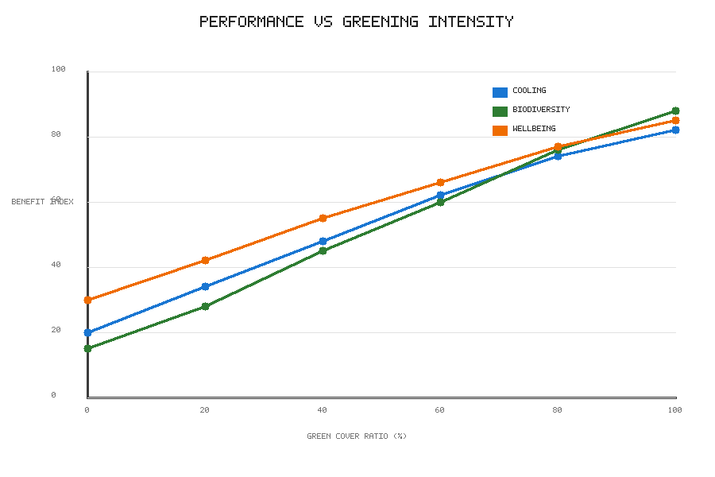
Figure 3. Modelled relationship between urban green cover ratio and cooling, biodiversity, and well-being benefit indices.
IoT sensors for air, water, soil, and microclimate monitoring generate the granular, real-time data on which intelligent management ultimately depends. Distributed networks of low-cost sensors track temperature, humidity, particulate levels, water quality, soil moisture, and more, producing a detailed and continuous picture of environmental conditions across the entire destination rather than at a handful of monitoring stations [34]. This dense observation reveals patterns and problems invisible to periodic manual survey—localised heat islands, pockets of poor air quality, early signs of vegetation stress—supporting both day-to-day management and long-term learning about how the destination behaves.
Smart irrigation and vegetation management apply IoT data directly to the care of living systems, aligning ecological performance with resource efficiency. Soil-moisture and weather sensors allow irrigation to be delivered precisely when and where it is needed, conserving water while maintaining plant health, and vegetation monitoring can detect stress, disease, or decline early enough for effective and inexpensive intervention [35]. This precision is especially valuable in the water-constrained contexts that many destinations now face, where the profligate irrigation of the past is no longer tenable and every litre must be justified.
Real-time ecological and tourism data platforms integrate diverse data streams into coherent, accessible interfaces for managers, planners, and sometimes visitors themselves. By combining environmental sensing with visitor and operational data, these platforms provide a unified view of the destination's living state, supporting coordinated decisions across departments and transparent reporting to stakeholders and the public [35]. When shared appropriately, such data can also engage visitors in the environmental story of the destination, turning passive tourists into informed participants and deepening the awareness and stewardship that bio-integrated tourism seeks to cultivate.

3.4 Geographic Information Systems and Spatial Planning
Geographic information systems (GIS) provide the spatial intelligence that underpins the planning and management of bio-integrated tourism, situating ecological and tourism data within a common geographic framework where their relationships become visible and analysable [36]. Because tourism and ecology are both fundamentally spatial phenomena, this geographic grounding is indispensable to sound decision-making.
Mapping urban ecological assets and tourism resources creates the foundational spatial knowledge base for bio-integration, without which coordinated action is impossible. GIS enables the systematic inventory of green and blue infrastructure, habitats, attractions, and mobility networks, revealing their distribution, condition, and relationships across the destination [36]. This spatial understanding is essential for identifying opportunities, diagnosing deficiencies, and coordinating interventions so that they reinforce rather than undermine one another, replacing fragmented and duplicative efforts with a coherent strategy grounded in evidence.
Spatial analysis of green accessibility examines how equitably the benefits of urban nature are distributed across the destination and its communities, giving analytical substance to the commitment to inclusion. GIS-based accessibility analysis can identify areas underserved by quality green space, expose patterns of environmental injustice, and guide the targeting of new investment toward the places and populations that need it most [37]. This analytical capacity operationalises the commitment to inclusive, equitable green tourism articulated earlier in the chapter, converting a principle into a map that can direct resources to where they will do the most good.
GIS-supported climate-risk and carrying-capacity assessment brings spatial analysis to bear on the central challenges of resilience and ecological limits. By overlaying hazard data—flood zones, heat exposure, sea-level rise—with the location of tourism assets, GIS helps destinations identify vulnerabilities and prioritise adaptation investments where they are most urgently required [37]. Carrying-capacity analysis, likewise, uses spatial data to define how much visitation different areas can sustain without ecological or experiential degradation, providing an evidence base for managing tourism within limits rather than exceeding them unknowingly. Table 3 summarises the principal computational technologies discussed in this section together with their functions and their specific contributions to bio-integrated tourism.
Table 3. Computational technologies for smart green infrastructure in tourism.
Technology | Core Function | Contribution to Bio-Integration | Key Data Inputs
Digital twins | Virtual replication and simulation | Scenario testing before physical change | Spatial models, sensor feeds
Artificial intelligence | Pattern detection and optimisation | Multi-objective configuration of green assets | Historical and real-time datasets
Internet of Things | Distributed environmental sensing | Continuous monitoring of living systems | Air, water, soil, microclimate readings
Geographic information systems | Spatial analysis and mapping | Equity, risk and carrying-capacity assessment | Ecological, hazard and tourism layers

4. Future Directions, Governance, and Sustainable Urban Tourism

4.1 Community Participation and Inclusive Green Tourism
The long-term success of bio-integrated urban tourism depends as much on social processes as on physical and technological design. Communities are not merely affected by tourism development; they are essential co-creators and custodians of the living infrastructure on which regenerative destinations depend, and their engagement determines whether that infrastructure thrives or decays over the decades that matter [38]. No amount of technical sophistication can substitute for the sustained care that only invested communities provide.
Participatory planning and local stakeholder engagement embed community knowledge and aspiration into the design and governance of green infrastructure from the earliest stages. Genuine participation—extending beyond token consultation to shared decision-making and shared power—produces interventions that are better attuned to local needs, more widely supported, and more durable over time [38]. For bio-integrated tourism, engaging residents, businesses, and civil society ensures that green infrastructure serves the community as well as the visitor, avoiding the displacement, resentment, and eventual neglect that top-down development so often provokes when it treats local people as obstacles rather than partners.
Community-based tourism initiatives place local people at the centre of the tourism economy, ensuring that the benefits of visitation are widely shared and that development reflects community values rather than external priorities. When residents lead the design and delivery of experiences, tourism becomes a vehicle for local empowerment, cultural continuity, and environmental stewardship, generating a virtuous circle in which economic benefit reinforces the will to protect the living landscape [39]. Such initiatives strengthen the reciprocal relationship between visitors, hosts, and the environment that defines regenerative practice, and they help ensure that the wealth tourism generates remains within the community rather than leaking away to distant owners.
Equity, accessibility, and social inclusion in green spaces address the persistent risk that the benefits of bio-integrated tourism accrue unevenly, entrenching rather than reducing existing inequalities. Deliberate attention to affordability, physical accessibility, cultural relevance, and the fair distribution of green investment is required to ensure that regenerative tourism advances rather than undermines social justice [39]. Inclusive green tourism recognises that ecological and social regeneration are inseparable, and that a destination cannot be truly resilient if its benefits are confined to a privileged few while its burdens fall on the marginalised; genuine regeneration must lift the whole community if it is to endure.

4.2 Governance and Policy for Bio-Integrated Tourism
Realising bio-integrated urban tourism at scale requires supportive governance and policy frameworks that align incentives, coordinate diverse actors, and safeguard the public interest against short-term pressures [40]. Individual projects, however exemplary, cannot transform a destination on their own; systemic change demands an enabling environment created and sustained through public policy.
Urban planning regulations and environmental policies shape the conditions within which bio-integrated tourism can flourish or founder. Zoning, building codes, green-space standards, and environmental protections can either enable or obstruct the integration of living systems into tourism infrastructure, depending on how they are designed and enforced [40]. Progressive frameworks embed requirements for green roofs, permeable surfaces, tree canopy, and biodiversity directly into the development process, ensuring that bio-integration becomes the default expectation rather than an optional extra pursued only by the most committed developers.
Public–private partnerships for green infrastructure mobilise the resources and capabilities of multiple actors toward shared regenerative goals that none could achieve alone. Because green infrastructure delivers benefits that span public and private domains—private profit alongside public ecological and social value—its financing and management often require collaboration between government, business, and community organisations [40]. Well-structured partnerships can align private investment with public benefit, sharing risk and reward equitably while ensuring that ecological outcomes are protected through binding commitments rather than left to good intentions that may not survive changing commercial circumstances.
Monitoring, certification, and sustainability standards provide the accountability that distinguishes genuine bio-integration from superficial claims and marketing spin. Credible measurement, transparent reporting, and independent certification allow destinations to demonstrate real performance, guide continuous improvement, and earn the trust of increasingly discerning travellers who have learned to be sceptical of unsubstantiated environmental claims [41]. Robust standards also create a level playing field, rewarding authentic practice and deterring the greenwashing that erodes public confidence in sustainable tourism and undermines the efforts of those genuinely committed to regeneration.
Governance for bio-integrated tourism must also grapple with the tension between the long time horizons of ecological systems and the short cycles of political and commercial decision-making. Trees take decades to mature, wetlands years to establish, and the resilience conferred by biodiversity accrues only over the long run, yet the electoral cycles, investment horizons, and management tenures that shape tourism decisions are typically far shorter. Effective governance therefore requires mechanisms that protect long-term ecological commitments from short-term pressures: endowments and dedicated funds that secure maintenance budgets, statutory protections that outlast individual administrations, and institutional arrangements that give ecological stewardship a durable voice in decision-making. Without such mechanisms, even well-designed green infrastructure risks being neglected, built over, or allowed to decline once the initial enthusiasm and funding fade, squandering the investment and forfeiting the benefits that patience would have delivered.

4.3 Measuring Ecological and Tourism Performance
Measurement is the connective tissue of regenerative tourism, translating aspiration into evidence and enabling the continuous learning on which improvement ultimately depends [41]. Without rigorous measurement, claims of regeneration remain unverifiable and the field cannot distinguish genuine progress from wishful thinking. Table 4 presents an integrated set of performance indicators spanning ecological, experiential, and socioeconomic dimensions, offering destinations a template for holistic assessment.
Table 4. Integrated performance indicators for bio-integrated urban tourism.
Dimension | Indicator | What It Measures | Data Source
Ecological | Biodiversity and habitat connectivity | Health of living systems | Ecological surveys and sensors
Ecological | Carbon and water balance | Net-positive resource performance | Metering and life-cycle accounting
Experiential | Visitor satisfaction and well-being | Quality of restorative experience | Surveys and sentiment analysis
Social | Community quality of life and equity | Fair distribution of benefits | Resident surveys and access mapping
Economic | Local economic value retained | Viability and community benefit | Financial and employment data

Biodiversity, carbon, water, and resource-efficiency indicators quantify the ecological performance of bio-integrated tourism in terms that can be tracked over time and compared across destinations. Metrics such as species richness, habitat connectivity, carbon sequestered, water reused, and materials diverted from landfill make the environmental contributions of the destination visible, comparable, and defensible [41]. These indicators anchor the net-positive claims at the heart of regeneration, allowing destinations to demonstrate with evidence rather than assertion that they are leaving places measurably healthier than they found them.
Visitor satisfaction and quality-of-life assessment capture the experiential and social dimensions of performance that purely environmental metrics overlook. Surveys, sentiment analysis, and well-being measures reveal whether the destination is delivering the restorative, meaningful experiences that visitors seek and whether residents' quality of life is enhanced rather than eroded by the presence of tourism [42]. Aligning ecological and experiential measurement ensures that regeneration serves people as well as the planet, and it guards against the error of pursuing environmental gains at the expense of the human communities whose support the whole enterprise requires.
Environmental, social, and economic performance metrics integrate these dimensions into a holistic account of the destination's overall contribution to sustainable development. By considering ecological health, social equity, and economic viability together rather than in isolation, integrated metrics support the balanced decision-making that regenerative tourism demands, revealing the synergies and trade-offs that single-dimension measures inevitably obscure [42]. This integrated perspective is essential for steering destinations toward genuinely sustainable and regenerative outcomes, and for resisting the temptation to optimise one dimension at the hidden expense of another.

4.4 Future Trends in Bio-Integrated Urban Tourism
Looking ahead, several converging trends promise to deepen and accelerate the bio-integration of urban tourism, pointing toward destinations that are not merely sustainable but actively regenerative and, ultimately, climate-positive. Figure 3 hinted at the growing returns available as greening intensity increases, and the trends discussed here suggest that those returns will become both larger and more attainable as technology, policy, and practice mature together.
Regenerative cities and climate-positive tourism represent the horizon toward which bio-integration points. In a regenerative city, tourism becomes one of many mutually reinforcing activities that contribute to net-positive ecological and social outcomes, drawing down carbon, restoring biodiversity, and enhancing well-being rather than depleting the very qualities that attract visitors [43]. Climate-positive tourism—removing more greenhouse gases than it emits across its full life cycle—moves from distant aspiration toward practical reality as renewable energy, carbon sequestration, and circular systems mature and combine into coherent destination strategies.
Autonomous and adaptive ecological infrastructure envisions living systems and their supporting technologies that increasingly manage themselves with minimal human intervention. Advances in sensing, artificial intelligence, and automation point toward infrastructure that continuously monitors its own condition, anticipates change, and adapts accordingly, sustaining ecological performance even under the shifting and uncertain conditions that climate change imposes [43]. Such adaptive capacity, illustrated conceptually in the layered technology stack of Figure 4, will be essential as destinations confront accelerating environmental change that outpaces the capacity of periodic, manual management to respond.
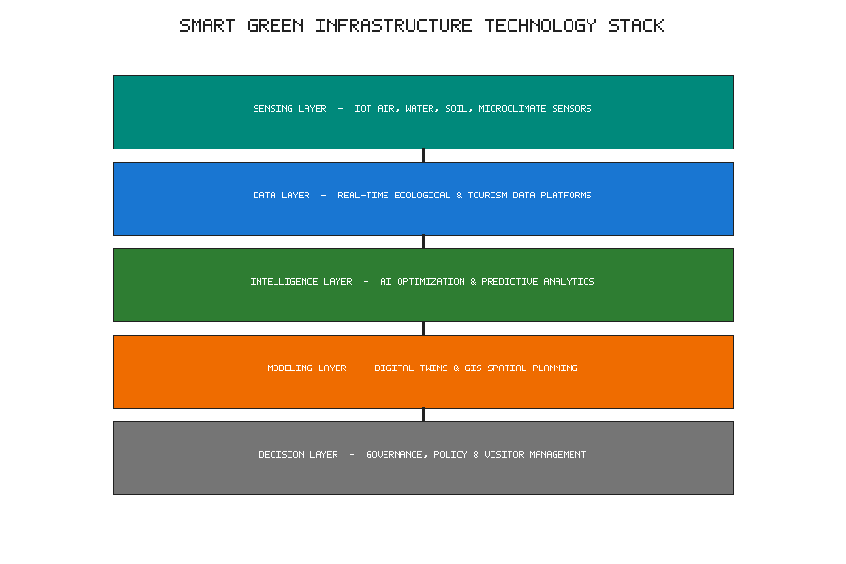
Figure 4. Layered technology stack for smart green infrastructure, from sensing through data, intelligence, and modelling to decision-making.
A further trend worth noting is the growing convergence between the physical and digital dimensions of the tourism experience. Immersive technologies—augmented and virtual reality, location-based digital storytelling, and interactive interpretation—offer new ways to reveal the invisible ecological workings of a destination to visitors, making the flow of water through a bioswale, the carbon captured by an urban forest, or the biodiversity supported by a green roof tangible and engaging. Used thoughtfully, these tools can deepen the environmental literacy that bio-integrated tourism seeks to cultivate, extending the reach of interpretation beyond what physical signage alone can achieve and allowing visitors to grasp processes that unfold too slowly or too subtly to perceive directly. Used carelessly, however, they risk substituting mediated representations for authentic contact with living systems, diluting the very connection they are meant to strengthen. The discerning integration of the digital and the living—amplifying rather than replacing direct experience—will be a defining design challenge for the next generation of nature-positive destinations.
Emerging technologies for resilient, nature-positive tourism destinations—from advanced low-carbon materials and biotechnology to immersive digital experiences and distributed energy systems—will continue to expand the possibilities for bio-integration in ways that are difficult to foresee fully. The layered integration of sensing, data, intelligence, modelling, and decision-making depicted in Figure 4 suggests how these technologies can be orchestrated in service of living systems rather than in competition with them. The central challenge and opportunity for the field lie in harnessing innovation so that it deepens rather than displaces the connection between people and nature that lies at the heart of bio-integrated urban tourism, ensuring that technology remains a means to ecological and human flourishing rather than an end in itself.
Overall, the transition toward bio-integrated urban tourism requires a balanced approach in which ecological function, design excellence, computational capability, inclusive governance, and community stewardship develop together rather than in isolation from one another. A data-driven, evidence-based framework can provide destinations with a structured mechanism for identifying gaps, prioritising investments, evaluating progress, and developing responsible regenerative strategies suited to their particular circumstances. Living systems and the communities that depend on them should remain at the centre of this transformation, so that tourism becomes an enabler of biodiversity, resilience, well-being, and climate-positive development rather than simply another layer of consumption imposed upon an already stressed urban landscape.

References
[1] Beatley, T. (2021). Biophilic Cities and Healthy Societies: Nature and Urban Well-Being. Island Press.
[2] Bellato, L., Frantzeskaki, N., & Nygaard, C. A. (2023). Regenerative tourism: A conceptual framework leveraging theory and practice. Tourism Geographies, 25(4), 1026–1046.
[3] Ahern, J. (2018). Green infrastructure for cities: The spatial dimension of urban resilience. Landscape and Urban Planning, 176, 1–9.
[4] Kellert, S. R. (2018). Nature by Design: The Practice of Biophilic Design. Yale University Press.
[5] Scott, D., Hall, C. M., & Gössling, S. (2019). Global tourism vulnerability to climate change. Annals of Tourism Research, 77, 49–61.
[6] UNEP (2021). Nature-Based Solutions for Climate, Biodiversity and People. United Nations Environment Programme.
[7] Benedict, M. A., & McMahon, E. T. (2019). Green Infrastructure: Linking Landscapes and Communities. Island Press.
[8] Nowak, D. J., & Greenfield, E. J. (2018). Urban forest structure and ecosystem services. Urban Forestry & Urban Greening, 32, 55–63.
[9] Berardi, U., GhaffarianHoseini, A., & GhaffarianHoseini, A. (2019). State-of-the-art analysis of green roof performance. Applied Energy, 236, 1156–1173.
[10] Voskamp, I. M., & Van de Ven, F. H. M. (2020). Planning support for blue-green infrastructure. Building and Environment, 168, 106503.
[11] Costanza, R., de Groot, R., & Braat, L. (2017). Twenty years of ecosystem services: How far have we come? Ecosystem Services, 28, 1–16.
[12] Beninde, J., Veith, M., & Hochkirch, A. (2015). Biodiversity in cities needs space. Ecology Letters, 18(6), 581–592.
[13] Bowler, D. E., Buyung-Ali, L., & Knight, T. M. (2010). Urban greening to cool towns and cities. Landscape and Urban Planning, 97(3), 147–155.
[14] Nowak, D. J., Greenfield, E. J., & Hoehn, R. E. (2013). Carbon storage and sequestration by trees. Environmental Pollution, 178, 229–236.
[15] Ives, C. D., Giusti, M., & Fischer, J. (2017). Human–nature connection: A multidisciplinary review. Current Opinion in Environmental Sustainability, 26, 106–113.
[16] Browning, W. D., & Ryan, C. O. (2020). Nature Inside: A Biophilic Design Guide. RIBA Publishing.
[17] Wolf, I. D., & Wohlfart, T. (2014). Walking, hiking and recreation in protected areas. Landscape and Urban Planning, 130, 89–103.
[18] Jennings, V., & Bamkole, O. (2019). Social cohesion and urban green space. International Journal of Environmental Research and Public Health, 16(3), 452.
[19] Cohen-Shacham, E., Walters, G., & Maginnis, S. (2016). Nature-Based Solutions to Address Global Societal Challenges. IUCN.
[20] Fletcher, T. D., Shuster, W., & Hunt, W. F. (2015). SUDS, LID, BMPs, WSUD and more. Urban Water Journal, 12(7), 525–542.
[21] Nesshöver, C., Assmuth, T., & Wittmer, H. (2017). The science, policy and practice of nature-based solutions. Science of the Total Environment, 579, 1215–1227.
[22] Söderlund, J., & Newman, P. (2015). Biophilic architecture: A review of the rationale and outcomes. AIMS Environmental Science, 2(4), 950–969.
[23] Perez, G., Coma, J., & Cabeza, L. F. (2017). Vertical greenery systems for energy savings in buildings. Renewable and Sustainable Energy Reviews, 39, 139–165.
[24] Legrand, W., Sloan, P., & Chen, J. S. (2022). Sustainability in the Hospitality Industry. Routledge.
[25] Banister, D. (2018). The sustainable mobility paradigm. Transport Policy, 15(2), 73–80.
[26] Le Pira, M., Marcucci, E., & Gatta, V. (2021). Sustainable urban mobility and tourism. Research in Transportation Economics, 86, 100986.
[27] Lindsey, G., Wilson, J., & Yang, J. (2018). Urban greenways, trail networks and connectivity. Journal of Urban Planning and Development, 144(2), 04018010.
[28] Ellen MacArthur Foundation (2019). Cities and the Circular Economy. Ellen MacArthur Foundation.
[29] Gude, V. G. (2017). Desalination and water reuse for sustainability. Journal of Cleaner Production, 148, 100–117.
[30] Batty, M. (2018). Digital twins. Environment and Planning B, 45(5), 817–820.
[31] Deng, T., Zhang, K., & Shen, Z. J. M. (2021). A systematic review of a digital twin city. Journal of Management Science and Engineering, 6(2), 125–134.
[32] Yigitcanlar, T., Desouza, K. C., & Butler, L. (2020). Artificial intelligence technologies and cities. Energies, 13(6), 1473.
[33] Sun, S., Wei, Y., & Tsui, K. L. (2019). Forecasting tourist arrivals with machine learning. Tourism Management, 70, 1–10.
[34] Zanella, A., Bui, N., & Castellani, A. (2014). Internet of Things for smart cities. IEEE Internet of Things Journal, 1(1), 22–32.
[35] Gupta, A., Nahar, P., & Bhardwaj, A. (2021). IoT-based smart irrigation systems. Computers and Electronics in Agriculture, 187, 106279.
[36] Longley, P. A., Goodchild, M. F., & Maguire, D. J. (2015). Geographic Information Science and Systems. Wiley.
[37] Xing, L., Liu, Y., & Liu, X. (2018). Measuring spatial disparity in accessibility to green space. Applied Geography, 94, 251–261.
[38] Tosun, C. (2020). Community participation in the tourism development process. Tourism Management, 21(6), 613–633.
[39] Giampiccoli, A., & Saayman, M. (2018). Community-based tourism development. Tourism Review International, 22(1), 15–29.
[40] Bulkeley, H., & Betsill, M. M. (2013). Revisiting the urban politics of climate change. Environmental Politics, 22(1), 136–154.
[41] Font, X., & McCabe, S. (2017). Sustainability and marketing in tourism. Journal of Sustainable Tourism, 25(7), 869–883.
[42] Uysal, M., Sirgy, M. J., & Woo, E. (2016). Quality of life and well-being in tourism. Tourism Management, 53, 244–261.
[43] Girardet, H. (2020). Creating Regenerative Cities. Routledge.

