AI-POWERED DIGITAL MARKETING FOR SUSTAINABILITY
Book: AI-Driven Sustainable Marketing: Transforming Consumers, Brands, and Society
Chapter ID: ADSM-2
Author(s): [Full Name], [Department, Institution, City, Country], [Email Address], ORCID: [0000-0000-0000-0000]

Abstract
[Abstract to be written by the author (150–200 words).]
Keywords: Artificial intelligence; sustainable marketing; green consumer behaviour; hyper-personalization; greenwashing; responsible AI; circular economy

1. Foundations of AI and Sustainable Marketing

1.1 The Convergence of AI, Digital Marketing, and Sustainability
Marketing now operates against a backdrop of measurable ecological strain. The Intergovernmental Panel on Climate Change reports that global surface temperature in 2011–2020 was about 1.1 °C above pre-industrial levels, and that household consumption and the production systems serving it are among the main drivers of this warming [1]. The 2030 Agenda for Sustainable Development made "responsible consumption and production" a stand-alone goal (SDG 12), which places marketers, whose job is to shape what people buy and how they use it, inside the policy problem rather than beside it [2]. Consumer attitudes have moved in the same direction. Surveys repeatedly show that many people say they prefer environmentally and socially responsible brands, yet purchase data reveal a persistent gap between these stated intentions and actual behaviour [3]. Closing that attitude–behaviour gap is one of the central practical problems of sustainable marketing.
Artificial intelligence has entered this space at the same time. In marketing, AI refers to computational systems that learn from data to perform tasks such as forecasting demand, segmenting customers, generating content, setting prices, and choosing which message to show to which person at which moment [4]. Huang and Rust distinguish three levels of marketing AI: mechanical AI for automating repetitive tasks, thinking AI for analysing data and making decisions, and feeling AI for recognising and responding to emotion [5]. Each level offers something to sustainability. Mechanical AI can automate the tracking of product-level environmental data, thinking AI can detect which customers are ready to switch to lower-impact alternatives, and feeling AI can tailor the tone of sustainability messages so that they persuade rather than lecture.
The idea that marketing should account for its environmental consequences is not new. Peattie and Crane trace green marketing from the "ecological marketing" of the 1970s, which concentrated on pollution-intensive industries, through the environmental marketing boom of the late 1980s, to a period of consumer scepticism caused by vague and exaggerated claims [6]. Belz and Peattie later argued for "sustainability marketing", a broader approach that combines the customer orientation of relationship marketing with ecological and social criteria across the whole product life cycle [7]. Kotler made a similar point when he called on the discipline to reinvent itself around the environmental imperative, accepting that unlimited growth in material consumption cannot continue on a finite planet [8]. These works share a diagnosis: sustainable marketing has struggled to scale because it lacked reliable data on impacts, cost-effective ways to reach and persuade different consumer groups, and credible methods for proving that its claims are true.
AI addresses some of these gaps directly. A large review of AI and the Sustainable Development Goals found that AI could act as an enabler for 134 of the 169 SDG targets, while also inhibiting 59 of them, often through increased resource use or widening inequality [9]. Nishant, Kennedy, and Corbett reach a similar conclusion for organisations: AI can improve resource efficiency and environmental monitoring, but its benefits depend on governance, data quality, and the purpose to which it is put [10]. For marketing, this dual potential is the main theme of the chapter. The same recommendation engine that steers a shopper towards a durable product can also push them into buying more than they need. The same language model that writes a clear explanation of a product's carbon footprint can also produce convincing greenwash at scale.
Four concepts recur throughout the chapter. AI-powered marketing means the use of machine learning, natural language processing, computer vision, and related methods to plan, execute, and measure marketing activity. Sustainability is understood in the sense of the 2030 Agenda, covering environmental, social, and economic dimensions [2]. Green consumerism refers to purchase and use decisions in which environmental considerations play an explicit role [3]. Responsible AI refers to the design and governance of AI systems so that they are fair, transparent, accountable, and aligned with human and environmental well-being. The rest of Section 1 builds the theoretical tools needed to evaluate how these concepts interact.

1.2 Theoretical Frameworks for Sustainable Digital Marketing
Several established theories explain why consumers do or do not act sustainably, and each suggests a different role for AI. The theory of planned behaviour holds that intention, and therefore behaviour, is shaped by attitudes, subjective norms, and perceived behavioural control [11]. In a digital setting, AI systems can influence all three: content can strengthen attitudes, social-proof features can make norms visible, and tools such as carbon calculators or repair finders can increase perceived control. Stern's value–belief–norm theory adds a moral layer, proposing that pro-environmental behaviour follows from personal values, beliefs about environmental consequences, and a felt obligation to act [12]. This implies that personalisation should aim to activate existing values rather than simply offer discounts, because behaviour driven by values tends to last longer than behaviour bought with incentives.
White, Habib, and Hardisty synthesise this literature in the SHIFT framework, which identifies five psychological levers for sustainable behaviour change: Social influence, Habit formation, the Individual self, Feelings and cognition, and Tangibility [3]. SHIFT is especially useful for AI-driven marketing because each lever corresponds to a capability that AI systems already possess. Social influence maps to network analytics and social-norm messaging, habit formation to well-timed reminders and defaults, the individual self to identity-based personalisation, feelings and cognition to sentiment-aware content, and tangibility to visualisations that make abstract impacts such as carbon emissions concrete.
At the organisational level, stakeholder theory argues that firms create value for, and are accountable to, all groups that affect or are affected by them, not only shareholders [13]. For AI-driven marketing this widens the set of interests that an algorithm's objective function should reflect. Elkington's triple bottom line expresses the same idea in performance terms by asking firms to report on people, planet, and profit [14]. The circular economy goes further by redesigning value chains so that products, components, and materials stay in use for as long as possible; Geissdoerfer and colleagues describe it as a regenerative system in which resource input, waste, emissions, and energy leakage are minimised by slowing, closing, and narrowing material loops [15]. Marketing has a specific role here, since resale, rental, repair, and take-back services all depend on persuading consumers to adopt unfamiliar ways of owning and using products.
Marketing ethics and AI ethics provide the final layer. Floridi and colleagues propose five principles for a good AI society: beneficence, non-maleficence, autonomy, justice, and explicability [16]. Hermann applies a similar ethical lens to marketing and argues that AI can serve social good when it is used to empower consumers and benefit society, but becomes problematic when it exploits vulnerabilities or reduces autonomy [17]. These principles are directly relevant to sustainability marketing, which often justifies persuasive techniques by pointing to the worthiness of the goal. An ethical framework helps marketers separate legitimate persuasion (clear information, honest framing, helpful defaults) from manipulation (dark patterns, exploitation of guilt, opaque targeting). Table 1 summarises the main frameworks and their implications for AI-driven marketing.
Table 1. Theoretical Frameworks and Their Implications for AI-Driven Sustainable Marketing
Framework | Core proposition | Implication for AI-driven marketing
Theory of planned behaviour [11] | Attitudes, norms, and perceived control shape intention | AI content, social proof, and decision tools can act on each antecedent
Value–belief–norm theory [12] | Values and felt moral obligation drive pro-environmental action | Personalisation should activate existing values rather than rely only on price incentives
SHIFT framework [3] | Social, habit, self, feelings, and tangibility levers change behaviour | Each lever maps to an AI capability, from norm messaging to impact visualisation
Stakeholder theory [13] | Firms create value for and answer to all affected groups | Algorithm objectives should reflect consumer, community, and environmental interests
Triple bottom line [14] | Performance covers people, planet, and profit | AI dashboards should report social and environmental metrics next to sales
Circular economy [15] | Slow, close, and narrow resource loops | AI can promote resale, repair, rental, and take-back services
AI ethics principles [16, 17] | Beneficence, non-maleficence, autonomy, justice, explicability | Persuasion must remain transparent and must not exploit consumer vulnerabilities
Building on these theories, this chapter proposes a conceptual model of responsible AI-driven sustainable marketing, shown in Figure 1. The model has four layers. The input layer consists of consumer, product life-cycle, and contextual data. The intelligence layer contains the AI capabilities discussed in Section 2. The engagement layer translates intelligence into marketing actions organised around the SHIFT levers [3]. The outcome layer measures results against the triple bottom line rather than against sales alone [14]. A governance band runs across all four layers and applies the ethical principles of transparency, accountability, fairness, and consumer autonomy [16]. Feedback loops connect outcomes back to inputs, so that environmental and social results, and not only conversions, are used to retrain models. The central claim of the model is that performance optimisation and ethical constraint should be designed together. When ethics is added only after a system has been optimised for clicks, the two goals tend to conflict; when sustainability metrics are part of the objective from the start, they can reinforce each other.
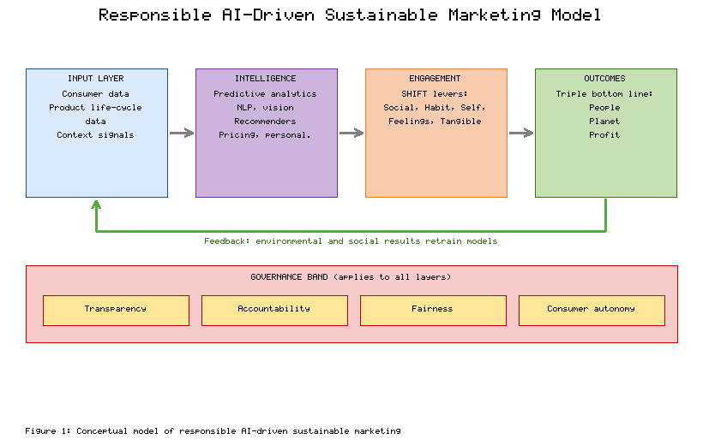
Figure 1. Conceptual Model of Responsible AI-Driven Sustainable Marketing

2. AI Technologies and Applications for Sustainable Marketing

2.1 Core AI Technologies Transforming Sustainable Marketing
Machine learning has become a standard part of the marketing toolkit, connecting large-scale computation with insight into human behaviour [18]. This subsection examines six families of technology that are particularly relevant to sustainability: predictive analytics, natural language processing (NLP), computer vision, recommender systems, dynamic pricing, and hyper-personalisation. Figure 2 shows how these technologies sit between data sources and sustainability outcomes, and Table 2 summarises their uses.
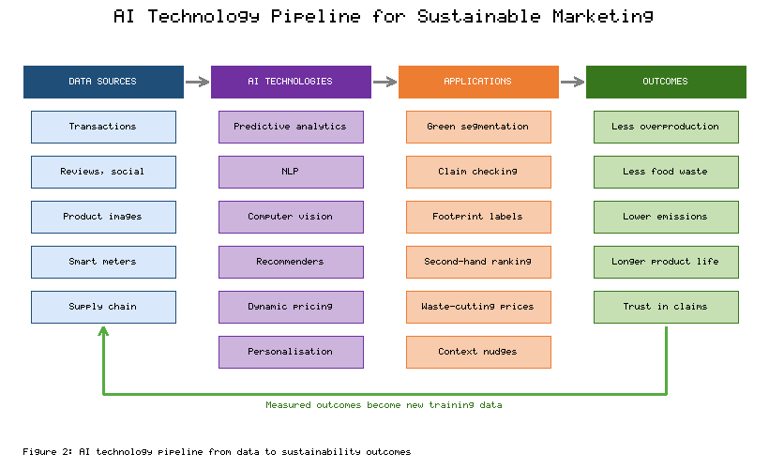
Figure 2. AI Technology Pipeline for Sustainable Marketing: From Data to Sustainability Outcomes
Predictive analytics. Supervised learning models trained on transaction histories, browsing behaviour, and survey data can estimate the probability that a customer will adopt an eco-friendly product, respond to a refill offer, or join a take-back scheme [18]. Such models let marketers concentrate budgets on consumers who are close to switching, which matters because the attitude–behaviour gap is not evenly distributed across a customer base [3]. On the supply side, more accurate demand forecasts reduce overproduction, which is a large and often hidden source of waste in sectors such as fashion and fresh food. Forecasting improvements therefore produce environmental gains even when consumer behaviour does not change at all.
Natural language processing. Text is the main medium of sustainability communication, appearing in product descriptions, reports, reviews, and social media posts. Berger and colleagues show how automated text analysis can extract insight from such content, from measuring sentiment to identifying the topics that drive engagement [19]. In sustainability marketing, NLP can track how consumers talk about issues such as plastic packaging or labour conditions, detect scepticism towards a brand's claims, and test which framings are clearest. NLP can also be applied to the brand's own output: classifiers can flag vague phrases such as "eco-friendly" or "natural" that lack supporting evidence, which helps compliance teams find potential greenwashing before publication.
Computer vision. Image recognition models can identify products, materials, and packaging from photographs. Rolnick and colleagues review many climate applications of machine learning, including the estimation of emissions and the monitoring of resource use from imagery and sensor data [20]. For marketers, computer vision makes it possible to attach life-cycle information to a product when a shopper scans it with a phone camera, to sort returned garments for resale or recycling, and to measure food waste in commercial kitchens by photographing discarded items. These applications turn sustainability data that once required manual audits into information that can be shown at the point of decision.
Recommender systems. Recommendation engines decide much of what consumers see in e-commerce and media platforms [21]. Most are trained to maximise clicks or conversions, but their objective functions can be extended to include sustainability criteria such as a product's carbon intensity, durability, or repairability. A multi-objective recommender might, for example, rank a second-hand item next to its new equivalent, or suggest a smaller pack size to a household whose purchase history indicates that food is often thrown away. Clustering methods applied to the same data can identify segments of eco-conscious consumers with different motives, such as health, thrift, or ethics, so that each group receives messages that match its reasons for caring [3].
Dynamic pricing. Algorithmic pricing adjusts prices in response to demand, inventory, and product condition. Buisman, Haijema, and Bloemhof-Ruwaard show that discounting perishable food according to its remaining shelf life can reduce retail food waste while maintaining profit [22]. The same logic can be used to make sustainable options more attractive at the moment of choice, for example through lower prices for refill packs, rewards for returning used products, or price signals that move energy use to periods when renewable supply is high. Dynamic pricing raises fairness concerns, however, which are discussed in Section 3.
Hyper-personalisation. Kumar and colleagues describe how AI enables personalised engagement marketing, in which content, offers, and timing are tailored to the individual in real time [23]. For sustainability, hyper-personalisation makes messages context-aware: a reminder to bring a reusable bag can be triggered on arrival at a store, or energy-saving tips can be timed to a heat wave. Behavioural economics adds guidance on choice architecture. Thaler and Sunstein show that defaults and framing influence decisions without restricting options [24], and Schultz and colleagues demonstrate that descriptive social-norm messages can produce a "boomerang" effect among people who already behave well unless they are paired with injunctive messages of approval [25]. Personalisation allows marketers to avoid this boomerang by sending different norm messages to people who consume more and less than average.
Table 2. Core AI Technologies and Their Applications in Sustainable Marketing
AI technology | Typical data inputs | Sustainability marketing application | Primary SHIFT lever
Predictive analytics [18] | Transactions, browsing, survey data | Identify consumers likely to adopt green products; reduce overproduction through better forecasts | Habit formation
Natural language processing [19] | Reviews, social posts, product copy | Monitor sentiment on sustainability issues; flag unsupported environmental claims | Feelings and cognition
Computer vision [20] | Product images, waste images, satellite data | Point-of-sale footprint labels; sorting of returns for resale; food-waste measurement | Tangibility
Recommender systems [21] | Interaction histories, product attributes | Multi-objective ranking that includes carbon, durability, and second-hand options | Individual self
Dynamic pricing [22] | Inventory, shelf life, demand signals | Discounts on near-expiry food; incentives for refills and returns | Habit formation
Hyper-personalisation [23, 25] | Context, location, real-time behaviour | Context-aware reminders and tailored social-norm feedback | Social influence
Taken together, these technologies change sustainability marketing in three ways. First, they make environmental impact visible at the moment of decision, which addresses the tangibility problem identified in the SHIFT framework [3]. Second, they allow messages to be matched to consumer motives, which reduces the waste of one-size-fits-all campaigns. Third, they connect marketing to operations, so that demand forecasting, pricing, and reverse logistics become part of the sustainability effort. The pipeline in Figure 2 reflects this integration: the value of AI lies less in any single algorithm than in linking data, models, and actions into a system that learns from its environmental results.

2.2 Sector-Specific Case Studies and Best Practices
Fashion. The fashion industry is estimated to produce 8–10% of global carbon dioxide emissions and to consume around 79 trillion litres of water a year, much of it driven by rapid product turnover and low garment use [26]. AI-based demand forecasting is used by large apparel retailers to align production volumes with expected sales and so reduce unsold stock. On the consumer side, resale platforms use computer vision and NLP to photograph, describe, and price second-hand garments, lowering the cost of listing items that would otherwise be discarded. Virtual try-on and size-recommendation tools are promoted as a way to reduce returns, which carry transport emissions and often end in disposal. The main lesson from fashion is that the largest environmental gains come from using AI to reduce production and extend product life, not from promoting "conscious" collections whose impact is hard to verify.
Food. Food systems account for roughly a quarter of global greenhouse gas emissions, and Poore and Nemecek show that impacts vary by an order of magnitude between products and even between producers of the same product [27]. The United Nations Environment Programme estimates that 1.05 billion tonnes of food were wasted in 2022, about 19% of the food available to consumers, with households responsible for the largest share [28]. AI applications in this sector include computer vision systems that measure what commercial kitchens throw away, apps that use dynamic pricing to sell surplus food from shops and restaurants before closing time [22], and recipe recommenders that suggest dishes based on ingredients a household already has. Because the differences between products are so large, personalised nudges towards lower-impact food choices can produce meaningful reductions in emissions [27].
E-commerce. Online retail combines all six technologies from Section 2.1. Platforms can add sustainability filters, recommend refurbished items, offer consolidated "green delivery" slots, and display estimated footprints for shipping options. Recommendation engines are the critical lever because they shape which products are seen at all [21]. The best-performing implementations treat sustainability as one ranking criterion among several, so that greener options appear without hiding the rest of the range, and they publish the criteria used to award any sustainability badge.
Energy, transport, and tourism. Energy utilities offer some of the strongest evidence on AI-enabled behavioural marketing. Allcott's analysis of large-scale randomised trials of home energy reports, which compare each household's use with that of similar neighbours, found an average reduction in consumption of about 2% [29]. The effect is modest per household but large in aggregate, and it is produced by the social-norm mechanism that Schultz and colleagues identified [25]. Modern versions use machine learning to disaggregate smart-meter data into appliance-level advice and to time messages. In transport, navigation services suggest routes that use less fuel, and mobility apps compare the emissions of different travel modes. In tourism, booking platforms use recommender systems to highlight certified accommodation and lower-carbon travel options, although the credibility of such labels has drawn regulatory attention. Table 3 summarises the patterns observed across sectors.
Table 3. Sector-Specific AI Applications, Sustainability Outcomes, and Lessons Learned
Sector | Illustrative AI application | Targeted sustainability outcome | Key lesson
Fashion [26] | Demand forecasting; resale listing via vision and NLP; size recommendation | Less overproduction; longer garment life; fewer returns | Volume reduction and life extension matter more than "conscious" ranges
Food [27, 28] | Kitchen waste vision systems; surplus-food dynamic pricing; recipe recommenders | Lower food waste and lower dietary emissions | Large impact differences between products make personalised nudges effective
E-commerce [21] | Multi-objective recommenders; sustainability filters; green delivery slots | Visibility of low-impact and second-hand products | Publish badge criteria and keep the full range accessible
Energy [29] | Smart-meter analytics; peer-comparison home energy reports | Reduced household energy use | Small individual effects produce large aggregate savings
Transport and tourism | Eco-routing; emission comparisons; recommender ranking of certified stays | Lower travel emissions | Labels need independent verification to retain trust
Several best practices emerge from these cases. Successful programmes tie AI to a specific, measurable environmental outcome (kilograms of food saved, kilowatt-hours avoided) rather than to general brand perception. They integrate marketing with operations, since the largest gains often come from changes to production, pricing, and logistics. They test interventions experimentally, as the energy-report trials did, rather than assuming that a well-intended message works [29]. Finally, they are transparent about the data and criteria behind sustainability claims, which protects them against the risks examined in Section 3.

3. Challenges, Risks, and Ethical Considerations

3.1 The Double-Edged Sword: Risks and Limitations of AI in Sustainable Marketing
Every capability described in Section 2 has a corresponding risk. Figure 3 sets these out side by side: personalisation is paired with privacy loss, segmentation with bias, generative content with greenwashing, and analytical power with the energy footprint of computation. This subsection examines each risk in turn.
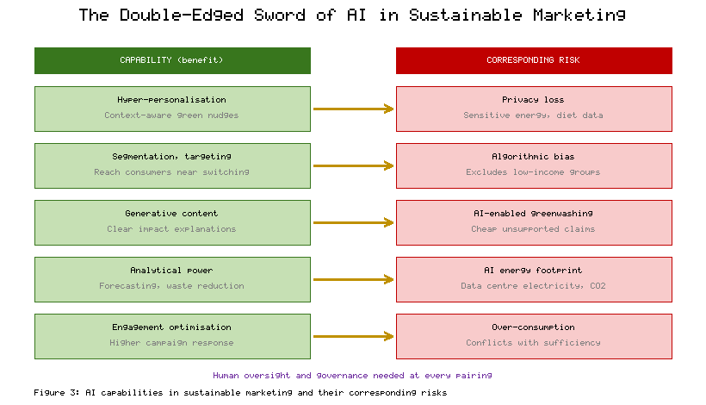
Figure 3. The Double-Edged Sword of AI in Sustainable Marketing: Capabilities and Corresponding Risks
Algorithmic bias. Machine learning systems can reproduce and amplify bias present in training data or introduced through design choices [30]. Bias does not require discriminatory intent. Lambrecht and Tucker found that an advertisement for careers in science and technology, which was intended to be gender-neutral, was shown to fewer women than men because the ad-delivery algorithm optimised for cost and young women were more expensive to reach [31]. Similar dynamics can affect sustainability marketing. If a model learns that affluent urban consumers respond best to green offers, it may stop showing discounts on energy-efficient appliances or electric mobility to lower-income or rural households, who would benefit most from lower running costs. Sustainable marketing that serves only the already-converted fails both the justice principle of AI ethics [16] and the social pillar of the triple bottom line [14].
Data privacy. Hyper-personalisation depends on detailed data about location, purchases, household energy use, and diet. Martin and Murphy show that privacy concerns reduce consumer trust and that perceived control over personal data affects how consumers respond to data-driven marketing [32]. Sustainability data can be especially sensitive: smart-meter readings can reveal when a home is empty, and food purchases can indicate health conditions or religious practice. Collecting such data in the name of environmental benefit does not remove the duty to obtain meaningful consent and to minimise collection. When sustainability is used as a justification for intrusive data practices, the result is likely to be backlash against both the brand and the cause.
AI-enabled greenwashing. Delmas and Burbano define greenwashing as the combination of poor environmental performance with positive communication about that performance [33]. Generative AI lowers the cost of producing persuasive sustainability content to almost zero, which makes it easier to generate large volumes of attractive but unsupported claims. AI-generated imagery of forests and oceans, automatically written "impact stories", and selective summaries of sustainability reports can all create an impression of responsibility that the underlying operations do not justify. Personalisation adds another layer, because claims can be tailored to the concerns of each audience segment, making inconsistencies harder for regulators and consumers to detect. Regulators have begun to respond to green claims that lack substantiation, and AI-generated content is not exempt from these rules.
The environmental footprint of AI. AI systems consume energy and hardware. Strubell, Ganesh, and McCallum estimated that training one large NLP model with neural architecture search could emit as much carbon dioxide as five cars over their lifetimes [34]. Luccioni, Viguier, and Ligozat measured the training of the 176-billion-parameter BLOOM language model at about 25 tonnes of CO₂-equivalent from dynamic power use, rising to about 50 tonnes when equipment manufacturing and idle consumption were included [35]. At the system level, the International Energy Agency estimates that data centres consumed around 415 TWh of electricity in 2024, about 1.5% of global demand, and projects that this will more than double to about 945 TWh by 2030, with AI the main driver of growth [36]. A sustainability campaign that relies on heavy model training, constant content generation, and real-time personalisation for millions of users therefore has its own footprint, which should be counted against the benefits it claims.
Limitations and the need for human oversight. AI models are only as reliable as the data behind them, and product-level environmental data are often incomplete, estimated, or supplied by parties with an interest in favourable numbers. Models optimised for engagement may also encourage more consumption, even of "green" products, which conflicts with the sufficiency principle that underlies much sustainability thinking [7]. These limitations call for human review of sustainability claims, of the objectives given to algorithms, and of the trade-offs between commercial and environmental goals. AI can support these judgements, but it cannot make them on behalf of the organisation.

3.2 Building Responsible AI Frameworks for Sustainable Marketing
A review of 84 AI ethics guidelines found convergence around five principles: transparency, justice and fairness, non-maleficence, responsibility, and privacy [37]. Translating these principles into marketing practice requires specific mechanisms at each stage of an AI system's life. Figure 4 presents a governance cycle for responsible AI in sustainable marketing with five stages: purpose and impact definition, data governance, model design and auditing, transparent deployment, and impact measurement with feedback.
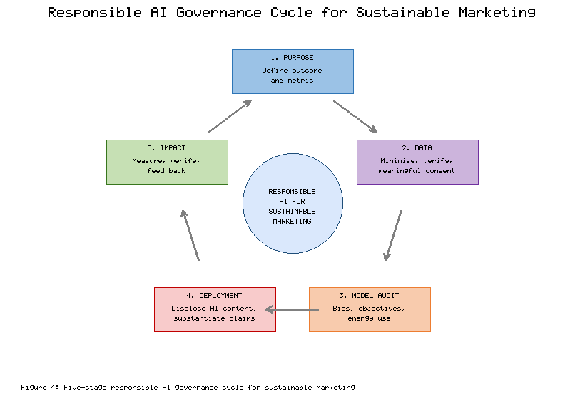
Figure 4. Responsible AI Governance Cycle for Sustainable Marketing
Purpose and impact definition. Each AI application should begin with an explicit statement of the sustainability outcome it is meant to achieve and the metric that will measure it. This prevents the common situation in which "sustainability" is used as a label for a system that is actually optimised only for sales. The statement should also list the stakeholders affected, in line with stakeholder theory [13].
Data governance. Organisations should collect only the data needed for the stated purpose, document where it came from, and verify any environmental data used in claims. Consumer consent mechanisms should explain in plain language what data are used for sustainability features and allow consumers to opt out of profiling without losing access to basic services [32]. Consent should be specific, and it should not be bundled into general terms of service.
Model design and auditing. Raji and colleagues propose an end-to-end framework for internal algorithmic auditing, with documented stages from scoping to post-audit review [38]. For sustainability marketing, audits should test whether targeting and pricing models treat demographic groups fairly [30], whether recommender objectives include environmental criteria as intended, and whether models trained for engagement push consumers towards over-consumption. Energy use of training and inference should be recorded so that the footprint discussed in Section 3.1 can be weighed against benefits [36].
Transparent deployment. Consumers should be able to see why a product carries a sustainability badge, what data support an environmental claim, and when they are interacting with AI-generated content. Regulation is moving in this direction. The European Union's Artificial Intelligence Act establishes a risk-based framework with transparency obligations, including duties to disclose certain AI-generated or manipulated content and a ban on AI practices that use manipulative or deceptive techniques to distort behaviour in ways that cause significant harm [39]. Directive (EU) 2024/825, on empowering consumers for the green transition, amends EU consumer law to prohibit generic environmental claims that cannot be substantiated and sustainability labels that are not based on a certification scheme or set by public authorities [40]. Marketers operating in or selling into the EU must therefore treat AI-generated sustainability claims with the same rigour as any other claim.
Impact measurement and feedback. The final stage closes the loop by measuring whether the intended sustainability outcome was achieved and feeding the results back into model objectives and data collection. Independent verification of results, through third-party assurance or published methodology, strengthens credibility.
Within this cycle, avoiding greenwashing requires a few concrete practices. Claims should be specific, quantified, and tied to verifiable data. Generative AI outputs that mention environmental attributes should pass both automated checks for vague or unsupported terms and human review by someone accountable for accuracy. Comparisons should state their baseline. Marketing should also communicate limitations honestly; admitting that a product is "lower impact" rather than "sustainable" often builds more trust than an absolute claim [33]. Authentic communication of this kind treats consumers as partners who can handle nuance, which is consistent with the principle of autonomy in AI ethics [16].

4. Future Directions and Practical Implementation

4.1 Emerging Trends and Future Research Directions
Generative AI is the most visible current trend. Dwivedi and colleagues describe both the productivity potential and the risks of conversational generative models across business, education, and research, including concerns about accuracy, bias, and accountability [41]. In sustainability marketing, generative models can produce product explanations tailored to each consumer's level of knowledge, answer questions about repair or recycling through conversational assistants, and generate many campaign variants for testing. The governance mechanisms in Section 3.2 apply with particular force here, because the cost of producing unsupported claims falls as generation becomes cheaper [33].
Blockchain and the Internet of Things (IoT) address the data problem that has limited sustainable marketing. Saberi and colleagues show how blockchain can improve traceability and transparency in sustainable supply chains by creating tamper-resistant records of provenance and handling [42]. Combined with IoT sensors that record conditions in production and transport, such systems can supply the verified data that AI needs to make credible claims. Digital product passports, which record a product's materials, origin, and repair information, could connect these technologies to the consumer, allowing a shopper to scan an item and see verified life-cycle data. AI can then turn these records into clear, personalised explanations, and support circular business models by matching used products with resale, repair, or recycling channels [15].
Several research directions follow from the analysis in this chapter. First, longitudinal studies are needed to test whether AI-driven nudges produce lasting behaviour change or only short-term effects; evidence from energy reports suggests that effects can persist when interventions continue, but this has rarely been tested for AI-personalised campaigns [29]. Second, cross-cultural comparisons are needed, because the importance of social norms, individual identity, and trust in technology varies across societies, and most existing evidence comes from North America and Europe [3]. Third, the field needs standardised metrics for sustainability marketing effectiveness that capture environmental outcomes, not only awareness or sales, and that account for the footprint of the AI systems themselves [36]. Fourth, researchers should study rebound effects, where efficiency gains or green purchases license additional consumption elsewhere. Finally, the effects of AI-generated sustainability content on consumer trust and scepticism remain largely untested.

4.2 Practical Recommendations for Stakeholders
The analysis above leads to specific recommendations for three groups of stakeholders, summarised in Table 4.
Marketers should start with an assessment of where AI can reduce the environmental impact of their products and customers, rather than where it can most easily produce sustainability content. A practical roadmap has four steps. The first is a baseline audit of the brand's current claims, data sources, and the life-cycle impacts of its main products. The second is the selection of one or two high-impact use cases, such as demand forecasting to cut overproduction or dynamic pricing to reduce waste [22]. The third is controlled experimentation with clear environmental and commercial metrics [29]. The fourth is scaling, accompanied by the governance cycle in Figure 4. Implementation checklists should confirm that each claim is substantiated, that targeting has been tested for bias, that consent is meaningful, and that the energy use of the AI system has been estimated.
Policymakers should aim for rules that encourage useful innovation while protecting consumers and the environment. Priorities include clear standards for substantiating environmental claims, including those produced by AI [40]; transparency duties for AI-generated content and for the criteria behind algorithmic sustainability rankings [39]; and requirements for large AI operators to report energy use and emissions so that the footprint of AI becomes visible [36]. Public investment in open, verified product-impact databases would help smaller firms, which cannot afford proprietary life-cycle assessments, compete on honest terms.
Technology developers should build systems in which sustainability is part of the design rather than an afterthought. Schwartz and colleagues argue for "Green AI", an approach that reports the computational cost of models alongside their accuracy and treats efficiency as an evaluation criterion [43]. Developers can apply this by choosing smaller models where they are sufficient, scheduling training when low-carbon electricity is available, and documenting energy use. They should also provide marketers with multi-objective tools that can optimise for environmental outcomes, with fairness testing and audit logging built in [38].
Table 4. Practical Recommendations for Key Stakeholders
Stakeholder | Strategic priority | Practical actions | Performance metrics
Marketers | Use AI where it reduces real impact | Baseline audit of claims and impacts; pilot high-impact use cases; experimental testing; governance checklist before scaling | Waste avoided; emissions per customer; claim substantiation rate; consumer trust scores
Policymakers | Encourage innovation while preventing harm | Claim-substantiation standards [40]; AI transparency duties [39]; energy reporting for AI [36]; open product-impact data | Share of verified claims; enforcement outcomes; availability of public impact data
Technology developers | Design AI for sustainability outcomes | Green AI efficiency reporting [43]; multi-objective optimisation; built-in fairness tests and audit logs [38] | Energy per training run and per query; fairness metrics; adoption of environmental objectives
Across all three groups, the common requirement is collaboration. Marketers depend on developers for tools that measure environmental outcomes and on policymakers for a level playing field in which honest claims are not undercut by cheap greenwash. Developers depend on marketers to specify sustainability objectives and on regulators for clear rules. Policymakers depend on both for data on what works. Collaboration of this kind, organised around shared environmental and social values, is the condition under which AI can strengthen sustainable relationships between brands and consumers.

5. Conclusion
[Conclusion to be written by the author.]

References
[1] Intergovernmental Panel on Climate Change. (2023). Climate change 2023: Synthesis report. Contribution of Working Groups I, II and III to the Sixth Assessment Report of the Intergovernmental Panel on Climate Change (Core Writing Team, H. Lee, & J. Romero, Eds.). IPCC. https://doi.org/10.59327/IPCC/AR6-9789291691647
[2] United Nations General Assembly. (2015). Transforming our world: The 2030 Agenda for Sustainable Development (A/RES/70/1). United Nations.
[3] White, K., Habib, R., & Hardisty, D. J. (2019). How to SHIFT consumer behaviors to be more sustainable: A literature review and guiding framework. Journal of Marketing, 83(3), 22–49. https://doi.org/10.1177/0022242919825649
[4] Davenport, T., Guha, A., Grewal, D., & Bressgott, T. (2020). How artificial intelligence will change the future of marketing. Journal of the Academy of Marketing Science, 48(1), 24–42. https://doi.org/10.1007/s11747-019-00696-0
[5] Huang, M.-H., & Rust, R. T. (2021). A strategic framework for artificial intelligence in marketing. Journal of the Academy of Marketing Science, 49(1), 30–50. https://doi.org/10.1007/s11747-020-00749-9
[6] Peattie, K., & Crane, A. (2005). Green marketing: Legend, myth, farce or prophesy? Qualitative Market Research, 8(4), 357–370. https://doi.org/10.1108/13522750510619733
[7] Belz, F.-M., & Peattie, K. (2012). Sustainability marketing: A global perspective (2nd ed.). Wiley.
[8] Kotler, P. (2011). Reinventing marketing to manage the environmental imperative. Journal of Marketing, 75(4), 132–135. https://doi.org/10.1509/jmkg.75.4.132
[9] Vinuesa, R., Azizpour, H., Leite, I., Balaam, M., Dignum, V., Domisch, S., Felländer, A., Langhans, S. D., Tegmark, M., & Fuso Nerini, F. (2020). The role of artificial intelligence in achieving the Sustainable Development Goals. Nature Communications, 11, Article 233. https://doi.org/10.1038/s41467-019-14108-y
[10] Nishant, R., Kennedy, M., & Corbett, J. (2020). Artificial intelligence for sustainability: Challenges, opportunities, and a research agenda. International Journal of Information Management, 53, Article 102104. https://doi.org/10.1016/j.ijinfomgt.2020.102104
[11] Ajzen, I. (1991). The theory of planned behavior. Organizational Behavior and Human Decision Processes, 50(2), 179–211. https://doi.org/10.1016/0749-5978(91)90020-T
[12] Stern, P. C. (2000). Toward a coherent theory of environmentally significant behavior. Journal of Social Issues, 56(3), 407–424. https://doi.org/10.1111/0022-4537.00175
[13] Freeman, R. E. (1984). Strategic management: A stakeholder approach. Pitman.
[14] Elkington, J. (1997). Cannibals with forks: The triple bottom line of 21st century business. Capstone.
[15] Geissdoerfer, M., Savaget, P., Bocken, N. M. P., & Hultink, E. J. (2017). The circular economy – A new sustainability paradigm? Journal of Cleaner Production, 143, 757–768. https://doi.org/10.1016/j.jclepro.2016.12.048
[16] Floridi, L., Cowls, J., Beltrametti, M., Chatila, R., Chazerand, P., Dignum, V., Luetge, C., Madelin, R., Pagallo, U., Rossi, F., Schafer, B., Valcke, P., & Vayena, E. (2018). AI4People—An ethical framework for a good AI society: Opportunities, risks, principles, and recommendations. Minds and Machines, 28(4), 689–707. https://doi.org/10.1007/s11023-018-9482-5
[17] Hermann, E. (2022). Leveraging artificial intelligence in marketing for social good—An ethical perspective. Journal of Business Ethics, 179(1), 43–61. https://doi.org/10.1007/s10551-021-04843-y
[18] Ma, L., & Sun, B. (2020). Machine learning and AI in marketing – Connecting computing power to human insights. International Journal of Research in Marketing, 37(3), 481–504. https://doi.org/10.1016/j.ijresmar.2020.04.005
[19] Berger, J., Humphreys, A., Ludwig, S., Moe, W. W., Netzer, O., & Schweidel, D. A. (2020). Uniting the tribes: Using text for marketing insight. Journal of Marketing, 84(1), 1–25. https://doi.org/10.1177/0022242919873106
[20] Rolnick, D., Donti, P. L., Kaack, L. H., Kochanski, K., Lacoste, A., Sankaran, K., Ross, A. S., Milojevic-Dupont, N., Jaques, N., Waldman-Brown, A., Luccioni, A. S., Maharaj, T., Sherwin, E. D., Mukkavilli, S. K., Kording, K. P., Gomes, C. P., Ng, A. Y., Hassabis, D., Platt, J. C., … Bengio, Y. (2022). Tackling climate change with machine learning. ACM Computing Surveys, 55(2), Article 42. https://doi.org/10.1145/3485128
[21] Ricci, F., Rokach, L., & Shapira, B. (Eds.). (2022). Recommender systems handbook (3rd ed.). Springer. https://doi.org/10.1007/978-1-0716-2197-4
[22] Buisman, M. E., Haijema, R., & Bloemhof-Ruwaard, J. M. (2019). Discounting and dynamic shelf life to reduce fresh food waste at retailers. International Journal of Production Economics, 209, 274–284. https://doi.org/10.1016/j.ijpe.2017.07.016
[23] Kumar, V., Rajan, B., Venkatesan, R., & Lecinski, J. (2019). Understanding the role of artificial intelligence in personalized engagement marketing. California Management Review, 61(4), 135–155. https://doi.org/10.1177/0008125619859317
[24] Thaler, R. H., & Sunstein, C. R. (2008). Nudge: Improving decisions about health, wealth, and happiness. Yale University Press.
[25] Schultz, P. W., Nolan, J. M., Cialdini, R. B., Goldstein, N. J., & Griskevicius, V. (2007). The constructive, destructive, and reconstructive power of social norms. Psychological Science, 18(5), 429–434. https://doi.org/10.1111/j.1467-9280.2007.01917.x
[26] Niinimäki, K., Peters, G., Dahlbo, H., Perry, P., Rissanen, T., & Gwilt, A. (2020). The environmental price of fast fashion. Nature Reviews Earth & Environment, 1(4), 189–200. https://doi.org/10.1038/s43017-020-0039-9
[27] Poore, J., & Nemecek, T. (2018). Reducing food's environmental impacts through producers and consumers. Science, 360(6392), 987–992. https://doi.org/10.1126/science.aaq0216
[28] United Nations Environment Programme. (2024). Food waste index report 2024. Think eat save: Tracking progress to halve global food waste. UNEP.
[29] Allcott, H. (2011). Social norms and energy conservation. Journal of Public Economics, 95(9–10), 1082–1095. https://doi.org/10.1016/j.jpubeco.2011.03.003
[30] Mehrabi, N., Morstatter, F., Saxena, N., Lerman, K., & Galstyan, A. (2021). A survey on bias and fairness in machine learning. ACM Computing Surveys, 54(6), Article 115. https://doi.org/10.1145/3457607
[31] Lambrecht, A., & Tucker, C. (2019). Algorithmic bias? An empirical study of apparent gender-based discrimination in the display of STEM career ads. Management Science, 65(7), 2966–2981. https://doi.org/10.1287/mnsc.2018.3093
[32] Martin, K. D., & Murphy, P. E. (2017). The role of data privacy in marketing. Journal of the Academy of Marketing Science, 45(2), 135–155. https://doi.org/10.1007/s11747-016-0495-4
[33] Delmas, M. A., & Burbano, V. C. (2011). The drivers of greenwashing. California Management Review, 54(1), 64–87. https://doi.org/10.1525/cmr.2011.54.1.64
[34] Strubell, E., Ganesh, A., & McCallum, A. (2019). Energy and policy considerations for deep learning in NLP. In Proceedings of the 57th Annual Meeting of the Association for Computational Linguistics (pp. 3645–3650). Association for Computational Linguistics. https://doi.org/10.18653/v1/P19-1355
[35] Luccioni, A. S., Viguier, S., & Ligozat, A.-L. (2023). Estimating the carbon footprint of BLOOM, a 176B parameter language model. Journal of Machine Learning Research, 24(253), 1–15.
[36] International Energy Agency. (2025). Energy and AI. IEA. https://www.iea.org/reports/energy-and-ai
[37] Jobin, A., Ienca, M., & Vayena, E. (2019). The global landscape of AI ethics guidelines. Nature Machine Intelligence, 1(9), 389–399. https://doi.org/10.1038/s42256-019-0088-2
[38] Raji, I. D., Smart, A., White, R. N., Mitchell, M., Gebru, T., Hutchinson, B., Smith-Loud, J., Theron, D., & Barnes, P. (2020). Closing the AI accountability gap: Defining an end-to-end framework for internal algorithmic auditing. In Proceedings of the 2020 Conference on Fairness, Accountability, and Transparency (pp. 33–44). Association for Computing Machinery. https://doi.org/10.1145/3351095.3372873
[39] European Parliament & Council of the European Union. (2024). Regulation (EU) 2024/1689 laying down harmonised rules on artificial intelligence (Artificial Intelligence Act). Official Journal of the European Union, L, 2024/1689.
[40] European Parliament & Council of the European Union. (2024). Directive (EU) 2024/825 amending Directives 2005/29/EC and 2011/83/EU as regards empowering consumers for the green transition through better protection against unfair practices and through better information. Official Journal of the European Union, L, 2024/825.
[41] Dwivedi, Y. K., Kshetri, N., Hughes, L., Slade, E. L., Jeyaraj, A., Kar, A. K., Baabdullah, A. M., Koohang, A., Raghavan, V., Ahuja, M., Albanna, H., Albashrawi, M. A., Al-Busaidi, A. S., Balakrishnan, J., Barlette, Y., Basu, S., Bose, I., Brooks, L., Buhalis, D., … Wright, R. (2023). "So what if ChatGPT wrote it?" Multidisciplinary perspectives on opportunities, challenges and implications of generative conversational AI for research, practice and policy. International Journal of Information Management, 71, Article 102642. https://doi.org/10.1016/j.ijinfomgt.2023.102642
[42] Saberi, S., Kouhizadeh, M., Sarkis, J., & Shen, L. (2019). Blockchain technology and its relationships to sustainable supply chain management. International Journal of Production Research, 57(7), 2117–2135. https://doi.org/10.1080/00207543.2018.1533261
[43] Schwartz, R., Dodge, J., Smith, N. A., & Etzioni, O. (2020). Green AI. Communications of the ACM, 63(12), 54–63. https://doi.org/10.1145/3381831

