Installing Nightingale and Its Music Fonts and Palettes

by David Gottlieb and Don Byrd — rev. early February 2022

To install the Nightingale application, just double-click its .zip file—normally called something like “Nightingale6p0PPC.app.zip” or “Nightingale6p0Intel.app.zip”—and drag it to the Application folder. Nightingale also requires one music fonts and it can take advantage two others. In addition, it needs special music-related characters for its tool palette and several dialogs; it gets those either from another font (versions before 6.0) or from BMP files (version 6). Follow the instructions below to install the font(s) and, for version 6, BMP files.

A Note on Nightingale File Formats

All versions of Nightingale for many years have had compatible files; their file format is version 'N105'. However, Nightingale 6—the first to run on Macs with Intel processors as well as those with PowerPC processors—uses file format version 'N106'. Running on a PowerPC, it opens 'N105' files and converts them to 'N106'. (Unfortunately, Nightingale 6 on Intel machines can't open 'N105' files.) NB: As of this writing, Nightingale 6 is in beta test, and the ‘N106’ format is not yet stable! That means that if you create or edit a file with Nightingale 6, it may not be usable with any future version of Nightingale, even the next beta.

If you want to use files in a format before 'N105', Nightingale 5.7 opens formats at least as far back as 'N102' and converts them to 'N105'. Note that Nightingale depends on information MacOS no longer maintains reliably to identify its files, so it may not recognize old files as Nightingale files at all! But it will attempt to open any file if you drop it on the Nightingale application icon (including in the dock).

Music Fonts

Nightingale supports three music fonts: Sonata (by Cleo Huggins, for Adobe Systems), the first PostScript music font; Briard (by Francis X. Mahoney), a font that, like Sonata, looks much like traditional engraved music; and BlueNotz (by Thomas Williams), a font that imitates the look of hand-copied lead sheets, jazz arrangements, etc. In addition, Nightingale's user interface before version 6.0 requires “user interface” fonts with a few specific music characters for use in palettes and so on. Nightingale 6.0 doesn't use those fonts. Instead, it gets the characters from BMP files; see the last section of this document for details.

Nightingale depends on the ancient “Carbon” Macintosh toolbox, which—due to limitations of the technology available at the time—uses separate “screen” (bitmap) fonts for drawing music on the screen. The fonts are distributed in the following files:

font | PostScript font file | screen font file
BlueNotz | BlueNotNG | BlueNotz-NG.bmap
Briard | Briar | Briard.bmap
Sonata | Sonat | Sonata.bmap
User interface | (none) | NightingaleUIFonts

However, note that the PostScript versions of BlueNotz and Sonata are proprietary and cannot be given away, so you may not have them. Nightingale assumes its user-interface font and the Sonata screen fonts are always available; the others are optional.
The picture below shows all of the files. It also shows where they belong: if “HD” is the name of your startup disk, HD/Library/Fonts.

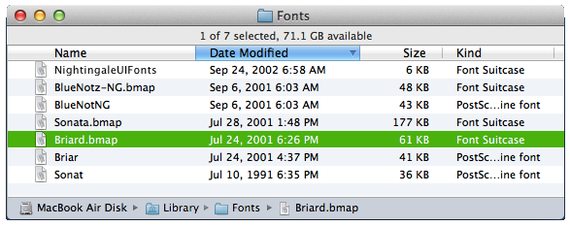

Apple’s Font Book application can check whether the fonts are properly installed. The next picture shows Font Book with Sonata selected, and the result of running its Validate Font command.

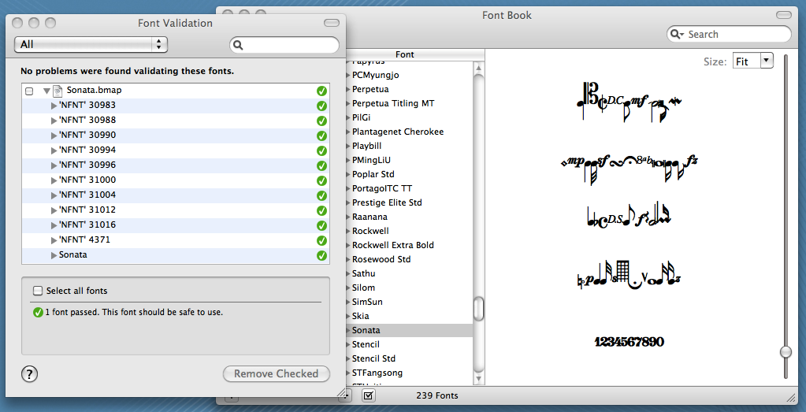

As we've said, Nightingale’s fonts should be in HD/Library/Fonts. If you're having problems, moving them out of that folder to the desktop and back may help. Make sure the fonts are enabled in Font Book. You should not have duplicate fonts in your system, and Font Book can help avoid that problem.

To launch Font Book, double click on the font in the Library/Fonts folder, or double click on Font Book itself. Double click on the name of the font in Font Book’s list. A new window should open, and it should say “installed” in the bottom of that window. Close that window. With the font still selected, use the Validate Font command in Font Book's File menu to check on the font. There is also a “resolve duplicates” command in its Edit menu. If a font is not installed, try dragging the font files (both screen and printer versions) from the Library/Fonts folder to the desktop and back. If that doesn't help, try restarting.

Screen fonts should be present in 7, 12, 14, 18, 24, 28, and 36 points. If they’re not, Nightingale should tell you, but in any case, it’ll do the best it can to display the music on the screen with the fonts that are available. PostScript printing isn’t affected by the presence or absence of particular screen-font sizes.

BMP files for Nightingale 6

Nightingale's tool palette and several dialogs require special music-related characters. Nightingale 6 gets these from four BMP files, namely:
• Duration_2dotsNB1b.bmp
• DynamicsNB1b.bmp
• NRModifierNB1b.bmp
• ToolPaletteNB1b.bmp

These are normally distributed with Nightingale itself in file BMPFileDistribution.zip .

Nightingale expects to find these files in /Library/Application Support . To get them there after unzipping BMPFileDistribution.zip, run the Terminal utility and enter these commands:
cd /Library/Application\ Support
open .

That will open a regular Finder window for the desired folder. Then just drag the .bmp files into it.

