Computer Vision HW#2

311605006 劉劭暐

Additional package:

pip install tqdm

pip install ipywidgets

1. SIFT

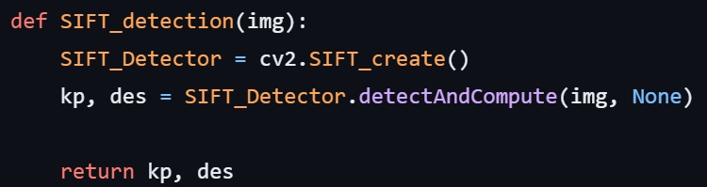

Call sift function of cv, obtain keypoints and descriptors

1. KNN feature matching

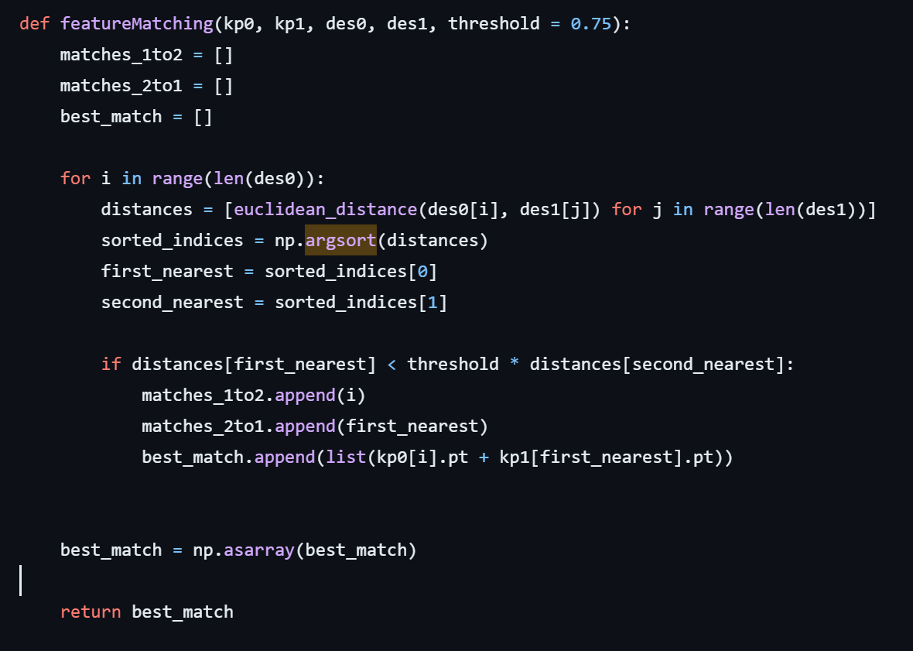

First I calculate the distance of descriptors between img1 and img2, then I sort them in ascending order. By this method, the first two index is the nearest img2 descriptors’ index of descriptor i.

After that we apply Lowe’s ratio test for eliminating bad match.

1. Homography

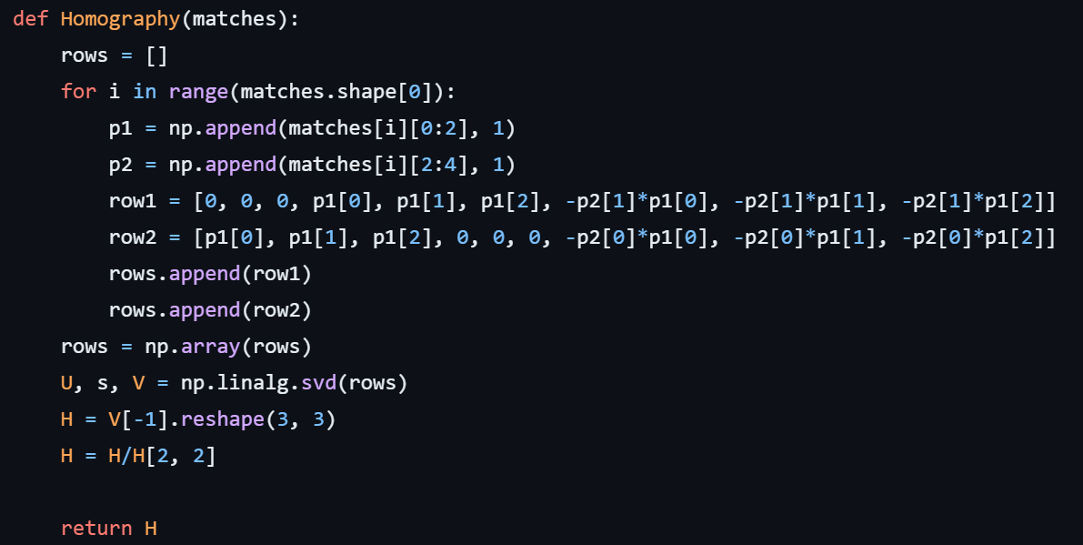

Construct A matrix and use SVD to find H.

Here we reshape the last row of V to H.

1. RANSAC

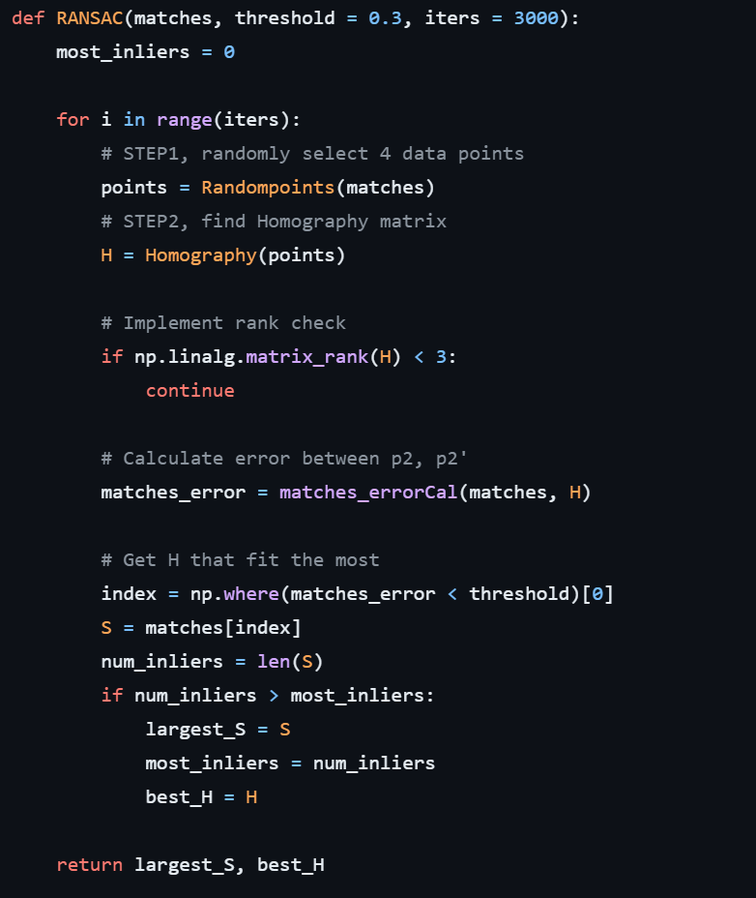

First we randomly select 4 pairs of matched points and find Homography of each pairs of matched points. Note that Homography should be full rank.

Second we calculate the error between estimated points and real points, if the error is small enough, add the match pairs to S.

If S has most inliers, best homography will be set to current H.

Run the loop a sufficient number of times, then return best homography.

5, Stitch image







Warp left and right image

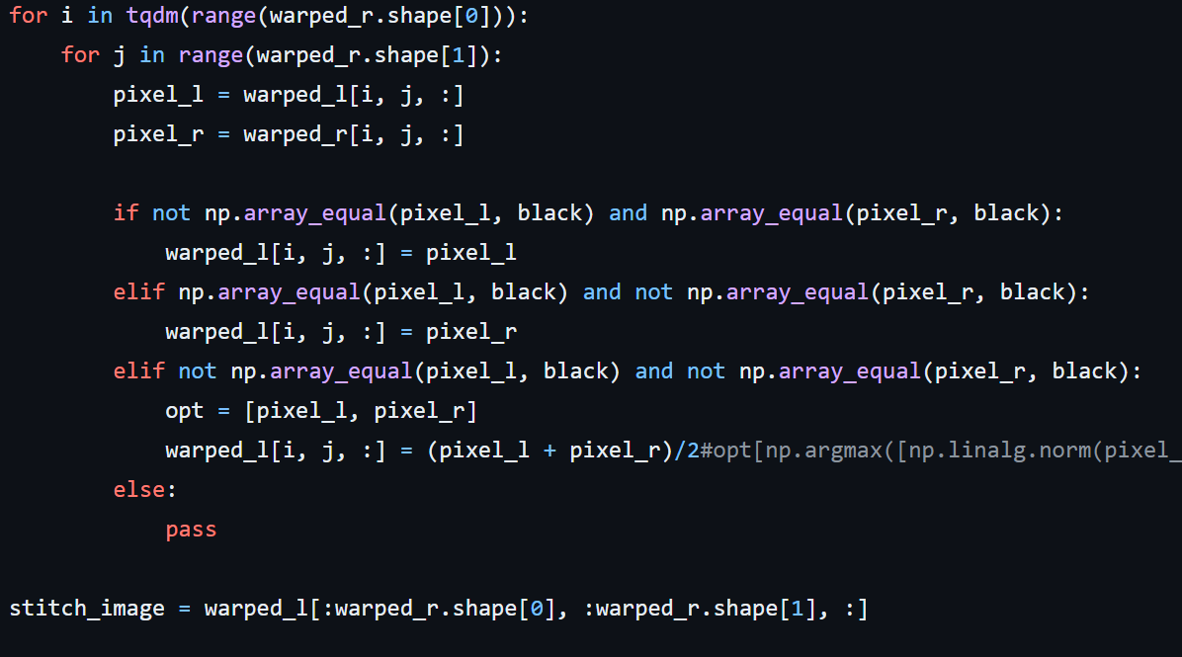

Stitch image and store results in warped_l

Results:

