Setting Up an IPSec VPN
Effective Date: June 09, 2026

1. Purpose
This Standard Operating Procedure (SOP) outlines the steps to set up an Internet Protocol Security (IPSec) Virtual Private Network (VPN) for secure data transmission between devices.

2. Scope
- Setting up an IPSec VPN
- Establishing a secure connection

3. Prerequisites
- Familiarity with networking protocols
- Access to device configurations and firewall settings

4. Roles and Responsibilities
Role | Responsibility
Device Administrator | Configures devices for IPSec VPN use
Network Administrator | Manages network traffic and firewall settings

5. Process Overview
The following WORKFLOW diagram illustrates the key steps in this procedure:
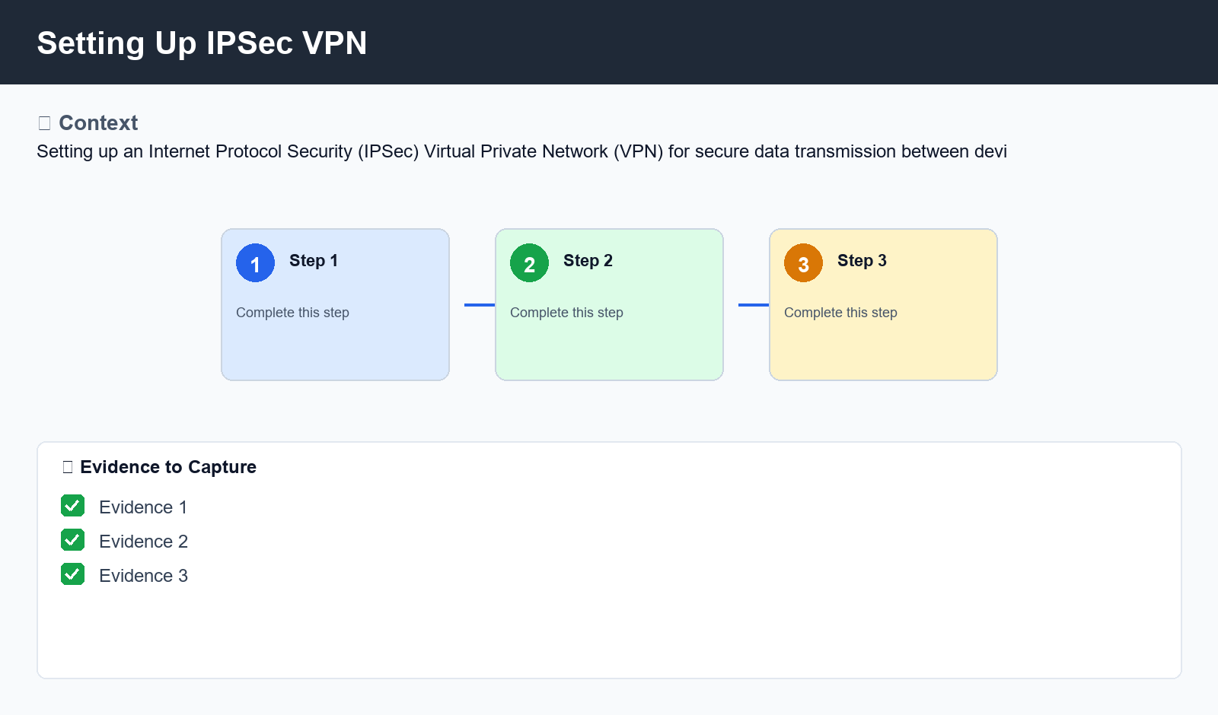
Figure: Setting Up IPSec VPN

6. Procedure
- Gather necessary information (IP addresses, subnet masks, firewall settings)
- Configure gateways to use correct IP addresses and subnet masks
- Set up firewall to allow incoming traffic on specific ports and protocols
- Establish IKE Phase I authentication process
- Negotiate encryption and authentication algorithms using IKE Phase II
- Derive IPSec keys from shared master key
- Create IPSec tunnel between devices

7. Validation
- Firewall configuration
- IKE Phase I and Phase II authentication

8. Troubleshooting
Issue | Cause | Resolution
Firewall conflicts | Incompatible firewall settings | Reconfigure firewall settings
Address conflicts | Conflicting IP addresses or subnet masks | Verify and resolve IP address conflicts
IKE Phase I errors | Authentication or negotiation issues | Check for errors in IKE Phase I authentication and negotiation

9. Rollback / Recovery
- Undo firewall configuration changes
- Restore original gateway configurations

10. References
- IPSec VPN documentation
- Network protocol guides

