SOP: Common Networking Issues
Effective Date: June 09, 2026

1. Purpose
Provides guidance on troubleshooting common networking issues and resolving them.

2. Scope
- Local area networks (LANs)
- Wireless networks
- Remote access via SSH or other protocols

3. Prerequisites
- Basic computer knowledge
- Understanding of network protocols (TCP/IP, etc.)
- Familiarity with device management tools (e.g., Netgear ProSafe)

4. Roles and Responsibilities
Role | Responsibility
IT Support Technician | Troubleshoots and resolves common networking issues
Network Administrator | Configures and maintains network devices, including wireless routers and switches

5. Process Overview
The following WORKFLOW diagram illustrates the key steps in this procedure:
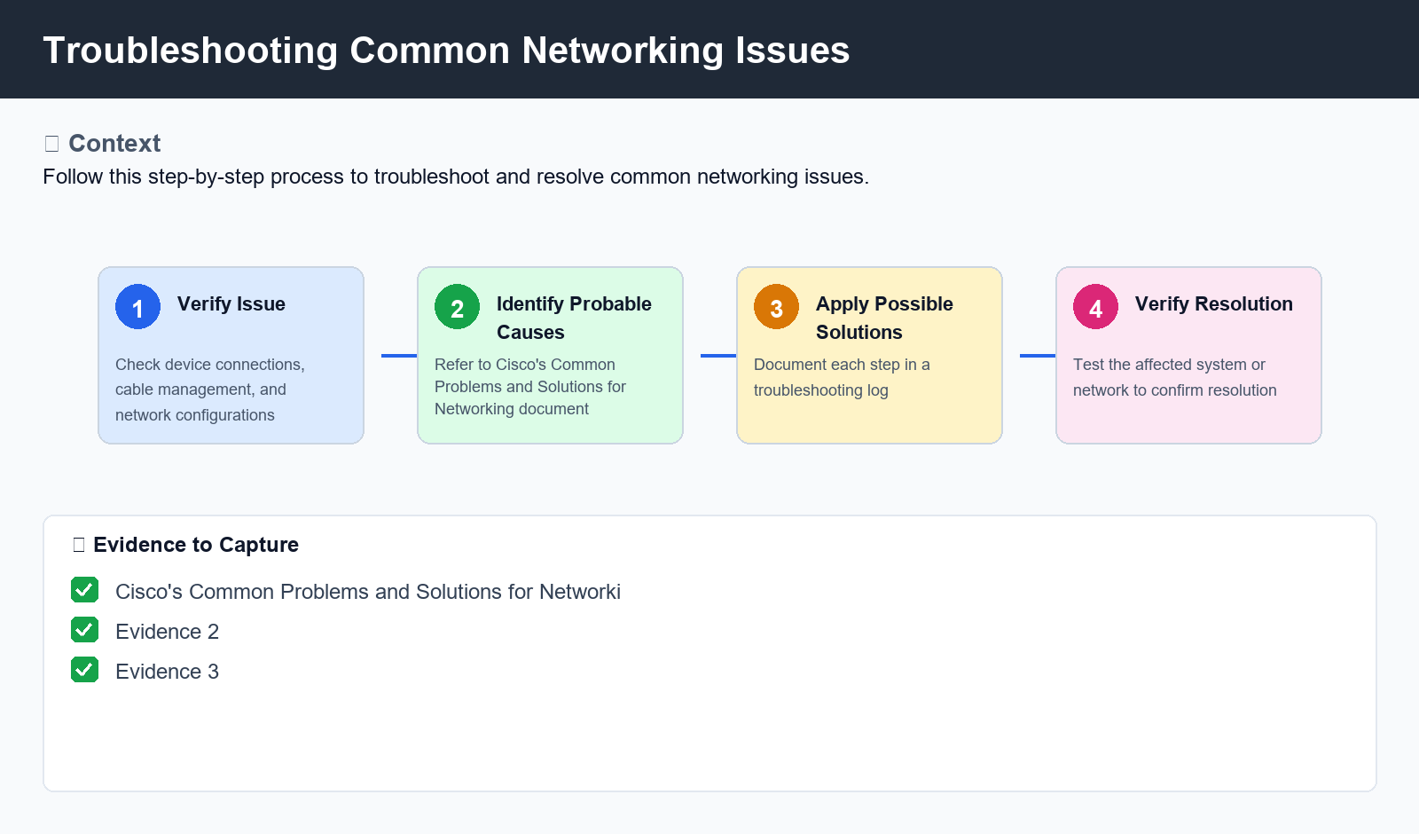
Figure: Troubleshooting Common Networking Issues

6. Procedure
- Step 1: Verify the issue is networking-related by checking device connections, cable management, and network configurations.
- Step 2: Identify probable causes using Cisco's Common Problems and Solutions for Networking document. Refer to page numbers 1-2 as necessary.
- Step 3: Apply possible solutions, documenting each step in a troubleshooting log.
- Step 4: Verify the resolution by testing the affected system or network.

7. Validation
- Check for working connections using ping or SSH
- Verify device configuration and settings are correct
- Test for connectivity issues with other devices or networks

8. Troubleshooting
Issue | Cause | Resolution
NIC LED lights not lit | Network cable is unplugged or damaged | Reconnect or replace the network connection to the computer
Device cannot connect to wireless network | Wireless capability of device is turned off | Enable wireless capability of device and restart router/access point if necessary

9. Rollback / Recovery
- Step 1: Disconnect from the network, then reconnect.

10. References
- Cisco's Common Problems and Solutions for Networking (PDF)
- Netgear ProSafe Device Management Guide
- Cisco's TCP/IP Tutorial

