Cisco Network Reconnection
Effective Date: June 09, 2026

1. Purpose
Establishes a clear method for reestablishing connectivity to a Cisco network.

2. Scope
- Reconnecting a Cisco router to a network
- Restoring Cisco switch access to a network
- Refreshing Cisco VPN connections

3. Prerequisites
- Administrative access to the affected device
- Basic knowledge of Cisco networking protocols
- Current IP address and subnet mask information

4. Roles and Responsibilities
Role | Responsibility
Network Administrator | Responsible for reconnecting Cisco devices
IT Manager | Oversees network connectivity and device management

5. Process Overview
The following WORKFLOW diagram illustrates the key steps in this procedure:
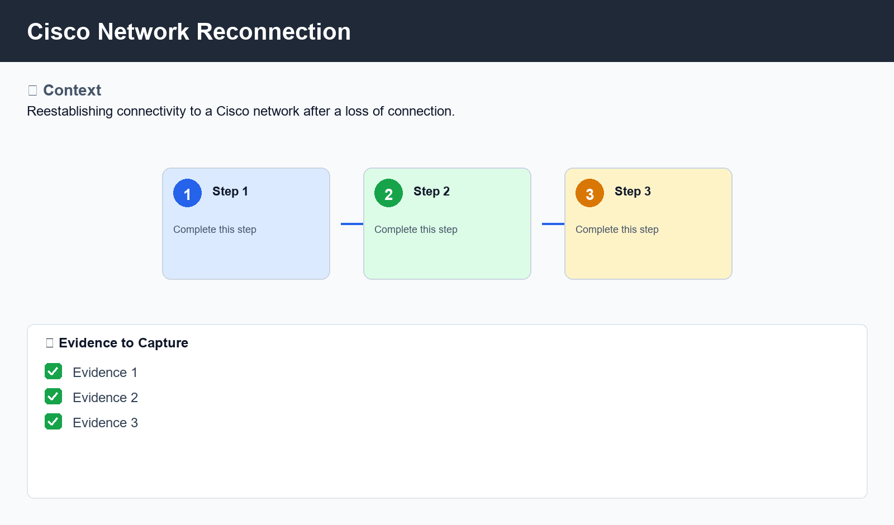
Figure: Cisco Network Reconnection

6. Procedure
- Step 1: Power cycle the Cisco router or switch to clear existing connections
- Step 2: Configure the correct IP address and subnet mask on the affected device
- Step 3: Verify connectivity using a ping test or SSH session

7. Validation
- Verifying the correct DNS server IP addresses are configured
- Checking for any firewall or NAT rules that may be blocking connectivity
- Testing network services to ensure they are functioning as expected

8. Troubleshooting
Issue | Cause | Resolution
Device does not respond to ping tests | Incorrect IP address or subnet mask configuration | Double-check IP address and subnet mask settings
No connectivity after power cycling | Firewall or NAT rules blocking connections | Check firewall or NAT rules and add necessary exceptions for Cisco devices

9. Rollback / Recovery
- Rollback to previous configuration settings if reconnecting fails
- Reset device to factory defaults if all else fails

10. References
- Cisco Networking Documentation: Connecting to a Network
- Cisco Router Configuration Guide: IP Address and Subnet Mask Settings

