Password Reset Process for VPN Users
Effective Date: June 08, 2026

1. Purpose
In the event a VPN user forgets or loses their password, this SOP outlines the steps to reset the password securely and efficiently.

2. Scope
- All VPN users
- Employees with administrative access to VPN accounts
- IT personnel responsible for managing VPN passwords

3. Prerequisites
- The user has an active VPN account
- The user has internet access on a device
- The IT department is available during business hours

4. Roles and Responsibilities
Role | Responsibility
VPN Administrator | Responsible for maintaining the integrity of VPN passwords and ensuring password reset procedures are followed
IT Support Specialist | Assists users with password resets, verifies user identity, and ensures secure password reset processes

5. Process Overview
The following diagram illustrates the key steps in this procedure:
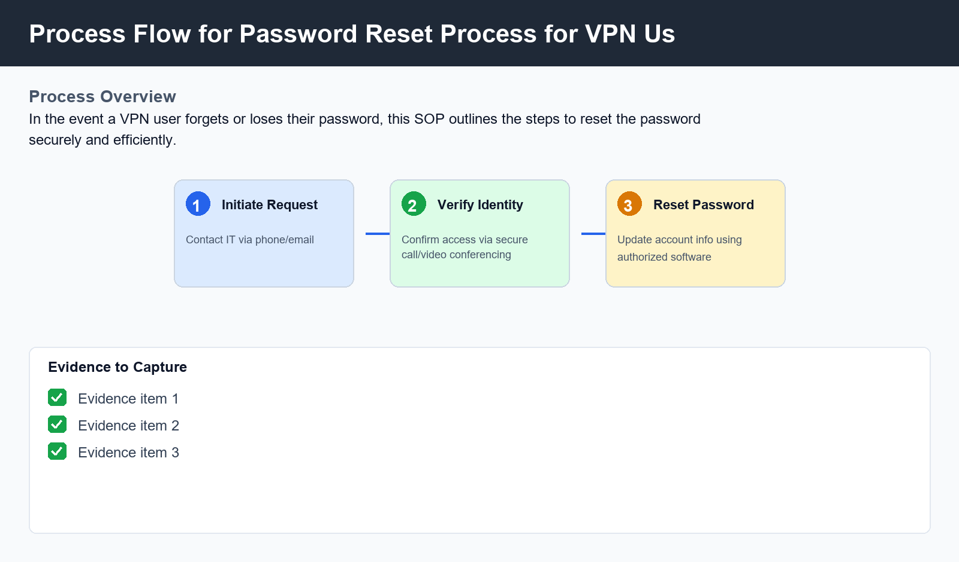

6. Procedure
- 1. Step 1: Initiate Password Reset Request - The user initiates the password reset process by contacting the IT department via phone or email, providing proof of identity to verify their access to the VPN account.
- 2. Step 2: Verify User Identity and Password Policy Compliance - The IT support specialist verifies the user's identity through secure means (e.g., phone call, video conferencing) and ensures the user has followed all password policy requirements.
- 3. Step 3: Perform Password Reset and Update Account Information - The IT support specialist uses authorized software to reset the VPN user's password. The user is then asked to update their account information, including any additional security questions or notifications.

7. Validation
- User confirms password has been successfully changed
- Password policy requirements are met
- Account information is updated correctly

8. Troubleshooting
Issue | Cause | Resolution
Password reset fails due to invalid user credentials | Incorrect username or password provided during password reset request | Request the user reinitiate the password reset process with corrected credentials
User reports having difficulty accessing VPN resources after password reset | Incorrectly configured VPN settings | Verify VPN settings are correctly configured and notify the user of any necessary adjustments

9. Rollback / Recovery
- Rollback to previous password if error occurs during password reset
- Notify IT department of issues encountered during password reset process

10. References
- VPN User Guide
- Password Policy Document

