sd-wan configuration error
Effective Date: June 08, 2026

1. Purpose
To ensure that all sd-wan configurations are thoroughly reviewed and validated before deployment to prevent configuration errors that can lead to connectivity issues, security breaches, or device failures.

2. Scope
- Network administrators
- System engineers
- IT teams

3. Prerequisites
- Familiarity with sd-wan devices and software
- Knowledge of network protocols (e.g., BGP, OSPF)
- Understanding of VPN configurations

4. Roles and Responsibilities
Role | Responsibility
Network Administrator | Reviews and validates sd-wan configuration files for accuracy and completeness
System Engineer | Ensures that all necessary security settings are configured and reviewed
IT Manager | Approves final sd-wan configuration changes and ensures compliance with organizational policies

5. Process Overview
The following diagram illustrates the key steps in this procedure:
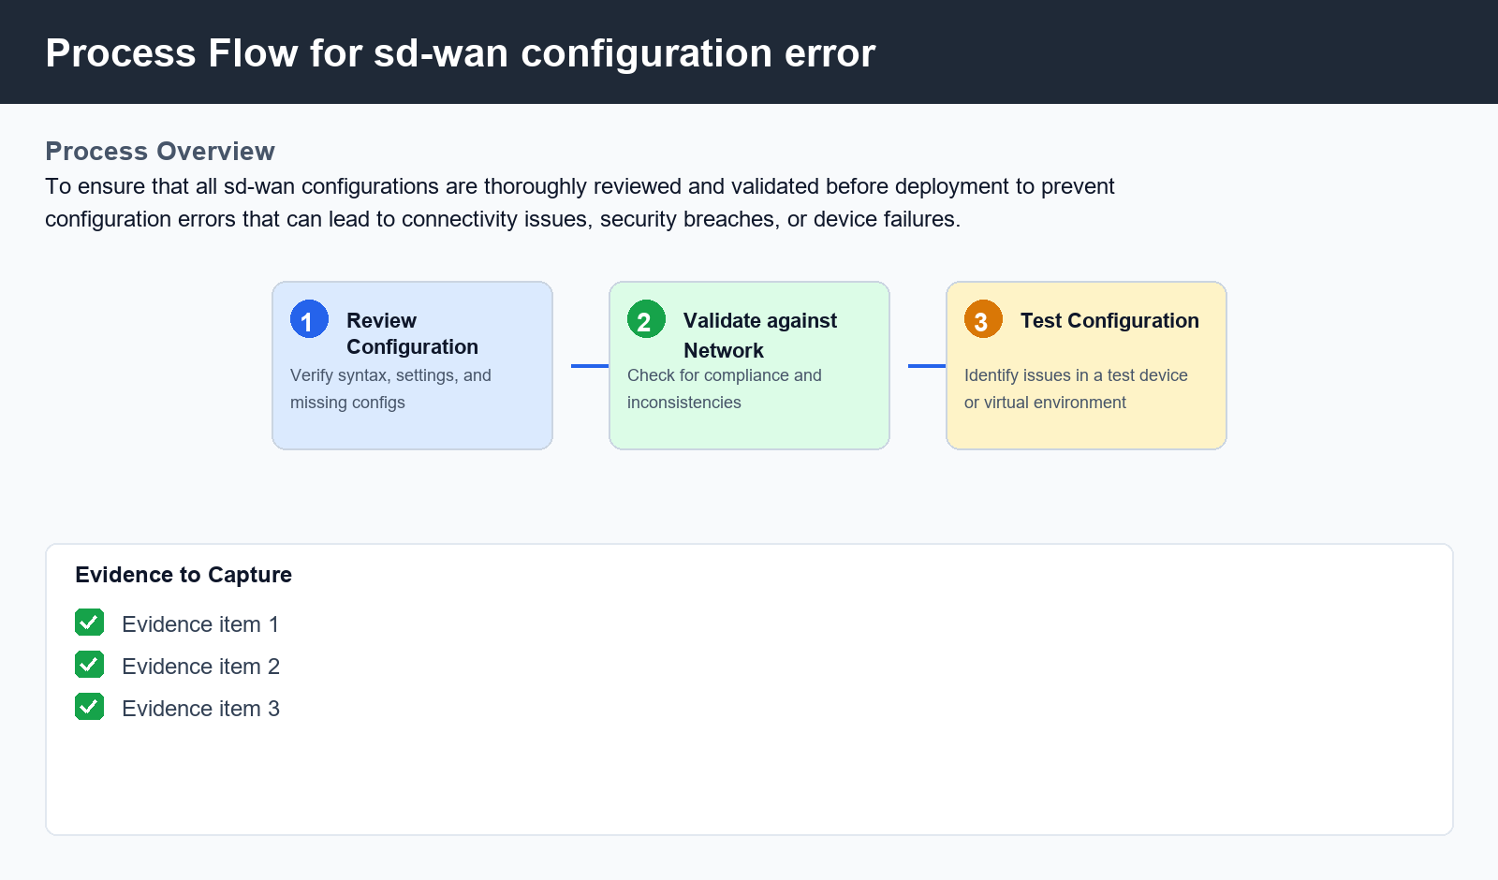

6. Procedure
- 1. Step 1: Review the sd-wan configuration file for syntax errors, incorrect settings, and missing configurations. Verify that all required settings are present, such as VPN connections, security protocols, and device authentication.
- 2. Step 2: Validate the configuration against the organization's network policies and standards to ensure compliance. Check for any inconsistencies or conflicts with other network devices or applications.
- 3. Step 3: Perform a thorough test of the sd-wan configuration using a test device or virtual environment to identify any issues or areas for improvement

7. Validation
- Validate the syntax and semantics of the configuration file using a tool such as 'sdwan-check' or 'vnstat-visualizer'
- Verify that all required settings are present and correct, including VPN connections, security protocols, and device authentication
- Check for any inconsistencies or conflicts with other network devices or applications

8. Troubleshooting
Issue | Cause | Resolution
sd-wan device fails to connect | Incorrect IP address configuration | Verify that the correct IP address is configured on the sd-wan device and update the configuration file accordingly
VPN connection drops frequently | Inadequate security settings | Review and update VPN security settings to ensure adequate encryption, authentication, and key exchange protocols
Device authentication fails | Incorrect username or password | Verify that the correct username and password are configured on the sd-wan device and update the configuration file accordingly

9. Rollback / Recovery
- If any issues arise during the deployment process, revert to a known good configuration by deleting the most recent changes made to the sd-wan configuration file
- Restore backup files or snapshots of the sd-wan device in case of data loss or corruption

10. References
- sdwan documentation and guides
- VPN security best practices
- Network protocol standards

