Outlook Configuration Error SOP
Effective Date: June 08, 2026

1. Purpose
This Standard Operating Procedure (SOP) outlines the steps to troubleshoot and resolve Outlook configuration errors, ensuring seamless communication and minimizing downtime.

2. Scope
- All users with active Outlook accounts
- IT Support Team for troubleshooting
- Outlook administrators for configuration changes

3. Prerequisites
- User has an active Outlook account
- System administrator has access to Outlook settings
- IT support team has basic knowledge of Outlook configuration

4. Roles and Responsibilities
Role | Responsibility
IT Support Team | Troubleshoot and resolve Outlook errors
Outlook Administrator | Configure and maintain Outlook settings
User | Report errors and provide necessary information

5. Process Overview
The following WORKFLOW diagram illustrates the key steps in this procedure:
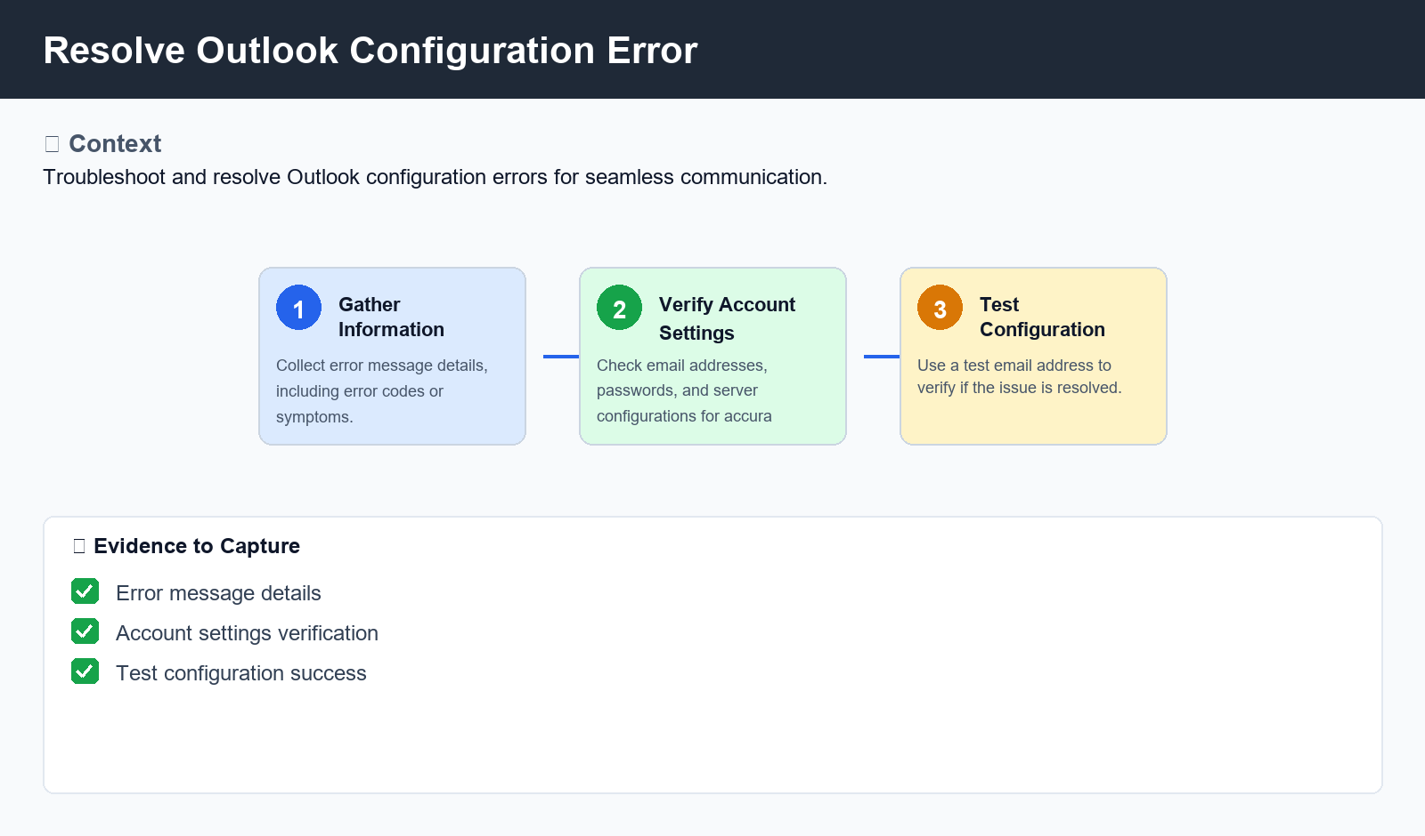
Figure: Resolve Outlook Configuration Error

6. Procedure
- 1. Step 1: Gather information on the error message, including any error codes or symptoms. This will help identify the root cause of the issue.
- 2. Step 2: Check the Outlook account settings, such as email addresses, passwords, and server configurations. Verify that all settings are correct and up-to-date.
- 3. Step 3: Test the Outlook configuration using a test email address or by sending an email to verify if the issue is resolved

7. Validation
- Verify that the error message has been cleared from the Outlook interface
- Check for any newly installed software or updates that may be causing the issue
- Test the email connectivity using a third-party email client

8. Troubleshooting
Issue | Cause | Resolution
Account not found | Incorrect account settings | Verify and correct account settings, such as email address and password
Email sending issues | Insufficient mailbox space or attachments exceeding size limits | Increase mailbox space or remove excessive attachments
Outlook crashes frequently | Conflicting software or outdated plugins | Uninstall conflicting software and update Outlook to the latest version

9. Rollback / Recovery
- If troubleshooting is unsuccessful, reset Outlook settings to default values
- Delete all temporary files and cache data related to Outlook

10. References
- Outlook documentation and user guides
- IT support team knowledge base articles
- MSDN forums for Outlook-related issues

