Outlook Configuration Error SOP
Effective Date: June 08, 2026

1. Purpose
To establish a standardized process for resolving Outlook configuration errors, ensuring consistency and efficiency in troubleshooting and resolution.

2. Scope
- User Support
- IT Infrastructure
- Network Operations

3. Prerequisites
- Active directory membership
- Outlook installation on client device
- Basic understanding of Outlook settings

4. Roles and Responsibilities
Role | Responsibility
Help Desk Technician | Initial triage and error reporting
IT Support Specialist | In-depth troubleshooting and resolution
Network Administrator | Configuring network settings for Outlook connectivity

5. Process Overview
The following WORKFLOW diagram illustrates the key steps in this procedure:
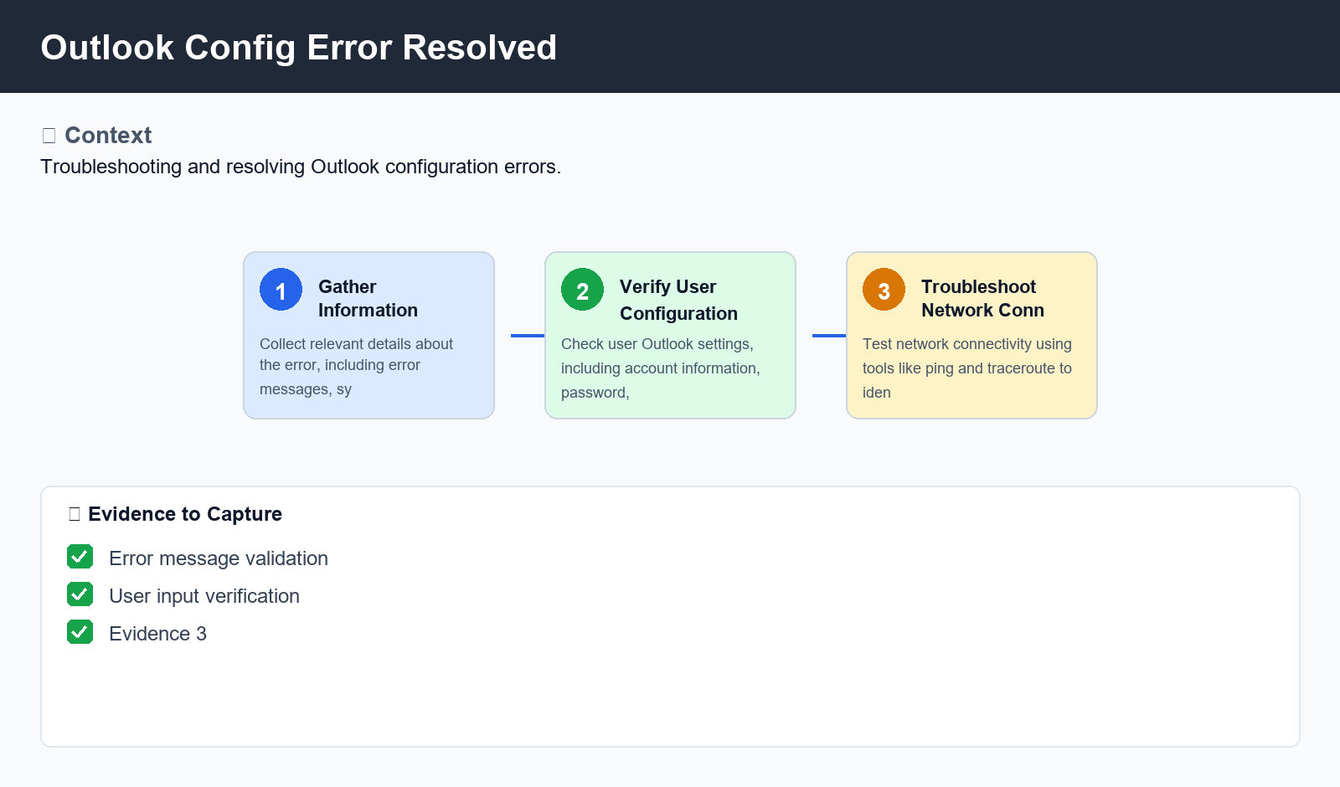
Figure: Outlook Config Error Resolved

6. Procedure
- 1. Step 1: Gather Information - Collect relevant details about the error, including error messages, system configuration, and recent changes.
- 2. Step 2: Verify User Configuration - Check user Outlook settings, including account information, password, and email server settings.
- 3. Step 3: Troubleshoot Network Connectivity - Test network connectivity using tools like ping and traceroute to identify potential issues

7. Validation
- Error message validation
- User input verification
- Network connectivity checks

8. Troubleshooting
Issue | Cause | Resolution
Outlook cannot connect to email server | Insufficient or incorrect network settings | Verify and update network configuration, including DNS settings
Account login failed with error code | Incorrect password or account lockout | Reset password and try logging in again

9. Rollback / Recovery
- Step 1: Remove temporary configurations
- Step 2: Restore original settings

10. References
- Outlook documentation and knowledge base
- IT Support Portal
- Network Administrator's Guide

