Outlook Configuration Error SOP
Effective Date: June 08, 2026

1. Purpose
To ensure timely and effective resolution of Outlook configuration errors, ensuring minimal disruption to end-users.

2. Scope
- IT Support Team
- All IT Departments
- End-Users Affected by Errors

3. Prerequisites
- Basic understanding of Outlook setup
- Access to IT support ticketing system
- Microsoft Office 365 or Exchange Server setup knowledge

4. Roles and Responsibilities
Role | Responsibility
Senior IT Technician | Lead troubleshooting efforts, prioritize resolution
Junior IT Technician | Assist senior technician with troubleshooting and testing
Management | Approve resolution plan and allocate necessary resources

5. Process Overview
The following WORKFLOW diagram illustrates the key steps in this procedure:
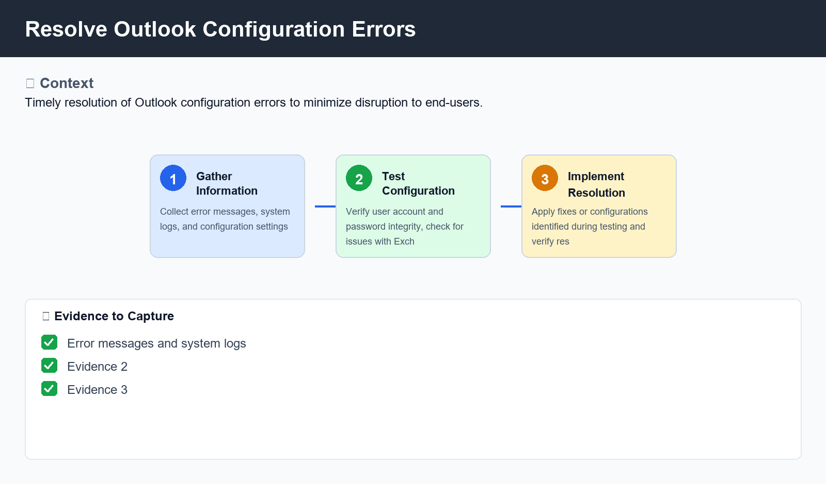
Figure: Resolve Outlook Configuration Errors

6. Procedure
- Step 1: Gather Information - Collect relevant error messages, system logs, and configuration settings to identify the root cause of the issue. Verify that Outlook is correctly configured and up-to-date.
- Step 2: Test Configuration - Verify user account and password integrity, check for any issues with Exchange Server or Office 365 setup. Run diagnostic tests on individual Outlook applications (e.g., Outlook Web Access, Outlook Desktop) to identify any errors or issues.
- Step 3: Implement Resolution - Apply fixes or configurations identified during testing, document resolution steps, and ensure that all necessary users are updated. Verify the issue is resolved by re-testing the user's configuration and functionality.

7. Validation
- Check for correct spelling of domain name
- Verify email address format compliance with company policies

8. Troubleshooting
Issue | Cause | Resolution
Outlook not syncing with Exchange Server | Incorrect DNS settings or misconfigured Outlook profile | Update DNS settings, verify Outlook profile configuration and re-sync data
Error connecting to Office 365 | Inadequate network connectivity or insufficient permissions | Check network connectivity, increase privileges for affected user accounts, or request Microsoft support for assistance
Missing calendar or contact data | Incomplete import from Exchange Server or incorrect Outlook setup | Re-import data from Exchange Server, verify correct Outlook configuration and re-check email account settings

9. Rollback / Recovery
- Step 1: Undo any changes made during troubleshooting or resolution steps

10. References
- Microsoft Office 365 Support Documentation
- Exchange Server Configuration Guide
- ITIL Foundation Level 4

