Network Configuration Error
Effective Date: June 08, 2026

1. Purpose
To establish a standardized process for resolving network configuration errors, ensuring minimal disruption to service and data integrity.

2. Scope
- Network administrators
- IT support teams
- Data center personnel

3. Prerequisites
- Basic knowledge of network protocols
- Understanding of device configuration management systems
- Access to network monitoring tools

4. Roles and Responsibilities
Role | Responsibility
Network Administrator | Performs initial troubleshooting and identifies the root cause of the error
IT Support Team Lead | Coordinates with Network Administrators and ensures timely resolution of issues

5. Process Overview
The following WORKFLOW diagram illustrates the key steps in this procedure:
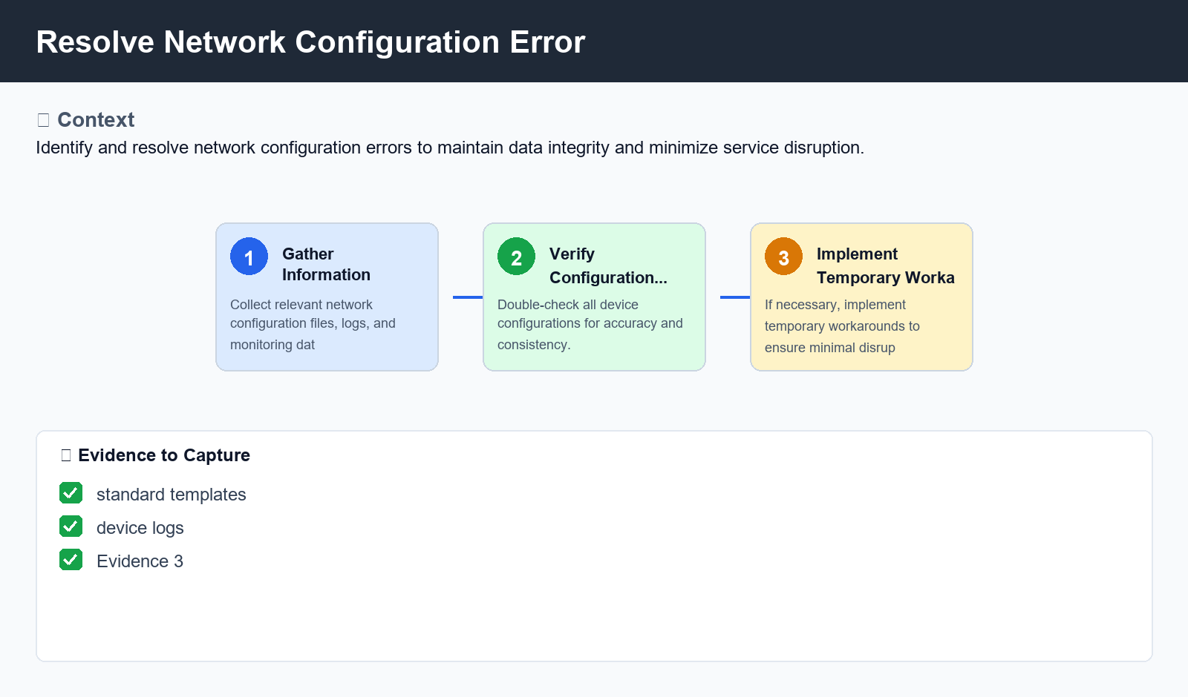
Figure: Resolve Network Configuration Error

6. Procedure
- Step 1: Gather Information - Collect relevant network configuration files, logs, and monitoring data to identify the source of the issue.
- Step 2: Verify Configuration Changes - Double-check all device configurations, including IP addresses, subnet masks, and gateway settings, for accuracy and consistency.
- Step 3: Implement Temporary Workarounds - If necessary, implement temporary workarounds to ensure minimal disruption to service while permanent fixes are being implemented.

7. Validation
- Validate network configuration against standard templates
- Verify device logs for errors or warnings
- Check network monitoring tools for anomalies

8. Troubleshooting
Issue | Cause | Resolution
Duplicate IP Address Error | Mismatched IP address assignments on devices | Reassign unique IP addresses to each device and reconfigure routing tables
Missing Firewall Rule Error | Inadequate firewall rule configuration | Create or update necessary firewall rules using a network configuration management system

9. Rollback / Recovery
- Rollback changes made during troubleshooting
- Revert temporary workarounds implemented in Step 3

10. References
- Cisco Networking Academy Course Materials
- Juniper Networks Configuration Guides
- RFC 2547 - Network Management Framework

