dns error
Effective Date: June 08, 2026

1. Purpose
This Standard Operating Procedure (SOP) outlines the steps to resolve DNS-related errors, ensuring minimal downtime and efficient troubleshooting.

2. Scope
- Domain management
- Network administration
- Server setup

3. Prerequisites
- Basic knowledge of DNS concepts
- Familiarity with command-line interfaces
- DNS configuration files (e.g., zone files, host files)

4. Roles and Responsibilities
Role | Responsibility
System Administrator | Responsible for maintaining DNS records and configurations
Network Engineer | Involved in network setup and configuration, including DNS servers

5. Process Overview
The following WORKFLOW diagram illustrates the key steps in this procedure:
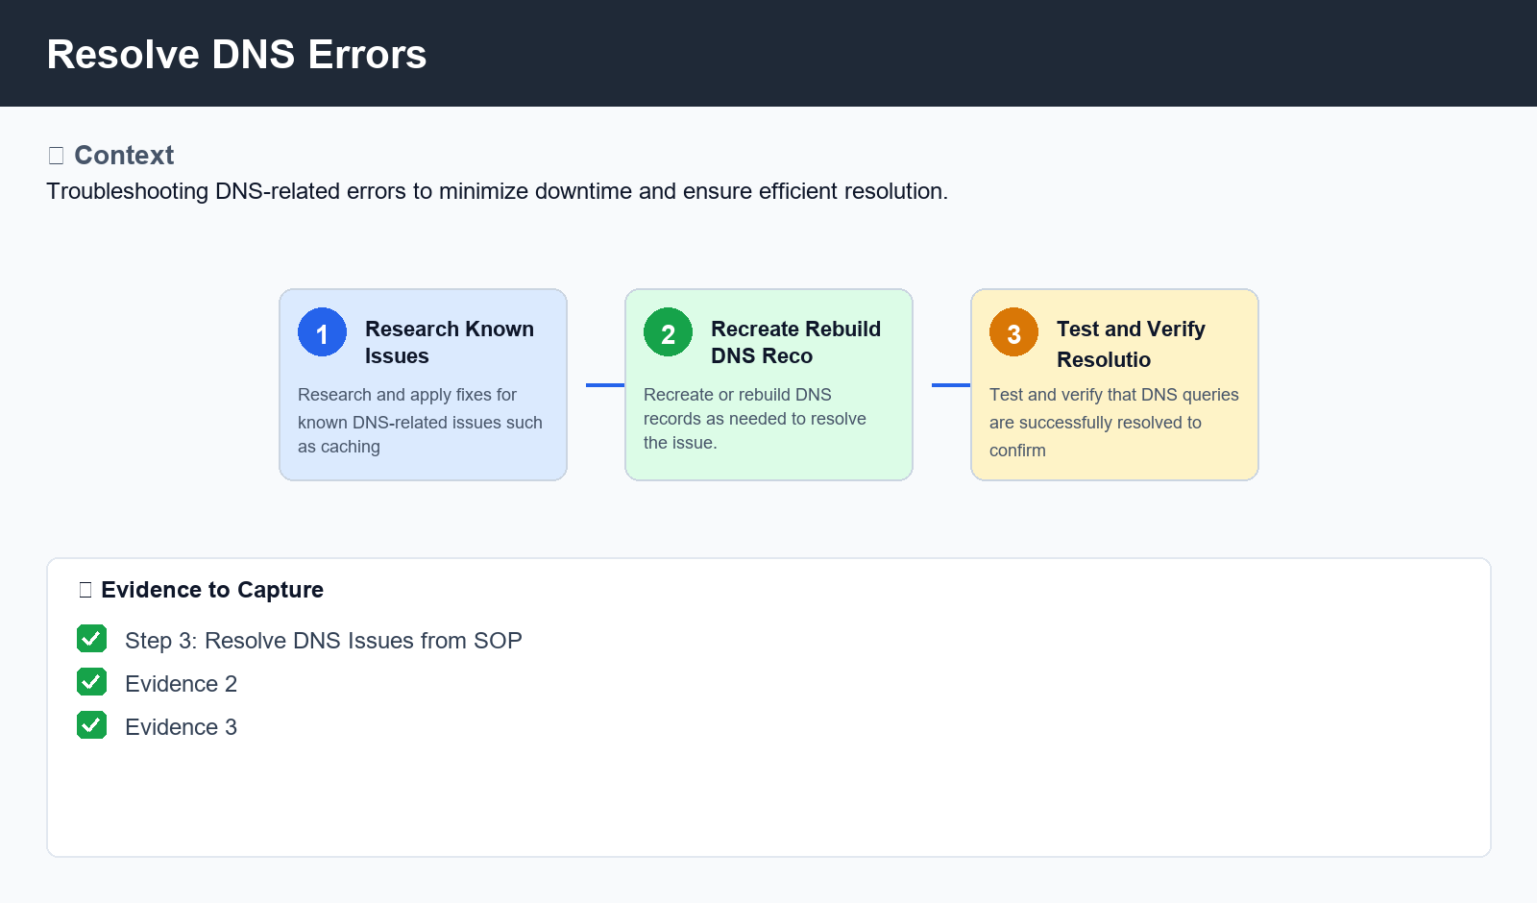
Figure: Resolve DNS Errors

6. Procedure
- Step 3: Resolve DNS Issues
- Research and apply fixes for known DNS-related issues (e.g., caching problems, DNS server misconfiguration).
- Recreate or rebuild DNS records as needed.
- Test and verify that DNS queries are successfully resolved.

7. Validation
- Verify that DNS queries return correct results.
- Check for any syntax errors in DNS configuration files.
- Use tools like `dig` or `nslookup` to validate DNS queries.

8. Troubleshooting
Issue | Cause | Resolution
DNS Server Not Responding | No connectivity issues with the network interface. | Restart the DNS server or check for any network configuration errors.
Inconsistent DNS Records | Incorrectly updated DNS records. | Verify that zone files and host files are up-to-date and correctly formatted.
Caching Issues | DNS caching not properly configured or expired. | Update DNS caching settings (e.g., TTL) or clear cache using a tool like `nslookup -debug`

9. Rollback / Recovery
- Restore previous DNS configuration files from backup.

10. References
- DNS Best Practices Guide
- Linux DNS Configuration Tutorial

