dns server issue
Effective Date: June 08, 2026

1. Purpose
To provide a standardized process for resolving DNS server issues, ensuring minimal disruption to network services.

2. Scope
- Network infrastructure
- Domain registration
- Internet connectivity

3. Prerequisites
- DNS server software installed and configured
- Basic network troubleshooting skills
- Administrative access to DNS server management tools

4. Roles and Responsibilities
Role | Responsibility
Network Administrator | Monitor DNS server performance, perform basic troubleshooting, and restart the DNS server as needed.
System Engineer | Implement DNS server upgrades or changes, configure backup systems, and ensure DNS server security

5. Process Overview
The following WORKFLOW diagram illustrates the key steps in this procedure:
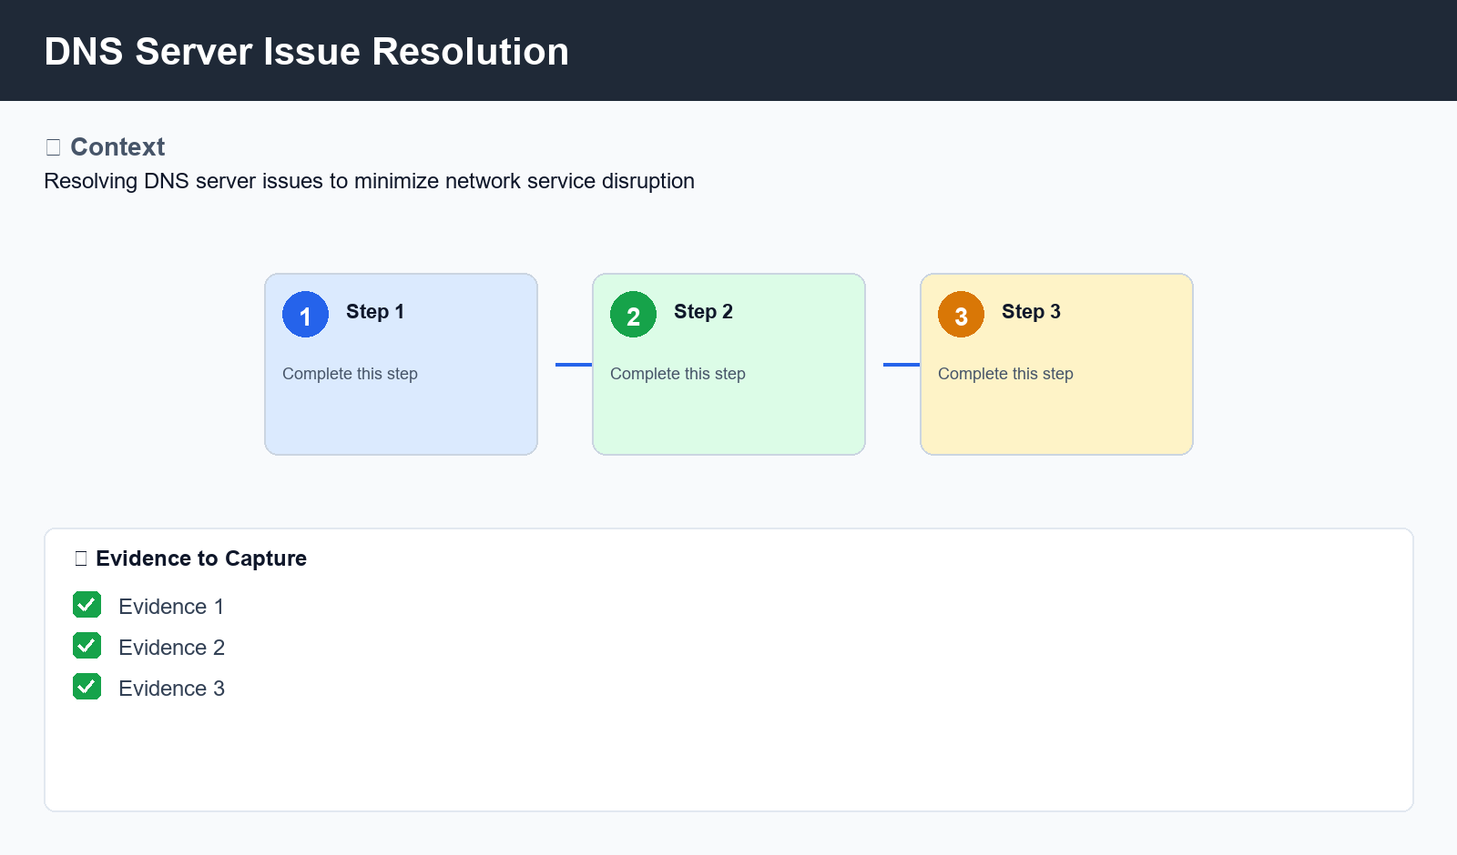
Figure: DNS Server Issue Resolution

6. Procedure
- Step 1: Gather information - Collect DNS server logs, check for any recent software updates or configuration changes that may have affected DNS server performance.
- Step 2: Perform network troubleshooting - Verify that the issue is not caused by other network components, such as routers or switches. Check for any connectivity issues between devices and the DNS server.
- Step 3: Restart or reinstall DNS server software - If necessary, restart the DNS server or reinstall the DNS server software to ensure it is running with the latest version and configurations.

7. Validation
- Verify DNS server IP addresses are correctly configured
- Check for any errors in DNS server logs
- Test basic network connectivity

8. Troubleshooting
Issue | Cause | Resolution
DNS resolution failure | Incorrect DNS server configuration or failed hardware component | Restart the DNS server and verify its configuration
DNS server not responding | Failed software update or corrupted DNS database | Reinstall DNS server software and restore from a backup

9. Rollback / Recovery
- Return to previous DNS server software version
- Restore DNS server configuration from backup

10. References
- DNS Server Administration Guide
- Network Troubleshooting Best Practices
- RFC 1035: Domain Names - Implementation and Specification

