dns error
Effective Date: June 08, 2026

1. Purpose
This Standard Operating Procedure (SOP) outlines the steps to be taken when a DNS (Domain Name System) error occurs.

2. Scope
- Network administrators
- IT support staff
- System engineers

3. Prerequisites
- Basic understanding of DNS concepts
- Familiarity with network protocols
- Access to DNS configuration files

4. Roles and Responsibilities
Role | Responsibility
Network Administrator | Responsible for monitoring DNS performance and responding to errors
IT Support Staff | Assists network administrators in resolving DNS-related issues

5. Process Overview
The following WORKFLOW diagram illustrates the key steps in this procedure:
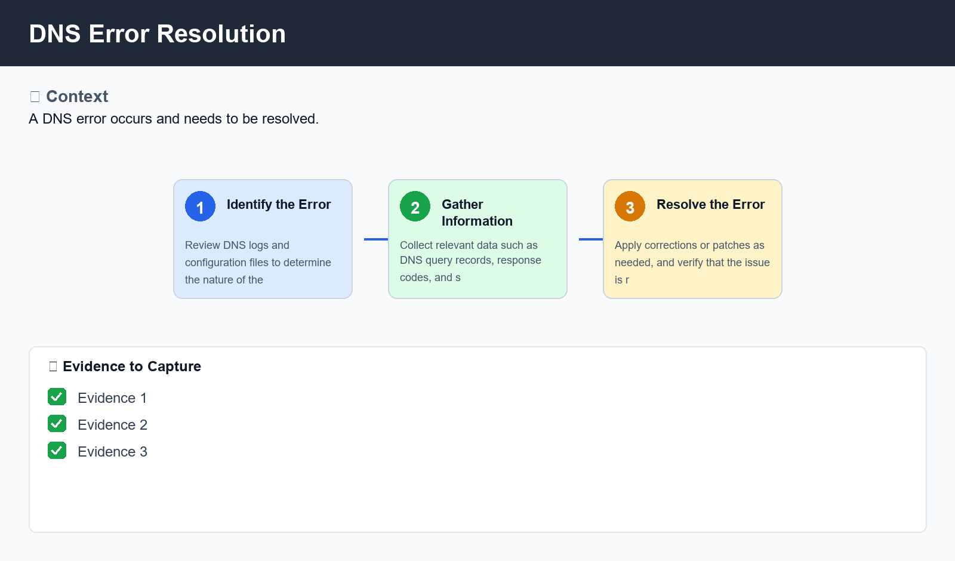
Figure: DNS Error Resolution

6. Procedure
- Step 1: Identify the error - Review DNS logs and configuration files to determine the nature of the error
- Step 2: Gather information - Collect relevant data such as DNS query records, response codes, and system logs to reproduce the issue
- Step 3: Resolve the error - Apply corrections or patches as needed, and verify that the issue is resolved

7. Validation
- Verify DNS server status
- Check for duplicate domain entries

8. Troubleshooting
Issue | Cause | Resolution
DNS resolution failure | Insufficient DNS server capacity or failed DNS query records | Increase DNS server resources or verify and correct DNS query records
Domain name resolution issues | Incorrect domain configuration or DNS record errors | Review and correct domain configuration, or update DNS records as needed

9. Rollback / Recovery
- Return DNS server to original configuration
- Verify system stability before proceeding

10. References
- DNS Configuration Guide
- Network Protocols Reference
- System Log Analysis Techniques

