DNS Server Error SOP
Effective Date: June 08, 2026

1. Purpose
To provide a clear and structured process for resolving DNS server errors, ensuring minimal downtime and optimal resolution.

2. Scope
- Network Operations
- Infrastructure Management
- IT Support

3. Prerequisites
- DNS Server Configuration Check
- Network Connectivity Verification
- Error Reporting Protocol

4. Roles and Responsibilities
Role | Responsibility
DNS Administrator | Responsible for DNS server configuration, updates, and maintenance
Network Engineer | Involved in network infrastructure management and monitoring

5. Process Overview
The following WORKFLOW diagram illustrates the key steps in this procedure:
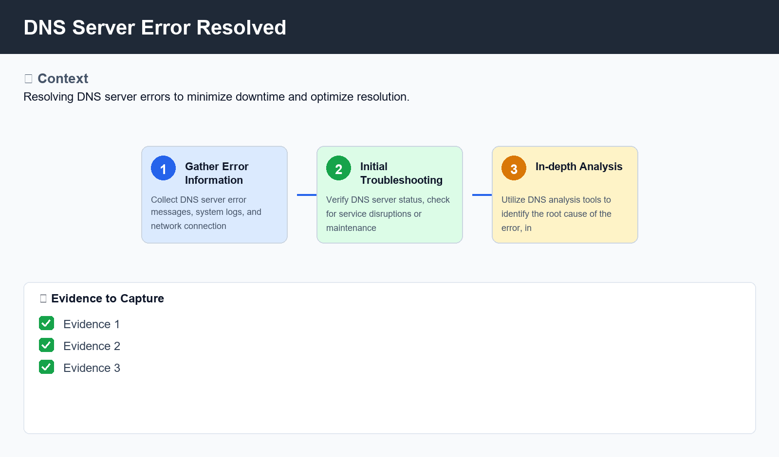
Figure: DNS Server Error Resolved

6. Procedure
- Step 1: Gather Error Information - Collect DNS server error messages, system logs, and network connection details from affected devices.
- Step 2: Initial Troubleshooting - Verify DNS server status, check for service disruptions or maintenance window notifications, and perform basic network connectivity checks.
- Step 3: In-depth Analysis - Utilize DNS analysis tools to identify the root cause of the error, including checking zone transfer logs, caching records, and recursive queries.

7. Validation
- DNS Server Configuration Check
- Network Connectivity Verification
- Error Message Analysis

8. Troubleshooting
Issue | Cause | Resolution
DNS server unreachable | Incorrect DNS server IP address or configuration issue | Verify DNS server IP address, update DNS records, and restart affected services.
DNS lookup failure | Cache poisoning or recursive query issues | Clear cache, adjust recursive query settings, and verify DNS server configuration.

9. Rollback / Recovery
- DNS Server Configuration Rollback
- Network Services Restart

10. References
- DNS Administration Guide
- Network Architecture Diagrams
- IT Service Management Documentation

