VPN Authentication Error
Effective Date: June 08, 2026

1. Purpose
To establish a standardized process for handling VPN authentication errors, ensuring minimal disruption to VPN services and maintaining confidentiality.

2. Scope
- Remote Access Network
- VPN Server Management
- User Support

3. Prerequisites
- Valid VPN credentials
- Active network connection
- Administrative access to VPN server

4. Roles and Responsibilities
Role | Responsibility
Network Administrator | Monitor VPN logs for errors, perform troubleshooting, and implement fixes
IT Support Specialist | Assist users with VPN authentication issues, escalate complex problems to Network Administrators

5. Process Overview
The following WORKFLOW diagram illustrates the key steps in this procedure:
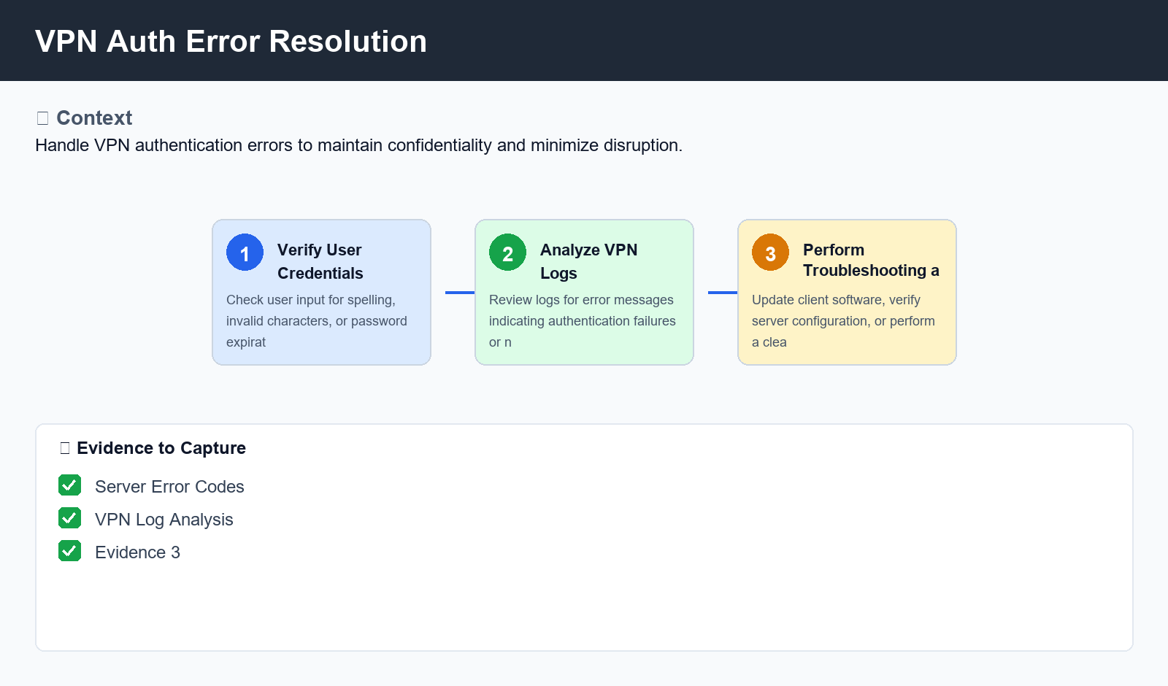
Figure: VPN Auth Error Resolution

6. Procedure
- Step 1: Verify User Credentials - Check user input for spelling errors, invalid character combinations, or password expiration. Ensure that the user's account is active and has not been locked out due to excessive failed login attempts.
- Step 2: Analyze VPN Logs - Review VPN logs for error messages indicating authentication failures, network connectivity issues, or certificate validation problems. Identify potential causes such as misconfigured clients, outdated software, or incorrect server settings.
- Step 3: Perform Troubleshooting and Resolution - Attempt to resolve the issue by updating client software, verifying server configuration, or performing a clean reboot of the VPN connection. If necessary, escalate the issue to senior Network Administrators for further investigation and resolution

7. Validation
- Server Error Codes
- VPN Log Analysis
- Client Software Version

8. Troubleshooting
Issue | Cause | Resolution
Authentication Failure with Error Code 1203 | Invalid username or password combination | Check user credentials for spelling errors, invalid character combinations, or password expiration. Verify that the account is active and has not been locked out due to excessive failed login attempts.
Connection Refused by Server with Error Code 10061 | Network connectivity issues or VPN server downtime | Verify network connectivity using a separate device or network cable. Check VPN server status for planned maintenance, upgrades, or downtime. If the issue persists, contact senior Network Administrators for further assistance.

9. Rollback / Recovery
- Revert to Default VPN Configuration

10. References
- VPN Server Manual
- Client Software Documentation
- Network Administrator Guidelines

