Outlook Configuration Error
Effective Date: June 08, 2026

1. Purpose
This SOP exists to provide a step-by-step guide for resolving Outlook configuration errors, ensuring minimal disruption to business operations.

2. Scope
- All employees using Outlook for email and calendar purposes
- IT department personnel responsible for Outlook configuration and maintenance
- Managerial staff with oversight of IT department activities

3. Prerequisites
- Valid Microsoft Office 365 subscription
- Outlook client software installed on the user's computer or mobile device
- Administrator account credentials with necessary permissions

4. Roles and Responsibilities
Role | Responsibility
IT Support Specialist | Resolve Outlook configuration errors using this SOP
Office Manager | Verify IT support specialist has completed the procedure and ensure all users are back online

5. Process Overview
The following WORKFLOW diagram illustrates the key steps in this procedure:
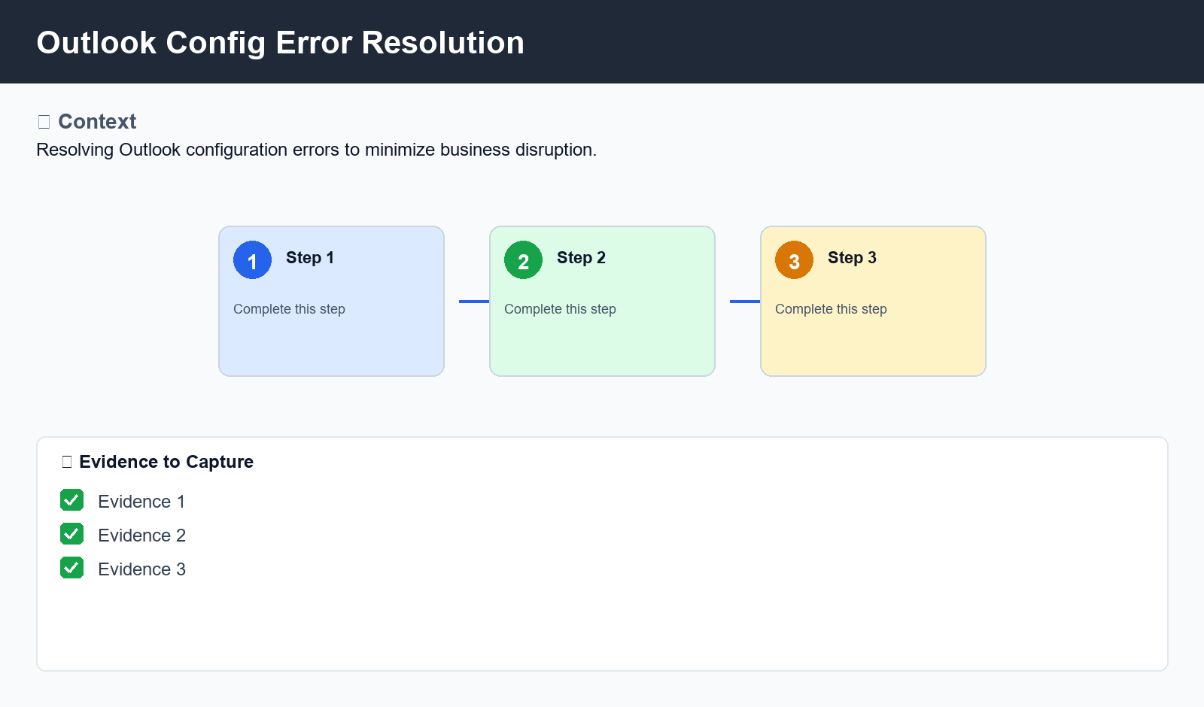
Figure: Outlook Config Error Resolution

6. Procedure
- Step 3: Verify Configuration and Client Settings
- Check Outlook client settings for any incorrect or conflicting configurations
- Verify that all account settings, including IMAP, POP3, and SMTP, are correct

7. Validation
- Verify all steps completed successfully

8. Troubleshooting

9. Rollback / Recovery
- Contact support if rollback is needed

10. References
- Related documentation

