vpn configuration error
Effective Date: June 08, 2026

1. Purpose
To establish a standardized process for resolving VPN configuration errors, ensuring minimal downtime and optimal security.

2. Scope
- Network Administrator
- IT Support Team
- Network Engineers

3. Prerequisites
- VPN software or device updates
- Internet connection check
- Current user permissions

4. Roles and Responsibilities
Role | Responsibility
Network Administrator | Verify VPN configuration, troubleshoot issues, and implement fixes
IT Support Team | Assist users with VPN connectivity, escalate issues to Network Administrators as needed

5. Process Overview
The following WORKFLOW diagram illustrates the key steps in this procedure:
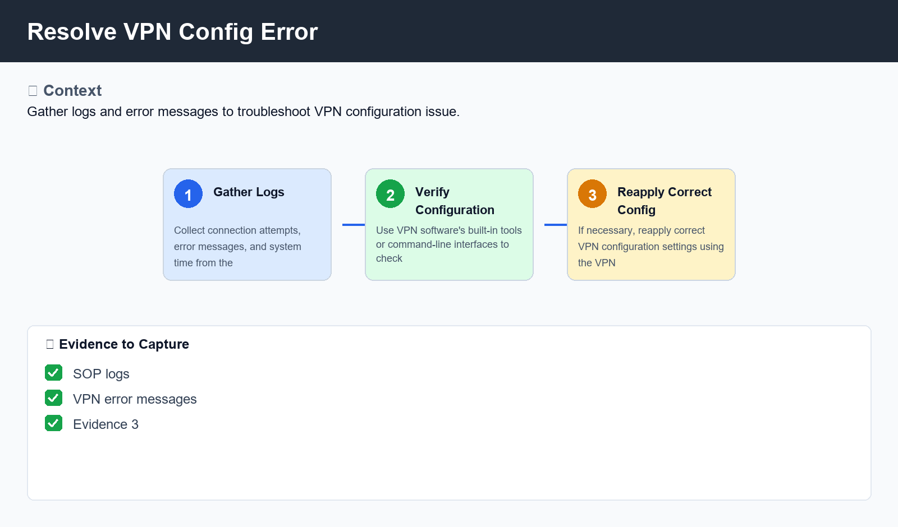
Figure: Resolve VPN Config Error

6. Procedure
- Step 1: Gather VPN Configuration Information - Collect logs from the affected device or user, including connection attempts, error messages, and system time.
- Step 2: Verify Configuration Integrity - Use the VPN software's built-in tools or command-line interfaces to check configuration settings, such as IP addresses, port numbers, and encryption protocols.
- Step 3: Reapply Correct Configuration - If necessary, reapply the correct VPN configuration settings using the VPN software's built-in wizards or manually editing configuration files.

7. Validation
- Check for duplicate connection attempts
- Verify IP address and subnet mask consistency
- Confirm firewall rules are not interfering with VPN connections

8. Troubleshooting
Issue | Cause | Resolution
VPN connection refused by server | Incorrect port number or protocol specified in the configuration | Check and correct port number and protocol settings
Inability to establish a secure tunnel | Insufficient encryption strength or key size specified in the configuration | Increase encryption strength and key size using VPN software's built-in settings

9. Rollback / Recovery
- Restore original configuration settings from backup
- Revert to previous working configuration version

10. References
- VPN configuration manual
- Internet Protocol (IP) documentation
- Secure Sockets Layer/Transport Layer Security (SSL/TLS) protocols guide

