sd-wan Configuration Error
Effective Date: June 08, 2026

1. Purpose
To establish a standardized process for resolving sd-wan configuration errors that impact network connectivity and performance.

2. Scope
- Network operations team
- IT management
- SD-WAN administrators

3. Prerequisites
- sd-WAN device firmware updated
- Firewall rules configured
- Network topology reviewed

4. Roles and Responsibilities
Role | Responsibility
SD-WAN Administrator | Verify configuration integrity and apply corrections
Network Operations Team Lead | Coordinate with SD-WAN administrators and ensure timely resolution

5. Process Overview
The following WORKFLOW diagram illustrates the key steps in this procedure:
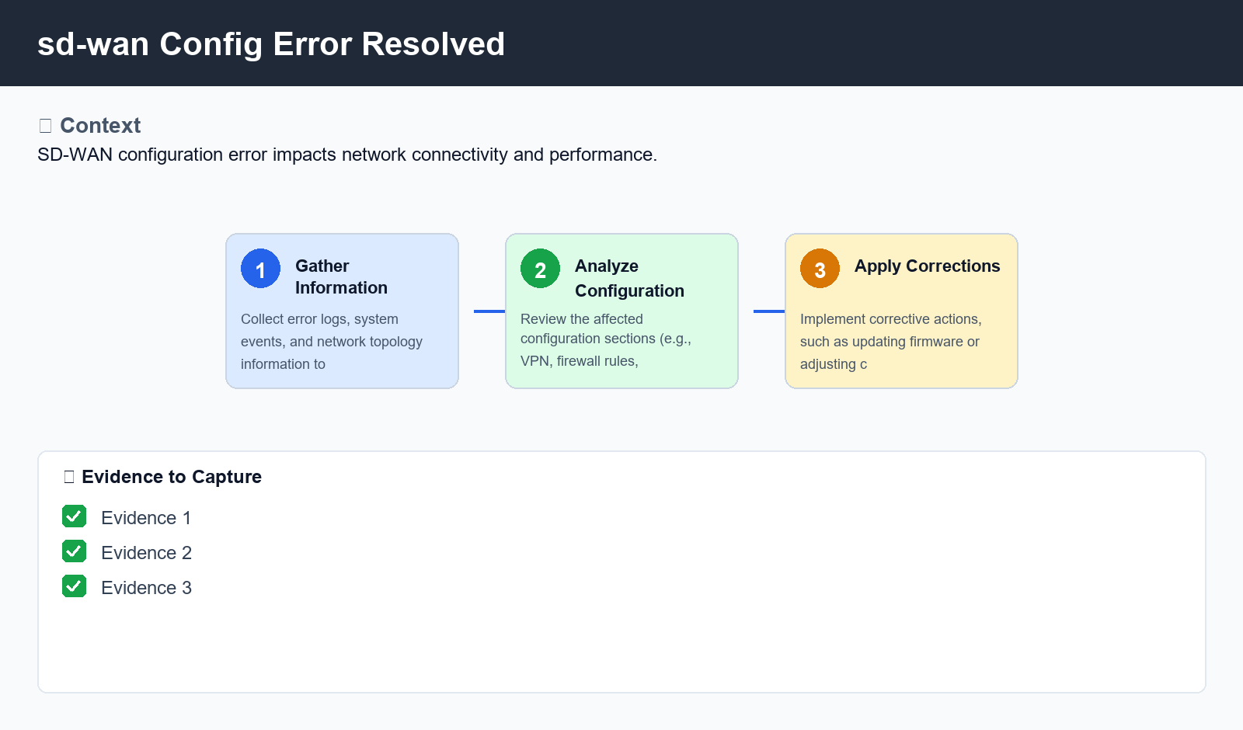
Figure: sd-wan Config Error Resolved

6. Procedure
- Step 1: Gather Information - Collect error logs, system events, and network topology information to identify the root cause of the configuration error.
- Step 2: Analyze Configuration - Review the affected configuration sections (e.g., VPN, firewall rules, routing) and compare with known good configurations to identify discrepancies.
- Step 3: Apply Corrections - Implement corrective actions, such as updating firmware or adjusting configuration settings, to resolve the issue.

7. Validation
- Verify device logs for successful error resolution
- Check network connectivity using ping and traceroute tests

8. Troubleshooting
Issue | Cause | Resolution
SD-WAN device fails to connect to HQ network | Incorrect VPN configuration | Reconfigure VPN settings according to known good configuration
Firewall rules not applied to SD-WAN devices | Insufficient firewall rules configured | Add missing firewall rules to ensure device access and traffic routing

9. Rollback / Recovery
- Rollback changes made in Step 3 (Apply Corrections) if issues persist after correcting configuration

10. References
- SD-WAN documentation
- Firewall best practices
- Network topology diagram

