Outlook Configuration Error SOP
Effective Date: June 08, 2026

1. Purpose
To ensure that Outlook configurations are corrected in a timely and consistent manner, preventing errors from occurring or recurring.

2. Scope
- Company-wide
- Department-specific
- Individual user accounts

3. Prerequisites
- Microsoft Office 365 subscription
- Outlook installation on the client device
- Basic understanding of Outlook settings

4. Roles and Responsibilities
Role | Responsibility
IT Support Specialist | Assist users with configuring their Outlook accounts and troubleshoot issues
Manager | Oversee IT support team's performance in resolving Outlook configuration errors
User | Report issues to the IT department promptly and provide necessary information

5. Process Overview
The following WORKFLOW diagram illustrates the key steps in this procedure:
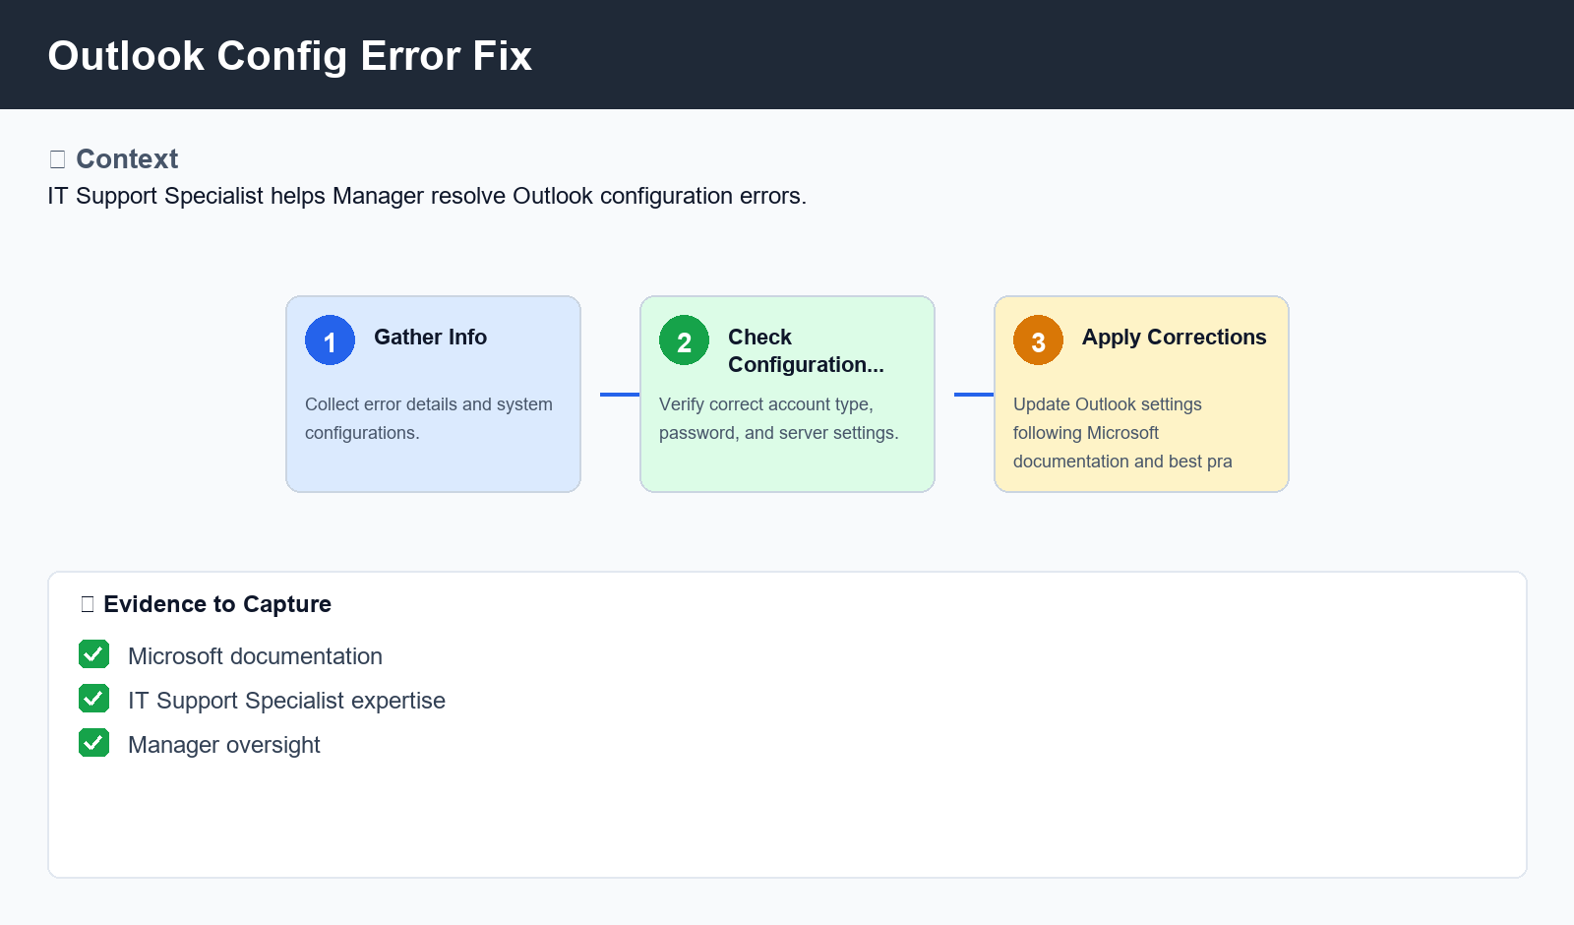
Figure: Outlook Config Error Fix

6. Procedure
- Step 1: Gather Information - Collect relevant details about the error, including error messages, system configurations, and any changes made recently.
- Step 2: Check Configuration Settings - Verify that Outlook settings are correct, including account type, password, and server settings. Use the 'Get Account Info' feature to retrieve account information.
- Step 3: Apply Corrections - Update or reset Outlook configuration settings as necessary, following Microsoft documentation and best practices. If updating is not possible, consider rolling back changes made previously.

7. Validation
- Verify that Outlook configuration is updated correctly
- Check for any error messages or warnings during the update process

8. Troubleshooting
Issue | Cause | Resolution
Error message 'Cannot connect to server' | Incorrect password or authentication settings | Check and correct password, then try connecting again
Outlook won't sync with Exchange/SMB | Insufficient permissions or incorrect server settings | Verify user permissions and update server settings to allow syncing

9. Rollback / Recovery
- Roll back changes made to Outlook configuration if issues persist after corrections
- Restore original settings from backup

10. References
- Microsoft Support Documentation: Outlook Configuration Errors
- Outlook Help Topics: Configuring Account Settings
- IT Best Practices for Outlook Configuration

