Enterprice Incident Management
Effective Date: June 09, 2026

1. Purpose
To ensure timely and effective response to enterprise-level incidents, minimizing impact on business operations and customer satisfaction.

2. Scope
- Enterprise IT infrastructure
- Cloud-based systems and services
- Data centers and colocation facilities

3. Prerequisites
- Incident Management team established and trained
- Enterprise IT service management framework in place
- Communication protocols with stakeholders and customers

4. Roles and Responsibilities
Role | Responsibility
Incident Manager | Assesses incident impact, prioritizes incidents, and leads the response effort
IT Operations Team | Provides technical expertise for incident resolution and maintenance of affected systems
Communication Specialist | Notifies stakeholders and customers, provides status updates, and ensures timely communication

5. Process Overview
The following WORKFLOW diagram illustrates the key steps in this procedure:
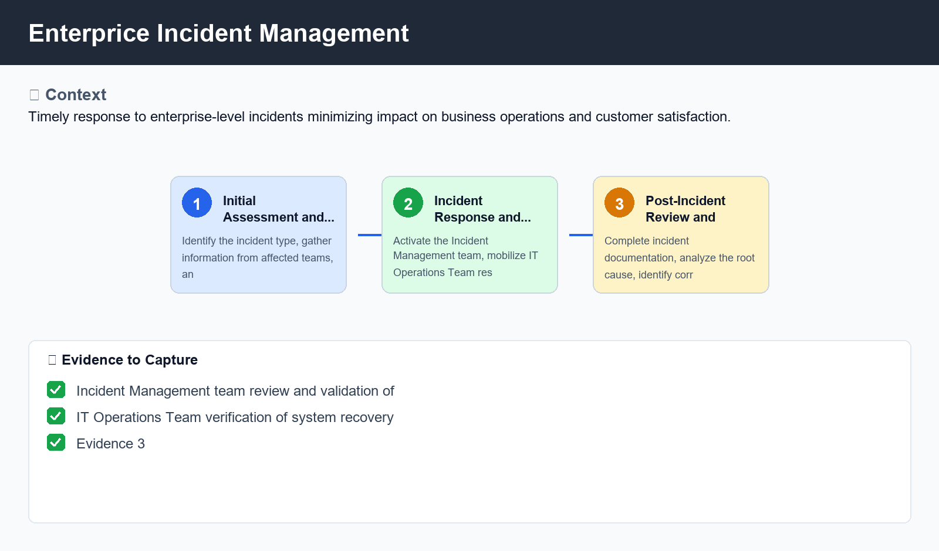
Figure: Enterprice Incident Management

6. Procedure
- Step 1: Initial Assessment and Prioritization - Identify the incident type, gather information from affected teams, and assess the potential impact on business operations. Determine the severity level (e.g., critical, major, minor).
- Step 2: Incident Response and Resolution - Activate the Incident Management team, mobilize IT Operations Team resources, and begin working to resolve the issue. Ensure all necessary stakeholders are informed and involve them in the decision-making process.
- Step 3: Post-Incident Review and Remediation - Complete incident documentation, analyze the root cause, identify corrective actions, and implement changes to prevent similar incidents. Communicate the outcome to stakeholders and confirm the resolution.

7. Validation
- Incident Management team review and validation of incident documentation
- IT Operations Team verification of system recovery and functionality
- Communication Specialist confirmation of stakeholder notification and updates

8. Troubleshooting
Issue | Cause | Resolution
Network connectivity issues | Hardware failure or misconfigured network settings | Restart the affected device, verify network configurations, and replace faulty hardware as needed
Data loss due to system crash | Insufficient disk space or corrupted data | Verify available storage capacity, backup and restore critical data, and run disk checks to prevent future corruption

9. Rollback / Recovery
- Rollback plan for complex incidents involving system downtime
- Automated deployment scripts for quick rollbacks of changes
- Documentation of known issues and workarounds for repeat incidents

10. References
- Enterprise IT incident management framework (e.g., ITIL)
- Cloud provider documentation and guidelines
- Industry benchmarks and best practices for incident management

