Dns Configuration Error SOP
Effective Date: June 09, 2026

1. Purpose
To establish a standardized process for resolving and resolving dns configuration errors, ensuring minimal disruption to the system and efficient resolution of issues.

2. Scope
- Network Devices
- Network Infrastructure
- DNS Server

3. Prerequisites
- Basic understanding of DNS protocol
- Access to network management tools
- Knowledge of firewall configurations

4. Roles and Responsibilities
Role | Responsibility
Network Administrator | Monitor dns configuration for errors and notify IT team
IT Team Lead | Coordinate with network administrators to resolve dns configuration errors

5. Process Overview
The following WORKFLOW diagram illustrates the key steps in this procedure:
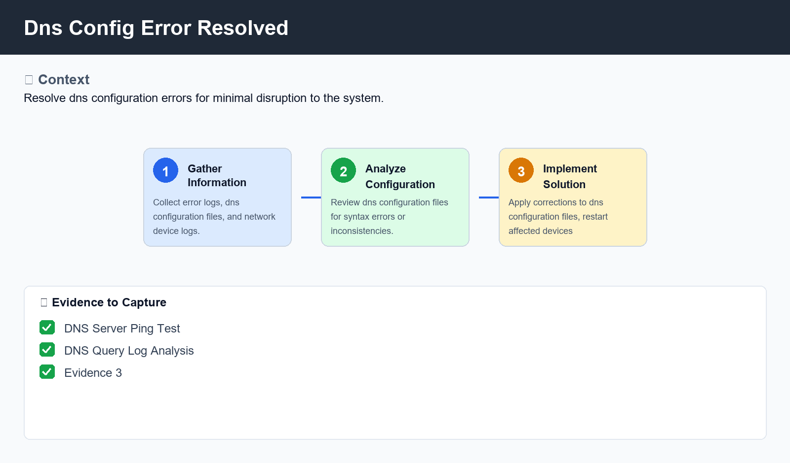
Figure: Dns Config Error Resolved

6. Procedure
- Step 1: Gather Information - Collect error logs, dns configuration files, and network device logs to identify the root cause of the issue.
- Step 2: Analyze Configuration - Review dns configuration files for syntax errors or inconsistencies that may be causing the issue.
- Step 3: Implement Solution - Apply corrections to dns configuration files, restart affected devices, and verify that the issue has been resolved.

7. Validation
- DNS Server Ping Test
- DNS Query Log Analysis

8. Troubleshooting
Issue | Cause | Resolution
Zone Transfer Error | Incorrect zone transfer settings or network connectivity issues | Verify zone transfer settings, check network connectivity, and restart affected devices.
DNS Resolution Failure | Missing dns records or incorrect record formatting | Verify dns records for accuracy, update records as necessary, and try the dns resolution again.

9. Rollback / Recovery
- Rollback dns configuration changes to previous version

10. References
- ReferenceURL
- ReferenceURL

