**Identification of the Driver's Drowsiness From Facial Expressions**

### Corresponding Author

### Benjula Anbu Malar M B

### Assistant Professor Sr. Grade 1

### *School of Information Technology & Engineering*

### *Vellore Institute of Technology*

Vellore, Tamil Nadu, India

mbbenjulaanbumalar@vit.ac.in

### Ayush Amoli

ayush.amoli2022@vitstudent.ac.in

### Harsh Vaibhav

harsh.vaibhav2022@vitstudent.ac.in

***Abstract -***

**Driver Drowsiness is a technique based on Neural Intelligence using Machine Learning. A person with no sound can sleep effortlessly or take a nap during a journey on the highway. There must be a system that can witness the Drowsiness of the Driver.**

**After a lot of research and experiments, Machine Learning (AI-based) has developed some methods to determine whether a person is sleepy or not by using some biological gestures of facial behavior which can save the lives of many people during their journey.**

**Machine learning has some specialized Video Processing Algorithms using OpenCV, through which we can detect the drowsiness named Neural Network Model. It mainly includes the eye**

**position, the estimation of the numeral times that person is blinking his/her eyes, also with the expression of mouth like yawning which will raise alarms, which will definitely gain the attention of the Driver. If no response comes through the driver's end, the system will inform their family members with some messaging/calling feature.**

### Md Qutubuddin Ansari

mdqutubuddin.ansari2022@vitstudent.ac.in

***Keywords:*** *Machine learning, Video Processing Algorithms, Neural Network Model, Messaging/Calling feature.*

**Introduction:-**

**In this Research Paper, we propose a Drowsiness Detection System as a means to improve automobile safety and security. This generally combines Image Processing through a webcam, Facial Pattern Recognition, Sound Alarm, etc.**

**Nowadays, there are so many car accidents that driver indifference is a major factor. Therefore, a key challenge for accident prevention systems is the advancement of technology in the field of detecting and eliminating tiredness, particularly at night. Therefore, in order to stop these dangerous incidents, we are putting forth a detection system that primarily relies on real-time video processing in OpenCV and keeps a watch on the driver's yawning and eye- blinking patterns.**

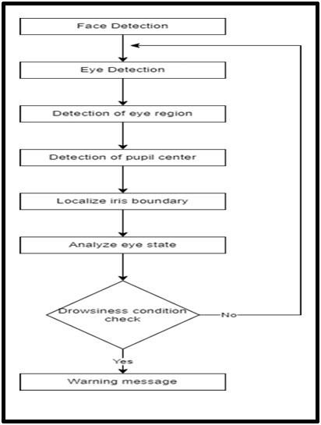

### Md Qutubuddin Ansari

mdqutubuddin.ansari2022@vitstudent.ac.in

Fig1.Flowchart

**Literature Survey:-**

**This article sought to prevent this issue by developing a method to calculate the level of sleepiness. A pre-requisite for this method was the use of the Raspberry Pi and the Raspberry Pi 3 module that can be used to calculate the driver's level of fatigue. The tilting of the head and blinking frequency was used to calculate if the driver felt drowsy.[1] Describes an efficient method in this paper, an online facial surveillance system was installed and the list of eye’s region features was extracted in the spatial and frequency domains. The characteristics monitored were the roundness and black ratio. 4-machine classification of support vectors was developed based on the combinations of the related features. The outcome of the proposed method showed promise for in-line implementation in vehicles to determine driver fatigue status [2] This paper detects drowsiness through well-defined in three stages. These three phases are facial feature detection, eye tracking, and yawn detection by Viola-Jones. When a face is detected, the system segments ( ) only skinny part and considers just color component to eliminate ( ) maximum without face image background according to the complexion. Lighting remains unchanged.[3] The study found that HRV parameters such as root mean square of successive differences (RMSSD , standard deviation of normal-to-normal intervals (SDNN),) and pNN50 (proportion of successive normal-to- normal intervals that differ above 50ms) were correlated with the participants' drowsiness levels. The researchers used these HRV parameters as features to teach a classifier based on a support vector machine (SVM,how to tell the difference between alert and sleepy states . Limitations in this study was that small sample size of only 8 participants, which may not be representative of the wider population, and the simulated driving task may not fully replicate real-world driving conditions. Additionally, the study did not consider the effect of individual differences in driving behavior on drowsiness detection.[4] The paper describes an analysis of road accidents using data mining techniques to identify the main causes of accidents and propose solutions to prevent them. The study was conducted in India, where road accidents are a major problem, resulting in thousands of deaths and injuries each year. According to her one of the main reasons was Drivers Fatigue, which lead us to choose this area for research. [5] The paper provides a comprehensive survey of camera-based techniques for driver detection in vehicles. The study reviews various approaches to driver detection, including facial recognition, eye tracking, and head pose estimation. It also emphasizes the need for further research in this area, particularly in developing more advanced algorithms that can detect driver behavior in real time and under varying conditions. [6] The paper presents a comparative study of EEG-based driver drowsiness detection methods. The study evaluates the performance of several techniques, such as power spectral density analysis, entropy analysis, and coherence analysis, in detecting drowsiness in real-world driving scenarios. Their performance is affected by several characteristic, like peculiarity of EEG signal and variability of individual driver. The paper concludes by highlighting the need for further research to develop more accurate and robust EEG-based 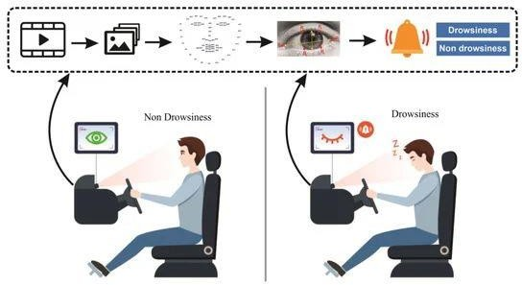detection systems[7]**

Fig 2: Architecture

**Methodology -**

**SOFTWARE REQUIRED: PYTHON**

**PYTHON LIBRARIES:**

**NUMPY:** *This library is a PRE-REQUISITE for the DLIB python lib.*

**SCIPY:** *It is a library used for the calculation consisting of Arithmetic operations. We have used the calculation of EUCLIDEAN Distance.*

**PYDUB:** *Used to activate the alarming system while the driver yawns or closes their eyes.*

**DLIB:** *This library file is used to get the frontal facial points and detect the activities using 68 landmarks contained in face.*

**IMUTILS:** *Functions written contained in OpenCV. It is an Image processing tool like Resizing, rotation, and translation.*

**OPENCV:** *Get video stream using the webcam, etc.*

**HARDWARE REQUIRED:**

**1)** *Laptop*

**2)** *A webcam*

**Implementation**

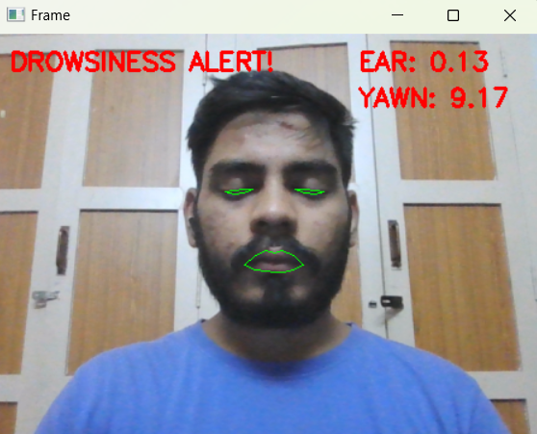

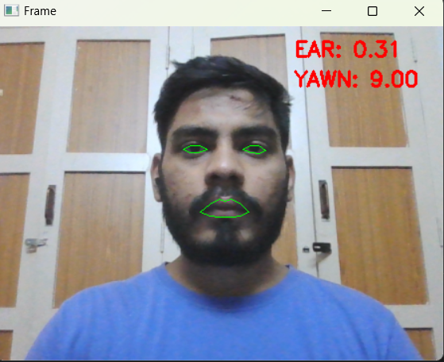

**Trial Results**

In the testing of the program, total 300 trials were made out of which 247 were successfully detected by the program giving an accuracy of 82.33%

**References:-**

**[1] Varakoorn Koschkosai, Oran Khunpisutha, Taweechain Cotchinansari, (2014), Real Time Embedded System Application of Driver Drowsiness for the Raspberry Pi Camera and the Raspberry Pi 3 module, IJETT, Volume 10 Number 9.**

**[2] Hardeep Singh, J K Bhatia and Jasbir Kaur(2011), Eye Tracking mainly based on Driver Fatigue Monitoring and Alarming System, IEEE.**

**[3] B. N. Manu, "Facial features monitoring for real time drowsiness detection," 2016 12th International Conference on Innovations in Information Technology (IIT), Al Ain, United Arab Emirates, 2016, pp. 1-4, doi: 10.1109/INNOVATIONS.2016.7880030.**

**[4] M. Omidyeganeh et al., "Yawning Detection Using Embedded Smart Cameras," in IEEE Transactions on Instrumentation and Measurement, vol. 65, no. 3, pp. 570-582, March 2016, doi: 10.1109/TIM.2015.2507378.**

**[5] Gupta, M., Solanki, V.K. and Singh, V.K., 2017. Analysis of Datamining Technique for Traffic Accident Severity Problem: A Review. RICE, pp.197-199.**

**[6] A. Altameem, A. Kumar, R. C. Poonia, S. Kumar and A. K. J. Saudagar, "Early Identification and Detection of Driver Drowsiness by Hybrid Machine Learning," in IEEE Access, vol. 9, pp. 162805-162819, 2021, doi: 10.1109/ACCESS.2021.3131601.**

**[7] Subasi, A., Saikia, A., Bagedo, K., Singh, A. and Hazarika, A., 2022. EEG-based driver fatigue detection using FAWT and multiboosting approaches. IEEE Transactions on Industrial Informatics, 18(10), pp.6602-6609.**