Heart Disease Prediction
An AI Mini-Project Report
Group Project — Artificial Intelligence Mini Project
Team Members: ______________________

1. Problem Definition & Objective
Cardiovascular disease is one of the leading causes of death worldwide, and early identification of at-risk patients is critical for timely intervention and improved treatment outcomes. This project addresses the problem of predicting the presence of heart disease in a patient using routinely collected clinical measurements: age, gender, chest pain type, resting blood pressure, cholesterol level, maximum heart rate achieved, ST depression induced by exercise, and exercise-induced angina.
The goal of this project is to build and evaluate a supervised machine learning classification model that can flag patients at higher risk of heart disease from these clinical attributes, and to package that model as a simple, usable prediction tool. This is a binary classification task, where the target variable (Heart_Disease) indicates the presence (1) or absence (0) of heart disease.
Relevance and impact: a lightweight, interpretable screening tool built on easily obtainable clinical measurements could support early-stage triage in resource-constrained healthcare settings, complementing (not replacing) full clinical diagnosis by a physician.

2. Data Acquisition
The dataset used for this project was provided as a CSV file (heart_patients_dirty_dataset.csv), structured similarly to well-known public heart disease datasets (e.g. the UCI Heart Disease dataset family commonly hosted on Kaggle).

Dataset Description
- Size: 1,020 rows × 10 columns (raw, before cleaning)
- Format: CSV (comma-separated values)
- Features (9): Patient_ID, Age, Gender, Chest_Pain_Type, Resting_BP_mmHg, Cholesterol_mg/dl, Max_Heart_Rate, ST_Depression, Exercise_Induced_Angina
- Target (1): Heart_Disease — binary classification label
Justification: this dataset was chosen because it represents a realistic, moderately messy clinical dataset — a good fit for demonstrating the full data science workflow, including non-trivial cleaning, without requiring domain-specific data collection infrastructure.

3. Data Cleaning & Preprocessing
The raw dataset contained substantial data quality issues that required systematic cleaning before modeling:
- Dropped Patient_ID — a unique identifier with no predictive value.
- Age contained the literal string "unknown" mixed with numeric values; these were converted to missing values via numeric coercion.
- Gender had inconsistent casing (male, Male, FEMALE, Female) — standardized to Male/Female.
- Exercise_Induced_Angina had inconsistent casing (Yes, yes, No, NO) — standardized to Yes/No.
- The target column Heart_Disease used mixed representations ("zero", "one", "0", "1", and blanks) — mapped to a clean integer 0/1, and rows with a missing target were dropped since a model cannot be trained or validated without a label.
- Removed exact duplicate rows.
- Remaining missing numeric values were imputed with the column median; missing categorical values were imputed with the column mode.
- Outliers in numeric columns were capped using the interquartile range (IQR) method rather than removed outright, since extreme-but-real values can be clinically meaningful.
After cleaning, the dataset was reduced from 1,020 to 769 rows, retaining a clean, consistent set of 9 usable columns (8 features + 1 target).

4. Exploratory Data Analysis (EDA)
Exploratory analysis was performed on the cleaned dataset to understand class balance, feature distributions, and relationships with the target.

Target Class Balance
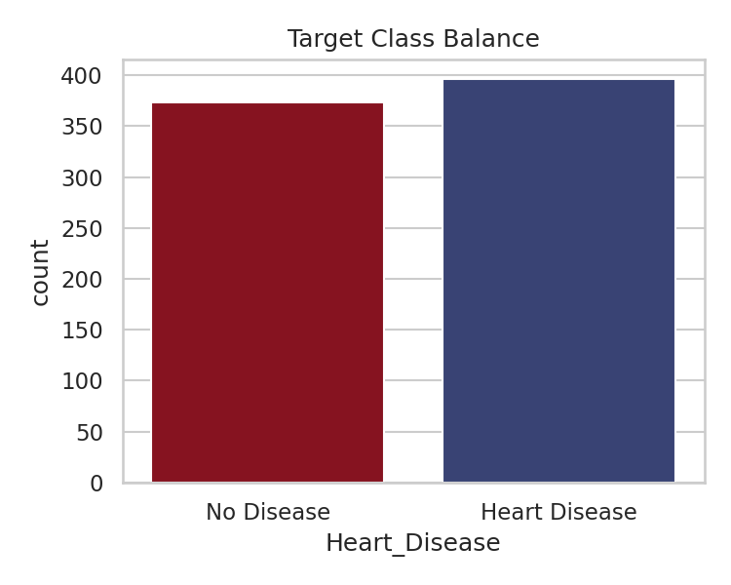

Age Distribution by Heart Disease Status
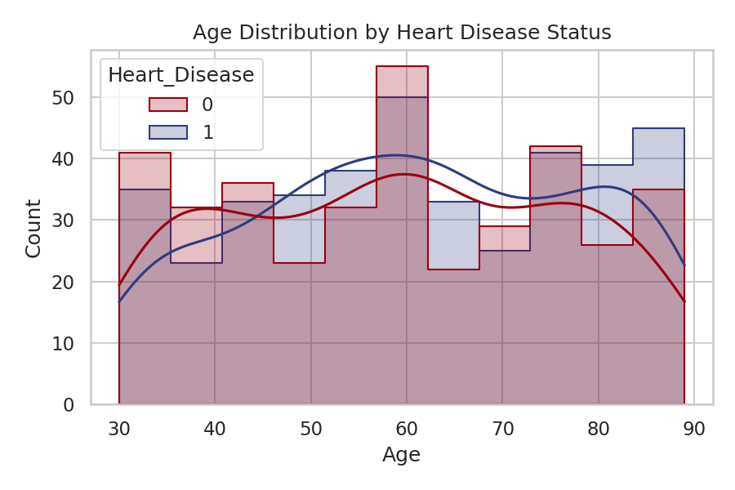

Correlation Heatmap
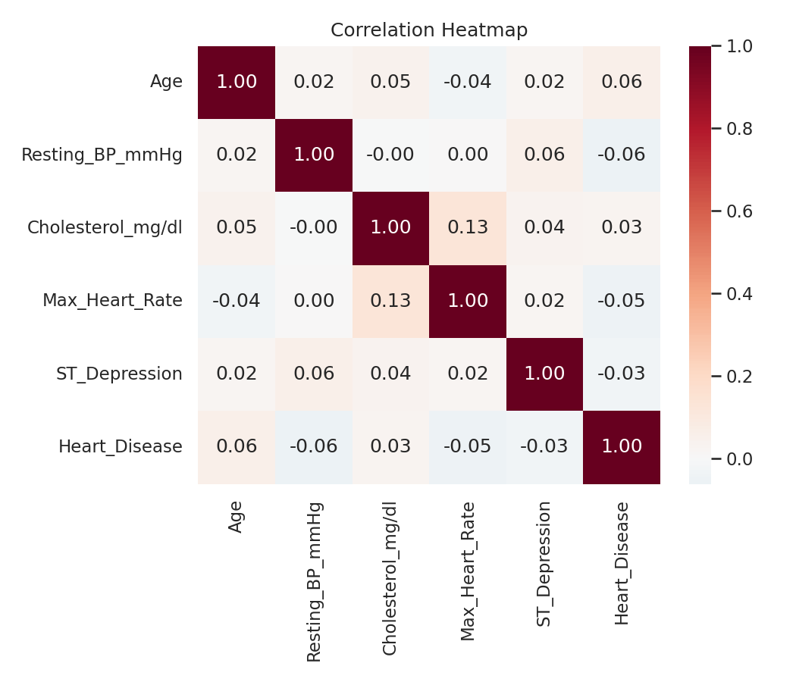

Boxplots of Key Numeric Features by Target
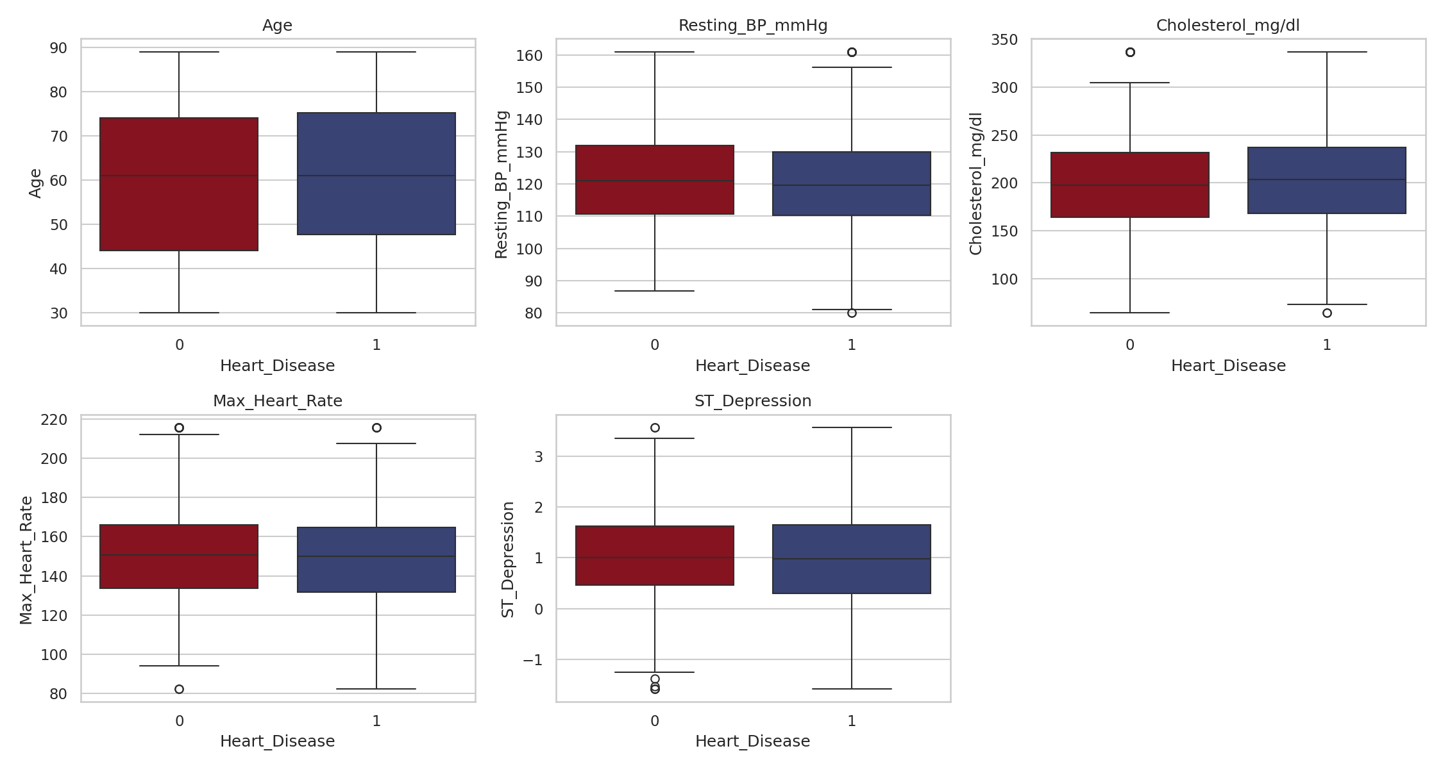

Chest Pain Type vs. Heart Disease
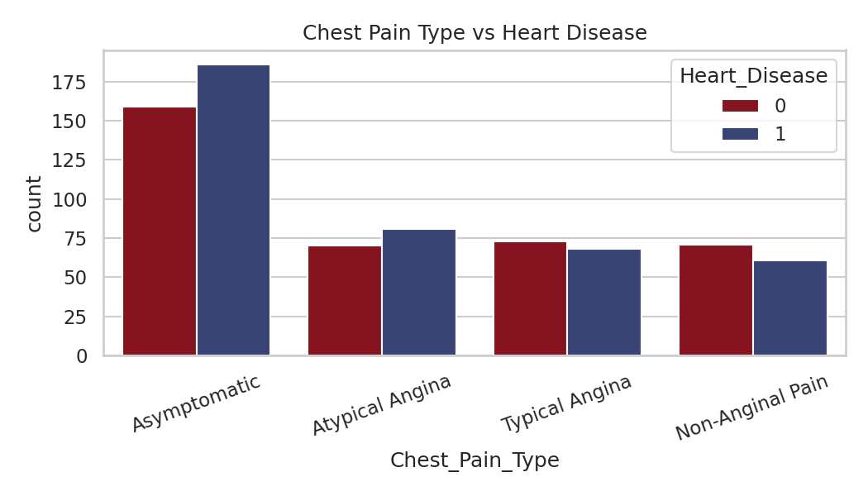

Gender vs. Heart Disease
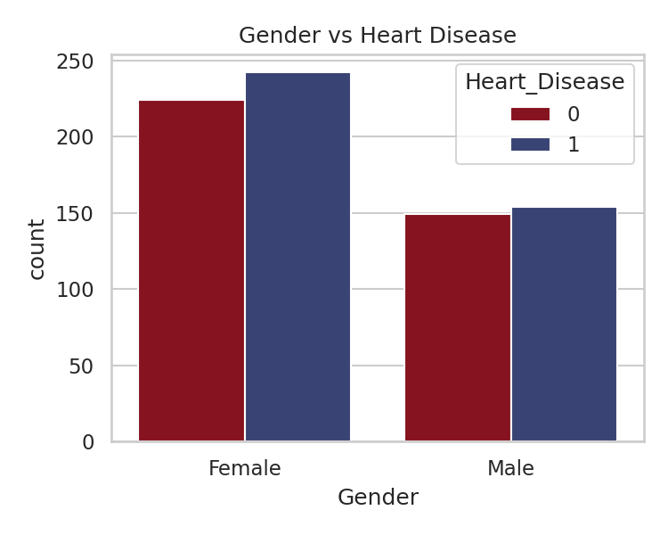
Key observations: the target classes are reasonably balanced. No single numeric feature shows a dramatically strong linear correlation with the target, suggesting the relationship between features and heart disease risk in this dataset is non-linear or weak — a point revisited in the Results Interpretation section.

5. Feature Engineering
Building on the cleaned dataset, the following transformations were applied to prepare features for modeling:
- One-hot encoded categorical variables: Gender, Chest_Pain_Type, and Exercise_Induced_Angina.
- Engineered an Age_Group feature by binning Age into clinically meaningful ranges (<40, 40–55, 56–70, 70+), one-hot encoded.
- Engineered a High_Cholesterol_Flag binary feature, flagging patients with cholesterol above the clinical threshold of 240 mg/dl.
- Standardized numeric features (Age, Resting_BP_mmHg, Cholesterol_mg/dl, Max_Heart_Rate, ST_Depression) using z-score scaling (StandardScaler), fit only on the training split to avoid data leakage.
The final feature set contained 14 columns after encoding and engineering.

6. Model Building
Since this is a binary classification problem, four candidate model families were trained and compared: Logistic Regression, Decision Tree, Random Forest, and Support Vector Machine (SVM). A fifth variant, a hyperparameter-tuned Random Forest, was produced using grid search (5-fold cross-validation, optimizing F1-score) over n_estimators, max_depth, and min_samples_split.
Data was split 80/20 into training and test sets using stratified sampling to preserve class balance, with a fixed random seed (random_state=42) for reproducibility.

7. Model Evaluation
All five models were evaluated on the held-out test set using Accuracy, Precision, Recall, F1-Score, and ROC-AUC:
Model | Accuracy | Precision | Recall | F1-Score | ROC-AUC
Decision Tree | 0.571 | 0.576 | 0.620 | 0.598 | 0.570
Random Forest (Tuned) | 0.519 | 0.527 | 0.608 | 0.565 | 0.501
Random Forest | 0.539 | 0.551 | 0.544 | 0.548 | 0.490
Logistic Regression | 0.448 | 0.468 | 0.557 | 0.509 | 0.448
SVM | 0.442 | 0.457 | 0.468 | 0.463 | 0.447

The Decision Tree achieved the best F1-score (0.598) and was selected as the final model.

Confusion Matrix — Decision Tree (Best Model)
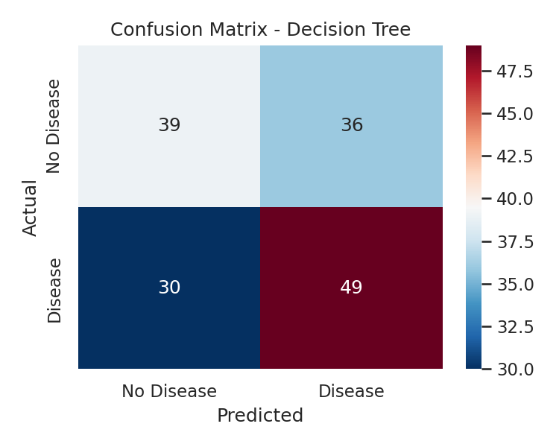

ROC Curve Comparison
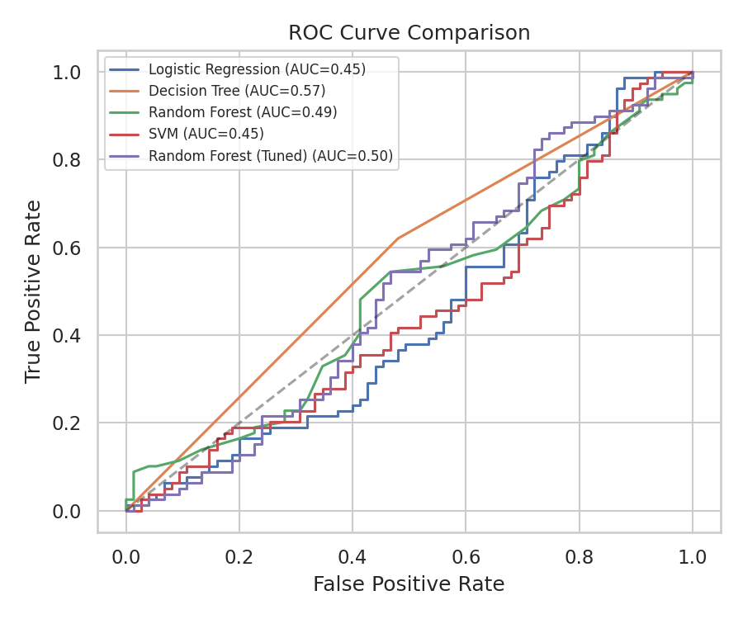

8. Results Interpretation & Insights

Feature Importance
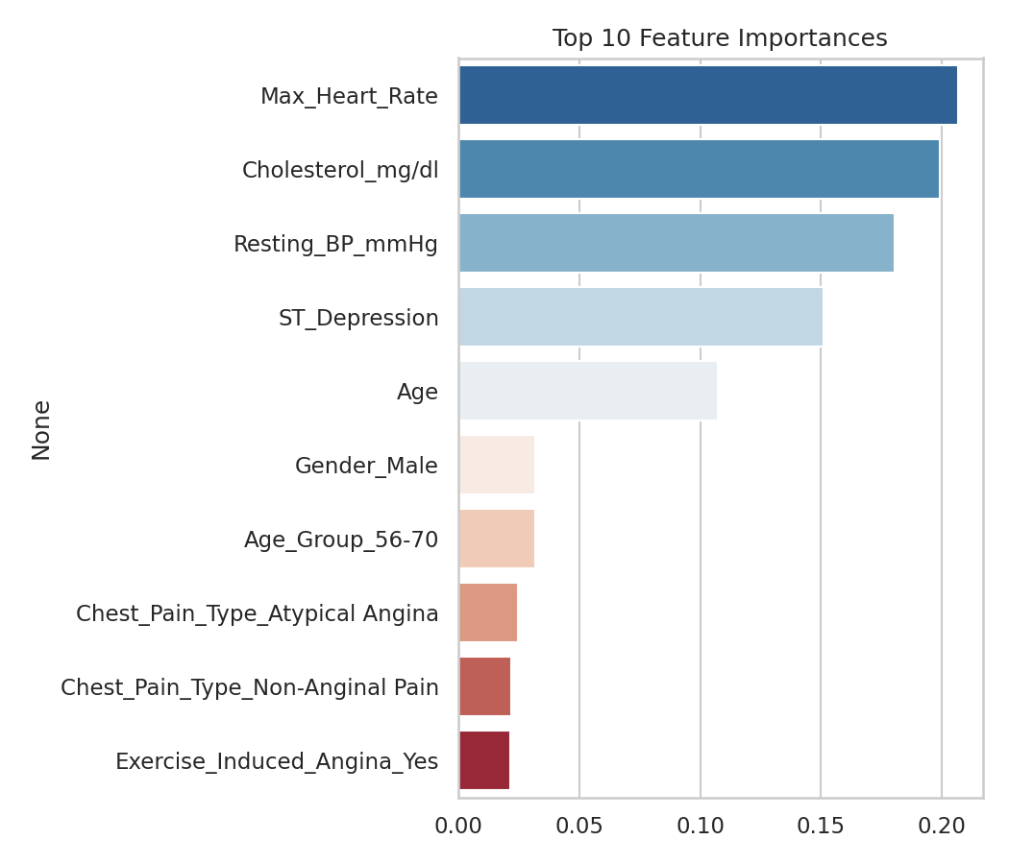
Max_Heart_Rate, Cholesterol_mg/dl, Resting_BP_mmHg, ST_Depression, and Age emerged as the top five most influential features for the Decision Tree model, broadly consistent with established clinical risk factors for cardiovascular disease.

Honest Assessment of Performance
All models achieved modest performance (accuracy and F1-score in the 0.44-0.60 range), only somewhat better than a random baseline (~0.50 for a balanced binary problem). This is an important and honest finding, not a flaw to hide: it suggests that either (a) the relationship between these particular features and heart disease in this dataset is weak or highly non-linear, (b) the dataset — after removing rows with missing/invalid labels — is too small (769 rows) for the models to learn robust patterns, or (c) there is inherent noise in how this dataset was constructed.
Real-world implication: this result is itself a valuable insight — it demonstrates why clinical decision support tools require large, high-quality, well-labeled datasets and rigorous validation before deployment, and why a model like this should be treated as a supplementary screening aid, never a diagnostic replacement for a qualified physician.
Recommendation: with access to a larger and more rigorously collected dataset (e.g. the full UCI Cleveland Heart Disease dataset, ~300+ additional clinical variables, or a larger Kaggle heart disease dataset), model performance would likely improve substantially. This is a natural direction for future extension of the project.

9. Deployment
The final trained model was deployed as an interactive web application using Streamlit. The app allows a user to enter a patient's clinical details (age, gender, chest pain type, resting BP, cholesterol, max heart rate, ST depression, and exercise-induced angina) through a simple form, and returns a predicted heart disease risk classification along with an estimated probability.
- Framework: Streamlit (Python)
- Location: app/app.py in the project repository
- To run locally: pip install -r requirements.txt, then streamlit run app/app.py
- The app loads the serialized model (best_model.joblib), scaler (scaler.joblib), and exact feature column order (feature_columns.joblib) to ensure predictions exactly match the trained pipeline.

10. Documentation & Conclusion
This report, together with the accompanying GitHub repository (containing the full cleaning/EDA/modeling script, trained model artifacts, deployment app, and presentation slides), documents the complete AI development lifecycle applied to the heart disease prediction problem: from problem definition through data acquisition, cleaning, EDA, feature engineering, model building, evaluation, honest results interpretation, and deployment.
Key learnings from this project include the practical challenges of real-world messy data (inconsistent formatting, missing values, ambiguous labels), the importance of transparent reporting of model limitations, and the value of packaging a model into a usable, interactive tool.
GitHub Repository: ______________________
Deployed App Link (if hosted): ______________________

