# Personal Details

**Full name**: Ashton Mondreo Petersen

**Contact Number**: 0613524805

**Email Address**: ashtonpetersen0@gmail.com

# Career Objectives

I am seeking opportunities to grow my skills and work in an environment that rewards hard work and adaptability therefore as part of my curriculum for the Diploma in Information and Communication Technology, I am seeking a placement in the field of application development for my current institute’s Work-Integrated-Learning program which starts in July. Through this placement I aim to apply the knowledge I’ve acquired over the course of my studies in a real-world setting and develop the skills necessary for aspects of the industry such as application development, agile and scrum methodology and software testing.

# Education

## Secondary Education

* **Name of Highschool:** Spine Road High School, Cape Town

**Qualification:** Senior Certificate

**Obtained Date:** December 2019

## Tertiary Education

* **Name of Institute:** Cape Peninsula University of Technology, Cape Town

**Qualification:** Higher Certificate of Information and Communication Technology

**Obtained Date:** January 2021

* **Name of Institute:** Cape Peninsula University of Technology, Cape Town

**Qualification:** Diploma in Information and Communication Technology

**Obtained Date:** Still Obtaining

# Work Experience

* **Name Of Company:** Vetzcare

**Job Title:** Part-time sales assistant

**Duration Of Job:** August 2018 - 2019

**Duties:** Answering customer inquiries

Assists customers in locating specific products

Cleaning the store

Assisting cashiers

Directing customers to the manager when applicable

Greeting customers upon entering the store

# Skills

* HTML
* CSS
* Javascript
* Delphi
* Java
* Greenfoot application development
* Relational Database management
* Github
* SQL
* Project Management
* Teamwork
* Communication Skills

# References

## Reference 1

**Name of person:** Mrs Genevieve Le Grange

**Name of organization:** Vetzcare

**Contact Number:** 079 186 1263

**Email Address**: Genevievelegrange95@gmail.com

# Supporting Documents

## Identification



## Matric Certification

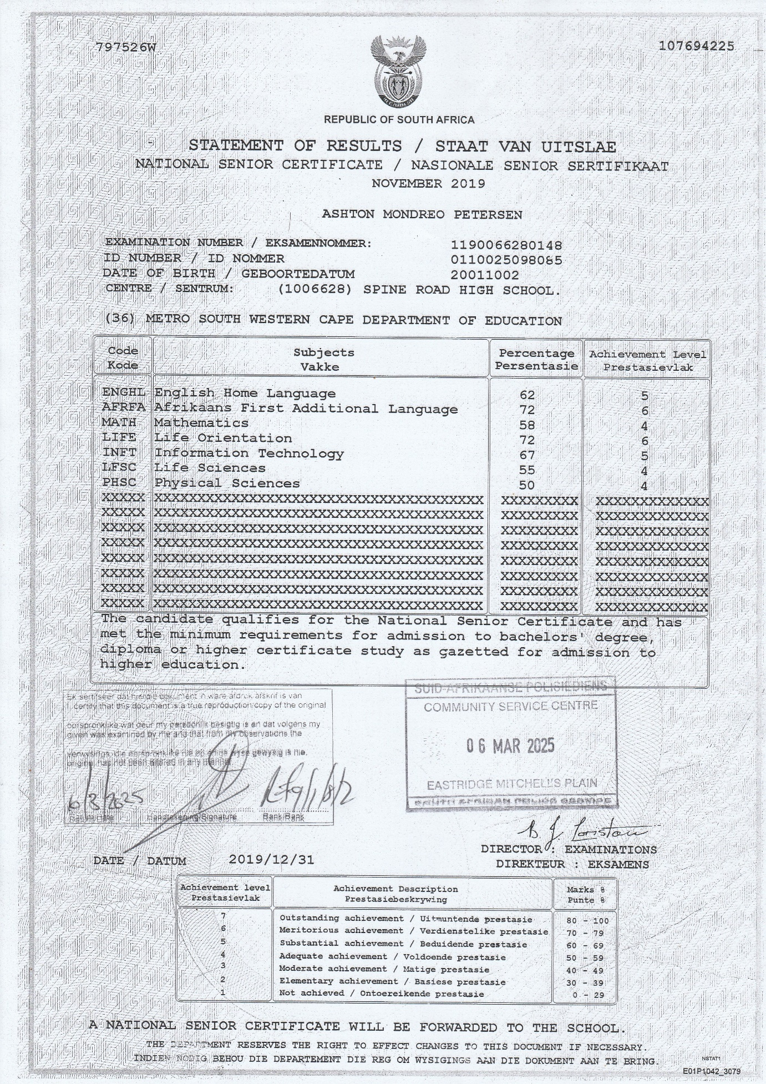

## Higher Certificate Certification

