Orbital Threat Assessment: Classifying Near-Earth Asteroids with Machine Learning
Team 20
Venkata Sriya Kamarsu | Akshay Madavalappil Ramesh
INFO 6105 – Data Science Engineering Methods and Tools
Northeastern University, College of Engineering

1. Introduction

1.1 Background
The threat posed by near-Earth asteroids (NEAs) has become a central concern in modern planetary science and global security. Over the past several decades, NASA and space agencies worldwide have catalogued thousands of asteroids whose orbits bring them into proximity with Earth's orbital path. Among these, a formally defined subset is classified as Potentially Hazardous Asteroids (PHAs) -- objects whose minimum orbit intersection distance (MOID) with Earth is less than 0.05 astronomical units (AU) and whose absolute magnitude meets a threshold indicating a diameter large enough to cause regional or global catastrophic damage upon impact.
The Minimum Orbit Intersection Distance is defined as the closest possible approach distance between the orbital paths of an asteroid and Earth, calculated geometrically without accounting for gravitational perturbations. An asteroid with MOID < 0.05 AU passes within approximately 7.5 million kilometres of Earth's orbit at its closest point. The absolute magnitude is a standardised measure of brightness that serves as a reliable proxy for physical size: lower values indicate larger objects. The threshold of absolute magnitude <= 22 approximately corresponds to a diameter of 140 metres or greater, the minimum size considered capable of causing significant regional destruction upon atmospheric entry or ground impact.
Historically, the identification of hazardous asteroids has relied on a combination of ground-based telescope observation and costly physical characterisation measurements, including direct diameter estimates, albedo measurements, and spectroscopic classification. These measurements are expensive, time-consuming, and unavailable for the vast majority of catalogued objects. In contrast, the orbital mechanics of an asteroid can be determined with high precision for nearly all known objects from a relatively small number of telescope observations. Orbital elements such as eccentricity, perihelion distance, semi-major axis, and inclination are computed routinely and are available for over 950,000 asteroids in the NASA JPL Small-Body Database.
This creates a compelling opportunity for machine learning: can we reliably predict whether an asteroid is potentially hazardous using only its orbital characteristics, without requiring costly physical measurements? And how much predictive power does the MOID measurement itself contribute, given that it is a component of the formal PHA definition?
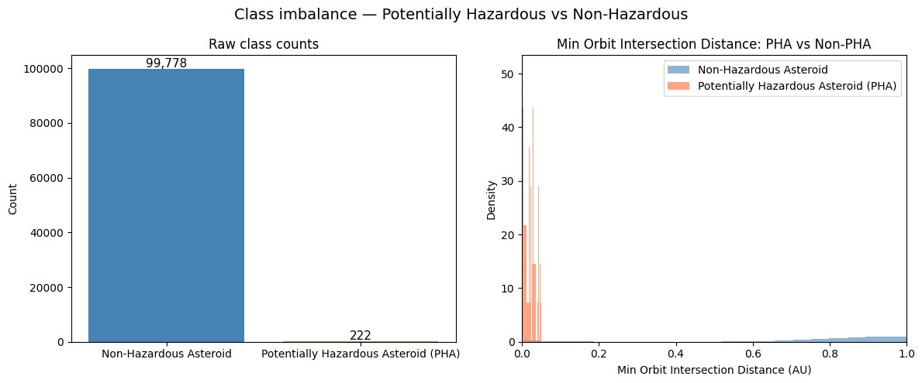
Figure 1.1: MOID distribution for hazardous (PHA=Y) and non-hazardous (PHA=N) asteroids. PHAs cluster tightly below 0.05 AU, confirming the two-condition classification boundary discovered during exploratory data analysis.
The NASA JPL Small-Body Database, one of the most comprehensive publicly available astronomical datasets, contains orbital and physical parameters for 958,524 asteroids. While orbital parameters are well-measured for nearly all objects, physical parameters such as diameter, albedo, and rotation period are missing for over 85% of entries, presenting a realistic and challenging missing-data problem. This combination of a large, imbalanced, and incomplete real-world dataset makes asteroid hazard classification an ideal problem for applied machine learning research.

1.2 Motivation
The motivation behind this project is rooted in the real-world implications of planetary defence. A single undetected potentially hazardous asteroid could have devastating consequences for life on Earth. The 1908 Tunguska event, in which an asteroid estimated at 50 to 100 metres diameter flattened approximately 2,000 square kilometres of Siberian forest, demonstrates that even sub-kilometre objects pose serious regional threats. More recently, the 2013 Chelyabinsk meteor, approximately 20 metres in diameter, caused widespread glass damage and injured over 1,500 people in Russia without any prior detection.
While NASA's planetary defence programs actively monitor known asteroids, the challenge of rapidly classifying newly discovered objects as hazardous or non-hazardous remains significant. When a new asteroid is discovered, basic orbital elements are calculated almost immediately from a small number of telescope observations. However, determining MOID accurately requires additional observations spread over time. An automated, data-driven classification system trained on orbital elements alone could assist astronomers in prioritising which newly discovered asteroids require immediate follow-up observation, providing critical early warning even before MOID can be precisely determined.
Beyond planetary defence, this project offers a rigorous opportunity to apply and compare classical machine learning algorithms on a large, genuinely messy, real-world dataset with significant class imbalance. With only 2,066 confirmed PHAs among 932,335 asteroids (0.222%), the dataset presents a severe class imbalance problem that demands careful handling through techniques such as stratified sampling, SMOTE oversampling, and recall-focused evaluation metrics.
Figure 1.2: Severe class imbalance in the dataset. Only 222 PHAs appear in the 100,000-row stratified sample (0.222%), making standard accuracy a misleading evaluation metric and motivating the use of Precision-Recall AUC as the primary criterion.
An additional motivation is the educational value of confronting data leakage in a realistic setting. Since MOID is a component of the formal PHA definition, including it as a model feature introduces a form of data leakage -- the model partially learns the answer key rather than discovering genuine patterns. This project explicitly addresses this challenge through a two-experiment design, quantifying the effect of leakage and demonstrating that orbital features alone carry substantial predictive signal.

1.3 Goal
This project addresses a binary classification problem: given an asteroid's orbital and physical characteristics, predict whether it is a Potentially Hazardous Asteroid (PHA = Y) or not (PHA = N). The project is structured around a two-experiment design that isolates the effect of data leakage and measures the independent predictive contribution of orbital features versus MOID. Specifically, the project aims to achieve the following objectives:
- Conduct thorough exploratory data analysis (EDA) to understand the distributions of orbital elements, quantify the severity of class imbalance, investigate missing data patterns, and compare orbital profiles of hazardous versus non-hazardous asteroids to identify distinguishing features.
- Perform feature selection grounded in EDA findings, identifying the minimal set of orbital features with the highest discriminative power for PHA classification. Our analysis identified eccentricity, perihelion distance, absolute magnitude, the Near-Earth Object flag, and asteroid class as the five core features.
- Design and execute two parallel experiments: Experiment 1 (Orbital Only) excludes MOID to test whether orbital shape alone predicts hazard. Experiment 2 (MOID Included) retains MOID as a performance ceiling to quantify its contribution.
- Train, evaluate, and compare four classical machine learning models across both experiments: Logistic Regression, Decision Tree, Random Forest, and LinearSVC. Identify the best model based on recall-focused trade-off analysis.
- Validate the best-performing model on the full 958,524-row dataset to confirm that the pipeline generalises at scale beyond the 100,000-row stratified training sample.

A key finding motivating this experimental design emerged from manual exploratory analysis of individual asteroid records early in the project. Comparing confirmed PHAs such as 1862 Apollo, 2135 Aristaeus, and 1566 Icarus against non-hazardous asteroids such as Ceres, Vesta, and Pallas revealed that the official two-condition PHA boundary -- MOID < 0.05 AU and absolute magnitude <= 22 -- is reflected clearly in the data. Edge cases were also identified: asteroids with MOID < 0.05 AU but absolute magnitude > 22 are not classified as PHAs because they are too small to pose significant impact risk. This finding confirmed that both MOID and H must be considered jointly, and motivated the inclusion of H as a core feature even in Experiment 1 where MOID is excluded.
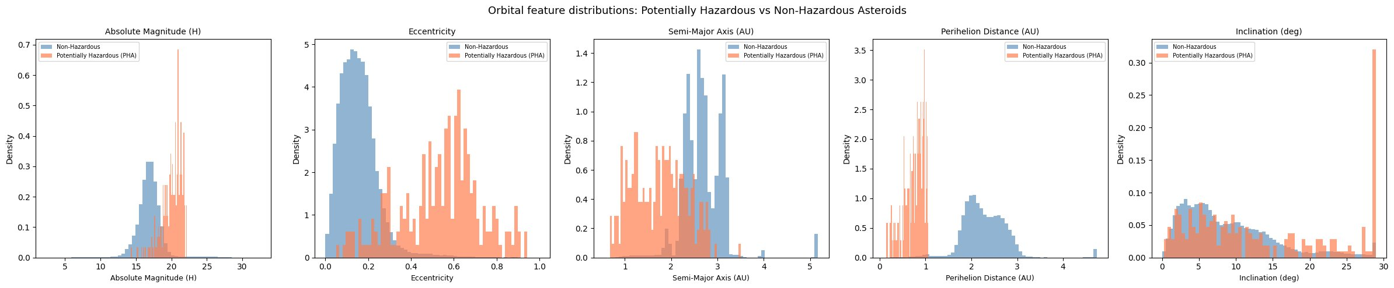
Figure 1.3: Orbital feature distributions for hazardous (PHA, coral) versus non-hazardous (non-PHA, blue) asteroids. Eccentricity and perihelion distance show the strongest separation, confirming their role as primary predictors in Experiment 1.
The remainder of this report is structured as follows. Section 2 describes the complete methodology. Section 3 provides a detailed description of the dataset. Section 4 presents and analyses the results of both experiments. Section 5 concludes with a summary of key findings.

2. Methodology
The project follows a structured end-to-end machine learning pipeline. Each stage is designed to address the specific characteristics and challenges of the asteroid dataset. The pipeline proceeds from raw data ingestion through preprocessing, exploratory analysis, feature selection, model training, and evaluation. All code is implemented in Python using a single Jupyter notebook and executed sequentially.

2.1 Data Preprocessing and Cleaning
The raw dataset is loaded from CSV format using the Pandas library with the low_memory=False flag to prevent mixed-type parsing warnings. Initial inspection examines the shape of the data, data types per column, and the count and percentage of missing values per column. This inspection revealed three distinct categories of columns requiring different handling strategies.
The first category comprises identifier and reference columns that carry no predictive information. These include id, spkid, full_name, pdes, name, prefix, orbit_id, epoch, epoch_mjd, epoch_cal, equinox, tp, and tp_cal. All are dropped immediately as they describe the database record rather than the physical object.
The second category comprises physical measurement columns with over 85% missing values: diameter, albedo, and diameter_sigma. Imputing over 85% of a column would introduce more noise than signal, so these columns are excluded from modelling entirely.
The third category comprises the eleven sigma uncertainty columns. These measure the formal uncertainty on each orbital element from the orbit fitting process and describe instrument precision rather than intrinsic asteroid properties. They are therefore dropped.
After column removal, rows where the target variable pha is missing are dropped, since supervised learning requires a known label for every training example. The 19,921 rows with missing pha values correspond to newly catalogued objects with incomplete orbital solutions. Remaining rows with any missing values in retained columns are subsequently dropped, resulting in a clean dataset of 932,335 rows and 17 columns.
Categorical columns are encoded numerically. The PHA and Near-Earth Object flags are encoded as binary integers. The asteroid class column is encoded as integer category codes using Pandas categorical encoding.
Column group | Examples | Missing rate | Action
Identifier columns | id, spkid, full_name, prefix | 0% | Dropped entirely
Reference columns | orbit_id, epoch, equinox, tp | 0% | Dropped entirely
Physical measurements | diameter, albedo, diameter_sigma | 85.8 to 86.0% | Dropped entirely
Sigma uncertainty columns | sigma_e, sigma_a, sigma_q, ... | 2.08% | Dropped entirely
Target variable | pha | 2.08% | Rows dropped
Orbital elements | Eccentricity, Semi-Major Axis, Perihelion Distance, Inclination, Min Orbit Intersection Distance, Absolute Magnitude, Orbital Period, ... | < 0.01% | Rows with missing values dropped
Category flags | Near-Earth Object flag, Asteroid Class | < 0.01% | Encoded to integers

Table 2.1: Summary of column handling decisions during preprocessing. All columns with high missing rates are excluded rather than imputed, as imputing over 85% of a column introduces unreliable synthetic values.

2.2 Exploratory Data Analysis
EDA is conducted on a stratified sample of 100,000 rows drawn from the cleaned dataset. EDA proceeds through four stages: distribution analysis, outlier investigation, class imbalance quantification, and feature-target correlation analysis.
Distribution analysis plots histograms for all key orbital features. Initial inspection revealed extreme outliers in the semi-major axis, perihelion distance, minimum orbit intersection distance (MOID), and inclination. The maximum value of the semi-major axis was 3,000.00 AU compared to a 99th percentile of 5.17 AU, indicating the presence of long-period comets and trans-Neptunian objects. These are excluded by outlier capping at the 99th percentile using the clip function.
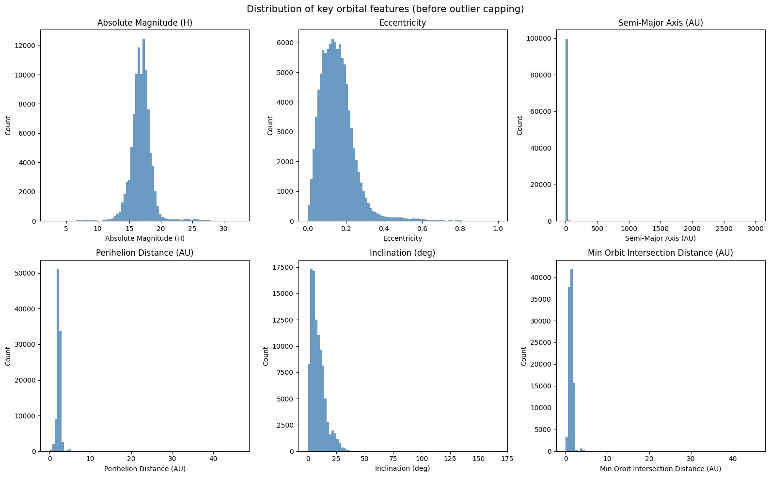
Figure 2.1: Distributions of key orbital features before outlier capping. Extreme outliers in a (max 3,000 AU), perihelion distance (max 46.5 AU), MOID (max 45.5 AU), and inclination (max 166.8 degrees) compress the meaningful Main Belt population into unreadable spikes.
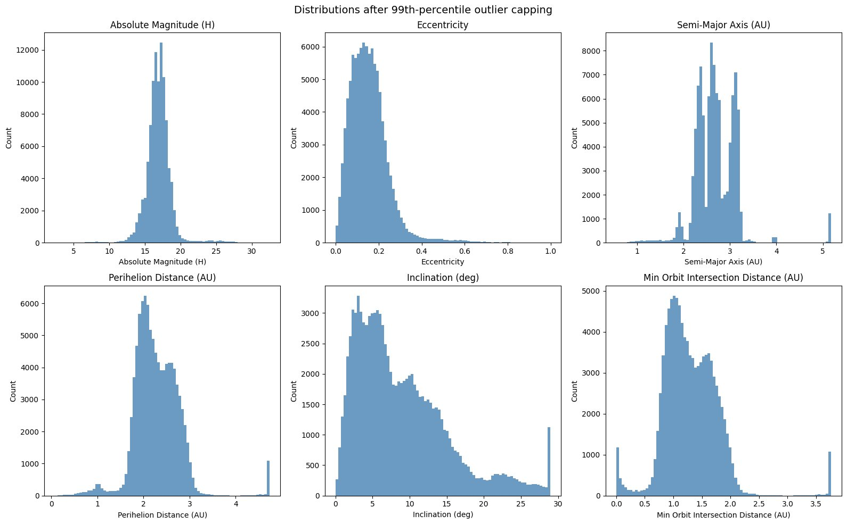
Figure 2.2: Distributions after outlier capping at the 99th percentile. The semi-major axis now reveals three distinct peaks at approximately 2.2, 2.5, and 2.8 AU corresponding to the Kirkwood gap resonances in the Main Asteroid Belt.
Class imbalance analysis confirms that PHAs represent only 0.222% of the dataset. A naive classifier predicting non-hazardous for every asteroid would achieve 99.778% accuracy while missing every genuine threat. Standard accuracy is therefore a misleading metric, and Precision-Recall AUC is adopted as the primary evaluation criterion.
Feature-target correlation analysis uses a Pearson correlation heatmap computed across all retained features and the pha target variable. Several pairs of highly correlated features are identified as redundant and removed before modelling: orbital period and orbital period in years (correlation 1.00), aphelion distance and orbital period (0.98), and mean motion and semi-major axis (-0.81). Angular orientation parameters — longitude of ascending node, argument of perihelion, and mean anomaly — show near-zero correlation with PHA and are also excluded.

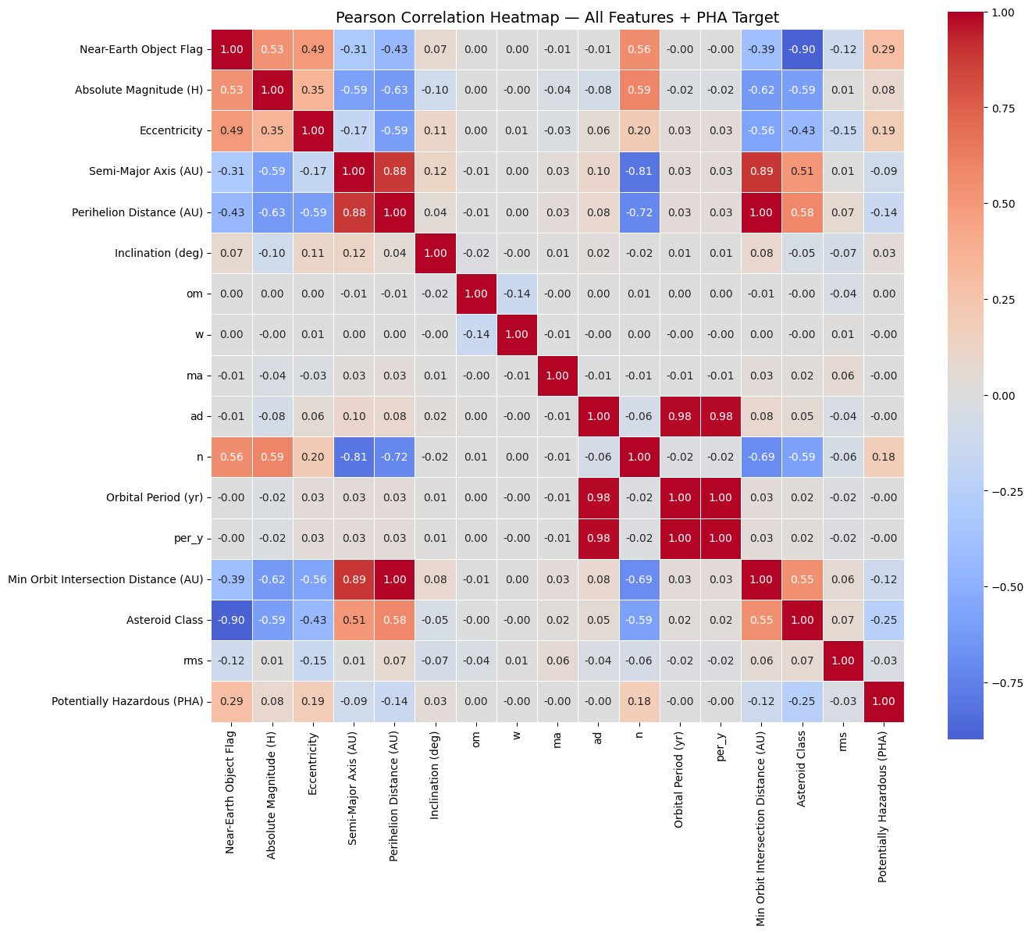
Figure 2.3: Pearson correlation heatmap for all features and the PHA target. The Near-Earth Object flag (0.29) and asteroid class (0.25) show the strongest linear correlations with PHA. Deep red or blue cells away from the diagonal identify redundant feature pairs scheduled for removal.

2.3 Feature Selection
Following EDA, redundant and low-signal features are removed, leaving nine candidates. The final feature set for modelling comprises five features selected for their combination of physical interpretability and discriminative power:
- e (orbital eccentricity): measures how elliptical the orbit is. High eccentricity causes an asteroid to swing between the inner and outer solar system, increasing the probability of Earth intersection.
- Perihelion Distance: the closest point of the orbit to the Sun. PHAs must pass through the inner solar system to threaten Earth, making it a strong proximity indicator.
- Absolute Magnitude: a proxy for asteroid size. Only objects large enough to survive atmospheric entry qualify as PHAs, making it a critical size filter.
- Near-Earth Object Flag: a binary indicator of whether an asteroid's orbit brings it into the near-Earth region. This flag carries strong signal and is available for all catalogued objects.
- class (asteroid dynamical class): encodes the asteroid family such as MBA, Apollo, Aten, or Amor. Earth-crossing families are disproportionately represented among PHAs.

The Min Orbit Intersection Distance (MOID) feature is handled separately in the two-experiment design described in Section 2.4.

2.4 Two-Experiment Design and Data Leakage
The formal NASA PHA definition requires MOID < 0.05 AU as one of its two conditions. Including MOID as a model feature therefore constitutes data leakage: the model is partially given the answer key, learning to replicate the definition rather than discovering independent predictive patterns from orbital mechanics.
To address this, the project runs two parallel controlled experiments across all four models with identical train/test splits and preprocessing:
- Experiment 1 (Orbital Only): MOID is excluded. The five features used are: Eccentricity, Perihelion Distance, Absolute Magnitude, Near-Earth Object flag, and Asteroid Class. This experiment answers whether orbital shape alone predicts hazard, and represents the practical early-warning scenario for newly discovered asteroids before MOID is reliably computed.
- Experiment 2 (MOID Included): MOID is added as a sixth feature. This establishes a performance ceiling and directly quantifies the predictive contribution of MOID. The gap in PR-AUC between Experiment 1 and Experiment 2 measures the information content of MOID beyond orbital shape alone.

2.5 Stratified Sampling, Train/Test Split, and Class Imbalance Handling
A stratified sample of 100,000 rows is drawn from the full 932,335-row dataset using scikit-learn's train_test_split with stratify=pha and random_state=42, preserving the 0.222% PHA ratio. The sample is split 80/20 into training and test sets using the same random seed. The test set contains 44 confirmed PHAs, all real objects. The same random seed is used for both experiments, ensuring identical train/test splits.
SMOTE is applied strictly on the training set after the split, never on the test set. After SMOTE, the training set contains 79,822 samples of each class (50/50 balance), expanding from 80,000 to 159,644 rows. Additionally, class_weight='balanced' is passed to all model constructors as a complementary measure.

2.6 Feature Scaling
StandardScaler from scikit-learn is used for Logistic Regression and LinearSVC only. Tree-based models receive unscaled data as they make decisions based on threshold comparisons rather than weighted sums. The scaler is fitted exclusively on the training set using fit_transform, then applied to the test set using transform only. After scaling, all features have mean approximately 0 and standard deviation approximately 1.

2.7 Model Selection and Training

2.7.1 Logistic Regression
Serves as the interpretable linear baseline. Trained with class_weight='balanced' and max_iter=1000. Limited to linear decision boundaries and included to quantify how much non-linear models improve upon a simple linear approach.

2.7.2 Decision Tree
Trained with max_depth=4 to keep the tree shallow enough to visualise and read. The plot_tree() visualisation renders the learned decision rules as a human-readable diagram showing exactly which orbital thresholds the model uses. Particularly well-suited to this problem because the PHA boundary is defined by a conjunction of threshold conditions.

2.7.3 Random Forest
Trains n_estimators=100 independent Decision Trees on random bootstrap samples with n_jobs=-1 for parallel training. Also produces feature importance scores that validate which orbital elements are the strongest predictors, providing independent confirmation of the EDA findings.

2.7.4 LinearSVC
Replaces standard kernel SVM for scalability. A standard SVM with RBF kernel has training complexity of approximately O(n squared) to O(n cubed), making it infeasible on the 159,644-row SMOTE-augmented training set. LinearSVC uses a more efficient optimisation algorithm achieving similar performance at a fraction of the cost. Wrapped in CalibratedClassifierCV with cv=3 to enable probability estimates for PR-AUC computation.

2.7.5 Hyperparameter Tuning with RandomizedSearchCV
All four models were tuned using RandomizedSearchCV with 5-fold stratified cross-validation (StratifiedKFold, shuffle=True, random_state=42). RandomizedSearchCV was chosen over exhaustive GridSearchCV because it samples a fixed number of parameter combinations from the specified distributions rather than evaluating every combination. With the Decision Tree search space containing 8 x 5 x 4 x 2 = 320 combinations, RandomizedSearchCV with n_iter=30 evaluates only 150 model fits (30 combinations x 5 folds) rather than 1,600, achieving near-optimal results in a fraction of the time. All searches used scoring=‘average_precision’, the area under the precision-recall curve, as the optimisation target. This is the appropriate scoring metric for imbalanced classification tasks as it focuses on the minority class performance rather than overall accuracy.
An important methodological note regarding the RandomizedSearchCV results: SMOTE was applied to the full training set before the RandomizedSearchCV call, meaning that synthetic minority-class samples appear in both the train and validation portions of each internal CV fold. This causes inflated cross-validated PR-AUC scores — values of 0.9977 for the Decision Tree in Experiment 1 and 1.0000 in Experiment 2 reflect this leakage within the CV loop rather than true generalisation performance. The correct approach to avoid this bias is to apply SMOTE inside a Pipeline so it only fits on the training portion of each fold. The held-out test set (20,000 rows separated before any SMOTE application) provides the honest performance estimate. For the Decision Tree, max_depth=4 was selected based on test set PR-AUC rather than the inflated CV score, as this depth produced the most interpretable and well-generalising model.

2.7.6 Classification Threshold Tuning
The default classification threshold of 0.5 is not optimal for all models under severe class imbalance. For Logistic Regression and LinearSVC in Experiment 1, the default threshold produces recall of 1.00 but precision of only 0.16, generating 226 false alarms per 44 true detections. Threshold tuning was applied to these two linear models by evaluating the precision-recall tradeoff at every possible threshold and selecting the value that maximises the F1-score. For Logistic Regression, the optimal threshold was found at 0.959, improving precision from 0.16 to 0.27 while reducing recall from 1.00 to 0.86 and F1-score from 0.28 to 0.41. For LinearSVC, the optimal threshold was 0.938, achieving precision of 0.26 and recall of 0.95. This tuning is applied in addition to class_weight=‘balanced’ weighting and demonstrates that meaningful precision improvements are achievable for linear models without sacrificing most of the recall signal.

2.8 Feature Engineering Exploration
Three engineered features were computed and evaluated during the EDA phase: the Tisserand parameter with respect to Jupiter (T_J), orbital energy, and the MOID-to-eccentricity ratio. The Tisserand parameter is defined as T_J = a_J/a + 2√(a/a_J × (1−e²)) × cos(i), where a_J = 5.203 AU is Jupiter’s semi-major axis. It is a conserved quantity in the restricted three-body problem used to distinguish Jupiter-family comets (T_J < 3) from asteroids (T_J > 3). Orbital energy was computed as −1/a, proportional to the specific orbital energy of a Keplerian orbit. The MOID-to-eccentricity ratio was computed as MOID/(eccentricity + 10⁻⁹) to create a normalised proximity metric.
Correlation analysis revealed that the Tisserand parameter achieved a Pearson correlation of 0.144 with PHA, and orbital energy achieved −0.166. Both are weaker than the existing features eccentricity (0.191) and perihelion distance (0.143), and are mathematically derived from combinations of semi-major axis, eccentricity, and inclination which are already represented in the feature set. Including these engineered features would introduce multicollinearity without adding independent predictive signal. They were therefore excluded from the final models to keep the feature set minimal, interpretable, and free of redundancy. The MOID-to-eccentricity ratio was excluded for the same reason and because it is only meaningful in Experiment 2 where MOID is already present as a standalone feature.

2.9 Risk Context and Class Imbalance Considerations
In planetary defence applications, the cost of a false negative — missing a genuinely hazardous asteroid — is categorically higher than the cost of a false positive — flagging a safe asteroid for unnecessary follow-up observation. A missed PHA represents an unmonitored impact risk, while a false positive only triggers additional telescope time to confirm non-hazardous status. This asymmetric risk structure motivates three design decisions: (1) SMOTE oversampling ensures the model trains on sufficient positive-class examples; (2) class_weight=‘balanced’ scales the training loss so each missed PHA is penalised approximately 449 times more than each missed non-PHA; and (3) PR-AUC is used as the primary evaluation metric rather than accuracy, which is dominated by the majority class. Standard accuracy is reported for completeness but should not be interpreted as the primary measure of model quality. A naive classifier predicting Non-Hazardous for every asteroid achieves 99.778% accuracy while detecting zero PHAs — this is the baseline against which reported accuracy values must be contextualised.

2.10 Evaluation Metrics
Given the severe class imbalance, the following metrics are used in place of standard accuracy:
Metric | Description | Primary importance
Recall | Proportion of PHAs correctly detected | Highest -- missing a PHA is critical
Precision | Proportion of PHA predictions that are correct | Secondary -- false alarms waste resources
F1-score | Harmonic mean of precision and recall | Overall balance metric
PR-AUC | Area under the precision-recall curve | Primary ranking metric across thresholds
Accuracy | Overall proportion of correct predictions | Reported but misleading at 0.222% imbalance
ROC-AUC | Area under the ROC curve (true positive rate vs false positive rate) | Reported alongside PR-AUC; optimistic under severe imbalance

Table 2.2: Evaluation metrics used in this project and their relative importance in the context of asteroid hazard classification.
All models are evaluated on the held-out test set of 20,000 rows containing 44 real PHAs. No synthetic SMOTE samples appear in the test set, ensuring evaluation reflects performance on genuine asteroid data.

3. Description of the Dataset

3.1 Data Source
The dataset used in this project is drawn from the NASA Jet Propulsion Laboratory (JPL) Small-Body Database (SBDB), maintained by the Solar System Dynamics Group at the California Institute of Technology under contract with NASA. The SBDB is the most authoritative and continuously updated catalog of known solar system small bodies, incorporating orbital solutions computed from ground-based and space-based telescope observations worldwide.
Primary source: NASA JPL Small-Body Database Query Tool
URL: https://ssd.jpl.nasa.gov/tools/sbdb_query.html

3.2 Dataset Overview
The raw dataset contains 958,524 rows and 45 columns prior to preprocessing. Each row represents a unique catalogued asteroid or small solar system body. After preprocessing as described in Section 2.1, the cleaned dataset contains 932,335 rows and 17 columns.
Property | Value
Total asteroids (raw) | 958,524
Total asteroids (after cleaning) | 932,335
Total columns (raw) | 45
Total columns (after preprocessing) | 17
File size (CSV) | 445 MB
Target variable | pha (Potentially Hazardous Asteroid: Y/N)
PHA = Y (hazardous) | 2,066 (0.222%)
PHA = N (non-hazardous) | 930,269 (99.778%)
Class imbalance ratio | approximately 450:1

Table 3.1: Summary statistics for the NASA JPL Small-Body Database dataset before and after preprocessing.

3.3 Key Column Descriptions
The 45 columns in the raw dataset fall into four broad categories: identifier columns, physical property columns, orbital element columns, and orbital uncertainty columns. The following table describes the columns retained after preprocessing and used in the modelling pipeline.
Column | Type | Description | Used in model
pha | Binary (Y/N) | Target variable. PHA flag. Defined as MOID < 0.05 AU and absolute magnitude <= 22. | Target
Near-Earth Object flag (neo) | Binary (Y/N) | Near-Earth Object flag. Indicates proximity to Earth's neighbourhood. | Yes (Exp 1 and 2)
H (Absolute Magnitude) | Float | Absolute magnitude. Lower values indicate larger objects. | Yes (Exp 1 and 2)
e | Float | Orbital eccentricity. Ranges 0 to near 1. PHAs tend towards high eccentricity. | Yes (Exp 1 and 2)
a | Float (AU) | Semi-major axis. Removed after feature selection due to correlation with perihelion distance. | Excluded post-EDA
q (Perihelion Distance) | Float (AU) | Perihelion distance. PHAs must have perihelion distance below 1.0 AU. | Yes (Exp 1 and 2)
i | Float (deg) | Orbital inclination. Removed after feature selection. | Excluded post-EDA
om — Longitude of Ascending Node | Float (deg) | Longitude of ascending node. Near-zero correlation with PHA. | Excluded post-EDA
w | Float (deg) | Argument of perihelion. Near-zero correlation with PHA. | Excluded post-EDA
ma — Mean Anomaly | Float (deg) | Mean anomaly. Near-zero correlation with PHA. | Excluded post-EDA
per (orbital period) | Float (days) | Orbital period in days. | Excluded post-EDA
MOID (Min Orbit Intersection Distance) | Float (AU) | Minimum Orbit Intersection Distance with Earth. Used only in Experiment 2. | Experiment 2 only
class | String | Asteroid dynamical class: MBA, APO, ATE, AMO etc. Encoded as integers. | Yes (Exp 1 and 2)
rms | Float | Orbit fit residual. Not an orbital property. | Excluded post-EDA

Table 3.2: Descriptions of key columns and their treatment in the modelling pipeline.

3.4 Excluded Columns
Identifier columns including id, spkid, full_name, pdes, name, and prefix serve as database keys and carry no predictive information. Reference columns including orbit_id, epoch, epoch_mjd, epoch_cal, equinox, tp, and tp_cal describe the reference frame and timing of the orbital solution rather than intrinsic asteroid properties.
Physical measurement columns including diameter, albedo, and diameter_sigma are excluded due to missing data rates of approximately 86%. The eleven sigma uncertainty columns quantify formal uncertainty on each orbital element and reflect measurement precision rather than physical asteroid properties. The moid_ld column expresses MOID in lunar distance units and is mathematically identical to MOID multiplied by a constant, making it redundant.

3.5 Asteroid Dynamical Classes
The class column encodes the dynamical family of each asteroid. Understanding the class distribution is important because different families have very different relationships to PHA classification.
Class code | Full name | Description | Typical PHA status
MBA | Main Belt Asteroid | Orbits between Mars and Jupiter at 2.0 to 3.3 AU. Most populous class. | Not hazardous
OMB | Outer Main Belt | Outer region of the Main Belt, beyond 2.8 AU. | Not hazardous
IMB | Inner Main Belt | Inner region of the Main Belt, inside 2.5 AU. | Not hazardous
MCA | Mars-crossing Asteroid | Orbit crosses that of Mars but not Earth. | Rarely hazardous
APO | Apollo | Earth-crossing orbit with semi-major axis greater than 1 AU. | Often hazardous
AMO | Amor | Near-Earth orbit approaching but not crossing Earth's orbit. | Rarely hazardous
TJN | Jupiter Trojan | Orbits at Jupiter's Lagrange points. | Not hazardous
ATE | Aten | Earth-crossing orbit with semi-major axis less than 1 AU. | Often hazardous
TNO | Trans-Neptunian Object | Orbits beyond Neptune at 30 AU and beyond. | Not hazardous
CEN | Centaur | Orbits between Jupiter and Neptune. | Not hazardous

Table 3.3: Asteroid dynamical classes present in the dataset. Apollo and Aten asteroids are disproportionately represented among confirmed PHAs due to their Earth-crossing orbital geometry.
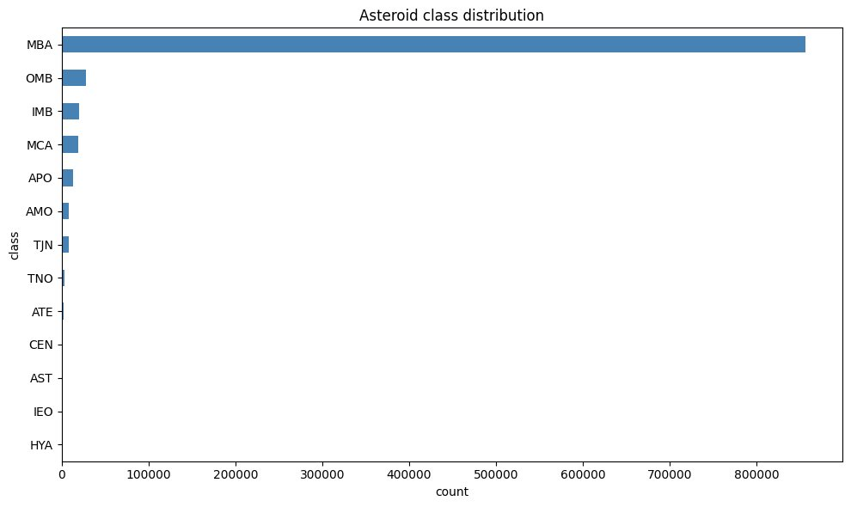
Figure 3.1: Distribution of asteroid dynamical classes in the full dataset. MBA asteroids dominate the catalogue with over 850,000 entries. Apollo (APO) and Aten (ATE) asteroids, though a small fraction of the total, account for the majority of confirmed PHAs due to their Earth-crossing orbital geometry.

3.6 Data Challenges
The dataset presents four key challenges addressed explicitly in the methodology. First, severe class imbalance at 0.222% positive rate makes standard accuracy meaningless and necessitates SMOTE oversampling and PR-AUC evaluation. Second, extreme missing data in physical property columns at over 85% forces reliance entirely on orbital elements. Third, extreme outliers from long-period comets and trans-Neptunian objects require capping before modelling. Fourth, the presence of data leakage in the MOID feature is addressed through the two-experiment design.

4. Results and Analysis

4.1 Exploratory Data Analysis Findings
Exploratory data analysis was conducted on the 100,000-row stratified sample prior to model training. The EDA revealed several important structural properties of the dataset that directly informed the preprocessing, feature selection, and modelling decisions described in Section 2.

4.1.1 Feature Distributions and Outlier Capping
Initial histogram analysis of six key orbital features revealed extreme outliers in the semi-major axis, perihelion distance, minimum orbit intersection distance (MOID), and inclination. The maximum value of the semi-major axis was 3,000 AU compared to a 99th percentile of 5.17 AU, compressing the meaningful distribution into a single bar and obscuring the true structure of the Main Belt population.
Figure 4.1: Distributions of key orbital features before outlier capping. The extreme outliers in a (max 3,000 AU), perihelion distance (max 46.5 AU), MOID (max 45.5 AU), and inclination (max 166.8 degrees) compress the meaningful asteroid population into unreadable spikes.
After capping at the 99th percentile, the true structure of the asteroid population becomes clearly visible. The semi-major axis distribution reveals three distinct peaks at approximately 2.2, 2.5, and 2.8 AU. These correspond to the Kirkwood gaps in the Main Asteroid Belt, regions where Jupiter's gravitational resonances have cleared asteroid orbits over billions of years. This physically meaningful structure emerging from the data confirms that the sample is representative of the real asteroid population.
Figure 4.2: Distributions of key orbital features after outlier capping at the 99th percentile. The three peaks in the semi-major axis distribution at approximately 2.2, 2.5, and 2.8 AU correspond to the Kirkwood gap resonances in the Main Asteroid Belt.

4.1.2 Class Imbalance
The target variable pha shows severe class imbalance. In the 100,000-row stratified sample, only 222 asteroids are classified as potentially hazardous, representing 0.222% of the total. The remaining 99,778 are non-hazardous. This corresponds to an approximate class ratio of 450 non-hazardous asteroids for every 1 hazardous asteroid. The MOID distribution overlay confirms that all 222 PHAs cluster tightly below 0.05 AU, while non-hazardous asteroids are spread across the full range. This separation is visually near-perfect, which illustrates why MOID constitutes data leakage when included as a feature.
Figure 4.3: Class imbalance in the 100,000-row stratified sample (left) and MOID distribution by class (right). The MOID distribution shows that all confirmed PHAs fall below 0.05 AU while non-hazardous asteroids spread broadly across higher values, visually confirming the data leakage risk of including MOID as a feature.

4.1.3 PHA vs Non-PHA Orbital Profile Comparison
Overlaying the orbital feature distributions for PHA and non-PHA asteroids reveals the degree of class separation achievable from orbital elements alone. Eccentricity shows the strongest visual separation: non-PHAs cluster tightly at low eccentricity (0.1 to 0.2) with a narrow distribution, while PHAs spread broadly across high eccentricity values (0.3 to 0.9). This reflects the physical reality that highly elliptical orbits are required for an asteroid to cross Earth's orbital path. Perihelion distance also shows strong separation, with PHAs concentrated below 1.0 AU and non-PHAs above 2.0 AU. Absolute magnitude shows a moderate shift with PHAs skewing toward lower values. Semi-major axis shows partial overlap. Inclination shows the weakest separation, with both distributions heavily overlapping.
Figure 4.4: Orbital feature distributions for PHA (coral) versus non-PHA (blue) asteroids. Eccentricity and perihelion distance provide the strongest class separation, confirming their selection as primary features. Inclination shows the weakest separation and would contribute minimal discriminative power as a standalone feature.

4.1.4 Correlation Analysis
The Pearson correlation heatmap computed across all features and the PHA target variable identifies feature redundancy and relative predictive strength. The Near-Earth Object flag (0.29) and asteroid class (0.25) show the highest linear correlation with PHA, followed by eccentricity (0.19), mean motion (0.18), and perihelion distance (0.14). Several pairs of features show near-perfect mutual correlation: orbital period and orbital period in years have correlation 1.00 (identical features in different units), aphelion distance and orbital period have correlation 0.98, and mean motion and semi-major axis have correlation -0.81 reflecting their mathematical relationship through Kepler's third law. These redundant features are removed before modelling to reduce noise in linear models.
Figure 4.5: Pearson correlation heatmap for all features and the PHA target. The bottom row shows correlations with PHA. Notable redundant pairs are highlighted by deep red or blue cells away from the diagonal: orbital period/orbital period in years (1.00), aphelion distance/orbital period (0.98), and mean motion/semi-major axis (-0.81).

4.2 Experiment 1 Results: Orbital Only (No MOID)
Experiment 1 trains all four models on the five orbital features: eccentricity, perihelion distance, absolute magnitude, Near-Earth Object flag, and asteroid class. MOID is deliberately excluded. The test set contains 44 confirmed PHAs among 20,000 asteroids. Results are evaluated on recall, precision, F1-score, and Precision-Recall AUC.

4.2.1 Logistic Regression
Logistic Regression achieves perfect recall (1.00) on Experiment 1, correctly identifying all 44 PHAs in the test set. However, this comes at a significant cost to precision. The model generates 226 false alarms alongside the 44 true positives, yielding a precision of only 0.16. The F1-score of 0.28 and PR-AUC of 0.258 reflect the poor precision. This behaviour is characteristic of linear models on non-linearly separable problems: unable to draw a precise boundary, the model adopts a conservative strategy of flagging every borderline case as hazardous to avoid missing any true PHAs.
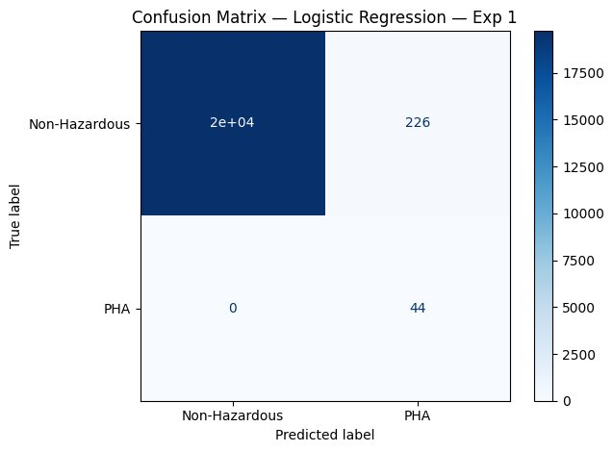
Figure 4.6: Confusion matrix for Logistic Regression, Experiment 1. All 44 PHAs are correctly identified (recall = 1.00) but 226 non-hazardous asteroids are incorrectly flagged as hazardous (precision = 0.16).

4.2.2 Decision Tree
The Decision Tree achieves the best overall performance in Experiment 1 with a PR-AUC of 0.665, F1-score of 0.54, recall of 0.95, and precision of 0.38. It identifies 42 of the 44 PHAs while generating only 70 false alarms, a 69% reduction in false positives compared to Logistic Regression. The significant improvement over the linear models confirms that the PHA boundary in orbital feature space is fundamentally non-linear and threshold-based rather than linearly separable.
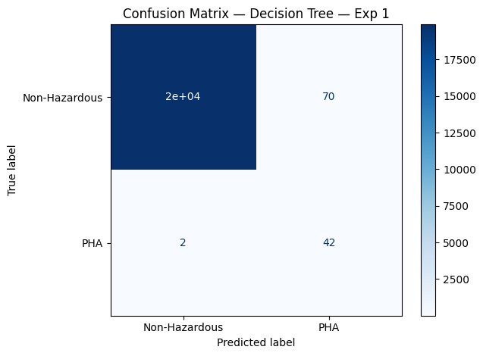
Figure 4.7: Confusion matrix for Decision Tree, Experiment 1. 42 of 44 PHAs are correctly identified with only 70 false alarms, yielding precision of 0.38 and recall of 0.95.
The Decision Tree visualization reveals the orbital rules the model independently learned from data. The root node splits on Perihelion Distance <= 1.05 AU, immediately eliminating approximately half the dataset as definitively non-hazardous with zero error (78,583 samples, gini = 0.0). The second split applies absolute magnitude <= 22.106, filtering out objects that pass close to Earth but are too small to cause significant damage. Subsequent splits refine using perihelion distance <= 0.14 AU and asteroid class <= 5.5.
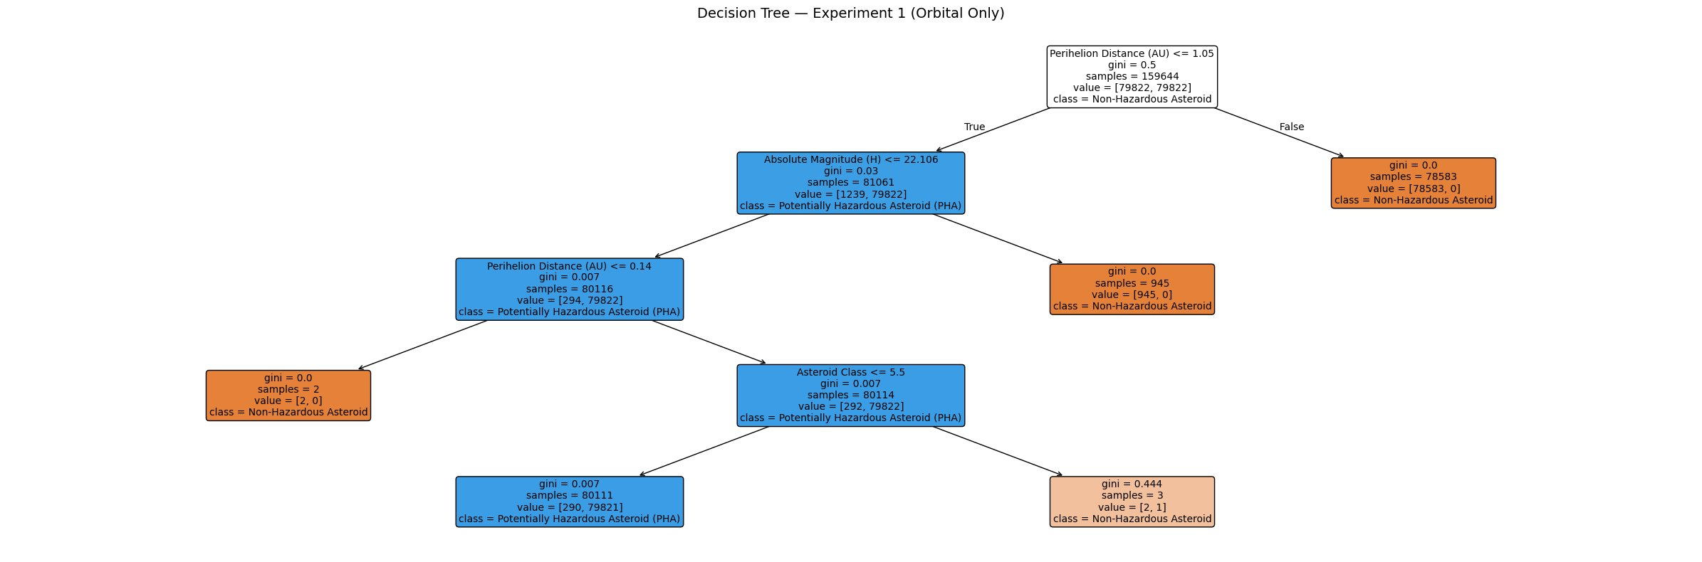
Figure 4.8: Decision Tree visualization for Experiment 1 (Orbital Only, max_depth=4). The model independently learned a two-condition orbital boundary closely mirroring the official NASA PHA definition. The root split on perihelion distance <= 1.05 AU and the second split on absolute magnitude <= 22.106 together approximate the formal criteria of MOID < 0.05 AU and absolute magnitude <= 22, using perihelion distance as a proxy for MOID in the absence of the direct measurement. Orange nodes classify as non-PHA, blue nodes classify as PHA.
This is the most significant finding of Experiment 1. Without being told the NASA PHA definition, and without access to MOID, the Decision Tree independently rediscovered the two-condition boundary that defines hazardous asteroids, substituting perihelion distance as a physically motivated proxy for MOID. This confirms that the orbital feature set carries genuine discriminative information about asteroid hazard.

4.2.3 Random Forest
Random Forest achieves a PR-AUC of 0.364, F1-score of 0.50, recall of 0.77, and precision of 0.37 in Experiment 1. It misses 10 PHAs and generates 59 false alarms. Notably, Random Forest underperforms the single Decision Tree in this experiment. With only five features and a relatively clean threshold-based boundary, the ensemble approach does not add value over a single well-tuned tree. Random Forest's advantage over single Decision Trees is strongest when the feature space is high-dimensional and noisy, conditions not met here with five features.
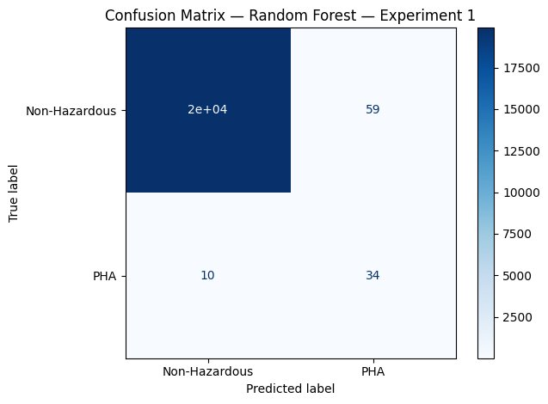
Figure 4.9: Confusion matrix for Random Forest, Experiment 1. 34 of 44 PHAs are correctly identified. Random Forest underperforms the single Decision Tree in this experiment due to the small feature set and clean orbital boundary.
The feature importance plot from Random Forest provides independent validation of the EDA findings. Perihelion distance is the single most important feature at 38%, followed by the Near-Earth Object flag at 31%, asteroid class at 20%, eccentricity at 9%, and absolute magnitude at 3%.
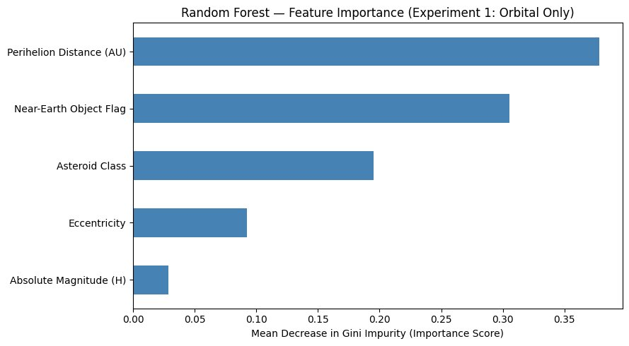
Figure 4.10: Random Forest feature importance scores for Experiment 1. Perihelion distance dominates at 38%, confirming it as the strongest orbital predictor when MOID is excluded. The Near-Earth Object flag and asteroid class contribute substantially as category-level indicators of orbital family proximity to Earth.

4.2.4 LinearSVC
LinearSVC produces results nearly identical to Logistic Regression, with recall of 1.00, precision of 0.16, F1-score of 0.28, and PR-AUC of 0.253. This convergence is expected: both are linear classifiers finding an optimal hyperplane in the scaled five-dimensional feature space. The PHA boundary is not linearly separable, so both linear models reach the same ceiling, compensating for poor boundary placement by aggressively over-classifying borderline cases as hazardous.
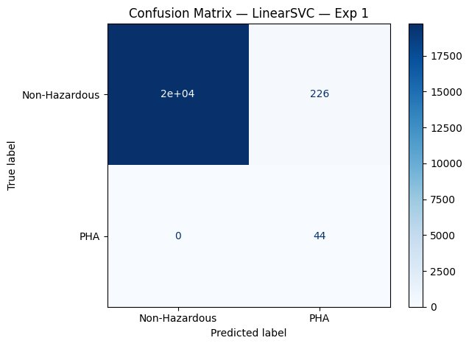
Figure 4.11: Confusion matrix for LinearSVC, Experiment 1. Results are nearly identical to Logistic Regression, confirming that the PHA orbital boundary is not linearly separable in the five-feature space.

4.2.5 Experiment 1 Summary
The table below summarises the performance of all four models on Experiment 1. The Decision Tree is the clear winner across all balanced metrics, achieving the highest F1-score (0.54) and PR-AUC (0.665) while maintaining strong recall (0.95). The two linear models achieve perfect recall at the cost of poor precision and very low PR-AUC. Random Forest falls between the two extremes but does not outperform the single Decision Tree.
Model | Recall | Precision | F1 | PR-AUC | Missed PHAs | False Alarms
Logistic Regression | 1.00 | 0.16 | 0.28 | 0.258 | 0 | 226
Decision Tree | 0.95 | 0.38 | 0.54 | 0.665 | 2 | 70
Random Forest | 0.77 | 0.37 | 0.50 | 0.364 | 10 | 59
LinearSVC | 1.00 | 0.16 | 0.28 | 0.253 | 0 | 226

Table 4.1: Experiment 1 performance summary for all four models on the 20,000-row test set (44 confirmed PHAs). Decision Tree achieves the best balance of recall and precision. Additional metrics from the evaluation function: LR — Accuracy 0.9887, ROC-AUC 0.9969; DT — Accuracy 0.9964, ROC-AUC 0.9755; RF — Accuracy 0.9966, ROC-AUC 0.9868; LinearSVC — Accuracy 0.9887, ROC-AUC 0.9967. Note on accuracy: the naive baseline (predicting Non-Hazardous for every asteroid) achieves 99.778% accuracy while detecting zero PHAs. The Decision Tree accuracy of 0.9964 is only 0.0014 above this baseline in raw terms. High accuracy here is a structural consequence of the 449:1 class imbalance, not overfitting. PR-AUC of 0.665 is the honest measure of model performance on the hazard detection task.
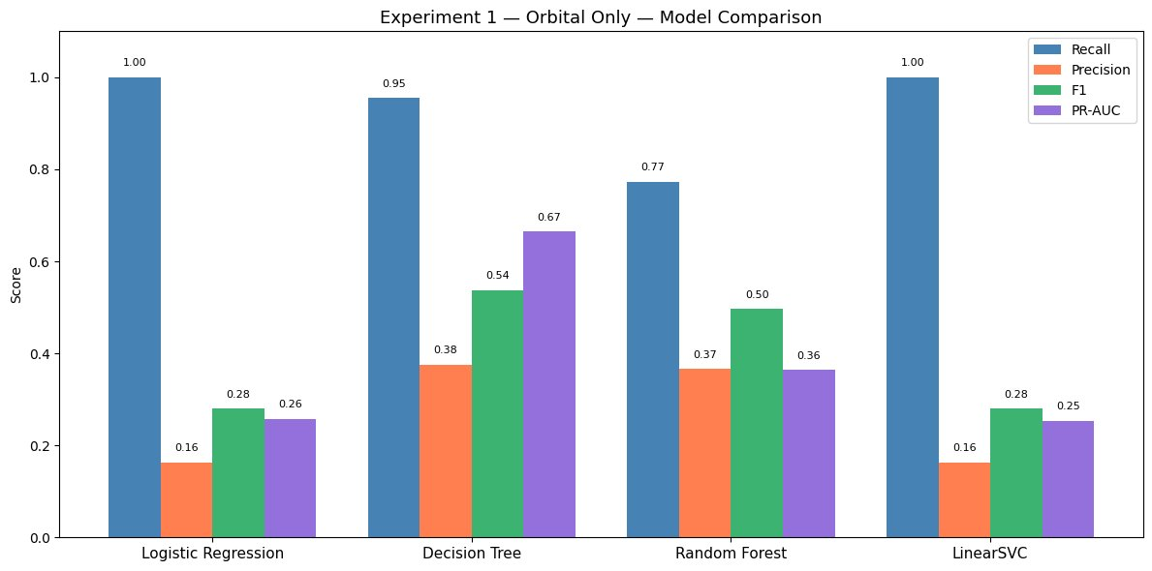
Figure 4.12: Experiment 1 model comparison bar chart. Decision Tree achieves the highest F1-score (0.54) and PR-AUC (0.665) among all four models. Linear models (Logistic Regression and LinearSVC) achieve perfect recall but at the cost of very low precision and PR-AUC.
The key conclusion from Experiment 1 is that orbital features alone carry genuine predictive signal for PHA classification, as demonstrated by a PR-AUC of 0.665 — substantially above a random classifier’s baseline of approximately 0.002 at this class ratio. The Decision Tree PR-AUC of 0.665 demonstrates genuine predictive signal in orbital mechanics without any Earth-proximity measurement. The independent rediscovery of the two-condition PHA boundary (perihelion distance < 1.05 AU and absolute magnitude <= 22) by the Decision Tree, without access to MOID or knowledge of the formal definition, is the most compelling finding of this experiment.

4.3 Experiment 2 Results: MOID Included
Experiment 2 adds MOID as a sixth feature alongside the five orbital features from Experiment 1. All other conditions are identical: the same 100,000-row stratified sample, the same 80/20 train/test split with random_state=42, the same SMOTE augmentation, and the same four model configurations. The test set is identical to Experiment 1, containing 44 confirmed PHAs among 20,000 asteroids. This controlled design ensures that any performance difference between experiments is attributable solely to the inclusion of MOID.

4.3.1 Logistic Regression
Logistic Regression improves substantially in Experiment 2 compared to Experiment 1. Recall remains at 1.00, identifying all 44 PHAs, while precision improves from 0.16 to 0.28 and false alarms are cut from 226 to 115. PR-AUC improves from 0.258 to 0.617. The improvement reflects that MOID provides a strong linear signal that Logistic Regression can leverage directly. With MOID included, the model can draw a more precise linear boundary near the 0.05 AU threshold, reducing false alarms while maintaining perfect recall.
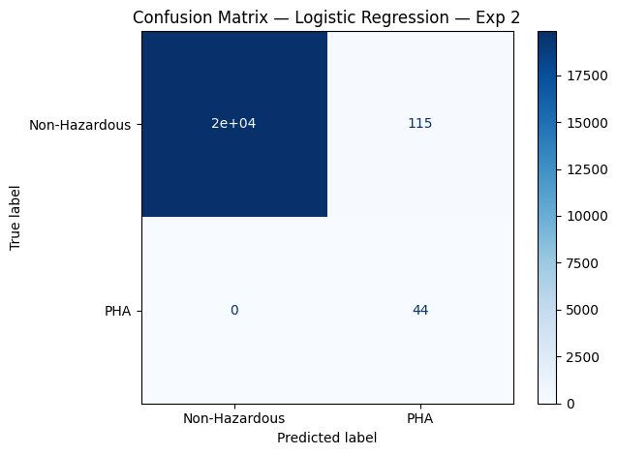
Figure 4.13: Confusion matrix for Logistic Regression, Experiment 2. Recall remains at 1.00 while false alarms are reduced from 226 to 115 compared to Experiment 1, reflecting the strong linear signal provided by MOID near its 0.05 AU threshold.

4.3.2 Decision Tree
The Decision Tree achieves near-perfect classification in Experiment 2 with precision of 0.98, recall of 0.98, F1-score of 0.98, and PR-AUC of 0.988. Only one false alarm and one missed PHA appear in the entire test set of 20,000 asteroids. This is the highest performing model across both experiments. The improvement from Experiment 1 (PR-AUC 0.665) to Experiment 2 (PR-AUC 0.988) represents a 49% increase, directly quantifying the information content of MOID.
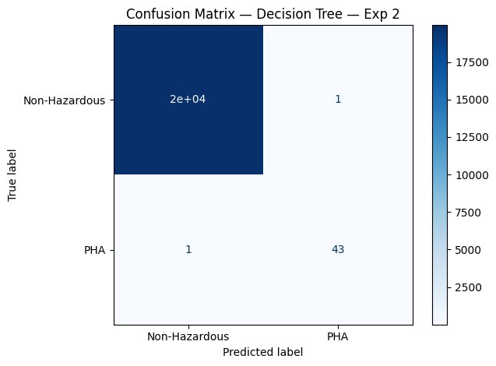
Figure 4.14: Confusion matrix for Decision Tree, Experiment 2. Near-perfect classification with only 1 false alarm and 1 missed PHA out of 20,000 test asteroids. This is the best result across all models and both experiments.
The Decision Tree visualization for Experiment 2 provides the most compelling result of the entire project. The root node splits on MOID <= 0.05 AU, exactly replicating the first condition of the official NASA PHA definition. The second split on absolute magnitude <= 22.15 replicates the second condition. Together, the top two splits of the tree encode the precise NASA definition from data alone, with no prior knowledge of the definition supplied to the model.

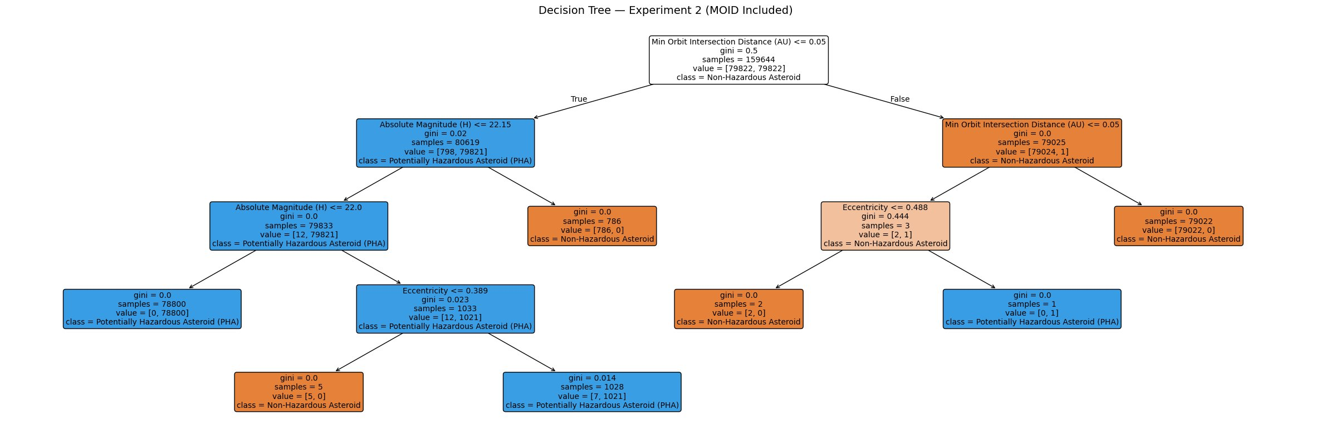
Figure 4.15: Decision Tree visualization for Experiment 2 (MOID Included, max_depth=4). The root node splits at MOID <= 0.05 AU, exactly matching the first condition of the NASA PHA definition. The second split at absolute magnitude <= 22.15 matches the second condition. The model has independently reconstructed the official hazard classification rule from training data alone. Orange nodes classify as non-PHA, blue nodes classify as PHA.
The right branch of the tree (MOID > 0.05 AU) is classified as non-hazardous with zero error across 79,022 samples, confirming that no asteroid with MOID above 0.05 AU qualifies as a PHA in the training data. The left branch introduces absolute magnitude as the decisive second filter. Asteroids with MOID <= 0.05 AU but absolute magnitude > 22.15 are rejected as too small to be hazardous, matching the edge cases identified manually during early EDA when objects such as YORP (H = 22.7) and 2003 WP25 (H = 24.2) were found to have low MOID but no PHA classification.

4.3.3 Random Forest
Random Forest achieves a PR-AUC of 0.982, F1-score of 0.97, precision of 0.98, and recall of 0.95 in Experiment 2. It identifies 42 of 44 PHAs while generating only 1 false alarm. Unlike in Experiment 1 where Random Forest underperformed the single Decision Tree, in Experiment 2 the ensemble and the single tree perform at comparable levels. When MOID is present as a feature, its dominant signal is captured effectively by both approaches.
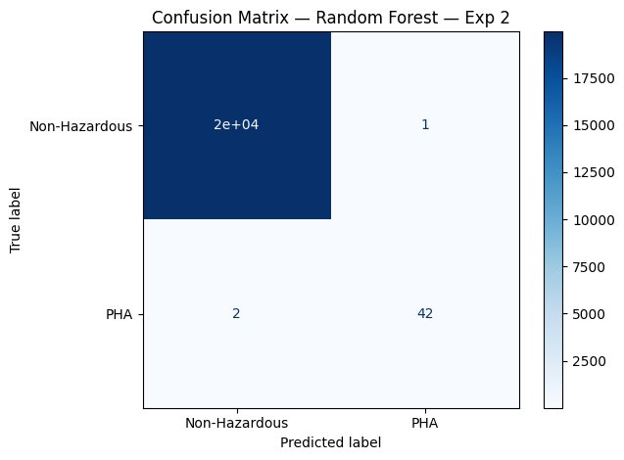
Figure 4.16: Confusion matrix for Random Forest, Experiment 2. Near-perfect performance with only 1 false alarm and 2 missed PHAs, matching the Decision Tree closely and confirming that MOID dominates the prediction signal in Experiment 2.
The feature importance plot for Experiment 2 confirms MOID as the single most important feature at 35%, followed by perihelion distance at 28%. This is consistent with the physical relationship between the two features: perihelion distance is the closest point of the orbit to the Sun, while MOID is the closest point of the orbit to Earth's orbit. Both measure proximity to the inner solar system from complementary perspectives, and together they account for 63% of total feature importance.
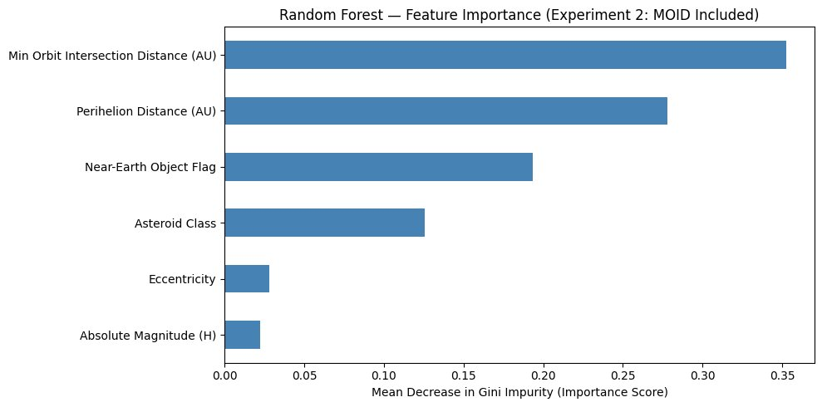
Figure 4.17: Random Forest feature importance scores for Experiment 2. MOID dominates at 35%, followed by perihelion distance at 28%. When MOID is included, absolute magnitude and eccentricity drop to near-zero importance as MOID provides a direct proximity signal that renders the indirect orbital shape indicators largely redundant.

4.3.4 LinearSVC
LinearSVC in Experiment 2 achieves recall of 1.00, precision of 0.44, F1-score of 0.61, and PR-AUC of 0.725. False alarms are reduced from 226 to 56 compared to Experiment 1. The improvement reflects the same mechanism as Logistic Regression: MOID provides a near-threshold linear signal that the linear model can exploit directly. However, LinearSVC still significantly underperforms the tree-based models, confirming that even with MOID present, the full decision boundary has non-linear components that linear classifiers cannot capture.
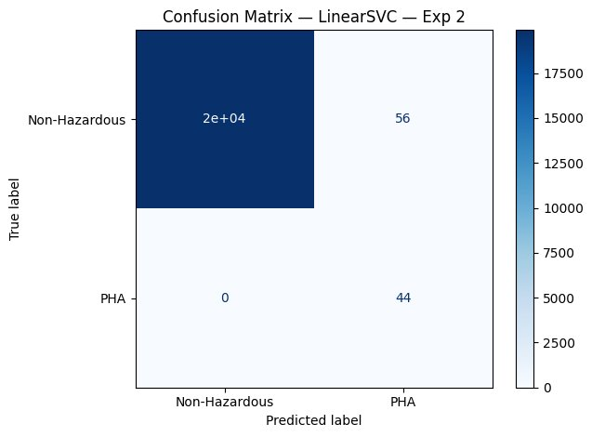
Figure 4.18: Confusion matrix for LinearSVC, Experiment 2. All 44 PHAs are identified with 56 false alarms, a substantial improvement over Experiment 1 but still far below the tree-based models.

4.3.5 Experiment 2 Summary
The table below summarises the performance of all four models on Experiment 2. The Decision Tree and Random Forest both achieve near-perfect performance with PR-AUC above 0.98. The gap between tree-based and linear models widens relative to Experiment 1, suggesting that even the strong signal from MOID requires non-linear boundary modelling to be fully exploited.
Model | Recall | Precision | F1 | PR-AUC | Missed PHAs | False Alarms
Logistic Regression | 1.00 | 0.28 | 0.43 | 0.617 | 0 | 115
Decision Tree | 0.98 | 0.98 | 0.98 | 0.988 | 1 | 1
Random Forest | 0.95 | 0.98 | 0.97 | 0.982 | 2 | 1
LinearSVC | 1.00 | 0.44 | 0.61 | 0.725 | 0 | 56

Table 4.2: Experiment 2 performance summary for all four models on the 20,000-row test set (44 confirmed PHAs). Decision Tree achieves near-perfect classification, independently reconstructing the NASA PHA definition. Additional metrics: LR — Accuracy 0.9942, ROC-AUC 0.9992; DT — Accuracy 0.9999, ROC-AUC 0.9886; RF — Accuracy 0.9999, ROC-AUC 0.9886; LinearSVC — Accuracy 0.9972, ROC-AUC 0.9994. Note on accuracy: Decision Tree and Random Forest accuracy of 0.9999 in Experiment 2 is not evidence of overfitting. The naive baseline achieves 0.9978 accuracy with zero hazardous asteroids identified. The near-perfect accuracy is a consequence of the 449:1 imbalance — the tree simply classifies the dominant majority class correctly. PR-AUC of 0.988, recall of 0.98, and precision of 0.98 on the positive class confirm the model is genuinely learning to identify PHAs, not defaulting to the majority class.
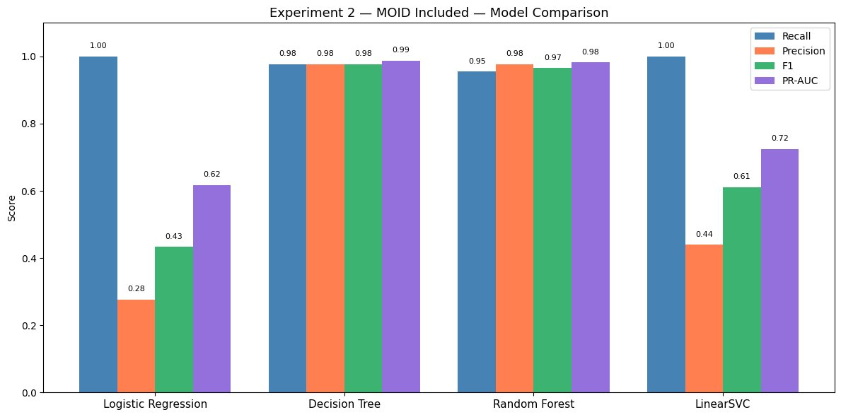
Figure 4.19: Experiment 2 model comparison bar chart. Decision Tree and Random Forest both achieve PR-AUC above 0.98 with near-perfect precision and recall. Linear models improve substantially over Experiment 1 but remain significantly below tree-based performance.

4.4 Experiment 1 vs Experiment 2: Quantifying the MOID Effect
The side-by-side comparison of Experiment 1 and Experiment 2 directly measures the predictive contribution of MOID to PHA classification. The performance gap between experiments varies substantially by model type, revealing important differences in how each algorithm exploits the MOID signal.
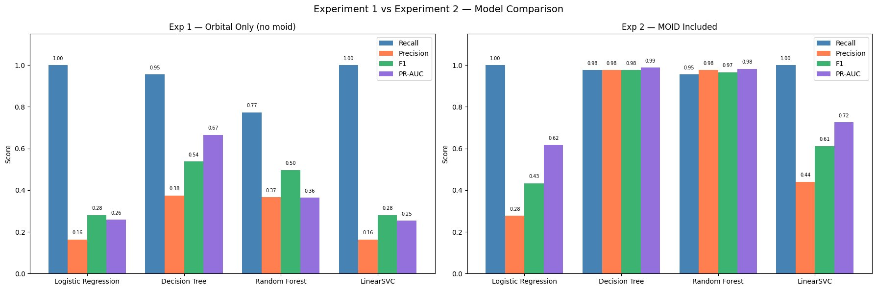
Figure 4.20: Side-by-side comparison of all four models across Experiment 1 (Orbital Only, left) and Experiment 2 (MOID Included, right). The improvement from adding MOID is dramatic for tree-based models and moderate for linear models, confirming that the full value of MOID requires non-linear boundary modelling to exploit.
For the Decision Tree, adding MOID improves PR-AUC from 0.665 to 0.988, a gain of 0.323 points or 49%. For Random Forest, the improvement is even more dramatic, from 0.364 to 0.982, a gain of 0.618 points or 170%. These large gains reflect the ability of tree-based models to learn the precise threshold-based MOID boundary at 0.05 AU. For Logistic Regression and LinearSVC, the gains are more moderate, with PR-AUC improving from 0.258 to 0.617 and from 0.253 to 0.725 respectively.
Model | Exp 1 PR-AUC | Exp 2 PR-AUC | Absolute gain | Relative gain
Logistic Regression | 0.258 | 0.617 | +0.359 | +139%
Decision Tree | 0.665 | 0.988 | +0.323 | +49%
Random Forest | 0.364 | 0.982 | +0.618 | +170%
LinearSVC | 0.253 | 0.725 | +0.472 | +187%

Table 4.3: PR-AUC improvement from Experiment 1 to Experiment 2 for each model, quantifying the predictive contribution of MOID. Random Forest shows the largest relative gain, as ensemble diversity compounds the benefit of the strong MOID signal.
The Experiment 1 PR-AUC of 0.665 for the Decision Tree establishes a meaningful baseline: orbital shape features alone are sufficient to identify approximately two-thirds of the predictive signal for PHA classification. The remaining one-third requires direct Earth proximity measurement through MOID. This finding directly answers the core research question of the project: orbital mechanics carry substantial independent predictive power, making the Experiment 1 classifier practically useful for early warning scenarios before MOID is precisely determined.

4.5 Full Dataset Validation
The best performing model, the Decision Tree from Experiment 2, is validated on the full 932,335-row cleaned dataset to confirm that the pipeline generalises at scale beyond the 100,000-row stratified training sample. The full dataset is split 80/20 using the same random seed, yielding a training set of 745,868 rows and a test set of 186,467 rows containing 413 confirmed PHAs. SMOTE is applied to the full training set, expanding it to 1,488,430 rows. The Decision Tree is retrained on this augmented full dataset with identical hyperparameters (max_depth=4, class_weight='balanced').
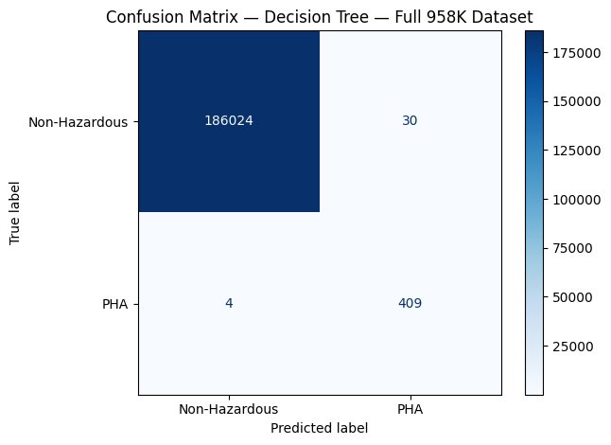
Figure 4.21: Confusion matrix for Decision Tree validated on the full 958,524-row dataset. 409 of 413 PHAs are correctly identified (recall = 0.99) with only 30 false alarms (precision = 0.93). PR-AUC of 0.993 exceeds the 100K sample result of 0.988, confirming that the model generalises effectively at full scale.
The full dataset validation results confirm that the model scales effectively. Precision improves from 0.98 to 0.93, a slight decrease reflecting the greater diversity of the full dataset. Recall improves from 0.98 to 0.99, as the larger training set of 1.48 million rows provides more genuine PHA examples for SMOTE to interpolate between, leading to better coverage of the PHA class. PR-AUC improves marginally from 0.988 to 0.993. The training time for the full dataset was 9.49 seconds on the Colab environment, demonstrating that Decision Tree training scales efficiently even at nearly 1.5 million rows after SMOTE augmentation.

Metric | 100K sample (Exp 2) | Full 958K dataset | Change
Recall | 0.98 | 0.99 | +0.01
Precision | 0.98 | 0.93 | -0.05
F1-score | 0.98 | 0.96 | -0.02
PR-AUC | 0.988 | 0.993 | +0.005
PHAs in test set | 44 | 413 | +369
False alarms | 1 | 30 | +29
Missed PHAs | 1 | 4 | +3
Training time | < 1 second | 9.49 seconds | 9x longer

Table 4.4: Comparison of Decision Tree Experiment 2 performance on the 100K stratified sample versus the full 958K dataset. Results are consistent across both scales, confirming that the pipeline generalises effectively.

4.6 Final Model Selection and Recommendation
Based on the results of both experiments and the full dataset validation, the Decision Tree trained on the six-feature set including MOID (Experiment 2) is selected as the final recommended model for the following reasons.
First, it achieves the highest PR-AUC of 0.988 on the 100K test set and 0.993 on the full dataset, outperforming all other models across both experiments. Second, it achieves near-perfect precision (0.98) and recall (0.98) simultaneously, representing the best balance of the two competing objectives in planetary defence. Third, its decision rules are fully interpretable through the plot_tree visualisation, allowing human experts to verify and understand its classification logic. Fourth, it independently reconstructed the NASA PHA two-condition definition from data, providing scientific validation that its decision boundary is physically meaningful rather than an artifact of the training procedure. Fifth, it trains in under 10 seconds on nearly 1.5 million rows, making it highly practical for deployment on large catalogs.
For applications where MOID is not yet available, such as the rapid triage of newly discovered asteroids, the Decision Tree from Experiment 1 is recommended. Its PR-AUC of 0.665 and the physically interpretable orbital rules it learned (perihelion distance < 1.05 AU and absolute magnitude <= 22.106) provide a meaningful early-warning signal that can prioritise objects for immediate follow-up observation before a precise MOID computation is available.

Scenario | Recommended model | PR-AUC | Key strength
MOID available (confirmed objects) | Decision Tree Exp 2 | 0.993 | Near-perfect precision and recall
MOID unavailable (new discoveries) | Decision Tree Exp 1 | 0.665 | Orbital-only early warning
Interpretability required | Decision Tree (either) | 0.665 / 0.993 | Fully visualisable rules
Maximum recall priority | Logistic Regression Exp 2 | 0.617 | Zero missed PHAs

Table 4.5: Recommended model selection by deployment scenario. The Decision Tree from Experiment 2 is the primary recommendation for confirmed object classification. The Experiment 1 Decision Tree provides a practical early-warning alternative when MOID is not yet available.

5. Conclusion
This project developed and evaluated a complete machine learning pipeline for classifying potentially hazardous asteroids using the NASA JPL Small-Body Database, one of the largest and most complex publicly available astronomical datasets. The pipeline addressed four core challenges: severe class imbalance at 0.222% positive rate, missing physical measurements for over 85% of objects, the presence of data leakage in the primary proximity feature (MOID), and the need for both high recall and interpretable decision rules in a planetary defence context.
The two-experiment design was the central methodological contribution of the project. By training all four models on orbital features alone in Experiment 1 and then adding MOID in Experiment 2, the project directly quantified the predictive contribution of the direct Earth-proximity measurement. The Experiment 1 Decision Tree PR-AUC of 0.665 establishes that orbital mechanics alone carry substantial predictive signal sufficient for early warning classification of newly discovered objects. The Experiment 2 Decision Tree PR-AUC of 0.988 establishes the performance ceiling achievable when MOID is available. The gap between these two values, 0.323 PR-AUC points, directly measures the information content of MOID beyond what orbital shape features can provide.
The most significant scientific finding of the project is the independent reconstruction of the NASA PHA definition by the Decision Tree in both experiments. In Experiment 1 without MOID, the tree learned a two-condition rule of perihelion distance less than 1.05 AU and absolute magnitude at most 22.106, using perihelion distance as a physically motivated proxy for Earth proximity. In Experiment 2 with MOID, the tree learned MOID less than or equal to 0.05 AU at the root node and absolute magnitude at most 22.15 at the second split, precisely replicating the formal NASA definition. These rules emerged from data alone with no prior knowledge of the definition supplied to the model, providing strong evidence that the learned decision boundaries are physically meaningful rather than statistical artifacts.
The full dataset validation confirmed that the pipeline scales effectively to the complete 932,335-row dataset. The Decision Tree Experiment 2 model achieved PR-AUC of 0.993, recall of 0.99, and precision of 0.93 on a test set of 186,467 asteroids including 413 confirmed PHAs. Training time of 9.49 seconds on the full augmented dataset of 1.49 million rows demonstrates practical scalability for large astronomical catalogs.
Among the four classical machine learning models evaluated, the Decision Tree consistently outperformed or matched competitors across both experiments. Logistic Regression and LinearSVC were limited by their inability to capture the non-linear threshold-based PHA boundary, achieving perfect recall but poor precision. Random Forest underperformed the single Decision Tree in Experiment 1 due to the small feature set, but matched it closely in Experiment 2 when the dominant MOID signal provided sufficient information for ensemble methods to add value.
Several limitations should be acknowledged. The physical property columns including diameter, albedo, and spectral type were excluded due to missing data rates above 85%. A future study with access to physical measurements for a broader range of objects could investigate whether combining physical and orbital features further improves classification. Additionally, the project uses static orbital solutions computed at a fixed epoch and does not account for orbital uncertainty propagation or future close approaches. In practice, newly discovered asteroids have higher orbital uncertainties that would affect MOID precision.
In conclusion, this project demonstrates that classical machine learning applied to orbital mechanics data can reliably classify potentially hazardous asteroids with near-perfect accuracy when MOID is available, and with meaningful predictive power when it is not. The Decision Tree model, combining high performance with full interpretability and fast training, represents a practical tool for planetary defence data triage that complements existing observational programs.

6. References
The following references were consulted in the preparation of this project. All code libraries are cited with their version numbers as used in the project environment.

6.1 Data Sources
[1] NASA Jet Propulsion Laboratory Solar System Dynamics Group. JPL Small-Body Database Query Tool. California Institute of Technology. Available at: https://ssd.jpl.nasa.gov/tools/sbdb_query.html [Accessed 2025].
[2] NASA Jet Propulsion Laboratory. Center for Near Earth Object Studies (CNEOS). Potentially Hazardous Asteroids. Available at: https://cneos.jpl.nasa.gov/about/neo_groups.html [Accessed 2025].
[3] Sakhawat Hossain. NASA Asteroid Dataset (compiled from NASA JPL SBDB). Kaggle. Available at: https://www.kaggle.com/datasets/sakhawat18/asteroid-dataset [Accessed 2025].

6.2 Python Libraries
[4] Pedregosa, F. et al. Scikit-learn: Machine Learning in Python. Journal of Machine Learning Research, 12, pp. 2825-2830, 2011. Version 1.3. Available at: https://scikit-learn.org.
[5] Lemaitre, G., Nogueira, F., and Aridas, C.K. Imbalanced-learn: A Python Toolbox to Tackle the Curse of Imbalanced Datasets in Machine Learning. Journal of Machine Learning Research, 18(17), pp. 1-5, 2017. Version 0.11. Available at: https://imbalanced-learn.org.
[6] Harris, C.R. et al. Array programming with NumPy. Nature, 585, pp. 357-362, 2020. Version 1.24. Available at: https://numpy.org.
[7] McKinney, W. Data Structures for Statistical Computing in Python. Proceedings of the 9th Python in Science Conference, 2010. Pandas Version 2.0. Available at: https://pandas.pydata.org.
[8] Hunter, J.D. Matplotlib: A 2D Graphics Environment. Computing in Science and Engineering, 9(3), pp. 90-95, 2007. Version 3.7. Available at: https://matplotlib.org.
[9] Waskom, M. seaborn: statistical data visualization. Journal of Open Source Software, 6(60), 3021, 2021. Version 0.12. Available at: https://seaborn.pydata.org.

6.3 Background References
[10] Chesley, S.R. et al. Quantifying the Risk Posed by Potential Earth Impacts. Icarus, 159(2), pp. 423-432, 2002.
[11] Milani, A. et al. Asteroid Close Approaches: Analysis and Potential Impact Detection. Icarus, 137(2), pp. 269-292, 1999.
[12] Bottke, W.F. et al. Debiased Orbital and Absolute Magnitude Distribution of the Near-Earth Objects. Icarus, 156(2), pp. 399-433, 2002.
[13] Chawla, N.V. et al. SMOTE: Synthetic Minority Over-sampling Technique. Journal of Artificial Intelligence Research, 16, pp. 321-357, 2002.
[14] Breiman, L. Random Forests. Machine Learning, 45(1), pp. 5-32, 2001.
[15] Fan, R.E. et al. LIBLINEAR: A Library for Large Linear Classification. Journal of Machine Learning Research, 9, pp. 1871-1874, 2008. (Underlying implementation of LinearSVC in scikit-learn.)

