**VBA-Challenge-Screenshots**

**Alphabeticall Testing**

Worksheet A(1)

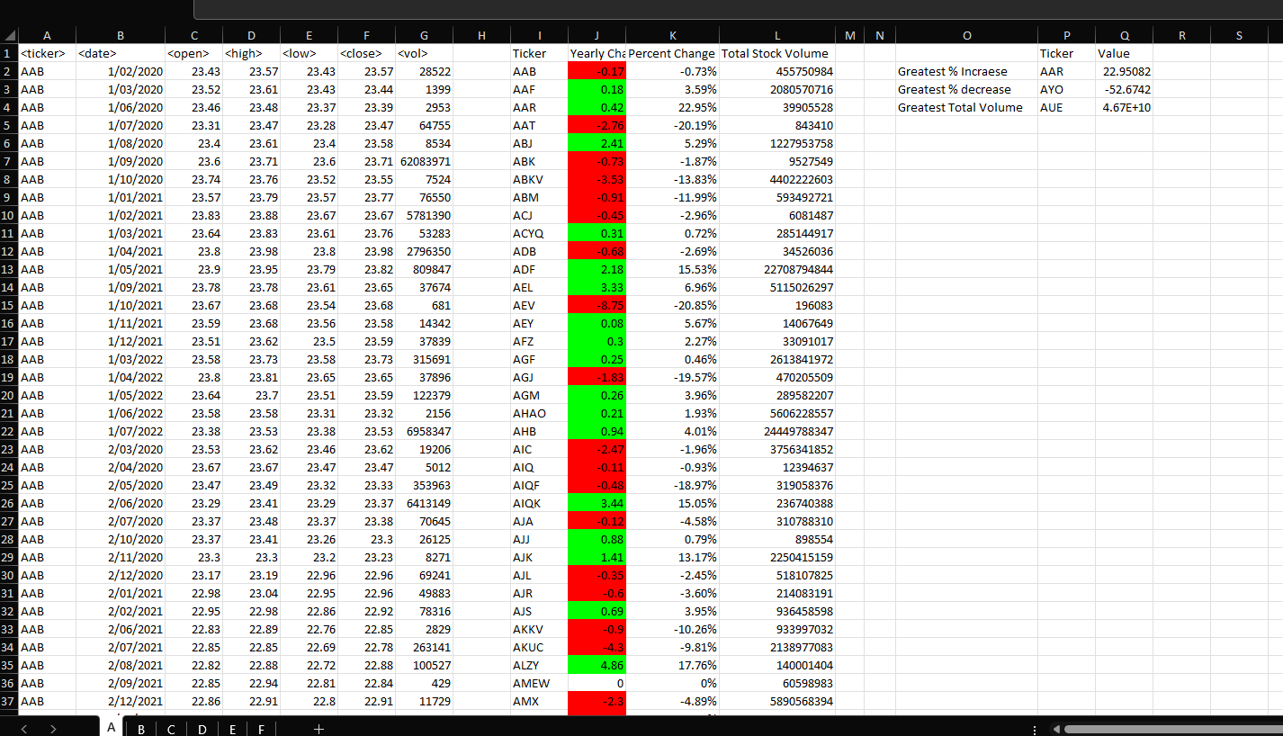

Worksheet B(1)

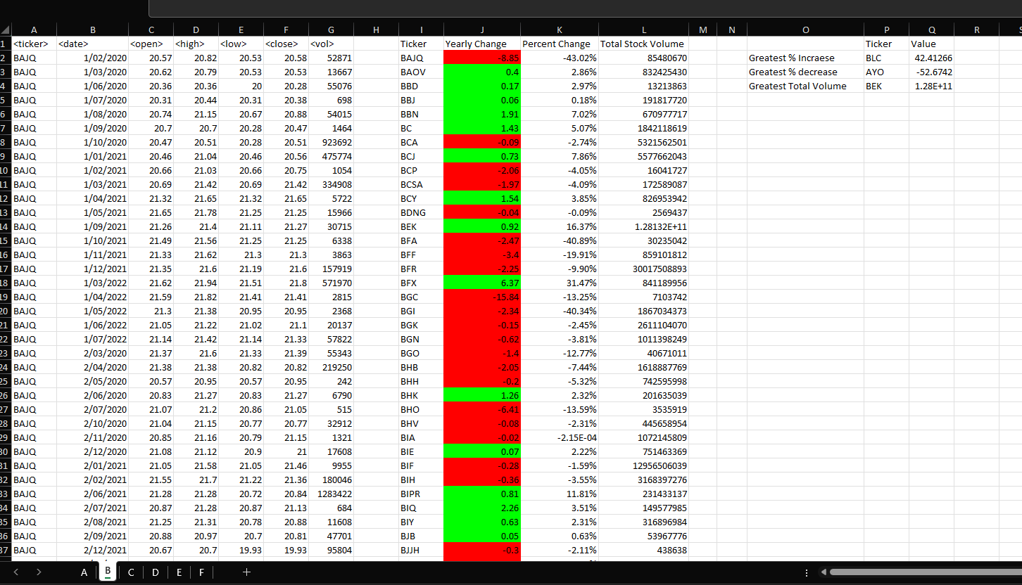

Worksheet C(1)

Worksheet D(1)

Worksheet E(1)

Worksheet F(1)

**File- Multiple Year Stock Data**

WorksheetQ1

WorksheetQ2

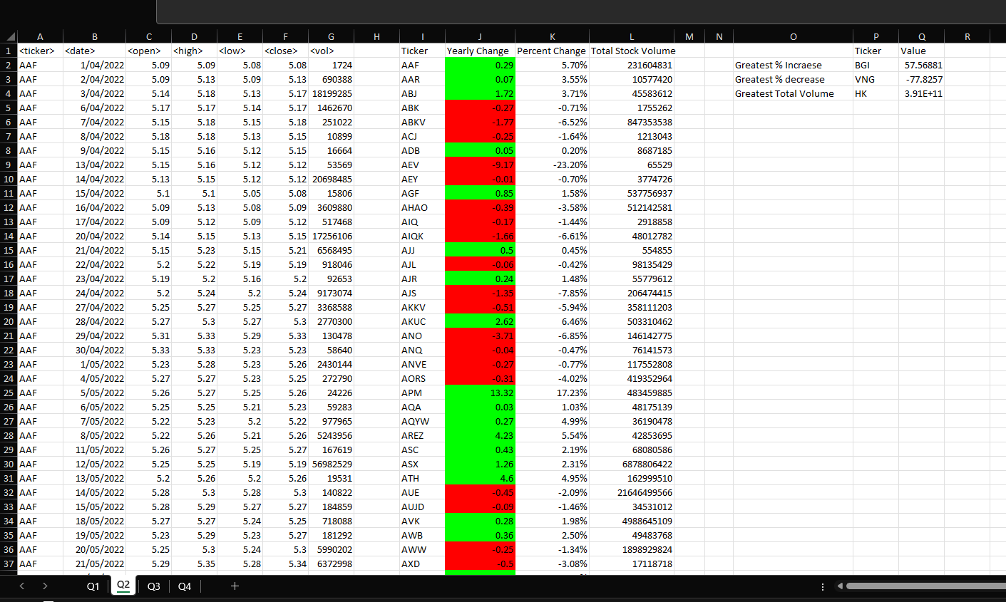

WorksheetQ3

WorksheetQ4

